Saanthvana – Tech Spec for the Healthathon Build
Oct 29, 2026 · @S
Build one mobile-first app with two linked records — a clinical emergency plan (ECTPR) and a legal living will (AMD) — and get the plan in front of an emergency doctor in 20 seconds.

1. What we are building
Ambulances and EDs resuscitate by default, so a wish counts only if the record is found and trusted at 2 a.m.; retrieval is the core feature.
- ECTPR (Saanthvana v1.0; the Healthathon form is its MVP subset): clinical plan for CPR, breathing ceiling, transfer, ICU, organ support and feeding. Not an AMD; valid once the treating clinician signs.
- AMD / living will (Vidhi–ACP India template): the patient's own refusal of life-prolonging treatment plus named representatives (DHRs). Valid only as signed paper attested by a notary or gazetted officer; if both exist, the AMD governs.
The app never decides to withhold or withdraw treatment, never validates an AMD by e-signature, and never offers active euthanasia (illegal).

2. Legal rules the code must enforce
From Common Cause (2018) as modified on 24 Jan 2023, applied in Harish Rana (11 Mar 2026). Rule → code:
- L1 Adult of sound mind → block DOB under 18; capacity declaration.
- L2 Names guardian(s) or close relative(s) → ≥ 1 DHR required, warn below 2; store preference order.
- L3 Signed before two (preferably independent) witnesses, attested by a notary or gazetted officer → app only generates the PDF; Executed only once the signed scan, witnesses and attestor are recorded; warn if a witness is a DHR.
- L4 Copies to DHRs, family physician and local-body custodian; may join digital health records → per-recipient checklist, optional ABHA link.
- L5 Doctor verifies via digital records or custodian → view scan, SHA-256 hash, custodian acknowledgement.
- L6 Revoke or change anytime in writing, same procedure → edits are new versions needing re-execution; latest executed version is current.
- L7 Ambiguous or unanticipated situation → not applied; show the caveat, never auto-apply.
- L8 Stopping running treatment needs Primary + Secondary Medical Boards (each preferably within 48 h) and JMFC intimation → no "withdraw" action in the app.
- L9 Tube feeding is medical treatment (Harish Rana) → a treatment choice; comfort feeding by mouth always continues.
- L10 DPDP Act 2023 + Rules 2025 (duties from May 2027) → Section 7.
Decided: allow "custodian pending" (few states have appointed custodians). The Healthathon "basis for authority" becomes NAMED_IN_AMD · NAMED_BY_PATIENT · NEXT_OF_KIN · COURT_APPOINTED; "family consensus" is a note, not a legal basis. Store ID type + last 4 digits, never a full Aadhaar. Mental Healthcare Act directives are out of scope.

3. Users and roles
Patients and surrogates/DHRs (mobile OTP) create, sign or revoke their own records and request reviews. Treating clinicians (hospital login + registration no.) create, sign and review ECTPRs. ED staff and ambulance crews read the ED Quick View by QR; the full record needs break-glass. Custodians (officer login) acknowledge AMDs; admins (2FA) manage form versions, translations and the audit log. A signed ECTPR is never edited; a review creates a new version.

4. Core flows
- ECTPR: patient → decision-makers → capacity and existing AMD → understanding gate (V4) → values → treatment choices → review date → signatures → ED Quick View generated.
- AMD: guided Vidhi-template questions → preview → PDF with blank signature, witness and notary blocks → upload signed scan → log copies.
- Emergency: QR → ED Quick View (wallet-card data plus validity and version); full record by break-glass.
- Review or cancel: any trigger (admission, transfer, condition change, request, interval) opens a prefilled draft; a signed cancellation revokes card tokens.

5. Data model and validation
Entities: Patient, Person, Clinician, ECTPR and AMD (versioned), Signature, Distribution, ReviewLog, AccessLog (append-only), CardToken. Store choices as enums, not translated text, so one record prints in any language.
ECTPR field | Values / rule
Patient | Name, DOB, sex, address, phone, UHID, language_pref (22 scheduled languages + English + other)
Care team | Oncologist, palliative physician (24 h phone), extra team[], local doctor
Decision-makers | Primary + alternate: name, relation, 24 h phone, ID type + last 4, authority_basis; family_to_inform[]
Clinical | Diagnosis, stage, ECOG 0–4
capacity | HAS · HAS_DELEGATED · FLUCTUATES · LACKS (last two need assessor, date, basis)
existing_directive | VALID_AMD (date, location, attestor) · PRIOR_WISHES · NONE
Values | patient_knows, own words (verbatim), unacceptable_outcomes[]
goal_of_care / cpr | A_LIFE · B_CEILING · C_COMFORT / ATTEMPT · DNACPR (reason); both nullable
hospital_transfer / icu | ANY · ONLY_FOR[reasons] · NO / YES · TRIAL(days) · NO; both nullable
resp_ceiling | 0 comfort … 5 intubation, nullable; highest acceptable level
Organ support, feeding, review_due | Per form options; trials need a duration > 0; review date required
Validation rules:
- V1 null = "No preference recorded", never refusal; nothing pre-selected.
- V2 Goal C, or a set ceiling below 5, with CPR = ATTEMPT → reason required.
- V3 Goal A with ceiling below 5 or ICU = NO → conflict warning to confirm.
- V4 Treatment sections locked until "illness explained as incurable; family can repeat it back" is ticked (Saanthvana 5.1; add to the Healthathon form).
- V5 Surrogate answering → substituted-judgement declaration confirmed first.
- V6 Thumb impression or limited literacy → two witnesses.
- V7 Active only with the consultant's signature + registration no.; one Active version per patient.
- V8 Every PDF page: name, UHID, version, form version, print date, page x of y.
- V9 Saanthvana Section 16 ("always provided" care) prints on every ECTPR.

6. Record lifecycle and the ED view
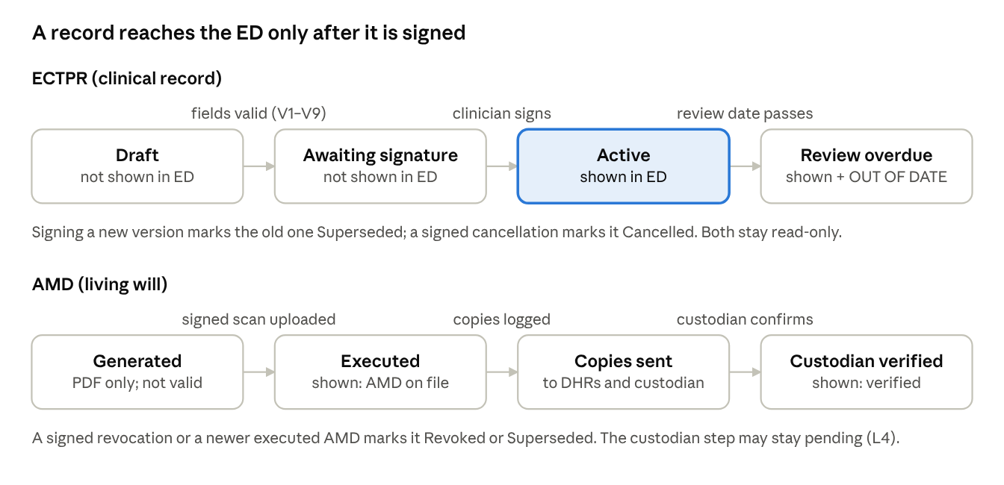
record lifecycles · ECTPR and AMD
Nothing reaches the ED screen until a clinician signs (ECTPR) or a signed, attested scan is uploaded (AMD). The ED Quick View always shows the "IF IN DOUBT, RESUSCITATE" box (record unsigned, out of date or missing; problem new and reversible; patient now disagrees; or record ambiguous → standard care). It leads with transfer, CPR, breathing ceiling and ICU, shows unticked items as "No preference recorded", and shows AMD status with the L7 caveat, version and review-due date.

7. Security, privacy and performance
- Data and consent: synthetic patients only for the hackathon. DPDP notice in the user's language; separate consent per copy recipient; handle access, correction and withdrawal requests.
- Access: role-based; break-glass logged with a reason and SMS to the primary decision-maker; append-only audit of every view, edit, print and share.
- Protection: TLS 1.2+, AES-256 at rest, Indian cloud region; SHA-256 on every PDF; random ≥ 128-bit revocable QR tokens with no personal data in the URL.
- Reach: ED view < 2 s on 3G, one printed page, works offline; Class 8 reading level, read-aloud audio, thumb path; Telugu, Hindi, Urdu (right-to-left) and English first. Stretch: FHIR R4 export (Consent scope adr) and ABHA link.

8. Hackathon scope and acceptance
Must: ECTPR wizard with V1–V9 · ED Quick View · ECTPR PDF + QR wallet card · AMD form → Vidhi-format PDF · status lifecycles · English + Telugu · audit log. Should: scan upload with hash, copy checklist, review SMS, break-glass. Won't: e-signed AMDs, automated withdraw decisions, AI treatment advice.
- ☐ All boxes unticked → "No preference recorded" everywhere; ED view says standard care.
- ☐ Goal C + Attempt CPR cannot save without a reason.
- ☐ Unsigned ECTPRs never reach the ED view; past review dates show OUT OF DATE.
- ☐ DOB under 18 blocks an AMD; an AMD stays Generated until scan, witnesses and attestor are recorded.
- ☐ Revoked QRs show "card withdrawn"; English and Telugu PDFs of one record match.
Open questions: Has Andhra Pradesh named living-will custodians? Will the hospital accept in-app clinician signatures? What default review interval?
Sources: SC order of 24 Jan 2023 (SCC Times) · Harish Rana, 11 Mar 2026 (Drishti IAS) · DPDP commencement (AZB & Partners) · State implementation (South First) · your files: Saanthvana v1.0, Healthathon form, Vidhi / ACP India model AMD.

