Supplementary Online File:

Table of Contents:

Fig A Integrated Palliative Outcome Scale Hindi version (available to download from: www.pos-pal.org) 2
Table A Exploratory factor analysis showing 3-factor solution with parcelled items as feasible (n=240)…………………………………………………………………………………………………………………………………………… 1
Table B Paired t-test comparing mean difference Standard Deviation, 95% CI, t, df and significance of baseline and first follow-up subscale scores of patients who reported at the second assessment that they have felt the ‘same’ since the last assessment 3
Table C Convergent and Divergent Validity - Spearman's Rho correlation of IPOS Hindi Subscales with EQ-5D-5L items and Health Status (n=237) 4
Table D Effect sizes for subscale change scores between baseline and first-follow up assessment in persons who self-reported to have improved. 5
Table E Effect sizes for subscale change scores between first and second-follow up assessment in participants who self-reported to have improved. 5
Table F SRM for mean change scores from baseline to second follow-up assessment with available data 6
Figure B CFA Model without host-hoc modification (n=240)……………………………………………………………6

Fig A Integrated Palliative Outcome Scale Hindi version (available to download from: www.pos-pal.org)
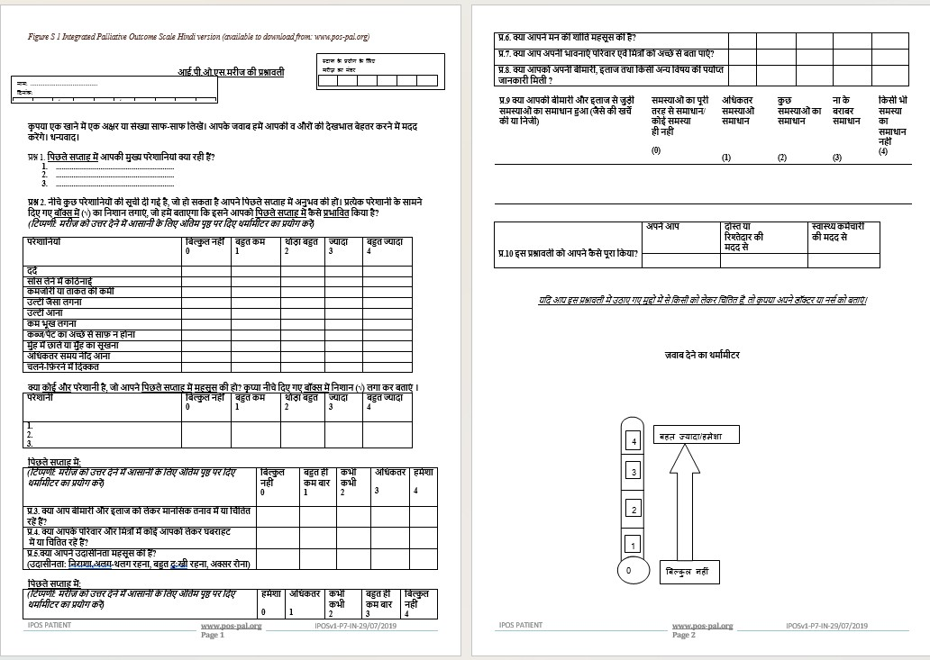

Table A Exploratory factor analysis showing 3-factor solution with parcelled items as feasible (n=240)
 | Physical | Communication &  Support | Emotional
Poor mobility | 0.70 |  | -0.28
Weakness or lack of energy | 0.61 |  | -0.40
Pain | 0.53 |  | -0.27
Shortness of breath | 0.47 |  | -0.25
Constipation | 0.44
Gastrointestinal Parcel | 0.38 |  | -0.28
Poor appetite | 0.27 |  | -0.25
Sore or dry mouth | 0.25
Drowsiness | 0.18
Practical (Personal and Financial) problems due to illness been addressed | 0.41 | -0.25 | -0.30
Sharing feelings with family or friend |  | -0.62
Getting information as much as wanted | 0.25 | -0.33 | -
Feeling anxious or worried about illness or treatment | 0.33 | -0.28 | -0.73
Feeling depressed | 0.37 | -0.29 | -0.72
Family or friends feeling anxious or worried | 0.31 |  | -0.58
Feeling at peace | 0.34 | -0.64 | -0.50
Extraction Method: Principal Axis Factoring.
Rotation Method: Oblimin with Kaiser Normalisation.
Blanks represent factor loadings <0.30/-0.30
Loadings in bold indicate the factor the items are grouped under.

Table B Paired t-test comparing mean difference Standard Deviation, 95% CI, t, df and significance of baseline and first follow-up subscale scores of patients who reported at the second assessment that they have felt the ‘same’ since the last assessment
 |  | Mean Difference | SD | 95% Confidence Interval of the Difference |  | t | df | p-value (2 sided)
 | n | Mean Difference | SD | Lower | Upper | t | df | p-value (2 sided)
Physical | 37 | 0.72 | 3.91 | -0.58 | 2.02 | 1.12 | 36 | 0.27
Emotional | 42 | 0.24 | 2.99 | -0.69 | 1.17 | 0.52 | 41 | 0.61
Communication & Support | 41 | -0.39 | 2.26 | -1.10 | 0.32 | -1.11 | 40 | 0.27

Table C Convergent and Divergent Validity - Spearman's Rho correlation of IPOS Hindi Subscales with EQ-5D-5L items and Health Status (n=237)
IPOS Hindi Subscales |  |  | EQ-5D-5L
Physical |  | Mobility |  | Self-care | Usual Activity | Pain/Discomfort | Anxiety/  Depression | Self-rated Health (VAS)
Physical | r | 0.53** |  | 0.46** | 0.55** | 0.40** | 0.53** | -0.44**
Physical | Sig(2-tailed) | <.001 |  | <.001 | <.001 | <.001 | <.001 | <.001
Physical | n | 208 |  | 208 | 208 | 208 | 208 | 205
Emotional | r | 0.57** |  | 0.50** | 0.58** | 0.44** | 0.31** | -0.41**
Emotional | Sig(2-tailed) | <.001 |  | <.001 | <.001 | <.001 | <.001 | <.001
Emotional | n | 213 |  | 213 | 213 | 213 | 213 | 210
Communication & Support | r | 0.29** |  | 0.26** | 0.35** | 0.27** | 0.62** | -0.34**
Communication & Support | Sig(2-tailed) | <.001 |  | <.001 | <.001 | <.001 | <.001 | <.001
Communication & Support | n | 237 |  | 237 | 237 | 237 | 237 | 234
VAS = visual analogue scale

Table D Effect sizes for subscale change scores between baseline and first-follow up assessment in persons who self-reported to have improved.
Time interval | Subscale | n | ES | Mean Change Score in Improved Group (n) | SD in the group who feels the same (unchanged) since T0 assessment (n)
Baseline (T0) to  First follow-up (T1) Assessment | Physical | 35 | -0.3 | -1.2(35) | 3.9(37)
Baseline (T0) to  First follow-up (T1) Assessment | Emotional | 43 | -0.6 | -1.8(43) | 3.0(42)
Baseline (T0) to  First follow-up (T1) Assessment | Communication  & Support | 41 | -0.4 | -0.9(41) | 2.3(41)

Table E Effect sizes for subscale change scores between first and second-follow up assessment in participants who self-reported to have improved.
Time interval | Subscale | n | ES | Mean Change Score (T2-T1) in Improved Group (n) | SD in the group who feels the same (unchanged) since T1 assessment (n)
First follow-up (T1) to Second follow-up (T2) Assessment | Physical | 29 | -0.6 | -2.7(29) | 4.6(32)
First follow-up (T1) to Second follow-up (T2) Assessment | Emotional | 32 | -0.5 | '-1.2(32) | 2.6(37)
First follow-up (T1) to Second follow-up (T2) Assessment | Communication & Support | 29 | 0.0 | -0.1(29) | 2.2(35)

Table F SRM for mean change scores from baseline to second follow-up assessment with available data
Subscale | SRM | Mean Change Score  T2-T0 in total sample (n) | SD of Mean Change Score T2-T0 assessment
Physical | -0.4 | -2.3(99) | 5.6
Emotional | -0.3 | -0.9(112) | 3.3
Communication & Support | 0.0 | 0(131) | 2.3

Fig B CFA Model without post-hoc modifications (n=240)
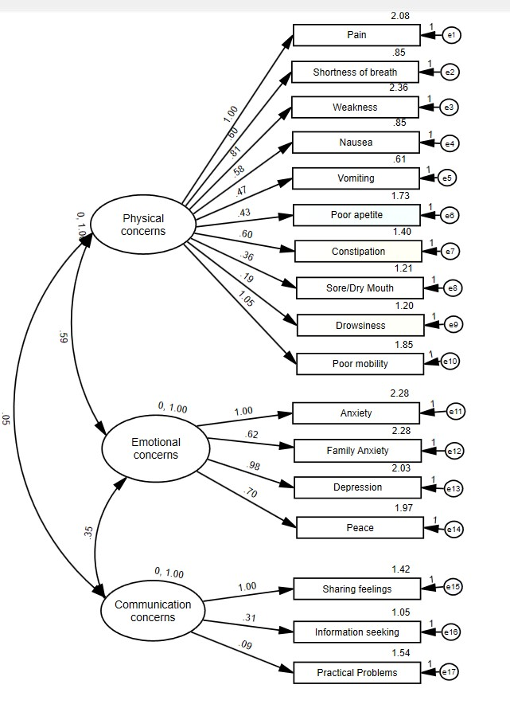

Legend
Latent variables or constructs or unobserved factors | e₁
Observed or measured variables
Residual or error variance
Factor loading
covariance or correlation

