Secure Database CI/CD Pipeline
GitHub Actions • Self-Hosted Runner • PostgreSQL in Docker

Design, Implementation and Test Evidence

Item | Detail
Repository | github.com/ahmedraza165/secure-db-pipeline
Database | PostgreSQL 16 (Docker container pg-db)
Server | AWS EC2 — 52.77.208.149 (Ubuntu)
CI/CD | GitHub Actions with a self-hosted runner
Date | 9 July 2026

1. Executive Summary
This document describes a secure CI/CD pipeline that deploys SQL changes from a GitHub repository to a database running in a Docker container on a remote server. The repository holds two SQL files: file 1 contains the DDL (CREATE TABLE) and file 2 contains DML (INSERT / UPDATE). On every push, the pipeline:
- Scans the DML file and refuses to run anything if it contains DELETE or TRUNCATE, failing the run with the explicit error “DELETE/TRUNCATE detected”.
- Checks whether the target table already exists in the database: if it does not exist, file 1 (DDL) is executed; if it exists, file 2 (DML) is executed instead.
- Takes an automatic snapshot of the table before any DML runs, so the table can be restored to its previous state at any time with a one-click rollback workflow.
- Publishes full logs of every stage: live step output, a formatted job summary per run, and downloadable log artifacts retained for 30 days.
Every requirement was implemented and verified end-to-end against the live server. The verification process also uncovered a subtle GitHub Actions behaviour (missing pipefail in the default shell) that initially allowed the guard to be bypassed; the incident, the fix and the successful re-test are documented in section 8.
Note on the database engine: the assignment originally referenced Oracle. The provided test server has ~900 MB of RAM while the Oracle Database container requires a minimum of 2 GB, so it cannot run there. As agreed, PostgreSQL 16 was used instead; the pipeline logic, guard, routing and rollback behave exactly as specified and the design is portable back to Oracle (sqlplus in place of psql) without structural changes.

2. Requirements and Delivery Status
# | Requirement | Status
1 | Detect DELETE/TRUNCATE in the DML file and block the run with an explicit error | Delivered & tested
2 | If the table does not exist, run file 1 (CREATE TABLE) | Delivered & tested
3 | If the table exists, run file 2 (INSERT / UPDATE) | Delivered & tested
4 | Pipeline logs available for every run | Delivered (summaries + artifacts)
5 | Rollback: restore the table to its previous state on demand | Delivered & tested
6 | Secure design (no exposed DB, secret credentials, least privilege) | Delivered

3. System Architecture
The pipeline uses a self-hosted GitHub Actions runner installed directly on the database server. This is the most secure connectivity option: GitHub never needs network access to the database, and the database port is bound to 127.0.0.1 so nothing is exposed to the internet. The runner receives jobs from GitHub over an outbound HTTPS connection and talks to PostgreSQL locally through Docker.
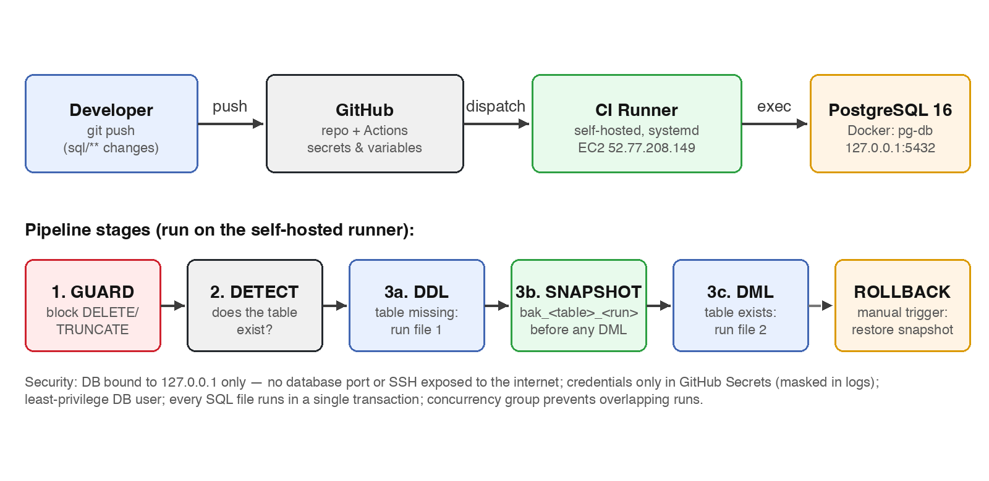
Figure 1 — End-to-end architecture and pipeline stages.
Component | Technology | Role
Source control | GitHub (private repo) | Holds SQL files, workflows, scripts
CI/CD | GitHub Actions | Orchestrates guard → detect → deploy → rollback
Runner | actions/runner 2.335.1 as a systemd service | Executes jobs on the DB server
Database | PostgreSQL 16 (postgres:16-alpine) | Target database, Docker volume pg-data
Server | AWS EC2, Ubuntu, 2 vCPU / ~1 GB RAM | Hosts the container and the runner

4. Environment Setup (how it was built)

4.1 Server preparation
The server is a small EC2 instance, so a 1 GB swap file was added first, then Docker was installed and the ubuntu user was added to the docker group:
sudo fallocate -l 1G /swapfile && sudo chmod 600 /swapfile
sudo mkswap /swapfile && sudo swapon /swapfile
sudo apt-get install -y docker.io
sudo usermod -aG docker ubuntu

4.2 PostgreSQL container
PostgreSQL 16 runs in a container named pg-db. The port mapping deliberately binds to 127.0.0.1 only, data is persisted on a named volume, and the container memory is capped so the database cannot starve the runner:
docker run -d --name pg-db --restart unless-stopped \
-p 127.0.0.1:5432:5432 \
-e POSTGRES_PASSWORD='<superuser password>' \
-v pg-data:/var/lib/postgresql/data \
--memory=400m postgres:16-alpine

4.3 Least-privilege application user
The pipeline never connects as the postgres superuser. A dedicated user owns a dedicated database, and the CI connects over TCP with password authentication:
CREATE ROLE appuser LOGIN PASSWORD '<secret>' NOSUPERUSER NOCREATEDB NOCREATEROLE;
CREATE DATABASE appdb OWNER appuser;

4.4 Self-hosted runner
The GitHub Actions runner was registered against the repository and installed as a systemd service so it starts automatically after reboots:
./config.sh --unattended --url https://github.com/ahmedraza165/secure-db-pipeline \
--token <registration token> --name db-test-server --labels self-hosted,db-server
sudo ./svc.sh install ubuntu && sudo ./svc.sh start
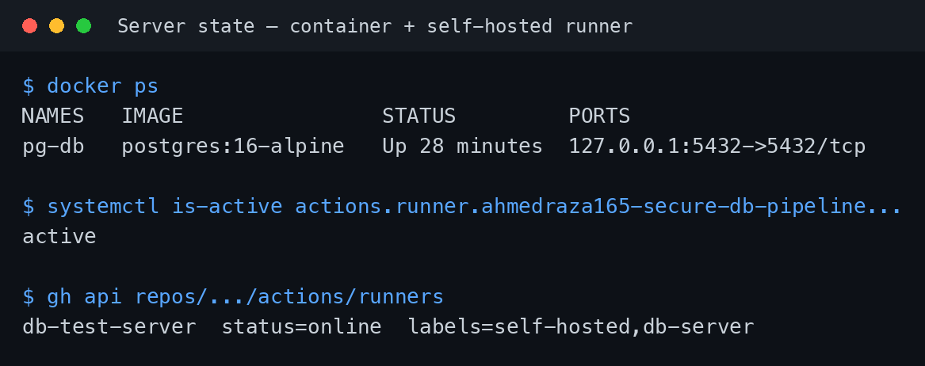
Figure 2 — Live server state: container up (localhost-only port) and runner service active/online.

4.5 Secrets and variables
Credentials are stored only in GitHub Actions Secrets, which are masked in every log line. Non-sensitive settings are repository Variables:
Kind | Name | Value / purpose
Secret | DB_USER | Application DB user (masked in logs)
Secret | DB_PASSWORD | Application DB password (masked in logs)
Variable | PG_CONTAINER | pg-db — container name
Variable | DB_NAME | appdb — target database

5. Pipeline Design (DB Deploy workflow)
The deploy workflow triggers on every push to main that changes anything under sql/, and can also be run manually. A concurrency group ensures deploy and rollback can never run at the same time. It consists of two jobs:

5.1 Stage 1 — Guard (destructive-DML detection)
Before anything touches the database, check_forbidden.sh scans the DML file. It first strips SQL comments and string literals, then searches for DELETE or TRUNCATE as whole words, case-insensitively. This means a comment like “-- delete later” or a column named deleted_at does not cause a false positive, while a real statement cannot hide behind casing (DeLeTe) or extra whitespace. On detection, the job fails with an explicit error and the deploy job is skipped entirely:
CLEANED=$(perl -0777 -pe "s{/\*.*?\*/}{}gs; s/--[^\n]*//g; s/'[^']*'//g" "$FILE")
if echo "$CLEANED" | grep -Eiq '\b(DELETE|TRUNCATE)\b'; then
echo "::error file=$FILE::DELETE/TRUNCATE detected - pipeline blocked."
exit 1
fi

5.2 Stage 2 — Detect and route
The target table name is parsed from the CREATE TABLE statement in file 1, and its existence is checked against information_schema.tables. The result routes the run:
- Table does not exist → branch A executes file 1 (DDL) and creates the table.
- Table exists → branch B first snapshots the table, then executes file 2 (DML).
Every SQL file is executed with psql --single-transaction and ON_ERROR_STOP, so a failing script rolls back completely — the database is never left half-migrated.

5.3 Logging
- Live step output in the Actions console for every command.
- A formatted job summary per run (target table, branch taken, snapshot name, full SQL output).
- guard.log / backup.log / deploy.log uploaded as artifacts, retained for 30 days.

6. Backup and Rollback Design
Before any DML executes, the pipeline creates a snapshot copy of the table named bak_<table>_<run number> (e.g. bak_employees_4). Only the five most recent snapshots per table are kept; older ones are pruned automatically. Rollback is a separate manually triggered workflow (Actions → DB Rollback → Run workflow) that takes two optional inputs: the table and the snapshot to restore (default: latest). The restore runs DELETE + INSERT inside a single transaction — if it fails midway, the table is left untouched.
-- snapshot (automatic, before every DML run)
CREATE TABLE bak_employees_4 AS TABLE employees;
-- restore (manual workflow, single transaction)
DELETE FROM employees;
INSERT INTO employees SELECT * FROM bak_employees_4;

7. Verification and Test Evidence
All four behaviours were tested against the live server on 9 July 2026. The complete run history below shows every test, including the intentionally failing guard test:
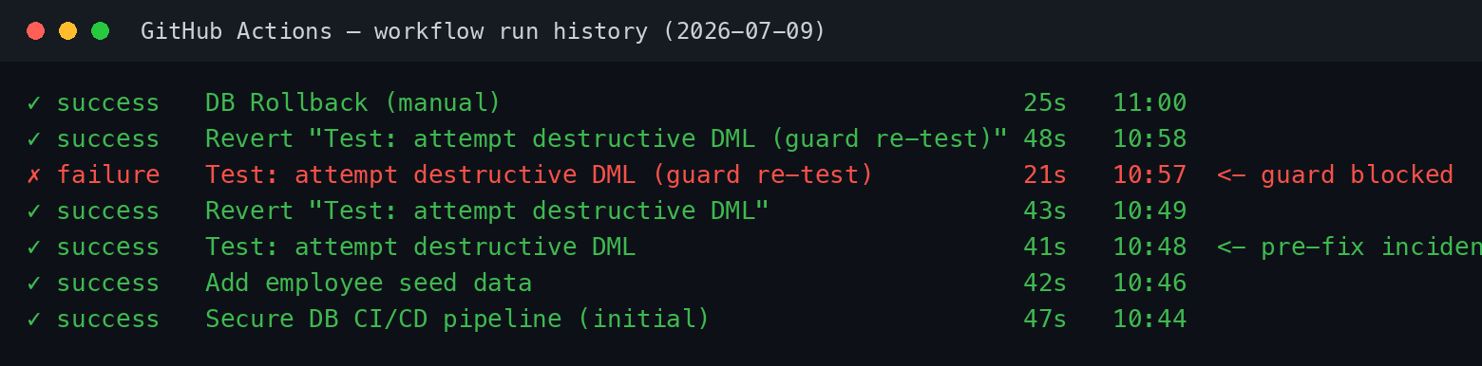
Figure 3 — Complete GitHub Actions run history for the test session.

7.1 Test 1 — Table does not exist → DDL runs
On the first run the employees table did not exist (exists in DB: 0), so the pipeline took branch A and executed file 1. Verified afterwards with psql: the table was created.
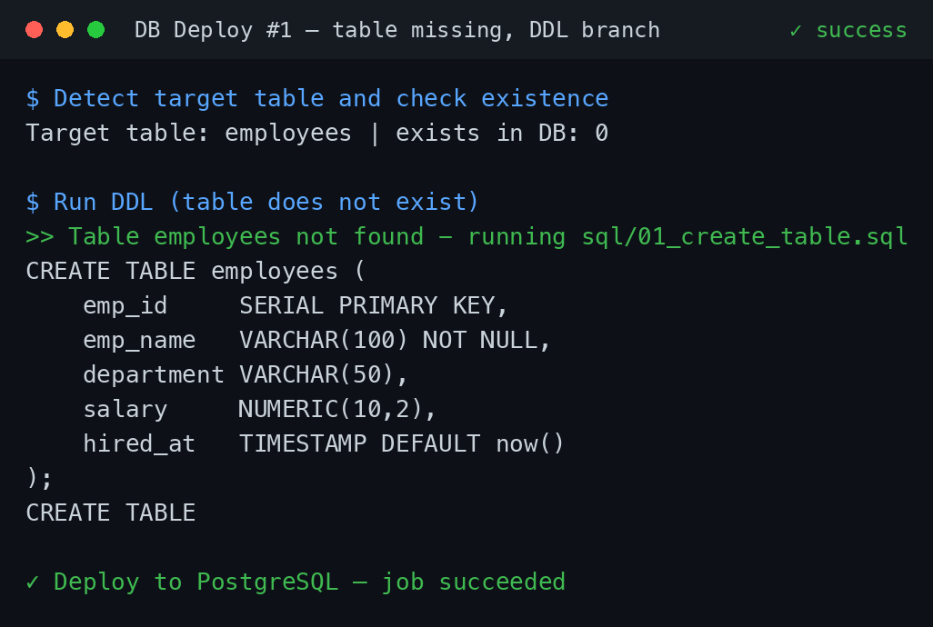
Figure 4 — Run #1 log: existence check returns 0, file 1 (CREATE TABLE) is executed.

7.2 Test 2 — Table exists → snapshot + DML runs
After changing the DML file and pushing, the pipeline detected the existing table (exists in DB: 1), created snapshot bak_employees_2 first, then applied the inserts and the salary update.
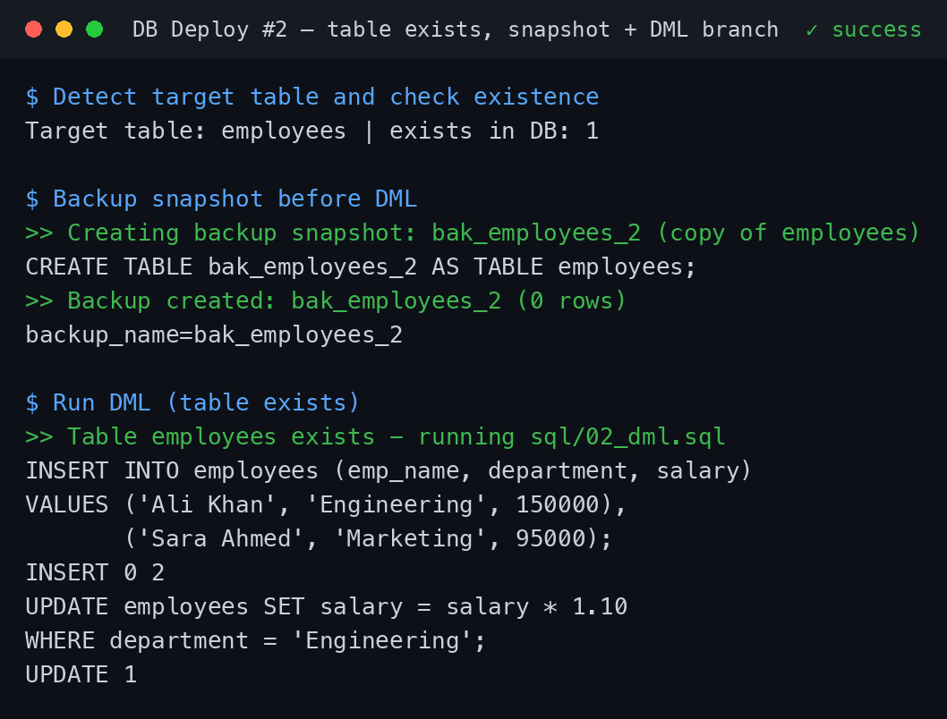
Figure 5 — Run #2 log: snapshot taken before the DML, then INSERT/UPDATE applied.

7.3 Test 3 — DML containing DELETE → run blocked
A DELETE statement was deliberately added to the DML file and pushed. The guard failed the run with the exact required error, reported the offending line number, and the deploy job was skipped — the database row count was verified unchanged afterwards.
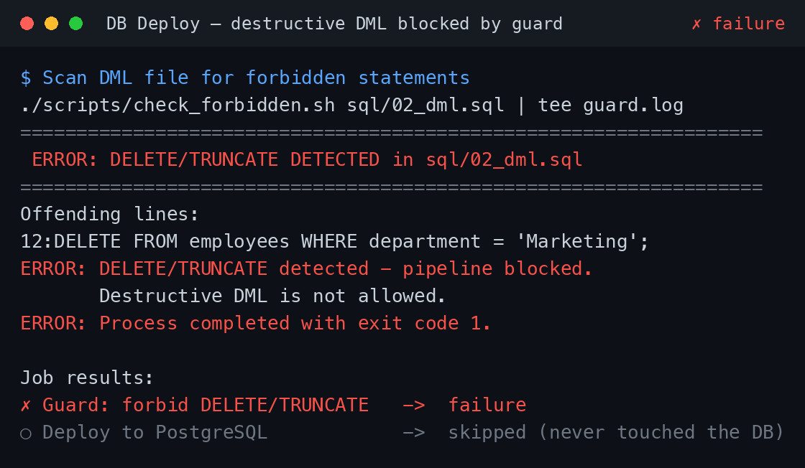
Figure 6 — Guard test: run fails with “DELETE/TRUNCATE detected”; deploy job skipped.

7.4 Test 4 — Rollback to a previous state
The rollback workflow was triggered manually, restoring snapshot bak_employees_3. The table went from 6 rows back to its exact earlier 2-row state. The final database state after the whole test session:
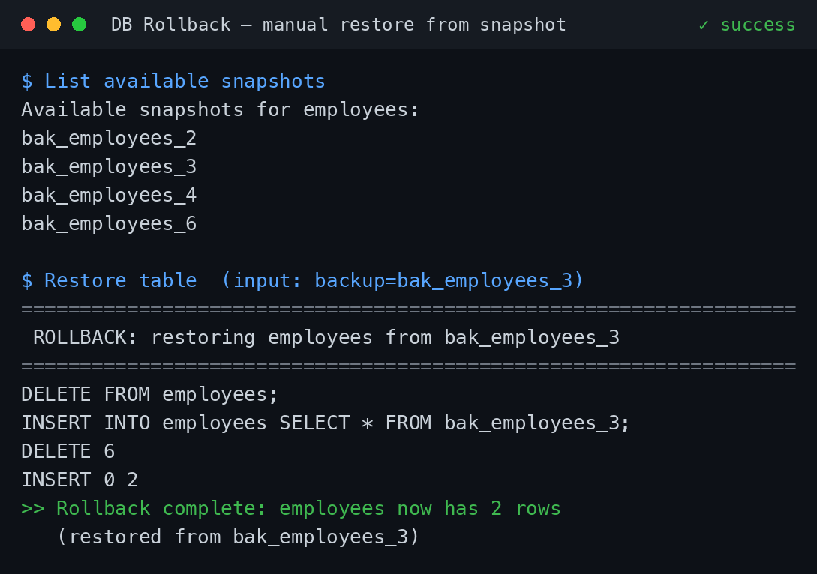
Figure 7 — Rollback run log: snapshot list, restore in one transaction, row counts before/after.
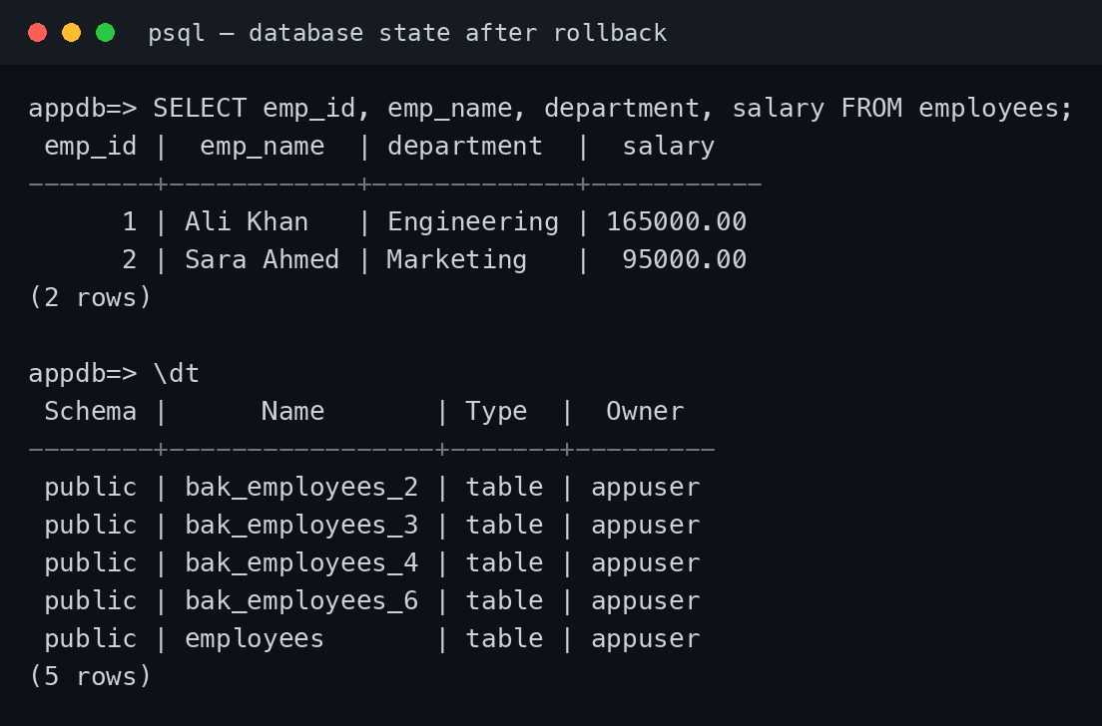
Figure 8 — Database state after rollback: original 2 rows restored; snapshots retained.

8. Hardening Finding: Guard Bypass via Missing pipefail (found and fixed)
During verification, the first destructive-DML test exposed a subtle but serious issue. The guard script correctly detected the DELETE and exited with a failure code — yet the run passed and the DELETE executed. Root cause: GitHub Actions' default shell is bash -e {0} without pipefail, and the guard step piped its output through tee (check_forbidden.sh | tee guard.log). The pipeline's exit status was therefore tee's (always 0), silently masking the guard failure.
Fix: setting an explicit shell in the workflow — which GitHub runs as bash --noprofile --norc -eo pipefail — so a failing command anywhere in a pipe fails the step:
defaults:
run:
shell: bash # runs with -eo pipefail; tee can no longer mask a failure
The destructive test was then repeated: the run failed at the guard stage and the deploy job was skipped (section 7.3). The rows affected by the original incident were fully recovered using the snapshot system — a real-world demonstration that the rollback design works. Lesson: never rely on a piped command's exit status in CI without pipefail, and always test the failure path, not just the happy path.

9. Security Measures
- No inbound exposure: PostgreSQL is bound to 127.0.0.1 inside the server; the self-hosted runner connects to GitHub outbound-only. No DB port is reachable from the internet.
- Credentials only in GitHub Secrets; automatically masked in all logs (visible as *** in run output).
- Least privilege: the pipeline connects as appuser (no superuser, no createdb/createrole), owning only the application database.
- Destructive-statement guard runs before any database connection is made.
- Atomicity: every SQL file runs in a single transaction with ON_ERROR_STOP.
- Concurrency control: a shared concurrency group prevents deploy and rollback from overlapping.
- Automatic pre-DML snapshots with retention (last 5), enabling point-in-time table restore.

10. Known Limitations and Future Improvements
- Snapshots copy table data, not indexes/constraints; rollback restores rows into the existing table.
- The DML file is re-executed in full on every push (not idempotent). A natural next step is ON CONFLICT clauses or a migration-tracking table (e.g. Flyway/Liquibase style).
- The guard currently blocks DELETE and TRUNCATE; DROP/ALTER can be added to the same regex.
- Single-environment setup; a production rollout would add a staging database and approvals (GitHub Environments with required reviewers).

11. Appendix — Repository Structure
.github/workflows/
db-deploy.yml # guard -> detect -> DDL or snapshot+DML
db-rollback.yml # manual restore from snapshot
scripts/
check_forbidden.sh # DELETE/TRUNCATE guard
db_exec.sh # psql helpers (single-transaction execution)
extract_tables.sh # parse table names from SQL files
backup_table.sh # pre-DML snapshot + retention pruning
rollback_table.sh # transactional restore
sql/
01_create_table.sql # file 1 - DDL
02_dml.sql # file 2 - DML (INSERT/UPDATE only)

