Web Application Vulnerability Assessment + Automated Recon
Abdul Basit Wani

1. Introduction
This report documents a full security assessment performed on Damn Vulnerable Web Application (DVWA) hosted locally on a Kali Linux environment. The objective was to simulate a realistic penetration test, identify common web vulnerabilities (SQL Injection, XSS, IDOR), automate reconnaissance, analyse root causes, and provide secure coding recommendations.
This project demonstrates key responsibilities of an Application Security Engineer:
✔ offensive testing
✔ defensive coding
✔ automation
✔ CVSS-based risk scoring
✔ threat modelling
✔ clear documentation

2. Environment Setup
Component | Details:
Application | DVWA hosted on http://localhost/dvwa
OS | Kali Linux (attacker)
Stack | Apache2 (server), MySQL (database), PHP (backend)
Tools | Nmap, Curl, Burp Suite, Browser DevTools, Bash

Purpose of Tools Used
Tool | Why Used
Apache2 | Serves DVWA web pages
MySQL | Stores DVWA user data & app tables
Nmap | Port & service version scanning
Curl | Directory enumeration, HTTP testing
Burp Suite | Capturing & modifying requests
Bash scripting | Automating recon
Browser DevTools | Inspecting HTML & JS

The DVWA security level was intentionally set to LOW to allow exploitation of vulnerabilities for educational purposes.

3. Automated Reconnaissance (Bash Script)
A custom Bash script (recon.sh) was developed to automate:
- Nmap service enumeration
- Directory discovery
- HTTP status checking
- Technology fingerprinting

🔧 Commands Used & Explanation
nmap -sV -oN nmap-output.txt localhost
- nmap → tool for scanning ports & services
- -sV → detects service versions (e.g., Apache 2.4.x)
- -oN → saves output to a file
- localhost → scan the local machine
To identify which services are running and confirm the web server/database stack.

3.2 Directory Enumeration Using Curl

curl -o /dev/null -s -w "%{http_code}" http://localhost/dvwa/admin
- curl → command-line HTTP client
- -o /dev/null → hide response content
- -s → silent mode
- -w "%{http_code}" → print only status code
To discover accessible or restricted directories (e.g., admin panels, config folders).
3.3 Fingerprinting Headers
curl -I http://localhost/dvwa | grep -E "Server|X-Powered-By"
- -I → fetch only response headers
- grep → filter lines
To identify underlying technologies (PHP version, server version).
This automated recon simulates real penetration testing workflows and provides a quick overview of the application surface.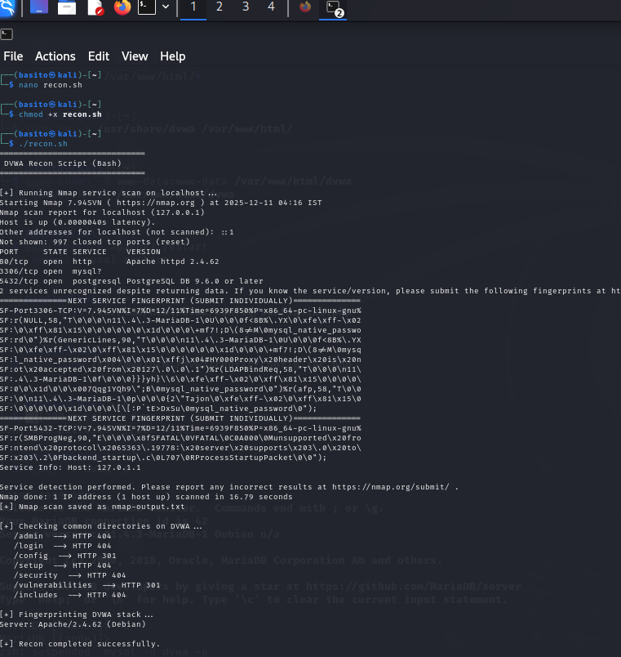

4. Vulnerability Findings

4.1 SQL Injection – Authentication Bypass
Description:
The DVWA login and user retrieval functionality directly embeds user input into SQL queries. This allows attackers to modify query logic.
Payload Used:
' OR '1'='1' --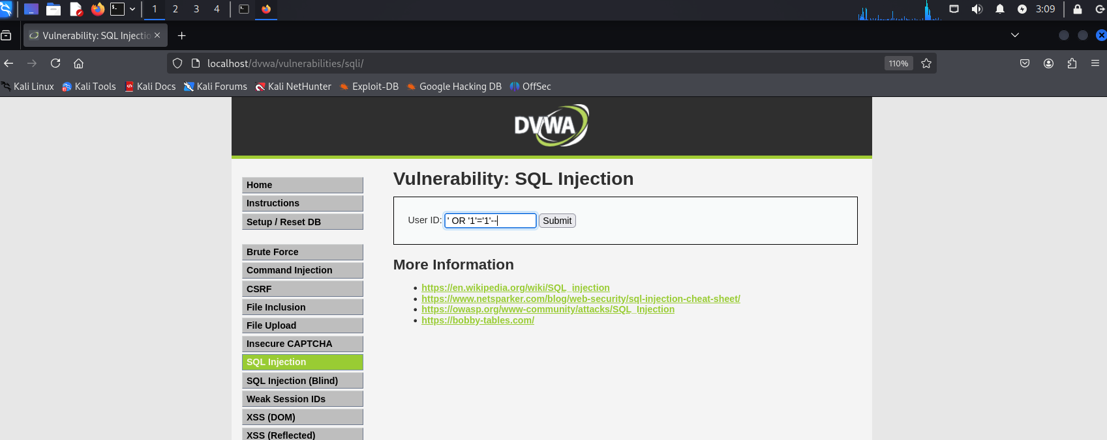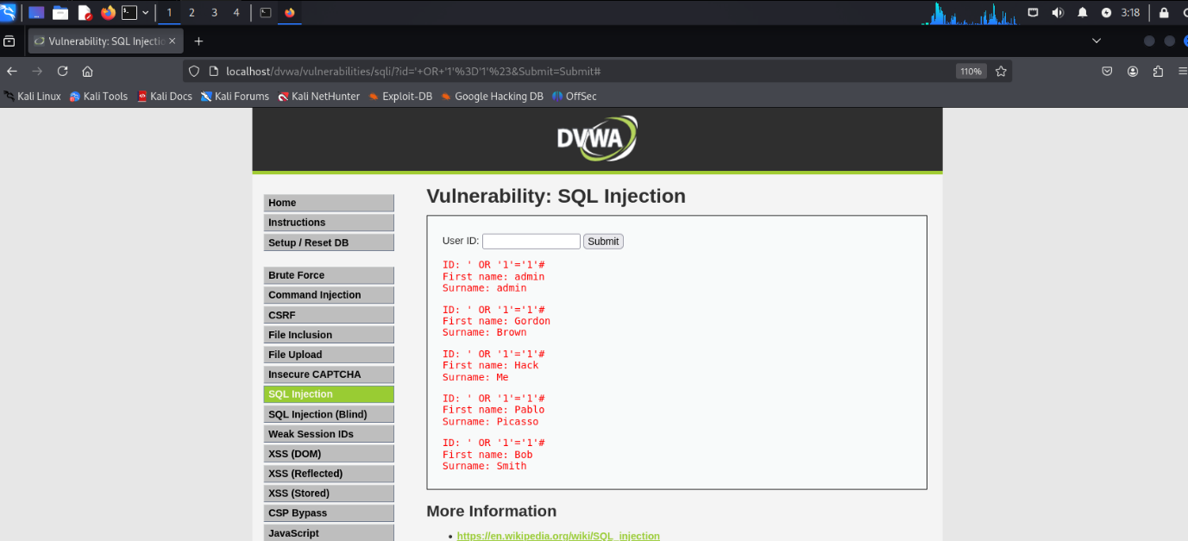
Impact:
- Bypass authentication
- Extract user records
- Gain admin-level access
Why it works:
The single quote (') breaks the original query, and:
OR '1'='1'
always evaluates to true.
-- comments out the rest of the query.
CVSS Score: 9.8 (Critical)
Why:
- AV:N (Network exploitable)
- AC:L (Low complexity)
- PR:N (No authentication needed)
- UI:N (No user interaction)
- Scope: Changed (gives access to protected data)
- CIA impact: High/High/High
This is one of the highest impact vulnerabilities in web applications.

4.2 Stored XSS – Persistent JavaScript Injection
Description:
User input is stored and later displayed without any sanitization. This allows attackers to inject malicious JavaScript.
Payload Used:
<script>alert('XSS');</script>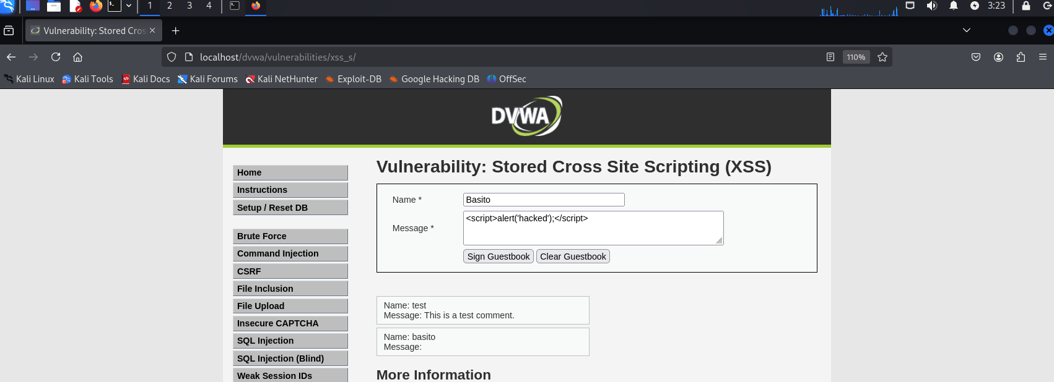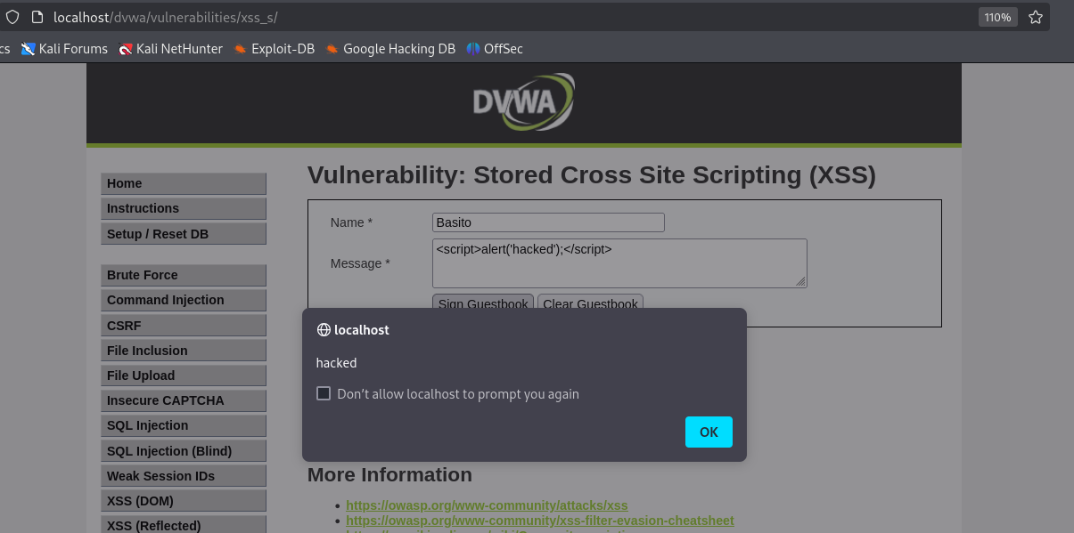
Impact:
- Execute scripts in victim’s browser
- Steal cookies
- Hijack sessions
- Deface UI
Why it works:
DVWA takes the comment input and outputs it directly using something like:
echo $_POST['comment'];
No escaping or sanitization is performed.
CVSS Score: 8.2 (High)
Why:
- Attack requires only sending input (AC:L)
- Occurs server-side and affects other users
- Confidentiality, integrity, and availability are all impacted via session hijacking possibilities
Stored XSS is more dangerous than reflected XSS.

4.3 IDOR – Broken Access Control
Description:
The application exposes user information using an id parameter:
?id=1
?id=2
?id=3
There is no check to validate whether the logged-in user is authorized to view other users’ data.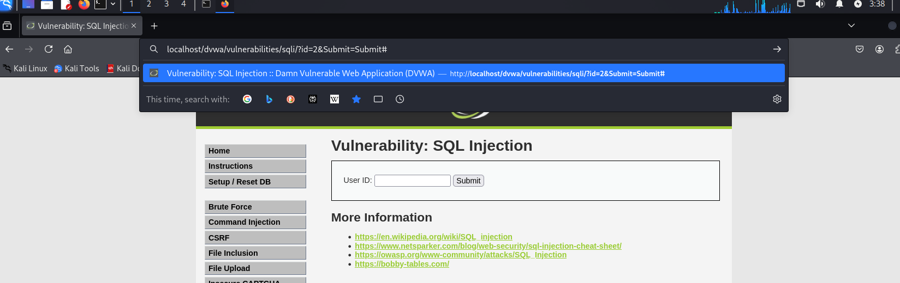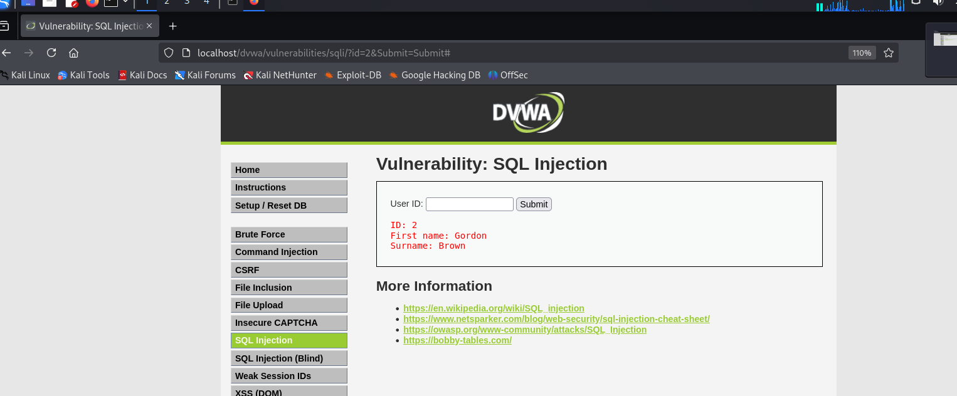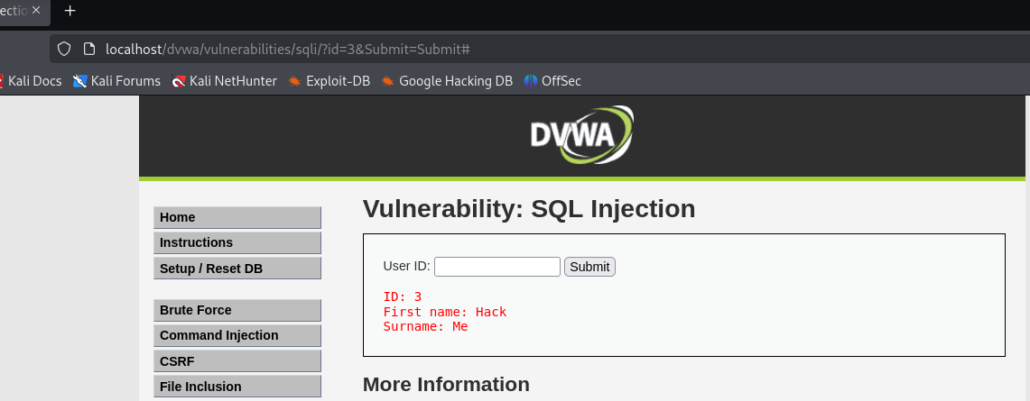
Impact:
- Unauthorized data access
- Privacy violations
- Potential account takeover if combined with enumeration
CVSS Score: 8.0 (High)
Why:
- Attacker can directly manipulate parameters
- No privileges required
- High confidentiality impact
- Very common in modern API/mobile apps
IDOR is one of the most exploited Broken Access Control vulnerabilities today.

5. Secure Code Review & Fixes
Located in /code-review/.

5.1 SQL Injection Fix
Vulnerable Code
$query = "SELECT * FROM users WHERE username='$user' AND password='$pass'";
Fixed Code
$stmt = $db->prepare("SELECT * FROM users WHERE username = ? AND password = ?");
$stmt->bind_param("ss", $user, $pass);
$stmt->execute();
Why it fixes the issue:
Prepared statements separate code from data → the attacker cannot modify the query structure.

5.2 XSS Fix
Vulnerable Code
echo $_POST['comment'];
Fixed Code
echo htmlspecialchars($_POST['comment'], ENT_QUOTES, 'UTF-8');
Why it fixes the issue:
HTML encoding neutralizes <script> and prevents browser execution.

5.3 IDOR Fix
Vulnerable Code
$user_id = $_GET['id'];
Fixed Code
if ($user_id != $_SESSION['user_id']) {
die("Unauthorized Access");
}
Why it fixes the issue:
Authorization is enforced server-side.
User cannot arbitrarily access other users’ data.

6. Threat Modelling (STRIDE)
STRIDE Component | DVWA Example
S – Spoofing | SQLi allows impersonation
T – Tampering | SQL injection modifies queries
R – Repudiation | Logs bypassed using injection
I – Information Disclosure | IDOR leaks user data
D – Denial of Service | Malformed queries break functionality
E – Elevation of Privilege | SQLi → Admin access

7. Mitigation Summary
General Mitigations
- Enforce HTTPS to prevent sniffing
- Implement strict input validation
- Use output encoding for user data
- Use secure cookie flags (HttpOnly, Secure)
- Disable debug messages & error disclosure
SQLi Mitigation
- Always use prepared statements
- Apply least-privilege DB accounts
XSS Mitigation
- Use HTML encoding (htmlspecialchars)
- Apply Content Security Policy (CSP)
IDOR Mitigation
- Enforce server-side authorization
- Never trust client-side parameters

8. Conclusion
This assessment demonstrated hands-on exploitation and remediation of three major OWASP Top 10 vulnerabilities: SQL Injection, Stored XSS, and IDOR. Alongside exploitation, secure coding best practices were applied to show real-world defensive understanding. The report incorporates automated scanning, CVSS scoring, threat modelling, and code fixes — reflecting a full end-to-end Application Security workflow.

