**Project Documentation**

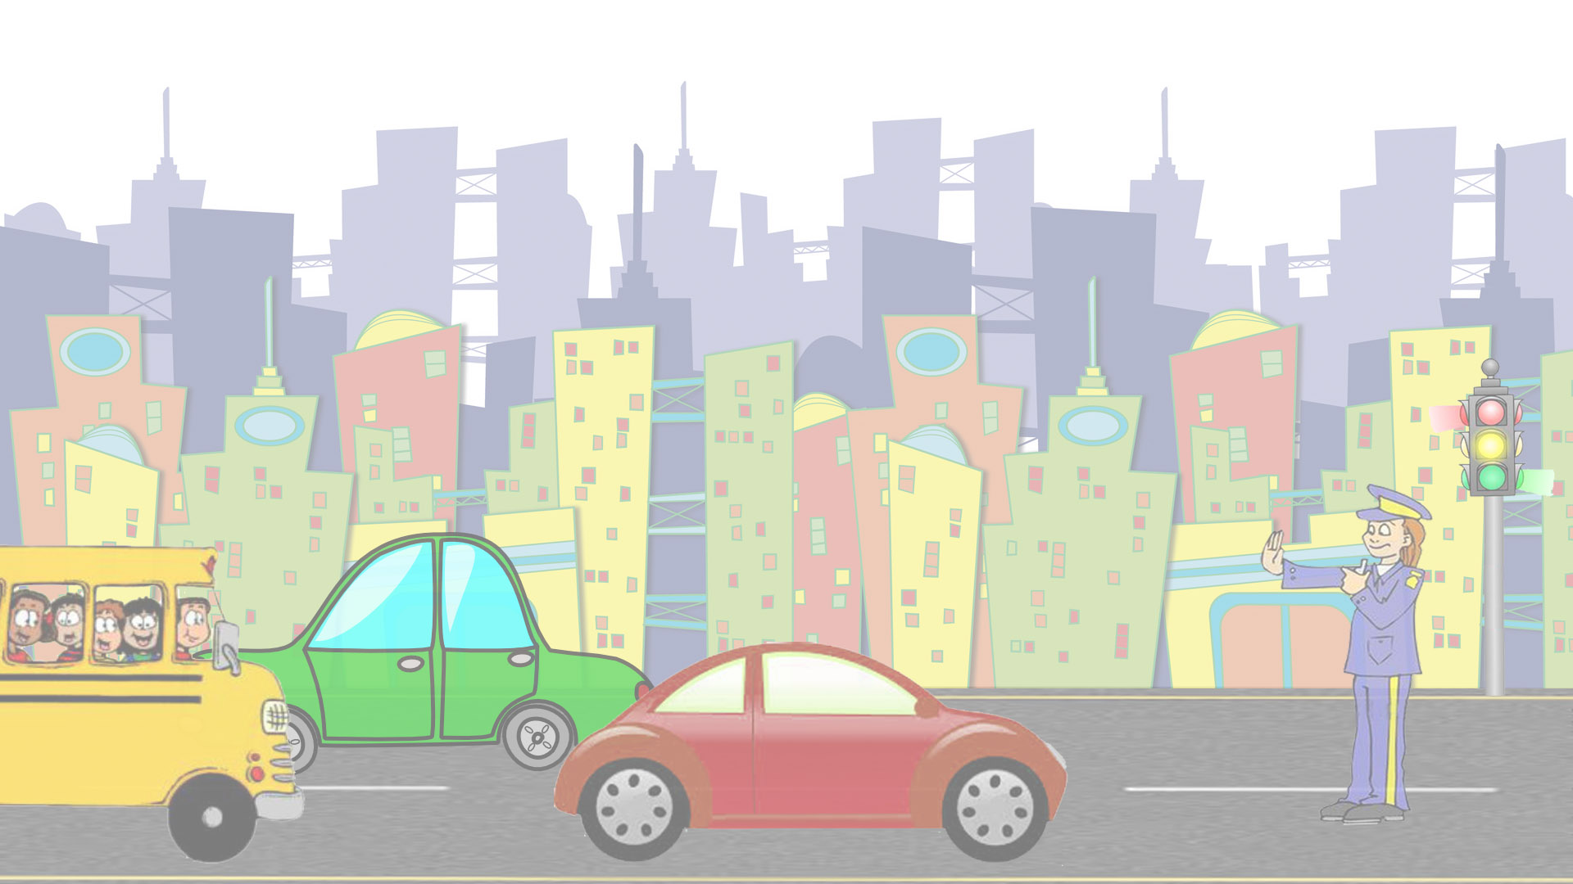

**Rush Hour**

**Name:** Abdul Basit  
**Class:** BESE-4A  
**Reg no. :** 4569

**Email:**13beseabasit@seecs.edu.pk

*This was a solo project with 100% contribution By ABDUL BASIT.*

**About the Project:**

I have made a game in which our player plays the role of a traffic warden and controls traffic on a square.

There are two modes of the game

**Four Lane Mode:**

In this game mode there are four sides and each side is controlled by a traffic signal. We have to make traffic signals ON or OFF depending on the anger level of each side. Anger level increases when a side has to wait for its turn. When a side is allowed to pass, the anger level again comes to its normal position. A car from each side has three choices .It can either go straight, left or right. Each car goes randomly. Number of cars and models of car in each side is also random.

**Two Lane Mode:**

In this game mode there are two active sides and one of them is controlled by a traffic signal. We have to pass one lane successfully by making traffic signal ON or OFF, while other lane is passing continuously.

This mode also has anger level. Anger level increases when a lane has to wait for its turn. When a side is allowed to pass, the anger level again comes to its normal position.

**Percentage Achievement:**

|  |  |  |
| --- | --- | --- |
| Sr. no. | Commitments | Achievement  (Yes/No) |
| 1 | Background Music | Yes |
| 2 | Four lane mode of game | Yes |
| 3 | Anger levels | Yes |
| 4 | Randomly generated traffic | Yes |
| 5 | Traffic signals | Yes |

**Extra features:**

|  |  |  |
| --- | --- | --- |
| Sr. no. | Features | Achievement  %age |
| 1 | Two modes of game | 100 |
| 2 | High score update | 100 |
| 3 | An additional map for mode2 | 100 |

**Problem faced:**

The problems I faced include generating random cars i.e. different types of car instead of predefined sequence. Another issue was to regenerate them and stop them behind each other. Saving the high score in the file was also a difficult task.

User manual:

**Four lane mode:**

**With keyboard:**

* To move the upper lane to downward press **“Arrow Down”** key.
* To move the bottom lane to upward press **“Arrow up”** key.
* To move the right lane to left side press **“Arrow Down”** key.
* To move the left lane to right side press **“Arrow Down”** key.

**With mouse:**

* You can either click on the respective side to move the particular side.

In order to stop all the signals at same time press the **“Spacebar”**

**Two lane mode:**

* In order to ON/OFF the signal you can either can press the “Spacebar” or click anywhere on the screen

**Certificate:**

I "Abdul Basit" do verify that the submitted code is my own effort and that I have not copied it from any peer or any internet source that has not been acknowledged. I also understand that if my submission fails the similarity detection, I would be awarded zero marks not only for this submission but the whole evaluation component.