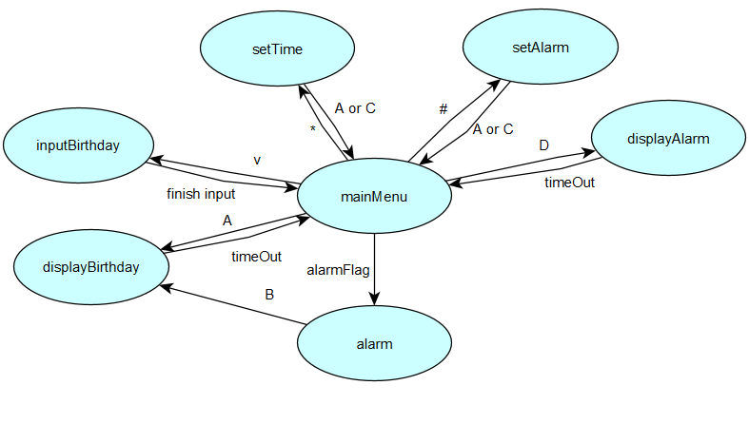

Key inputs per state

mainMenu:

|  |  |
| --- | --- |
| A | displayBirthday |
| B | toggleAlarm |
| C | toggleLight |
| D | displayAlarm |
| * | setTime |
| # | setAlarm |
| 4 | Increase light intensity |
| 7 | Decrease light intensity |

setTime / setAlarm:

|  |  |
| --- | --- |
| * | Move cursor left |
| # | Move cursor right |
| A | Store and go back |
| C | Discard changes and go back |

Alarm:

|  |  |
| --- | --- |
| B | display birthdays and turn of alarm |

Round robin tasks:

* Refresh time
* Update LCD
* Check for summer and winter time
* Check for alarm time