**Random forest Classification report and AUC & ROC Score**

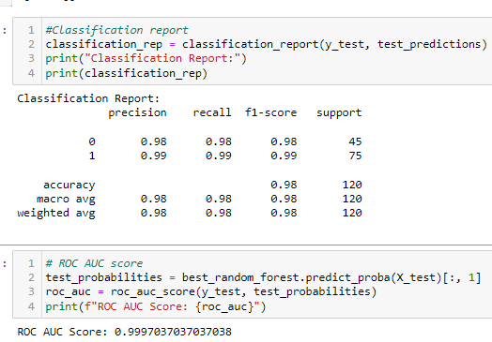

**Gaussian Naive Bayes Classification report and AUC & ROC Score**

**Decision Tree Classification report and AUC & ROC Score**

**SVM Classification report and AUC & ROC Score**

**KNN Classification report and AUC & ROC Score**

**Logistic Regression report and AUC & ROC Score**

