**Study of Ansible as an automation tool for**

**Site Reliability**

* + 1. **CSI ZG628T: Dissertation**

by

Baskar Balasubramanian

2019HT66015

**Dissertation work carried out at: IBM India, Chennai**





**BIRLA INSTITUTE OF TECHNOLOGY & SCIENCE**

**PILANI (RAJASTHAN)**

April 2021

Birla Institute of Technology & Science, Pilani

Work-Integrated Learning Programmes Division

Second Semester 2020-2021

CSI ZG628T : Dissertation Pre-Final Report

**ID No. : 2019HT66015**

**NAME OF THE STUDENT :** BASKAR BALASUBRAMANIAN

**EMAIL ADDRESS :** 2019HT66015@wilp.bits-pilani.ac.in

**STUDENT’S EMPLOYING :** IBM India

**ORGANIZATION & LOCATION**

**SUPERVISOR :** Swetha J, SAP Technical Architect, IBM

**SUPERVISOR’S EMPLOYING :** IBM India, Chennai

**ORGANIZATION & LOCATION**

**SUPERVISOR’S EMAIL :** [swethaj.iyer@in.ibm.com](mailto:swethaj.iyer@in.ibm.com)

**ADDITIONAL EXAMINER :** Raghu Srinivasan, Senior Technical Staff Member -

Technology Architect Lead Client Transformation SRE

**ADDITIONAL EXAMINER’S EMAIL** : [sriniv@us.ibm.com](mailto:rsriniv@us.ibm.com)

**BITS FACULTY :** Rajesh Kumar, Assistant Professor, Dept of Computer Science

**BITS FACULTY EMAIL :** rajesh.k@pilani.bits-pilani.ac.in

**DISSERTATION TITLE :** Study of Ansible as an automation tool for Site Reliability

Table of Contents

1. ABSTRACT 5

2. INTRODUCTION 6

2.1 BACKGROUND 6

2.1.1 SITE RELIABILITY 6

2.2 INTRODUCTION TO THE TECHNOLOGICAL TERMS 7

2.2.1 OPERATING SYSTEMS TERMS 7

2.2.2 COMPUTER NETWORKING TERMS 8

2.2.3 PROGRAMMING LANGUAGES 8

2.2.4 OPEN SOURCE TOOLS USED IN THE PROJECT 9

3. PROJECT OBJECTIVE AND SCOPE 10

3.1 PROJECT OBJECTIVE 10

3.1.1 WHY CHOOSE ANSIBLE FOR THIS PROJECT? 10

3.2 SCOPE OF WORK 10

3.2.1 USE CASE 1 – AUTOMATION TO REDUCE TOIL WITH ANSIBLE 10

3.2.2 USE CASE 2 - CAPTURING THE SYSTEM AND TCP METRICS WITH PROMETHEUS AND VISUALIZE THE METRICS WITH GRAFANA FOR ANALYSIS 11

3.2.3 ASSUMPTIONS FOR THE USE CASES: 11

4. SETTING THE STAGE FOR THE PROJECT 12

4.1 LAB ENVIRONMENT 12

4.2 LAB HOST SYSTEM 12

4.3 VIRTUALIZATION ON THE HOST SYSTEM 13

4.4 ANSIBLE ENGINE AND ANSIBLE MODULES 13

4.4.1 BOOT A PRE-BUILT RHEL VIRTUAL MACHINE 13

4.4.2 INSTALL DOCKER 14

4.4.3 DOCKER OPERATIONS 14

4.4.4 TCP ECHO SERVER AND TCP ECHO CLIENT 15

4.4.5 INSTALL AND CONFIGURE MONITORING TOOLS (PROMETHEUS & NODE_EXPORTER) 16

4.4.5.1 INSTALLATION OF THE MONITORING TOOLS 16

4.4.5.2 SCRAPE SYSTEM METRICS WITH prometheus.yml 16

4.4.5.3 ENABLE THE MONITORING TOOLS AS LINUX SYSTEM SERVICES 17

4.4.6 INSTALL AND CONFIGURE GRAFANA FOR VISUAL DASHBOARDS 17

4.5 VISUALIZE THE SYSTEM METRICS USING GRAFANA WITH PROMETHEUS AS DATA SOURCE 18

4.5.1 VISUALIZE CUSTOMIZED METRICS FOR TCP ECHO SERVER USING NODE EXPORTER COMMAND LINE FLAG –collector.textfile.directory 19

5. EXPERIMENTS WITH IMPLEMENTATION OF USE CASES 21

5.1 USE CASE 1 - DEPLOYMENT OF TCP ECHO SERVER WITHIN DOCKER CONTAINER 21

5.1.1 USE CASE 1 FLOW DIAGRAM 21

5.1.2 IMPLEMENTING THE USE CASE 1 WITH END-TO-END AUTOMATION 22

5.1.3 BENEFITS OF AUTOMATING THE VM AND DOCKER OPERATIONS USING ANSIBLE 23

5.2 USE CASE 2 - COLLECTING SYSTEM METRICS AND MONITORING THE ENVIRONMENT 23

5.2.1 MONITORING THE METRICS WITH NODE_EXPORTER AND PROMETHEUS 23

5.2.1.1 COLLECTING THE CUSTOM METRICS FOR TCP ECHO SERVER 24

5.2.1.2 MONITORING LINUX SYSTEM METRICS AND CUSTOM METRICS WITH PROMETHEUS 26

5.2.2 VISUALIZATION, MONITORING AND ALERTING WITH GRAFANA DASHBOARDS 28

5.2.2.1 TCP ECHO SERVER STATUS DASHBOARD 28

5.2.2.1 EVENT MANAGEMENT WITH GRAFANA ALERT RULES AND NOTIFICATION CHANNELS 31

5.2.3 BENEFITS OF VISUALIZING, MONITORING AND ALERTING WITH PROMETHEUS AND GRAFANA 33

6. STUDY AND ANALYSIS ON SITE RELIABILITY OF THE TCP ECHO SERVER 33

6.1 REDUCING TOIL WITH ANSIBLE AUTOMATION 33

6.2 OBSERVABILITY WITH PROMETHEUS AND GRAFANA 33

8. LITERATURE REFERENCES 34

APPENDIX A – Design and Source Code 35

APPENDIX B – USING PRE-COFIGURED GRAFANA DASHBOARDS 35

## 1. ABSTRACT

* 1. Reliability of a website is a quality that is measured based on user experience. It appears to be simple phenomenon from the outside, but it takes constant effort in steering the moving parts of the systems and software behind the scene. Automation, monitoring and alerting of the system functions and effective communication among the systems and support personnel are few of the foundational requirements that attempts to solve the problem of site reliability.
  2. The choice of tools used to meet the above requirements becomes crucial to deploy such an eco-system. In this dissertation work, there is an attempt to study Ansible, a Python module, as the Automation tool and how it helps to eliminate the toil [4] due to tasks that are manual, repetitive, automatable, tactical, devoid of enduring value, and that scales linearly as a service grows. The work also involves studying the interfacing capabilities of ansible with tools that helps in monitoring the system metrics and visualize the data captured for analysis. The monitoring tool under consideration is Prometheus while the visualization tool considered is Grafana.

The use-case for the project involves automating the deployment of docker container, running a TCP Echo Server, hosted on top of a Linux Virtual Machine. The operations of Linux VM, Docker container and TCP Echo Server are all automated using Ansible as the automation tool. A TCP Echo client runs anywhere within or outside Linux VM, can be used to send TCP echo messages to the TCP Server, to test the application functionality.

This effort demonstrates the value of automating the repeatable task of deploying the docker containers with a hosted server, in a large scale environment, such as a cloud data center. The use-case also demonstrates the value of using monitoring and analytics tools such as Prometheus and Grafana, respectively, that can interface with Ansible in the deployed environment. The scope of system parameters captured for monitoring and analysis with the tools is restricted to the TCP statistics such as the number of connections, state of the connections, etc. There will be a detailed analysis on how Ansible automation combined with monitoring and analytics of the system, can address the problem of site reliability.

The extensibility of the project is such that, TCP Echo Server can be replaced with any other server like web servers, application servers, etc during study. Having the server as TCP Echo Server can be of much use for students with academic interest on the study. It can be shown that it is simple to develop, modify, build the code base for the TCP Echo Server and monitor the system characteristics that are fundamental to study any server that run over a TCP protocol.

On the other hand, the time needed to build, develop or extend web server or application servers, with voluminous code base is time consuming. In this case, complex system characteristics involving application layer protocols like HTTP, TLS, SOAP, etc are generally considered for study. This study with TCP Echo Server is analogous to study of the implementation of Data Encryption Standard (DES) in field of Cryptography, the fundamental block cipher algorithm, before studying the more complex algorithms like Advanced Encryption Standard. With this approach, the dissertation gives a way for a wide range of options for future study by keeping this project as the reference study on Site Reliability of web sites.

# 2. INTRODUCTION

## 2.1 BACKGROUND

### 2.1.1 SITE RELIABILITY

In the current world, there are innumerable number of websites and applications that are hosted in remote computers and accessed by users across the world through Internet that forms a communication medium and backbone of the computer network. A **Site** can be defined as any useful application or software available for use over computer networks which is accessible over the Internet or private interconnected networks.

Users experience in using the sites to access application is based on various parameters, which makes the user to make repeatable use of the websites to realize the benefits of the application. Users have various expectations which inclue the site to be available whenever they want to access, cater to the need of the user irrespective of the number of concurrent users using the system, irrespective of the geography of the server hosting the application, tolerant response times, etc.

The above parameters are measured in terms of the site's,

* availability (how much time the application is available for use?)
* scalability (how flexible is the system when there is a need to address an increase in the number of users or resource requirements?)
* recoverability (how quickly the system can recover from a failure?)
* maintainability (how effectively application changes can be incorporated?)
* security (What is the level confidentiality and integrity that the system provides to user's data within the systems and the network?).
* elasticity (how robust the system responds to sudden surge or drop in the processing load?).
* economic value (what is the cost savings for the IT service provider?).

From the perspective of the service provider, they would want to ensure they are able to address all the above expectations and many more, to provide the best experience to the end users. In the same way, users of the sites would fall back to the websites that are able to meet their expectations. Such sites are reliable from user experience perspective, which is the primary goal for anyone providing information services. If such reliable services are realized with the hosted websites, then the sites are meant to have an added quality called as **Site Reliability**. The art of practicing the principles to meet the expectations from reliability perspective can be named as **Site Reliability Engineering**.

The following are considered as some of the important principles of Site Reliability engineering

* **Automation** of tasks that are manual, repetitive, automatable, tactical, devoid of enduring value, and that scales linearly as a service grows. In IT industry terms this could be called as *eliminating the toil or backlogs*.
* **Measurement and Interpretation of the system data** which is essential in a system that automatically adjusts its resources and configurations, there by meet the demands of the end users. This could be termed as the *Observability* principle in Site Reliability.
* **Alerting** the support personnel and experts and **effective communication** among them, about the system malfunctioning and take corrective actions for speedy recovery. This functionality is normally categorized as *Event Management or Incident Management* based on the severity of the issue.

In order to practice the above, service providers have to choose the tools wisely, that could be integrated and interfaced with the core systems that serves the user requests. For example there are **automation tools** like *ansible, chef,* *puppet, etc* that can automate complex IT system tasks with simple yet feature rich modules. There are open source tools like *Prometheus, Logstash, etc* that can **capture the metrics** captured from the functioning system and other open source tools like *Grafana, Kibana, etc* that can **interpret the data** captured as useful information for analysis.

## 2.2 INTRODUCTION TO THE TECHNOLOGICAL TERMS

### 2.2.1 OPERATING SYSTEMS TERMS

**2.2.1.1 Linux and it’s flavors**

Linux is a free software built and ported as the operating system binary for various processor architectures.

Initial version of Linux was developed by Linus Torvalds. Linux is one of the largest free software projects actively developed by the Linux community. [5]

Linux System Base (LSB) comprises of kernel and shell utilities that forms the core of linux operting system. There are various flavors of Linux developed on top of the LSB to give added features to the Linux OS. Ubuntu, RedHat, openSUSE, debian are well known Linux flavors to name a few. In this project, redhat flavour of Linux has been used for host machine as well as the virtual machine that hosts the docker container.

* + 1. **2.2.1.2 Virtualization**

Virtualization of operating system means emulating operating systems to share the computing resources like processor, memory, storage, I/O system and networks. Virtualization could be either directly done over the hardware using the drivers named as hypervisors or emulated over a host operating system which manages the system resources.

**2.2.1.3 libvirt**

libvirt is a tool kit comprising of set of operating system libraries for virtualization management system. There are server side and client side components to it. The server side component manages the virtualized guest operating systems by starting, stopping, pausing, unpausing the virtual OS. The client libraries and utilities that connect to the server side component to issue tasks and collect information about the configuration and resources of the host system and guests. [6][7]

**2.2.1.4 KVM**

KVM (for Kernel-based Virtual Machine) is a full virtualization solution for Linux on x86 hardware containing virtualization extensions (Intel VT or AMD-V). Using KVM, one can run multiple virtual machines running unmodified Linux or Windows images. Each virtual machine has private virtualized hardware: a network card, disk, graphics adapter, etc

KVM is open source software. The kernel component of KVM is included in mainline Linux while The userspace component of KVM is included in mainline QEMU. [8]

**2.2.1.5 QEMU**

QEMU is a generic and open source machine emulator and virtualizer. When used as a machine emulator, QEMU can run OSes and programs made for one machine (e.g. an ARM board) on a different machine (e.g. your own PC). When used as a virtualizer, QEMU achieves near native performance by executing the guest code directly on the host CPU. QEMU supports virtualization when executing under the Xen hypervisor or using the KVM kernel module in Linux. [9]

**Note:** In this project, a RHEL OS is virtualized using qemu-kvm emulator. **qemu-kvm** is an open source virtualizer that provides hardware emulation for the KVM hypervisor. qemu-kvm acts as a virtual machine monitor together with the KVM kernel modules, and emulates the hardware for a full system such as a PC and its associated peripherals. [10]

**2.2.1.6 docker**

Docker is written in the Go Programming Language, it takes advantage of several features of the Linux kernel to deliver its functionality. Docker uses a technology called namespaces to provide the isolated workspace, which is called as the container. Docker provides the ability to package and run an application in a loosely isolated container environment. A container is a runnable instance of an image, while image is a read-only template with instructions for creating a Docker container. [20]

### 2.2.2 COMPUTER NETWORKING TERMS

**2.2.2.1 TCP (Transmission Control Protocol)**

Internet Engineering Task Force’s RFC (RFC793) [11] mentions about TCP as below

TCP is a connection-oriented, end-to-end reliable protocol designed to fit into a layered hierarchy of protocols which support multi-network applications. The TCP provides for reliable inter-process communication between pairs of processes in host computers attached to distinct but interconnected computer communication networks.

TCP is based on concepts first described by Cerf and Kahn in [https://tools.ietf.org/html/rfc793#ref-1](https://tools.ietf.org/html/rfc793" \l "ref-1) [11]

The TCP fits into a layered protocol architecture just above a basic Internet Protocol (IP) which provides a way for the TCP to send and receive variable-length segments of information enclosed in internet datagram "envelopes".

**2.2.2.2 TCP Echo Server**

TCP Echo Server is a preliminary application written using C programming language. It demonstrates TCP Server design using socket programming. It uses TCP sockets to listen to the requests from a TCP Echo client.

**2.2.2.3 TCP Echo Client**

TCP Echo Client is basically connects to the Echo Server using socket programming with C language.

**Note:** In this project TCP Echo Server and Echo Client have been developed and compiled using the instructions from the book “The Linux Programming Interface” authored by Michael Kerrisk [12]

### **2.2.3** PROGRAMMING LANGUAGES

**2.2.3.1 C**

C is a popular programming language created by Dennis Ritchie and Ken Thompson of AT&T Bell Laboratories in 1970s.

C programs are pre-processed, assembled, compiled and linked to result in an executable, which can be run directly on the processor. Popular operating systems like UNIX and Linux, programming languages like Java and Python uses C programming language. In this project, TCP Echo Server and TCP Echo client have been developed using C programming language and compiled using gcc (GNU Compiler Collection) compiler. [13]

**2.2.3.2 Python**

Python is the most popular programming language in the world where the programs are interpreted before executed by the processor. The language is interactive and object-oriented. Python is a free software and distributed under an Open Source license. Python is bundled with a large number of modules which includes the core package and extensions. This project uses Ansible which is built with Python. [14]

### 2.2.4 OPEN SOURCE TOOLS USED IN THE PROJECT

**2.2.4.1 Ansible**

Ansible is a free software originally written by Michael DeHaan. It Is released under the terms of the GPLv3 license.

It uses the python interpreter, providing an automation platform for a wide range of modules to automate applications and computing systems and infrastructure deployment and maintenance. Ansible uses SSH for network connections, with no agents to install on remote systems. [1]

**2.2.4.2 Prometheus**

Prometheus is a system and service monitoring system. It collects metrics from configured targets at given intervals, evaluates the rule expressions, displays the results, and can trigger alerts when specified conditions are observed [16]. It is 100% open source, available under Apache 2 License and development is completely a community driver project. Prometheus is designed for reliability, to be the system you go to during an outage to allow you to quickly diagnose problems. [21]

**2.2.4.3 Grafana**

Grafana is an analytics and visualization web application. It is used to visualize the data captured with monitoring systems in the form of charts and graphs by creating monitoring dashboards [18]. It is used in combination with time-series databases such as InfluxDB, Prometheus, etc to visualize metrics, logs and traces. Written in Go language, Grafana is an open source project [19].

The below table provides the list of open source tools along with the download page and license information. Please refer to the introduction to the terminologies / literature references section to understand more about the tools.

|  |  |  |  |  |
| --- | --- | --- | --- | --- |
| **Sl. No** | **Name** | **Description** | **Source Code Webpage** | **License** |
| 1 | Kernel Virtual Machine(kvm) | Full virtualization solution for Linux on x86 | <https://git.kernel.org/pub/scm/virt/kvm/kvm.git/snapshot/kvm-for-linus.tar.gz> | GNU General Public License version 2 only (GPL-2.0) |
| 2 | QEMU | Open source machine & userspace emulator and virtualizer. | <https://gitlab.com/qemu-project/qemu> | GNU General Public License, version 2 |
| 3 | libvirt | C API and bindings to other languages for managing virtualization technologies | <https://gitlab.com/libvirt/libvirt> | GNU Lesser General Public License, version 2.1 (or later) |
| 4 | Ansible | IT Automation Platform to deploy and maintain applications and systems | <https://github.com/ansible/ansible> | GNU General Public License v3.0 or later |
| 5 | Prometheus | Systems and Service Monitoring system | <https://github.com/prometheus/prometheus> | Apache License 2.0 |
| 6 | Grafana | Observability and Data Visualization platform | <https://github.com/grafana/grafana> | Apache 2.0 License |
| 7 | Node exporter | Metrics exporter for operating system and hardware metrics plugged into prometheus | <https://github.com/prometheus/node_exporter> | Apache License 2.0 |

**Table 1.1 – Open Source Softwares**

# 3. PROJECT OBJECTIVE AND SCOPE

## **3.1 PROJECT OBJECTIVE**

This project concentrates mainly on the SRE principle **eliminating toil using ansible automation.** [1] [4]

The project also involves studying the **interfacing capabilities of ansible with tools that monitor the service level metrics.** [1][2]

### 3.1.1 WHY CHOOSE ANSIBLE FOR THIS PROJECT?

Using Python as the interpreter, ansible is basically a python module and classified as configuration management tool, supporting traditional IT and cloud based system automation. This helps to automate tasks on the website hosting systems. The extent of automation possible with Ansible seems to be having a larger scope including Observability and event management, against simply using it for configuration management.

* Ansible is chosen for study as it is a free software (released under the terms of the GPLv3 license) with community based development.
* It has a rich set of modules providing extensive scope for experimentation on IT systems.
* Unlike other open source tools, it is a simple automation tool using SSH (Secure Shell) protocol to perform tasks on the remote hosts, without dependency of agent processes on the hosts.
* Interfacing capabilities with monitoring and analytic tools, is another area of interest.
* Ansible modules not only caters to needs of automating, but also interfacing with various tools that orchestrate together to provide infrastructure solutions at large.

This research work provides an opportunity to

* Study the internals of how ansible modules interact with operating system libraries
* Develop an automation solution with ansible and interface the solution with monitoring and analytic tools.
* Practice the principles that eventually results in Site Reliability.

## 3.2 SCOPE OF WORK

The scope of this project is to

* Study, practice and document how Ansible would help to automate system functions and reduce toil the with its configuration management & provisioning modules. Refer Use Case 1 for the details of the automation.
* Understand and implement the potential to interface [2] with Prometheus and Grafana for service metrics observability. Refer to Use Case 2 for the details on monitoring and visualization of the metrics.

There are two broad use cases that would be worked upon as part of the project listed here.

### 3.2.1 USE CASE 1 – AUTOMATION TO REDUCE TOIL WITH ANSIBLE

Automation of the following with Ansible

* Boot a Linux virtual machine from a pre-built image repository
* Install Docker on top of the VM
* Spin a Docker container within the VM
* Host a TCP Echo Server within the container
* Demonstrate TCP Client-Server communication between TCP Client and TCP Echo Server.

### 3.2.2 USE CASE 2 - CAPTURING THE SYSTEM AND TCP METRICS WITH PROMETHEUS AND VISUALIZE THE METRICS WITH GRAFANA FOR ANALYSIS

* Push infrastructure operational time-series data with **Prometheus**

Reliability of a system depends on the ability to capture the system metrics and use it to analyze the system health. In this project, TCP Echo Server health check metrics and general VM host metrics are collected using metrics collected by the node_exporter tool. A wide variety of data is collected using node_exporter tool with respect to the OS and Hardware. We can also capture customized metrics using textfile collector feature available within node_exporter. The following are the metrics collected:

- TCP Echo Server Running Status (True / False) (Custom metric)

- TCP Echo Server Socket Listen Status (True / False) (Custom metric)

- VM Memory Usage (Memory Used/Memory Free) (Default metric)

- Disk I/O Statistics of VM (read/write I/O) (Default metric)

- Disk Space Usage within VM (Free/Used Bytes) (Default metric)

- Network Usage (Bytes Received / Transmitted) (Default metric)

* Visualization of observable data with **Grafana**

Time series metrics captured with Prometheus, can be visualized within a sophisticated dashboard facility available in Grafana. Graphical representation gives a meaningful understanding of the metrics which can be used for analyzing the behavior of the system under prevailing conditions.

Anomalies in the data can be defined and alerts generated based on the definition. The alerts can be sent to the support personnel via communication channels like mail, chat applications, so that corrective action can be performed. In this project, the use-case involves sending a mail when the TCP Echo Server is not reachable or TCP sockets changes its ‘Listen’ status.

### 3.2.3 ASSUMPTIONS FOR THE USE CASES:

1) Use case assumes the availability of the operating system image in the local system storage. The **pre-built OS image** is used to create the VM for the experiments. Building an image from the scratch is not within the scope in this project. However automation for building an image is a prospective extension to the project in the future. The automation only involves managing the life-cycle of the operating system image.

2) **Network interfaces** are **well defined** and configured on both host and virtual operating systems., so that the development work in the project involves only at the application layer and TCP layers of the Network protocol stack.

3) VM would be readily **connecting to the tool repositories**, which includes RHEL repositories, Prometheus and Grafana download locations, etc.

4) Network **firewall rules** are **enabled** so that access to the TCP ports used for prometheus (9090), node_exporter (9100) and grafana (3000) is available to the host Linux machine.

5) **SMTP** configuration is **setup** on the Linux VM in order to send the alert messages from Grafana to the support personnel.

# 4. SETTING THE STAGE FOR THE PROJECT

## 4.1 LAB ENVIRONMENT

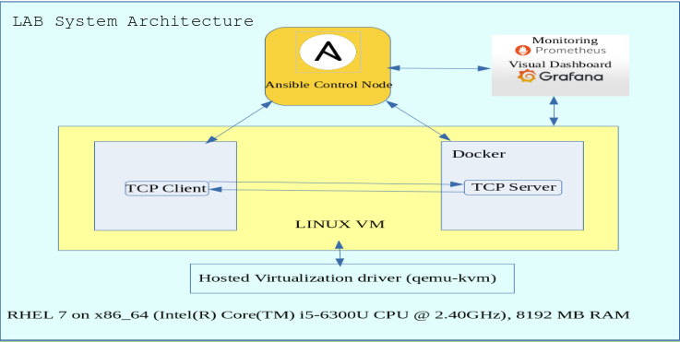

**Fig 1. LAB SYSTEM**

The figure above shows the system architecture of the lab environment which has been created for project

activities.

* The lab host is a Linux platform (RedHat flavour) on x86_64 processor.
* The virtualization driver used for the lab environment is qemu-kvm.
* In the lab environment the virtual machine is also a Linux VM with RedHat flavour.
* The TCP Echo Server would be started when the Docker container using a centos container image is started by Ansible control node.
* A TCP Echo Client would be communicating with Echo Server using TCP sockets.
* Ansible Control node would use SSH to connect to the VM to deploy the TCP applications and operate the docker container.
* Prometheus and Grafana will be installed to measure and monitor the TCP statistics.

## 4.2 LAB HOST SYSTEM

The experimental setup for the project needs a host system that would run the desired processes for the project.

The host system used for lab hardware consists of

* A Dual core processor using **x86_64** architecture (Intel(R) Core(TM) i5-6300U CPU @ 2.40GHz)
* 8 GB RAM
* sufficient storage (>30 GB)

The operating system software managing the system resources is Redhat Linux release 3.10.0-1127.19.1.**el7**.x86_64

## 4.3 VIRTUALIZATION ON THE HOST SYSTEM

The RHEL operating system consists of the kernel module of **kvm (kernel virtual machine) hypervisor** which helps to realize full virtualization. In this project, the scope of virtualization is constrained to the host based virtualization of the Linux OS using kvm. If the implementation of project work is using hypervisors other than kvm, then virtualization drivers need to be chosen appropriately. Other hypervisors are out of scope in this project.

Emulation of the hardware for KVM hypervisor and virtual machine monitoring function is performed by **qemu-kvm** package.

The version and release details of qemu-kvm package used in the host system is as given below.

**Version** : 1.5.3

**Release**  : 175.el7_9.3

**libvirt** toolkit is used for Management of virtual machine monitoring system. It facilitates the API which can interact with virtualization capabilities exposed by qemu-kvm. The version and release details of libvirt toolkit used in the host system is given below.

**Version** : 4.5.0

**Release** : 36.el7_9.3

## 4.4 ANSIBLE ENGINE AND ANSIBLE MODULES

Ansible Engine, identified as **Ansible Control Node** in the lab environment, is built from a group of python modules. Using python as interpreter, Ansible consists of python modules, useful in automating the **system configuration management**. In this project, various **ansible modules** are used to perform the following:

* Boot a pre-built image of RHEL as a virtual machine
* Install docker and start docker as a system service.
* Perform docker operations to pull or build docker images
* Use the docker image, to build and run a docker container with a TCP Echo Server process.
* Install and configure monitoring tool prometheus and node_exporter
* Install and configure data visualizer tool grafana for the analysis of the system state.

The above tasks are explained in detail in the following sections.

### 4.4.1 BOOT A PRE-BUILT RHEL VIRTUAL MACHINE

Ansible’s **virt module** can be used to manage virtual machines supported by ‘libvirt’ API. This module can be used to create/destroy, define/undefine, pause/unpause, shutdown/start/stop virtual machines. The module uses a libvirt connection uri to connect to the virtual machine instance to perform the tasks on the VM. By default, the libvirt connection uri is “*qemu:///system*”. ‘virt’ module can connect to any VM managed by qemu, to execute any command like stop,start,shutdown,etc.

Examples of using virt module with ansible to boot, stop and shutdown the a virtual machine using default libvirt connection uri is provided below.

#boot/start the VM Virtual_Client_RHEL_7-KVM

ansible <host_name> -m virt -a "name=Virtual_Client_RHEL_7-KVM command=start”

#stop the VM Virtual_Client_RHEL_7-KVM

ansible <host_name> -m virt -a "name=Virtual_Client_RHEL_7-KVM command=stop”

#shutdown the VM Virtual_Client_RHEL_7-KVM

ansible <host_name> -m virt -a "name=Virtual_Client_RHEL_7-KVM command=shutdown”

It should be noted that **sshd service must be started** on the host where ansible is performing the tasks. Ansible uses an ssh connection to perform the remote tasks on the host. Usually a ping test is done using ansible **ping module**, to verify ansible connectivity to the hosts on which the automation is needed.

### 4.4.2 INSTALL DOCKER

Ansible’s **yum module** is useful to install, upgrade, downgrade, remove and list linux packages with yum package manager. By providing the name of the linux package while using ‘yum’ module, the linux package can be installed on the host ansible is connecting to. The below example show how docker package can be installed on a linux host that ansible connects with.

#install latest docker package

ansible -i ./hosts ${IP_rhel} -m yum -a "name=docker state=latest"

Ansible’s **ansible.builtin.service_facts module** can be used fetch list of all systemd linux services configured on the remote host. By using these facts, ansible scripts is developed to verify if docker service is started or not. If not started, docker service is started on the remote host using ansible **command module**.

It should be noted that, using ansible **systemd module** is recommended while operating with system services.

**Example** invocation using systemd module with ansible is given below:

ansible <host> -m systemd -a “name=docker.service state=started”

### **4.4.3 DOCKER OPERATIONS**

Once the docker service is started, docker images can be built and containers can be run using the images. In this project, **centos** docker image pulled from docker.io repository using ansible **command module** as given below.

tasks:

- name: build docker image for centos

command: /usr/bin/docker pull centos

The above way of defining tasks in ansible is used when a list of ansible tasks is executed in order by ansible-playbook utility. Refer to the ansible-playbook web page [26] provided in the ‘Literature References’ section.

A docker container running TCP Echo server is built using the centos docker image.A Dockerfile is used to provide the instructions to the docker service while building a docker container. The below command would create a docker container

- name: build docker image for tcpserver

command: /usr/bin/docker build -t tcpserver /home/baskar/ansible/TCP/app

On successfully building the docker container with TCP Echo Server, docker container is started, which initiates an isolated docker container environment running the TCP Echo Server on the desired port number. In the project ansible command module is used to run the TCP Echo server with container name tcpserver_1 and using TCP port 4305.

Refer to the next [section 4.1.3.4](#3.1.7.4.1.3.4 TCP ECHO SERVER AND TCP ECHO CLIENT|outline) to understand more about the nature of TCP Echo Server and Echo Client.

- name: Run docker container for tcpserver

command: /usr/bin/docker run --network host --name tcpserver_1 -d tcpserver

The ‘ –network host ‘ option provided in the command above ensures that the docker container uses the host network interface of the virtual machine. While using the host network interface, the virtual network bridge used by virtual machine. This would enable the external clients to send requests to the docker container. For example, a TCP Echo Client can communicate with TCP Echo Server running within the docker container which in-turn run within the virtual machine.

By default docker would be connected to a bridge network named usually as ‘docker0’. This is usually recommended network interface used when docker containers would communicate among each others.

It should be noted that python module **docker** can be used to perform all the docker operations mentioned above. Ansible modules make use of the python docker API to perform docker operations. For example, docker images can be built using **docker_image** module and docker container management can be done using **docker_container** module.

### **4.4.4 TCP ECHO SERVER AND TCP ECHO CLIENT**

The **TCP Echo Server** is an **iterative server**, where it will be accepting only one client connection at a time. The server handles one client at a time, processing that client’s requests completely, before proceeding to the next client. In general, iterative TCP Echo Server is used when there is simple request-response exchange between client and server. Alternatively, when there is significant processing time is needed to process client request, **concurrent** TCP Echo Server would be implemented. This project considers the most simplest form of a client-server architecture, the iterative TCP Echo server. The binary executable name of the TCP Echo Server used in the project is **echoser.** Usage of the server program is as given below

**Usage:** <binary_location>/echoser <Server Port>

As already mentioned in the project abstract, the project aims at fundamental study of site reliability with minimal set of functionality for the deployed server. This gives an opportunity to perform research in terms of fundamental study of TCP/IP communication, unlike the webservers and application servers where the code base voluminous with research focussed on the application layers of the network architecture.

**TCP Echo Client** sends requests to the TCP Echo Server. TCP Echo Client has a simple design, which is programmed to communicate to the TCP Echo Server using the IP address of the server and port where the server socket listens to the client’s connect requests. The client program can be invoked either from within the Linux VM or from outside the VM, as long as the firewall for the server port is opened. The binary executable name of the TCP Echo Server used in the project is **echocli.** Usage of the client program is as given below

**Usage:** <binary_location>**/**echocli <Server_IP> <any_dummy_word> <Server_Echo_Port>

Refer to Appendix A to understand the design and code for both TCP Client and Server.

### **4.4.5 INSTALL AND CONFIGURE MONITORING TOOLS (PROMETHEUS & NODE_EXPORTER)**

### **4.4.5.1 INSTALLATION OF THE MONITORING TOOLS**

Prometheus and Node Exporter binaries can downloaded from a download URL using **get_url** ansible module.

Ansible playbook contains the following task to install prometheus.

The version of prometheus can be changed with the usage of standard variables prometheus_version, os_name and arch.

- name: **copy prometheus to dest server**

get_url:

url: "https://github.com/prometheus/prometheus/releases/download/v{{ prometheus_version }}/prometheus-{{ prometheus_version }}.{{ os_name }}-{{ arch}}.tar.gz"

dest: "{{ prometheus_install_loc }}/prometheus-{{ prometheus_version }}.{{ os_name }}-{{ arch }}.tar.gz"

Similarly node_exporter binary can be downloaded from the download url by providing the version information for node_exporter which includes node_exporter_version, os_name and arch variables.

- name: **copy node exporter to dest server**

get_url:

url: "https://github.com/prometheus/node_exporter/releases/download/v{{ node_exporter_version }}/node_exporter-{{ node_exporter_version }}.{{ os_name }}-{{ arch }}.tar.gz"

dest: "{{ prometheus_install_loc }}/node_exporter-{{ node_exporter_version }}.{{ os_name }}-{{ arch }}.tar.gz"

### **4.4.5.2 SCRAPE SYSTEM METRICS WITH prometheus.yml**

Prometheus collects system metrics by itself and also by integrating with other monitoring tools. In this project, prometheus is integrated with node_exporter. This helps prometheus in scraping the OS metrics collected by node exporter, and monitor the metrics as time series data.

The configuration of prometheus to collect the metrics is done using the prometheus.yml file, is placed in the directory where prometheus is installed. The prometheus.yml file is copied to the Linux virtual machine, using ansible **copy module** as given below**.**

- name: **copy the prometheus.yml**

copy:

src: prometheus/prometheus.yml

dest: "{{ prometheus_install_loc }}/prometheus-{{ prometheus_version }}.{{ os_name }}-{{ arch }}/prometheus.yml"

node_exporter is configured as a ‘job’ in prometheus.yml file. Multiple instances of node_exporter is configured as ‘targets’. The targets corresponds to a host name or IP address followed by a TCP port number where prometheus can scrape the system metrics from node_exporter. This enables prometheus to collect metrics from any number of targets where monitoring is required.

The lab system runs one single instance of node_exporter to monitor the Linux system metrics mentioned in the Use case 2.

The prometheus.yml configuration for node_exporter job and instance is provided as given below.

scrape_configs:

- job_name: '**prometheus**'

static_configs:

- targets: ['localhost:9090']

**-** job_name: **node**

static_configs:

- targets: ['**localhost:9100**']

Here, job_name ‘node’ corresponds to the node_exporter installed in the Linux virtual machine. The OS system metrics are available at port ‘9100’ which can be scraped by prometheus for collecting metrics as time series data.

### **4.4.5.3 ENABLE THE MONITORING TOOLS AS LINUX SYSTEM SERVICES**

Both prometheus and node_exporter are enabled as linux system services. A **promethus.service** file and **node_exporter.service** file are copied to the linux virtual machine */etc/systemd/system/* location to install them as linux services.

- name: **copy prometheus service file**

copy:

src: prometheus/prometheus.service

dest: /etc/systemd/system/prometheus.service

- name: **copy node_exporter service file**

copy:

src: prometheus/node_exporter.service

dest: /etc/systemd/system/node_exporter.service

Ansible’s **systemd** module can be now used to run both the monitoring tools as linux services.

On enabling and running the monitoring services using the corresponding ansible tasks, prometheus console can be accessed from a browser using the http URL **http://<*prometheus_host*>:<*prometheus_http_port*>**

*prometheus_host* and *prometheus_http_port* information is available in prometheus.yml file under the configuration where **job_name** is **‘prometheus’.** The default prometheus_http_port is 9090.

scrape_configs:

- job_name: '**prometheus**'

static_configs:

- targets: ['localhost:9090']

### 4.4.6 INSTALL AND CONFIGURE GRAFANA FOR VISUAL DASHBOARDS

Grafana is available as a linux package under the repository URL <https://packages.grafana.com/oss/rpm>. Grafana provides with a standard grafana.repo file which can be used as a repository file to download and install. The package installer tool ‘yum’ available within RHEL, can use this repository file to download and install grafana on the Linux virtual machine.

Ansible’s **yum module** refers to the grafana.repo file, to download and install grafana on virtual machine. It is required that the grafana.repo file is available under /etc/yum.repos.d directory for yum package to look for the repository information.

- name: **copy the grafana repo file to dest server**

copy:

src: grafana/grafana.repo

dest: /etc/yum.repos.d/grafana.repo

- name: **install grafana from /etc/yum.repos.d/grafana.repo using yum**

yum:

name: grafana

state: present

Note: It is also possible to download grafana from a download URL using ansible’s **get_url module** and install it in the VM.

Installation of the grafana package is followed by enabling grafana-server to run as linux system service using ansible **systemd module**.

- name: Start grafana service

systemd:

name: grafana-server

state: started

enabled: yes

The version of grafana used in the project is **grafana-7.4.3.linux-amd64.**

## 4.5 VISUALIZE THE SYSTEM METRICS USING GRAFANA WITH PROMETHEUS AS DATA SOURCE

A detailed explanation of the automation of various tasks in this project, where booting a pre-built RHEL VM, installing docker, configuring a centos docker image, spinning up a centos docker container with a hosted TCP Echo Server, installation and configuration of prometheus, node_exporter and grafana, was explained in section 4.4 and its subsections.

It can be noticed that ansible provides with a rick set of modules to automate the above mentioned tasks, which includes the modules **virt** for virtual machine related operations with libvirt API, **yum** for installing linux packages, **systemd** for linux services management, **docker** for docker operations, **get_url** for download files using an URL, **copy** to push files from source to destination and **file** for operations on the operating system files. There are also other modules such as **command** and **shell** which have been used for performing few tasks that are performed on the virtual machine.

Using the above automation, a linux VM with a docker container hosting a TCP Echo Server can be quickly deployed for used to realize a TCP Echo Client – Server application. The automation can be modified to quickly spin up other applications such as web servers, application servers, etc by creating a *Dockerfile* corresponding to the application. This automation solutions tries to address the site/system reliability goal or tenet named as ‘elimination of toil’.

Installation and configuration of prometheus, node_exporter and grafana in the above sections 4.4.5 and 4..4.6 respectively. Prometheus, node_exporter and grafana takes care of the monitoring and visualization of the system data trying to address the site/system reliability requirement for achieving ‘observability’ of the system.

Prometheus scrapes OS metrics by integrating with node_exporter and the metrics can be viewed with prometheus console http://<prometheus_host>:<prometheus_http_port>. The time series data can be viewed in a tabular format and graphical format.

Visualization of the metrics on prometheus console is raw in nature i.e. either tabular or graphical view. It also doesn’t provide a facility to view the metrics in a consolidated view where multiple metrics can be visualized in a single screen. An appealing visualization of prometheus data can be realized by using Grafana’s visual dashboards. With Grafana, a consolidated view of the system metrics can be configured by designing dashboards based on the need. For this, prometheus must be defined as a datasource configuration in Grafana. It is a simple configuration where prometheus host name and http port number is provided in the datasource configuration. Grafana has the capability of integrating with prometheus to display the collected time series data.

Apart from defining the dashboards from scratch, there are also official and community built grafana dashboards in JSON format files. These files can be imported into Grafana configuration to view them as visual dashboards. These dashboards are available in the webpage <https://grafana.com/grafana/dashboards>. In this project a preconfigured **Node Exporter and Quickstart Dashboard** has been used to capture the following metrics from prometheus. [[28]](#7.8. LITERATURE REFERENCES|outline)

* CPU Usage
* Load Average
* Memory Usage
* Disk I/O
* Disk Usage
* Network Received
* Network Transmitted

### **4.5.1 VISUALIZE CUSTOMIZED METRICS FOR TCP ECHO SERVER USING NODE EXPORTER COMMAND LINE FLAG –collector.textfile.directory**

Prometheus scrapes the useful system metrics collected by node_exporter. node_exporter comes with a set of collectors, each representing a group of system data as metrics. The collectors are denoted as --collector.<collector_type> where collector type could denote a particular type of system information like cpu information, memory information file system information, network status information, etc. There are group of collectors that are enabled by default and few collectors need to be explicitly enabled. The collectors are passed as command line flags when the node_exporter starts.

Example:

<node_exporter_path>/node_exporter --collector.disable-defaults --collector.cpu --collector.meminfo --collector.netstat

When node_exporter is started as shown above, it can be noted that the all the default collectors are disabled using --collector.disable-defaults and then specific collectors related to cpu information, memory information and network statistics information only are enabled.

The application in this project used is a TCP Echo Server. The server listens on a TCP port to accept the TCP Echo client connections. Hence the primary purpose of monitoring should ensure the TCP Echo server is healthy. This project is designed to check the following two basic information on the server.

* TCP Echo Server Running Status – up (1) or down (0)
* TCP Echo Server Socket State – Listening (1) or Not listening (0)

There are various other factors that can be considered which could determine the health of the server like the response time, number of clients connections waiting, etc. But the scope of this project is restricted to demonstrate the running status and server socket listen status. Monitoring of other parameters can be easily extended by understanding the implementation of these two metrics.

In prometheus, metrics are identified with ‘job_name’ of the instance at the start of the metric name. The format is like <prometheus_job_name>_<collected_metric_name>. For example, to denote a metric from node_exporter, node_<collected_metric_name> is used where ‘node’ is the job_name for node_exporter used in prometheus configuration.

The following are some of the examples of metric names, collected by node_exporter.

node_memory_Active_bytes – Number of bytes used in the main memory

node_filesystem_avail_bytes – Number of available bytes in the file system

node_network_receive_bytes_total – Number of total received bytes by network interfaces

The list of all metrics collected by node_exporter can be checked using the http URL http://<node_exporter_host>:9100/metrics where 9100 is the default port number used by node_exporter.

Prometheus scrapes this information from node_exporter by using this URL.

If there are metrics which are not available in the node_exporter default metrics list, then we can create custom metrics by creating entries in files with .prom extension in the folder specified by the collector flag –collector.textfile.directory

The data available in the .prom files would be available as metrics for node_exporter process. Prometheus can scrape these metrics when it is integrated with node_exporter.

In this project there are two of .prom files created in the –collector.textfile.directory /var/lib/node_exporter/textfile_collector. These files are run_status.prom and socket_state.prom. The metric names captured in these two files are **my_tcp_echo_server_running** and **my_tcp_echo_server_socket_listening** respectively.

If the TCP Echo Server is up and running then the metric value for my_tcp_echo_server_running would be ‘1’. If TCP Echo Server process is not reachable or stopped then the metric value for my_tcp_echo_server_running would be ‘0’. Similarly when the TCP socket for TCP Echo Server is in ‘LISTEN’ status, then the metric value of my_tcp_echo_server_socket_listening is ‘1’ and if the socket state change something other than ‘LISTEN’ then metric value of my_tcp_echo_server_socket_listening would be ‘0’. Since the - - collector.textfile.directory flag is passed to the node_exporter process, these metrics are monitored and ollected by node_exporter every 300 ms.

Prometheus would scrape these metrics from the node_exporter http port (9100). Since Grafana is configured with Prometheus as data source, these custom metrics are available in the Grafana dashboards. Dashboard panels are created one for TCP Echo Server Running status and another panel for TCP Echo Server Listening Status monitoring.

# 5. EXPERIMENTS WITH IMPLEMENTATION OF USE CASES

## 5.1 USE CASE 1 - DEPLOYMENT OF TCP ECHO SERVER WITHIN DOCKER CONTAINER

The first use case demonstrates the value of automating end-to-end build, deployment, configuration and operations of VM, docker and the TCP Echo Server server. It is evident from sections 4.4 that the entire set of tasks starting from booting the VM to building a docker image to spinning up the docker container to deploying monitoring and visualizaiton tools is taken care by various ansible modules.

It is one of the project objectives that, we are able to study the extent to which ansible is used as an automation tool to address the problem of site reliability. All the manual, repetitive tasks have been automated entirely using ansible modules , ansible commands and ansible playbooks. This section explains the experimental observations of the ansible automation tasks. The analysis of how ansible is able to eliminate toil with respect to reliability requirements of the site, is explained in [Section 6](#5.6. A STUDY OF SITE RELIABILITY OF THE LAB ENVIRONMENT|outline) of this dissertation documentation.

Let’s first understand the use case flow diagram of the automation tasks followed by the seemless execution of the automation, which completes end-to-end deployment in a single run.

### 5.1.1 USE CASE 1 FLOW DIAGRAM

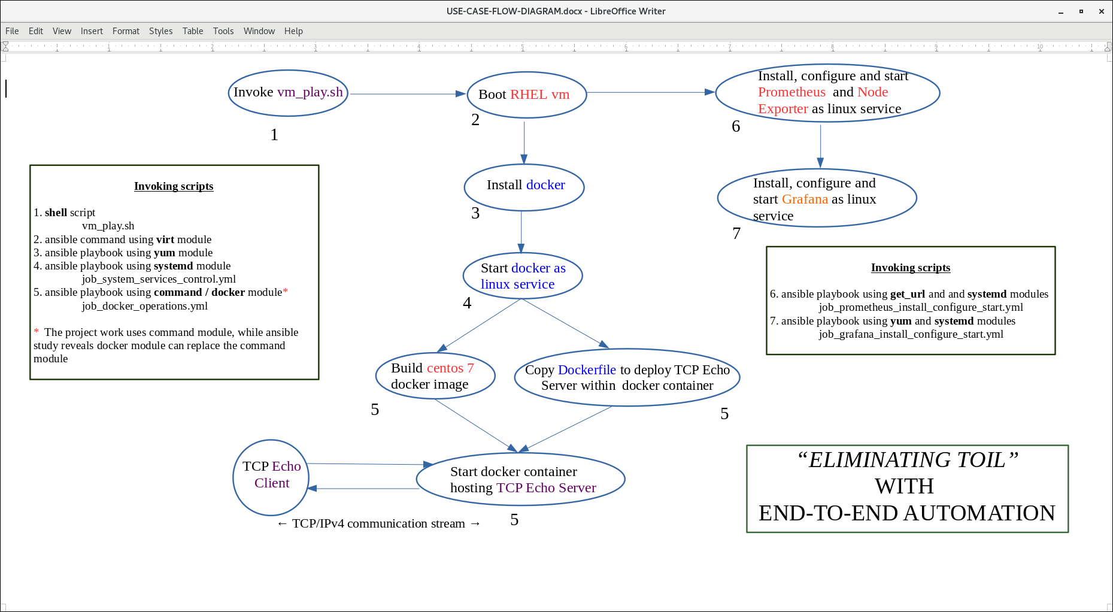

### 5.1.2 IMPLEMENTING THE USE CASE 1 WITH END-TO-END AUTOMATION

As mentioned in the scope of work, the project work involves starting a Linux VM using ansible. Ansible’s virt module can make use of the libvirt library which in-turn uses qemu-kvm driver to start virtual machines. Once the Linux VM boots up, next step would be installing a docker container which hosts the TCP Echo server within the VM. The docker images used in the project includes a centos 7 docker image. The docker container running a TCP Echo server is hosted within the centos container image. TCP echo client to communicate with the TCP Echo server running within the docker container.

The following video demonstrates the Use Case 1 where a TCP Echo server is hosted and started within a docker container within the RHEL virtual machine.

[**CLICK HERE FOR THE PROJECT DEMO**](http://www.youtube.com/watch?v=J3yoHYbJeJs)

As seen from the video a shell script named as *vm_play.sh* is run, which internally calls a series of ansible command line tasks and playbooks to complete the execution. The use-case flow diagram in Section 5.1.1 explains step by step task performed when vm_play.sh script is invoked.

Step 1. Invoke the **shell** script *vm_play.sh* which performs the list of tasks 2 – 7 in sequence.

Step 2. Invokes an ansible command using **virt** module to boot RHEL Virtual Machine.

Step 3. Invokes an ansible command using **yum** module to install docker.

Step 4. Invokes ansible playbook *job_system_services_control.yml* using **systemd** module to start docker as a linux service.

Step 5. Invokes ansible playbook *job_docker_operations.yml* using **command / docker** module which performs the following in order

Step 5a. Build a centos 7 docker image

Step 5b. Copy *Dockerfile* to deploy TCP Echo Server within a centos docker container

Step 5c. Start the docker container hosting TCP Echo Server

Note: The project work uses command module, while ansible study reveals docker module can replace command module

Step 6. Invokes ansible playbook job_prometheus_install_configure_start.yml using **get_url** and and **systemd** modules to install, configure and start the prometheus and node_exporter as linux services.

Step 7. Invokes ansible playbook job_grafana_install_configure_start.yml using **yum** and **systemd** modules to install, configure and start grafana-server as linux service.

Refer to Appendix A for the detailed source code for the *vm_play.sh* script, ansible yml files, Dockerfile and linux service files used in the project. The source code is also available in the github repository <https://github.com/2019HT66015/CSI-ZG628T-Dissertation/tree/dev_SRE_Ansible_study>. Please send an email to [2019HT66015@wilp.bits-pilani.ac.in](mailto:2019HT66015@wilp.bits-pilani.ac.in) to request access to the source code. In future the repository would be made public, once all the licensing information is included and any proprietary information is removed from the project repository.

A TCP client process connects to the TCP server to the IP address of the container and a specific port (4305). It is shown from the demonstration that the TCP Echo Client is able to send messages to the Echo Server and the Echo Server is able to echo back the message to the Echo client.

Installing Docker image with TCP Echo Server hosted, starting a docker container and TCP Echo Server started within the docker container is also demonstrated in the video. Copying docker files for TCP Echo Server and Client and performing docker operations.

TCP Echo Client program is used to test the communication with the TCP Echo Server and its functionality.

### **5.1.3 BENEFITS OF AUTOMATING THE VM AND DOCKER OPERATIONS USING ANSIBLE**

Automation of deploying the TCP Echo Server in the docker container within a VM is a significant improvement over the manual installation of VM followed by installing the docker container and then deploying the TCP Echo server within the container.

This effort would help to spend more time on the actual project work related to monitoring, data gathering and analysis, drastically reducing the time to deploy the TCP Echo Server application compared to manual deployment.

In any commercial or enterprise environment, where the system resources scale to the level of traditional or cloud data centers, this ansible automation would be useful, where Linux virtual machines and docker containers can be spun instantaneously catering to the scalability and elasticity requirements for the hosted web applications.

## 5.2 USE CASE 2 - COLLECTING SYSTEM METRICS AND MONITORING THE ENVIRONMENT

In the Use Case 2 TCP and system metrics are measured and collected using monitoring and the data collected is used for interpretation in a visual dashboard. **Monitoring** tools used are **prometheus and node_exporter** while the **visual dashboards** are created using **Grafana.**

### 5.2.1 MONITORING THE METRICS WITH NODE_EXPORTER AND PROMETHEUS

In **section 4.4.5** details on installation, configuration and startup of prometheus and node_exporter tools have been explained. It was seen that various ansible modules were used to complete this task automatically. In this section we would understand how these tools provide the interface to monitor the system metrics that can aid in the observab

node_exporter has the capability of collecting the operating system and hardware metrics. It is bundled with a set of collectors supporting various *NIX kernels. The collectors are supplied as flags when the node_exporter tool is invoked. There are group of collectors that are enabled by default and other group of collectors that are disabled by default. In this project, we are using RHEL VM which runs a Linux kernel. Some of the notable collectors that can collect linux system metrics are listed below.

|  |  |  |
| --- | --- | --- |
| **Collector Name** | **Description** | **Enabled by default (Y/N)** |
| boottime | Exposes system boot time | Y |
| cpu | Exposes CPU statistics | Y |
| diskstats | Exposes disk I/O statistics | Y |
| filefd | Exposes file descriptor statistics | Y |
| mountstats | Exposes filesystem statistics /proc/self/mountstats | N |
| loadavg | Exposes load average | Y |
| meminfo | Exposes memory statistics | Y |
| netclass | Exposes network interface from /proc/net/netstat | Y |
| network_route | Exposes routing table as metrics | N |
| tcpstat | Exposes TCP connection status information | N |
| sockstat | Exposes various statistics from /proc/net/sockstat | Y |
| time | Exposes the current system time | Y |
| vmstat | Exposes statistics from /proc/vmstat | Y |
| textfile | Exposes statistics read files in directory defined by flag --collector.textfile.directory | Y |
| processes | Exposes aggregate of process statistics | N |
| systemd | Exposes systemd services status | N |

As explained in section 4.4.5, collector flags that are not enabled by default are passed to the node_exporter to collect the corresponding metrics.

### 5.2.1.1 COLLECTING THE CUSTOM METRICS FOR TCP ECHO SERVER

In order to monitor the TCP Echo Server related metrics, the following collector flags, not enabled by default, would be useful.

--collector.tcpstat

--collector.sockstat

--collector.textfile.directory

The third flag --collector.textfile.directory given above, is very useful, when we would like to define custom metrics. The metrics can be collected in the files with extension .prom in the directory name provided in this flag. In this project, the custom metrics used to monitor TCP Echo Server are provided in the table below.

|  |  |  |
| --- | --- | --- |
| **Custom metric for TCP Echo Server** | **Description** | **.prom file in --collector.texfile.directory** |
| my_tcp_echo_server_running | If the value is ‘1’, then TCP Echo Server is running  If the value is ‘0’, then TCP Echo Server is not running | run_status.prom |
| my_tcp_echo_server_socket_listening | If the value is ‘1’, then status of TCP Echo Server’s TCP socket is in listen state  If the value is ‘0’, then status of TCP Echo Server’s TCP socket is not in listen state | socket_state.prom |

The above method is useful, when metrics that are not captured by node_exporter by default. For example, an extension to the above list could be the *number of TCP Echo Clients connected* to the TCP Echo Server, average *time taken by TCP Echo Server to respond,* etc.

The below shell script code collects the metrics *my_tcp_echo_server_running* and *my_tcp_echo_server_socket_listening* to the .prom files run_status.prom and socket_state.prom updated in –collector.textfile.directory

#Scrip check_tcp_server.sh to collect custom metrics for TCP Echo Server status

while(true)

do

ps -ef| grep './echoser 4305' | grep -v grep

if [ "$?" == "0" ]

then

# If the echoser process is running then update metric my_tcp_echo_server_running with value 1

echo my_tcp_echo_server_running 1 > /var/lib/node_exporter/textfile_collector/run_status.prom

socket_state=`ss -lp | grep batman | awk -F" " '{print $2}'`

if [ "$socket_state" == "LISTEN" ]

then

#If the socket_state is ‘LISTEN’ then update metric my_tcp_echo_server_socket_listening with value 1

echo my_tcp_echo_server_socket_listening 1 > /var/lib/node_exporter/textfile_collector/socket_state.prom

else

#If the socket_state is not ‘LISTEN’ then update metric my_tcp_echo_server_socket_listening with value 0

echo my_tcp_echo_server_socket_listening 0 > /var/lib/node_exporter/textfile_collector/socket_state.prom

fi

else

# If the echoser process is not running then update metric my_tcp_echo_server_running with value 1

echo my_tcp_echo_server_running 0 > /var/lib/node_exporter/textfile_collector/run_status.prom

echo my_tcp_echo_server_socket_listening 0 > /var/lib/node_exporter/textfile_collector/socket_state.prom

fi

usleep 300000

done

#

The above script should be running on the Linux VM so that the custom metrics can be collected for TCP Echo Server.

It should be noted that check_tcp_server.sh manually started in the lab environment. There can be a systemd service created for this activity and started as service before the node_exporter service is started.

With the above custom arrangement, it can be noticed that the metrics *my_tcp_echo_server_running* and *my_tcp_echo_server_socket_listening* would be ‘1’ when TCP Echo Server is in a healthy state. Any event that could cause either of the metrics to be changed to ‘0’ indicates an unhealthy TCP Echo Server state. By capturing the metrics and visualizing it on a dashboard, availability of the TCP Echo Server can be controlled well.

### 5.2.1.2 MONITORING LINUX SYSTEM METRICS AND CUSTOM METRICS WITH PROMETHEUS

In Section 4.4.5.2 & 4.4.5.3, it was explained how prometheus integrates with node_exporter and scrapes the linux system metrics at http port 9100. prometheus.yml file was configured to create a job_name ‘node’ with target instance as the node_exporter host at port 9100. This enables prometheus to monitor the node metrics exposed by node_exporter at port 9100. To obtain the list of all metrics exposed, URL to be used is http://<node_exporter_host>:9100/metrics

The list of all metrics collected by default by node_exporter is available in the file shared in the github repository - <https://github.com/2019HT66015/CSI-ZG628T-Dissertation/blob/dev_SRE_Ansible_study/prometheus/node_exporter_metrics/node_metrics.txt>

Prometheus has its own console accessible using URL http://<prometheus_host>:9090. The configuration of prometheus as a job is done in the prometheusm.yml file by mentioning the prometheus host name and the http port (default 9090) as the target. Prometheus can scrape data about itself at this port with metric names starting with ‘prometheus_’. The list of all prometheus metrics collected can be accessed using URL http://<prometheus_host>:9090/metrics

Prometheus console features a Graphical UI, which can be used to monitor the metrics exposed by node_exporter and prometheus itself. The URL corresponding to Graphical UI is http://<prometheus_host>:9090/graph. The ‘Expression’ field in the UI has an auto complete feature using which metric names can be listed and chosen for monitoring. For example by entering ‘node_sockstat’ lists all the metrics that start with node_sockstat, i.e. the metrics for sockets statistics for various types of sockets like TCP, RAW, UDP, TCP6, etc. The Classic UI view has a list of all metrics captured in a list box on the screen. This would be a better option for first time users of prometheus console.

Refer to the demo video <https://www.youtube.com/watch?v=J3yoHYbJeJs> to understand how the prometheus Graph UI can be used to monitor Linux system metrics.

As seen in section 5.2.1.1, there are two custom metrics created specific to this project, *my_tcp_echo_server_running* and *my_tcp_echo_server_socket_listening* which are exposed as node_exporter metrics. Prometheus would also be able to view these metrics when node_exporter is configured as a job instance. While using the expression ‘my_tcp_echo_server_running’, in the Expression field, the metric value my_tcp_echo_server_running{**instance**="localhost:9100", **job**="node"} is displayed as a ‘Table’.

There is also a ‘Graph’ view of the data, which can expose the time series data for the metrics in a graphical format. The value of the metrics over specified time period can be viewed and monitored continuously. In the below graph the time series values of my_tcp_echo_server_running for a period of 2 hours is shown.

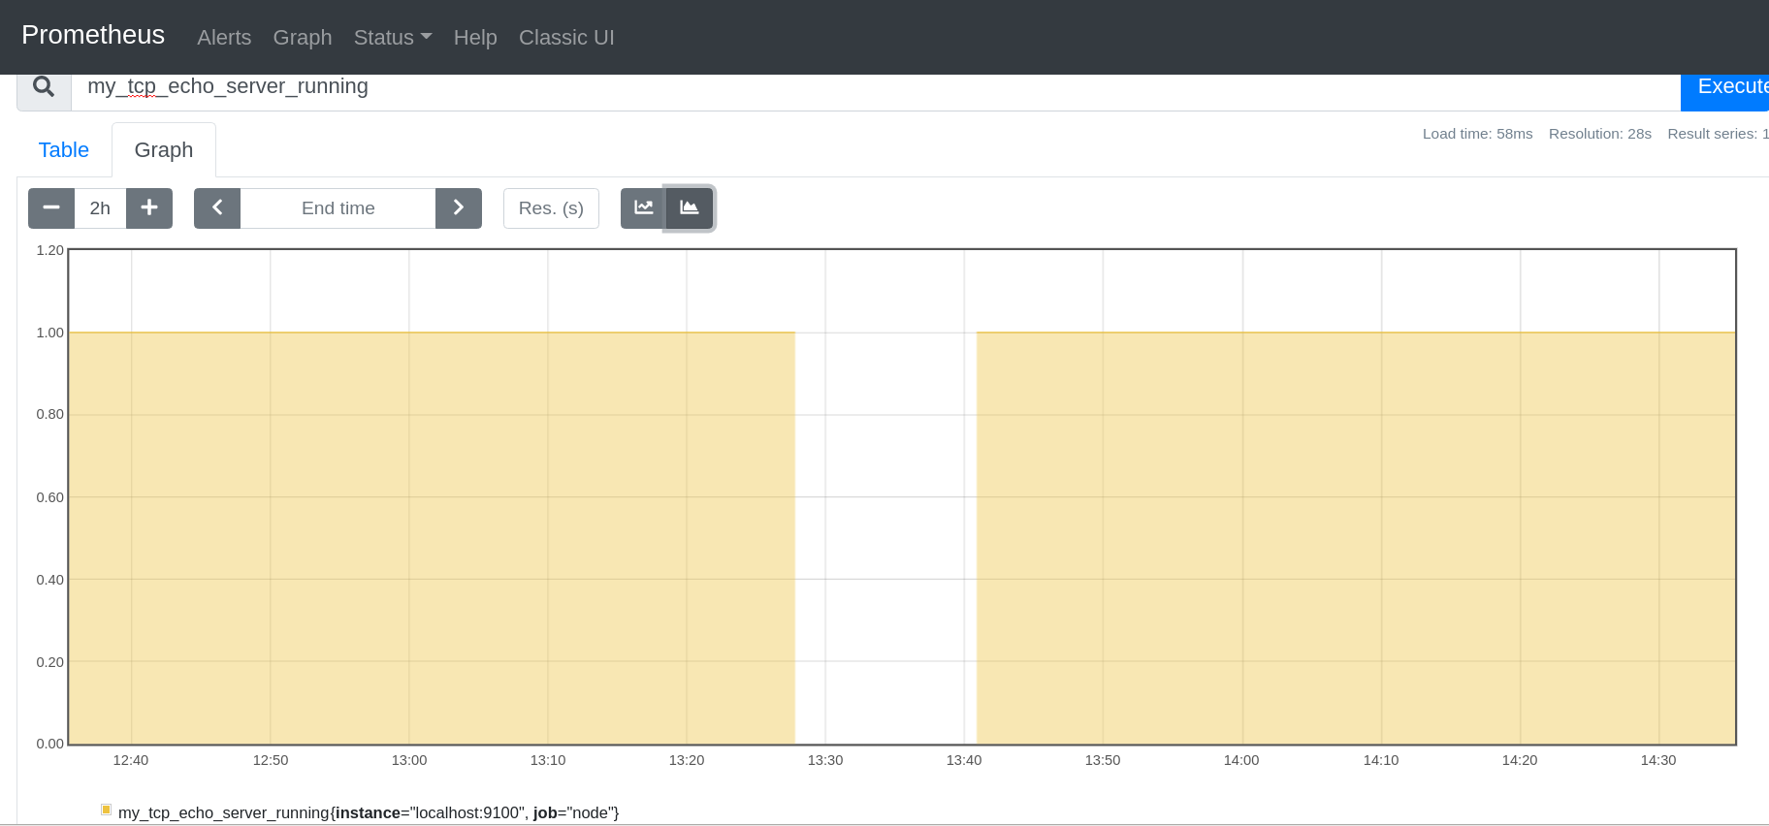

In the above graph it is seen that for a brief span between starting around 13:26 until 13:41, TCP echo server wasn’t running for some reason. This means prometheus wasn’t able to collect the time series data between this time period.

A similar graph for metric my_tcp_echo_server_socket_listening is shown below. A pattern similar to the graph pattern for server run status can be seen in this graph for socket listening status.

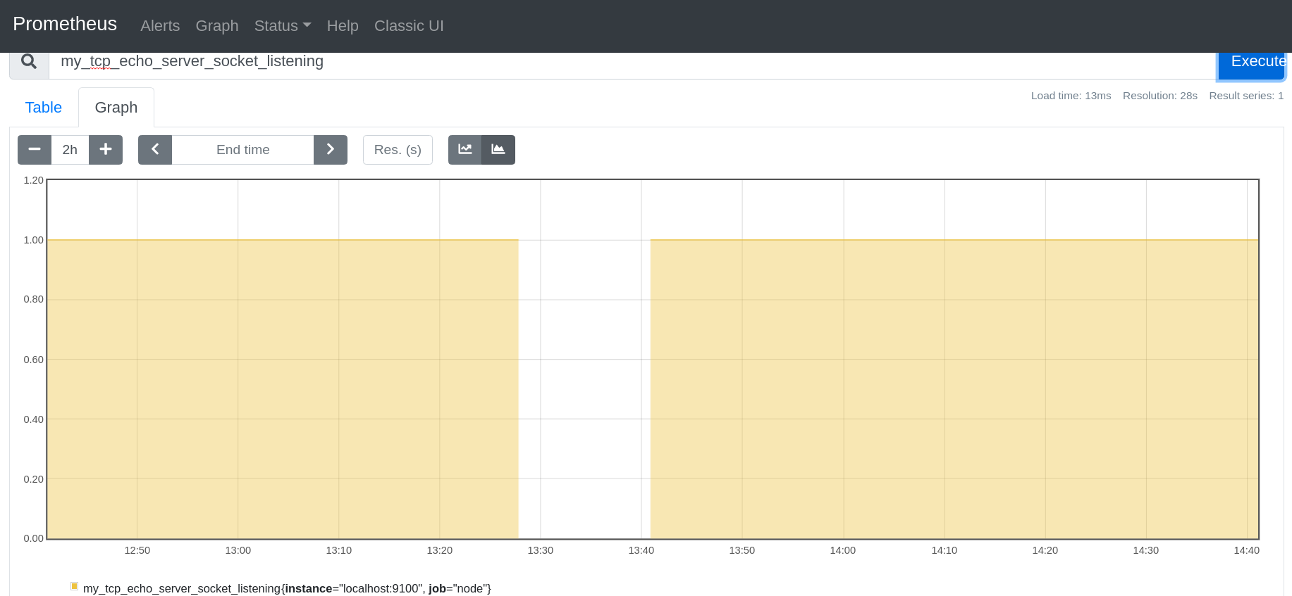

It is seen in this section that prometheus can be effectively used to monitor both linux system metrics as well as custom defined system metrics using the graphical console. This facility is used to identify any system anomalies and take corrective actions accordingly.

### 5.2.2 VISUALIZATION, MONITORING AND ALERTING WITH GRAFANA DASHBOARDS

In Section 4.5 it was seen that Grafana can use the time series data source like prometheus to visualize and monitor system metrics. The HTTP URL of prometheus where time series data can be fetched needs to be configured in Grafana datasource configuration.

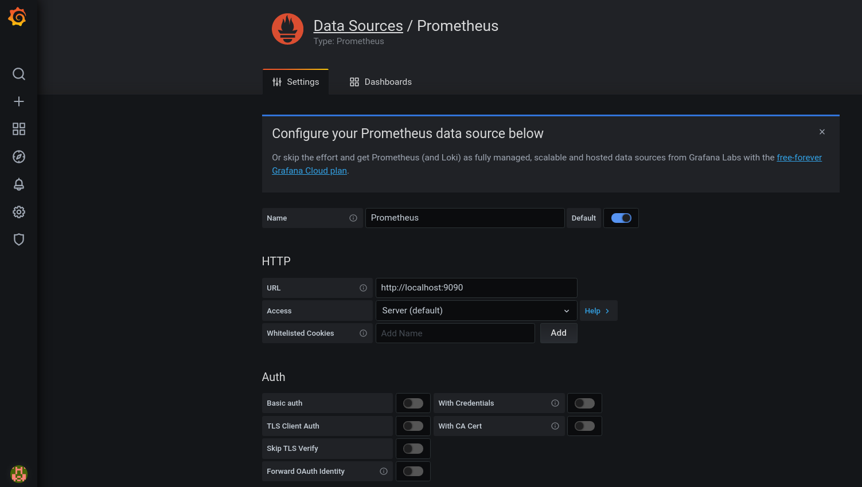

The default prometheus scrape interval in grafana would be 15 seconds. This decides the frequency with which the time series data would be collected from the prometheus datasource.

Using Grafana for visualization has various advantages over using prometheus like consolidated view of the system metrics using dashboard panels.

In this section, we can see how visualization and monitoring of the metrics and event management through alerts can be realized with Grafana.

### 5.2.2.1 TCP ECHO SERVER STATUS DASHBOARD

As seen in section 5.2.1, the custom metrics which are scoped in this project include *my_tcp_echo_server_running* and *my_tcp_echo_server_socket_listening.* As prometheus is configured in grafana as a datasource, these custom metrics can also be visualized and monitored from grafana. A dashboard named as **TCP Echo Server Status** is created to view both the metrics under the same dashboard.

There are two panels created under this dashboard, one named as **TCP Echo Server Status** which captures the metric *my_tcp_echo_server_running* and another panel named as **TCP Echo Server Listening Status** *my_tcp_echo_server_socket_listening.* The below image shows the snapshot of the custom dashboard TCP Echo Server Status for a period of two days. The graph where the value of metric is ‘1’ (green) denotes a healthy TCP Echo Server and when the value of metric is ‘0’ (red) denotes the server is unhealthy.

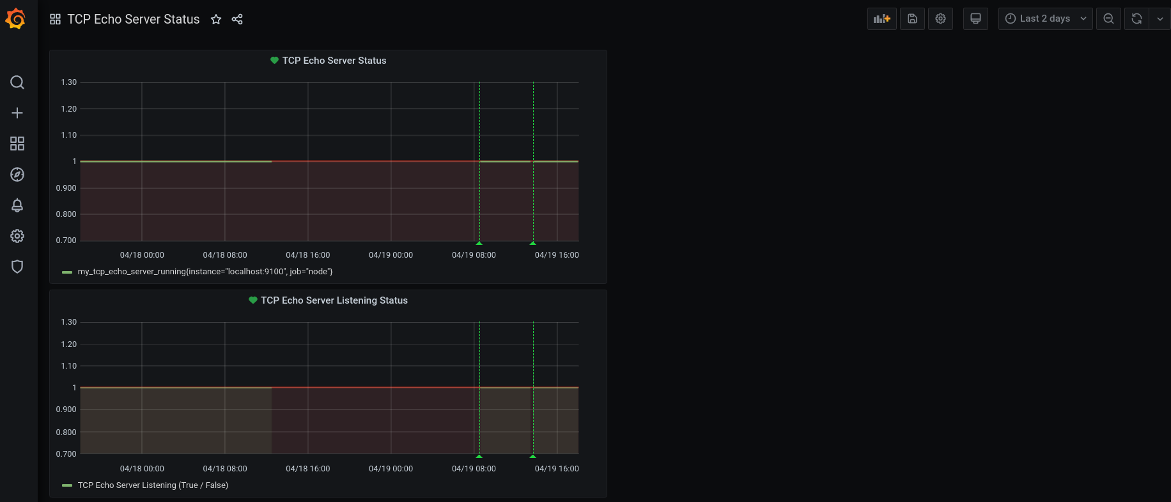

Grafana dashboard provides a feature to choose the **relative time range** for which the data needs to be visualized starting from ‘Last 5 minutes’ to ‘Last 7 days’ . It also has a provision to provide **absolute time range** to visualize the time series data from prometheus. In the latter case, a range of time like ‘From (now – 2days) To (now)’ means, the dashboard would visualize the data for past two days.

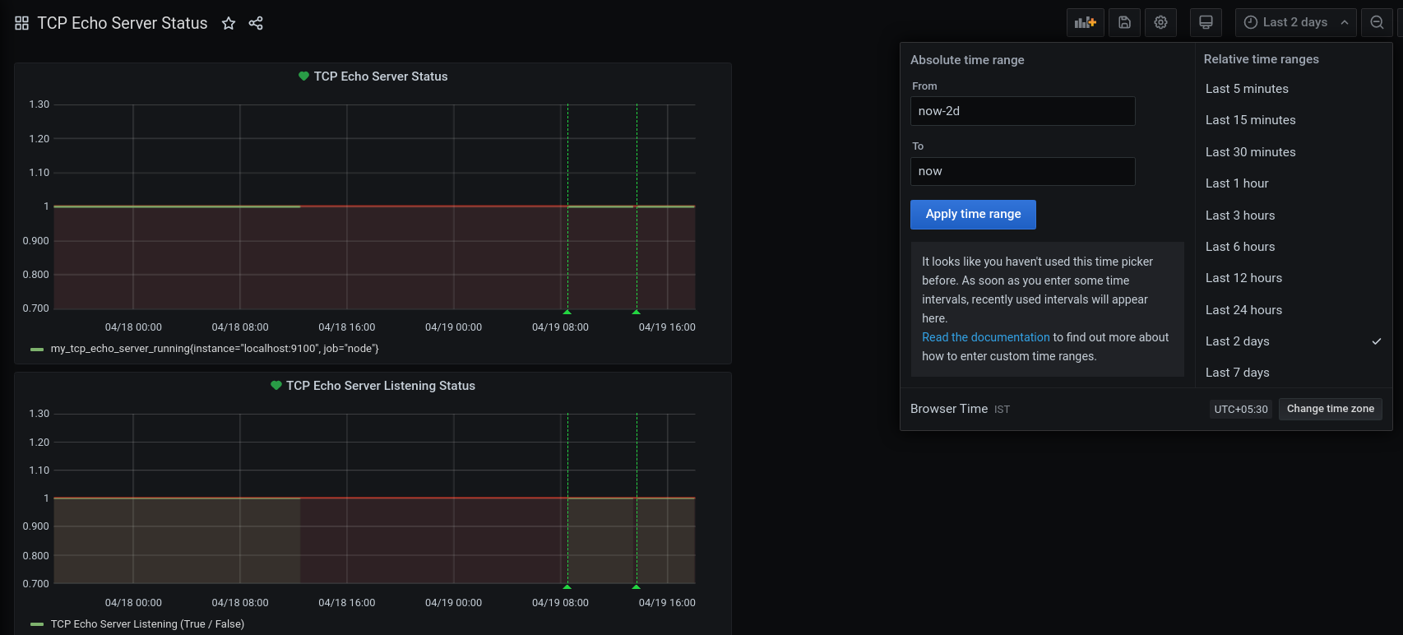

Refer to the demo video <https://www.youtube.com/watch?v=J3yoHYbJeJs> to understand how the grafana dashboard panels can be used to visualize time series data from prometheus.

Appendix B contains details of how official and community built grafana dashboards in JSON format files can be imported as dashboards into grafana. The example shown captures the following metrics using the preconfigured **Node Exporter and Quickstart Dashboard**

* CPU Usage
* Load Average
* Memory Usage
* Disk I/O
* Disk Usage
* Network Received
* Network Transmitted

The snapshot shown below visualizes all the above mentioned metrics obtained from prometheus datasource for a relative time range of ‘last 1 hour’.

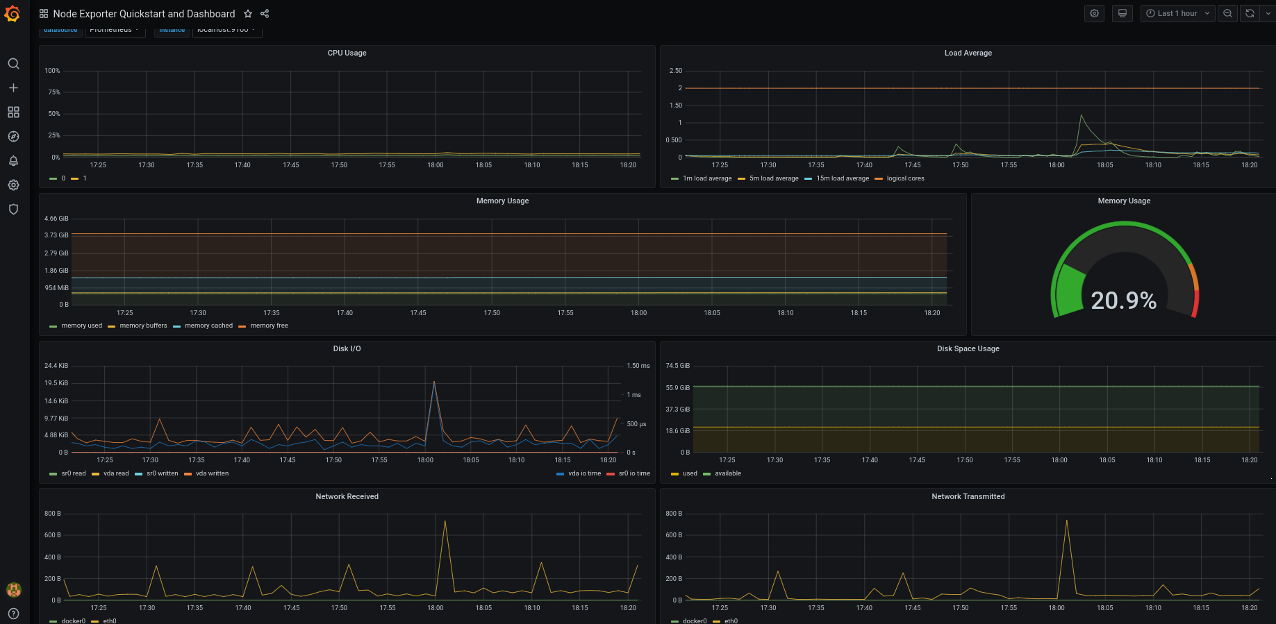

### **5.2.2.1 EVENT MANAGEMENT WITH GRAFANA ALERT RULES AND NOTIFICATION CHANNELS**

Anomalies detection is critical to the high availability of any website. There should be a way in which support teams must be notified about any failures in the system. In this project, the scope of work considered is ensuring the health of TCP Echo Server. The custom metrics captured related to TCP Echo Server Run status and TCP Echo Server Socket Listen status can be used as indicators of the health of the server.

The custom metrics *my_tcp_echo_server_running* and *my_tcp_echo_server_socket_listening* are designed in such a way that when the server is healthy these values would be ‘1’ and while the server is not running or socket status changed these values would be ‘0’. Whenever the value changes from ‘1’ to ‘0’, there should be an alert generated that could notify the support personnel to take some corrective action. This could be of much value especially in production systems where the availability of the systems should be almost 100% for the end users.

Grafana comes with the **Alerting** feature where ‘Alert Rules’ can be created which can use the ‘Notification Channels’ configured to send the details of anomalies detected using the time series data collected. In this project, there are two alert rules created – ‘TCP Echo Server Status Alert’ and ‘TCP Echo Server Listening Status Alert’.

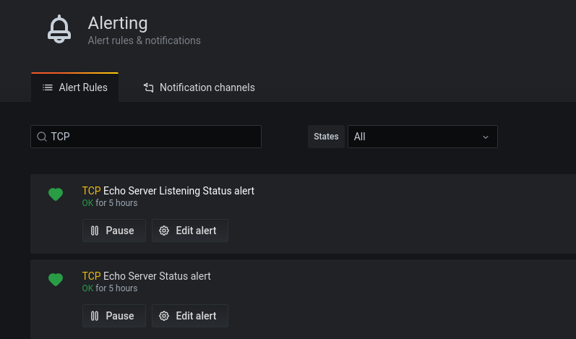

The alert rules are created as part of the configuration of dashboard panel. As seen earlier there are two custom panels created to monitor and visualize TCP Echo Server health - ‘TCP Echo Server Status’ and ‘TCP Echo Server Listening Status’. For each of the panel, alert rules are set where alert conditions are defined. The alert conditions decides ‘when’ the alert must be generated. For example, ‘TCP Echo Server Listening Status Alert’ is configured with a condition like

*“alert must be generated when average value of tcp_echo_server_listening metric is below ‘1’ “*

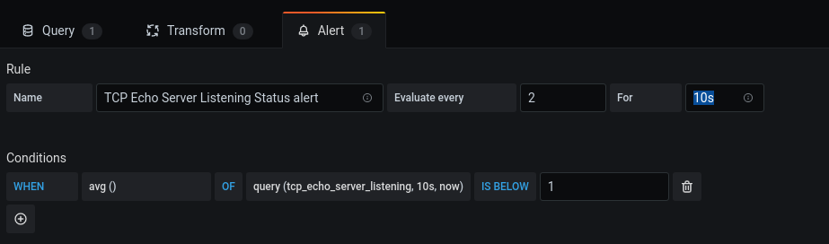

The other configuration while generating the alert would be to notify the support personnel with the details of the alert. In this example, alert notifications are sent to the notification channel named as ‘TCPEchoServerStatus’ with a custom message. The notification channel ‘TCPEchoServerStatus’ corresponds to sending an email to the id mentioned in the notification channel configuration.

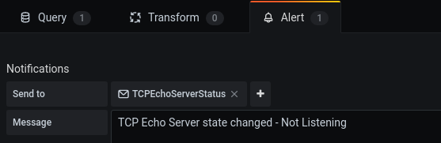

The notification channel used in this example is of type ‘Email’ where the email addresses of the support personnel is provided in the ‘Addresses’ field. When the alert condition is satisfied, an email would be generated with the details of the condition detected to all the email addresses provided in the ‘Addresses’ field.

For grafana to send the email, it is necessary that the SMTP server configuration is created in the Linux system. This is covered in the assumptions section of the document (Section 3.2.3).

### 5.2.3 BENEFITS OF VISUALIZING, MONITORING AND ALERTING WITH PROMETHEUS AND GRAFANA

In sections 5.2.1 and 5.2.2, it was explained in detail on how prometheus time series data can be used for visualizing and monitoring default system metrics and custom metrics created for TCP Echo Server. It was also explained about how grafana helps in alerting the support team when the TCP Echo Server becomes unhealthy.

Measurement of system data is essential in managing a website to ensure accurate information is available for analysis and interpretation. This ability of the measurement and monitoring of the data forms the core for ‘observability’ to address the problem of site reliability. In business environments, service level objectives of the desired system metrics and service level indicators of the allowed values of system metrics, becomes critical in achieving business goals and objectives that depends on IT systems. With prometheus’s time series data collection feature and grafana’s visualization and alerting capabilities, observability of the environment is achieved and hence the business goals and objectives.

# 6. STUDY AND ANALYSIS ON SITE RELIABILITY OF THE TCP ECHO SERVER

## 6.1 REDUCING TOIL WITH ANSIBLE AUTOMATION

## 6.2 OBSERVABILITY WITH PROMETHEUS AND GRAFANA

# 8. LITERATURE REFERENCES

1. Ansible references – <https://github.com/ansible/ansible>, <https://docs.ansible.com/>
2. Integration with DevOps tools: <https://www.ansible.com/integrations/devops-tools>
3. Site Reliability Engineering principles and practises – <https://sre.google/sre-book/part-II-principles/>, <https://sre.google/sre-book/part-III-practices/>
4. Eliminating Toil - <https://sre.google/sre-book/eliminating-toil>
5. GitHub page for Linux - <https://github.com/torvalds/linux>
6. Linux manual pages - <https://www.kernel.org/doc/man-pages/>
7. libvirt reference - <https://libvirt.org/>
8. Linux KVM website - <https://www.linux-kvm.org/page/Main_Page>
9. QEMU wiki - <https://wiki.qemu.org/Main_Page>
10. QEMU website - <https://www.qemu.org/>
11. TCP RFC 793 - <https://tools.ietf.org/html/rfc793>
12. The Linux Programming Interface book by Michael Kerrisk - <https://www.man7.org/tlpi/>
13. GNU Compiler Collection (GCC) webpage - <http://gcc.gnu.org/onlinedocs/gcc/>
14. Python website - <https://www.python.org/>
15. Visualize Prometheus data with Grafana - <https://www.openlogic.com/blog/how-visualize-prometheus-data-grafana>
16. GitHub page for Prometheus - <https://github.com/prometheus/prometheus>
17. Prometheus web site - <https://prometheus.io/>
18. Wikipedia page for Grafana - <https://en.wikipedia.org/wiki/Grafana>
19. GitHub page for Grafana - <https://github.com/grafana/grafana>
20. Overview of Docker - <https://docs.docker.com/get-started/overview>
21. Overview of Prometheus - <https://prometheus.io/docs/introduction/overview/>
22. How to make docker container use local network interface - <https://docs.docker.com/network/network-tutorial-host/>
23. docker module in ansible - [https://docs.ansible.com/ansible/2.9/modules/list_of_cloud_modules.html#docker](https://docs.ansible.com/ansible/2.9/modules/list_of_cloud_modules.html" \l "docker)
24. ansible systemd module - [https://docs.ansible.com/ansible/2.9/modules/systemd_module.html#systemd-module](https://docs.ansible.com/ansible/2.9/modules/systemd_module.html" \l "systemd-module)
25. Working with Ansible Playbooks - <https://docs.ansible.com/ansible/latest/user_guide/playbooks.html>
26. Michael Kerrisk, The Linux Programming Interface, 2021, O’Reilly Media, Inc. Chapter 60. "SOCKETS: SERVER DESIGN"
27. Michael Kerrisk, Source Code for The Linux Programming Interface - <https://man7.org/tlpi/code/index.html>
28. Node Exporter and Quick Start Dashboard for Grafana - <https://grafana.com/grafana/dashboards/13978?pg=dashboards&plcmt=featured-sub1>

# APPENDIX A – Design and Source Code

* 1. <https://github.com/2019HT66015/CSI-ZG628T-Dissertation.git>

# APPENDIX B – USING PRE-COFIGURED GRAFANA DASHBOARDS