Age-related differences in task-related modulation of cerebellar brain inhibition

Shanti Van Malderena,b,c, Melina Hehla,b,c, Marten Nuytsa, Stefanie Verstraelena, Robin E. Heemelsa, Robert M. Hardwickd, Stephan P. Swinnenb,c, Koen Cuypersa,b,c,

(a) Neuroplasticity and Movement Control Research Group, Rehabilitation Research Institute (REVAL), Hasselt University, Diepenbeek, Belgium

(b) KU Leuven, Leuven Brain Institute (LBI), Leuven, Belgium

(c) Movement Control and Neuroplasticity Research Group, Department of Movement Sciences, Group Biomedical Sciences, KU Leuven,

Heverlee, Belgium

(d) Faculty of Movement and Rehabilitation Sciences, Institute of NeuroScience (IONS), UCLouvain, Woluwe-Saint-Lambert, Belgium

**Keywords:** Cerebellar brain inhibition (CBI), Cerebellum, Transcranial magnetic stimulation (TMS), Aging, Dual-site TMS, Motor learning

*Corresponding author:

Prof. Dr. Koen Cuypers,

Neuroplasticity and Movement Control Research Group,

Rehabilitation Research Institute (REVAL)

Wetenschapspark 7

3590 Diepenbeek Belgium

Tel: +32 11 26 93 16

Email: [koen.cuypers@uhasselt.be](mailto:koen.cuypers@uhasselt.be)

Supplementary materials

# Supplement 1. Sex differences in CBI measurements at rest and task-related CBI

## 1.1 Task-related CBI

Women demonstrated significantly more CBItask (lower %CSEunconditioned) during task preparation as compared to men (F(1,38) = 4.51; *p* = 0.04) (Supplemental Figure 1.A).

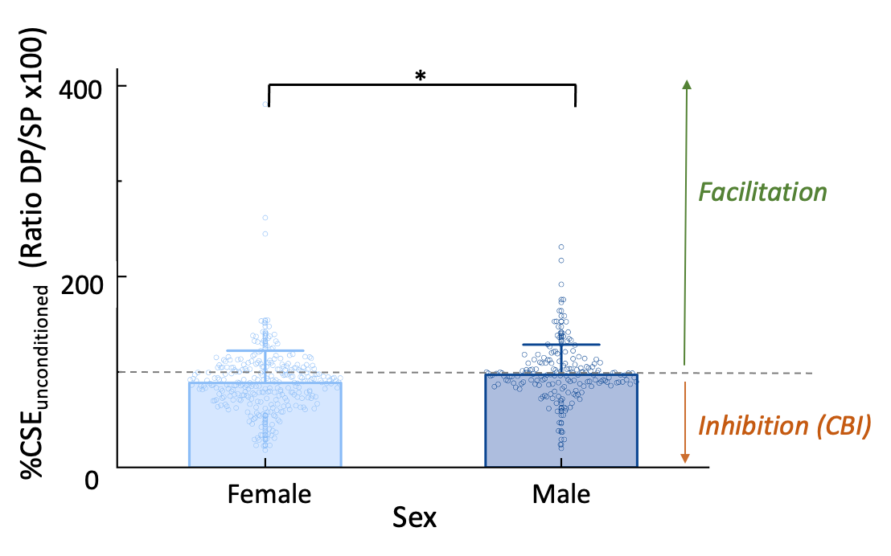

**Supplemental Figure 1.A.** Task-related CBI. During task preparation, women demonstrated a lower %CSEunconditioned and, hence, more CBItask as compared to men.

Bar graphs with SD (whiskers) and individual data points superimposed. The gray dashed line indicates no CBI, i.e., a %CSEunconditioned [DP (MEPCS+TS)to SP (MEPTS) x 100] of 100. Values below 100 are interpreted as an inhibitory interaction (i.e., CBI), whereas ratios above 100 are interpreted as facilitation.

*\* indicates a significant difference of p < 0.05*

*Abbreviations: CBI = cerebellar brain inhibition; CSE = corticospinal excitability; DP = double-pulse; ns = not significant; Older = older adults; SP = single-pulse; Younger = younger adults*

### 1.2 CBI at rest

For completeness, an additional analysis of CBIrest differences between both sexes at rest was done using a t-test.

Women demonstrated a significantly lower %CSEunconditioned and hence had significantly more CBIrest compared to men (F(1,38) = 9.83; *p* = 0.0033) [female/ male mean±SD: 60.71±3.49 / 78.56±4.50) (Supplemental Figure 1.B).

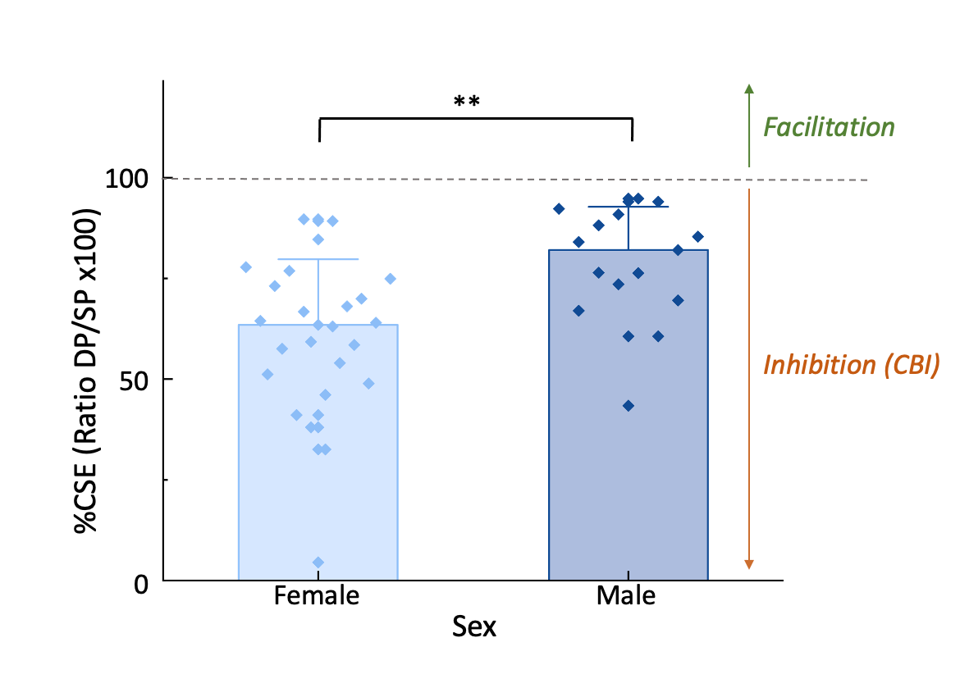

**Supplemental Figure 1.B.** CBI at rest. Female participants showed a noticeably lower %CSEunconditioned and thus had significantly more CBIrest in comparison to male participants.

Bar graphs with SD (whiskers) and individual data points superimposed. The gray dashed line indicates no CBI, i.e., a %CSEunconditioned [DP (MEPCS+TS)to SP (MEPTS) x 100] of 100. Values below 100 are interpreted as an inhibitory interaction (i.e., CBI), whereas ratios above 100 would be interpreted as facilitation.

*\*\* indicates a significant difference of p < 0.01*

*Abbreviations: CBI = cerebellar brain inhibition; CSE = corticospinal excitability; DP = double-pulse; ns = not significant; Older = older adults; SP = single-pulse; Younger = younger adults*

## 1.3 Sex-specific variations in CBI measurements during resting state and task-related conditions

Men showed less inhibition than women in the present study, both during rest and during the preparatory period of a motor task. This could be explained by cerebellum-specific physiological male-female differences. Specifically, mice research demonstrated sex differences in synaptic excitation, inhibition, and intrinsic properties (Mercer et al., 2016). More specifically, in male as compared to female mice, cerebellar cells have smaller synaptic-evoked glutamate receptor-dependent currents, slower Purkinje-mediated inhibitory postsynaptic currents and lower spontaneous firing rates. These cellular differences did not affect behavioral performance (Mercer et al., 2016). Based on this information, one can speculate that if the inhibitory control over the cerebellar nuclei, which is mediated by Purkinje-induced inhibitory postsynaptic currents, operates at a slower pace in males. This could potentially lead to a delayed expression of CBI, e.g., optimally elicited CBI at an ISI of 7 but not 5 ms in males.

Despite the presence of these physiological differences, at least in mice, the sex-based difference in inhibition found in this study could also be explained methodologically. This methodological consideration is twofold. First, as demonstrated by Van Hoornweder et al. (2023), there is a difference in scalp-to-cortex distance between sexes, with men having a larger scalp-to-cortex distance in brain regions farther from the vertex, such as the cerebellum, than women.

Secondly, men typically have, on average, bigger crania compared to females (Abdel Fatah et al., 2014; Milella et al., 2021) and both sexes have different skull shapes (Milella et al., 2021). In the present study, when using the DC coil with a fixed angle, the average head-coil distance was typically observed to be bigger in males (i.e., individuals with larger craniums) relative to females. The strength of the magnetic field in TMS is closely linked to the distance from the source, as it operates through an electromagnetic mechanism. More specifically, the electric field strength diminishes almost exponentially as the distance from the source increases (Deng et al., 2014; Van Hoornweder et al., 2023). When using a fixed CS intensity as in the current study, it is arguable that the E-field induced in the cerebellar hemisphere is much smaller in men compared to women due to the higher coil-to-cortex distance.

As CBI strength was found in a sample of young adults to decrease (i.e., MEP amplitudes increased) as CS intensity decreased (i.e., lower E-field) (Panyakaew et al., 2016; Schlerf et al., 2015) this might explain the lower CBI strength found in males in the present study.

# Supplement 3. TS intensity and SP MEPs

The TS intensity was set to elicit an MEP of ~1 mV. Additionally, to account for potential changes in excitability due to habituation, fatigue, or boredom, the intensity was re-evaluated and adjusted as needed after each block. The percentage of maximum stimulator output (%MSO) necessary to elicit an MEP of ~1 mV was 50.95±10.89 on average during the rest measurement and 51.70±10.96 and 52.25±10.80 after adjustment before task blocks 1 and 2, respectively. The %MSO per participant and per task block is outlined in Supplemental Table 1. Additionally, MEPs of single pulses (SP MEPs), averaged over conditions, are reported per task block and timing (BL and prep).

**Supplemental Table 1.** TS intensity as a percentage of maximum stimulator output (%MSO) and single pulse MEPs.

|  |  |  |  |  |  |  |  |
| --- | --- | --- | --- | --- | --- | --- | --- |
| **Subject** | **TS intensity initial (%MSO)** | **TS intensity (A) Task Block 1 (%MSO)** | **TS intensity (B) Task Block 2 (%MSO)** | **SP MEPs BL Block 1 (mV)** | **SP MEPs BL Block 2 (mV)** | **SP MEPs prep Block 1 (mV)** | **SP MEPs prep Block 2 (mV)** |
| Sub-Y001 | 39 | 39 | 39 | 2.58 | 1.99 | 1.88 | 1.62 |
| Sub-Y002 | 35 | 35 | 35 | 2.36 | 2.35 | 2.57 | 2.96 |
| Sub-Y003 | 44 | 42 | 44 | 4.07 | 4.22 | 3.97 | 4.21 |
| Sub-Y004 | 56 | 57 | 57 | 3.06 | 2.75 | 2.28 | 2.46 |
| Sub-Y005 | 46 | 47 | 47 | 5.20 | 4.40 | 5.19 | 4.89 |
| Sub-Y006 | 37 | 38 | 40 | 2.50 | 1.76 | 2.99 | 2.12 |
| Sub-Y007 | 45 | 47 | 45 | 2.42 | 2.33 | 2.34 | 2.21 |
| Sub-Y008 | 55 | 57 | 58 | 2.49 | 3.64 | 1.28 | 2.53 |
| Sub-Y009 | 51 | 56 | 56 | 1.66 | 1.50 | 1.40 | 1.31 |
| Sub-Y010 | 55 | 55 | 55 | 2.35 | 2.19 | 2.34 | 2.24 |
| Sub-Y011 | 37 | 37 | 40 | 2.91 | 1.86 | 3.94 | 3.24 |
| Sub-Y012 | 44 | 43 | 46 | 1.60 | 1.52 | 1.57 | 1.48 |
| Sub-Y013 | 60 | 60 | 62 | 1.89 | 1.94 | 2.00 | 1.94 |
| Sub-Y014 | 45 | 51 | 51 | 2.02 | 2.32 | 2.04 | 2.05 |
| Sub-Y015 | 70 | 70 | 70 | 0.92 | 0.77 | 0.98 | 1.05 |
| Sub-Y016 | 62 | 62 | 62 | 2.06 | 1.42 | 2.29 | 1.81 |
| Sub-Y017 | 39 | 40 | 41 | 3.62 | 3.84 | 3.35 | 2.65 |
| Sub-Y018 | 55 | 55 | 55 | 2.95 | 2.71 | 3.47 | 3.40 |
| Sub-Y019 | 44 | 44 | 44 | 6.84 | 6.73 | 4.36 | 5.19 |
| Sub-Y020 | 58 | 58 | 58 | 1.85 | 1.47 | 1.68 | 2.23 |
| Sub-O001 | 37 | 37 | 38 | 4.88 | 4.36 | 3.82 | 4.56 |
| Sub-O002 | 46 | 47 | 47 | 4.65 | 4.04 | 4.59 | 4.64 |
| Sub-O003 | 52 | 52 | 57 | 3.08 | 2.69 | 3.089 | 3.11 |
| Sub-O004 | 50 | 50 | 53 | 2.21 | 1.93 | 3.10 | 2.60 |
| Sub-O005 | 41 | 41 | 41 | 1.49 | 1.39 | 1.34 | 1.30 |
| Sub-O006 | 67 | 67 | 67 | 3.66 | 3.72 | 3.81 | 4.01 |
| Sub-O007 | 37 | 39 | 39 | 3.14 | 1.55 | 3.08 | 1.79 |
| Sub-O008 | 55 | 55 | 55 | 6.82 | 6.76 | 4.79 | 6.61 |
| Sub-O009 | 57 | 58 | 58 | 5.00 | 7.33 | 4.70 | 3.45 |
| Sub-O010 | 69 | 69 | 69 | 2.72 | 2.01 | 2.61 | 2.65 |
| Sub-O011 | 63 | 64 | 64 | 1.19 | 1.97 | 1.50 | 2.34 |
| Sub-O012 | 65 | 67 | 67 | 3.71 | 4.76 | 4.69 | 4.86 |
| Sub-O013 | 40 | 43 | 43 | 2.79 | 2.92 | 2.74 | 2.66 |
| Sub-O014 | 70 | 70 | 71 | 1.75 | 1.57 | 2.02 | 1.76 |
| Sub-O015 | 68 | 70 | 70 | 3.61 | 4.36 | 3.47 | 3.73 |
| Sub-O016 | 40 | 40 | 40 | 1.80 | 1.63 | 2.54 | 2.24 |
| Sub-O017 | 60 | 60 | 60 | 2.19 | 2.12 | 1.54 | 1.92 |
| Sub-O018 | 47 | 47 | 47 | 4.90 | 4.28 | 4.18 | 4.05 |
| Sub-O019 | 37 | 37 | 37 | 2.89 | 4.00 | 3.54 | 2.98 |
| Sub-O020 | 60 | 62 | 62 | 2.19 | 2.67 | 3.07 | 3.31 |

***Abbreviations:*** *%MSO = percentage of maximal stimulator output; BL = baseline timepoint; MEP = motor evoked potential; mV = millivolt; Prep = prep timepoint; SP = single pulse; TS = test stimulus*

# Supplement 4. Resting-motor threshold as a covariate of no interest

All models included sex (female and male) as a covariate of no interest. Starting from a full-factorial model, the final model was obtained through a series of models using backward selection. Specifically, starting from the initial model, this involved iteratively removing fixed effects that lacked significance. The normality and homoscedasticity of conditional residuals of all models were visually checked using the Q-Q plot and the residual-by-predicted plot, respectively.

rMT (%MSO) was included as an additional covariate of no interest to all models that include CBI. The fixed effects of the initial simplified model, as well as those of the model including rMT, are reported below. The parameter ‘rMT’ was not significant, nor did the covariate significantly influence any other effects.

**Group-differences in task-related CBI**

To investigate CBI during task anticipation, a linear mixed model analysis was used, with CBItask used as a Y-variable and age group (YA and OA), condition (1:1, 1:3 and 3:1), block (task-related ds-TMS block 1 and block 2), and timing (BL and Prep) as fixed effects and subject as a random intercept. Uncorrected fixed effects of the simplified model are represented in Supplemental Table 2.

**Supplemental Table 2.** Fixed effects test linear mixed model group-differences in task-related CBI.

|  |  |  |  |  |  |
| --- | --- | --- | --- | --- | --- |
| **Term** | **Nparm** | **DFNum** | **DfDen** | **F Ratio** | **Prob > F** |
| Sex | 1 | 1 | 38.0 | 4.51 | **0.0403\*** |

rMT (%MSO) was added to the model as a covariate of no interest. Uncorrected fixed effects of the simplified model are represented in Supplemental Table 3.

**Supplemental Table 3.** Fixed effects test linear mixed model group-differences in task-related CBI with rMT added as a covariate of no interest.

|  |  |  |  |  |  |
| --- | --- | --- | --- | --- | --- |
| **Term** | **Nparm** | **DFNum** | **DfDen** | **F Ratio** | **Prob > F** |
| Sex | 1 | 1 | 36.9 | 4.73 | **0.0360\*** |
| rMT | 1 | 1 | 36.9 | 1.78 | 0.1906 |

**Comparison of resting vs. task-related CBI**

CBI was also directly compared between resting-state and the Prep timepoint, using a linear mixed model as described in the manuscript with CBI as a Y-variable. Age group (YA and OA) and state (rest and task) were used as fixed effects and subjects as a random intercept. Uncorrected fixed effects of the simplified model are represented in Supplemental Table 4.

**Supplemental Table 4.** Fixed effects test linear mixed model resting vs. task-related CBI.

|  |  |  |  |  |  |
| --- | --- | --- | --- | --- | --- |
| **Term** | **Nparm** | **DFNum** | **DfDen** | **F Ratio** | **Prob > F** |
| Sex | 1 | 1 | 40.7 | 6.43 | **0.0150\*** |
| State | 1 | 1 | 238.8 | 37.80 | **<0.0001\*** |

rMT (%MSO) was added to the model as a covariate of no interest. Uncorrected fixed effects of the simplified model are represented in Supplemental Table 5.

**Supplemental Table 5.** Fixed effects test linear mixed model resting vs. task-related CBI with rMT added as a covariate of no interest.

|  |  |  |  |  |  |
| --- | --- | --- | --- | --- | --- |
| **Term** | **Nparm** | **DFNum** | **DfDen** | **F Ratio** | **Prob > F** |
| Sex | 1 | 1 | 40.7 | 6.37 | **0.0156\*** |
| State | 1 | 1 | 238.8 | 37.80 | **<0.0001\*** |
| rMT | 1 | 1 | 36.9 | 0.36 | 0.5522 |

**Association between CBI modulation and task performance**

Linear mixed model as reported in the manuscript, with the averaged BTT score (S score) as the Y-variable. Age group (YA and OA), condition (1:1, 1:3 and 3:1), block (1 and 2), and CBI modulation (i.e., difference between Prep and BL) were added as fixed effects and subject as a random intercept. Uncorrected fixed effects of the simplified model are represented in Supplemental Table 6.

**Supplemental Table 6.** Fixed effects test linear mixed model association between task performance and CBI modulation.

|  |  |  |  |  |  |
| --- | --- | --- | --- | --- | --- |
| **Term** | **Nparm** | **DFNum** | **DfDen** | **F Ratio** | **Prob > F** |
| Age group | 1 | 1 | 37.8 | 28.33 | **<0.0001\*** |
| Condition | 2 | 2 | 189.1 | 62.30 | **<0.0001\*** |
| Block | 1 | 1 | 189 | 1.14 | 0.2869 |
| Group*block | 1 | 1 | 189 | 2.05 | 0.1535 |
| Condition*block | 2 | 2 | 189.2 | 18.17 | **<0.0001\*** |
| Modulation BL | 1 | 1 | 200.4 | 2.99 | 0.0855 |
| Age group*modulation | 1 | 1 | 200.5 | 0.76 | 0.3833 |
| Block*Modulation | 1 | 1 | 194 | 12.58 | **0.0005\*** |
| Group*Block*Modulation | 1 | 1 | 194 | 6.02 | **0.0150\*** |

rMT (%MSO) was added to the model as a covariate of no interest. Uncorrected fixed effects of the simplified model are represented in Supplemental Table 7.

**Supplemental Table 7.** Fixed effects test linear mixed model association between task performance and CBI modulation with rMT added as a covariate of no interest.

|  |  |  |  |  |  |
| --- | --- | --- | --- | --- | --- |
| **Term** | **Nparm** | **DFNum** | **DfDen** | **F Ratio** | **Prob > F** |
| Age group | 1 | 1 | 36.9 | 23.50 | **<0.0001\*** |
| Condition | 2 | 2 | 189.1 | 62.31 | **<0.0001\*** |
| Block | 1 | 1 | 189.1 | 1.14 | 0.2862 |
| Group*block | 1 | 1 | 189.1 | 2.04 | 0.1535 |
| Condition*block | 2 | 2 | 189.2 | 18.20 | **<0.0001\*** |
| Modulation BL | 1 | 1 | 200.1 | 2.92 | 0.0855 |
| Age group*modulation | 1 | 1 | 200.2 | 0.80 | 0.3833 |
| Block*Modulation | 1 | 1 | 193.9 | 12.53 | **0.0004\*** |
| Group*Block*Modulation | 1 | 1 | 194 | 6.03 | **0.0149\*** |
| rMT (%MSO) | 1 | 1 | 36.9 | 0.56 | 0.4580 |

# Supplement 5. Estimated fixed effect coefficients and standardized effect sizes

Currently, there is no consensus on calculating effect sizes for linear mixed models. Additionally, the variance in LMMs is partitioned (Rights and Sterba, 2019). To address this, both the estimated fixed effects (with standard errors and confidence intervals) and standardized coefficients for all linear mixed models in this study are reported. While the estimated fixed effects indicate the effect size for each component of the original model on the outcome when holding all other variables constant, standardized coefficients provide effect sizes for individual predictors on a comparable scale. For the Wilcoxon rank-sum test, the Wilcoxon effect size (r) and a conversion to Cohen’s d for easier interpretation are included.

Standardized coefficients ( $βstandardized)$ were calculated using:

$$βstandardized=\frac{(b⋅{SD}_{x})}{{SD}_{y}}$$

Where b is the unstandardized regression coefficient; SDX is the standard deviation of the predictor and SDY is the standard deviation of the outcome variable.

## 5.1 Task performance

**Supplemental Table 8.** Parameter estimates of all fixed effects in the final linear mixed model for BTT task performance.

|  |  |  |  |  |  |  |  |
| --- | --- | --- | --- | --- | --- | --- | --- |
| **Term** | **Estimate** | **Std Error** | **DFDen** | **t Ratio** | **Prob>|t|** | **95% Lower** | **95% Upper** |
| Intercept | 46.75 | 1.42 | 38 | 32.99 | **<0.0001\*** | 43.88 | 49.62 |
| Age group[OA] | -7.47 | 1.42 | 38 | -5.27 | **<0.0001\*** | -10.34 | -4.60 |
| Condition[1:1] | 7.24 | 0.67 | 195 | 10.89 | **<0.0001\*** | 5.93 | 8.55 |
| Condition[1:3] | -3.37 | 0.67 | 195 | -5.07 | **<0.0001\*** | -4.68 | -2.06 |
| Block[1] | 0.35 | 0.47 | 195 | 0.74 | 0.4587 | -0.58 | 1.28 |
| Condition [1:1]*Block[1] | -2.09 | 0.67 | 195 | -3.14 | **0.0020\*** | -3.40 | -0.77 |

***Abbreviations****: BTT = bimanual tracking task; OA = older adults*

**Supplemental Table 9.** Standardized coefficients of all fixed effects in the final linear mixed model for BTT task performance.

|  |  |  |
| --- | --- | --- |
| **Parameter** | **|Std. Coef.|** | **95% CI** |
| (Intercept) | |-0.02| | [-0.30, 0.27] |
| Group [YA] | |1.03| | [ 0.65, 1.42] |
| Condition[1:3] | |-0.73| | [-0.89, -0.58] |
| Condition[3:1] | |-0.77| | [-0.92, -0.61] |
| Block | |0.12| | [ 0.01, 0.23] |
| Condition [1:3]*Block | |-0.02| | [-0.18, 0.14] |
| Condition [3:1]*Block | |-0.41| | [-0.57, -0.26] |

***Abbreviations****: BTT = bimanual tracking task; YA = younger adults*

## 5.2 TMS results

### Group differences in CBI at rest

Group differences in CBI at rest were analyzed using a Wilcoxon rank-sum test. To estimate the effect size, the Wilcoxon effect size (r) was calculated (Rosenthal, 1986), using:

$$r= \frac{Z}{\sqrt{N}}$$

where Z is the test statistic (Z) and N is the sample size.

There was no significant difference between age groups for CBI at rest (%CSEunconditioned OA / YA: 66.93±16.55 / 67.88±21.33; z = 0.61, *p* = 0.5428). Using the obtained Z statistic:

$$r= \frac{0.61}{\sqrt{40}}=0.1$$

The Wilcoxon effect size (r) can be converted to Cohen’s d using:

$$d=\frac{2r}{\sqrt{1-r^{2}}}$$

Applying this formula:

$$d=\frac{2*(0.1)}{\sqrt{1-{(0.1)}^{2}}}=0.20$$

### Task-related CBI

**Supplemental Table 10.** Parameter estimates of all fixed effects in the final linear mixed model for group-differences in task-related CBI.

|  |  |  |  |  |  |  |  |
| --- | --- | --- | --- | --- | --- | --- | --- |
| **Term** | **Estimate** | **Std Error** | **DFDen** | **t Ratio** | **Prob>|t|** | **95% Lower** | **95% Upper** |
| Intercept | 94.21 | 2.49 | 38 | 37.82 | **<0.0001\*** | 89.17 | 99.25 |
| Sex[F] | -5.29 | 2.49 | 38 | -2.12 | **0.0403\*** | -10.33 | -0.25 |

***Abbreviations****: F = female*

**Supplemental Table 11.** Standardized coefficients of all fixed effects in the final linear mixed model for group-differences in task-related CBI.

|  |  |  |
| --- | --- | --- |
| **Parameter** | **|Std. Coef.|** | **95% CI** |
| (Intercept) | |-0.12| | [-0.31, 0.06] |
| Sex [M] | |0.33| | [0.02, 0.63] |

***Abbreviations****: M = male*

### Difference in CBI between rest and task-related CBI

**Supplemental Table 12.** Parameter estimates of all fixed effects in the final linear mixed model resting vs. task-related CBI.

|  |  |  |  |  |  |  |  |
| --- | --- | --- | --- | --- | --- | --- | --- |
| **Term** | **Estimate** | **Std Error** | **DFDen** | **t Ratio** | **Prob>|t|** | **95% Lower** | **95% Upper** |
| Intercept | 81.88 | 3.23 | 60.1 | 25.33 | **<0.0001\*** | 75.42 | 88.35 |
| Sex[F] | -7.19 | 2.84 | 41.7 | -2.54 | **0.0150\*** | -12.92 | -1.47 |
| State[Rest] | -12.68 | 2.06 | 238.8 | -6.15 | **<0.0001\*** | -16.74 | -8.62 |

***Abbreviations****: F = female*

**Supplemental Table 13.** Standardized coefficients of all fixed effects in the final linear mixed model resting vs. task-related CBI.

|  |  |  |
| --- | --- | --- |
| **Parameter** | **|Std. Coef.|** | **95% CI** |
| (Intercept) | |-0.89| | [-1.21, -0.57] |
| State[Task] | |0.83| | [0.56,1.10] |
| Sex [M] | |0.47| | [0.11,0.83] |

***Abbreviations****: M = male*

### Association between bimanual motor control and CBI modulation

**Supplemental Table 14.** Parameter estimates of all fixed effects in the final linear mixed model for the association between task performance and CBI modulation.

|  |  |  |  |  |  |  |  |
| --- | --- | --- | --- | --- | --- | --- | --- |
| **Term** | **Estimate** | **Std Error** | **DFDen** | **t Ratio** | **Prob>|t|** | **95% Lower** | **95% Upper** |
| Intercept | 47.27 | 1.45 | 36.8 | 32.67 | **<0.0001\*** | 44.34 | 50.20 |
| Group[OA] | -7.54 | 1.40 | 36.8 | -5.37 | **<0.0001\*** | -10.38 | -4.69 |
| Condition[1:1] | 7.04 | 0.63 | 189 | 11.16 | **<0.0001\*** | 5.79 | 8.28 |
| Condition [1:3] | -3.40 | 0.64 | 189.2 | -5.32 | **<0.0001\*** | -4.67 | -2.14 |
| Block[1] | 0.48 | 0.45 | 189.1 | 1.07 | 0.2867 | -0.40 | 1.36 |
| Group[OA]*Block[1] | 0.64 | 0.45 | 189.1 | 1.43 | 0.154 | -0.24 | 1.52 |
| Condition[1:1]*Block[1] | -2.02 | 0.63 | 189.1 | -3.20 | **0.0016\*** | -3.26 | -0.77 |
| Condition [1:3]*Block[1] | -1.81 | 0.64 | 189.3 | -2.82 | **0.0053\*** | -3.07 | -0.54 |
| Modulation | 0.02 | 0.01 | 200.7 | 1.68 | 0.0948 | -0.00 | 0.05 |
| Group[OA]*Modulation | 0.011 | 0.01 | 201.1 | 0.84 | 0.4007 | -0.01 | 0.04 |
| Block[1]*Modulation | -0.043 | 0.01 | 194.3 | -3.54 | **0.0005\*** | -0.07 | -0.02 |
| Group[OA]*Block[1]*Modulation | -0.03 | 0.01 | 194.3 | -2.20 | **0.0150\*** | -0.05 | -0.00 |
| Sex[F] | -2.59 | 1.45 | 36.9 | -1.79 | 0.0824 | -5.53 | 0.35 |

***Abbreviations****: F = female; OA = older adults*

**Supplemental Table 15.** Standardized coefficients of all fixed effects in the final linear mixed for the association between task performance and CBI modulation.

|  |  |  |
| --- | --- | --- |
| **Parameter** | **|Std. Coef.|** | **95% CI** |
| (Intercept) | |-0.18| | [-0.49, 0.14] |
| Group [YA] | |1.04| | [0.66, 1.42] |
| Condition[1:3] | |-0.72| | [-0.87, -0.57] |
| Condition[3:1] | |-0.73| | [-0.88, -0.58] |
| Block | |0.06| | [-0.06, 0.19] |
| Modulation | |0.10| | [-0.01, 0.20] |
| Sex[M] | |0.36 | [-0.04, 0.75] |
| Group[Y]*Block | |0.09| | [-0.03, 0.21] |
| Condition [1:3]*Block | |-0.01| | [-0.16, 0.14] |
| Condition [3:1]*Block | |-0.40| | [-0.55, -0.25] |
| Group[YA]*Modulation | |-0.06| | [-0.21, 0.09] |
| Block*Modulation | |0.20 | | [ 0.11, 0.30] |
| Group[YA]*Block*Modulation | |-0.16| | [-0.30, -0.02] |

***Abbreviations****: M = male; YA = younger adults*

# Supplement 6. Comparative analysis of potential factors influencing CBI elicitation

To explore possible factors affecting CBI elicitation, a comparative analysis of anatomical head shape measurements (nasion-to-inion distance, ear-to-ear distance, and head circumference), resting motor threshold (rMT), 1 mV intensity, and sex between participants excluded due to the inability to elicit CBI and those included in the study was conducted. The normally distributed variable nasion-inion distance was analyzed using a pooled t-test. Statistical analyses of parameters with non-normal distributions – ear-to-ear distance, head circumference, 1 mV intensity and rMT – were performed using the Wilcoxon Rank-sum test. Finally, a Fisher’s exact Test was used to examine whether the probability of subjects being male is different across the exclusions/inclusion groups.

There were no differences in ear-to-ear distance, head circumference, and TMS measures (all *p* > 0.05), see Supplemental Table 7. The Fisher’s exact test revealed that proportionally more men than women were excluded due to the inability to elicit CBI (two-tailed, *p* = 0.0035). The nasion-inion distance was significantly greater in excluded compared to included participants as demonstrated by a paired t-test (*p* = 0.0363). The contingency table (Supplemental Table 9) and mosaic plot (Supplemental Figure 2) are reported below.

**Supplemental Table 16.** Comparative analysis of potential factors influencing CBI elicitation.

|  |  |  |  |
| --- | --- | --- | --- |
| **Parameter** | **Exclusions** | **Inclusions** | **Comparison** |
| Nasion-inion (cm) | 36.37±1.88 Δ | 35.32±1.88 Δ | **0.0363**Δ* |
| Ear-to-ear (cm) | 39.5±4.50 | 38.28±2.51 Δ | 0.3785 |
| Head circumference (cm) | 57.8±2.23 Δ | 56.6±4 | 0.0600 |
| 1 mV (%MSO) | 48.59±9.11 Δ | 50.5±19.75 | 0.5217 |
| rMT (%MSO) | 41±8 | 41±11.75 | 0.9715 |
| Sex (%male) | 78.26 | 37.5 | **0.0035○\*** |

*Variables denoted by ∇ represent normally distributed data, for which the mean and standard deviation are reported. These variables were analyzed using a pooled t-test. Statistical analyses of parameters with non-normal distributions were performed using the 2-sample Wilcoxon test. A Fisher’s exact Test, denoted by ○, was used to examine whether the probability of subjects being male is different across the exclusions/inclusion groups.*

**Supplemental Table 17.** Contingency Table – Exclusion/inclusion by sex.

|  |  |  |  |
| --- | --- | --- | --- |
| **Count**  **Total %**  **Col %**  **Row %** | **Female** | **Male** | **Total** |
| **Exclusion** | 5  7.94  16.67  21.74 | 18  28.57  54.55  78.26 | 23  36.51 |
| **Inclusion** | 25  39.68  83.33  62.50 | 15  23.81  45.45  37.50 | 40  63.49 |
| **Total** | 30  47.62 | 33  52.38 | 63 |

**

**Supplemental Figure 2.** Mosaïc plot showing the proportion of males and females participants excluded due to the inability to elicit CBI and those included in the study

The difference in nasion-inion distance between the groups may be attributed to the disproportionate distribution of men, as men exhibit a significantly greater nasion-inion distance than women (z = -4.20, *p* < 0.0001), as shown by a Wilcoxon Rank-sum test. The sex difference might be explained by the overall bigger scalp-to-cortex distance in men as compared to women (Van Hoornweder et al., 2023). Since the magnetic field strength during TMS is largely dependent on the distance from the source (e.g., Stokes et al., 2005), the bigger scalp-to-cortex distance in men might result in a lower magnetic field strength in the target region. However, since no anatomical MRI scans have been performed in the context of this study, this can neither be confirmed nor refuted.

**References**

Abdel Fatah, E.E., Shirley, N.R., Jantz, R.L., Mahfouz, M.R., 2014. Improving sex estimation from crania using a novel three-dimensional quantitative method. J Forensic Sci 59(3), 590-600, doi: 10.1111/1556-4029.12379.

Deng, Z.D., Lisanby, S.H., Peterchev, A.V., 2014. Coil design considerations for deep transcranial magnetic stimulation. Clin Neurophysiol 125(6), 1202-1212, doi: 10.1016/j.clinph.2013.11.038.

Mercer, A.A., Palarz, K.J., Tabatadze, N., Woolley, C.S., Raman, I.M., 2016. Sex differences in cerebellar synaptic transmission and sex-specific responses to autism-linked Gabrb3 mutations in mice. Elife 5, doi: 10.7554/eLife.07596.

Milella, M., Franklin, D., Belcastro, M.G., Cardini, A., 2021. Sexual differences in human cranial morphology: Is one sex more variable or one region more dimorphic? Anat Rec (Hoboken) 304(12), 2789-2810, doi: 10.1002/ar.24626.

Panyakaew, P., Cho, H.J., Srivanitchapoom, P., Popa, T., Wu, T., Hallett, M., 2016. Cerebellar brain inhibition in the target and surround muscles during voluntary tonic activation. Eur J Neurosci 43(8), 1075-1081, doi: 10.1111/ejn.13211.

Rights, J.D., Sterba, S.K., 2019. Quantifying explained variance in multilevel models: An integrative framework for defining R-squared measures. Psychological Methods 24(3), 309-338, doi: 10.1037/met0000184.

Rosenthal, R., 1986. Meta-Analytic Procedures for Social Science Research Sage Publications: Beverly Hills, 1984, 148 pp. Educational Researcher 15(8), 18-20, doi: 10.3102/0013189x015008018.

Schlerf, J.E., Galea, J.M., Spampinato, D., Celnik, P.A., 2015. Laterality Differences in Cerebellar-Motor Cortex Connectivity. Cereb Cortex 25(7), 1827-1834, doi: 10.1093/cercor/bht422.

Stokes, M.G., Chambers, C.D., Gould, I.C., Henderson, T.R., Janko, N.E., Allen, N.B., Mattingley, J.B., 2005. Simple metric for scaling motor threshold based on scalp-cortex distance: application to studies using transcranial magnetic stimulation. J. Neurophysiol. 94(6), 4520-4527, doi: 10.1152/jn.00067.2005.

Van Hoornweder, S., Geraerts, M., Verstraelen, S., Nuyts, M., Caulfield, K.A., Meesen, R., 2023. From scalp to cortex, the whole isn't greater than the sum of its parts: introducing GetTissueThickness (GTT) to assess age and sex differences in tissue thicknesses. bioRxiv, doi: 10.1101/2023.04.18.537177.