DatingApp – Notes (UDEMY)

# Course 1 - Basic

1. Created the backend
2. Created class Values.cs in Models with just two getter and setter

Code First Approach

namespace DatingApp.API.Models

{

public class Value

{

public int Id {get; set;}

public string Name { get; set; }

}

}

1. Created through dotnet cmd migrations folder
2. Created Controller class ValuesController in Controllers (I think the REP are default)
3. Switched the controller to be asynch
4. Loaded Angluar CLI
5. Created Angular Project DatingApp-SPA
6. Loaded lots of VS extensions
7. Created app\value
8. Linked in value.component.ts the Value Controller
9. Installed bootstrap and front-awesome

npm install bootstrap font-awesome

1. Imported the modules in styles.css
2. Added GIT

# Course 2 – Authentication

1. Added new Model User.cs
2. Added to Users to the DBContext
3. Executed dotnet ef migrations add AddedUserEnitity

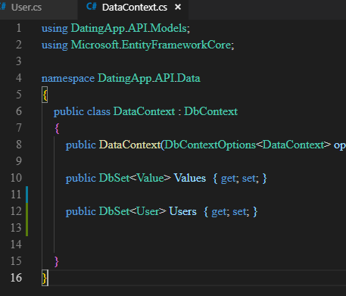

1. Updated the data base: dotnet ef database update
2. DB Browser shows:

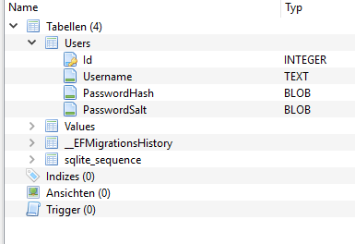

1. Introduction to repository pattern
2. Created first the Interface IAuthRepository
3. Created AuthRepository (concrete implementation)