**CREATE CUSTOMER** **TABLE**

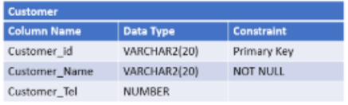

**CREATE TABLE** Customer (

Customer_Id **VARCHAR2**(20) **CONSTRAINT** pk_Customer **PRIMARY** **KEY**,

Customer_Name **VARCHAR2**(20) **CONSTRAINT** nn_Customer **NOT** **NULL**,

Customer_Tel **NUMBER**

) ;

**CREATE PRODUCT** **TABLE**

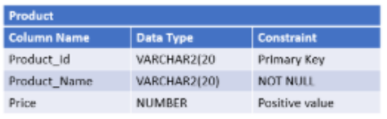

**CREATE** **TABLE** Product (

Product_Id **VARCHAR2**(20) **CONSTRAINT** pk_Product **PRIMARY** **KEY**,

Product_Name **VARCHAR2**(20) **CONSTRAINT** nn_Product **NOT** **NULL**,

Price **NUMBER** **CONSTRAINT** check_price **CHECK** (Price > 0)

) ;

**CREATE ORDERS TABLE**

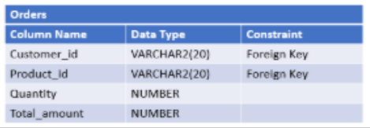

**CREATE** **TABLE** Orders (

Quantity **NUMBER** ,

Total_amount **NUMBER**

**CONSTRAINT** fk_Orders_Customer **FOREIGN** **KEY** (Customer_id) **REFERENCES** Customer (Customer_id) ,

**CONSTRAINT** fk_Orders_Product **FOREIGN** **KEY** (Product_id) **REFERENCES** Product (Product_id)

) ;

**Add Column Category to the PRODUCT table**

**ALTER** **TABLE** Product **ADD** Category **VARCHAR2**(20) ;

**Add Column OrderDate to the ORDERS table**

**ALTER** **TABLE** Orders **ADD** OrderDate **DATE** **DEFAULT** SYSDATE () ;