CENTRAL SUPERSTORE
SQL Database Project Documentation
Normalization • Star Schema • Advanced SQL • Views • Stored Procedure • Optimization

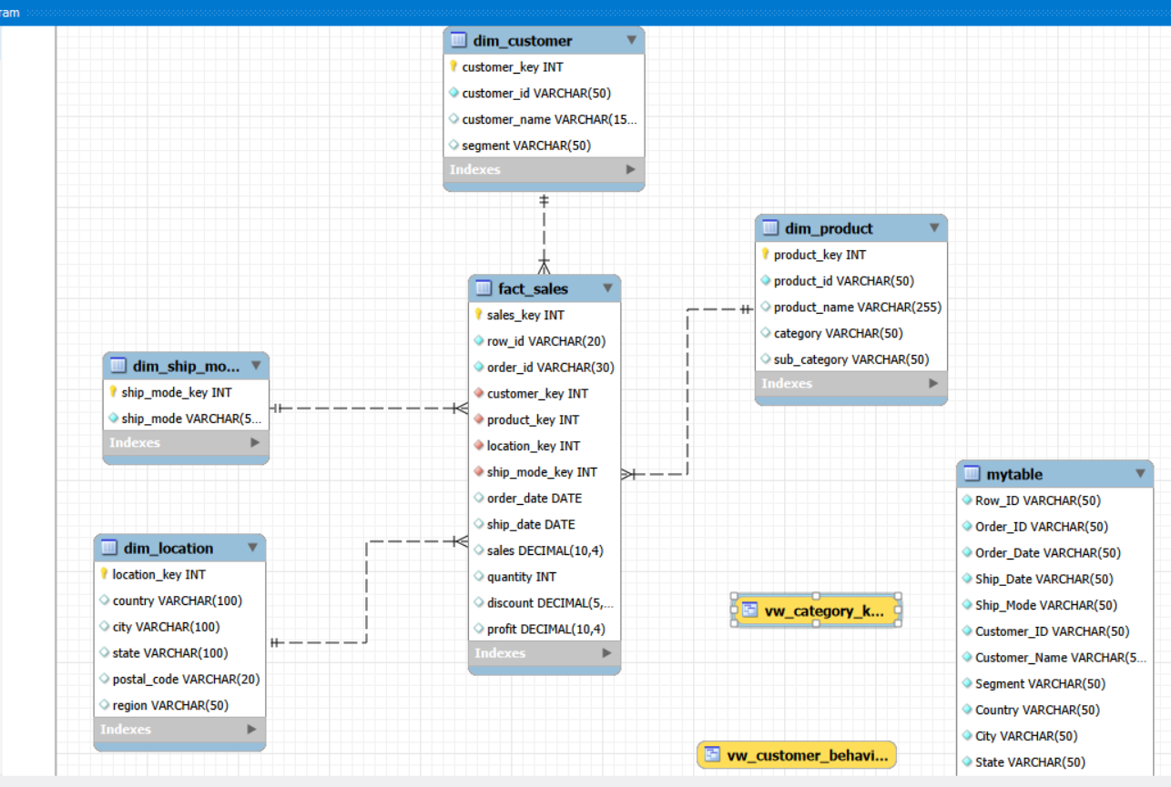
Prepared from the project SQL script and ER diagram

Table of Contents
1. Project Overview
2. Source Dataset and Data Validation
3. Database Design and Normalization
4. Star Schema Design
5. Table Documentation
6. Data Loading Process
7. Advanced SQL Analysis
8. Views
9. Stored Procedure
10. Performance Optimization
11. ER Diagram
12. Execution Flow
13. Conclusion

1. Project Overview
The Central Superstore project transforms a raw Superstore-style sales table into a relational analytical database using MySQL. The implementation creates a source table, separates descriptive information into dimension tables, creates a central sales fact table, and then applies analytical SQL techniques such as aggregation, joins, CASE expressions, subqueries, CTEs, views, a stored procedure, and indexes.

Project Objectives
- Store the raw sales dataset in a structured MySQL database.
- Validate the source data using row counts, NULL checks, distinct-value checks, and duplicate checks.
- Normalize the descriptive data into customer, product, location, and shipping-mode dimensions.
- Build a star-schema model centered on fact_sales.
- Use foreign keys to enforce relationships between the fact and dimension tables.
- Perform profitability, customer, category, state, monthly, discount, and shipping-duration analysis.
- Create reusable SQL views and a KPI stored procedure.
- Add indexes to commonly filtered/joined columns and inspect a query with EXPLAIN.

2. Source Dataset and Data Validation
The raw table is named mytable. It stores the original fields before dimensional modeling. The SQL script defines the source columns as NOT NULL and loads the sales records directly into this table.

Main Source Columns
Column | Purpose
Row_ID | Unique row identifier for the source record.
Order_ID | Order identifier.
Order_Date / Ship_Date | Order and shipping dates stored as text in the raw table and converted to DATE in fact_sales.
Ship_Mode | Shipping mode.
Customer_ID / Customer_Name / Segment | Customer-level descriptive attributes.
Country / City / State / Postal_Code / Region | Location attributes.
Product_ID / Product_Name / Category / Sub-Category | Product attributes.
Sales / Quantity / Discount / Profit | Measures used for analysis.

Validation Checks Included in the Script
- SELECT DATABASE() confirms the active database.
- COUNT(*) checks the number of source records.
- SUM(column IS NULL) checks NULL values for key fields.
- COUNT(DISTINCT ...) measures unique customers, products, orders, shipping modes, categories, sub-categories, and regions.
- GROUP BY Row_ID ... HAVING COUNT(*) > 1 checks for duplicate Row_ID values.
- A final UNION ALL count compares the source table with each dimension and the fact table.

3. Database Design and Normalization
The project separates the original wide source structure into descriptive dimensions and a central fact table. This reduces repeated descriptive data in the analytical fact table and makes aggregation and dimensional analysis easier.

Normalization Logic
- Customer attributes are moved to dim_customer.
- Product attributes are moved to dim_product.
- Geographical attributes are moved to dim_location.
- Shipping-mode values are moved to dim_ship_mode.
- Transactional measures and foreign keys are stored in fact_sales.
- Surrogate integer keys are generated with AUTO_INCREMENT for the dimension tables and the fact table.

4. Star Schema Design
fact_sales is the central fact table. It contains measurable business events such as sales, quantity, discount, and profit, together with foreign keys that point to the descriptive dimensions.
The four dimensions surrounding fact_sales are dim_customer, dim_product, dim_location, and dim_ship_mode. This forms the project's star-schema structure.
Table | Role | Primary Key | Referenced by fact_sales
dim_customer | Customer dimension | customer_key | customer_key
dim_product | Product dimension | product_key | product_key
dim_location | Geography dimension | location_key | location_key
dim_ship_mode | Shipping dimension | ship_mode_key | ship_mode_key
fact_sales | Central transaction fact | sales_key | —

5. Table Documentation

5.1 dim_customer
Stores one row per distinct customer identifier with the customer's name and segment.
customer_key INT AUTO_INCREMENT PRIMARY KEY
customer_id VARCHAR(50) NOT NULL UNIQUE
customer_name VARCHAR(150)
segment VARCHAR(50)

5.2 dim_product
Stores distinct products together with product name, category, and sub-category.
product_key INT AUTO_INCREMENT PRIMARY KEY
product_id VARCHAR(50) NOT NULL UNIQUE
product_name VARCHAR(255)
category VARCHAR(50)
sub_category VARCHAR(50)

5.3 dim_location
Stores distinct combinations of country, city, state, postal code, and region. A composite UNIQUE constraint prevents duplicate location combinations.
location_key INT AUTO_INCREMENT PRIMARY KEY
country VARCHAR(100)
city VARCHAR(100)
state VARCHAR(100)
postal_code VARCHAR(20)
region VARCHAR(50)
UNIQUE(country, city, state, postal_code, region)

5.4 dim_ship_mode
Stores each distinct shipping mode once.
ship_mode_key INT AUTO_INCREMENT PRIMARY KEY
ship_mode VARCHAR(50) NOT NULL UNIQUE

5.5 fact_sales
Stores the transactional measures and foreign keys linking each transaction to the dimensions.
sales_key INT AUTO_INCREMENT PRIMARY KEY
row_id VARCHAR(20) UNIQUE NOT NULL
order_id VARCHAR(30) NOT NULL
customer_key INT NOT NULL
product_key INT NOT NULL
location_key INT NOT NULL
ship_mode_key INT NOT NULL
order_date DATE
ship_date DATE
sales DECIMAL(10,4)
quantity INT
discount DECIMAL(5,2)
profit DECIMAL(10,4)

6. Data Loading Process
The dimensions are populated using SELECT DISTINCT from mytable. After the dimension keys exist, fact_sales is populated by joining the raw table to every dimension.

Fact Loading Logic
- Customer_ID joins to dim_customer.customer_id.
- Product_ID joins to dim_product.product_id.
- Country, City, State, Postal_Code, and Region join to the composite location definition.
- Ship_Mode joins to dim_ship_mode.ship_mode.
- Order_Date and Ship_Date are converted using STR_TO_DATE(..., '%m/%d/%Y').
- Sales, Quantity, Discount, and Profit are copied as measures.
STR_TO_DATE(m.Order_Date, '%m/%d/%Y'),
STR_TO_DATE(m.Ship_Date, '%m/%d/%Y')

7. Advanced SQL Analysis
The script contains 18 analytical query sections. They demonstrate aggregation, joins, CASE expressions, subqueries, CTEs, date functions, and business-oriented KPI calculations.
Query | Topic | Main SQL Technique
1 | Total Sales | SUM + ROUND
2 | Total Profit | SUM + ROUND
3 | Total Quantity | SUM
4 | Total Orders | COUNT(DISTINCT)
5 | Total Customers | COUNT(DISTINCT)
6 | Profit Margin | SUM / NULLIF / ROUND
7 | Sales & Profit by Category | JOIN + GROUP BY
8 | Sales by Segment | JOIN + GROUP BY
9 | Top 10 Customers | Aggregation + ORDER BY + LIMIT
10 | Sales & Profit by State | JOIN + GROUP BY
11 | CASE Statement | CASE classification
12 | Subquery | Nested SELECT
13 | CTE | WITH clause
14 | CTE + CASE | WITH + CASE
15 | Monthly Sales Trend | YEAR/MONTH/MONTHNAME
16 | Loss-Making Products | Aggregation + HAVING
17 | Shipping Duration | DATEDIFF + AVG
18 | Discount Analysis | Aggregation / grouping

Important Date Analysis
The monthly trend uses the DATE values already stored in fact_sales. The shipping-duration analysis calculates the average number of days between ship_date and order_date.
YEAR(f.order_date) AS year,
MONTH(f.order_date) AS month,
MONTHNAME(f.order_date) AS month_name,
ROUND(SUM(f.sales), 2) AS total_sales

8. Views

8.1 vw_category_kpis
Provides category-level KPIs: total sales, total quantity, total profit, and profit margin. It joins fact_sales with dim_product and groups by category.
SELECT
p.category,
SUM(f.sales) AS total_sales,
SUM(f.quantity) AS total_quantity,
SUM(f.profit) AS total_profit,
ROUND(
SUM(f.profit) / NULLIF(SUM(f.sales), 0) * 100, 2
) AS profit_margin
FROM fact_sales f
JOIN dim_product p
ON f.product_key = p.product_key
GROUP BY p.category;

8.2 vw_customer_behavior
Provides customer-level behavior metrics including distinct orders, units, sales, profit, and profit margin. It groups by customer ID, customer name, and segment.

9. Stored Procedure
The stored procedure sp_sales_kpis() returns the project's main overall KPIs from fact_sales.
- Total distinct orders.
- Total distinct customers.
- Total units.
- Total sales.
- Total profit.
- Profit margin percentage.
CALL sp_sales_kpis();

10. Performance Optimization
The script creates indexes on foreign-key columns and commonly queried business columns. These indexes are intended to support joins, filtering, and lookup operations.
Index | Column
idx_fact_customer | customer_key
idx_fact_product | product_key
idx_fact_location | location_key
idx_fact_order_date | order_date
idx_fact_ship_date | ship_date
idx_fact_ship_mode | ship_mode_key
idx_fact_order | order_id
The script also uses EXPLAIN on the category KPI query so that the execution plan can be inspected.

11. ER Diagram
The ER diagram shows fact_sales as the central table and the four dimension tables connected through foreign-key relationships. The raw mytable source and the project views are also visible in the Workbench model.

12. Execution Flow
Step | Stage | Description
1 | Create/select database | CREATE DATABASE IF NOT EXISTS central_superstore; USE central_superstore;
2 | Create raw table | Create mytable and load the source records.
3 | Validate source | Run row count, NULL, distinct-value, and duplicate checks.
4 | Reset project objects | Drop previous dimensions, fact table, views, and procedure if they exist.
5 | Create dimensions | Create and populate the four dimension tables.
6 | Create fact table | Create fact_sales with primary/foreign keys.
7 | Load facts | Join mytable to the dimensions and convert date strings to DATE.
8 | Run analysis | Execute the analytical queries.
9 | Create reusable objects | Create the two views and sp_sales_kpis().
10 | Optimize | Create indexes and inspect a query with EXPLAIN.

13. Conclusion
The Central Superstore SQL project implements a complete analytical database workflow: raw data ingestion, validation, dimensional modeling, fact loading, advanced SQL analysis, reusable views, a KPI stored procedure, and indexing. The final design uses fact_sales as the center of a star schema and keeps descriptive entities in dedicated dimension tables.
The documentation reflects the supplied SQL implementation. It describes the structures and techniques that are actually present in the project rather than introducing a separate date dimension or other redesign.

Appendix A — Key SQL Objects
CREATE DATABASE IF NOT EXISTS central_superstore;
USE central_superstore;
CREATE TABLE dim_customer (...);
CREATE TABLE dim_product (...);
CREATE TABLE dim_location (...);
CREATE TABLE dim_ship_mode (...);
CREATE TABLE fact_sales (...);
CREATE VIEW vw_category_kpis AS ...;
CREATE VIEW vw_customer_behavior AS ...;
CREATE PROCEDURE sp_sales_kpis() ...;

