BTECH
Assignment Brief

Name | Basmala Ahmed Mahdi
Task | Unit_4 (Task #2)
School | WE El-Mansoura
Class | C4

Introduction:
It describes the development of an interactive quiz website that uses SQL for efficient database management, PHP for the backend, and HTML, CSS, and JS for the dynamic front end. Core features shall include user registration, quiz selection, scoring, and options either for team or individual logins. The report covers the main file structure, high-level website diagram, key page descriptions, and basic troubleshooting steps that ensure the application functions smoothly.

Programming Language:
I used SQL , PHP , HTML , CSS , JS
SQL: To store data.
PHP: Backend
HTM , CSS , JS: Frontend.

Names of files used:
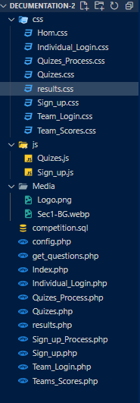

Diagram of Website:


Home Page:
This item to display Total Scores for All Teams.
This item use to if you Register before with team you can search by Team ID and Team name to display team information
This Item use to If you Registre before you can search by your ID and Name to Display your information
This button for Register to Play.

Sign_up.php: This page contain registration information for you to play first choose whether you will play with a team or play alone if you choose to play alone you will enter only your name and if you choose team, You will enter a name for the team and the name of each person who will play. The team only contains 5 people.
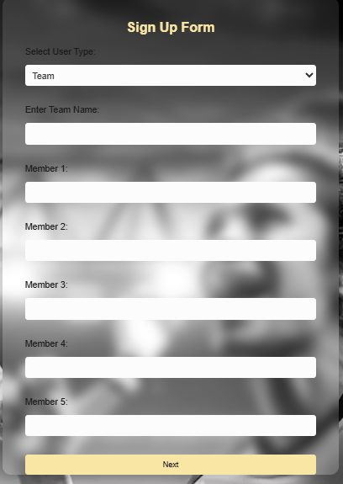
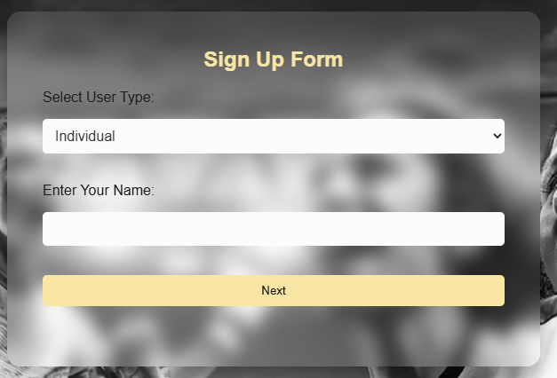
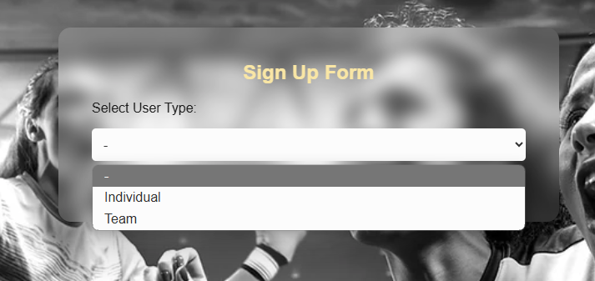

Quizes.php: From this page first choose type of question after display (Programming , Sport) questions.
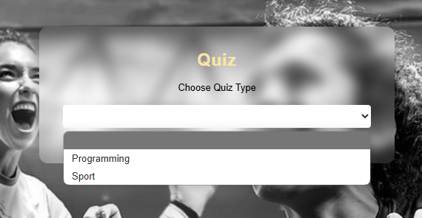
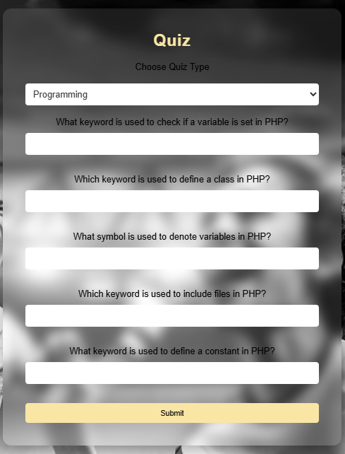
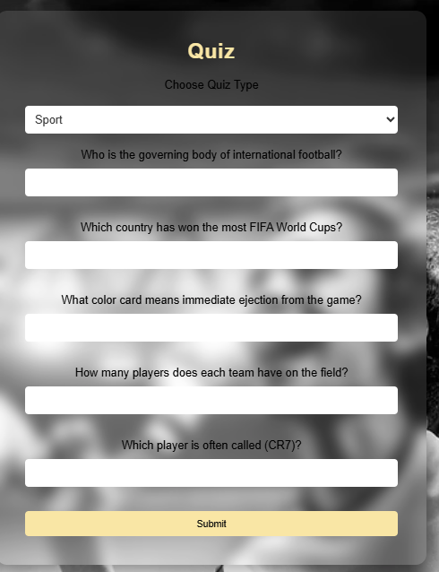

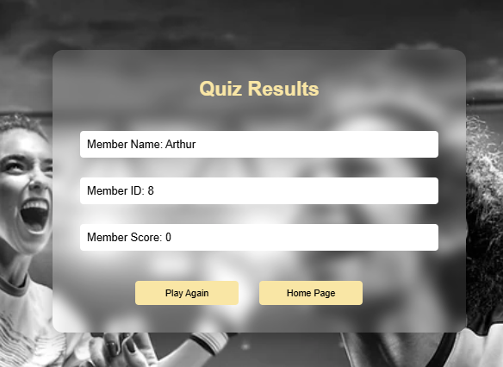
Quizes_Process.php: After you Submit quiz display result of your quiz (Name , ID , Score), and 2 buttons one to play again and second button for went to home page.

Individual_Login.php: This Item use to If you Registre before you can Login by your ID and Name to Display your information.
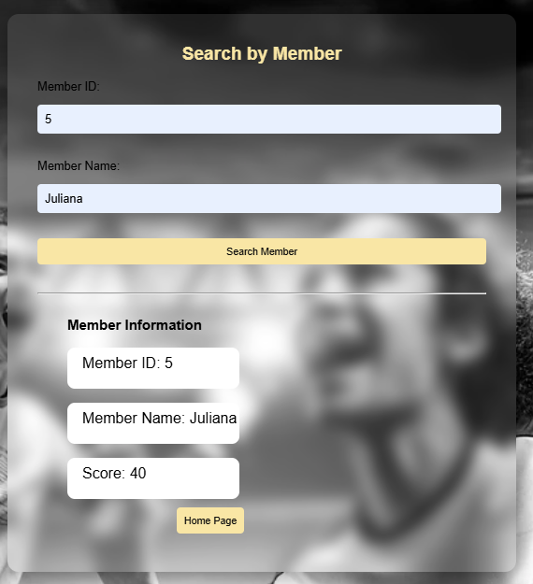

Team_Login: This item use to if you Register before with team, you can Login by Team ID and Team name to display team information.
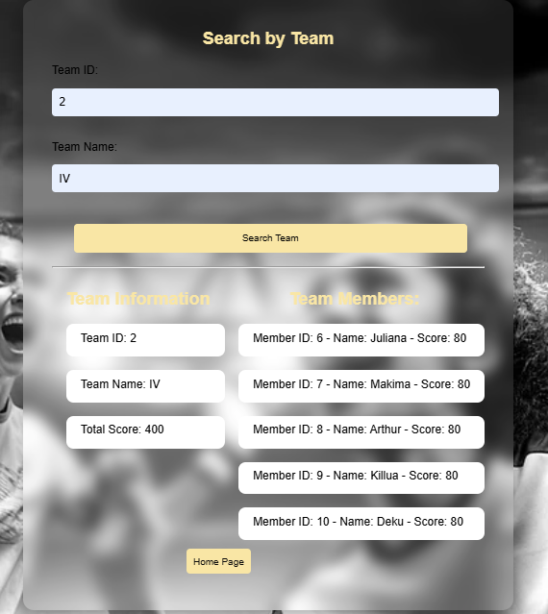

Quizes_Process.php: Page display Total Scores of All Teams.
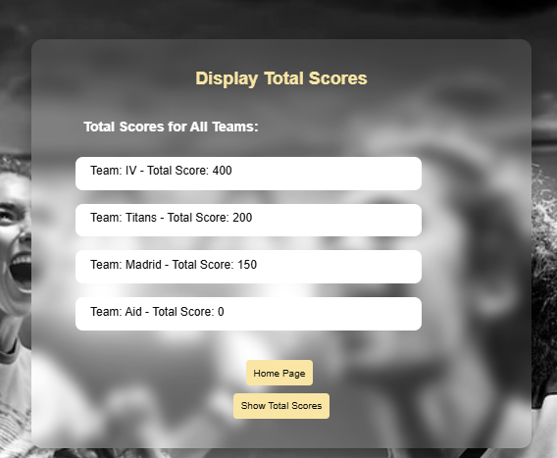

Evaluation:
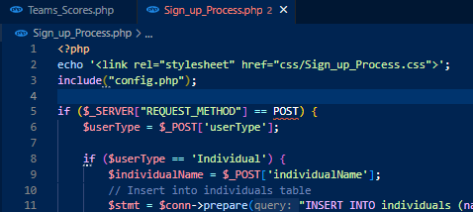
- In file Sign_up_Process.php in Line 12 missed double quotes , Solve it by adding double quotes

- In file Team_Login.php don’t display Team Members Because I write wrong Condition in line 71, Solve it by write correct condition.
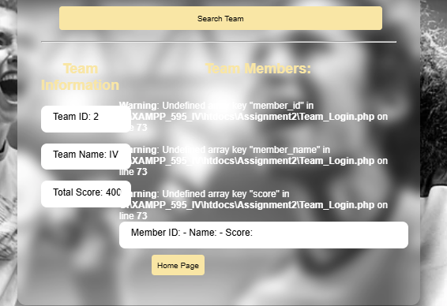
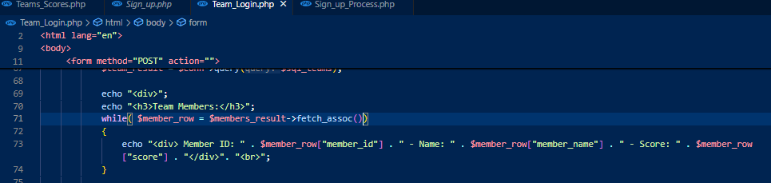

- Don’t insert Data In Database, Because the name of database incorrect in page config.php in line 2 , solve it by write the name of Database correct.
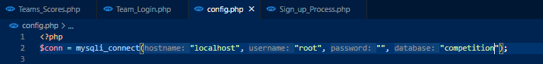

Testing:
After Solving Errors, The Program work well.

Feedback (Classmate):
Professional program as it contains all requirements.

Conclusion:
After introducing those minor coding errors, the application works perfectly. Tests were run, and it was confirmed that a user can easily register, select, and display the results. Classmates' comments also noted its professional structure in meeting all the requirements. The overall project has shown effective management of databases, and with a clear file structure, an intuitive interface was created for both individuals and teams to take quizzes.

