Social Network Analysis Report — (WICO Dataset)
Analysis performed in Gephi
Student : basmala safwat ahmed - 2205095

5G Conspiracy Graph :
Network Type: Directed

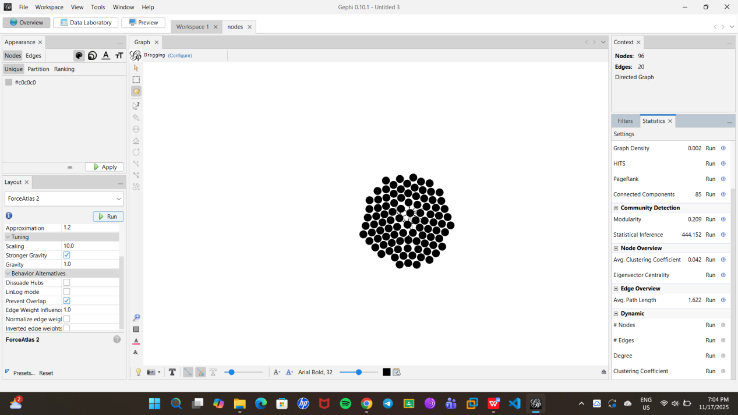

1. Introduction
This report analyzes a Twitter subgraph extracted from the WICO 5G_Conspiracy_Graphs dataset.
The goal is to understand the structural properties of misinformation communities, including:
Network connectivity
Centrality patterns
Community detection
Density and clustering
Influence pathways

2. Network Overview
Metric | Value
Average Degree | 0.208
Average Weighted Degree | 0.208
Diameter | 3
Radius | 0
Average Path Length | 1.62
Density | 0.002
Clustering Coefficient | 0.042
Weakly Connected Components | 85
Strongly Connected Components | 93
Modularity (Q) | 0.209
# of Communities | 87
Eigenvector Sum Change | 1.34 × 10⁻⁴

3. Interpretation of Metrics

3.1 Degree & Connectivity

Average Degree = 0.208 (very low)
On average, each user interacts with 0.2 other users.
This means most accounts tweet in isolation with almost no connections and Sparse interaction between clusters.
✔ This is consistent with misinformation behavior: accounts amplify claims separately rather than engage in real discussions.

3.2 Graph Density

Density = 0.002 (extremely sparse)
Only 0.2% of all possible edges actually exist.
Indicates the graph is very fragmented.
In misinformation networks, this is expected because:
Bots/posters broadcast messages
Few reply or interact
The network does not function like a conversational community

3.3 Clustering Coefficient

Clustering Coefficient = 0.042 (very low)
Only 4.2% of a node’s neighbors are connected to each other.
Suggests users do not form meaningful “discussion circles”.
Another sign of a broadcast-style misinformation network.

3.4 Path Length and Diameter

Average Path Length = 1.62
Any two connected users are about 1–2 steps apart.
Indicates that within micro-clusters, information spreads quickly.

Diameter = 3
The longest shortest path between any two nodes is only 3.
Even though the overall graph is fragmented, small pockets of users are tightly linked.

3.5 Connected Components

Weakly Connected Components = 85

Strongly Connected Components = 93
This means the graph is almost entirely broken into separate pieces:
85 weak components → 85 separate “islands” of users
93 strongly connected components → almost no mutual interactions
#Strongly connected = A → B → A
#Weakly connected = A → B OR B → A
Since most SCCs are of size 1:
Users do not interact in both directions.
Misinformation flows one-way, consistent with:
retweet chains
bot broadcasting
quote tweets without conversations

3.6 Modularity (Community Structure)

Modularity Q = 0.209

Number of Communities = 87
A Q value of 0.209 indicates:
Clear community structures
Many small groups
Not a single unified conspiracy cluster
But 87 communities with only ~100 nodes implies:
👉 Almost every node forms its own micro-community
👉 Very weak internal cohesion
👉 No large shared discussion hub
This is typical for fragmented misinformation.

3.7 Eigenvector Centrality

Low eigenvector centrality change suggests:
No dominant influential node
Influence is not concentrated
No “super-spreader account” inside this sample
This means the conspiracy content is not spread by a single leader; rather, it's disconnected micro-posts across many users.

Network Analysis Report – Non-Conspiracy Nodes
Network Type: Directed

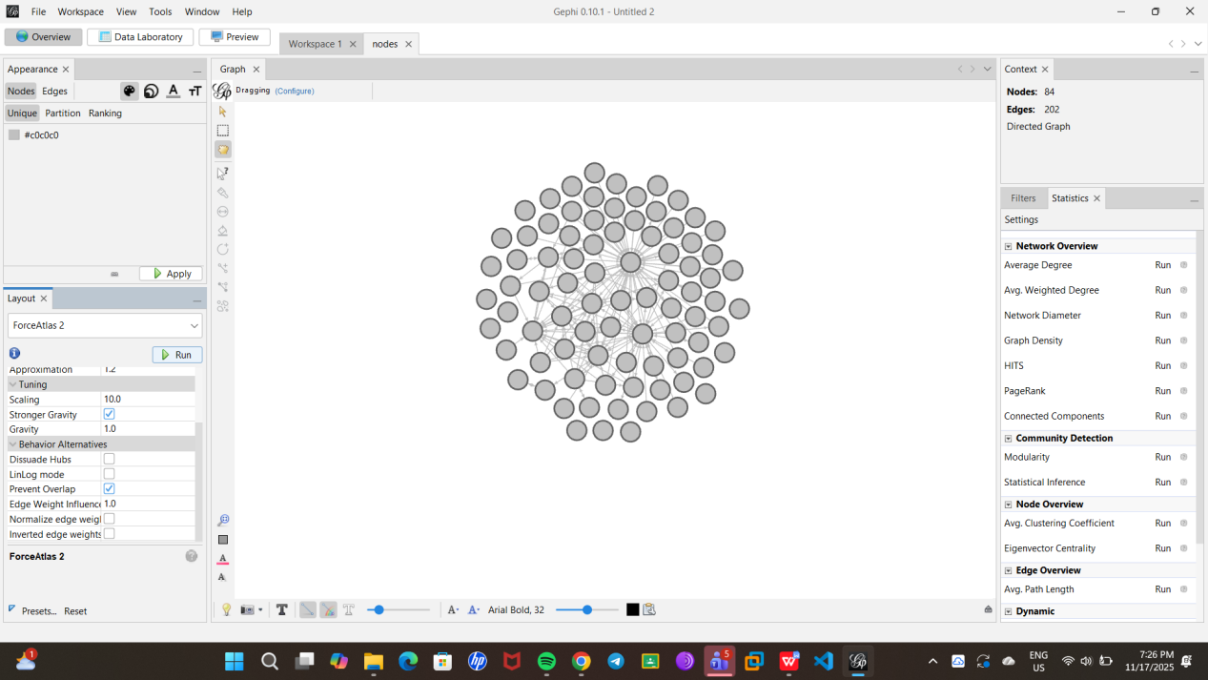

1. Degree Analysis
Average Degree: 2.405
Average Weighted Degree: 2.405
The average degree of 2.405 indicates that, on average, each node is connected to approximately 2–3 other nodes. Since the weighted degree equals the degree, edge weights are likely uniform, suggesting similar interaction strength across connections.

2. Graph Distance Analysis
Diameter: 5
Radius: 0
Average Path Length: 2.419
Interpretation:
Diameter: The maximum shortest path between any two nodes is 5, meaning the network is relatively compact.
Average Path Length: 2.419 indicates that most nodes are reachable within 2–3 steps, suggesting efficient information flow.
Radius 0: The presence of isolated nodes or nodes with no incoming edges may explain the radius of 0.

3. Graph Density
Density: 0.029
Interpretation:
The network is sparse, with only ~3% of all possible edges present. This is typical for social or informational networks where nodes are selective in their connections.

4. HITS Metric
Parameter: Epsilon = 1.0E-4
Interpretation:
HITS analysis (authority and hub scores) can identify influential nodes that either distribute information widely (hubs) or are highly referenced (authorities). Exact scores are not provided here, but this metric is useful for identifying key nodes in information dissemination.

5. PageRank
Parameters:
Epsilon = 0.001
Probability = 0.85
Interpretation:
PageRank evaluates node importance based on incoming connections and the importance of the nodes linking to them. This helps identify central nodes in the network, which may play pivotal roles in spreading information.

6. Connected Components
Weakly Connected Components: 13
Strongly Connected Components: 51
Interpretation:
Weakly Connected Components: 13 clusters where nodes are reachable if edge direction is ignored.
Strongly Connected Components: 51 clusters where nodes can reach each other following the directed edges.
This suggests many small tightly-knit groups exist, with few nodes bridging different groups.

7. Modularity
Modularity: 0.253
Number of Communities: 17
Interpretation:
Modularity indicates the presence of well-defined communities. A value of 0.253 is moderate, suggesting some community structure exists but it’s not highly segregated. 17 communities were detected, showing a fairly diverse network structure.

8. Statistical Inference
Description Length: 544.914
Number of Communities: 13
Interpretation:
Statistical inference aligns with modularity analysis, confirming that the network can be partitioned into several meaningful clusters.

9. Clustering Coefficient
Average Clustering Coefficient: 0.273
Interpretation:
A clustering coefficient of 0.273 indicates moderate clustering. Nodes tend to form small local groups, but the network is not highly clustered. This is consistent with the presence of multiple communities.

10. Eigenvector Centrality
Parameters:
Iterations: 100
Sum Change Threshold: 0.00298
Interpretation:
Eigenvector centrality measures node influence by considering the centrality of neighbors. Higher values identify nodes that are connected to other well-connected nodes, potentially serving as influential nodes in the network.

Comparison Between Conspiracy and Non-Conspiracy Networks
Metric | Conspiracy Network | Non-Conspiracy Network | Interpretation
Average Degree | 0.208 | 2.405 | Non-conspiracy nodes are much more connected, forming real interactions, whereas conspiracy nodes mostly tweet in isolation.
Density | 0.002 | 0.029 | Non-conspiracy network is denser (~3% vs 0.2%), allowing information to flow more easily between nodes.
Clustering Coefficient | 0.042 | 0.273 | Non-conspiracy nodes form small discussion groups; conspiracy network lacks meaningful discussion circles.
Average Path Length | 1.62 | 2.419 | Despite sparse connections, conspiracy nodes spread information quickly in micro-clusters, but non-conspiracy nodes are slightly more “distributed” with multiple paths.
Diameter | 3 | 5 | Conspiracy network’s small diameter shows tight micro-clusters; non-conspiracy network has larger diameter due to more widespread connections.
Weakly Connected Components | 85 | 13 | Conspiracy network is extremely fragmented, whereas non-conspiracy network has fewer disconnected groups.
Strongly Connected Components | 93 | 51 | Conspiracy network shows almost no mutual interactions; non-conspiracy nodes interact more bidirectionally.
Modularity / # of Communities | 0.209 / 87 | 0.253 / 17 | Conspiracy network has many micro-communities with almost no cohesion; non-conspiracy network has fewer but more meaningful communities.
Eigenvector Centrality | Low / dispersed | Moderate / meaningful | No dominant node spreads conspiracy content; non-conspiracy network has influential nodes that guide information flow.

