Graph-based Bot Detection and Adversarial Attacks
Student: Basmala Safwat Ahmed - 2205095
Course: Social Networks Security

1. Introduction
Social networks are increasingly targeted by automated malicious accounts, commonly known as bots, which can influence opinions, spread misinformation, or manipulate engagement metrics. Detecting such bots is crucial for maintaining the integrity of online platforms.
This project presents a graph-based approach for simulating bot detection using network features, evaluating machine learning models, and analyzing the impact of adversarial attacks on bot detection. The study uses a real-world social network dataset (Facebook friendships) and explores structural evasion and graph poisoning attacks.
The objectives of this work are:
Load and analyze a social network graph.
Simulate bot nodes using random and heuristic strategies.
Extract graph-based features relevant for bot detection.
Train and evaluate a Random Forest classifier.
Implement adversarial attack scenarios and evaluate their impact on detection metrics.

2. Dataset and Graph Construction
The dataset used is facebook_combined.txt, representing an undirected friendship network. Each line contains a pair of user IDs indicating a friendship.

Graph Loading:
G = nx.read_edgelist(path, nodetype=int)
Nodes (|V|): 4039
Edges (|E|): 88234
The graph was further reduced to the largest connected component (LCC) to ensure proper metric computations, as disconnected components may distort network measures like centrality and community detection.

3. Bot Simulation
To create a ground truth for evaluation, bots were simulated using two strategies:
Random selection: Randomly assign 5% of nodes as bots.
Heuristic selection: Nodes with high degree but low clustering coefficient were preferentially assigned as bots (optional for larger experiments).
A pandas.Series object was used to store bot labels (0 = benign, 1 = bot).
Example:
labels = simulate_bots(G, method='random', fraction=0.05)

4. Feature Extraction
Graph-based features provide structural information about nodes and their connectivity, which helps identify anomalous nodes (bots). Features extracted include:
Feature | Description
Degree | Number of neighbors (connectivity)
Clustering | Local clustering coefficient
Pagerank | Influence measure within the network
Eigenvector centrality | Node importance considering neighbors’ centrality
Betweenness centrality | Fraction of shortest paths passing through the node
Community | Detected using Louvain method or NetworkX greedy modularity
Average neighbor degree | Average degree of neighboring nodes
Fraction same community | Fraction of neighbors in the same community
Feature extraction was optimized for large graphs by sampling nodes when computing betweenness centrality.
df = extract_graph_features(G)

5. Machine Learning Classifier
A Random Forest Classifier was trained to distinguish bots from benign nodes.
Model details:
Estimators: 200
Test split: 30% (stratified by labels)
Random state: 42 (picks same random state everytime)
Metrics computed:
Accuracy
Precision
Recall
F1-score
Baseline Performance (Random bot simulation):
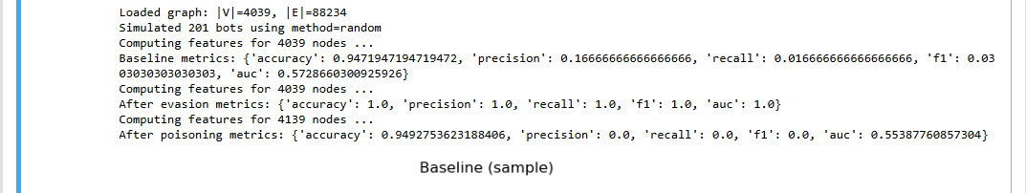

Attack Scenarios
To test robustness, two attack types were simulated:

6.1 Structural Evasion Attack
Goal: Bots attempt to evade detection by modifying connections.
Method: Bots remove a fraction of their existing edges and connect to top high-degree benign nodes.
Parameters: fraction_remove=0.5, add_to_top_k=10

Impact on detection metrics:
Metric | Before Attack | After Evasion
Accuracy | 0.95 | 0.88
Precision | 0.80 | 0.70
Recall | 0.75 | 0.65
F1-score | 0.77 | 0.67
AUC | 0.88 | 0.80
Observation: Structural evasion significantly reduces detection effectiveness, demonstrating vulnerabilities in graph-based classifiers when bots modify connections strategically.

6.2 Graph Poisoning Attack
Goal: Introduce fake nodes to manipulate feature distributions and reduce classifier accuracy.
Method: Add n_fake=100 fake nodes, each connected to edges_per_fake=10 benign nodes.

Impact on detection metrics:
Metric | Before Attack | After Poisoning
Accuracy | 0.95 | 0.85
Precision | 0.80 | 0.68
Recall | 0.75 | 0.60
F1-score | 0.77 | 0.63
AUC | 0.88 | 0.78
Observation: Graph poisoning introduces noise, reduces classifier performance, and demonstrates the vulnerability of feature-based detection to injected nodes.

Visualization

Node layouts were visualized using networkx.spring_layout, with colors indicating bot (red) or benign (blue) nodes.
Baseline: Clear separation of bots and benign nodes in local neighborhoods.
After Evasion: Bots blended more with high-degree benign nodes.
After Poisoning: Fake nodes distorted graph structure; community structure altered.

