Report about best devices in PC, best operating system and suitable programming languages.
System Name:
- Best Devices
Dell: great for coding ,work 8-10 hours without battery
Lenovo :suitable for business
- Best Operating System
Windows11 : support .Net Framework ,Visual Studio ,SQL Server
Linux :secure ,and ideal for hosting DataBase
MacOs :Cross Platform testing
- Suitable Programming Languages
C#:backend /Desktop App
SQl :for querying and managing data
Java :simplifies data analysis

Design of an integrated system (Class diagram)
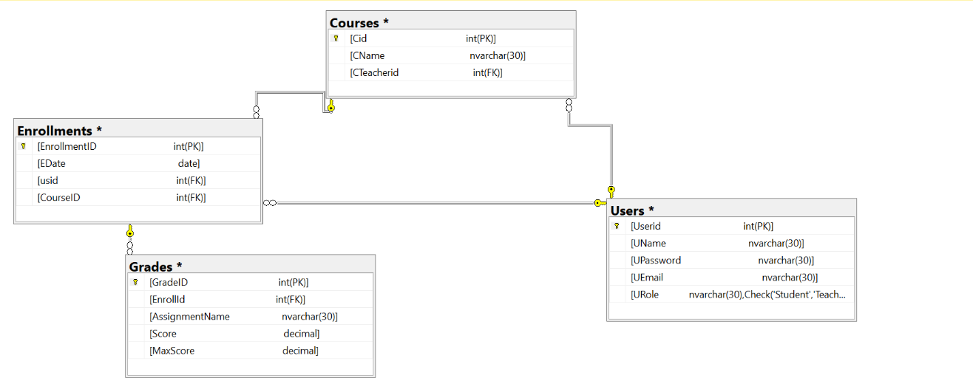

Testing
Test case ID | Test case description | Test Steps | Test Data | Expected Result | Actual Result | Pass/Fail
1 | Login Page for Student | Enter valid UserName and password  click Login | UserName= Basmalla  password=bbbb | Successful login and enter student page | Successful login and enter student page | Pass
2 | Login Page for Teacher | Enter Invalid UserName and password  click Login | UserName= fozoo  password=  fqoe | Successful login and enter Teacher page | Failed login and enter Teacher page | Fail
3 | Login Page for Student | Enter valid UserName and invalid password  click Login | UserName= Fayza  password=gket | Successful login and display student page | Failed login and enter student page | Fail
4 | Login Page | Enter blank UserName and password  click Login | UserName=  password= | Failed login and enter student page | Failed login and enter student page | Pass
5 | Login Page | Enter Invalid UserName and valid password click Login | UserName= bebo  password=bbbb | Successful login and enter student page | Failed login and enter student page | Fail
6 | Login Page for teacher | Enter valid UserName and password  click Login | UserName= Eng Kholoud  password=  ENG | Successful login and enter Teacher page | Successful login and enter Teacher page | Pass

