Today, the 8th of March, is International Women’s day, where the whole world celebrates the enormous contributions Women have made to society.  This creature whom without her, the path of life cannot be travelled alone by man.  This day is not only to celebrate her achievement but a day to understand and admire her importance in society.  We need to empower all women around us, so they live with respect, equality and honor.

This year’s theme is #choosetochallenge because a challenged world is an alert world, and today we need to choose to challenge, call out gender bias and inequality.  We can collectively create an inclusive world as from challenge comes change.  So please all, stand up, raise your hand and pledge that you are all in.  Support all the women in your life and drive to provide them the right platform to be the women they choose to be.

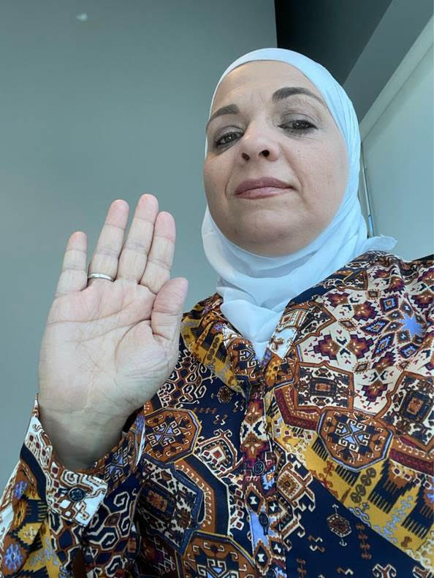

As it is my habit every year, I would like to share some of my personal churns and challenges because all these events have helped develop me into the person I am today.  The story I am sharing took place 22 years ago; unfortunately, this still affects women today.

In 1998, when I first learned that I was about to become a mother, the joy was beyond imagination and I felt like I was flying on top of the clouds because this is the moment I guess many women wait for in life.  I was even more elated when I found out that the newcomer will be a baby girl.  During that moment, I felt that the world could not contain my joy; however, I could only share this happiness with few people because of others that surrounded me. My in-laws kept talking about how they were waiting for a boy to come given the fact that my husband is the eldest son; so the name of my father-in-law and the family legacy would be carried on through him and his children.  Nothing more than a boy would ever satisfy them.  January 17th, 7 am, was the birth of baby girl Alaa who came to this world to lighten up my life; however, my father-in-law made it extremely dark. He left the hospital and never came back because the new family member turned out to be female.  Today, seeing the woman she has become, this talented mechanical engineer who graduated with distinction and selected as part of an accelerated leadership program in one of the biggest multinational companies; I could not be prouder as she proved that she was able to achieve what other men in the family and around us could not.  Unfortunately, I just heard of a similar case of someone I mentor.  It is devastating to see that 22 years later, the same mentality still takes place.

My message here is that never underestimate what women can do and be there for the women in your life being them a grandmother, mother, aunt, sister, daughter, granddaughter, cousin, colleague or friend.  Support them, encourage them, fight for them and with them.

And Finally, after 1.5 years at NOMAC, I could not be prouder of being part of this company and the leadership who showed me nothing but support, empowerment, respect and encouragement.  I have been very inspired by each and every one I have interacted with. To my fellow female colleagues, I encourage each and every one of you to continue pursuing your dream and reach out to the stars because you can.  #choosetochallenge and you will succeed.

Happy International Women’s Day 2021

Thanks & Best Regards, مع تحياتي الخالصة

Lana