**Lab 2:**

**ABC**

**Y 🡪 0 0 0**

**O 🡪 0 0 1**

**🡪 0 1 0**

**K 🡪 0 1 1**

**E 🡪 1 0 0**

**V 🡪 1 0 1**

**I 🡪 1 1 0**

**N 🡪 1 1 1**

**Truth Table:**

|  |  |  |  |  |  |  |  |  |  |
| --- | --- | --- | --- | --- | --- | --- | --- | --- | --- |
| **A** | **B** | **C** | **Seg0** | **Seg1** | **Seg2** | **Seg3** | **Seg4** | **Seg5** | **Seg6** |
| 0 | 0 | 0 | 0 | 1 | 1 | 1 | 0 | 1 | 1 |
| 0 | 0 | 1 | 1 | 1 | 1 | 1 | 1 | 1 | 0 |
| 0 | 1 | 0 | 0 | 0 | 0 | 0 | 0 | 0 | 0 |
| 0 | 1 | 1 | 0 | 1 | 1 | 0 | 1 | 1 | 1 |
| 1 | 0 | 0 | 1 | 0 | 0 | 1 | 1 | 1 | 1 |
| 1 | 0 | 1 | 0 | 0 | 1 | 1 | 1 | 0 | 0 |
| 1 | 1 | 0 | 0 | 0 | 0 | 0 | 1 | 1 | 0 |
| 1 | 1 | 1 | 0 | 0 | 1 | 0 | 1 | 0 | 1 |

**K – Maps:**

**Seg0:**

|  |  |  |  |  |
| --- | --- | --- | --- | --- |
| **AB**  **C** | **00** | **01** | **11** | **10** |
| **0** | **0** | **0** | **0** | **1** |
| **1** | **1** | **0** | **0** | **0** |

Seg0 = A’B’C + AB’C’

**Seg1:**

|  |  |  |  |  |
| --- | --- | --- | --- | --- |
| **AB**  **C** | **00** | **01** | **11** | **10** |
| **0** | **1** | **0** | **0** | **0** |
| **1** | **1** | **1** | **0** | **0** |

Seg1 = A’B’ + A’C

**Seg2:**

|  |  |  |  |  |
| --- | --- | --- | --- | --- |
| **AB**  **C** | **00** | **01** | **11** | **10** |
| **0** | **1** | **0** | **0** | **0** |
| **1** | **1** | **1** | **1** | **1** |

Seg2 = A’B’ + C

**Seg3:**

|  |  |  |  |  |
| --- | --- | --- | --- | --- |
| **AB**  **C** | **00** | **01** | **11** | **10** |
| **0** | **1** | **0** | **0** | **1** |
| **1** | **1** | **0** | **0** | **1** |

Seg3 = B’

**Seg4:**

|  |  |  |  |  |
| --- | --- | --- | --- | --- |
| **AB**  **C** | **00** | **01** | **11** | **10** |
| **0** | **0** | **0** | **1** | **1** |
| **1** | **1** | **1** | **1** | **1** |

Seg4 = A + C

**Seg5:**

|  |  |  |  |  |
| --- | --- | --- | --- | --- |
| **AB**  **C** | **00** | **01** | **11** | **10** |
| **0** | **1** | **0** | **1** | **1** |
| **1** | **1** | **1** | **0** | **0** |

Seg5 = A’B’ + AC’ + A’C

**Seg6:**

|  |  |  |  |  |
| --- | --- | --- | --- | --- |
| **AB**  **C** | **00** | **01** | **11** | **10** |
| **0** | **1** | **0** | **0** | **1** |
| **1** | **0** | **1** | **1** | **0** |

Seg6 = CB + C’B’

**Circuits:**

**Seg0:**

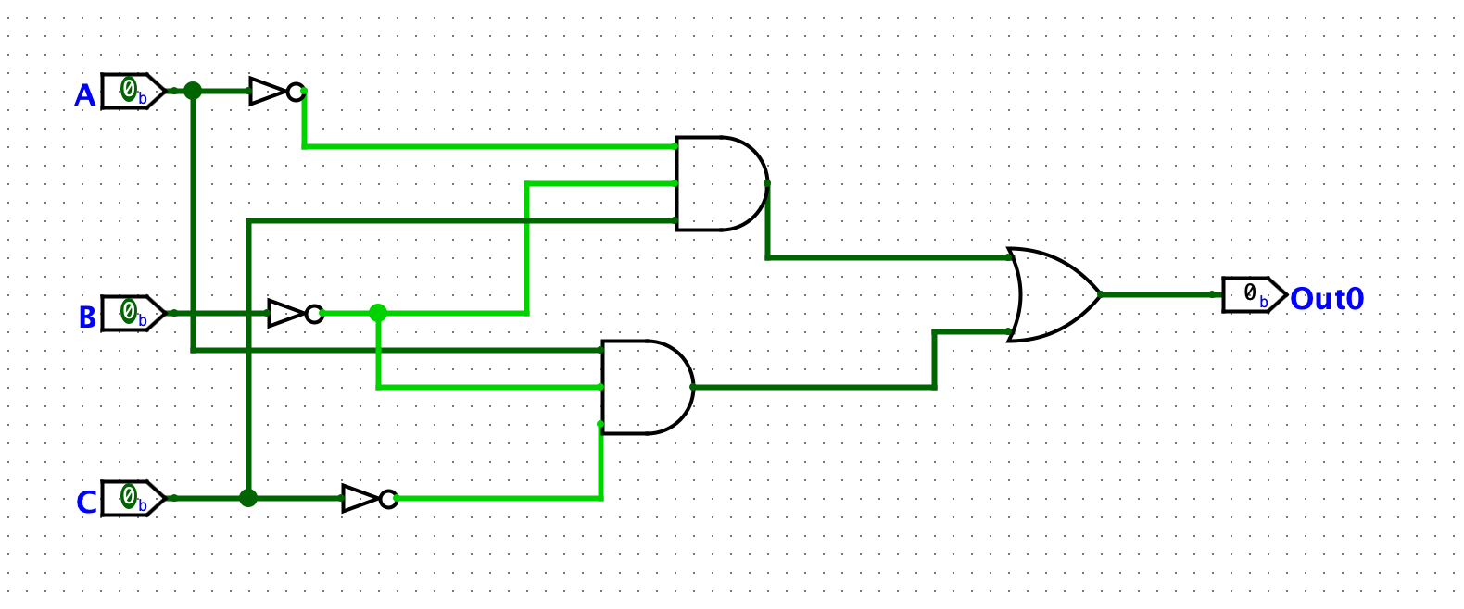

**Seg1:**

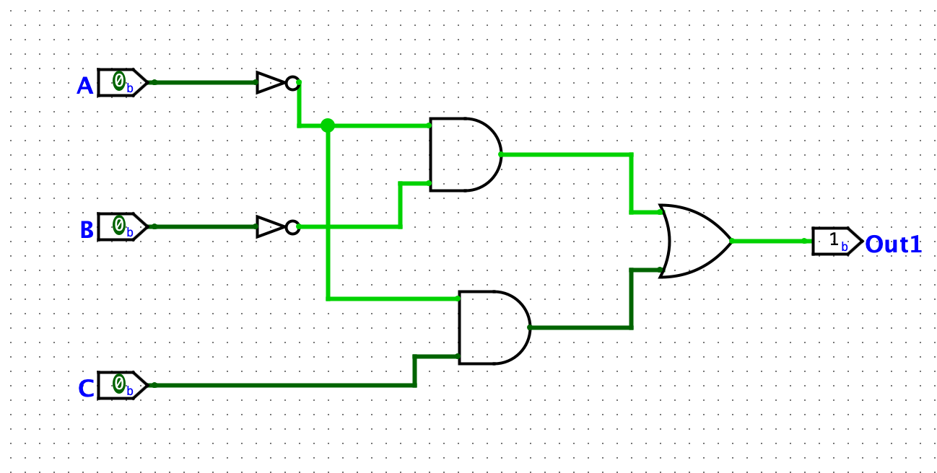

**Seg2:**

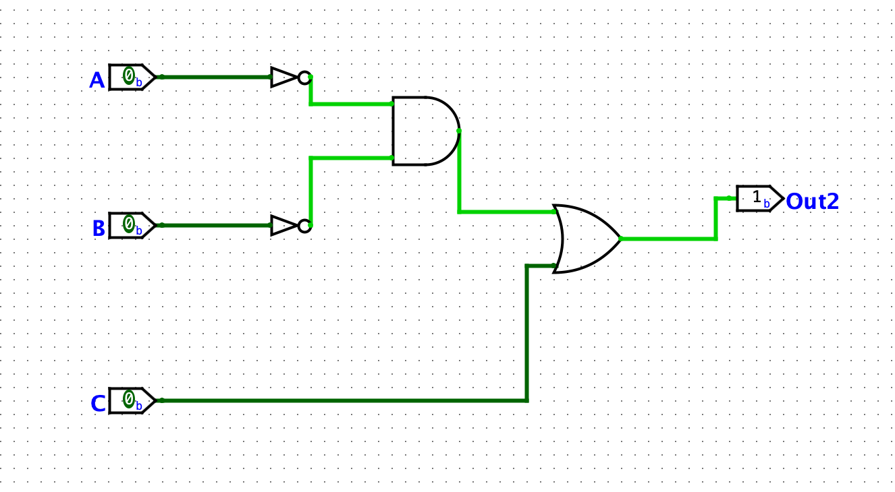

**Seg3:**

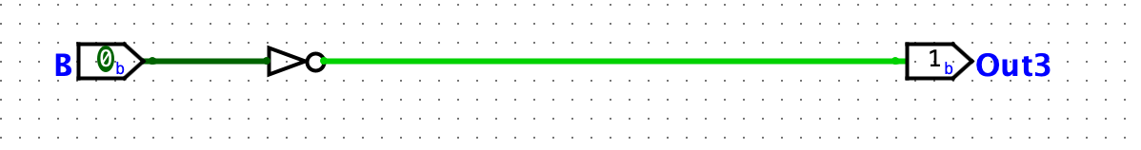

**Seg4:**

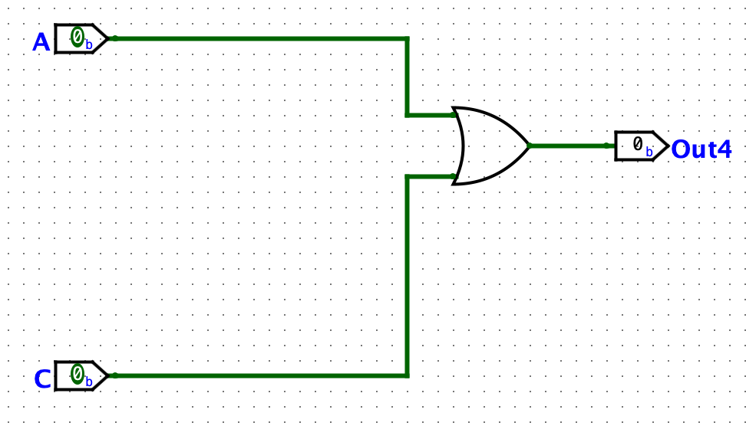

**Seg5:**

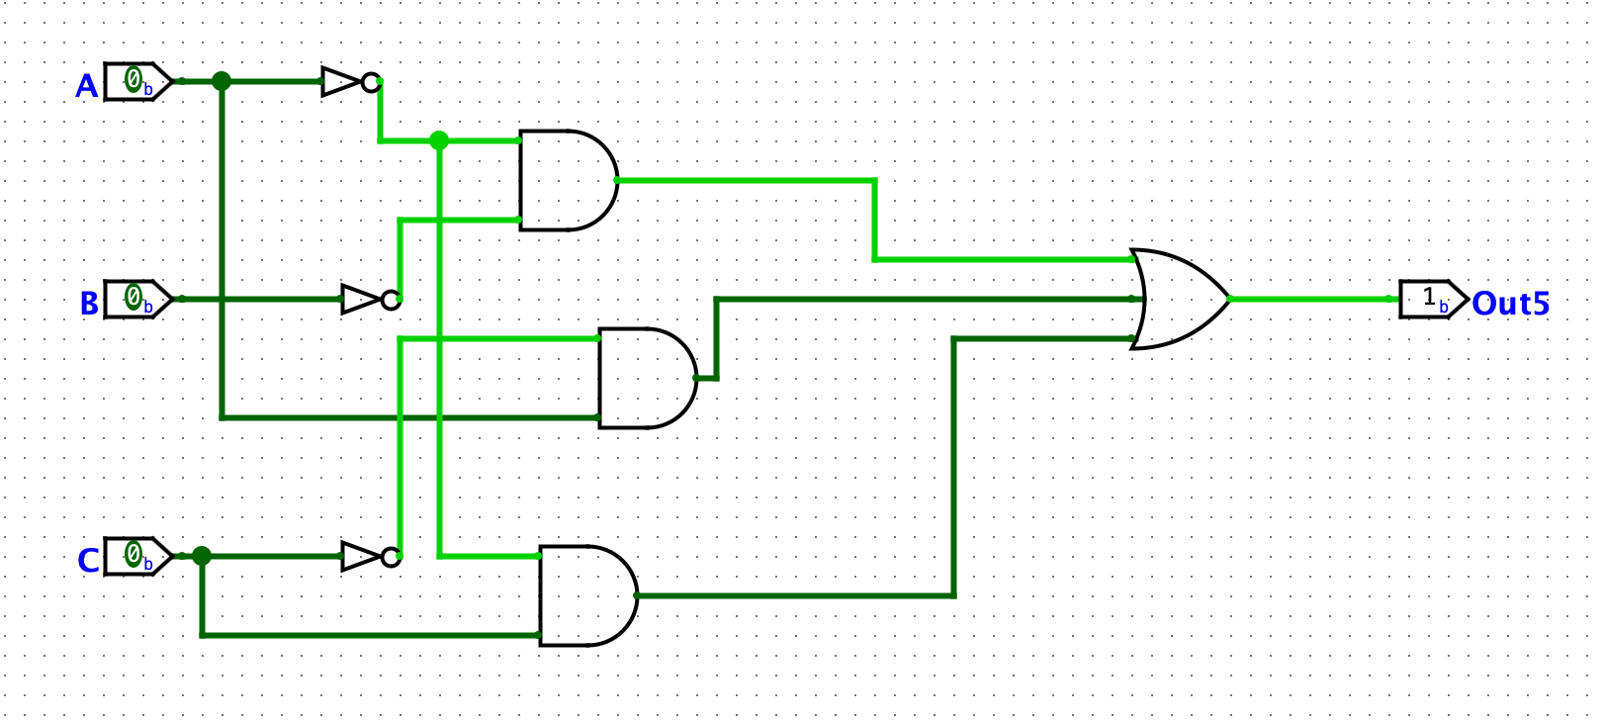

**Seg6:**

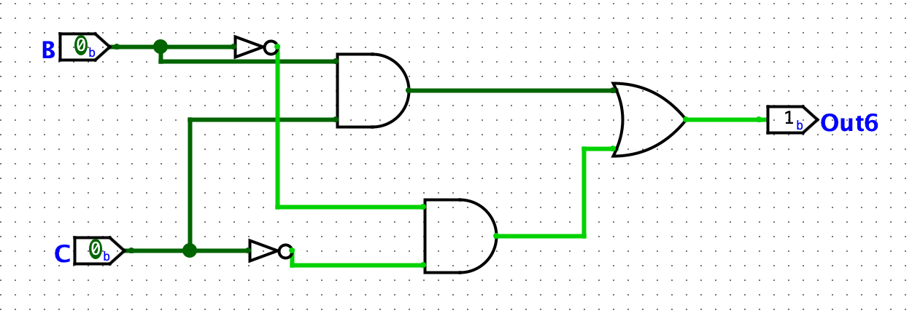

**Main:**

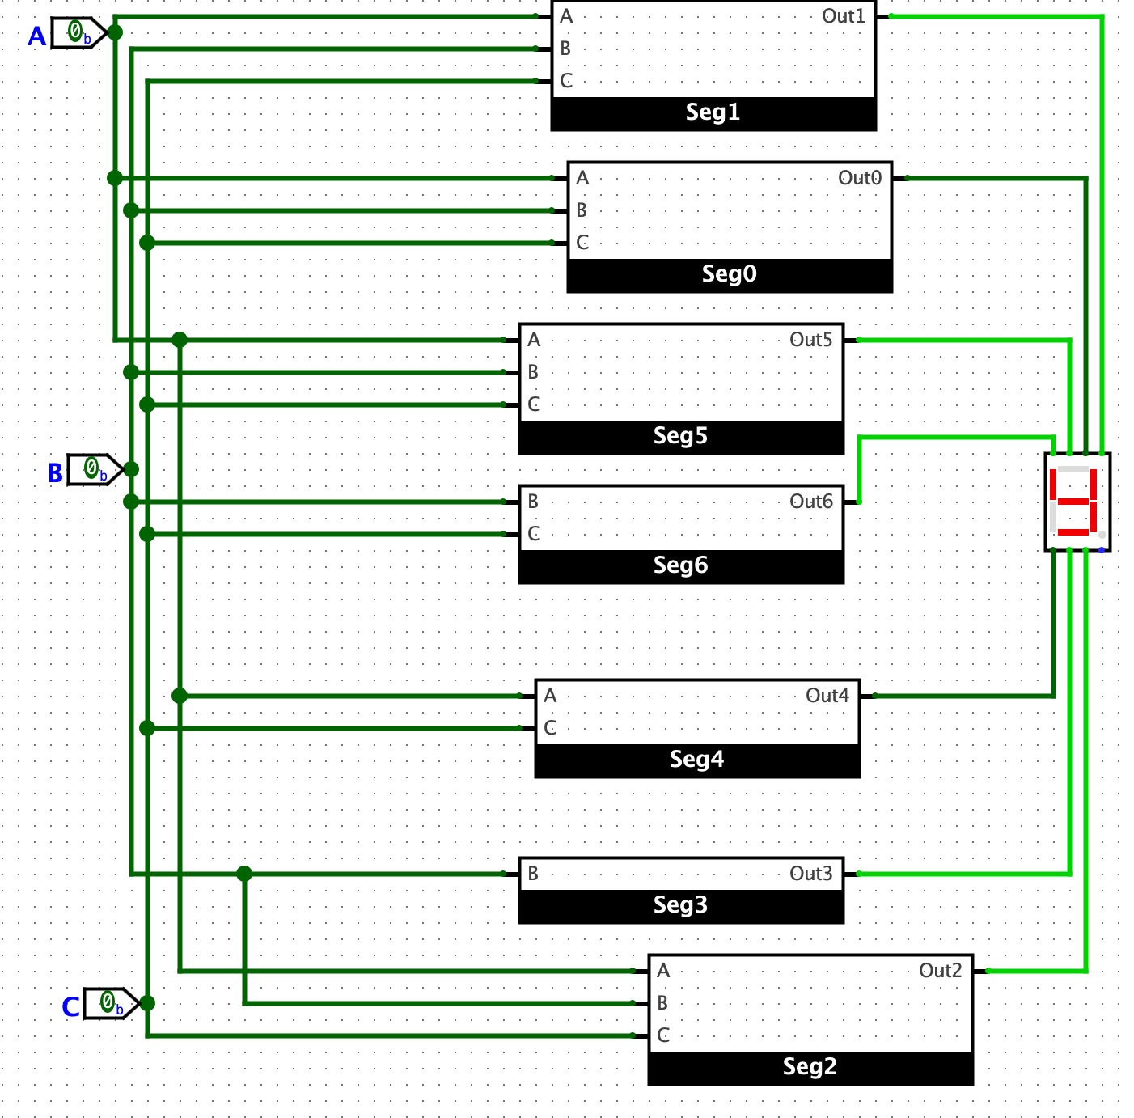

**Y: 000**



**O: 001**

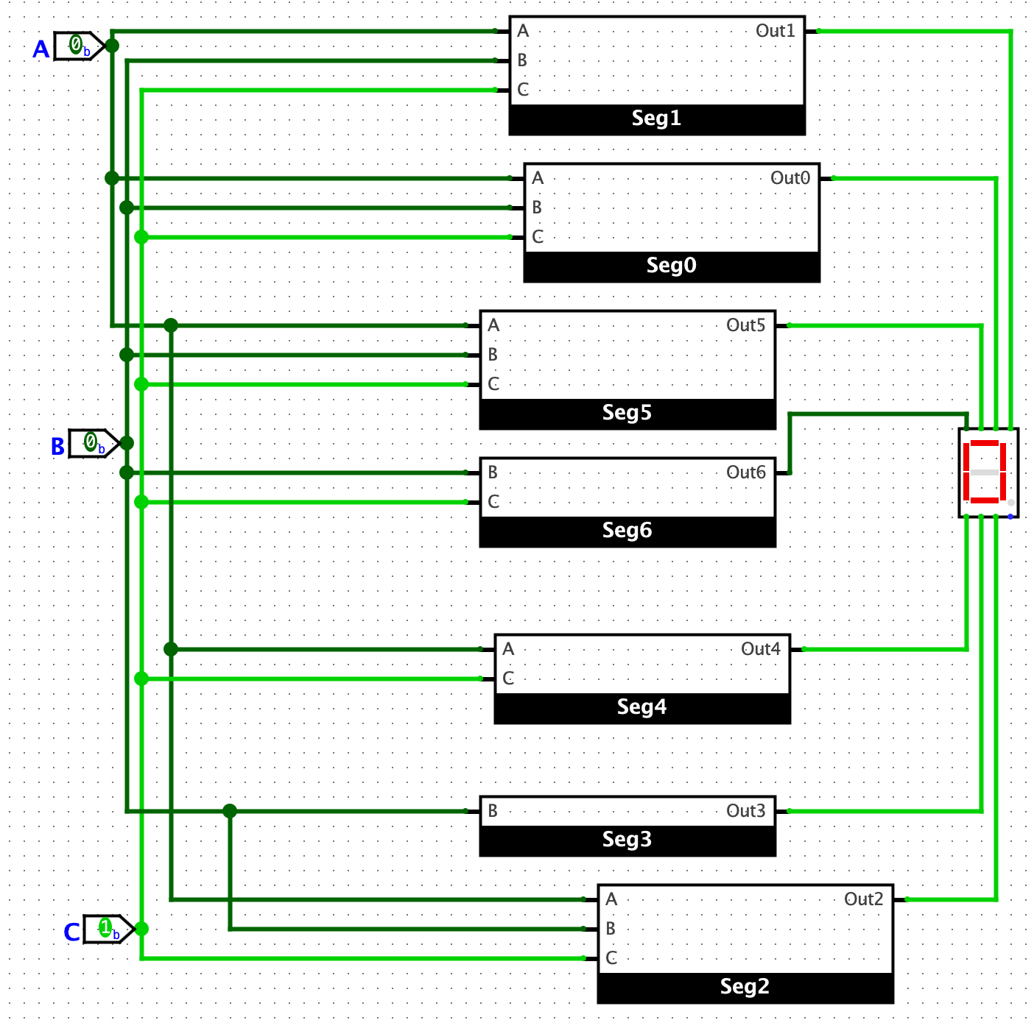

**Space: 010**

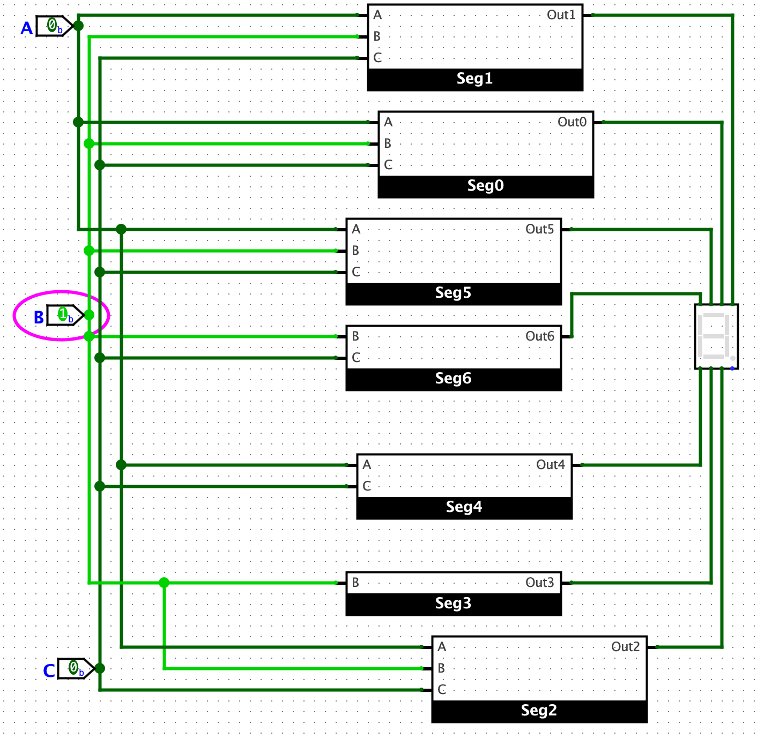

**K: 011**

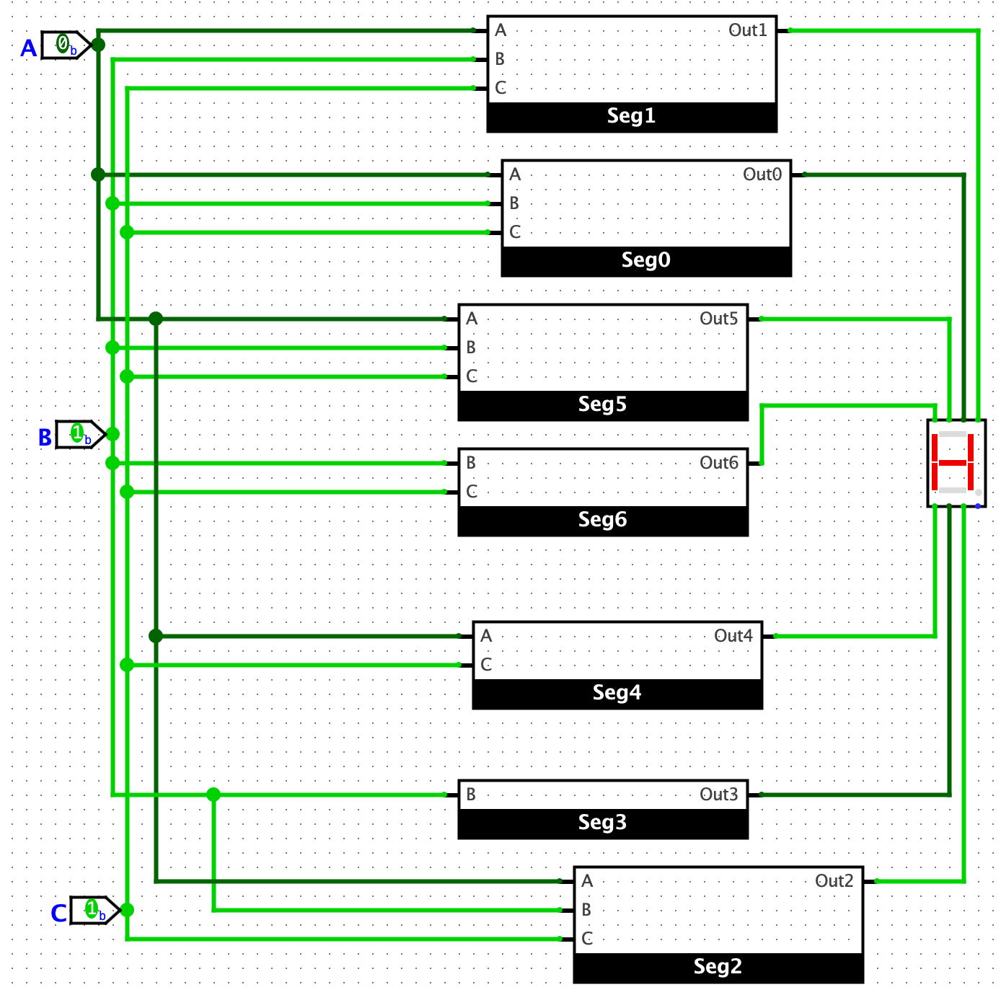

**E: 100**

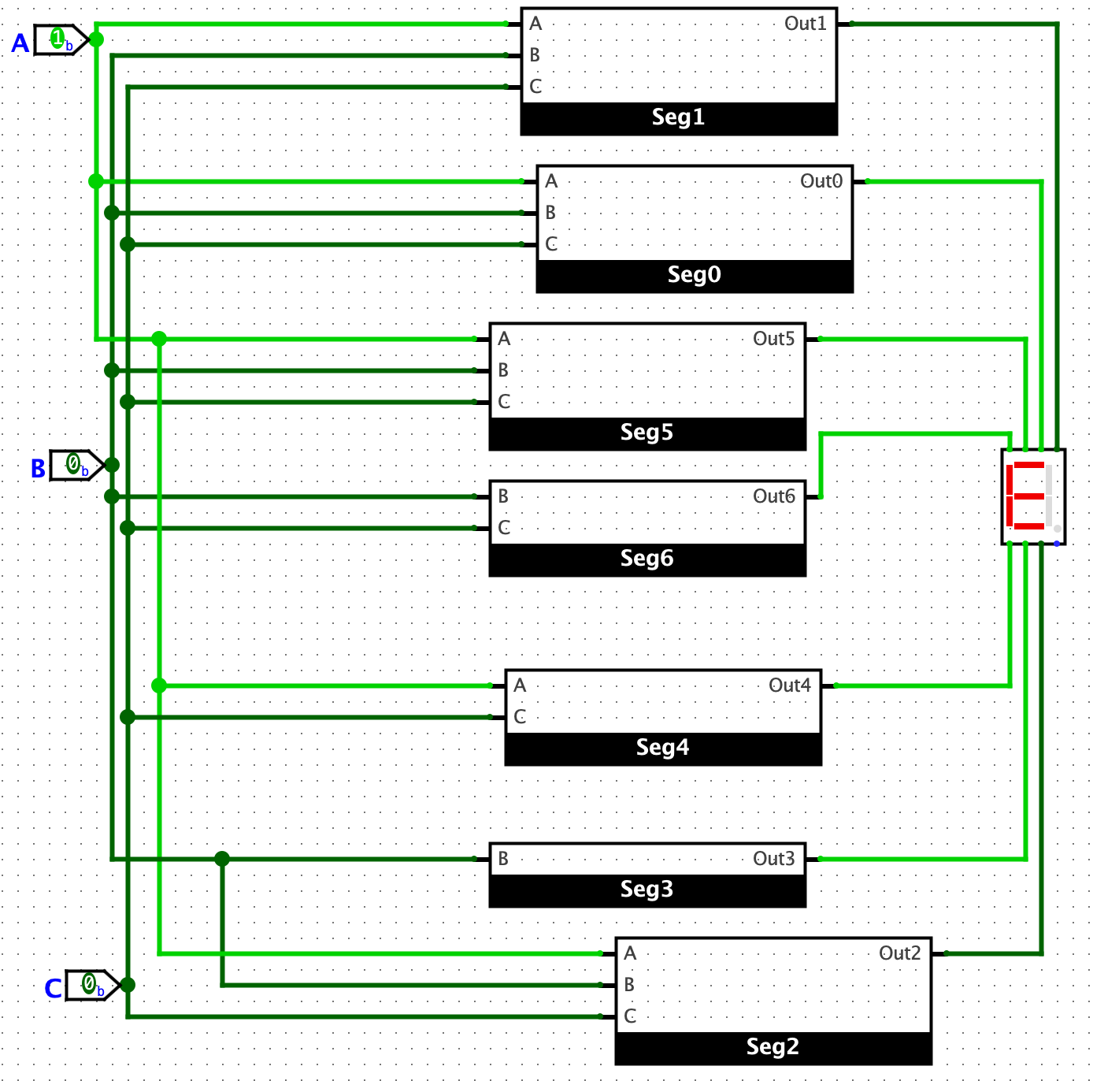

**V: 101**

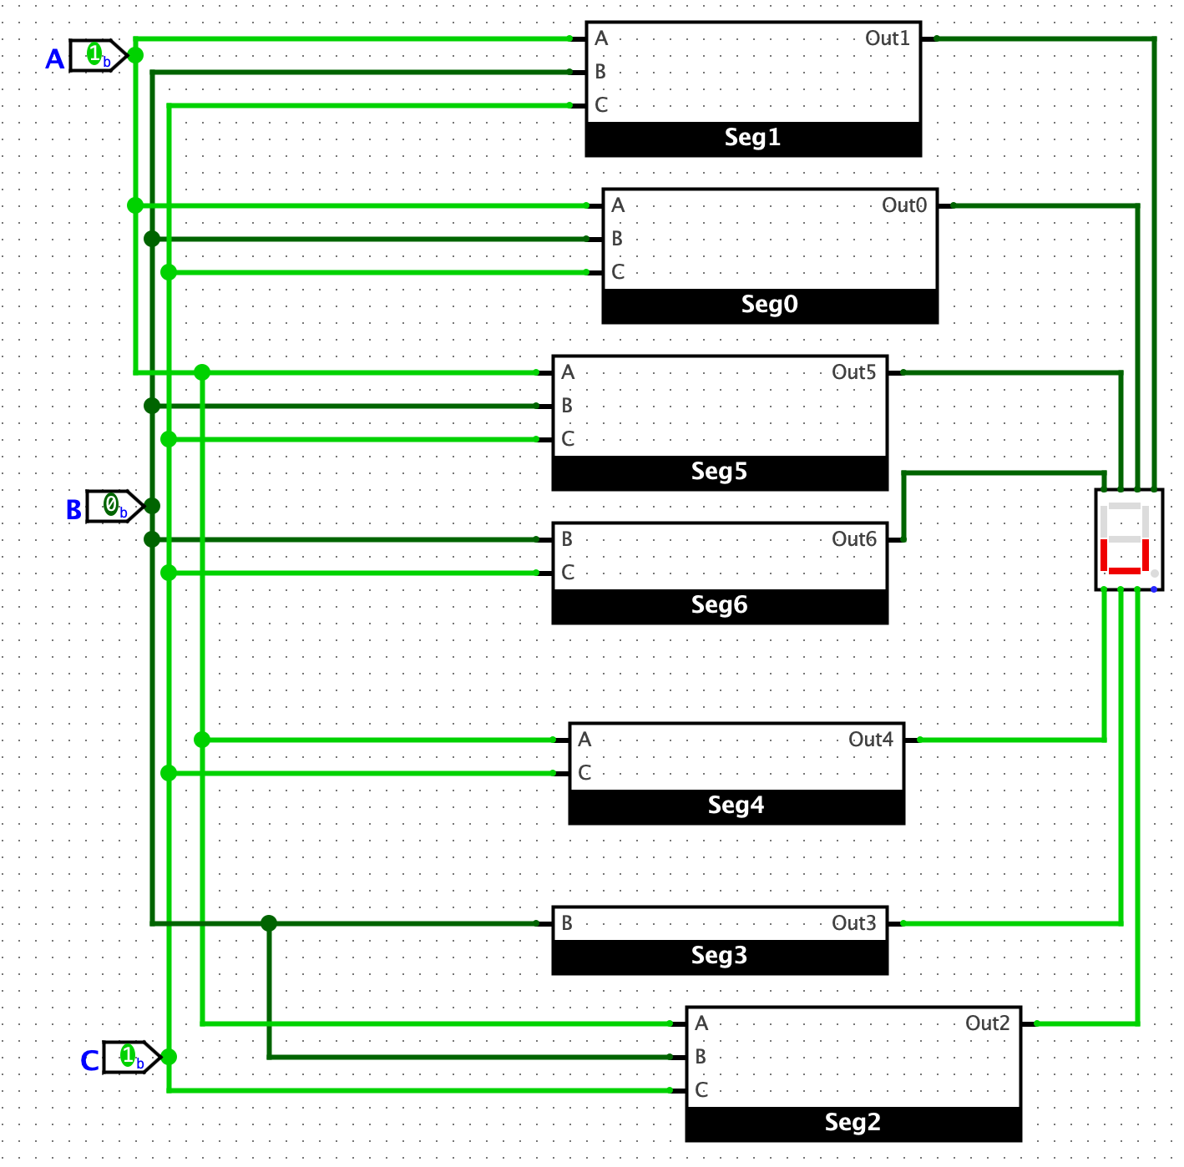

**I: 110**

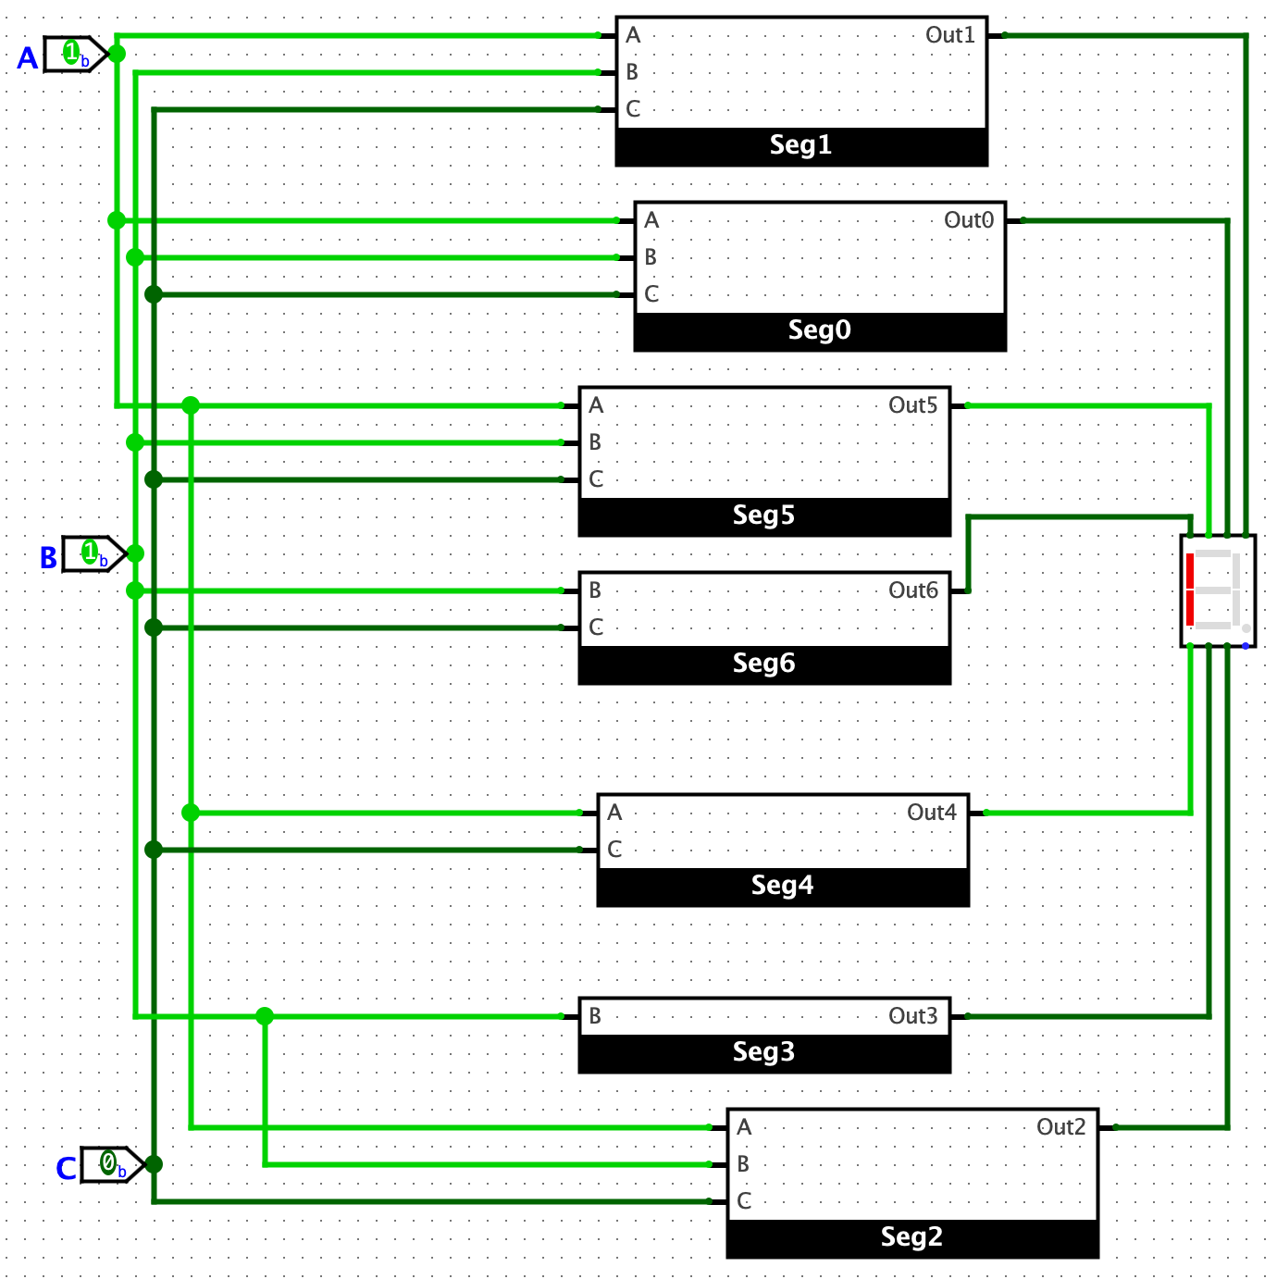

**N: 111**

