**1 to 6 Demultiplexer:**

|  |  |  |  |  |  |  |  |  |  |
| --- | --- | --- | --- | --- | --- | --- | --- | --- | --- |
| Data Input | Select Inputs | | | Outputs | | | | | |
| Data | S_2 | S_1 | S_0 | Output0 | Output1 | Output2 | Output3 | Output4 | Output5 |
| Data | 0 | 0 | 0 | 1 | 0 | 0 | 0 | 0 | 0 |
| Data | 0 | 0 | 1 | 0 | 1 | 0 | 0 | 0 | 0 |
| Data | 0 | 1 | 0 | 0 | 0 | 1 | 0 | 0 | 0 |
| Data | 0 | 1 | 1 | 0 | 0 | 0 | 1 | 0 | 0 |
| Data | 1 | 0 | 0 | 0 | 0 | 0 | 0 | 1 | 0 |
| Data | 1 | 0 | 1 | 0 | 0 | 0 | 0 | 0 | 1 |

**6 to 1 Multiplexer:**

|  |  |  |  |  |  |  |  |  |  |
| --- | --- | --- | --- | --- | --- | --- | --- | --- | --- |
| Select Inputs | | | Inputs | | | | | | Output |
| S_2 | S_1 | S_0 | Input0 | Input1 | Input2 | Input3 | Input4 | Input5 | Output0 |
| 0 | 0 | 0 | 1 | 0 | 0 | 0 | 0 | 0 | Input0 |
| 0 | 0 | 1 | 0 | 1 | 0 | 0 | 0 | 0 | Input1 |
| 0 | 1 | 0 | 0 | 0 | 1 | 0 | 0 | 0 | Input2 |
| 0 | 1 | 1 | 0 | 0 | 0 | 1 | 0 | 0 | Input3 |
| 1 | 0 | 0 | 0 | 0 | 0 | 0 | 1 | 0 | Input4 |
| 1 | 0 | 1 | 0 | 0 | 0 | 0 | 0 | 1 | Input5 |

**Circuits:**

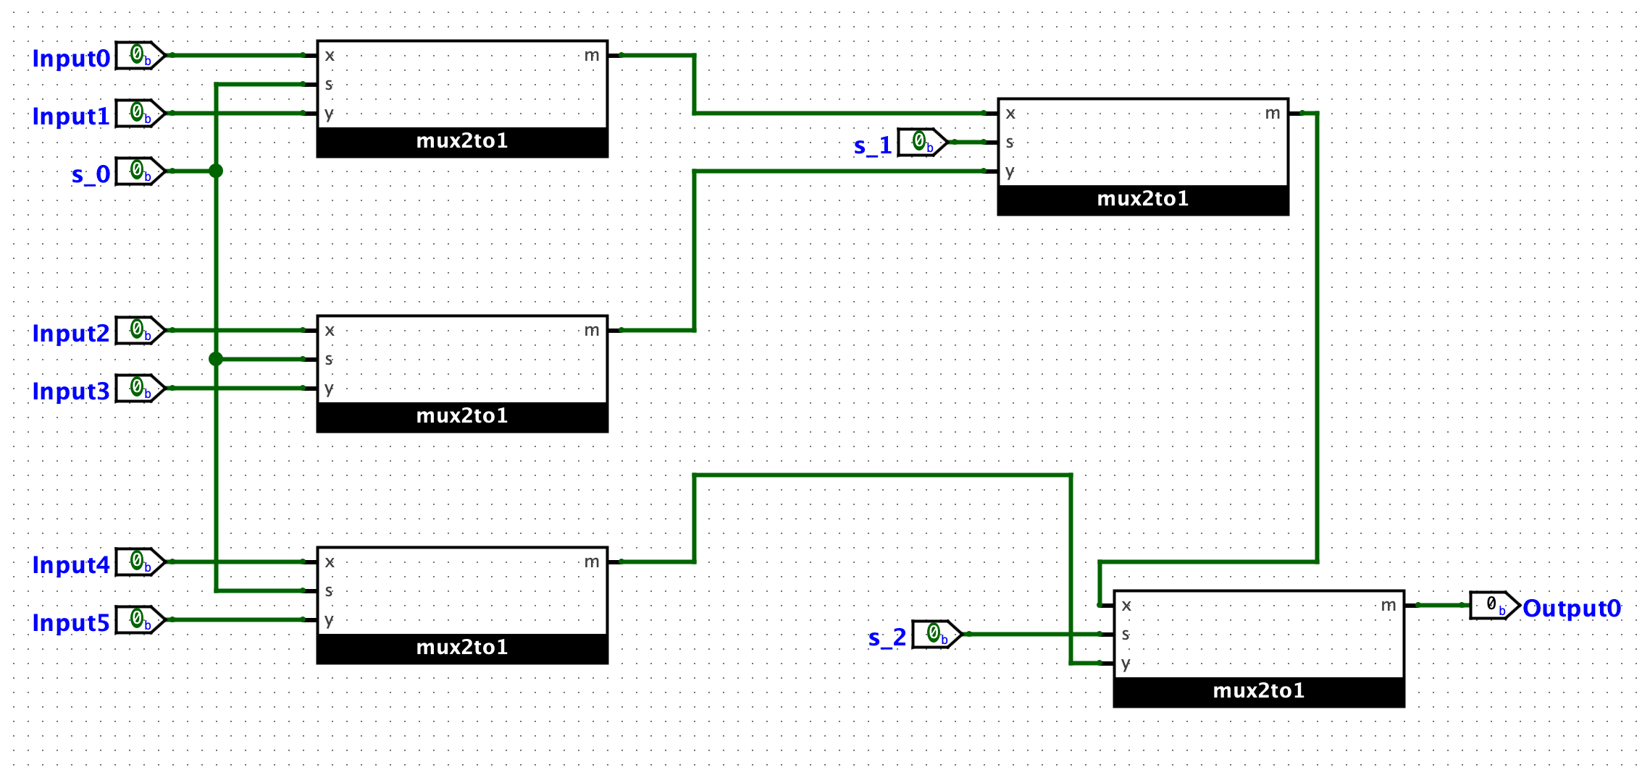**6 to 1 Multiplexer:**

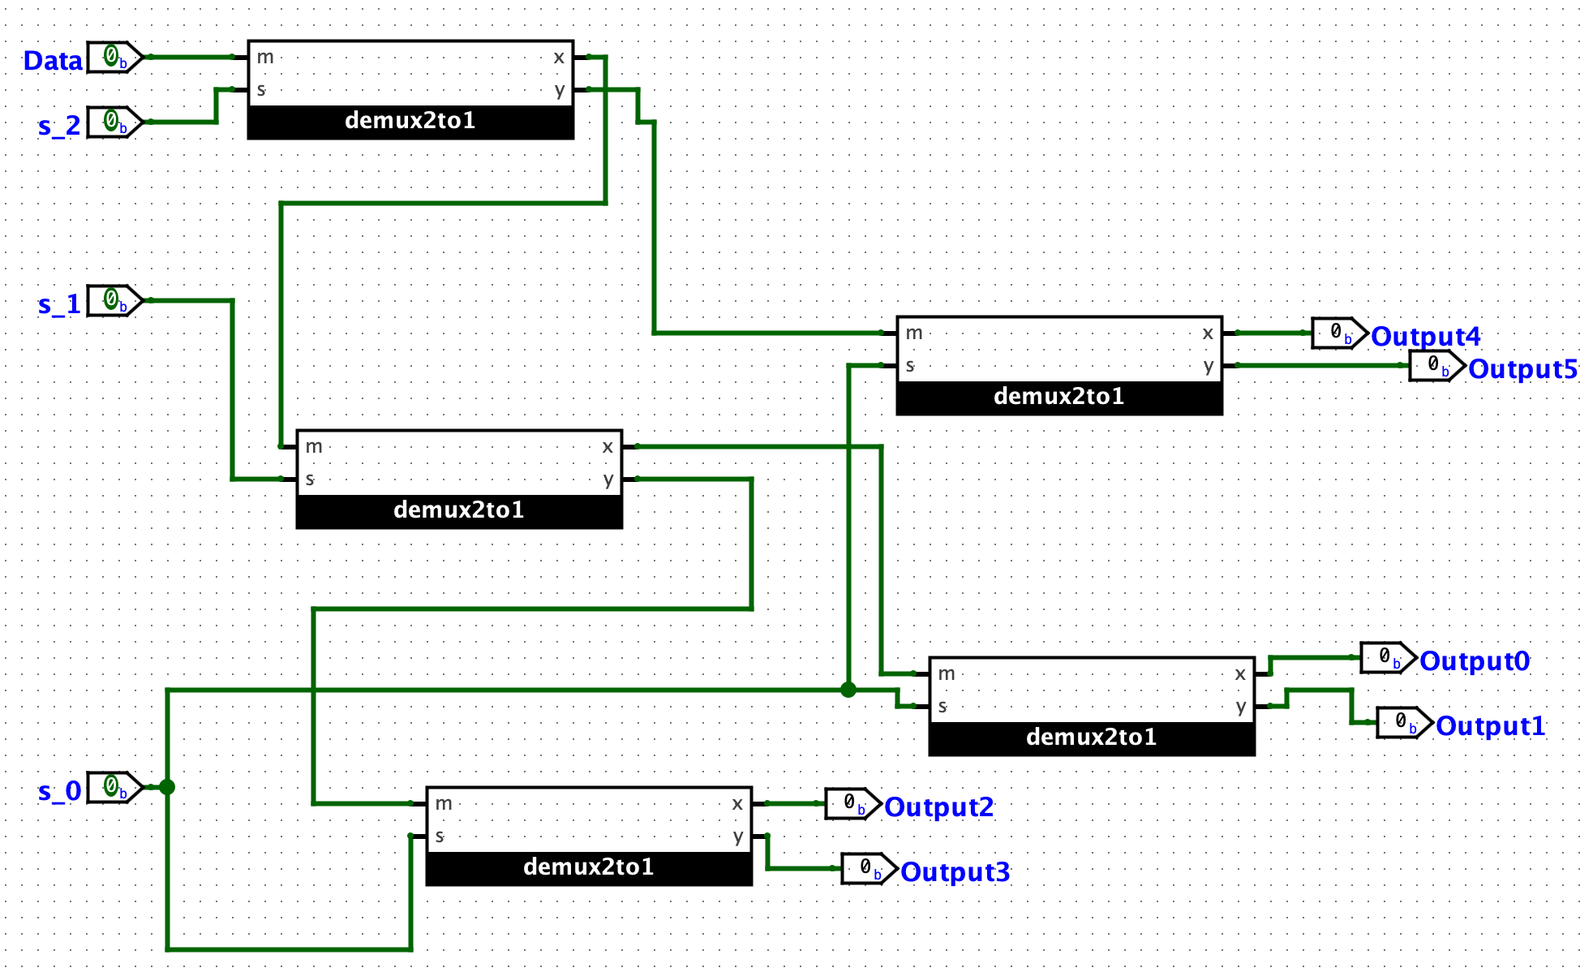**1 to 6 Demultiplexer:**

**Screenshots of Correct Functionality:**

**6 to 1 mux – 011 (s_2 s_1 s_0)**

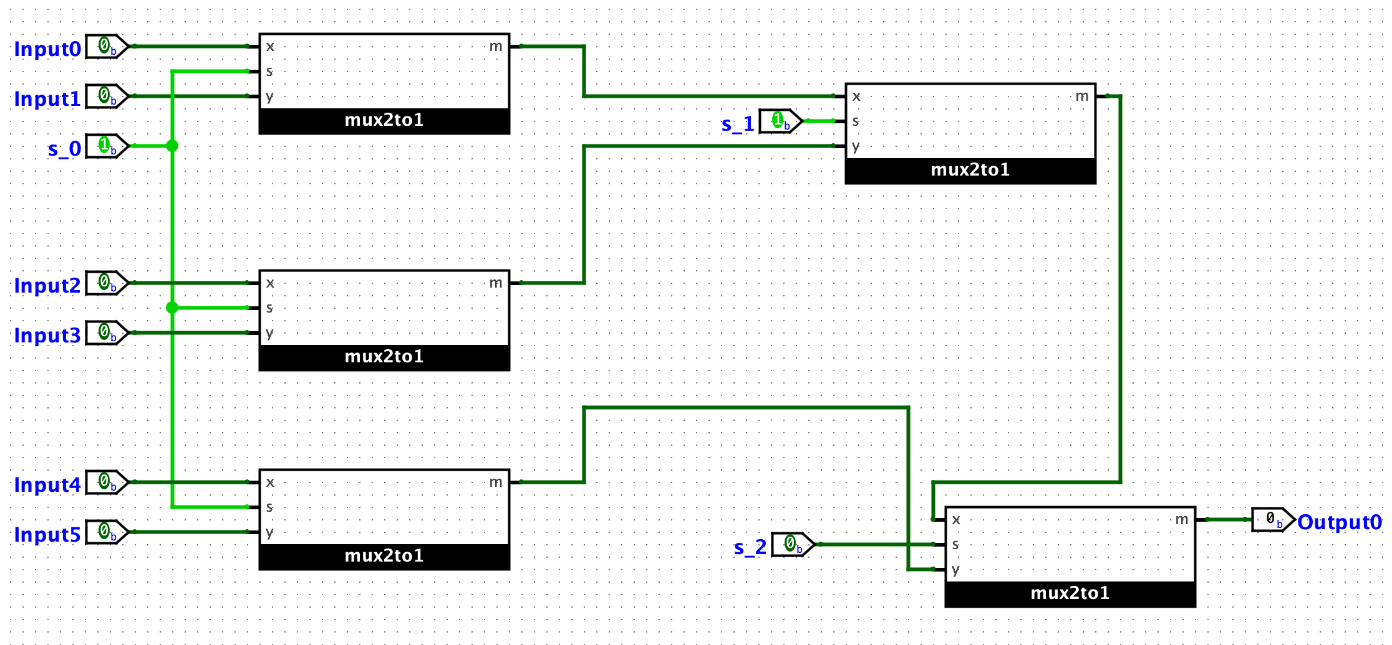

**🡪 Input3 is 1**

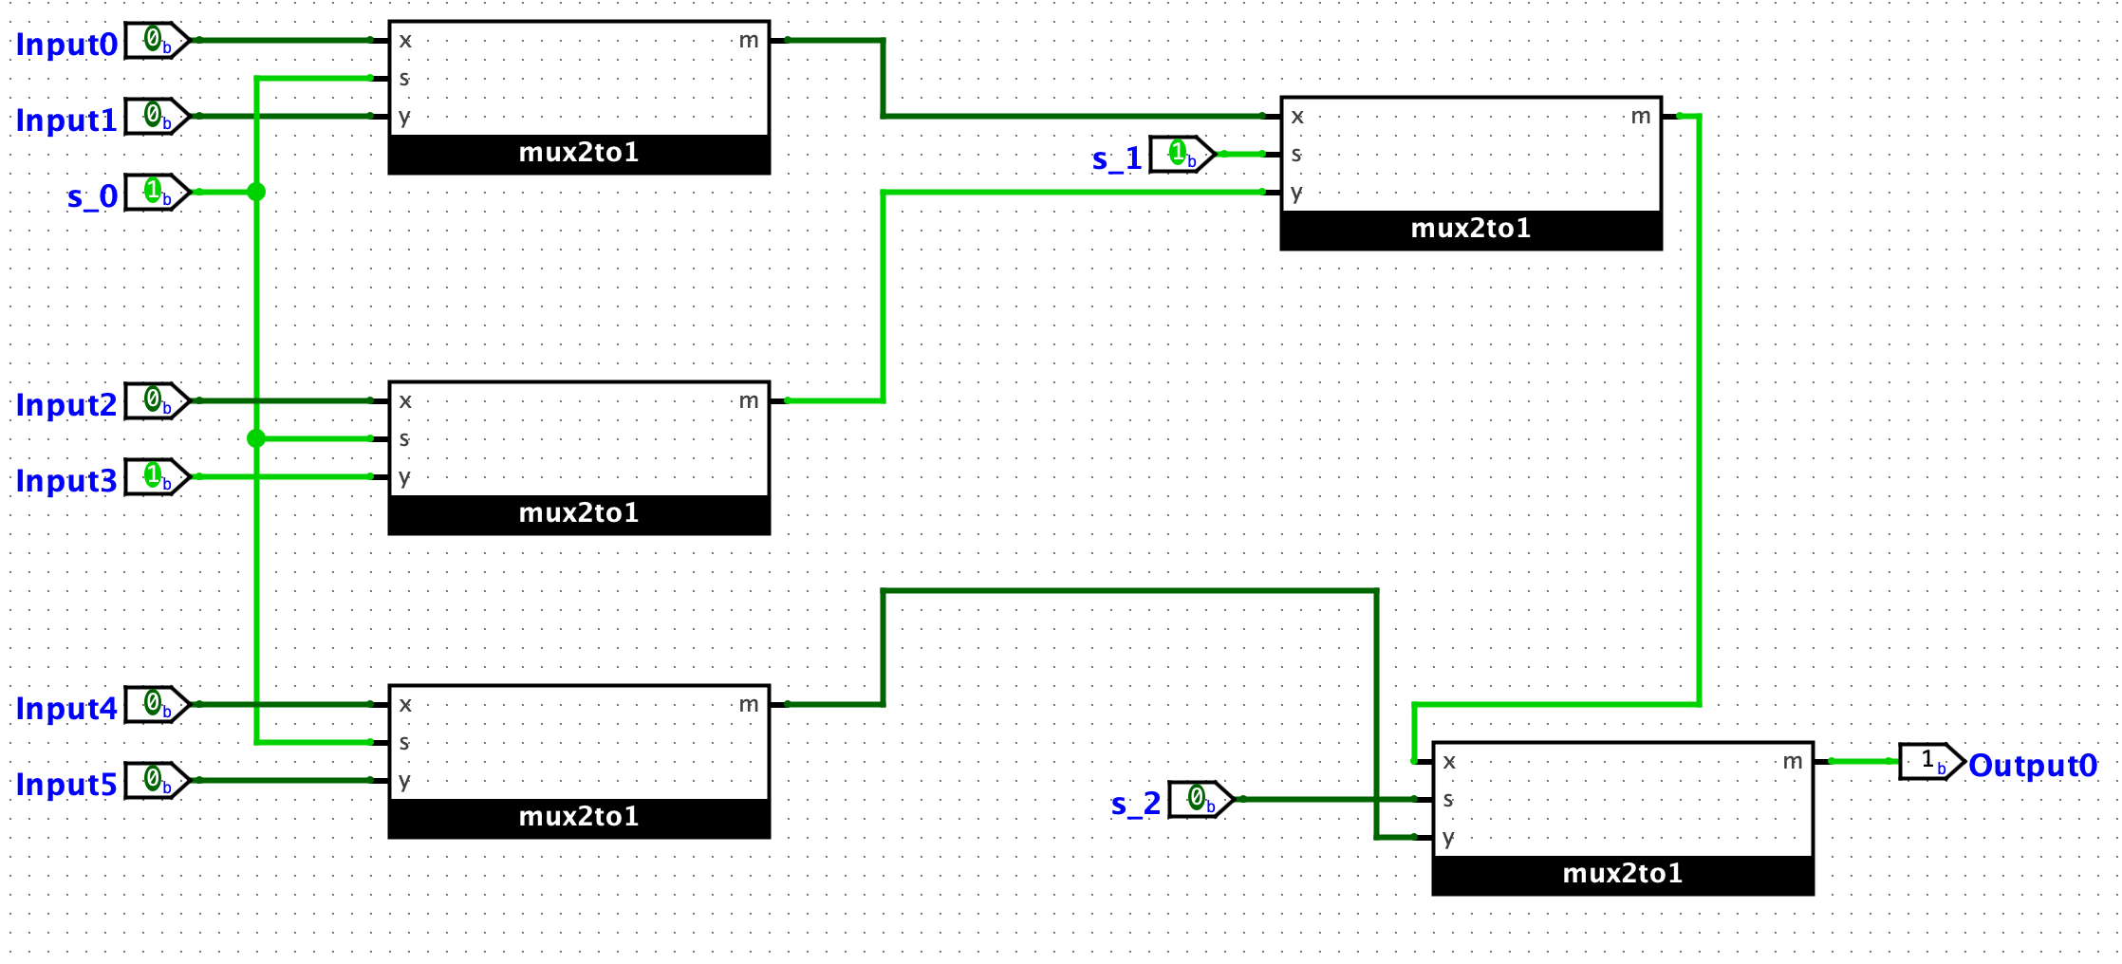

**1 to 6 demux – 101 (s_2 s_1 s_0)**

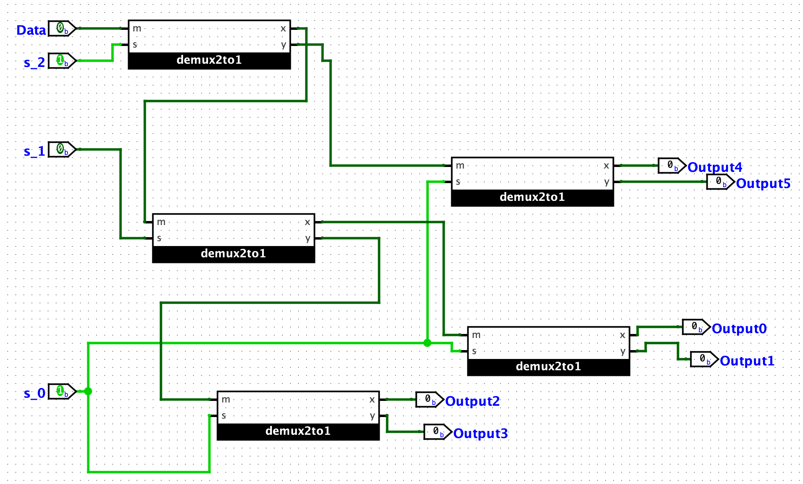

**🡪 Data is 1**

