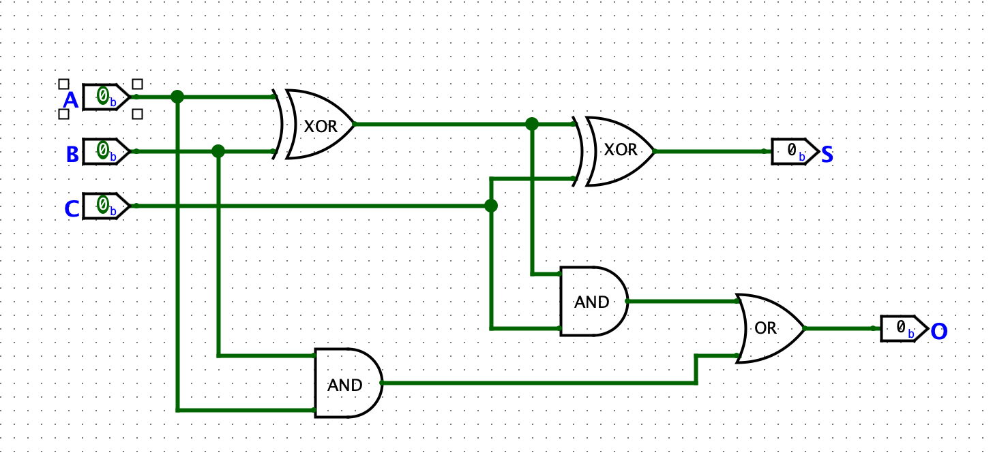**Mystery** **Circuit:**

**Truth Table of Mystery Circuit:**

|  |  |  |  |  |
| --- | --- | --- | --- | --- |
| **A** | **B** | **C** | **S** | **O** |
| 0 | 0 | 0 | 0 | 0 |
| 1 | 0 | 0 | 1 | 0 |
| 0 | 1 | 0 | 1 | 0 |
| 1 | 1 | 0 | 0 | 1 |
| 0 | 0 | 1 | 1 | 0 |
| 1 | 0 | 1 | 0 | 1 |
| 0 | 1 | 1 | 0 | 1 |
| 1 | 1 | 1 | 1 | 1 |

**Circuit Equations:**

S = AB’C’ + A’BC’ + A’B’C + ABC

O = ABC’ + AB’C + A’BC + ABC

= BC (A’ + A) + ABC’ + AB’C

= BC + ABC’ + AB’C + ABC + ABC

= BC + AC (B’ + B) + AB (C’ + C)

= BC + AC + AB

**Description:**

When A is high and BC are low then S is high. When B is high and AC are low, then S is high. When C is high and AB are low then S is high.

S is only high when an odd number of inputs are high. As well, S is high when the decimal value of input ABC is part of the quadratic sequence (refer below).

|  |  |
| --- | --- |
| **Binary (ABC)** | **Decimal Value** |
| 001 | 1 |
| 010 | 2 |
| 100 | 4 |
| 111 | 7 |

S: 1, 2, 4, 7

+1 +2 +3

+1 +1

🡺 Quadratic sequence

O is high when 2 or more inputs are high. When AB are high, then O is high. When AC are high and B is low, O is high. When BC are high and C is low, O is high.

When ABC is high, then S and O are high, and the number value of ABC is a multiple of 7 (refer below). When all inputs are low, S and O are low.

Binary: 111 🡪 7 (decimal number)