
TMA FOR TM355

Student Name | Marh Ayman Abo Eicheh
Student ID | 22410217
Date Submitted | 9-4-2026

1. Introduction

In the field of communications technology, signals are transmitted between a source and a destination using a variety of transmission media. The most familiar examples covered in this course are optical fibre, copper cables, and radio waves. However, there is another important type of transmission channel that is widely used at microwave frequencies — the waveguide. This report explores waveguides in detail, covering four key areas: their physical construction, the methods used to introduce and extract signals, the modes of wave propagation they support (including why the TEM mode cannot exist in a hollow guide), and the concept of the cavity resonator. The discussion is supported throughout by references to standard textbooks in the field of electromagnetics and microwave engineering.

2. What is a Waveguide? Definition and Construction

A waveguide is a hollow metallic tube, usually made of copper, brass, or aluminium, that is designed to carry electromagnetic waves from one point to another. The key difference between a waveguide and a conventional transmission line is that there is no inner conductor — the signal energy travels inside the empty hollow space of the tube, guided by reflections off the metallic walls (Pozar, 2011).

The most commonly used type is the rectangular waveguide, which has a rectangular cross-section defined by two dimensions: the broad wall width, labelled a, and the narrow wall height, labelled b. Standard design practice sets a ≈ 2b, a ratio chosen to maximise the usable operating bandwidth of the dominant mode and provide a well-defined cut-off behaviour. Circular waveguides also exist and offer lower attenuation in some configurations, but rectangular types are far more common in practical communications systems
(Hayt & Buck, 2012)

The conducting walls of the waveguide are typically silver-plated on the inside to reduce resistive losses. The interior may be filled with air, dry nitrogen, or a low-loss dielectric material. As an electromagnetic wave travels through the guide, it reflects off the walls at a grazing angle, producing a zigzag forward motion along the length of the tube. This repeated bouncing is the physical mechanism of guided propagation. Figure 1 below illustrates the cross-sectional structure of a standard rectangular waveguide, showing the two defining dimensions and the electric field distribution for the dominant TE₁₀ mode.

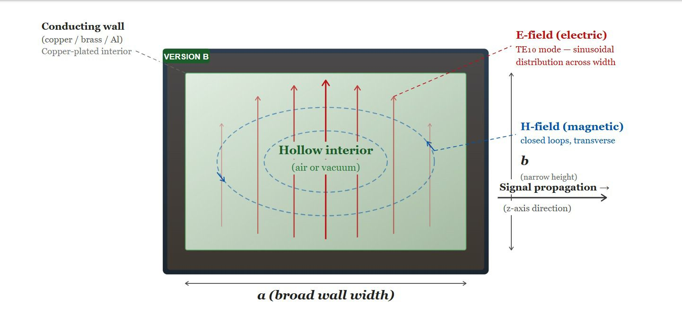

Figure 1: Rectangular waveguide showing TE₁₀ mode with electric and magnetic field distribution and direction of wave propagation

.

3. Signal Introduction, Extraction, and Use as a Transmission Line

Since a waveguide is a single hollow tube with no inner conductor, it is not possible to connect a standard electrical cable directly to it. Instead, engineers use specialised coupling techniques to transfer energy into and out of the guide.

Probe coupling is the most widely used method. A short metallic probe — connected to the inner conductor of a coaxial cable — is inserted through a small hole in the broad wall of the waveguide. When positioned at a field maximum and oriented parallel to the electric field of the desired mode, it efficiently launches the wave into the interior of the guide (Pozar, 2011)
Loop coupling uses a small conducting loop placed inside the waveguide and connected to a coaxial feed. The loop is oriented to link with the magnetic flux of the desired propagation mode. This method is particularly effective when strong magnetic-field coupling near the wall is required (Hayt & Buck, 2012).
Aperture (slot) coupling involves cutting a small hole or slot in the shared wall between two waveguide sections or between a waveguide and a cavity. Electromagnetic energy couples through the aperture via fringing fields. This technique is widely used in waveguide filters and antenna arrays (Balanis, 2012).
Signal extraction at the output port works in exactly the same way but in reverse — the guided wave excites the coupling element, converting the field energy back into a usable electrical signal. Regarding the use of waveguides as transmission lines: classical two-conductor transmission line theory, based on voltage and current, does not directly apply to hollow single-conductor waveguides. However, each propagating mode can be characterised by an equivalent transmission-line model, and familiar concepts such as matched termination, standing waves, and impedance transformation all carry over. This analogy is extensively used in the design of microwave filters, directional couplers, and impedance-matching networks (Pozar, 2011)

4. TEM Mode, Wave Propagation, and Modes in Waveguides

The Transverse Electromagnetic (TEM) mode is a mode of propagation in which both the electric field (E) and the magnetic field (H) are entirely perpendicular to the direction of propagation — neither field has a component along the transmission axis. TEM modes are supported by two-conductor transmission structures such as coaxial cables and parallel-plate lines, and they have no cut-off frequency, meaning they can propagate at any frequency including DC (Hayt & Buck, 2012).

A hollow single-conductor waveguide cannot support TEM mode propagation. This follows directly from electromagnetic theory: for a TEM mode to exist, a static electric potential distribution must be possible in the cross-section of the structure, and this requires at least two separate conductors at different potentials. In a hollow waveguide, there is only one conductor — the outer metallic wall — and the interior is empty. Applying Laplace's equation to the cross-section under these boundary conditions yields only a trivially zero field, confirming that no TEM wave can exist (Pozar, 2011).

Instead, hollow waveguides support Transverse Electric (TE) modes, in which the electric field has no longitudinal component (Ez = 0), and Transverse Magnetic (TM) modes, in which the magnetic field has no longitudinal component (Hz = 0). Each mode is identified by two integers m and n, representing the number of half-wave field variations across the broad wall (m) and the narrow wall (n). A mode can only propagate if the operating frequency exceeds its cut-off frequency, given by: fc = (c/2) × √[(m/a)² + (n/b)²], where c is the speed of light in the medium

The dominant mode — the one with the lowest cut-off frequency — in a rectangular waveguide is the TE₁₀ mode (m = 1, n = 0). Its electric field varies sinusoidally across the broad wall width, being strongest at the centre and zero at the walls, as shown in Figure 1. In practice, waveguides are designed so that the operating frequency lies above the cut-off of TE₁₀ but below the cut-off of the next higher-order mode. This guarantees single-mode propagation, which prevents signal distortion caused by multiple modes travelling at different velocities.
(Balanis, 2012)

5. Cavity Resonator

A cavity resonator is formed by enclosing a section of waveguide with metallic walls at both ends, creating a fully closed metallic box. This structure can store electromagnetic energy at specific discrete frequencies, called its resonant frequencies. It is the microwave equivalent of a lumped LC resonant circuit: instead of physical inductors and capacitors, the resonance arises from the three-dimensional geometry of the enclosure itself (Pozar, 2011).

The resonant frequencies of a rectangular cavity with dimensions a × b × d are given by: f_mnp = (c/2) × √[(m/a)² + (n/b)² + (p/d)²], where m, n, and p are three mode integers. At each resonant frequency, the time-averaged electric and magnetic energies stored inside the cavity are equal, and energy oscillates continuously between the two field components — this is the physical definition of resonance (Hayt & Buck, 2012).

A critical performance parameter of a cavity resonator is its Quality factor Q, defined as: Q = 2π × (energy stored) / (energy lost per cycle). Metallic cavities achieve Q values in the range of thousands to tens of thousands, far superior to any lumped LC circuit. This exceptionally high Q translates into an extremely narrow and selective frequency response, making cavity resonators indispensable in applications that require precision frequency selection (Balanis, 2012).

In waveguide system design, cavity resonators are used as bandpass or bandstop filters, as frequency-stabilising elements in microwave oscillators, and as reference standards in spectrum analysers and frequency meters. Many cavity resonators are mechanically tunable — by moving an end wall or inserting a tuning screw — allowing the resonant frequency to be adjusted over a range. Coupling energy into and out of a cavity uses the same probe, loop, or aperture techniques described in Section 3 (Pozar, 2011).

6. Conclusion

This report has examined waveguides as a distinct and important class of communication channel. A waveguide is a hollow metallic tube that guides electromagnetic energy through repeated internal wall reflections, offering very low loss and high power-handling capability at microwave frequencies. Signals are coupled in and out via probe, loop, or aperture techniques, and waveguide behaviour can be usefully modelled using transmission-line equivalents for each mode. Hollow waveguides cannot support TEM modes and instead support TE and TM modes with defined cut-off frequencies; the TE₁₀ dominant mode is used in the vast majority of practical applications. Finally, cavity resonators formed by closing a waveguide section provide extremely high-Q resonant elements that are essential to filtering, oscillator stabilisation, and frequency measurement in modern microwave communications and radar systems.

References
Balanis, C. A. (2012). Advanced Engineering Electromagnetics. New York: John Wiley & Sons.
Hayt, W. H., & Buck, J. A. (2012). Engineering Electromagnetics. New York: McGraw-Hill Education.
Pozar, D. M. (2011). Microwave Engineering. Hoboken, NJ: John Wiley & Sons.
Ramo, S., Whinnery, J. R., & Van Duzer, T. (1994). Fields and Waves in Communication Electronics. New York : John Wiley & Sons.

