Arab Open University- Saudi Arabia



Faculty of Computer Studies
Information Technology and Computing Department



<SkillArena>

Basma Yousef Alakad 22413137
TM471: Final Year Project, 2025-2026
Dr.Dalia El-khaled

Declaration

I, Basma Alaqqad, confirm that the work I am submitting is completely my own and does not include any plagiarism. Any information or ideas taken from other sources have been properly cited. I also confirm that this work has not been submitted before, in full or in part, for any degree or qualification. It is not being submitted anywhere else except for my Information Technology and Computing studies at the Arab Open University.I understand the importance of academic honesty, and this submission reflects my own effort and understanding.

Acknowledgment

Above everything, I offer my deepest thanks to Allah (God), whose blessings, strength, and guidance carried me from the very first idea of this project to its final page.
My gratitude belongs first to my mom Elham and my father Yousef. Their support has been the steady ground I stood on, and their belief in me kept me moving even on the hardest days. I’m also thankful beyond words for my brother Mohammed, who has always been there in the most genuine and quiet ways, and for my sisters Fatima and Noor, whose encouragement and kindness gave me endless comfort throughout this journey.
To my friends, thank you for every check-in, every laugh, and every push when I needed it. And I want to give special appreciation to my project partner Marah, who walked with me through every detail and challenge of this work.
I’m also grateful to my supervisor for their guidance, and to the Arab Open University for shaping an environment where I could learn, improve, and finally reach this milestone.

Abstract

The shift toward lifelong digital learning is held back by the persistent problem of passive engagement in traditional e-learning systems. These platforms often feel static and unmotivating, offering little psychological incentive for learners to stay committed, which contributes heavily to rising dropout rates. At the same time, the market remains fragmented due to limited monetization options, slowing the growth of diverse, high-quality educational content.
This project presents SkillArena, a next-generation learning environment designed to overcome these barriers. The platform integrates social learning with advanced Gamification elements—such as leaderboards, leveling systems, and achievement tracking—supported by an intelligent AI recommendation engine. The objective was to build a full-stack solution that strengthens learner motivation while enabling creators to sustain and scale their contributions.
By transforming learning into an engaging, community-driven experience, SkillArena offers both dynamic participation and meaningful revenue opportunities, establishing a sustainable model for future digital skill development.

Table of content
Declaration ii
Acknowledgment ii
Abstract iii
Table of content iv
1. Chapter 1: Introduction 1
1.1 Overview 1
1.2 Introduction(Background and Motivation) 1
1.3 Problem Specification 2
1.4 Solution 3
1.5 Project Aims and Objectives 3
1.5.1 Project Objectives 3
1.5.2 Project Aims 4
1.6 Scope 4
1.7 Target 5
1.8 Constraints and Limitation 5
1.8.1 Constraints 5
1.8.2 Limitation 5
1.9 SkillArena Project Timeline – (20/09/2025 -01/05/2026) 6
1.10 gantt project 8
1.11 Dissertation Structure 9
2.Chapter 2: Literature Review 10
2.1 Introduction 10
2.2 Theoretical Foundations of Engagement and Motivation 11
2.2.1 Understanding Motivation in Learning 11
2.2.2 Self-Determination Theory (SDT) and Gamification Design 12
2.2.3 Gamification vs. Serious Games 12
2.3 State of E-Learning Platforms and Critical Comparison 13
2.3.1 Duolingo: The Power of Micro-Gamification 13
2.3.2 Coursera / edX: Academic Rigor vs. Passive Engagement 14
2.3.3 Udemy: Skill Diversity and Creator Monetization 15
2.4 Application of AI in Personalized Learning 16
2.4.1 AI-Driven Recommendation Systems 16
2.5 Synthesis of Findings and Market Gap Identification 17
2.5.1 The Identified Market Gap 17
2.8 References 18
2.6 Chapter Conclusion 18
3. Chapter 3: Requirements and Analysis 19
3.1 Introduction and Chapter Structure 19
3.2 Functional Requirements (FRs) 20
3.2.1 User & Content Management (P2P Exchange) 20
3.2.2 Gamification & Engagement Framework 21
3.2.3 AI Services 22
3.2.4 Monetization & Access Control 22
3.3 Non-Functional Requirements (NFRs) 23
3.3.1 Performance and Scalability 23
3.3.2 Security 23
3.3.3 Usability and Maintainability 24
3.4 Hardware Requirements Tools 24
3.5 Software Requirements Tools 24
3.6 System Analysis and Design Techniques 25
3.7 Diagrams 26
3.7.1 Class diagram 26
3.7.2 Activity diagram 27
3.7.2 Entity-Relationship diagram 28
3.8 Ethical, Legal, and Social Issues 29

List of figures

figure 1. 1 gantt project1 8
figure 1. 2 gantt project 2 8

figure 2. 1 doulingo 13
figure 2. 2 coursera 14
figure 2. 3 udemy 15

figure 3. 1 class diagram 26
figure 3. 2 activity diagram 27
figure 3. 3 entity-relation digram 28

List of tables

table 1. 1 timeline plan 6

table 2. 1 SkillArena Competitor Contrast 17

Chapter 1: Introduction

1.1 Overview
This section serves as a brief overview of the entire project report , setting the context for the reader and introducing the need for the SkillArena platform. It briefly mentions the critical need for engaging e-learning solutions and the innovative approach this project takes by integrating Gamification and AI.

1.2 Introduction(Background and Motivation)
This section sets the scene for the project by giving relevant background information. The world today requires people to keep learning new skills throughout their lives, covering a massive range of skills from technical areas (programming, UI/UX) to practical and creative talents (music, cooking, personal development).
-Background: The e-learning market is growing quickly, but many traditional methods fail to keep people motivated and engaged.
-Motivation of the Project: The project is motivated by the need to transform passive learning into an active and rewarding process. The introduction of Gamification (like points and levels) is the main motivation to solve the issue of high dropout rates and low engagement found in existing platforms.

1.3 Problem Specification
Despite the vast number of digital learning platforms currently available, a core weakness remains: most existing e-learning models are predominantly passive. They primarily rely on static mediums such as pre-recorded videos and reading materials, which often fail to provide the high level of motivation and sustained engagement that modern learners require. This lack of interactivity and challenge makes the learning process feel isolated and unrewarding, which is the primary contributor to high dropout rates and limited knowledge retention within these systems. Consequently, the lack of effective and integrated Gamification is a major factor undermining the success of many current market offerings.
Furthermore, a parallel issue exists concerning knowledge creators. Talented individuals who possess valuable expertise struggle to find accessible and effective methods to share their knowledge globally and, crucially, to monetize their skills. This difficulty acts as a barrier, limiting the variety of specialized content available to the public and often leading to an outdated educational content landscape. Therefore, there is a clear and urgent necessity for a comprehensive platform that not only delivers diverse and high-quality knowledge across all skills and talents but also builds an active community where learning, teaching, and earning money happen together, driven by strong Gamification features for maximum user motivation.

1.4 Solution
The suggested solution is the SkillArena web app, which merges social learning with gamification. The solution provides:
- Courses across all skills and talents.
- Gamification features (points, levels, badges, challenges) to foster engagement.
- An AI-driven recommendation engine.
- Monetization for instructors .
The solution transforms learning into a fun, rewarding, and inclusive experience.

1.5 Project Aims and Objectives

1.5.1 Project Objectives
The primary steps to be achieved are:
- To develop and build a platform that supports the creation and exploration of diverse courses.
- To integrate gamification features (points, badges, leaderboards) to boost user engagement.
- To use an AI-driven engine for personalized course recommendations.
- To enable instructors to monetize their content.

1.5.2 Project Aims

The overall aim is to transform learning into an inclusive, rewarding, and fun experience for everyone by establishing an active community where learning, teaching, and earning money happen together.

1.6 Scope
The project is a "Design and Build" effort focused on implementing a Proof-of-Concept web application for SkillArena.
Inclusions (Key Deliverables):
- System Foundation: Design and implement the basic database and back-end logic for user profiles and content management.
- Diverse Content: Functionality to host courses across the full range of skills (technical, creative, and practical).
- Core Gamification: Implementation of the essential motivation features: points, levels, and a leaderboard.
- AI Prototype: Development of a functional, demonstrative AI-driven recommendation engine prototype.
- Monetization Framework: Logic to designate courses as 'paid' and manage the enrollment process.

1.7 Target
The platform targets two main groups:
- Learners: Individuals seeking flexible, lifelong learning across diverse skills (programming, arts, cooking, etc.) who are looking for a highly engaging and motivational environment.
- Content Creators (Instructors): Talented individuals looking for an effective and reliable way to share their expertise, build a community, and monetize their knowledge.

1.8 Constraints and Limitation
This section elucidates the constraints that might affect the way the project is carried out.

1.8.1 Constraints
Constraints may include:
- Time Constraints: The project must be completed within the allocated timeframe of the final year project (TM471).
- Resource Constraints: Limitations on budget or specific hardware/software required for developing the AI components.
- Skill Constraints: Dependence on specific technical skills for developing the full-stack system and integrating complex AI models.

1.8.2 Limitation
Limitations may include:
- The AI model developed may be a simplified prototype focused only on basic recommendations due to time and data limitations.
- The system's testing may be limited to functional and user-acceptance testing, without full-scale load testing.

1.9 SkillArena Project Timeline – (20/09/2025 -01/05/2026)
table 1. 1 timeline plan
Phase | Dates | Task
Phase 0 – Planning | 20/09 – 25/09 | Review TM471 guidelines and understand report structure
Phase 0 – Planning | 26/09 – 30/09 | Define project boundaries and key SkillArena features and take proposal approval
Phase 1 – Introduction | 01/10 – 05/10 | Prepare background overview
Phase 1 – Introduction | 06/10 – 07/10 | Draft the problem definition
Phase 1 – Introduction | 08/10 – 9/10 | Set project aims and objectives
Phase 1 – Introduction | 10/10 – 15/10 | Outline the report organization
Phase 1 – Introduction | 16/10 – 18/10 | Revise and finalize Chapter 1
Phase 2 – Literature Review | 19/10 – 25/10 | Identify relevant previous studies
Phase 2 – Literature Review | 26/10 – 29/10 | Analyze selected sources
Phase 2 – Literature Review | 31/10 – 2/11 | Write comparison and critical review
Phase 2 – Literature Review | 03/11 – 08/11 | Refine and complete literature section
Phase 2 – Literature Review | 09/11 – 10/11 | Apply referencing and finalize Chapter 2
Phase 3 – Requirements & Analysis | 11/11 – 13/11 | Document Functional Requirements
Phase 3 – Requirements & Analysis | 27/11 – 28/11 | Document Non-Functional Requirements
Phase – final report for part A | 28/11-1-12 | Review and submit
Phase 3 – Requirements & Analysis | 11/12 – 20/12 | Develop UML diagrams (Use Case, Activity, Class)
Phase 3 – Requirements & Analysis | 21/12 – 25/12 | Perform system analysis and set evaluation metrics
Phase 3 – Requirements & Analysis | 26/12 – 30/12 | Write Part A (ethical and legal considerations)
Phase 4 – Design | 01/01 – 10/01 | Create interface sketches and layout concepts
Phase 4 – Design | 11/01 – 20/01 | Design database structure (ERD)
Phase 4 – Design | 21/01 – 31/01 | Develop system design and architecture
Phase 4 – Implementation | 01/02 – 05/02 | Initialize project environment
Phase 4 – Implementation | 06/02 – 15/02 | Build Login and Registration module
Phase 4 – Implementation | 16/02 – 25/02 | Implement Skill Assessment functionality
Phase 4 – Implementation | 26/02 – 29/02 | Build ranking and scoring mechanisms
Phase 4 – Testing | 01/03 – 10/03 | Develop Admin Dashboard
Phase 4 – Testing | 11/03 – 15/03 | Enhance user interface
Phase 4 – Testing | 16/03 – 25/03 | Conduct functional testing
Phase 4 – Testing | 26/03 – 31/03 | Perform user acceptance testing
Phase 5 – Results & Discussion | 01/04 – 10/04 | Prepare findings and attach screenshots
Phase 5 – Results & Discussion | 11/04 – 15/04 | Assess how well objectives were met
Phase 5 – Results & Discussion | 16/04 – 20/04 | Write future improvement suggestions
Phase 5 – Results & Discussion | 21/04 – 25/04 | Write Part B (ethical, social, legal issues)
Phase 6 – Conclusion | 26/04 – 28/04 | Compose project conclusions
Phase 6 – Conclusion | 29/04 – 30/04 | Final revision of Chapter 6
Final Submission | 01/05 | Compile report, finalize formatting, and submit

1.10 gantt project

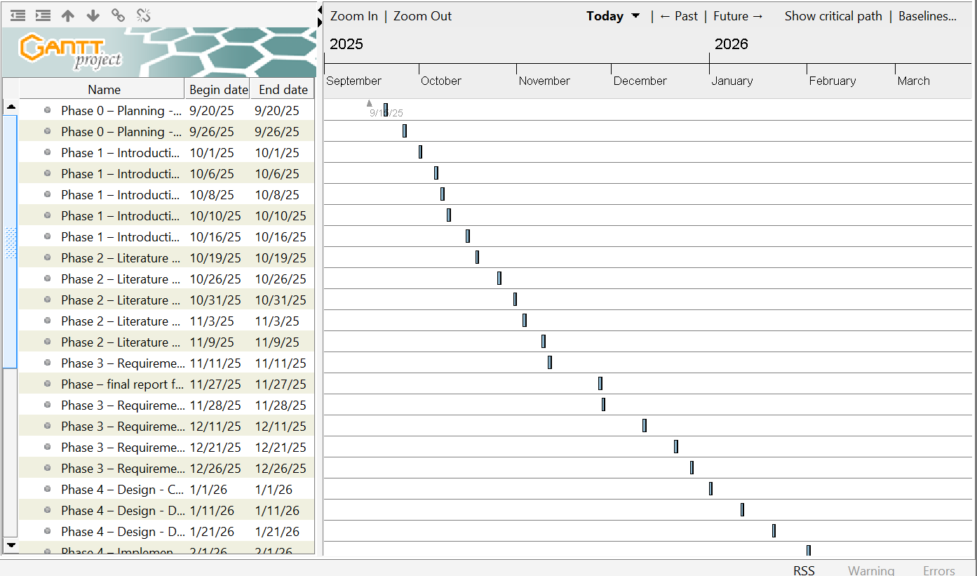
figure 1. 1 gantt project1

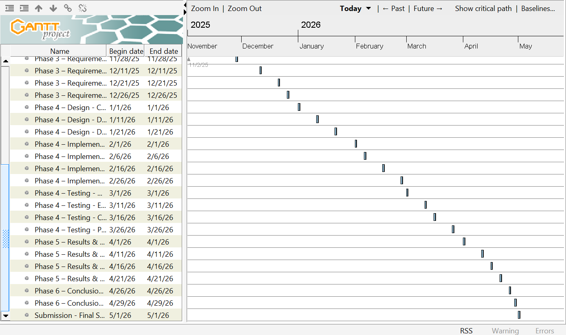
figure 1. 2 gantt project 2

1.11 Dissertation Structure
The remainder of this dissertation outlines the comprehensive process of building the SkillArena system, following the typical structure required for a 'design and build' project:
- Chapter 2 will provide a critical review and synthesis of existing literature , comparing other research and similar platforms related to the theoretical foundations and practical applications of gamification, social learning, and AI in educational environments.
- Chapter 3 will clearly define all the detailed functional and non-functional requirements needed for the SkillArena platform and provide a comprehensive system analysis, utilizing appropriate diagrammatic techniques such as UML or DFDs.
- Chapter 4 will explain the chosen design methodology, detail the implementation process (coding and development) of the platform's core features, and outline the systematic testing procedures used for validation.
- Chapter 5 will present the project's key findings and results, offer a critical discussion on the degree to which the initial objectives were achieved , and importantly, address the ethical, legal, and social issues related to the project.
- Chapter 6 will provide a final summary of the project’s key conclusions and suggest areas for further work and future improvements of the SkillArena platform.

2.Chapter 2: Literature Review

2.1 Introduction
This chapter provides a focused review of the main academic studies and industry solutions related to the SkillArena project. The purpose of this review is to build a strong theoretical base for the system and to highlight the weaknesses in today’s e-learning platforms that SkillArena aims to solve. In simple terms, the chapter explains why SkillArena’s combination of gamification, varied learning content, and AI-based personalization is needed.
The chapter starts by discussing key theories about motivation and user engagement. It then examines well-known e-learning platforms, comparing what they do well and where they fall short in relation to SkillArena’s goals. Finally, it brings these insights together to identify the market gap SkillArena will fill, setting the stage for the requirements analysis presented in Chapter 3.

2.2 Theoretical Foundations of Engagement and Motivation
The successful design of an e-learning platform like SkillArena must be grounded in robust psychological theory regarding human motivation and engagement. This section establishes the theoretical framework, defining motivation types and introducing the psychological model that validates the use of gamification.

2.2.1 Understanding Motivation in Learning
Motivation, as the driver of voluntary behavior, is crucial for sustained success in non-compulsory learning environments, such as online courses. Motivation is primarily understood through two lenses: Intrinsic and Extrinsic Motivation.
- Intrinsic Motivation arises from internal desires, such as pleasure, curiosity, or the inherent satisfaction of skill mastery. In this state, the learning activity itself serves as the reward.
- Extrinsic Motivation is driven by external factors, including tangible rewards like grades, prizes, monetary benefits, or social recognition. While useful for prompting initial action, extrinsic motivation alone often fails to foster long-term commitment.
Gamification is strategically employed in e-learning platforms to bridge the gap between these two types of motivation. By transforming passive learning actions into rewarding experiences, Gamification, through elements like points and badges, aims to scaffold the user’s motivation and encourage positive learning behaviors.

2.2.2 Self-Determination Theory (SDT) and Gamification Design
The theoretical basis for SkillArena's engagement strategy is the Self-Determination Theory (SDT), a leading psychological model developed by Deci and Ryan. SDT posits that optimal motivation and well-being are achieved when three basic psychological needs (BPNs) are consistently met. Gamification is a powerful tool for designing systems that directly fulfill these three needs:
- Autonomy: The need to feel self-directed, having choice and control over one's own actions and learning path. Gamification supports autonomy by offering personalized choices of courses and self-paced progression through levels.
- Competence: The need to feel capable and effective in achieving desired outcomes and mastering skills. This is met through clear progression indicators, immediate feedback mechanisms, and the acquisition of badges that visibly demonstrate skill mastery.
- Relatedness: The need to interact with and feel connected to others, fostering a sense of social belonging. SkillArena’s social learning features and competitive leaderboards directly address this need by creating a communal and interactive environment.

2.2.3 Gamification vs. Serious Games
It is essential to clarify that SkillArena utilizes the concept of Gamification rather than Serious Games. Gamification is defined as the application of game elements (points, badges, leaderboards) in a non-game context—the e-learning platform itself. SkillArena leverages Gamification to enhance motivation across all its diverse content, making it applicable to any skill without requiring the full structure of a specific game. (Ghoulam & al., 2024)

2.3 State of E-Learning Platforms and Critical Comparison
This section moves from theory to practice by critically evaluating three dominant e-learning models. This comparative analysis demonstrates that while existing platforms excel in single areas (Gamification, academic quality, or monetization), none successfully integrate all three with the necessary social elements and skill diversity offered by SkillArena.

2.3.1 Duolingo: The Power of Micro-Gamification

figure 2. 1 doulingo
Duolingo stands as the industry benchmark for effective Gamification within the educational sector. Its success lies in its sophisticated use of micro-gamified elements, which effectively tap into the user’s intrinsic need for competence and challenge. This system is highly effective at driving short-term engagement and building a daily learning habit.
However, Duolingo’s model presents critical limitations. Firstly, its scope is strictly limited to language acquisition, severely lacking the skill diversity required for holistic lifelong learning. Secondly, it operates on a centralized content creation model and does not offer a viable or sustainable monetization channel for external instructors. By adopting Duolingo’s effective Gamification mechanics but applying them across a wide spectrum of skills, SkillArena fills this gap. ((2024), 2024)

2.3.2 Coursera / edX: Academic Rigor vs. Passive Engagement

figure 2. 2 coursera
Coursera and edX represent the academic cornerstone of the e-learning market, focused primarily on delivering high-quality, university-accredited content and professional certifications. Their greatest strength is the depth and rigor of their course materials.
The major weakness lies in their passive engagement model. Courses primarily consist of video lectures and readings, making the learning experience largely isolated and lacking in dynamic interaction. They offer minimal Gamification features and social mechanics, failing to fulfill the user’s need for relatedness and immediate feedback. This passive structure contributes to high non-completion rates. SkillArena, in contrast, maintains high content standards while embedding Gamification to ensure active, continuous participation. ((2024), 2024)

2.3.3 Udemy: Skill Diversity and Creator Monetization

figure 2. 3 udemy
Udemy is characterized by its broad skill diversity and its powerful creator monetization model. This decentralized model successfully ensures an unparalleled volume of niche and diverse content, allowing individuals to monetize virtually any skill set. Despite its vast content library, Udemy’s platform suffers from two key deficiencies: a significant lack of engagement and social features, and a learning environment that is transactional and solitary. The platform offers minimal Gamification, leaving learners vulnerable to the motivation failures inherent in passive systems. SkillArena is designed to retain Udemy’s model of diverse content and monetization while radically enhancing engagement by introducing a robust Gamification framework for sustained user interaction. ((2024), 2024)

2.4 Application of AI in Personalized Learning
The integration of Artificial Intelligence (AI) is a non-negotiable requirement for developing a next-generation platform that moves beyond passive content delivery. This section reviews the literature on the two critical AI components necessary for SkillArena: personalized content recommendation and automated quality assurance.

2.4.1 AI-Driven Recommendation Systems
Recommendation systems are essential for enhancing user experience and overcoming the challenge of content overload. These systems leverage machine learning algorithms to suggest courses, instructors, and learning paths based on the user's past behavior.
The primary benefit of a robust recommendation engine is its ability to foster Autonomy (a core SDT need) by providing relevant choices, thereby keeping the learner engaged with content tailored precisely to their developmental stage and interests. For SkillArena, the AI must be sophisticated enough to recommend content across the diverse skill sets. (Chen, 2020)

2.5 Synthesis of Findings and Market Gap Identification
This chapter has demonstrated that while the existing e-learning market offers specialized excellence, it is fundamentally fragmented. The theoretical grounding in SDT validates the necessity of a system that simultaneously fulfills the three basic psychological needs (Autonomy, Competence, and Relatedness).

The Identified Market Gap
The core market gap identified is the absence of a single, integrated platform that successfully marries scale, quality, motivation, and monetization. SkillArena is strategically positioned to occupy this gap by combining the strongest elements of the reviewed models
table 2. 1 SkillArena Competitor Contrast
Feature | SkillArena (Proposed) | Udemy | Coursera | Duolingo
Gamification (PBLs) | HIGH / CORE | NONE | LOW / MINIMAL | HIGH
P2P/Social Exchange | HIGH / CORE | LOW / NONE | LOW (Forums Only) | NONE
AI Personalization & Guidance | HIGH (AI-Driven) | LOW (Basic Suggestion) | MODERATE (Course Paths) | HIGH (Adaptive)
Monetization for Creators | HIGH (Fair Model) | HIGH | Restricted | N/A (App Revenue)

2.8 References

(2024), C., 2024. Online courses from top universities and companies. [Online]
Available at: https://www.coursera.org/
[Accessed 24 11 2025].
(2024), D., 2024. Duolingo: The world's most popular language learning app. [Online]
Available at: https://www.duolingo.com/
[Accessed 24 11 2025].
(2024), U., 2024. Udemy: Online courses. [Online]
Available at: https://www.udemy.com/
[Accessed 24 11 2025].
Chen, L. C. P. &. L. Z., 2020. Artificial intelligence in education: A review. IEEE Access, Volume 8, pp. 75264-75278.
Ghoulam, K. & al., e., 2024. Gamification in E-learning: Bridging Educational Gaps in Developing Countries. International Journal of Advanced Corporate Learning (IJAC).

2.6 Chapter Conclusion
This chapter has provided the essential theoretical and comparative foundation for the SkillArena project. It established the use of Self-Determination Theory (SDT) as the psychological basis for the platform's Gamification design, ensuring that user needs for Autonomy, Competence, and Relatedness are met. Furthermore, the critical review of Duolingo, Coursera/edX, and Udemy confirmed a clear market fragmentation where no current platform successfully integrates high-quality, diverse content, social interaction, and robust motivational features. The subsequent review of AI in learning solidified the need for intelligent recommendation and quality assurance systems. The findings presented in this literature review directly lead to the definition of the functional and non-functional requirements for the SkillArena platform, which will be elaborated upon in detail in Chapter 3.

3. Chapter 3: Requirements and Analysis

3.1 Introduction and Chapter Structure
This chapter serves as the crucial transition from the theoretical concepts established in the literature review (Chapter 2) to the practical specifications for system development. The primary goal is to detail the project's objectives by articulating the precise functional and non-functional requirements of the SkillArena platform. Furthermore, this chapter outlines the system analysis methodology, breaking the complex problem down into manageable, definable steps and introducing the diagrammatic techniques necessary for the subsequent design phase (Chapter 4).

3.2 Functional Requirements (FRs)

Functional Requirements define the expected behaviors, features, and interactions within the SkillArena platform. These requirements support the core pillars of the project: P2P Skill Exchange, Gamification, AI Personalization, and Monetization.

3.2.1 User & Content Management (P2P Exchange)
- FR1.0 User Roles & Profiles
The system must allow users to register and create distinct profiles, selecting one or both roles: Learner and Creator, and manage profile information, achievements, XP, and skill tags.
- FR2.0 Content Creation & Upload
Creators must be able to upload diverse educational content (videos, documents, guides, quizzes) and tag each item with relevant skill categories (e.g., "Python", "Web Design").
- FR3.0 P2P Monetization & Transactions
The system must integrate a secure payment gateway to handle paid content access, enabling direct Learner-to-Creator financial transactions.
- FR4.0 Ratings & Feedback System
The platform must allow users to rate content, leave reviews, and provide feedback on both creators and other learners to promote community trust and quality.
- FR5.0 Notifications & Activity Alerts
The system must provide real-time notifications for new content uploads, challenge participation, profile interactions, purchases, and system events.
- FR6.0 Instructor Verification System (Academic Credentials)
The platform must allow Instructors to formally submit academic credentials (e.g., Bachelor’s/Master’s degree, PhD, or certified professional training certificates) to the System Administrator for manual review and validation.
- FR7.0 Verification Mark Display (Trust Badge)
The system must display a distinct visual verification badge (a 'blue checkmark' or similar trust mark) directly on the Instructor’s profile and alongside their course listings upon successful administrative approval of their academic credentials.
- FR8.0 Learner Filtering by Verification
The Learner should be provided with the option to filter course search results to prioritize content offered exclusively by Verified Instructors, thereby enhancing the perceived quality and trustworthiness of the selected courses.

3.2.2 Gamification & Engagement Framework
- FR9.0 XP (Points) System
The system must automatically assign points (XP) to users for productive actions such as completing lessons, passing quizzes, submitting challenge entries, and consistent engagement.
- FR10.0 Level Progression
The system must maintain predefined XP thresholds and automatically promote users to higher levels as they accumulate points.
- FR11.0 Badges & Achievements
The system must award digital badges to users when they reach key milestones such as "First Upload", "Course Completion", or "Top 10 Leaderboard".
- FR12.0 Dynamic Leaderboards
The system must generate dynamic, skill-based leaderboards ranking users by XP, level, and challenge performance to foster friendly competition.
- FR13.0 Weekly Challenges
The platform must host periodic challenges where users submit practical solutions and receive points based on AI-assisted or human evaluation.

3.2.3 AI Services
- FR14.0 AI Recommendation Engine
The system must use AI models to recommend personalized courses, challenges, and skill paths based on user behavior, interests, and proficiency history.
- FR15.0 Adaptive Learning
The system must analyze user performance to adjust challenge difficulty, content recommendations, and skill progression paths for individualized learning experiences.

3.2.4 Monetization & Access Control
- FR16.0 Course Monetization Settings
Creators must be able to set courses as free or paid and define their pricing.
- FR17.0 Access Management (Simulated or Live Payment)
The system must handle granting access to paid content once a payment is confirmed (real or simulated depending on MVP stage).

3.3 Non-Functional Requirements (NFRs)
Non-Functional Requirements define the key qualities that make SkillArena reliable, fast, and secure. They also describe how well the system performs and how easy it is to maintain.

3.3.1 Performance and Scalability
The platform must run efficiently under normal and peak load to ensure a smooth user experience:
- NFR1 (Response Time): Core pages (dashboard and course pages) must load within 6 seconds max.
- NFR2 (AI Response): Personalized AI recommendations must appear within 10 seconds after login.
- NFR3 (Concurrency): The system must support up to 1,000 concurrent active users without performance issues.

3.3.2 Security
Security protects user data and builds trust:
- NFR4 (Encryption): All sensitive user information should always be protected through HTTPS (TLS 1.2+), stored using AES-256 encryption, and any user passwords must be hashed securely with a strong algorithm like Argon2 or bcrypt.
- NFR5 (Access Control): Implement role-based access control (RBAC) so Learners, Creators, and Administrators can only access authorized features.
- NFR6 (Compliance): Payment handling must comply with PCI DSS standards to ensure safe financial transactions.

3.3.3 Usability and Maintainability
The platform should be user-friendly and easy to maintain:
- NFR7 (Usability/UI): Clear, intuitive interface, mobile-friendly, and easy to navigate.
- NFR8 (Maintainability): Modular and well-documented code for easy updates and bug fixes.
- NFR9 (Compatibility): Must work perfectly on the latest two versions of all major browsers (Chrome, Firefox, Safari, Edge).

3.4 Hardware Requirements Tools
- Laptop: Used for coding and running the system.
- Smartphone and desktop monitor: Used for testing platform responsiveness.
- Internet connection: Essential for research and using online tools.

3.5 Software Requirements Tools
- IDE or code editor: Visual Studio Code (for frontend development) and Visual Studio (for backend development).
- Programming languages and frameworks: Frontend: React.js (JavaScript library for building user interfaces), Backend: .NET using C# (for server-side logic and API development).
- Database: PostgreSQL (for storing system data such as users, courses, skills, and interactions).
- Version Control Tools: Git/GitHub (for version control, project collaboration, and backups).

3.6 System Analysis and Design Techniques
- The complexity of integrating Gamification, AI, and monetization requires a structured approach to system analysis and design. The problem must be broken down into manageable steps.
- UML (Unified Modeling Language): UML will be adopted as the primary diagrammatic technique. UML diagrams will be crucial for modeling the system's architecture before implementation.
- Entity-Relationship (ER) Diagrams: Will be used to model the static structure and data relationships necessary for the SkillArena database. This involves defining key entities (User, Course, Badge, and Transaction) and specifying the precise multiplicity between them, ensuring the database foundation effectively supports the Gamification and Monetization features.Class Diagrams: Will model the static structure of the database and the relationships between key objects (User, Course, Point, Badge).
- Activity Diagrams: Will illustrate the flow of events for critical processes, such as the point assignment flow after a user completes a quiz.
- Modular Breakdown: The analysis will break the system into three primary modules for design: 1) The Monetization Module 2) The Engagement/Gamification Module, and 3) The AI/Recommendation Module.

3.7 Diagrams

3.7.1 Class diagram

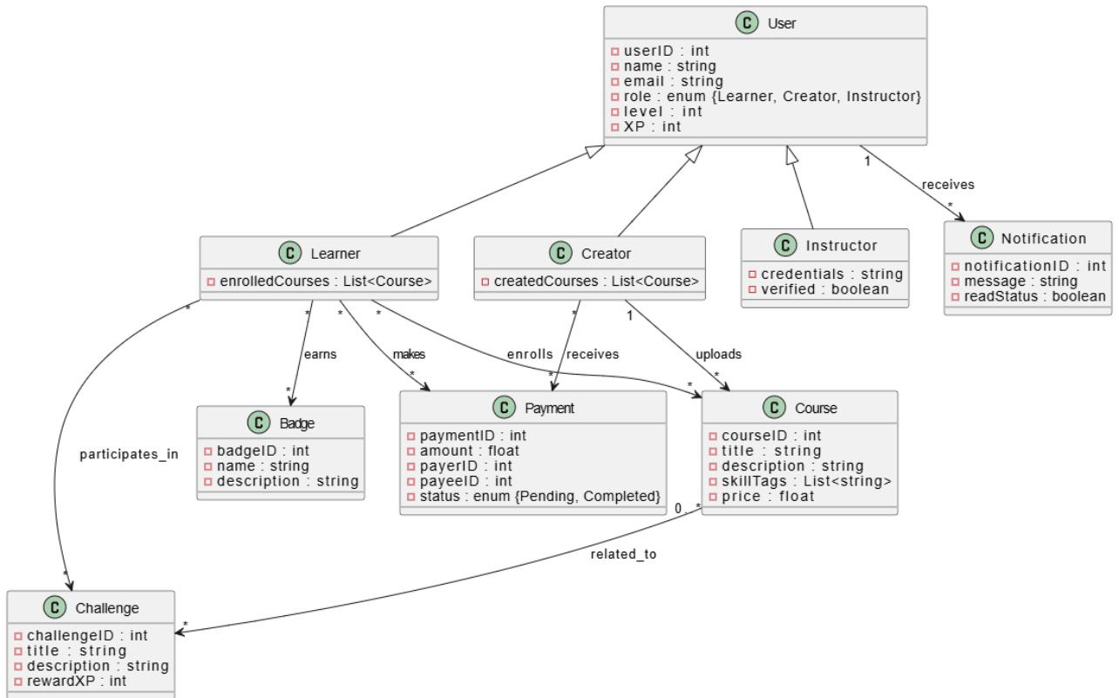
figure 3. 1 class diagram
The Class Diagram shows the basic structure of the SkillArena system. The main entity is the User, which is divided into Learner and Creator, and both share common information like userID, XP, and level.
The diagram also explains the main features of the system:
Gamification happens through the Badge and Challenge classes, which increase the user’s XP.
Payments are shown through the Payment class, which connects the Learner (who pays) with the Creator (who receives the payment) through the Course.
This structure makes sure the system supports both the reward system and the payment process in a clear and organized way.

3.7.2 Activity diagram
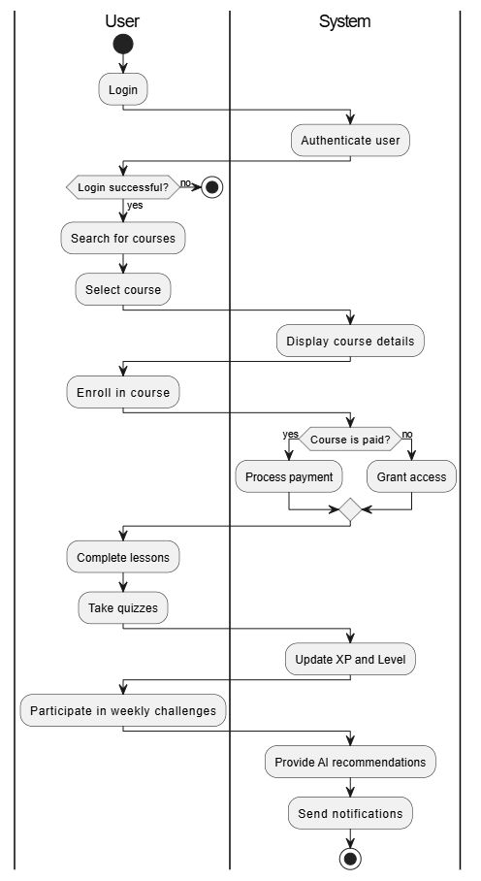
figure 3. 2 activity diagram
The Activity Diagram describes how the user moves through the SkillArena learning experience from start to finish. It separates the user’s actions from the system’s actions to make the process clear. The journey starts when the user signs in, searches for a course, chooses one, and tries to enroll. At this point, the system checks whether the course requires payment, and based on the result, it either handles the payment or allows the user to enter the course right away.
As the user continues learning by completing lessons and quizzes, the system updates their XP and level as part of the gamification system. The flow continues with the user joining weekly challenges to stay motivated. Toward the end, the system provides AI-based recommendations and sends notifications to keep the user engaged. This creates a smooth and connected experience that combines learning, rewards, and intelligent support in one process.

3.7.2 Entity-Relationship diagram
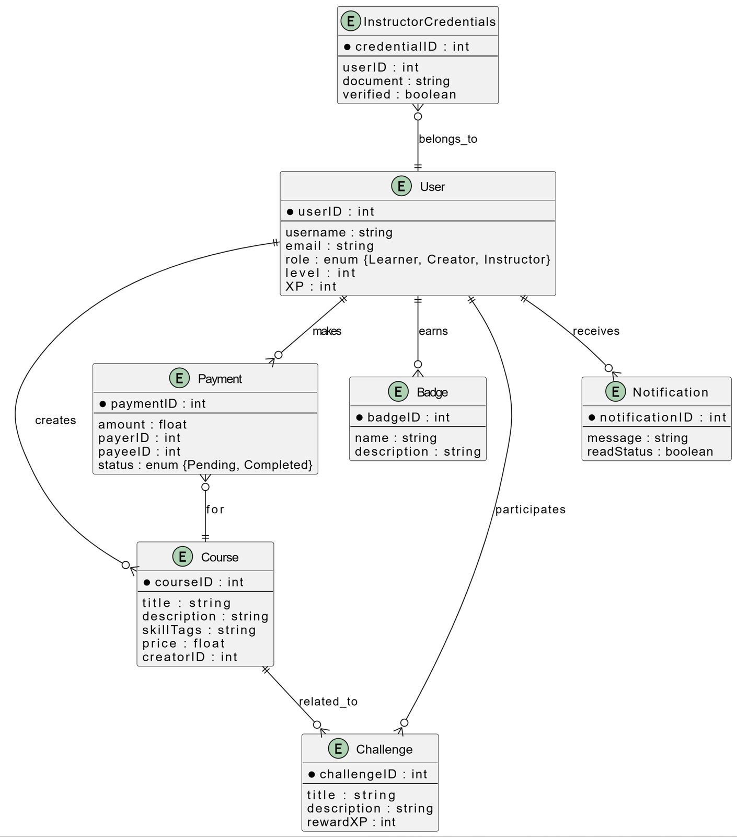
figure 3. 3 entity-relation digram
The Entity-Relationship (ER) Diagram shows how the main parts of the SkillArena database are connected. The User is the central entity, and it has a one-to-one link with InstructorCredentials for verification, and a one-to-many link with Course because each course is created by a single user. The diagram also includes the Badge and Challenge entities to represent the gamification system, where users can join challenges and earn badges through many-to-many relationships. Payments are handled through the Payment entity, which connects a user to the course they paid for. Overall, the diagram organizes user roles, courses, payments, and gamification in a clear and simple way.

3.8 Ethical, Legal, and Social Issues
- Ethical Consideration (Data Use): How will the project ensure the ethical handling of user data collected by the AI recommendation engine? Users must be informed about data collection.
- Legal Consideration (Content IP): The platform must establish clear terms of service regarding Intellectual Property Rights for the content uploaded by instructors (FR2.0).
- Social Consideration (Competition): How will the Gamification features (Leaderboards) be implemented to foster healthy competition rather than discourage lower-ranked users?

