Basma Tamer El Shenawy

900150283

Assignment 3

PDML

**My own Implementation**

Data-processing:   
- I got the mean image and subtracted it from all the images  
- I got the standard deviation and divided all the images by it  
- I did data augmentation by flipping the Images and adding them to my data

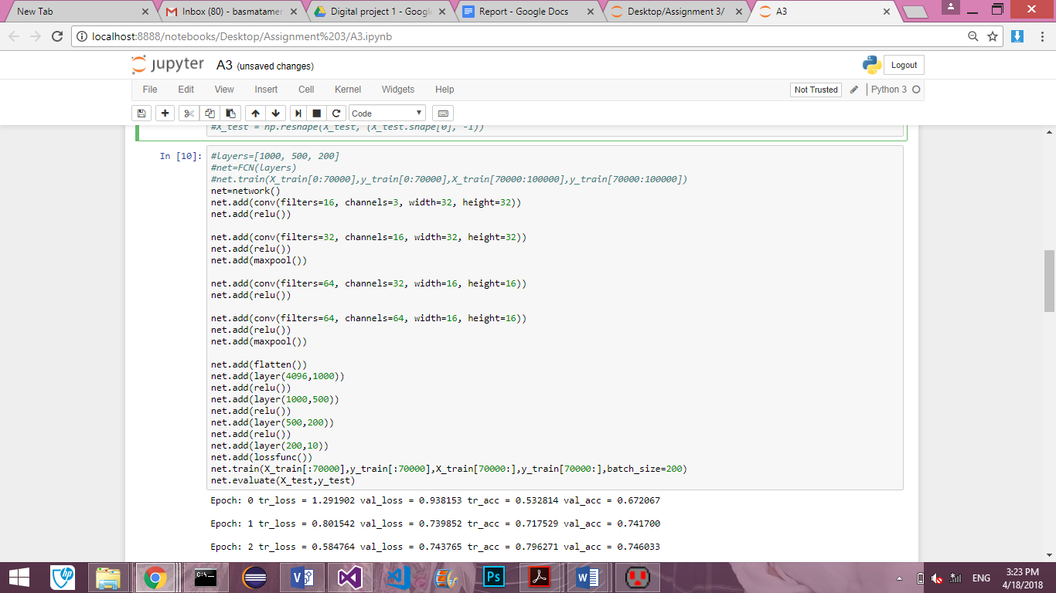My Architecture:   
My architecture is made of 4 convolutional layers, 2 pooling layers and 3 fully connected layers. The architecture goes as follows:

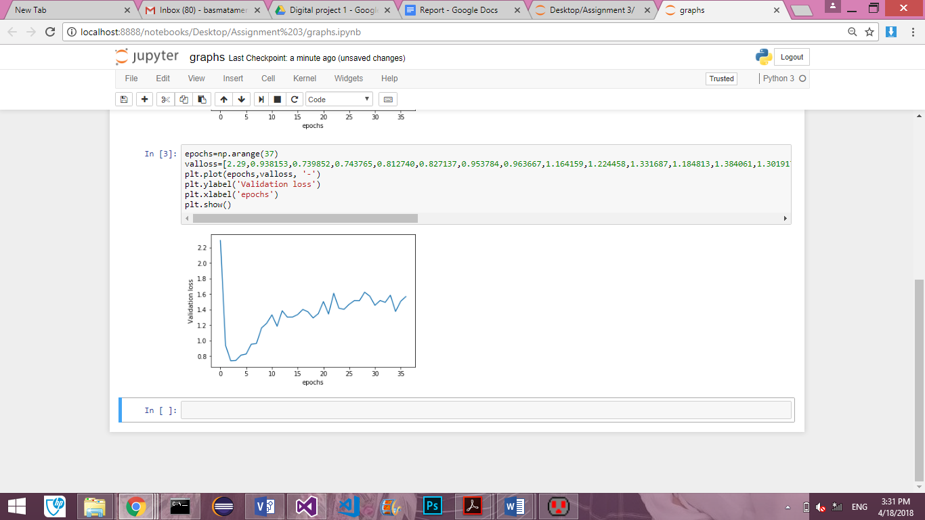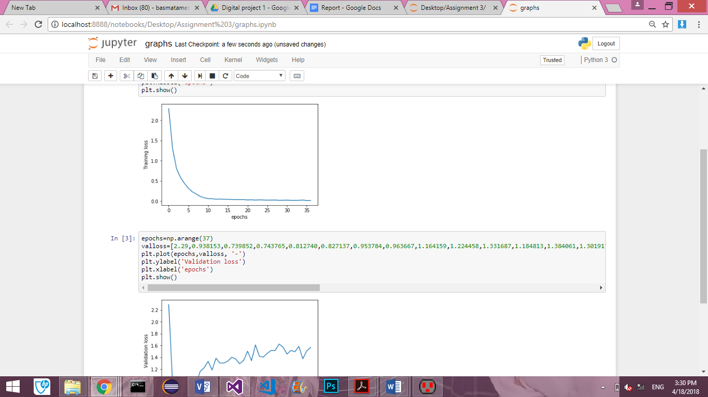I used a random seed of 7. I began by trying one convolutional network and 3 fully connected networks. The code was very fast however the accuracies were not good. So I then tried having 2 convolutional layers and 2 fully connected layers but the accuracy wasn't that high either so I tried the architecture mentioned above and it got the testing accuracy: 75.96%. Check the file A3 and graphs to see the graphs and the accuracies. I stopped training when I saw that the validation accuracy saturated for about 10 epochs.

I then got the accuracy of each of the classes.

|  |  |
| --- | --- |
| C:\Users\LaptopMarket\Downloads\Screenshot_2018-03-02_04-30-45.png |  |
| Accuracies of the LLS (assignment 1) | Accuracies of the CNN |

As we can see here, the Accuracy of the CNN is much higher than that of the LLS.

**Keras**

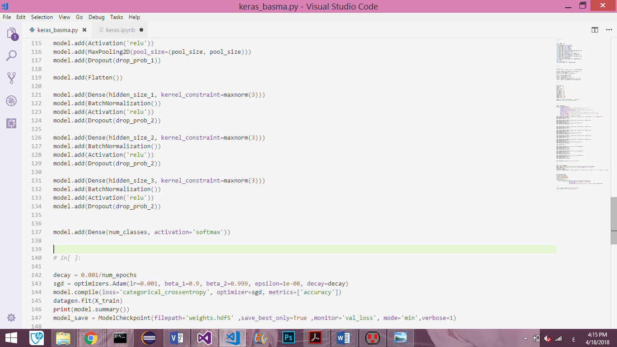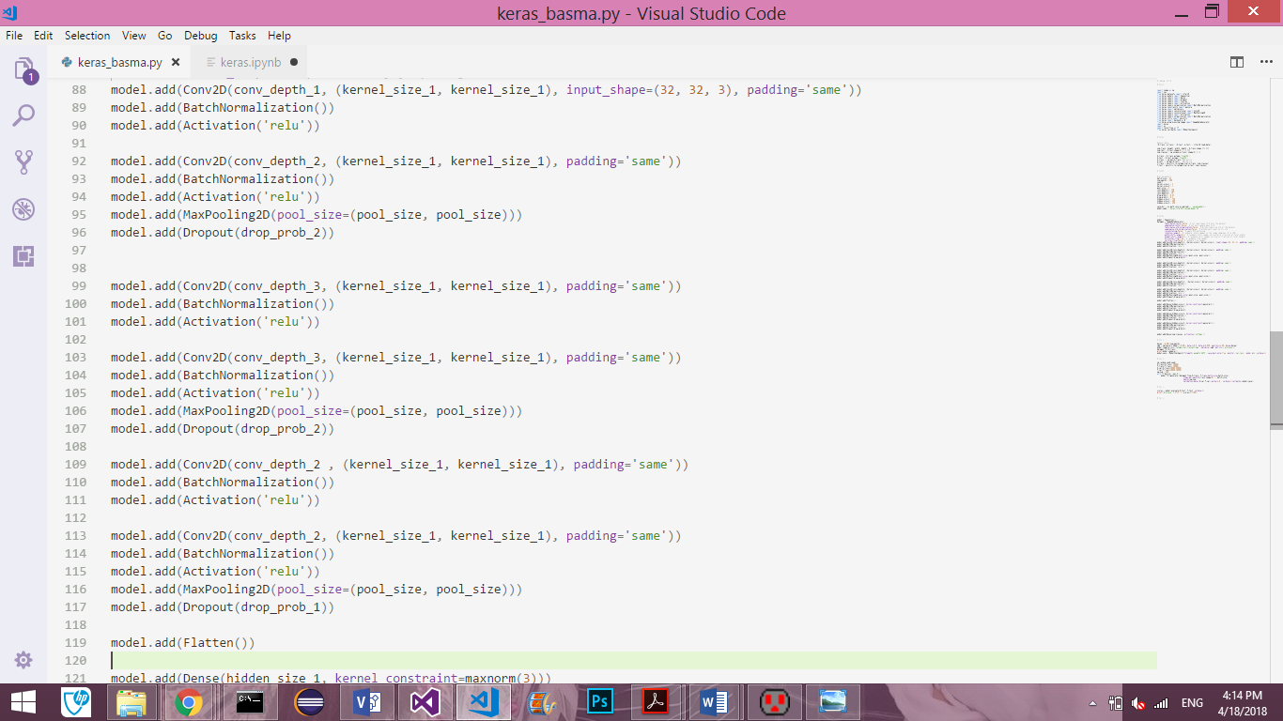I implemented a keras code with the following architecture.



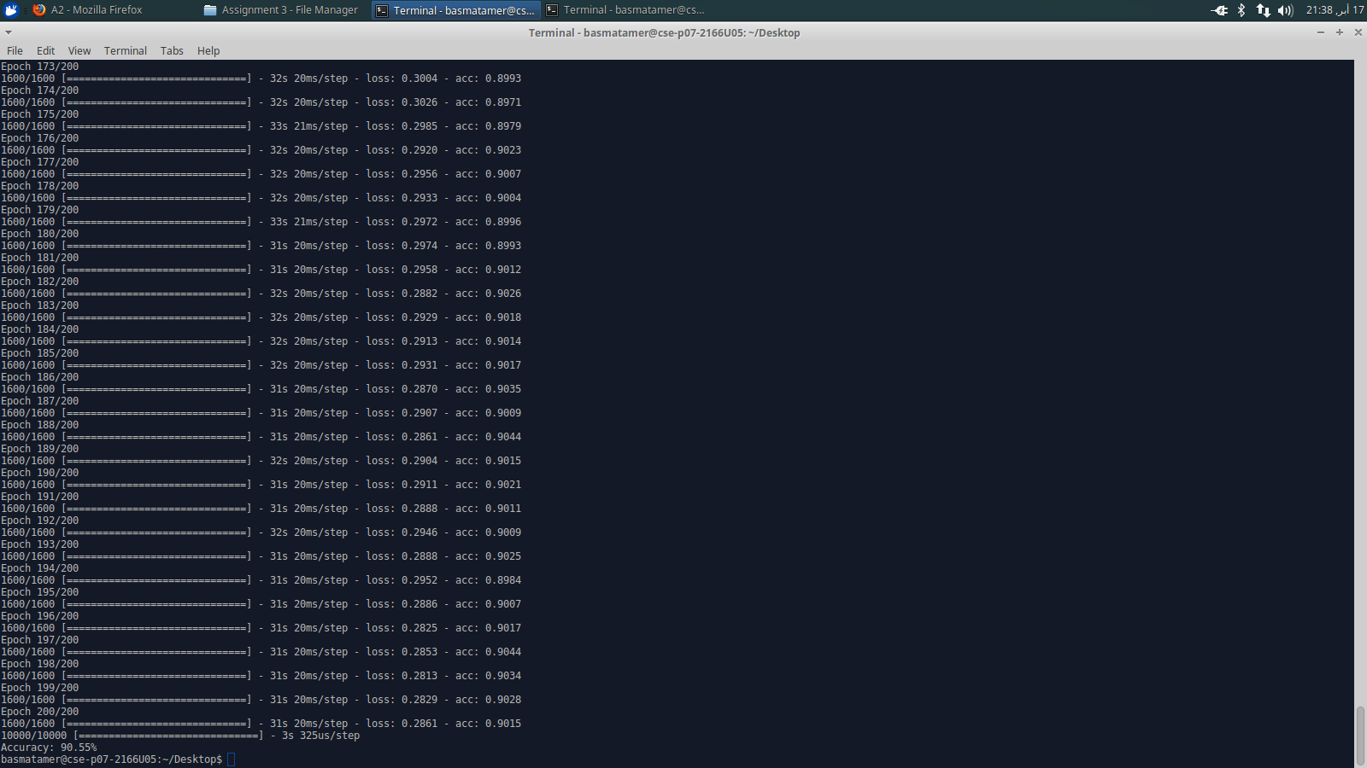This produced an accuracy of 90.55%;

Therefore, my average accuracy is: 83.255%