**Professional Programming Practice**

**ITC 515 - Assignment 4**

**Roshan Basnet - 11620446**

**BUG 4 – Same dice values rolled at any loop**

**Description:** The 3 dice values player rolls and gets remain the same while it should be randomly and differently between 2 rolls.

1. **Replication.**

Bellows are screenshots which best describing the bug. According to them, the 3 dice values player gets remain unchanged:

CROWN, CLUB, CROWN rolled every turn:

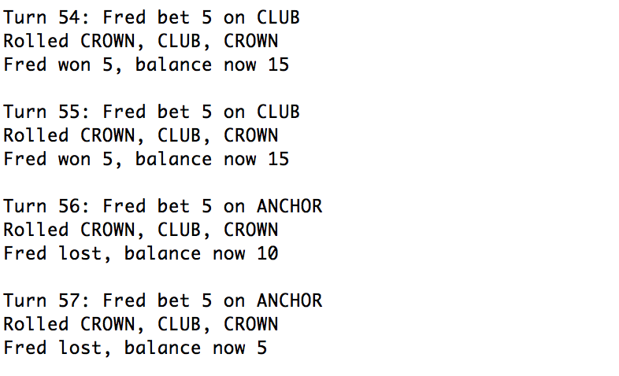

Run the game again, this time DIAMOND, ANCHOR, CROWN rolled and remained unchanged:

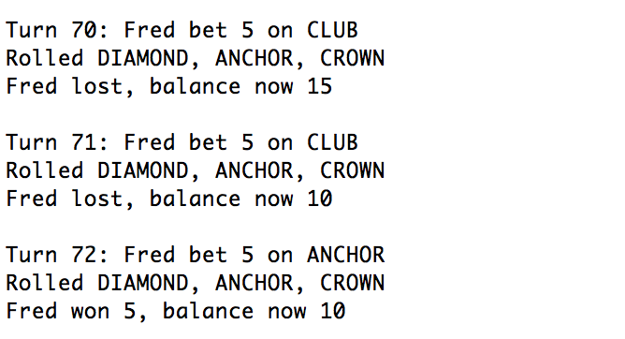

**2. Simplification.**

Regrading the rolled values, we can clearly seen it starts from Main class at:

With the messages printout we can see if the dice values changed after the playRound method invoked. And the console shows:

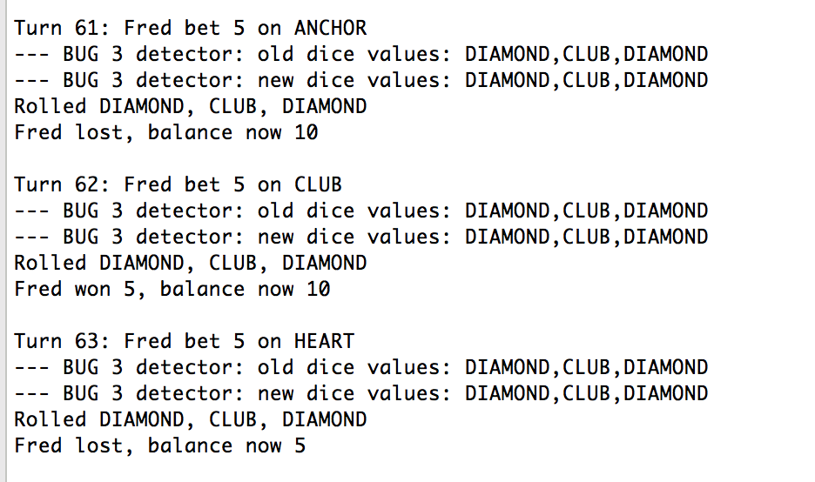

Which means the playRound method does not change the dice values (while it should). The bug is rooted inside this method.

In the playRound method, every dice of the game is rolled:

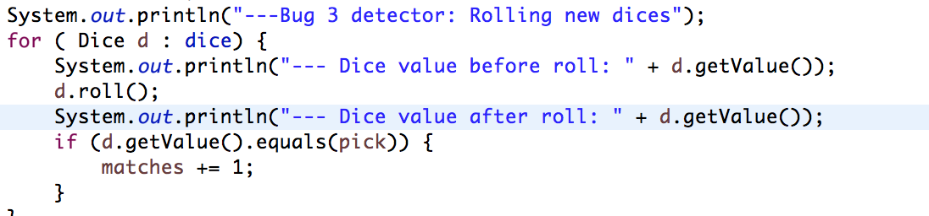

And the console after game run:

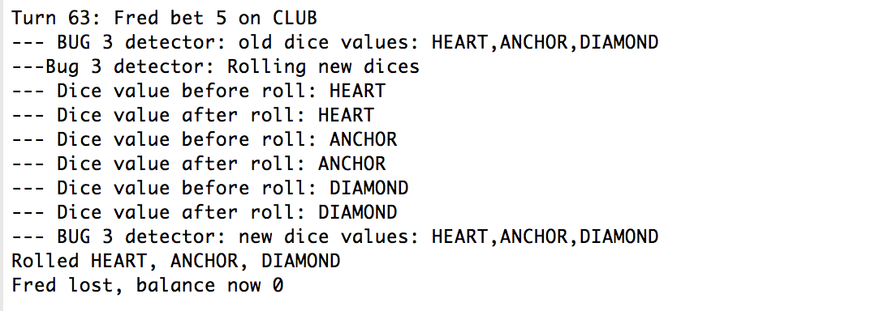

Clearly, the roll() method does not change the dice value (while it should). The bug must rooted in the roll method.

The roll() method of the Dice class:

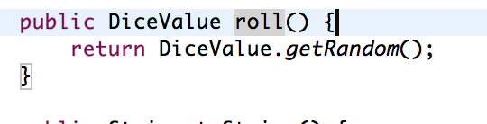

Here we identify the point of bug, the affected value which causes the bug is the Dice.value

**3. Tracing.**

The bugging point has been detected, at the point it should set the new value for the Dice object which is currently invoked with the random value generated:

**4. Resolution**

The resolution is clearly, we just have to update the random value for the Diceclass:

And run the game to see if the bug is fixed:

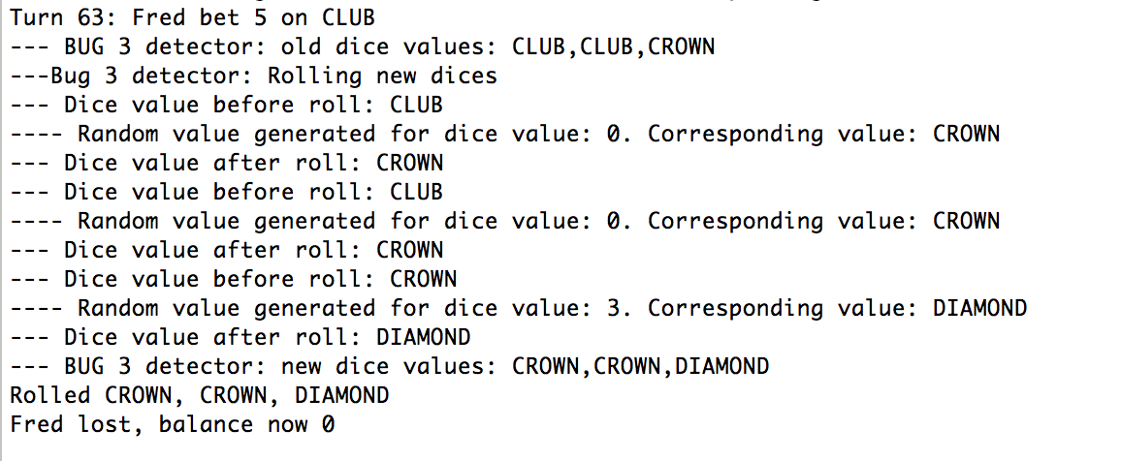

Now the dice values are CHANGED time to time, randomly!

Try with other runs:

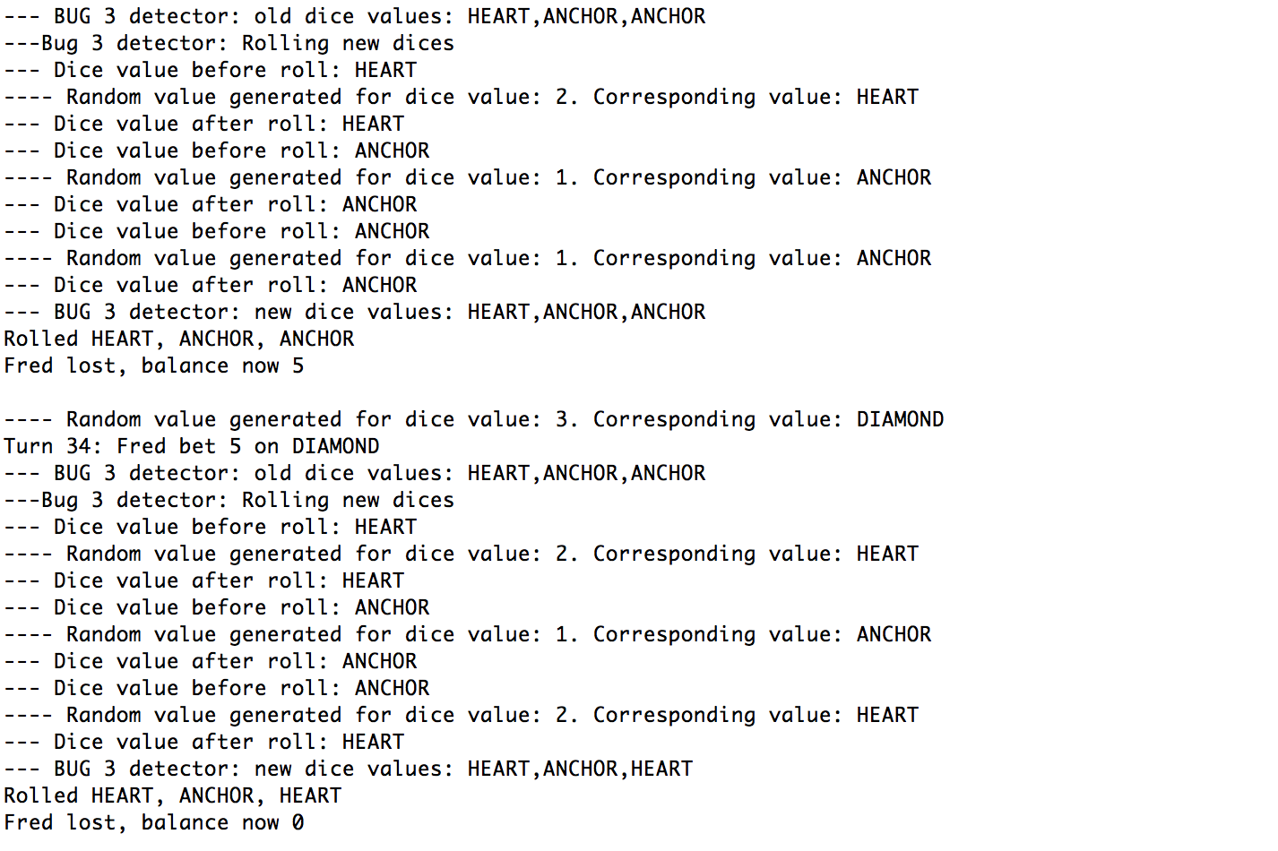

After removing all debugging messages:

