**Professional Programming Practice**

**ITC 515 - Assignment 4**

**Roshan Basnet - 11620446**

**BUG 8 – Bet amount inflexible**

**Description:** The player is not allowed to enter his amount of bet. The bet amount is hard coded

1. **Replication**

In the main class, the bet amount is initialised equals 5. And in every turn and game, the bet amount is the same:

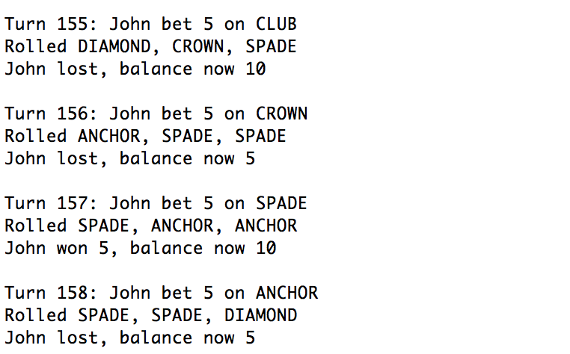

**2. Simplification**

The bug occurs here when the balance is assigned to the playerBalance variable which privously hard coded.

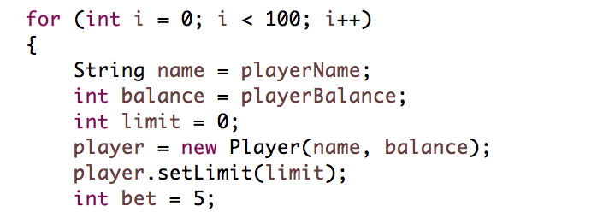

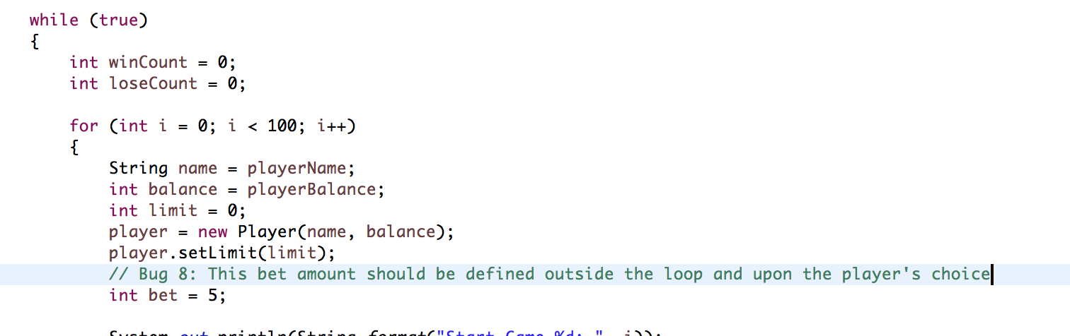

**3. Tracing**

To the point of bug, code should be inserted to solve the issue:

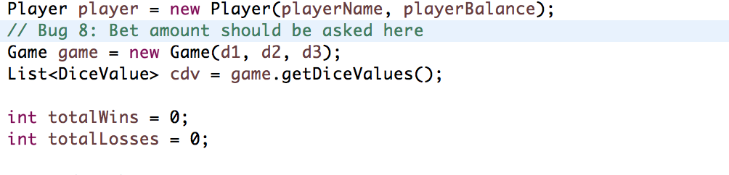

**4. Resolution**

Just as asking for player’s age, name and balance. Code to ask for bet amount is the same. 5 by default (in case player enters nothing or a string or out of range permitted).

Here are screenshots after bug fixed:

