You are given a database. Figure 1 describe the database structure.
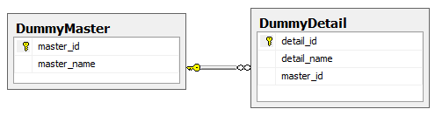
- Create API as following:
- Get all Master
- Get detail by detail name
- Get detail by master name
- Using WebMVC to call the above API to execute the following requirements:
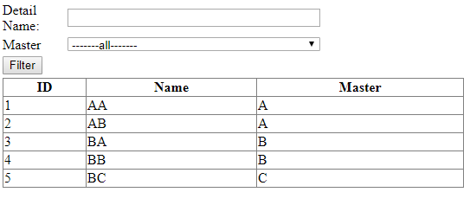
- Master is a Dropdown list, and its data will be loaded from [DummyMaster] Table.
Note : -----alll------ is not a record in the table.
- When user clicks on [Filter] button data will be loaded to the GridView such that:
- IF Detail Name is blank, means users want to find all of DummyDetail without caring about its name. IF user fill text into Detail Name, means users want to find all of DummyDetail which have name contains value what they fill.
- If [all] is selected on the dropdownlist, means users want to find all of DummyDetail without caring about its master. IF another item is selected on the dropdownlist, means users want to find all of DummyDetail which belong to the corresponding master.
See below picture for more detail:
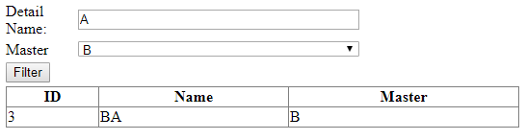
The filter result shows that: User want to find all of DummyDetail that have name contains [A] and belongs to Master [B].

