

**Online-Shopping-for-Baking-Ingredients**

**System Software Design Specification**

– Hanoi, August 2022 –

**Table of Contents**

I. Overview 3

1. Use Case Diagram 3

2. Use Case Diagram 3

3. Class Diagram 5

II. Code Designs 7

1. Login 7

2. Sign up Account 7

3. Add to Cart 8

4. Cart Detail 8

5. Remove Cart Item 10

6. View Product List 11

7. View Product Detail 12

8. View Blog List 13

9. Update Quantity 13

10. Cancel Order 14

11. View Order Management 14

12. Change Order State 15

13. View Account List 15

14. View Account Detail 16

15. Change Account Status 16

# I. Overview

## 1. Use Case Diagram

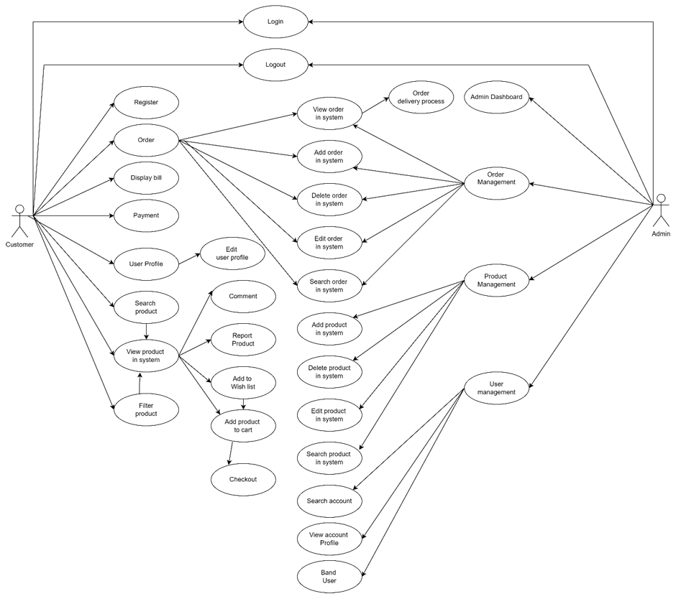

## 2. Use Case

* **Guest use cases**

|  |  |  |
| --- | --- | --- |
| **Use Case ID** | **User case Name** | **Description** |
| UC-01 | Login | Allows the user to enter account & password to login; on this page, there are also links for users to register new information or reset the password for the case they forget it |
| UC-02 | Sign Up Account | Allows the guest to register to the system by inputting following information: full name, email, phone, user name, password, confirm password, dob |
| UC-03 | Add To Cart | Allow user to add selected products to the cart |
| UC-04 | Cart Detail | Allow user view list of selected product in cart |
| UC-05 | Remove Cart Item | User remove chosen product from shopping cart |
| UC-06 | View Product List | Display list of products including thumbnail, name, brief information; divided into multiple pages; when clicking redirect to product details  Allow users to filter products by name, price, brand,... |
| UC-07 | View Product Detail | Show product details and related product |
| UC-08 | View Blog List | Show the paginated list of all blogs. From each blog, the admin can choose to view blog details |
| UC-09 | Update Quantity | Allow user to increase or decrease the number of quantity of a specific product |

* **Customer use cases**

|  |  |  |
| --- | --- | --- |
| **Use Case ID** | **User case Name** | **Description** |
| UC-01 | View Order History | Allow logged in users to view their placed orders |
| UC-02 | Cancel order | User can cancel one or many order(s) |

* **Staff use cases**

|  |  |  |
| --- | --- | --- |
| **Use Case ID** | **User case Name** | **Description** |
| UC-01 | View Order Management | Display all order(s), Staff also can manage it such as confirm order, cancel shipping,… |
| UC-02 | Change Order State | Allow Staff to change orders status that the user has been set to buy |

* **Admin use cases**

|  |  |  |
| --- | --- | --- |
| **Use Case ID** | **User case Name** | **Description** |
| UC-01 | View Account List | View all users, from each user, the admin can choose to view details or change account status |
| UC-02 | View Account Detail | Allow admin to view details of account and edit some account information |
| UC-03 | Change Account Status | Allows the admin to block or re-active an account |

## 3. Class Diagram

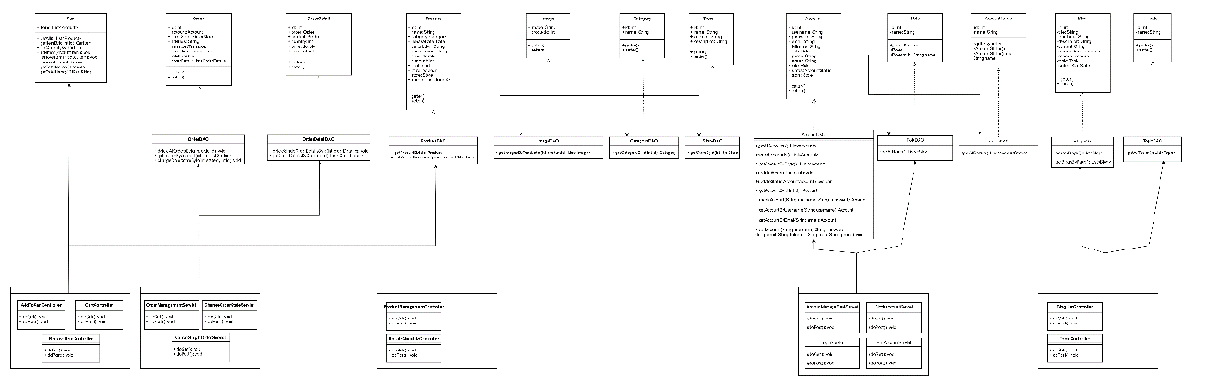

# II. Code Designs

## 1. Login

Sequence Diagram(s)

## 2. Sign up Account

Sequence Diagram(s)

## 3. Add to Cart

Sequence Diagram(s)

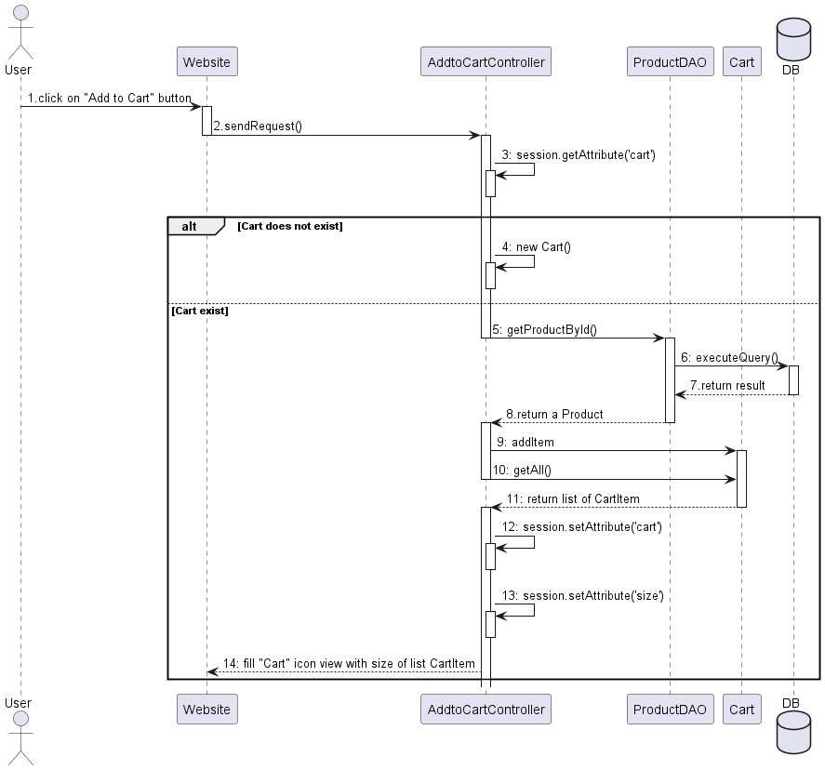

## 4. Cart Detail

Sequence Diagram(s)

## 5. Remove Cart Item

Sequence Diagram(s)

## 6. View Product List

Sequence Diagram(s)

## 7. View Product Detail

Sequence Diagram(s)

## 8. View Blog List

Sequence Diagram(s)

## 9. Update Quantity

Sequence Diagram(s)

## 10. Cancel Order

Sequence Diagram(s)

## 11. View Order Management

Sequence Diagram(s)

## 12. Change Order State

Sequence Diagram(s)

## 13. View Account List

Sequence Diagram(s)

## 14. View Account Detail

Sequence Diagram(s)

## 15. Change Account Status

Sequence Diagram(s)

## 