

**Online-Shopping-for-Baking-Ingredients**

**SystemSoftware Design Specification**

– Hanoi, August 2022 –

**Table of Contents**

I. Overview 3

1. Use Case Diagram 3

2. Class Diagram 3

II. Code Designs 3

1. View product information 4

2. View delivery process 4

3. Search product by name 5

4. Checkout 6

5. Wish List 7

6. Report 8

7. Login 9

8. Comment 10

9. Edit Information of items 11

10. Filter items 11

11. User Profile 12

12. Logout 13

13. Add new product 13

14. Add to cart 13

15. Register 14

# I. Overview

## 1. Use Case Diagram

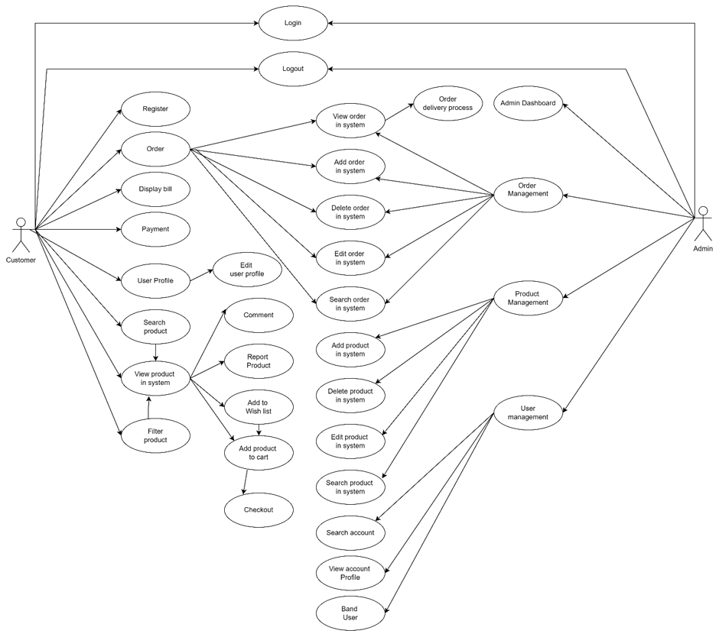

## 2. Class Diagram

# II. Code Designs

## 1. View product information

Sequence Diagram(s)

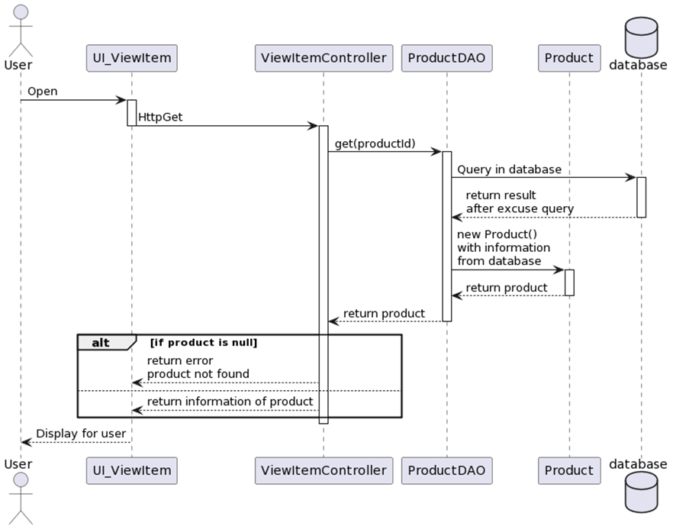

## 

## 2. View delivery process

Sequence Diagram(s)

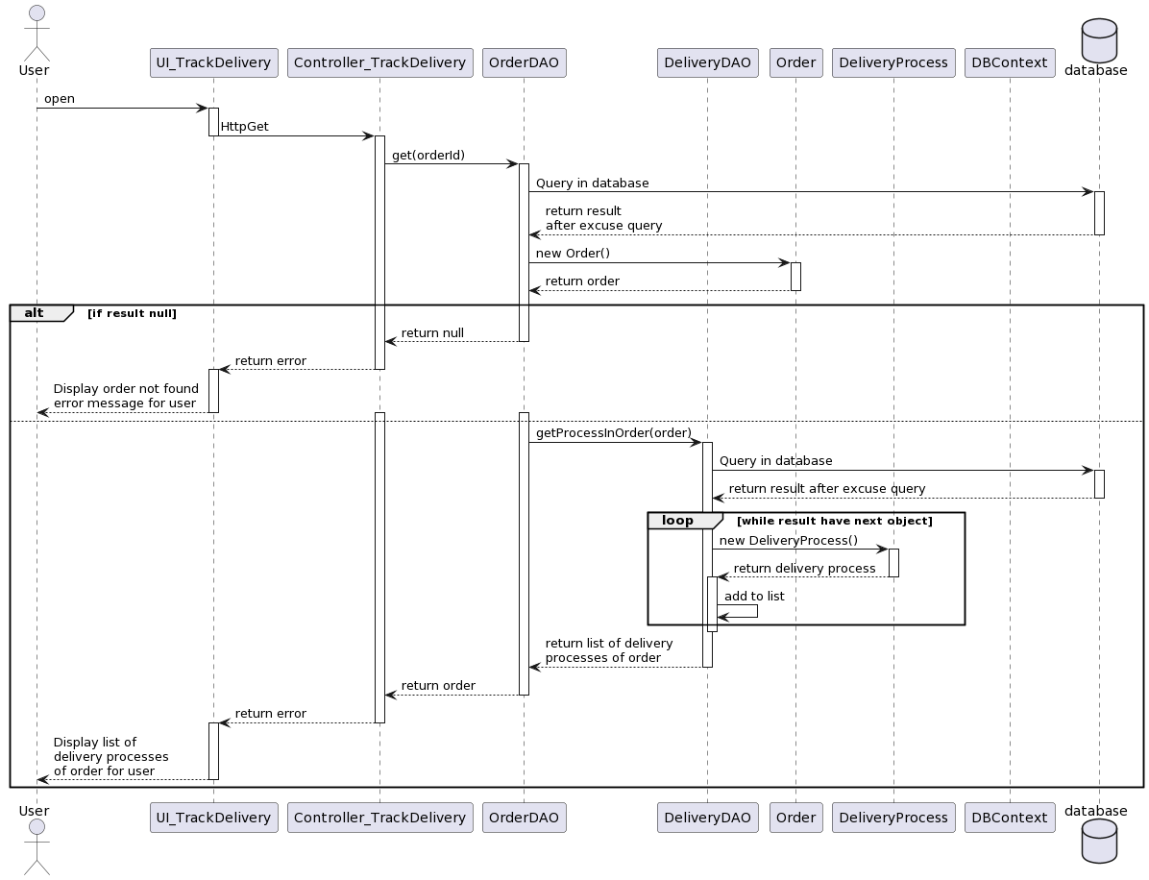

## 3. Search product by name

Sequence Diagram(s)

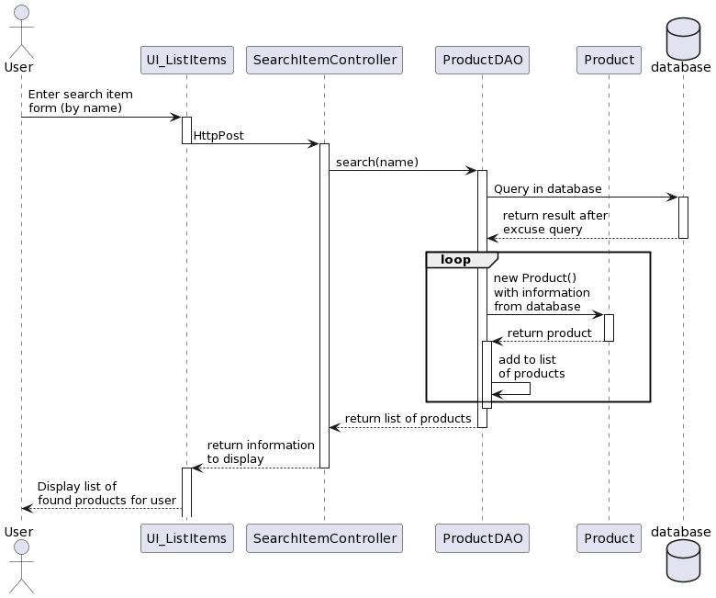

## 

## 4. Checkout

Sequence Diagram(s)

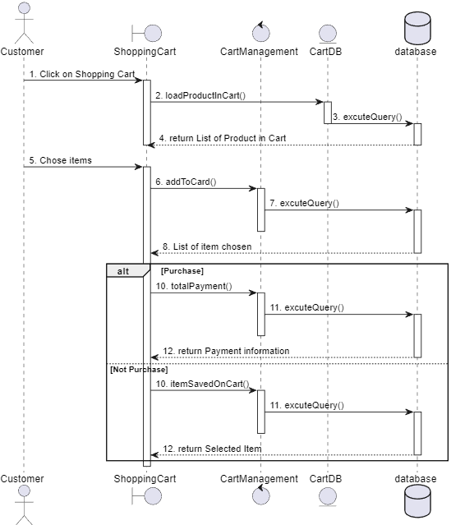

## 5. Wish List

Sequence Diagram(s)

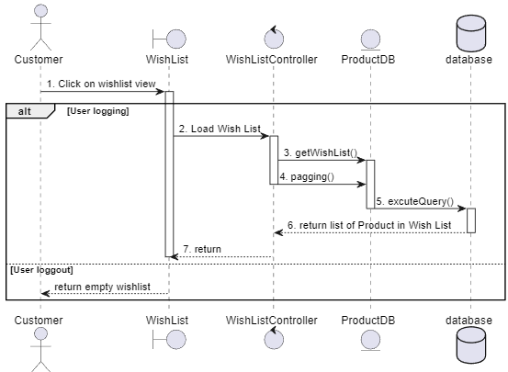

## 6. Report

Sequence Diagram(s)

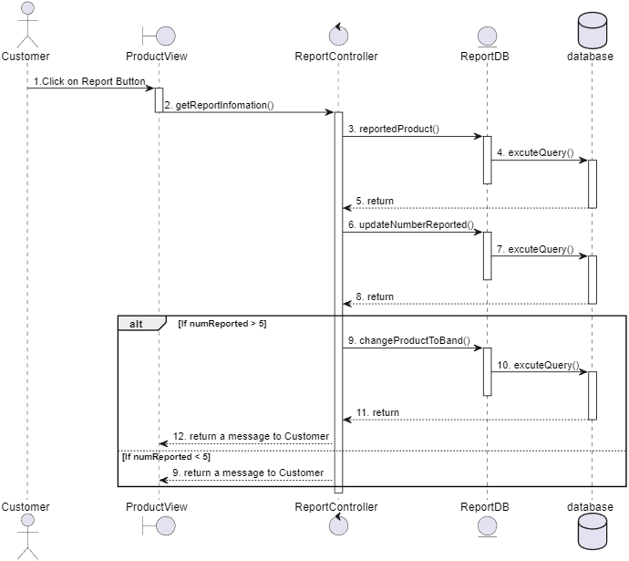

## 7. Login

Sequence Diagram(s)

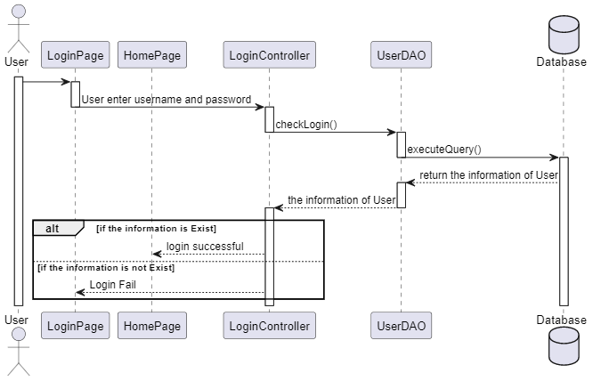

## 8. Comment

Sequence Diagram(s)

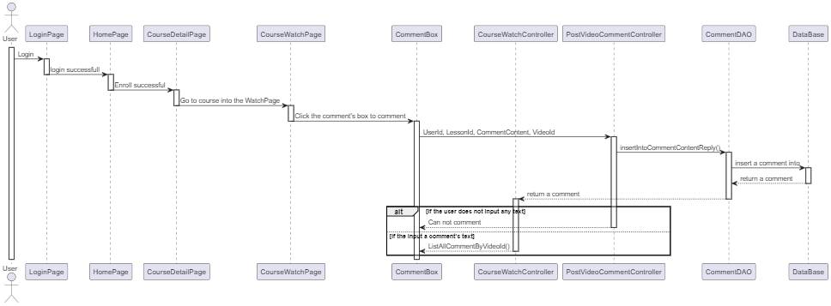

## 9. Edit Information of items

Sequence Diagram(s)

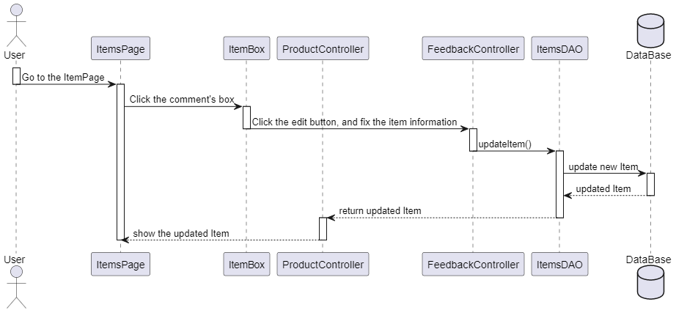

## 10. Filter items

Sequence Diagram(s)

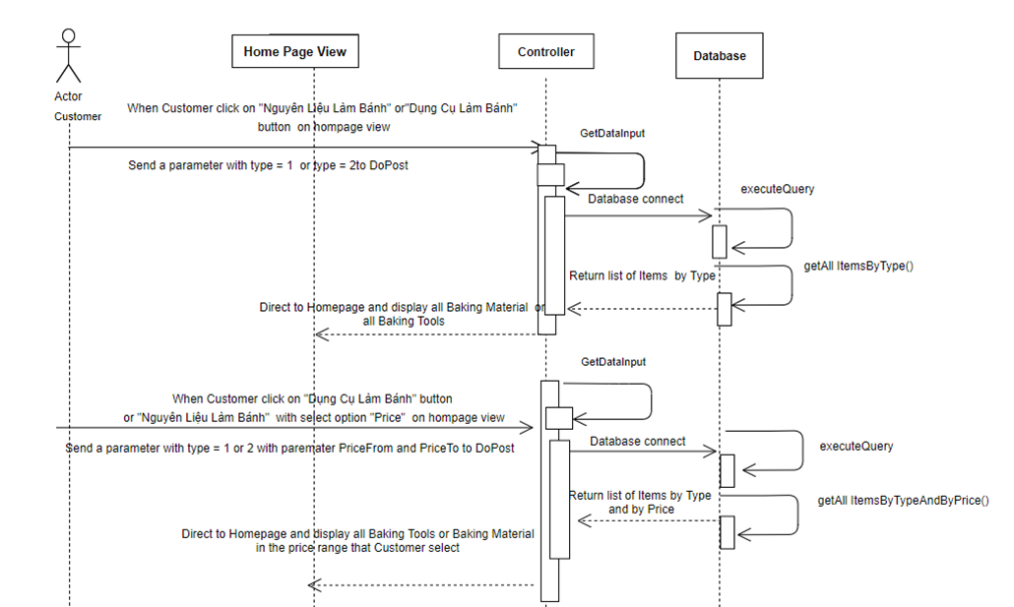

## 

## 11. User Profile

Sequence Diagram(s)

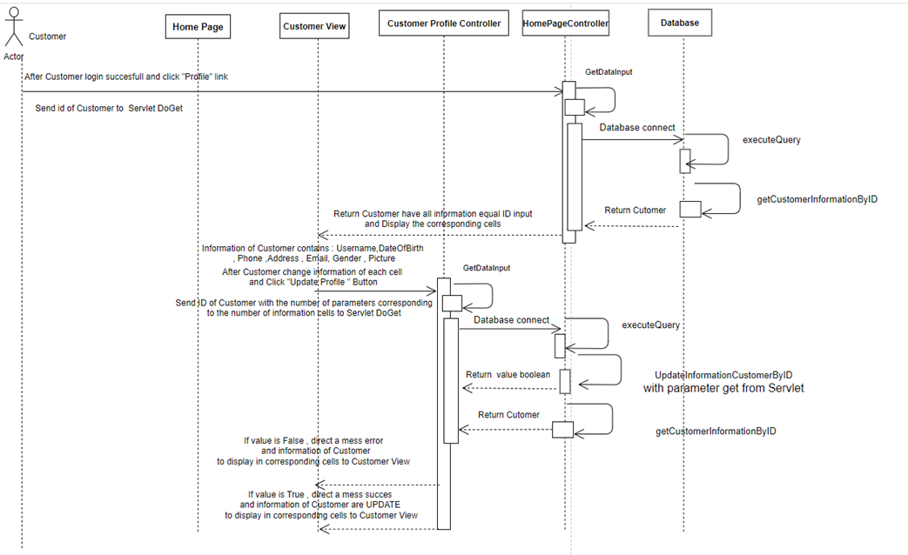

## 12. Logout

Sequence Diagram(s)

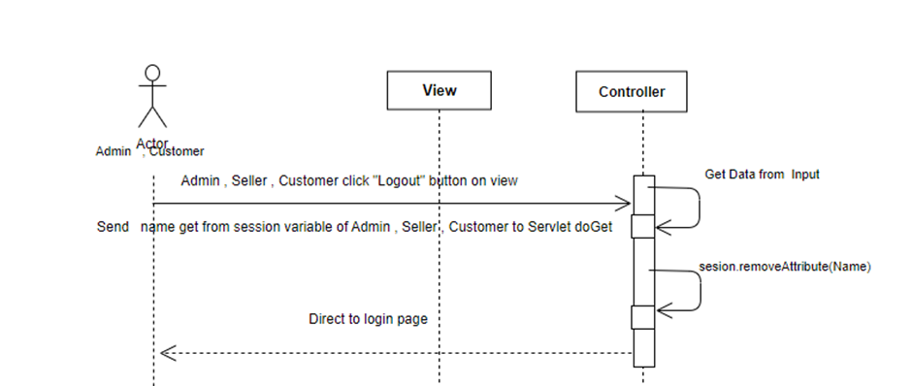

## 13. Add new product

Sequence Diagram(s)

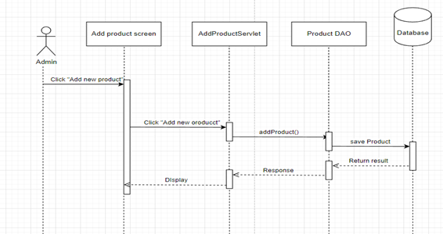

## 14. Add to cart

Sequence Diagram(s)

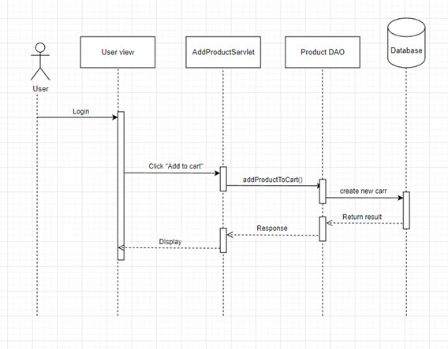

## 15. Register

Sequence Diagram(s)



 