

**BOOKIE – EBOOK SYSTEM**

**Software Requirement Specification**

– Hanoi, September 2022 –

Contents

I. Overview 4

1. Introduction 4

2. System Functions 5

a. Screen Flow 5

b. Screen Details 5

3. Common Requirements 8

II. Functional Requirements 9

1. Home 9

2. User register 10

3. Forget Password 11

4. Logout 12

5. Sign In 13

6. View profile (Admin) 14

7. Update profile (Admin) 15

8. View list of books 16

9. View book’s description 17

10. View profile (User) 18

11. Update profile (User) 19

12. View security status 20

13. Change password 21

14. Comment 22

15. Rate book 23

16. Add to Favourite 24

17. Report Book 25

18. View/Update/Disable Book 26

19. View/Update/Delete Table of Contents 28

20. Access Level 29

21. View List User 30

22. Users Management 31

23. Wallet 32

a. View 32

b. Transaction history 33

c. Recharge 34

d. Withdraw 35

24. Payment 36

a. Remove 36

b. Add 37

25. Purchase a book 38

26. Reading interface 38

27. Pre-reading 39

28. Table of Contents 40

29. Update Library’s View (Search Engine + Paging) 42

30. Delete from Favourite 44

31. View/Manage Novels 46

32. View List Author 48

33. Edit Author 49

34. Admin Panel 50

35. List book of this author 51

36. Add chapter for user’s novel 52

37. Edit chapter for user’s novel 54

38. Delete chapter for user’s novel 55

39. Category Management 56

a. View 56

b. Remove 57

c. Update 58

d. Add 59

40. Bookshelf 60

41. View/Solve Reports 61

42. Ban Comment 63

43. Report Comment 65

44. View author’s information 66

45. Payment 67

a. View 67

b. Deposit 68

c. Withdraw 69

d. Transaction manage 70

46. Purchase novel’s chapter 71

47. Ticket 72

48. Notification 73

49. Update Comment (Reply + Edit + Delete) 74

50. Report Transactions 75

# I. Overview

## 1. Introduction

The Bookie – eBook System is a new web system that replaces the current library and all kind of it. Nowadays, people are getting more busy and lazier. They don’t have enough time or don’t want to go to the library to find a book or a shop to buy one. The system is expected to prevent the dead of knowledge come from books. Bookie want to create a brand new online-library that people can have access anytime, anywhere.

Main users:

* Administrators
* Customers: Normal person and authors

Figure 1: Context diagram

## 2. System Functions

### a. Screen Flow

Figure 2: Screen Flow

### b. Screen Details

|  |  |  |  |
| --- | --- | --- | --- |
| **#** | **Feature** | **Screen** | **Description** |
| 1 | Common | Home Page | Default screen where all users can visit. There has information of system, contact of developer. The site can lead to login page and register page |
| 2 | Common | User Register | Screen where users can create new account with personal information. Click Submit to submit new account |
| 3 | Common | Login | Screen where the user logs into the system with the registered account. If the account or password is wrong, the system will notify the user |
| 4 | Common | Change Password | Allow users who want to change their password account |
| 5 | Common | User Profile | Display information about the user who is logged in to the system |
| 6 | Admin | Dashboard | Display the dashboard that helps administrator manage the system. |
| 7 | Common | Forgot Password | Allow user to reset password using registered email in case user forgot password |
| 8 | Customers | Top Favourite | Display books having the most users adding to favour |
| 9 | Customers | Weekly sales | Display books chosen with special discount weekly |
| 10 | Customers | Book List | Display all books/novels |
| 11 | Customers | View Book’s Information | Display information about name, authors, category, description, price, index… of the book |
| 12 | Customers | Library | Display all books/novels customers purchase |
| 13 | Customers | Wallet | Display balance in customer’s wallet |
| 14 | Customers | Purchase | Allow customers to purchase a book/chapter with their wallet |
| 15 | Customers | Read content | Allow customers to read the book/novel they purchased |
| 16 | Customers | Comment | Allow customers to write their comment in book’s section |
| 17 | Customers | Rating | Allow customers to rate a book/novel on a 5-star scale |
| 18 | Customers | Searching | Allow customers to search for specific book by enter key words |
| 19 | Customers | Report a purchase | Allow customers to report defective work or problematic transactions to request a refund/exchange |
| 20 | Customers | Report a book | Allow customers to report a book that violates the community standards |
| 21 | Customers | Create an Original Work | Allow authors to write and post their own work (must satisfy special rules for self-work) |
| 22 | Customers | Paid mode | Allow authors to open the charge for their work |
| 23 | Admin | Manage Category | Allow admins who want to add, edit and delete category of books |
| 24 | Admin | Manage Book | Allow admins who want to add, edit and delete book’s information |
| 25 | Admin | Manage OW | Allow admins who want to add, edit and delete user’s OW |
| 26 | Admin | Manage Comment | Allow admins who want to view and delete if there are any inappropriate/offensive comments |
| 27 | Admin | Manage User | Allow admins who want to up user to admin or disable any excessive user |
| 28 | Admin | View transactions | Display all purchase in the system |
| 29 | Admin | View reports | Allow admins who want to receive and handle any report by users |
| 30 | Common | Change email | Allow users who want to change their email |

Table 1: Screen Flow

#### c. User Authorization

|  |  |  |  |
| --- | --- | --- | --- |
| **Screen** | **Admin** | **Staff** | **Customers** |
| Home Page | X | X | X |
| User Register | X | X | X |
| Customers Login | X | X | X |
| Admin Login | X | X |  |
| User Profile | X |  | X |
| Admin Screen | X | X |  |
| Forgot Password | X | X | X |
| Top Favourite | X | X | X |
| Weekly sales | X | X | X |
| Book List | X | X | X |
| View Book’s Information | X | X | X |
| Library | X | X | X |
| Wallet |  |  | X |
| Purchase | X | X | X |
| Read content | X | X | X |
| Comment | X | X | X |
| Rating | X | X | X |
| Searching | X | X | X |
| Report a purchase |  |  | X |
| Report a book |  |  | X |
| Create an OW |  |  | X |
| Paid mode |  |  | X |
| Manage Category | X | X |  |
| Manage Book | X | X |  |
| Manage OW | X | X |  |
| Manage Comment | X | X |  |
| Manage User | X | X |  |
| Change email | X | X | X |
| Change Access Level | X | X |  |
| Promote to Staff | X |  |  |

Table 2: User Authorization

In which:

* Admin: The manager of the organisation, has access to all system functions, decides every access to the system.
* Staff: The presentative of admin, who has the right to manage the system
* Customers: People who want to read book, novels and do the simple function of an eBook system. They can also be an author to write their own books, novels to make money

#### d. Non-Screen Functions

|  |  |  |  |
| --- | --- | --- | --- |
| **#** | **Feature** | **System Function** | **Description** |
| 1 | Common | User Authorization | Implement the authorization mechanism into the system. Using both frontend and backend code to prevent users from accessing links without proper role. |

Table 3: Non-Screen Functions

## 3. Common Requirements

# II. Functional Requirements

## 1. Home

* Function trigger: when user visits the page or when they click on the logo.
* Function description:
* Actor: Users and Guests
* Purpose: Landing page for all users
* Interface:
* + A logo can access Homepage
* + A fixed Menu collapsed
* + A introduction slide show
* + A quote about book
* + Photos of featured product
* + Highlight/latest blogs
* + Contact interface
* Screen Layout:

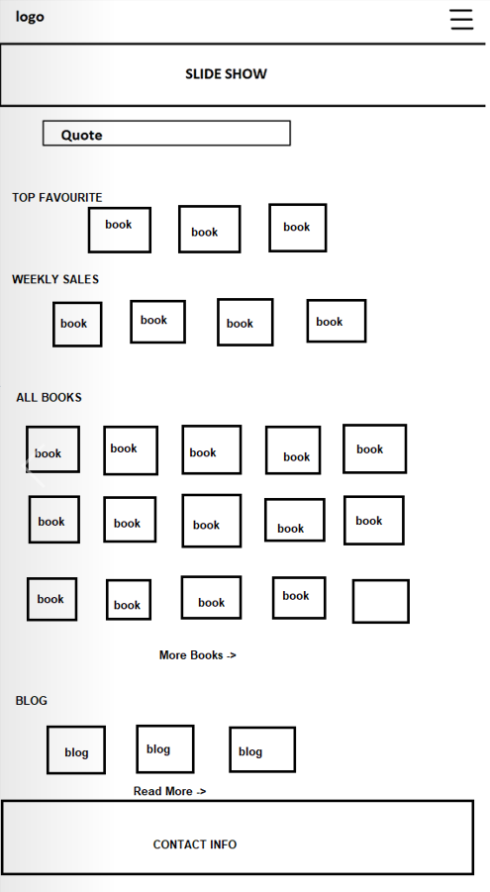

Figure 3: Home

* Function Detail: When access website, user can see overview of page. The fixed Menu when open can see all the options that mention in Logout function. Slides Show part contains 3 pictures. Clicking on “See more” or “Read more”, user can see all of books or blogs. The contact carry information to connect to Administrators.

## 2. User register

* Function trigger: User clicks the “Sign Up” on Log In display.
* Function description:
* Actor: Guests
* Purpose: Register for the page
* Interface:
* 7 fields that users have to fill in all: Email, Username, Password. Phone, Full Name in the text style, Gender in option style and Birthday in date style.
* 1 link head back to the Login screen
* Screen Layout

Figure 4: Sign Up

* Function Detail:
  + All fields must be filled up with data
  + Email and phone must be unique
  + Phone: start with 0, have 10 letters of number
  + Email: must have @
  + After click “Sign Up”, if all fields are validated and account created successfully, Users will head back to the Login Screen
  + After click “Log In”, users will head Home screen

## 3. Forget Password

* Function trigger: When users click the “Forget Password” in the Login Screen
* Function description:
  + Actor: Users
  + Purpose: Help users find back their account by receive a new password sent into the email they provided when they created account.
  + Interface:
* + Input for email
* + 1 button to submit
* + 1 link to head back Login Screen
* Screen Layout:

Figure 5: Forgot Password

* Function details:
  + Users have to fill the form with an existing email that he/she had registered while they created the account
  + When he/she clicks the “Process” button, system will check the email they entered, check if it is existing in the database or not
  + If it is a valid email, a new password will be sent to that email

## 4. Logout

* Function trigger: In Home Page has been Logged In, user clicks on Menu and then selects Logout.
* Function description:
  + Actor: Users (include administrators and customers)
  + Purpose: to end access to a website
  + Interface: a Menu contains options change before and after Logout
* Screen Layout:

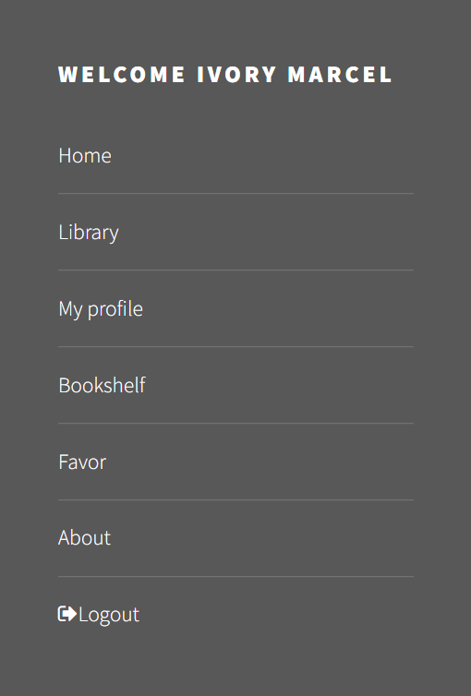 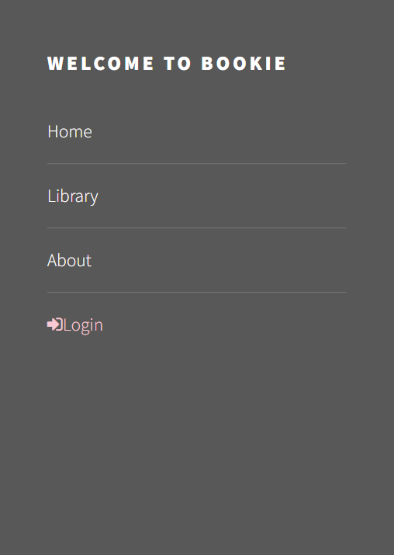

Figure 6: Before Logout Figure 7: After Logout

* Function Detail: When user click to “Logout” option, its session will be destroyed. User will be directed to Homepage.

## 5. Sign In

* Function trigger: Click “Login” on pop up home page
* Function description:
  + Actor: Admin, User
  + Users that have not yet registered cannot log in. They must contact the education unit to create a new account.
* Interface:
  + - 2 input text fields
    - 1 button “Sign In” to head into the home page of the system
    - 1 button “forget password” to head the users to the take back account screen
    - 1 button “sign up” to help users create their accounts
* Screen layout:

Figure 8: Sign In

* Function detail:
  + Users shall login to the system by using the username and password which is registered.
  + Users shall be able to use system functionalities and be directed to the formal screen after successful login.
  + The Users will receive “errors” to the login screen if the username or password is invalid.

## 6. View profile (Admin)

* Function trigger: Dash board page click “Profile”
* Function description:
  + Actor: Admin
  + Purpose: Admin can view account’s profile
* Interface:
* 5 fields are Email, Username, Password, Phone, Full Name
* “Sex” field in choice field
* Date of Birth in date field
* Screen layout:

Figure 9: View Profile (Admin)

* Function detail:

## 7. Update profile (Admin)

* Function trigger: From Profile page
* Function description:
  + Actor: Admin
  + Purpose: Admin can update profile if he/she need to
  + Interface:

● Screen layout:

Figure 10: Update Profile (Admin)

* Function detail:
  + There is a list of data of admin account.
  + Admin can check and rewrite what they want
  + Click the “Update” button to save the new details
  + Notice updating successfully

## 8. View list of books

* Function trigger: When admin click the “Book Manager” in the Admin Panel
* Function description:
  + Actor: Customers
  + Interface:
* 1 list of Categories for users to choose
* List books by category or all kind of books
* Screen Layout:

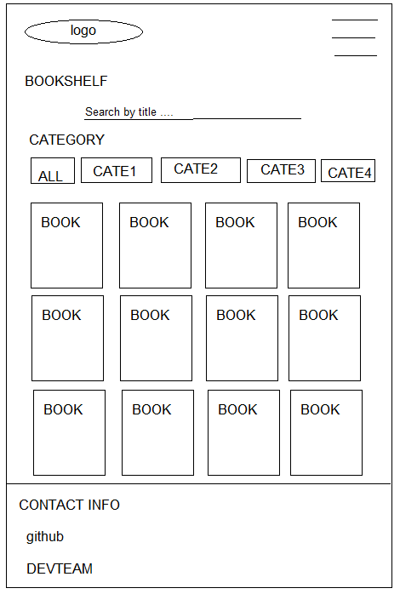

Figure 11: View list of books

* Function details:
* All Categories can be chosen to search book by category
* If click to a Book, users can see the Book details

## 9. View book’s description

* Function trigger: When users click button in Edit column in Book Manager page
* Function description:
  + Actor: Users
  + Purpose:
  + Interface:
* + 1 button GET: send book to user’s carts where user can pay money to buy books
* + 1 button Add to Favourite: send this book to user’s favourite list
* + 1 button Report: help users report the book that violate the rules
* + 1 textbox: give space for user to type their comment
* + 1 button to help user post their comments
* + 1 list of check box that represent as star: help user vote/rate this book
* Screen Layout:

Figure 12: View book’s description

* Function detail:

## 10. View profile (User)

* Function trigger: This use case starts when a user clicks on navigation bar button on top right of website and click “My profile”.
* Function description:
* Role: User
* Purpose: User view their profile
* Interface:
* A fixed menu contains: My profile, Security, Settings, Support
* A logo access homepage
* A navigation
* An interface head “My profile” contains fields: Name, Email, Birth, Gender, Phone Number, Address
* Screen layout:

Figure 13: View profile (Customer)

* Function detail:
  + System displays user’s profile include his user id, username, name, date of birth, gender, email, phone, address.
  + From this screen, user can choose to edit his profile.

## 11. Update profile (User)

* Function trigger: This use case starts when user click on “Edit” button in view profile screen.
* Function description:
  + Role: Customers
  + Purpose: Update user’s profile
  + Interface:
    - 2 input text boxes for to enter name, and address
    - 1 input date to enter date of birth
    - 1 input number to enter phone number
    - 2 input radiant to choose gender
    - 2 button “Cancel” and “Save”
* Function layout:

Figure 14: Update profile (User)

* Function detail:
  + The user can see his current information and change them (except user id, username and email). All fields cannot be empty except address.
  + Phone number must be a string of 10 digits.
  + Name only have alphabetic characters and space characters. Name cannot be longer than 40 characters.
  + User can choose “Save” to save new information or choose “Cancel” to back to view profile screen without any change.

## 12. View security status

* Function trigger: This use case starts when user click on “Security” tab in left sidebar.
* Function description:
  + Role: User
  + Purpose: View account’s security
  + Interface:
* Function layout:

Figure 15: View security status

* Function detail:
  + The user can see current email and password level of account.
  + Password level show how strong current password is:
    - Password just have number or alphabetic characters, password level is week.
    - Password have both alphabetic characters and numbers, password level is medium.
    - Password have alphabetic characters, number and special character, password level is strong.

## 13. Change password

* Function trigger: This use case starts when user click on “Change” beside password level in security screen.
* Function description:
* Role: User
* Purpose: Change password
* Interface:
  + - 3 text boxes to enter password, new password and confirm password
    - 2 button “Cancel” or “Confirm”
* Function layout:

Figure 16: Change password

* Function detail:
* When user choose to change password, this pop-up will open. User enter current password to authorize this action, then enter new password 2 times.
* Then choose confirm to change password.
* If user does not want to change password, click “Cancel”.
* User cannot confirm if current password is wrong, or confirm password does not match with new password, or new password is invalid. New password is invalid when:
* It is empty.
* Its length is less than 6 character or more than 32 characters.
* It starts with a space.

## 14. Comment

* Function trigger: When user write their comment in the text box and click Comment in the Book-detail page
* Function description:
* Role: Users
* Purpose: let users write their feeling about the book
* Interface:
* 1 text box for users to write their comments
* 1 button to submit their comment
* 1 textbox to display the previous comments
* Function Layout:

Figure 17: Comment

* Function Detail:
* Text box “Write your comment here” can accept any kind of data (String)
* When user click the button “POST”, their comment will be added to the textbox in the right, the page is refresh at the same time.

## 15. Rate book

* Function trigger: When user click on the Star
* Function description:
* Role: Users
* Purpose: Let user rate this book
* Interface:
* 5 stars that represent the rating from 1 to 5
* 1 button to submit rate
* Function Layout:

Figure 18: Rate book

* Function Detail: This function will not be shown unless users log in into the system

## 16. Add to Favourite

* Function trigger: When user click the Add to Favourite button in the Book detail page
* Function description:
* Role: Users
* Purpose: Send this book to user Favourite’s book list
* Interface:
* Function Layout:

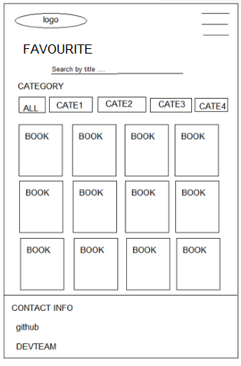

Figure 19: Add to favourite

* Function Detail:

## 17. Report Book

* Function trigger: When user click the Report button in the Book detail page
* Function description
  + Roles: Users
  + Purpose: let user send report to admin that the book violated the community’s rules
  + Interface:
* Function Layout:

Figure 20: Report Book

* Function Detail:
  + The screen displays the book name, author, image
  + The checkboxes that store options for user can check it and click the Report button to send it to the admin

## 18. View/Update/Disable Book

* Function trigger: When users click the “Book Management” in the Management Panel
* Function description:
  + Actor: Admin, Staff
  + Purpose: Admin/Staff can add new books or disable old ones. It is also possible to edit or update the information of the student.
  + Interface:
    - Total book:
      * Button: Book Management, Add Book, Update, TOC (Tables of Contents), Disable
      * Table includes Book ID, Title, Author, Image, Category, Price, Sale Status
    - Detail book:
      * Button: Save
      * Inputs field for Book’s information
* Screen Layout:

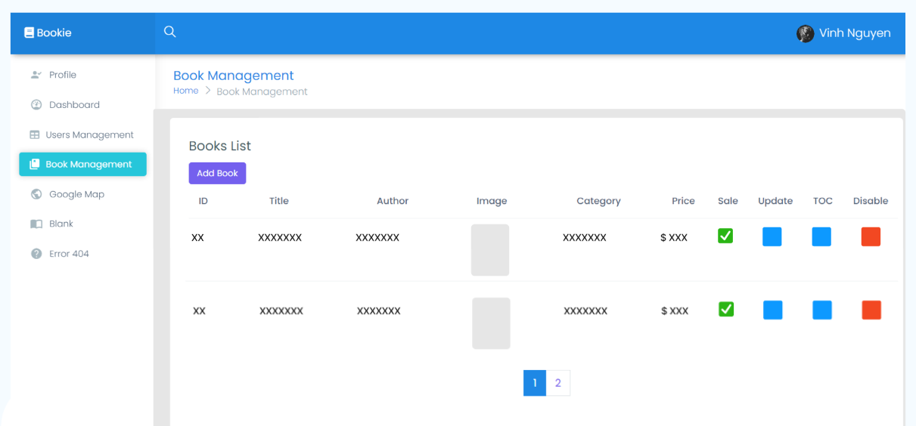

Figure 21: Total book

Figure 22: Detail book

* Function detail:
* Click on Add Book button to add new books, there will be information text boxes which are needed to add a book.
* If you want to disable the book, click button at Disable column at the end of that row
* If you want to edit the information of the book, click button at Update column

## 19. View/Update/Delete Table of Contents

* Function trigger: When users click button in TOC column in Book Management page
* Function description:
  + Actor: Admin/Staff
  + Purpose: Admin/Staff can add new volumes, new chapters or delete old ones. It is also possible to edit or update the information of the volumes or the chapters
  + Interface:
    - Volume:
      * Button: Add Volume, Arrange Volume, Edit Volume, Delete Volume, Save
      * Input fields for Volume’s information
* Chapter:
  + Button: Add Chapter, Edit Chapter, Delete Chapter, Arrange Chapter
  + Input fields for Chapter’s information
* Screen Layout:

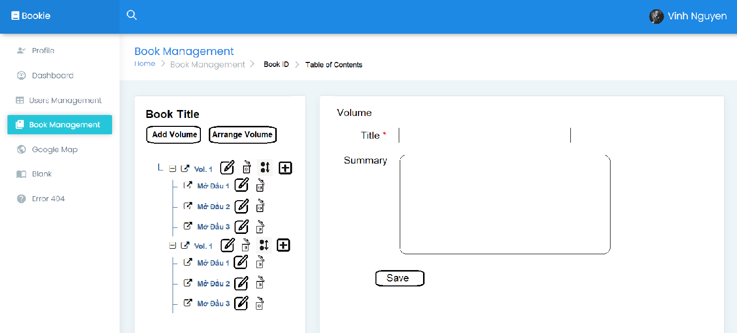

Figure 23: Volume

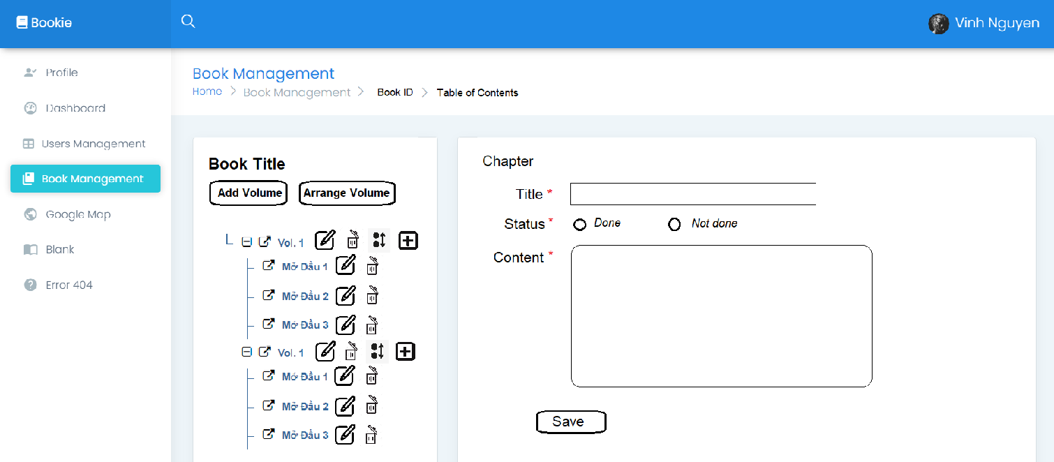

Figure 24: Chapter

* Function detail:
* Click on Add Volume to add new volumes, there will be information text boxes which are needed to add a volume
* To arrange the order of the book’s volumes, click on Arrange Volume
* To delete the volume, click at the end of each volume row, select Delete
* To edit the volume, do the same as above and select Edit
* Click on Add Chapter to add new chapters, there will be information text boxes which are needed to add a chapter, including chapter’s contents
* To arrange the order of the volume’s chapters, click at the end of their volume row, and select Arrange
* To delete the chapter, click at the end of each chapter row, select Delete
* To edit the chapter, do the same as above and select Edit

## 20. Access Level

* Function trigger: Login
* Function description
  + - Roles: Admins, Users
    - Purpose: locate role for the account
* Function Detail:
  + - Depend on the level of account user can login or not
    - Also from 4 or upper is for admin and super admin

## 21. View List User

* Function trigger: When admin click Users Management title
* Function description
* Roles: Admin
* Purpose: let admin can see the list of users account below which have some recent actions
* Screen Layout:

Figure 25: View List User

* Function Detail:
* The screen will display the users account detail
* Depend on admin’s level, it will display all the accounts which have the lower level

## 22. Users Management

* Function trigger: When admin click any button, title or input in search box
* Function description
  + Roles: Admin
  + Purpose: adjust and view the account’s details
  + Interface:
* Screen Layout: Graphical user interface, application

  Description automatically generated

Figure 26: Users Management

* Function Detail:
  + Admin can adjust the level of that account from: normal user to author or admin
  + Admin can ban the account
  + Admin can search, sort by each title

## 23. Wallet

### a. View

* Function trigger: This use case starts when user click on “Payment” on left side bar in profile screen.
* Function description:
  + Role: User
  + Purpose: View wallet’s balance
  + Interface:
* Function layout:

Figure 27: View wallet

* Function detail:
  + Wallet’s balance will be hidden at start. User can click on eye icon to show or hide it.

### b. Transaction history

* Function trigger: This use case starts when user click on “Payment” on left side bar in profile screen and scroll down.
* Function description:
  + Role: User
  + Purpose: View list of all transactions
* Function layout:

Figure 28: Wallet - Transaction history

* Function detail:
* User can see list of all transaction he made

### c. Recharge

* Function trigger: This use case starts when user click on “Recharge” at right of balance.
* Function description:
* Role: User
* Purpose: Recharge money from linked bank into wallet
* Interface: Pop-up
  + - 3 input field to enter amount, payment and password
    - 2 button to choose cancel or confirm
* Function layout:

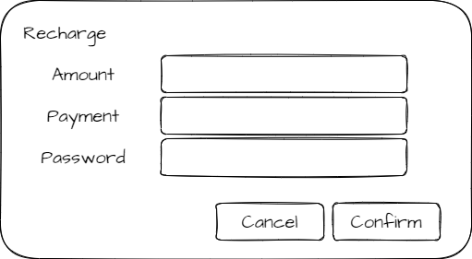

Figure 29: Wallet recharge

* Function detail:
* Amount to recharge cannot greater than balance in chosen payment.
* Password must match with current password of user.
* If user don’t want to recharge more, click cancel.
* If user certainly want to recharge, click confirm.

### d. Withdraw

* Function trigger: This use case starts when user click on “Withdraw” at right of balance.
* Function description:
* Role: User
* Purpose: Withdraw money from wallet to linked bank
* Interface: Pop-up
  + 3 input fields to enter amount, payment and password
  + 2 buttons to choose cancel or confirm
* Function layout:

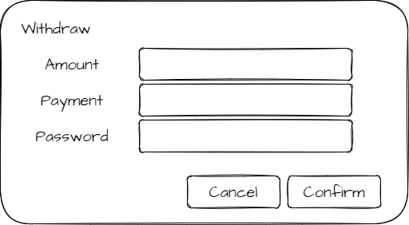

Figure 30: Wallet withdraw

* Function detail:
  + Amount to withdraw cannot greater than balance in wallet.
  + Password must match with current password of user.
  + If user don’t want to withdraw more, click cancel.
  + If user certainly want to withdraw, click confirm.

## 24. Payment

### a. Remove

* Function trigger: This use case starts when user click on Trash can icon at the right of payment method that user wants to remove
* Function description:
* Role: User
* Purpose: Remove a payment method
* Interface: Popup
* 1 input field to enter password
* 2 buttons cancel and confirm
* Function layout:

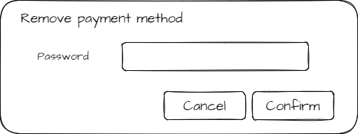

Figure 31: Payment remove

* Function detail:
* Password must match with current password of user.
* If user don’t want to remove this payment method more, click cancel.
* If user certainly want to remove this payment method, click confirm.
* User can not remove wallet

### b. Add

* Function trigger: This use case starts when user click on “Add payment” button under the payment method’s table
* Function description:
* Role: User
* Purpose: Add a payment method
* Interface: Popup
* 3 input fields to enter account number, payment name, password
* 2 buttons cancel and confirm
* Function layout:

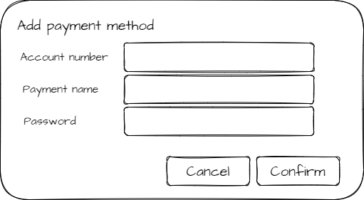

Figure 32: Add payment

* Function detail:
  + Account number is required.
  + If there is no payment account have this number, not do anything.
  + Password must match with current password of user.
  + If user don’t want to add payment method more, click cancel.
  + If user certainly want to add this payment method, click confirm.
  + User can not remove wallet

## 25. Purchase a book

* Function trigger: This use case starts when user click on “Buy” in book detail screen
* Function description:
  + Role: User
  + Purpose: Remove a payment method
  + Interface: Popup
    - 1 input field to enter password
    - 2 buttons cancel and confirm
* Function layout:

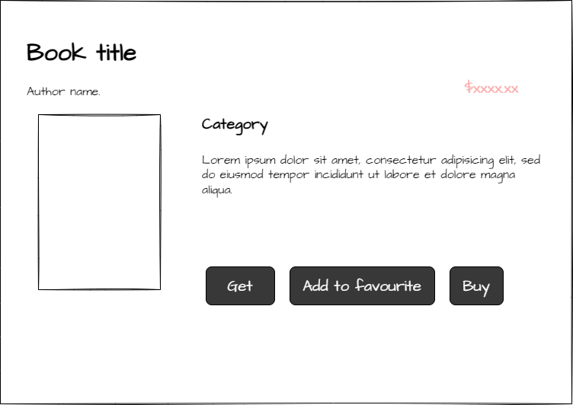

Figure 33: Get book

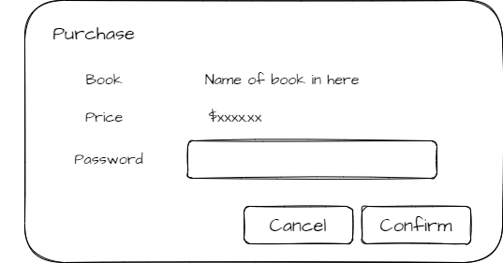

Figure 34: Purchase

* Function detail:
  + Password must match with current password of user.
  + If user don’t want to buy this book more, click cancel.
  + If user certainly want to buy this book, click confirm.
  + Before buy this book, user should warrant that book’s price is not greater than balance in his wallet

## 26. Reading interface

* Function trigger: when user (has paid for the book) click on chapters
* Function description:
  + Actor: Users
  + Purpose: Setting interface for reading book
  + Interface:
* A logo can access Homepage
* A fixed Menu collapsed
* A header of book’s name
* A header of Chapter
* Content of chapter
* Contact interface
* Screen Layout:

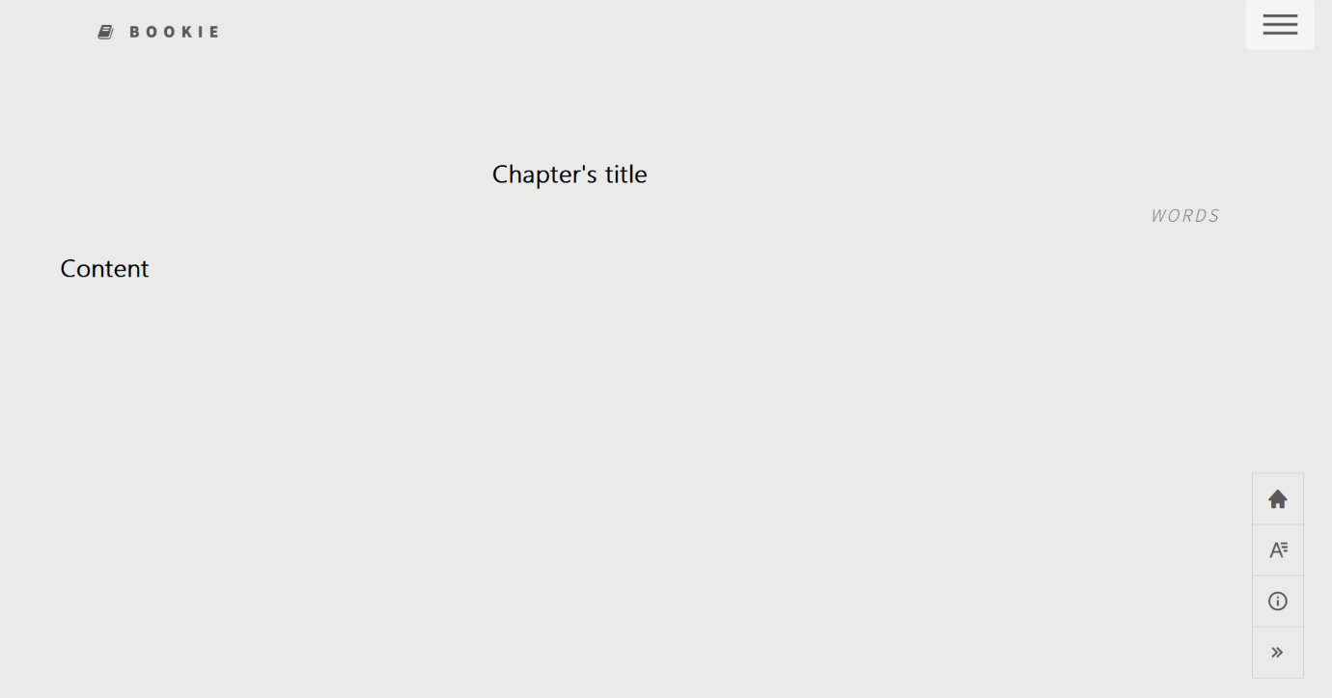

Figure 35: Reading interface

* Function details: After purchasing for books, user can read all chapters from Table of Contents. The book-reading page display content of the chapters that user choose. The contact carry information to connect to Administrators.

## 27. Pre-reading

* Function trigger: when user clicks on “Preread” button
* Function description:
  + Actor: Users
  + Purpose: Reading the brief chapter of book
  + Interface:
    - A logo can access Homepage
    - A fixed Menu collapsed
    - A header of book’s name
    - A header of Chapter
    - Content of chapter
* Screen Layout:



Figure 36: Pre read book

* Function details: Before purchasing book, user can read the first chapter before deciding to purchase or not. If user hasn’t paid for book yet, table of contents only direct to pre-read chapter

## 28. Table of Contents

* Function trigger: After using purchase for a book successfully, the table of contents will be automatically displayed
* Function description:
  + Actor: Users
  + Purpose: Accessing chapters’ content for reading
  + Interface:
* A header named “Table of contents”
* All volumes’ name of books
* All names of chapters of each volume
* Screen Layout:

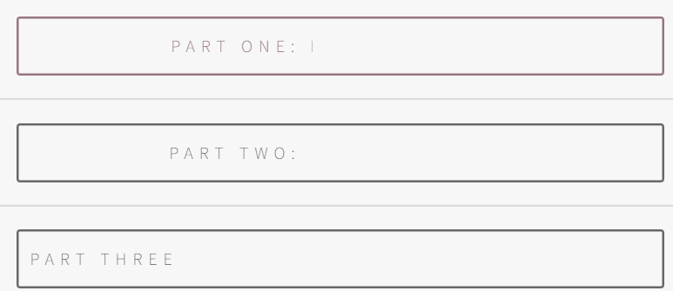

Figure 37: Table of contents - 1

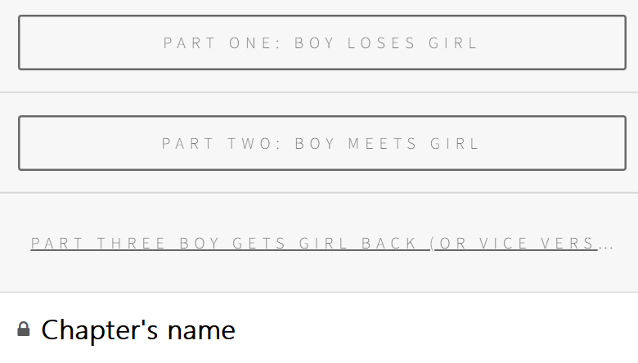

Figure 38: Table of contents - 2

* Function details: The Table of Contents only be display after user purchase for book. When they click on Chapter’s name, it will redirect to book-reading interface. The book-reading page display content of the chapters that user has chosen.

## 29. Update Library’s View (Search Engine + Paging)

* Function trigger: When user click on the Search button in Library and select the book’s category in Genre list (Search Engine), whenever the library shows list of books, the list will be split into pages (Paging)
* Function description:
  + Actor: Users
  + Purpose:
    - Let user search the book of their wants (Search Engine)
    - Split the collection of books into pages to make the library more succinct
  + Interface:
    - Page number in the nearby footage of the page: Click will send users to others pages of library
    - List of Category in buttons on the left
    - Search Engine: Search by title and Advanced Search
* Screen layout:

Figure 39: Search

Figure 40: Advanced Search

* Function detail:
  + Genre list in both outside and inside advanced search will show all the categories that have in the database
  + Genre Lists are checkbox, let user choose more than 1 category
  + When user click button “Search”, the system will return all the book/novel that meet the requirements in pages (paging)
  + In both advanced search and library interface will have textbox for user to enter title of the book (in the library interface) and enter author’s name (in advanced search)
  + Each page will have 12 books
  + While users are in 1 page, that page’s number will have a different colour

## 30. Delete from Favourite

* Function trigger: When users click the “Delete Favourite” in the Book Detail Screen
* Function description:
  + Actor: Users
  + Purpose: Let users remove this book from their favourite collection
  + Interface:
    - 4 buttons: Get (Purchase book), Delete Favourite (Remove this book from Favourite), Report (Report this book), Post (Send the comment to this book)
    - 1 text input: where to let users enter the comment they want to
    - 5 radio buttons represent for 5 stars rating
* Screen Layout:

Figure 41: Before click “Delete Favourite”

Figure 42: After click “Delete Favourite”

* Function detail:

## 31. View/Manage Novels

* Function trigger: When users click the “My Novels” in the User Profile screen
* Function description:
  + Actor: Customer
  + Purpose: Customer can create his/her own novel or delete/disable old ones. It is also possible to edit or update the information of the novel.
  + Interface:
    - View Novels:
      * Button: Create, Update, TOC (Tables of Contents), Disable
      * Table includes Title, Image (default if no input), Genres, Paid Status
    - Manage Novels:
      * Button: Create/Update, Delete
      * 6 fields: Title, Gerne, Summary, Price, Image
* Screen Layout:

Figure 43: View Novels

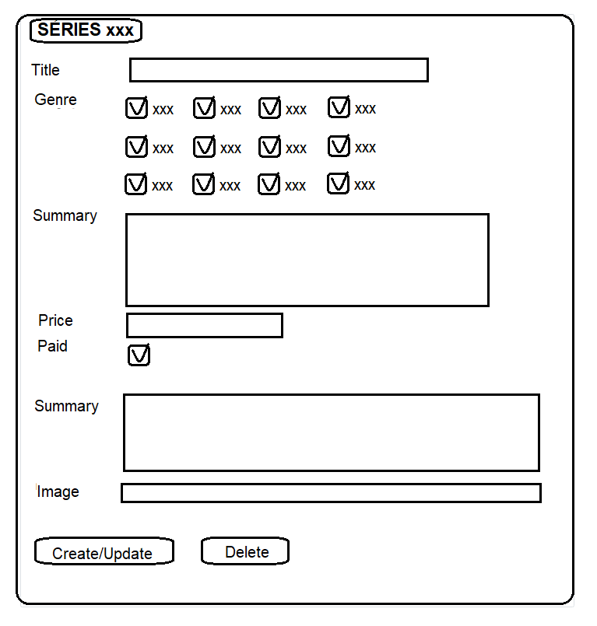

Figure 44: Manage novels

* Function detail:
* View Novels
* Click on “Create!” button to create new novel, there will be information text boxes which are needed to add a novel.
* If you want to disable the novel, click button at Disable column at the end of that row.
* If you want to edit the information of the novel, click button at Update column. In update screen, if the novel hasn’t been bought by any customer, “Delete” button can be displayed and entered to be permanently deleted.
* Manage Novels
  + Inputs field for Book’s information, if customer reaches access level 3, the field for Price and Paid status can be displayed and altered by themselves.

## 32. View List Author

* Function trigger: When admin click Author Management title or page button
* Function description
  + Roles: Admin
  + Purpose: let admin can see the list of authors below
  + Interface:
* Screen Layout: Graphical user interface

  Description automatically generated

Figure 45: View List Author

* Function Detail:
  + The screen will display the authors-generated and authors-users detail
  + Paging with 10 authors each page

## 33. Edit Author

* Function trigger: When admin search, input new author name and click on button , click button “ADD”
* Function description
  + Roles: Admin
  + Purpose: let admin can adjust the list of authors below
  + Interface
* Screen Layout: Graphical user interface

  Description automatically generated with medium confidence

Figure 46: Edit Author

* Function Detail:
  + The screen will display the authors-generated and authors-users detail
  + Each table has different search and will return the list after enter
  + Input new name and click “button” on the right will update the new name for that author
  + Click on the id of author will return a list of books belong to that author
  + Click “Add” button send to Add-book page

## 34. Admin Panel

* Function trigger: When admin Dashboard
* Function description
  + Roles: Admin
  + Purpose: let admin can data research
  + Interface:
* Screen Layout:

Figure 47: Admin panel

* Function Detail:
  + The screen will display some features: total books, total comments, total
  + Chart will display: the change of users approach per month, user approach per quarter in year, the amounts of authors and users-authors

## 35. List book of this author

* Function trigger: User click on the book, it will automatically display list books of that author
* Function description:
* Actor: Users
* Purpose: See all book of a authors
* Interface:
* A logo to access homepage
* A fixed Menu collapsed
* A header named “From this author”
* All books from the same author, 3 books per row
* Contact interface
* Screen Layout

Figure 48: List book of this author

* Function details: When user clicks on author’s name, system redirects to a new page to display all book have same author that they have chosen.

## 36. Add chapter for user’s novel

* Function trigger: User click on the “+” button, system will display the interface that user can add content for chapter.
* Function description:
* Actor: Users
* Purpose: Create a new chapter
* Interface:
* A logo to access homepage
* A fixed Menu collapsed
* A fixed User menu
* A header “Series of” this book
* A div tag that user use for adding new chapter. “Title” and “Content” are in text-form, Status is in option-form. All field is required.
* Screen Layout

Figure 49: Add chapter for user’s novel before creating

Figure 50: Add chapter for user’s novel after creating

* Function details: When user clicks on “Add” button, the create chapter interface appear. After fill in all field of the dialog, the dialog is change to disable mode and appear to button are “Edit” and “Delete”.

## 37. Edit chapter for user’s novel

* Function trigger: User click on name of chapter, system will display interface contains information chapter
* Function description:
* Actor: Users
* Purpose: Changing information of chapter
* Interface:
* A logo to access homepage
* A fixed Menu collapsed
* A fixed User menu
* A header “Series of” this book
* A div tag that display information of chapter, contains chapter’s name, status, and content, in disable mode
* Two buttons “Edit” and “Delete”
* Screen Layout:

Figure 51: Edit chapter for user’s novel

* Function details: User clicks on name of chapter, the dialog appear with two options “Edit’ and “Delete”. All fields are in disable mode. User click on “Edit” to change information of chapter. After choosing “Edit”, all fields are allowed to edit. To finish work, user re-click on “Edit” button and then all fields are back to disable mode.

## 38. Delete chapter for user’s novel

* Function trigger: User click on name of chapter, system will display interface contains information chapter
* Function description:
* Actor: Users
* Purpose: Delete chapter
* Interface:
* A logo to access homepage
* A fixed Menu collapsed
* A fixed User menu
* A div tag contains book’s name, option add chapter and back to book-detail page.
* A div tag that display information of chapter, contains chapter’s name, status, and content, in disable mode
* Two buttons “Edit” and “Delete”
* Alert screen
* Message confirm decision
* Two buttons “Close” and “Delete”
* Screen Layout:

Figure 52: Delete chapter for user’s novel

Figure 53: Delete chapter for user’s novel

* Function details: User clicks on name of the chapter, the dialog appear with two options “Edit’ and “Delete”. All fields are in disable mode. User click on “Delete” to remove chapter. After choosing “Delete”, a message warning displayed. User click on “Delete” to confirm, or “Close” to recall decision

## 39. Category Management

### a. View

* Function trigger: This use case starts when user click on “Category management” on left side bar in profile srceen.
* Function description:
* Role: Admin
* Purpose: View list of categories
* Interface:
* Function layout:

Figure 54: View Category

* Function detail:
  + Admin can see all of categories and how many books in each category.
  + From here, user can edit category name, delete category or add new category

### b. Remove

* Function trigger: This use case starts when user click on garbage can icon in the line of category that they want to remove
* Function description:
* Role: Admin
* Purpose: Remove a category
* Interface: A dialog has confirm message with two buttons “Cancel” and “Ok”
* Function layout:

Figure 55: Review Category

* Function detail:
  + When user click on remove button, a pop-up appears to confirm his request.
  + If user confirm, remove this category. Otherwise, close pop-up without any change

### c. Update

* Function trigger: This use case starts when user click on pen icon next to category’s name
* Function description:
* Role: Admin
* Purpose: Rename category
* Interface
* Function layout:

Figure 56: Update Category

* Function detail:
  + When user click on update button, this button is replaced by “Save” and “Discard” button and category name field become an input field.
  + After enter new category name, if user click “Save”, category name will be update. Otherwise, back to normal category view without any change.

### d. Add

* Function trigger: This use case starts when user click on “Add category” button above the table of categories.
* Function description:
* Role: Admin
* Purpose: Add new category
* Interface: Popup
* 1 text field to enter new category name
* 2 buttons to choose add or cancel
* Function layout:

Figure 57: Add Category

* Function detail:
  + Admin can enter new category name and click on “confirm” button to add new category.
  + If admin don’t want to add new category anymore, click on “cancel” button.
  + Show message if this action success.

## 40. Bookshelf

* Function trigger: This use case starts when user click on “Bookshelf” from right menu.
* Function description:
* Role: User
* Purpose: Show all books of this user, include bought books, favorite books and creations
* Interface
* Function layout:

Figure 58: Bookshelf

* Function detail:
* User can see how many books he bought, he added to favorite or he wrote.
* When click on tab “My books”, user sees all of books that he bought.
* When click on “My favorites”, user sees all of books that he added to favorite.
* When click on “My creations”, user sees all of books that he wrote

## 41. View/Solve Reports

* Function trigger: When users click the “Report” in the Management screen
* Function description:
* Actor: Admin/Staff
* Admin/Staff can view details and take action of all reports.
* Interface:
  + See All Reports:
    - Table includes ID, reporter, type of report, violations, sent date
    - Button: Open/Close/Reject, View Details, Select Type
  + Reports Detail:
* Information about object reported in the left (name, owner/creator, id, link to details page)
* Report information: ID, Type, Reporter, Violations, Detail, sent date, status
* Input: Action
* Button: Close/Reject
* Screen Layout:

Figure 59: See All Reports

Figure 60: Report Detail

* Function detail:
* Click on Open/Close/Reject button to view reports of different state
* Click on another choice in select button to view reports of different type
* If you want to view details and take action with a report, click button at column at the end of that row
* Click on Close/Reject button on report details page to mark a report as solved or rejected.

## 42. Ban Comment

* Function trigger: When clicks on ban comment button
* Function description:
* Actor: Admin
* Purpose: Block comment that not suitable
* Interface:
* A logo can access Homepage
* A fixed Menu collapsed
* A book-detail display
* A comment area
* Contact interface
* Function layout:

Figure 61: Ban Comment

Figure 62: Confirm dialog

Figure 63: After deleting

* Function detail: When admin click logo “x” on the screen, the confirmation dialog appears. Click “Close” to skip and back, click “Yes, ban it” to confirm decision.

## 43. Report Comment

* Function trigger: When clicks on report comment button
* Function description:
* Actor: User
* Purpose: Report comment that not suitable
* Interface:
* A logo can access Homepage
* A fixed Menu collapsed
* A book-detail brief
* A comment that has reported
* A list of violation type
* A contact interface
* Function layout:

Figure 64: Report Comment

* Function detail: When user click logo report on book-details screen, it will direct to report-comment screen. User choose violation type and input reason at the end of the list and click “Report” button to finish.

## 44. View author’s information

* Function trigger: When click on author’s name
* Function description:
* Actor: Users
* Purpose: See all book of a authors
* Interface:
* A logo to access homepage
* A fixed Menu collapsed
* A brief information of this author
* A header named “From this author”
* All books from the same author, 3 books per row
* Contact interface
* Screen Layout

Figure 65: View's author information

* Function detail: When user click author’s name in book-details, it will direct to book-author screen to see author’s information with their novel

## 45. Payment

### a. View

* Function trigger: This use case starts when user click on “Payment” on left side bar in profile srceen.
* Function description:
* Role: User
* Purpose: View balance in wallet and transaction history
* Interface:
* Function layout:

Figure 66: View payment

* Function detail:
* Wallet’s balance will be hidden at start. User can click on eye icon to show or hide it.
* User can see list of all transaction he made.
* If a transaction has any problem, user can report it by report button at right of that transaction.

### b. Deposit

* Function trigger: This use case starts when user click on “Deposit” button at right of balance.
* Function description:
* Role: User
* Purpose: Show deposit instructions and create deposit request.
* Interface:
* Function layout:

Figure 67: Deposit payment

* Function detail:
* User is asked to enter amount of money they want to deposit to wallet in website before make the transaction. This amount of money need to same with how much he sent to website’s receiving account
* User must check the captcha before confirm.
* If user don’t want to deposit anymore, click “Cancel” button to back to payment screen. Otherwise, click “Submit” button.
* After submit, user can see status of this transaction in payment screen.

### c. Withdraw

* Function trigger: This use case starts when user click on “Withdraw” button at right of balance.
* Function description:
* Role: User
* Purpose: Show withdraw instructions and create withdraw request.
* Interface
* Function layout:

Figure 68: Payment withdraw

* Function detail:
* User is asked to enter amount of money they want to withdraw and payment account that they want to withdraw to it.
* User must check the captcha before confirm.
* If user don’t want to deposit anymore, click “Cancel” button to back to payment screen. Otherwise, click “Submit” button.
* After submit, user can see status of this transaction in payment screen.

### d. Transaction manage

* Function trigger: This use case starts when user click on “Transaction management” at the left side bar in admin panel screen.
* Function description:
* Role: Admin
* Purpose: Manage transaction of user
* Interface:
* Function layout:

Figure 69: Transaction manage

* Function detail:
* Admin can see list of all transactions of all users.
* Admin can filter transactions by user id, type of transaction, status and product id.
* Admin can change status of a pending transaction to fail or success. This action cannot be undo.
* If a transaction is pending, admin can report it to user if there is any problem with it.

## 46. Purchase novel’s chapter

* Function trigger: This use case starts when user click on locked chapter in book detail screen
* Function description:
* Role: User
* Purpose: Purchase a chapter of a novel
* Interface: Popup
* 1 input field to enter password
* 2 buttons cancel and confirm
* Function layout:

Figure 70: Purchase novel's chapter

* Function detail:
* Password must match with current password of user.
* If user don’t want to buy this chapter more, click cancel.
* If user certainly want to buy this chapter, click confirm.
* Before buy this book, user should warrant that book’s price is not greater than balance in his wallet

## 47. Ticket

* Function trigger: When User click on Support on My Profile Title
* Function description:
* Roles: User
* Purpose: let user can view all the reports and send ticket to unlock account or monetization
* Interface
* Screen Layout:

Figure 71: See al ticket

Figure 72: Report Detail Figure 73: Ticket

* Function Detail:
  + The screen will display some features: Read report, Unread report, Sending report. Each feature has its table
  + Table will display the type of report, sent day, received day, status, note
  + If user account is banned or total view of user’s books greater then 5000, user can write ticket
  + Ticket is automatically match with user’s level, ticket will be passed straightway if transaction for more than 3 times

## 48. Notification

* Function trigger: When Admin click on Mail icon on sidebar
* Function description
* Roles: Admin
* Purpose: let admin can view all the ticket and handle them
* Screen Layout

Figure 74: List ticket

Figure 75: Recent activities

* Function Detail:
* The screen will display List of with features: user id, sent day, note
* After click on user id, admin can see recent transaction and report
* If ticket is “Enable Monetization”, Admin can view all related book
* Dropdown in the end of row, admin pass and level up that user or reject the ticket
* Admin can pass or reject all

## 49. Update Comment (Reply + Edit + Delete)

* Function trigger: It will be revealed after the customer login into the system and click to see any book
* Function description
* Roles: Both User and Customer
* Purpose: Let users and customers reply an existed comment, edit or their comments
* Interface: (Like book’s detail interface)
* 1 button for reply, 1 button for edit, 1 button for Delete
* Screen Layout:

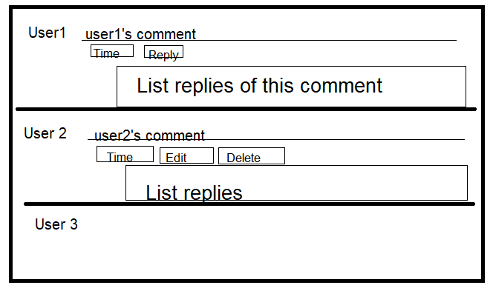

Figure 76: Recent activities

* Function Details:
  + If customers are not login into the web, all the comment will have Reply button. If they write and press Reply, they will be sent redirect to Login screen
  + When click Reply: A text area will be shown to enter comment. Next to it is Reply button that allows user post the reply
  + Reply button only appear in other’s comments. Which mean: User 1 can’t see the Reply button below the comment that User 1 posted
  + Edit and Delete button will be shown below the comments that users own
  + If click Edit, a text area will be shown to let user edit their comment, next to it is button Edit
  + If click Delete, a Warning box will be shown to ask user whether delete this comment or not

## 50. Report Transactions

* Function trigger: It will be revealed after the customer login into the system and click to Payment in the Profile
* Function description:
* Roles: User
* Purpose: Let users send reports to admin that tell what problems they are with
* Interface: (Like book’s detail interface)
* 1 button for send report next to each transaction
* A table display all information of transactions
* Function Layout:

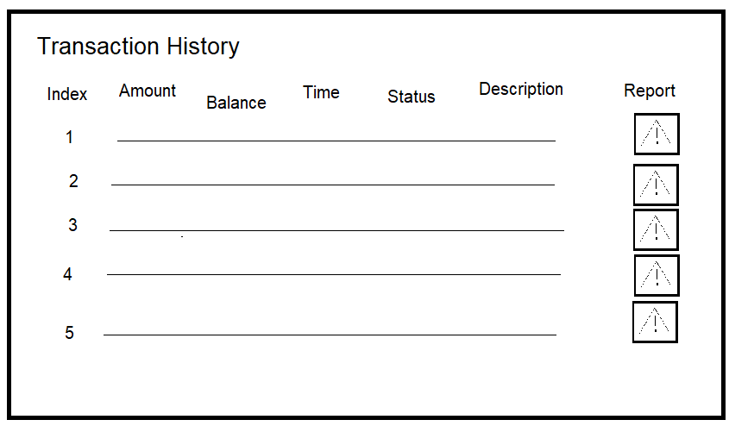

Figure 77: Report Transaction

Figure 78: Problem detail

* Function Details:
* If click the “Report” button, a Pop up will be shown that let user choice what problems are and they can write the problem details
* Click “Report” will send report to database
* Click “Cancel will” close this pop up
* Users can choice more than 1 options