

**BOOKIE – EBOOK SYSTEM**

**Software Requirement Specification**

– Hanoi, September 2022 –

Table of Contents

I. Overview 3

1. Introduction 3

2. System Functions 4

3. Common Requirements 6

II. Functional Requirements 6

1. Home 6

2. User register 7

3. Forget Password 8

4. Logout 9

5. Login 10

6. View profile(Admin) 11

7. Update profile(Admin) 12

8. View list of books 13

9. View book’s description 14

10. View profile(Customers) 15

11. Update profile(Customers) 16

12. View security status 17

13. Change password 18

# I. Overview

## 1. Introduction

The Bookie – eBook System is a new web system that replaces the current library and all kind of it. Nowadays, people are getting more busy and lazy. They don’t have enough time or don’t want to go to the library to find a book or a shop to buy one. The system is expected to prevent the dead of knowledge come from books. Bookie want to create a brand new online-library that people can have access anytime, anywhere.

Main users:

* Administrators
* Customers: Normal person and authors

## 2. System Functions

#### a. Screen Flow

#### b. Screen Details

| **#** | **Feature** | **Screen** | **Description** |
| --- | --- | --- | --- |
| 1 | Common | Home Page | Default screen where all users can visit. There have information of system, contact of developer. The site can lead to login page and register page |
| 2 | Common | User Register | Screen where users can create new account with personal information. Click Submit to submit new account |
| 3 | Common | Login | Screen where the user logs into the system with the registered account. If the account or password is wrong, the system will notify the user |
| 4 | Common | Change Password | Allow users who want to change their password account |
| 5 | Common | User Profile | Display information about the user who is logged in to the system |
| 6 | Admin | Dashboard | Display the dashboard that helps administrator manage the system. |
| 7 | Common | Forgot Password | Allow user to reset password using registered email in case user forgot password |
| 8 | Customers | Top Favourite | Display books having the most users adding to favor |
| 9 | Customers | Weekly sales | Display books chosen with special discount weekly |
| 10 | Customers | Book List | Display all books/original works |
| 11 | Customers | View Book’s Information | Display information about name, authors, category, description, price, index… of the book |
| 12 | Customers | Library | Display all books/original work customers purchase |
| 13 | Customers | Wallet | Display balance in customer’s wallet |
| 14 | Customers | Purchase | Allow customers to purchase a book/chapter with their wallet |
| 15 | Customers | Read content | Allow customers to read the book/novel they purchased |
| 16 | Customers | Comment | Allow customers to write their comment in book’s section |
| 17 | Customers | Rating | Allow customers to rate a book/novel on a 5-star scale |
| 18 | Customers | Searching | Allow customers to search for specific book by enter key words |
| 19 | Customers | Report a purchase | Allow customers to report defective work or problematic transactions to request a refund/exchange |
| 20 | Customers | Report a book | Allow customers to report a book that violates the community standards |
| 21 | Customers | Create original work | Allow customers to write and post their own work (must satisfy special rules for self-work) |
| 22 | Customers | Manage original work | Allow customers to edit, delete their own work |
| 23 | Customers | Paid mode | Allow authors to open the charge for their work |
| 24 | Admin | Manage Category | Allow admins who want to add, edit and delete category of books |
| 25 | Admin | Manage Book | Allow admins who want to add, edit and delete book’s information |
| 26 | Admin | Manage Novel | Allow admins who want to add, edit and delete user’s novel |
| 27 | Admin | Manage Comment | Allow admins who want to view and delete if there are any inappropriate/offensive comments |
| 28 | Admin | Manage User | Allow admins who want to up user to admin or disable any excessive user |
| 29 | Admin | View transactions | Display all purchase in the system |
| 30 | Admin | View reports | Allow admins who want to receive and handle any report by users |
| 31 | Common | Change email | Allow users who want to change their email |

#### c. User Authorization

| **Screen** | **Admin** | **Customers** |
| --- | --- | --- |
| Home Page | X | X |
| User Register | X | X |
| Customers Login | X | X |
| Admin Login | X |  |
| User Profile | X | X |
| Admin Screen | X |  |
| Forgot Password | X | X |
| Top Favourite | X | X |
| Weekly sales | X | X |
| Book List | X | X |
| View Book’s Information | X | X |
| Library | X | X |
| Wallet | X | X |
| Purchase | X | X |
| Read content | X | X |
| Comment | X | X |
| Rating | X | X |
| Searching | X | X |
| Report a purchase |  | X |
| Report a book |  | X |
| Create a novel | X | X |
| Paid mode |  | X |
| Manage Category | X |  |
| Manage Book | X |  |
| Manage Novel | X |  |
| Manage Comment | X |  |
| Manage User | X |  |
| Change email | X | X |

In which:

* Admin: The manager of the organisation, has access to all system functions.
* Customers: People who want to read book, original work and do the simple function of an eBook system. They can also be an author to write their own books, novels to make money or satisfy their hobby

#### d. Non-Screen Functions

| **#** | **Feature** | **System Function** | **Description** |
| --- | --- | --- | --- |
| 1 | Common | User Authorization | Implement the authorization mechanism into the system. Using both front end and back end code to prevent users from accessing links without proper role. |

## 3. Common Requirements

# II. Functional Requirements

## 1. Home

* Function trigger: when user visits the page or when they click on the logo.
* Function description:
  + Actor: Users and Guests
  + Purpose: Landing page for all users
  + Interface:

+ A logo can access Homepage

+A fixed Menu collapsed

+ A introduction slide show

+A quote about book

+ Photos of featured product

+ Highlight original work

+ Contact interface

* Screen Layout:

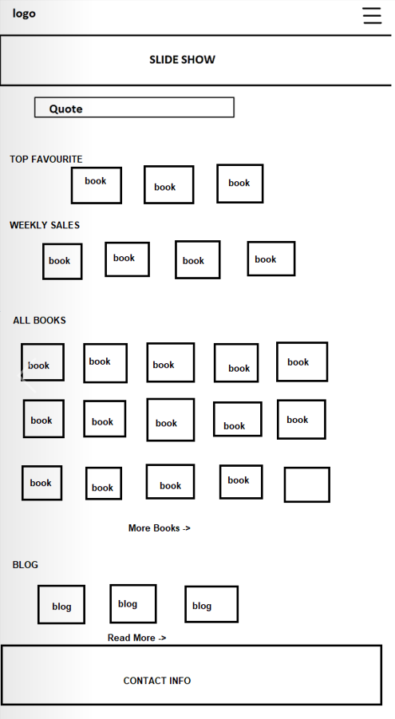

* Function Detail: When access website, user can see overview of page. The fixed Menu when open can see all the options that mention in Logout function. Slides Show part contains 3 pictures. Clicking on “See more” or “Read more”, user can see all of books or blogs. The contact carry information to connect to Administrators.

## 2. User register

* Function trigger: User clicks the “Sign Up” on Log In display.
* Function description:
  + Actor: Guests
* Interface:
  + 7 fields that users have to fill in all: Email, Username, Password. Phone, Full Name in the text style, Gender in option style and Birthday in date style.
  + 1 link head back to the Login screen
* Screen Layout

* Function Detail:
  + All fields must be filled up with data
  + Email and phone must be unique
  + Phone: start with 0, have 10-11 letters of number
  + Email : must have @
  + After click “Sign Up”,If all fields are validated and account created successfully, Users will heading back to the Login Screen
  + After click “Log In”, users will heading back to the Login Screen

## 3. Forget Password

* Function trigger: When users click the “Forget Password” in the Login Screen
* Function description:
  + Actor: Users
  + Purpose: Help users find back their account by reveice a new password sent into the gmail they provided when they created account.
  + Interface

+ input for email

+ 1 button to submit

+ 1 link to head back Login Screen

* Screen Layout:

* Function details:
  + Users have to fill the form with an existing email that he/she had registerd while they created the account
  + When he/she clicks the “Process” button, system will check the email they entered, check if it is existing in the database or not
  + If it is a valid email, a new password will be sent to that email

## 4. Logout

* Function trigger: In Home Page has been Logged In, user clicks on Menu and then selects Logout.
* Function description:
  + Actor: Users (include administrators and customers)
  + Purpose: to end access to a website
* Screen Layout:

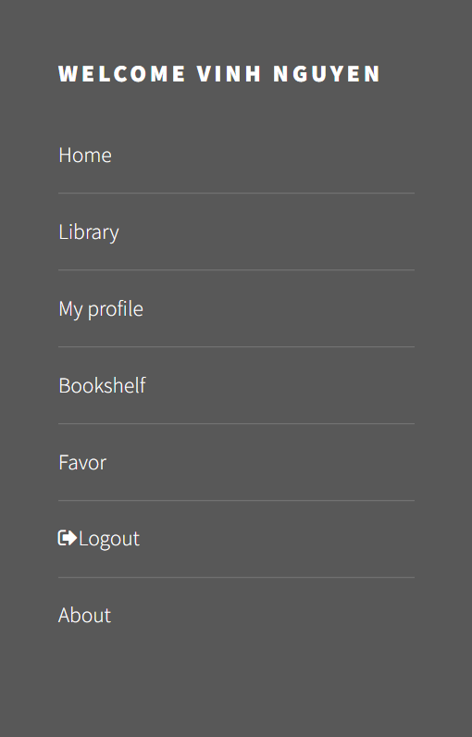

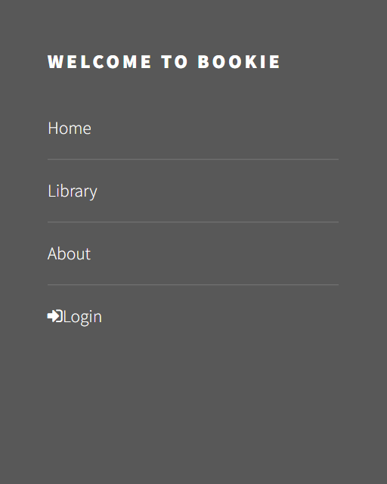

Before Logout After Logout

* Function Detail: When user click to “Logout” option, its session will be destroyed. User will be directed to Homepage.

## 5. Login

* Function trigger: Click “Login” on pop up home page
* Function description:
  + Actor: Admin , User
  + Users that have not yet registered cannot log in. They must contact the education unit to create a new account.
* Function interface:
  + 2 input text fields
  + 1 button “Sign In” to head into the home page of the system
  + 1 button “forget password” to head the users to the take back account screen
  + 1 button “sign up” to help users create their accounts
* Function detail:
  + Users shall login to the system by using the username and password which is registered.
  + Users shall be able to use system functionalities and be directed to the formal screen after successful login.
  + The Users will receive “errors” to the login screen if the username or password is invalid.
* Screen layout:

## 6. View profile (Super Admin)

* Function trigger: Dash board page click “ Profile”
* Function description:
  + Actor: Admin
  + Admin can view account’s profile
* Function interface:
  + The profile of Admin account will display on profile screen
  + Admin can view all those details
  + Screen layout:

## 7. Update profile(Super Admin)

* Function trigger: From Profile page
* Function description:
  + Actor: Admin
  + Admin can update profile need to
* Function detail:
  + There is a list of data of admin account.
  + Admin can check and rewrite what they want
  + Click the “Update” button to save the new details
  + Notice update successfully

● Screen layout:

## 8. View list of books

* Function trigger: When admin click the “Book Manager” in the Admin Panel
* Function description:
  + Actor: Customers
  + Interface

+ 1 list of Categories for users to choose

+ List books by category or all kind of books

* Screen Layout:

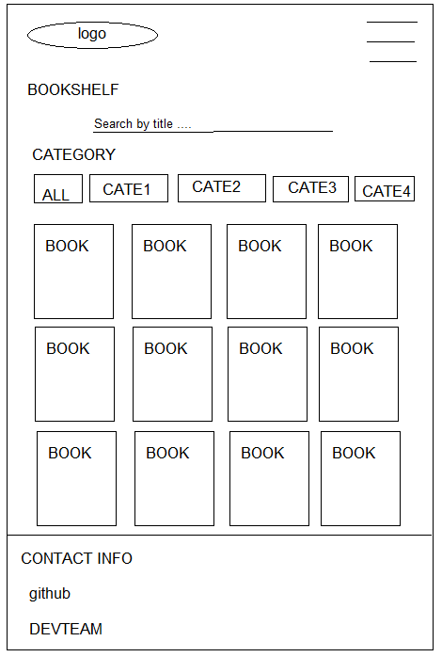

* Function details:

- All Categories can be chose to search book by category

- If click to a Book, users can see the Book details

## 9. View book’s description

* Function trigger: When users click button in Edit column in Book Manager page
* Function description:
  + Actor: Users
  + Interface:

+ 1 button Add to Cart: send book to user’s carts where user can pay money to buy books

* Screen Layout:

## 10. View profile (Customers)

* Function trigger: This use case starts when an user click on navigation bar button on top right of website and click “My profile”.
* Function description:
  + Role: Customers
* Screen layout:

* Function detail:
  + System display user’s profile include his user id, username, name, date of birth, gender, email, phone, address.
  + From this screen, user can choose to edit his profile.

## 11. Update profile (Customers)

* Function trigger: This use case starts when user click on “Edit” button in view profile screen.
* Function description:
  + Role: Customers
  + Purpose: Update user’s profile
  + Interface:
    - 2 input text box for to enter name, and address
    - 1 input date to enter date of birth
    - 1 input number to enter phone number
    - 2 input radiant to choose gender
    - 2 button “Cancel” and “Save”
* Function layout:

* Function detail:
  + The user can see his current information and change them (except user id, username and email). All fields cannot be empty except address.
  + Phone number must be a string of 10 digits.
  + Name only have alphabetic characters and space characters. Name can not be longer than 40 characters.
  + User can choose “Save” to save new information or choose “Cancel” to back to view profile screen without any change.

## 12. View security status

* Function trigger: This use case starts when user click on “Security” tab in left sidebar.
* Function description:
  + Role: User
  + Purpose: View account’s security
* Function layout:

* Function detail:
  + The user can see current email and password level of account.
  + Password level show how strong current password is:
    - Password just have number or alphabetic characters, password level is week.
    - Password have both alphabetic characters and number, password level is medium.
    - Password have alphabetic characters, number and special character, password level is strong.

## 13. Change password

* Function trigger: This use case starts when user click on “Change” beside password level in security screen.
* Function description:
  + Role: User
  + Purpose: Change password
  + Interface:
    - 3 text boxes to enter password, new password and confirm password
    - 2 button “Cancel” or “Confirm”
* Function layout:

* Function detail:
  + When user choose to change password, this pop-up will open. User enter current password to authorize this action, then enter new password 2 times. Then choose confirm to change password.
  + If user does not want to change password, click “Cancel”.
  + User cannot confirm if current password is wrong, or confirm password does not matches with new password, or new password is invalid. New password is invalid when:
    - It is empty.
    - It’s length is less than 6 character or more than 32 character.
    - It starts with a space.