

**<<bOOKIE>>**

**Software Design Document**

– Hanoi, September 2022 –

Table of Contents

I. Overview 3

1. Code Packages/Namespaces 3

II. Code Designs 4

1. Homepage 4

a. Class Diagram 4

b. Class Specifications 4

c. Sequence Diagram(s) 6

d. Database queries 6

2. Signup 7

a. Class Diagram 7

b. Class Specifications 7

c. Sequence Diagram(s) 8

d. Database queries 8

3. Login 10

a. Class Diagram 10

b. Class Specifications 10

c. Sequence Diagram(s) 11

d. Database queries 11

4. Logout 11

a. Class Diagram 11

b. Class Specifications 11

c. Sequence Diagram(s) 12

d. Database queries 12

5. Forget password 12

a. Class Diagram 12

b. Class Specifications 12

c. Sequence Diagram(s) 14

d. Data queries 14

6. View Admin Profile 15

a. Class Diagram 15

b. Class Specifications 15

c. Sequence Diagram(s) 16

d. Database queries 16

7. Update Admin Profile 17

a. Class Diagram 17

b. Class Specifications 17

c. Sequence Diagram(s) 18

d. Database queries 18

8. Forget password 18

a. Class Diagram 18

b. Class Specifications 18

c. Sequence Diagram(s) 20

d. Data queries 20

9. Code Packages/Namespaces 21

10. Profile 21

a. Class Diagram 21

b. Class Specifications 22

c. Sequence Diagram(s) 22

11. Edit profile 22

a. Class Diagram 22

b. Class Specifications 23

c. Sequence Diagram(s) 24

d. Database queries 24

12. View security 24

a. Class Diagram 24

b. Class Specifications 24

c. Sequence Diagram(s) 25

13. Change password 26

a. Class Diagram 26

b. Class Specifications 26

c. Sequence Diagram(s) 27

d. Database queries 27

III. Database Design 28

1. Database Schema 28

2. Table Description 28

# I. Overview

## 1. Code Packages/Namespaces

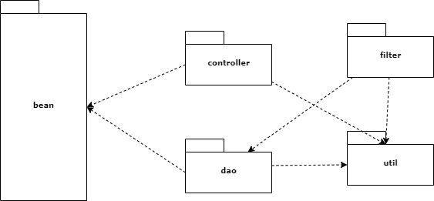

***Package descriptions & package class naming conventions***

|  |  |  |
| --- | --- | --- |
| **No** | **Package** | **Description** |
| 01 | DAO | Used to contain files that arre related to Database Connected Files |
| 02 | controller | Used to contain files that are directly control the system |
| 03 | Utilities | Used to contain files that helps the controllers to manage the system |
| 04 | Filter | Used to contain files whose purpose are user authorization and encoding the web |

# II. Code Designs

## 1. Homepage

### a. Class Diagram

### b. Class Specifications

**- BookDAO class**

|  |  |  |
| --- | --- | --- |
| No | Method | Description |
| 01 | getNumberBook | Return an integer which is quantity of books |
| 02 | getWeeklySaleBooks | Return a list contains 4 that has sale in week to display in homepage |
| 03 | getFeaturedBooks | Random selected 15 books in all book to display in homepage |
| 04 | getFavouriteBooks | Get top 3 books that has highest user choose to display in homepage |

**- Book class**

|  |  |  |
| --- | --- | --- |
| No | Method | Description |
| 01 | Book(int id, String title, String author, int categoryid, float rating, int favourite, float price, boolean issale, String image, String description, int views) | Get all information of a books for details |
| 02 | Book(int id, String title, String author, float price, boolean issale, int favourite, String image) | Get general information of a books for display on homepage |

**- Home class**

|  |  |  |
| --- | --- | --- |
| No | Method | Description |
| 01 | processRequest(HttpServletRequest request, HttpServletResponse response) | - ArrayList to take a list from getFeaturedBooks() from Book  - ArrayList to take a list from getWeeklySaleBooks() from Book  - ArrayList to take a list from getFavouriteBooks() from Book |
| 02 | doGet() | Doing processRequest |
| 03 | doPost() | Doing processRequest |

**- DBContext class**

|  |  |  |
| --- | --- | --- |
| No | Method | Description |
| 01 | getConnection() | Connecting with database |

### c. Sequence Diagram(s)

### d. Database queries

- getFeaturedBooks(): “select * from [Book]”

- getWeeklySaleBooks(): "select * from [Book] where [is_sale] = 1"

- getFavoriteBooks(): “select top(3)* from BOOK order by favourite desc”

## 2. Signup

### a. Class Diagram

### b. Class Specifications

**- UserDAO class**

|  |  |  |
| --- | --- | --- |
| No | Method | Description |
| 01 | getUser | Get username and password |
| 02 | generatePass | Encode users’ password |
| 03 | checkDupEmail | Checking that user’s email is exist or not |
| 04 | checkDupUsername | Checking that user’s username is exist or not |
| 05 | editProfile | Allow user to edit their information |
| 06 | changePassword | Allow user to change their password |
| 07 | getNumberUser | Get Total Number |
| 08 | getAllUser | Taking a list contains all user includes their information |
| 09 | getUserName | Taking user’s ursername |
| 10 | updateUser | Update information of user |
| 11 | checkOldPass | Checking user’s old password when they want to change their one. |

**- User class**

|  |  |  |
| --- | --- | --- |
| No | Method | Description |
| 01 | User(int id, String name, String gender, String dob, String email, String phone, String address, String username, String password, boolean is_super) | Get all information of user for detail |
| 02 | User(String name, String gender, String dob, String email, String phone, String address, String username, String password) | Get general information of user |

**- DBContext class**

|  |  |  |
| --- | --- | --- |
| No | Method | Description |
| 01 | getConnection() | Connecting with database |

### c. Sequence Diagram(s)

### 

### d. Database queries

- getUser(): "Select * from [User] where (username=? OR email=?) AND password=?"

- checkDupEmail(String email): "select * from [User] where email='" + email + "'"

- checkDupUsername(String key): "select * from [User] where username='" + key + "'"

- createNewUser(String name, String gender, String dob, String email, String phone, String username, String password): "insert [User] ([fullname],[gender] ,[dob] , [email], [phone],[username], [password])"

+ " values (N'" + name + "',"

+ "N'" + (gender.equals("Male") ? 1 : 0) + "',"

+ "CAST(N'" + dob+ "' AS Date),"

+ "N'" + email + "',"

+ "N'" + phone + "',"

+ "N'" + username + "',"

+ "N'" + password + "')"

- editProfile(int userid, String name, String gender, String dob, String email, String phone, String address): "update [User] set "

+ " [fullname] = N'" + name+ "' AND"

+ " [gender] = " + (gender.equals("male") ? 1 : 0) + " AND"

+ " [dob] = N'" + dob + "' AND"

+ " [phone] = N'" + phone + "' AND"

+ " [address] = N'"+ address+"'"

+ "where [id] = "+userid

- changePassword(int userid, String newPassword): "update [User] set " + " [password] = N'" +newPassword + "'"+ "where [id] = "+userid

- getNumberUser(): "select count([id]) from [User] where [is_super] = 'False'"

- getAllUsers(): "Select * from [User] where [is_super] = 0"

- getUsername(int userid): "select [username] from [User] where [id] = "+userid

- updateUser(int id, String name, String phone, String address): "update [User] set "

+ " [fullname] = N'" +name + "'"

+ ", [phone] = N'"+phone+"'"

+ ", [address] = N'"+address+"'"

+ "where [id] = "+id

- checkOldPass(int id,String oldpass): "select * from [User] where [id] = "+id+" AND [password]=N'"+oldpass+"'"

## 3. Login

### a. Class Diagram

### b. Class Specifications

#### LoginController

***Class Methods***

|  |  |  |
| --- | --- | --- |
| **No** | **Method** | **Description** |
| *1* | *doGet()* | *Handles the HTTP <code>GET</code> method.* |
| *2* | *doPost()* | *Handles the HTTP <code>POST</code> method.* |

#### UserDAO

***Class Methods***

|  |  |  |
| --- | --- | --- |
| **No** | **Method** | **Description** |
| *1* | *getUser()* | *Method used to check if an account record existed in database and get all data of that account.Inputs are username and password.Return an <Code>model.User</Code> represents the user’s data* |

#### DBContext

***Class Methods***

|  |  |  |
| --- | --- | --- |
| **No** | **Method** | **Description** |
| *1* | *getConnection* | *Method used to connect to the database. Return a <Code>java.sql.Connection</Code> represents a connection to the database.* |

### c. Sequence Diagram(s)

### d. Database queries

Select * from [User] where (username=? OR email=?) AND password=?

## 4. Logout

### a. Class Diagram

**A, Class diagram**

|  |
| --- |
| LogoutController |
| processRequest(request: HttpServletRequest, response: HttpServletResponse)  doGet()  doPost() |

### b. Class Specifications

**- Logout Controller**

|  |  |  |
| --- | --- | --- |
| No | Method | Description |
| 01 | processRequest(HttpServletRequest request, HttpServletResponse response) | - Destroy session  - Redirect to Homepage |
| 02 | doGet() | Doing processRequest |
| 03 | doPost() | Doing processRequest |

### c. Sequence Diagram(s)

## d. Database queries

## 5. Forget password

### a. Class Diagram

### b. Class Specifications

#### ForgetController

***Class Methods***

|  |  |  |
| --- | --- | --- |
| **No** | **Method** | **Description** |
| *1* | *doGet()* | *Handles the HTTP <code>GET</code> method.* |
| *2* | *doPost()* | *Handles the HTTP <code>POST</code> method.* |

#### UserDAO

#### Class Methods

|  |  |  |
| --- | --- | --- |
| **No** | **Method** | **Description** |
| *1* | *checkEmailExisted* | *Method used to check if an email of a User record existed in the database and get id data of that account. Input is email. Return an Integer represents the account‘s id.* |
| *2* | *createResetToken* | *Method used to insert token of a ResetToken record with expiration time. Input is the user's id. Return the generated token as a String* |
| *3* | *resetPassword* | *Method used to update password of a User record if the token input is still in expiration time. Return a String represents the new user’s password* |
|  |  |  |

#### DBContext

***Class Methods***

|  |  |  |
| --- | --- | --- |
| **No** | **Method** | **Description** |
| *1* | *getConnection* | *Method used to connect to the database. Return a connection to the database* |

#### MyUtil

***Class Methods***

|  |  |  |
| --- | --- | --- |
| **No** | **Method** | **Description** |
| *1* | *sendEmail* | *Method used to send an email of a reset instruction. Inputs include recipient’s email and message .* |
| *2* | *randomString* | *Method used to generate a randomized any-number-character string. Return that string.* |

### c. Sequence Diagram(s)

### 

### d. Data queries

* **Get id of a record with specific email from User table**

SELECT id

FROM [User]

WHERE email = ?

* **Insert a record with specific user id into ResetToken table**

INSERT INTO [ResetToken] ([uId], [token], [expiredDate])

VALUES ( ? , ? , ?)

* **Update password of a record with specific token in User table**

UPDATE [User]

SET [password] = ?

WHERE [id] = (select [uid] from [ResetToken] where [token] = ? )

## 6. View Admin Profile

### a. Class Diagram

### b. Class Specifications

#### LoginController

***Class Methods***

|  |  |  |
| --- | --- | --- |
| **No** | **Method** | **Description** |
| *1* | *doPost()* | *Handles the HTTP <code>POST</code> method.* |

#### EditController

***Class Methods***

|  |  |  |
| --- | --- | --- |
| **No** | **Method** | **Description** |
| *1* | *doGet()* | *Handles the HTTP <code>GET</code> method.* |

#### UserDAO

***Class Methods***

|  |  |  |
| --- | --- | --- |
| **No** | **Method** | **Description** |
| *1* | *getUser()* | *Method used to check if an account record existed in database and get all data of that account.Inputs are username and password.Return an <Code>model.User</Code> represents the user’s data* |

#### DBContext

***Class Methods***

|  |  |  |
| --- | --- | --- |
| **No** | **Method** | **Description** |
| *1* | *getConnection* | *Method used to connect to the database. Return a <Code>java.sql.Connection</Code> represents a connection to the database.* |

### c. Sequence Diagram(s)

### d. Database queries

Select * from [User] where (username=? OR email=?) AND password=?

## 7. Update Admin Profile

### a. Class Diagram

### b. Class Specifications

#### EditController

***Class Methods***

|  |  |  |
| --- | --- | --- |
| **No** | **Method** | **Description** |
| *1* | *doGet()* | *Handles the HTTP <code>GET</code> method.* |
| *2* | *doPost()* | *Handles the HTTP <code>POST</code> method.* |

#### UserDAO

***Class Methods***

|  |  |  |
| --- | --- | --- |
| **No** | **Method** | **Description** |
| *1* | *editProfile()* | *Method used to let admin update the data of that account.Inputs are admin details.Update those to database.* |

#### DBContext

***Class Methods***

|  |  |  |
| --- | --- | --- |
| **No** | **Method** | **Description** |
| *1* | *getConnection* | *Method used to connect to the database. Return a <Code>java.sql.Connection</Code> represents a connection to the database.* |

### c. Sequence Diagram(s)

### d. Database queries

update[User] set

[email] = ?,

[fullname] = ?,

[phone] = ?,

[address] = ?

where [id] = ?

## 8. Forget password

### a. Class Diagram

### b. Class Specifications

#### ForgetController

***Class Methods***

|  |  |  |
| --- | --- | --- |
| **No** | **Method** | **Description** |
| *1* | *doGet()* | *Handles the HTTP <code>GET</code> method.* |
| *2* | *doPost()* | *Handles the HTTP <code>POST</code> method.* |

#### UserDAO

#### Class Methods

|  |  |  |
| --- | --- | --- |
| **No** | **Method** | **Description** |
| *1* | *checkEmailExisted* | *Method used to check if an email of a User record existed in the database and get id data of that account. Input is email. Return an Integer represents the account‘s id.* |
| *2* | *createResetToken* | *Method used to insert token of a ResetToken record with expiration time. Input is the user's id. Return the generated token as a String* |
| *3* | *resetPassword* | *Method used to update password of a User record if the token input is still in expiration time. Return a String represents the new user’s password* |
|  |  |  |

#### DBContext

***Class Methods***

|  |  |  |
| --- | --- | --- |
| **No** | **Method** | **Description** |
| *1* | *getConnection* | *Method used to connect to the database. Return a connection to the database* |

#### MyUtil

***Class Methods***

|  |  |  |
| --- | --- | --- |
| **No** | **Method** | **Description** |
| *1* | *sendEmail* | *Method used to send an email of a reset instruction. Inputs include recipient’s email and message .* |
| *2* | *randomString* | *Method used to generate a randomized any-number-character string. Return that string.* |

### c. Sequence Diagram(s)

### d. Data queries

* **Get id of a record with specific email from User table**

SELECT id

FROM [User]

WHERE email = ?

* **Insert a record with specific user id into ResetToken table**

INSERT INTO [ResetToken] ([uId], [token], [expiredDate])

VALUES ( ? , ? , ?)

* **Update password of a record with specific token in User table**

UPDATE [User]

SET [password] = ?

WHERE [id] = (select [uid] from [ResetToken] where [token] = ? )

## 9. Code Packages/Namespaces



***Package descriptions & package class naming conventions***

|  |  |  |
| --- | --- | --- |
| **No** | **Package** | **Description** |
| 01 | DAO | Used to contain files that arre related to Database Connected Files |
| 02 | controller | Used to contain files that are directly control the system |
| 03 | Utilities | Used to contain files that helps the controllers to manage the system |
| 04 | Filter | Used to contain files whose purpose are user authorization and encoding the web |

## 10. Profile

### a. Class Diagram

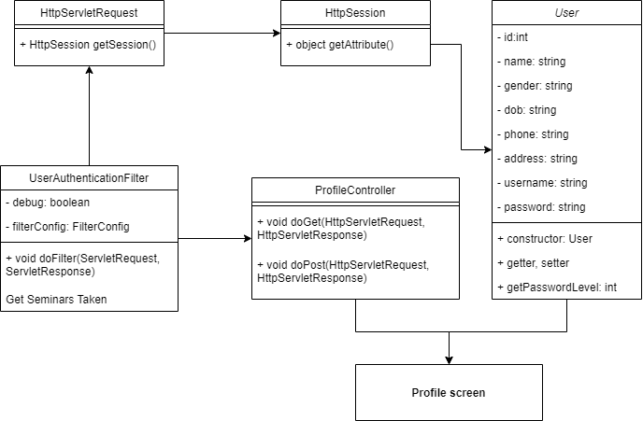

### b. Class Specifications

#### Controller.User.ProfileController

|  |  |  |
| --- | --- | --- |
| **No** | **Method** | **Description** |
| 01 | doGet | Handles the HTTP <code>GET</code> method. |
| 02 | doPost | Handles the HTTP <code>POST</code> method. |

#### Filter.UserAuthenticationFilter

|  |  |  |
| --- | --- | --- |
| **No** | **Method** | **Description** |
| 01 | doFilter | Handles the HTTP <code>GET</code> method. |

### c. Sequence Diagram(s)

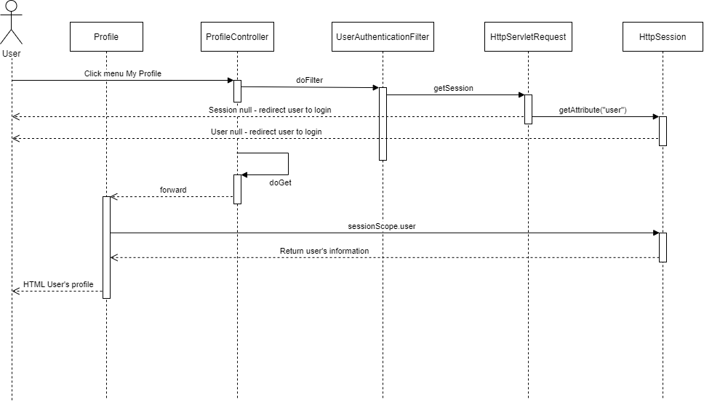

## 11. Edit profile

### a. Class Diagram

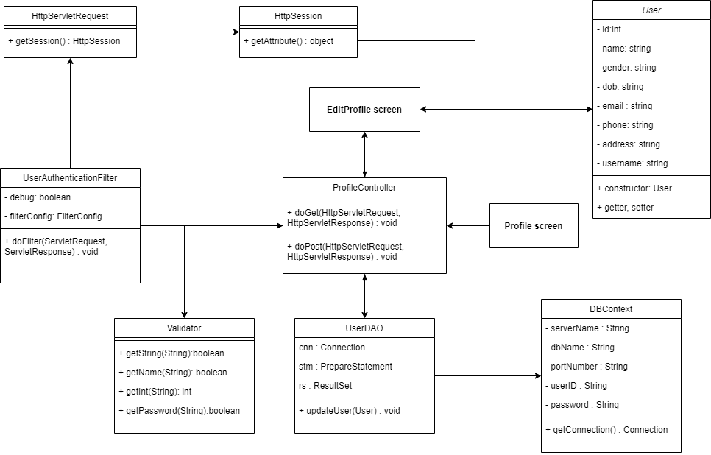

### b. Class Specifications

#### Controller.User.ProfileController

|  |  |  |
| --- | --- | --- |
| **No** | **Method** | **Description** |
| 01 | doGet | Handles the HTTP <code>GET</code> method. |
| 02 | doPost | Handles the HTTP <code>POST</code> method. |

#### Filter.UserAuthenticationFilter

|  |  |  |
| --- | --- | --- |
| **No** | **Method** | **Description** |
| 01 | doFilter | Handles the HTTP <code>GET</code> method. |

#### Model.User

|  |  |  |
| --- | --- | --- |
| **No** | **Method** | **Description** |
| 01 | getId | Get ID of user |
| 02 | getName | Get name of user |
| 03 | getGender | Get gender of user |
| 04 | getPhone | Get phone number of user |
| 05 | getAddress | Get address of user |
| 06 | getEmail | Get email of user |
| 07 | setName | Set name of user |
| 08 | setPhone | Set phone number of user |
| 09 | setAddress | Set address of user |
| 10 | setGender | Set gender of user |

#### Context.UserDAO

|  |  |  |
| --- | --- | --- |
| **No** | **Method** | **Description** |
| 01 | updateProfile | Update information of user in database |

#### Model.Validator

|  |  |  |
| --- | --- | --- |
| **No** | **Method** | **Description** |
| 01 | getString | Check if string is empty |
| 02 | getName | Check if name is empty or contains digit or so long |

### c. Sequence Diagram(s)

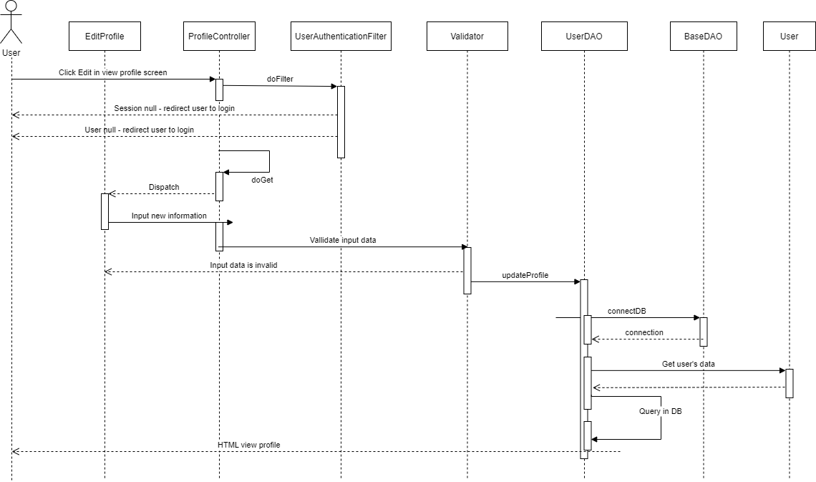

### d. Database queries

update [User] set [fullname] = ?, [phone] = ?, [address] = ?, [gender] = ?, [dob] = ? where [id] = ?

## 12. View security

### a. Class Diagram

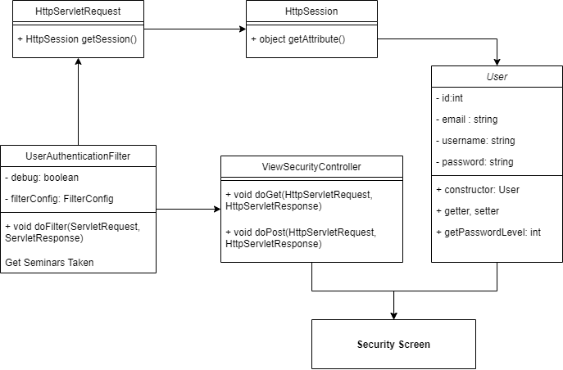

### b. Class Specifications

#### Controller.User.ProfileController

|  |  |  |
| --- | --- | --- |
| **No** | **Method** | **Description** |
| 01 | doGet | Handles the HTTP <code>GET</code> method. |
| 02 | doPost | Handles the HTTP <code>POST</code> method. |

#### Filter.UserAuthenticationFilter

|  |  |  |
| --- | --- | --- |
| **No** | **Method** | **Description** |
| 01 | doFilter | Handles the HTTP <code>GET</code> method. |

#### Model.User

|  |  |  |
| --- | --- | --- |
| **No** | **Method** | **Description** |
| 01 | getEmail | Get email of user |
| 02 | getPasswordLevel | Get level of password |

### c. Sequence Diagram(s)

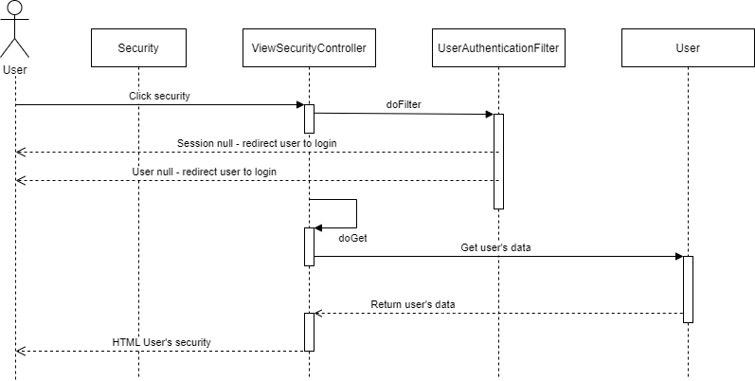

## 13. Change password

### a. Class Diagram

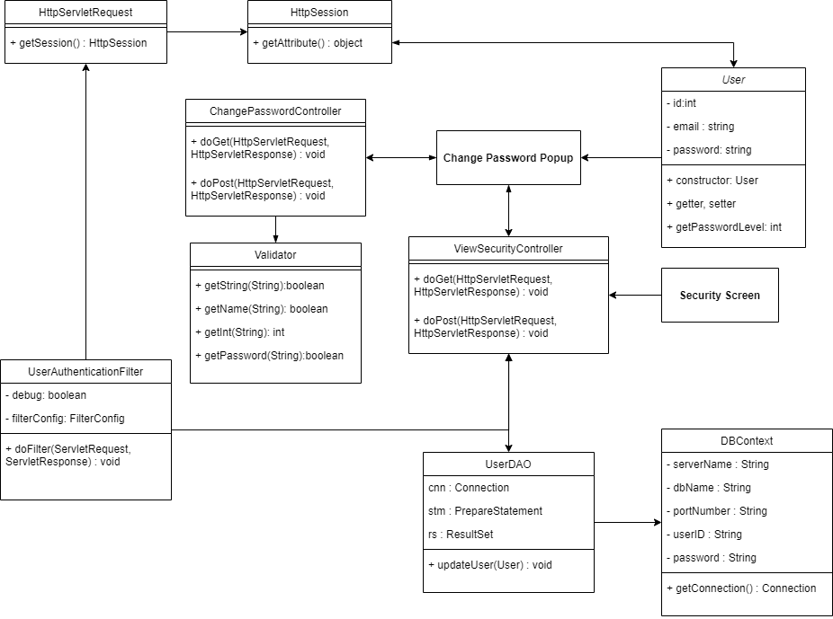

### b. Class Specifications

#### Controller.User.ProfileController

|  |  |  |
| --- | --- | --- |
| **No** | **Method** | **Description** |
| 01 | doGet | Handles the HTTP <code>GET</code> method. |
| 02 | doPost | Handles the HTTP <code>POST</code> method. |

#### Filter.UserAuthenticationFilter

|  |  |  |
| --- | --- | --- |
| **No** | **Method** | **Description** |
| 01 | doFilter | Handles the HTTP <code>GET</code> method. |

#### Model.User

|  |  |  |
| --- | --- | --- |
| **No** | **Method** | **Description** |
| 01 | getPassword | Get password of user |
| 02 | getId | Get ID of user |

#### Context.UserDAO

|  |  |  |
| --- | --- | --- |
| **No** | **Method** | **Description** |
| 01 | changePassword | Change password of user by id and new password |

#### Model.Validator

|  |  |  |
| --- | --- | --- |
| **No** | **Method** | **Description** |
| 01 | getString | Check if string is empty |
| 02 | getPassword | Check if password is valid |

### c. Sequence Diagram(s)

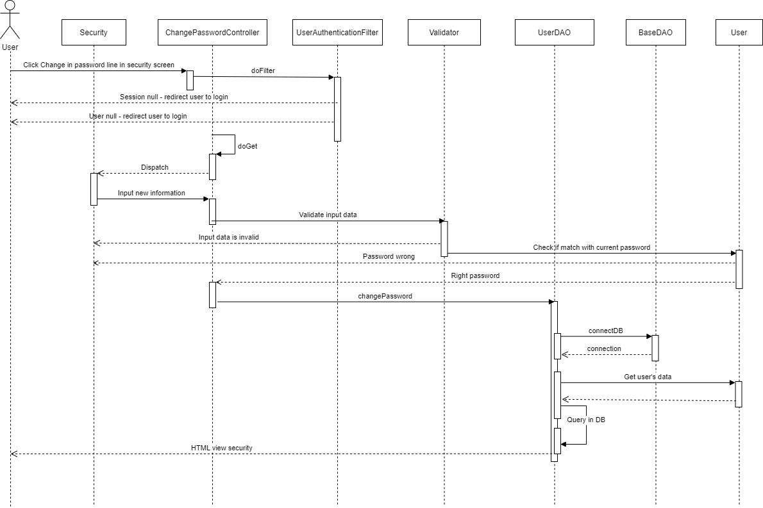

### d. Database queries

update [User] set [password] = ? where [id] = ?

# III. Database Design

## 1. Database Schema

## 2. Table Description

|  |  |  |
| --- | --- | --- |
| **No** | **Table** | **Description** |
| 01 | Book | - Primary key: ID  - Foreign key :<none>  - Attribute: tittle, author, categoryID, rating, favourite, price, is_sale, image, description, views |
| 02 | User | - Primary key: ID  - Foreign key: <none>  - Attribute: fullname, gender, dob, email, phone, address,username, password, is_super |
| 03 | Favourite | - Primary key: uID  - Foreign key: uID(User: ID), bID(Book: ID)  - Attribute: <none> |
| 04 | Category | - Primary key: ID  - Foreign key: ID(Book: categoryID)  - Attribute: name |
| 05 | Star | - Primary key: bID  - Foreign key: bID(Book: ID)  - Attribute: <none> |
| 06 | ResetToken | - Primary key: uID  - Foreign key: uID(Book: ID)  - Attribute: token, expired data |
| 07 | Volumn | - Primary key: bID, vol  - Foreign key: bID(Book: ID)  - Attribute: vol_name |
| 08 | Chapter | - Primary key: bID, vol, chapter  - Foreign key: bID(Book: ID), vol(Volumn: vol)  - Attribute: chapter_name, content |