1. In this situation, my recommendation is the Waterfall software development methodology ,cause :

* It prefer for a small size projects which we can easy to understand the requirements.
* Because of its nature, each phase has specific deliverables and a review process. So it is the most convenient management model
* Each section: Process or results are reported
* The team run the project which noticed just include a start-up and a software development professional . So it is impossible to split the works .

1. The 4 functional requirements which are necessary for babysitters are :

* Validating the Payment for the service : the website requires babysitter must verify their payment method like bank account , credit – debit card , .. before using since they also have to pay for using fees
* Posting CV with some features : the ages, the location , enroll as a part-time or full-time , …
* Booking : babysitters can choose the parent they wanted

1. As a parent , I want to see some profile and the rate of the babysitters before booking. Because , I want to sure that my baby will prefer to that babysitter.

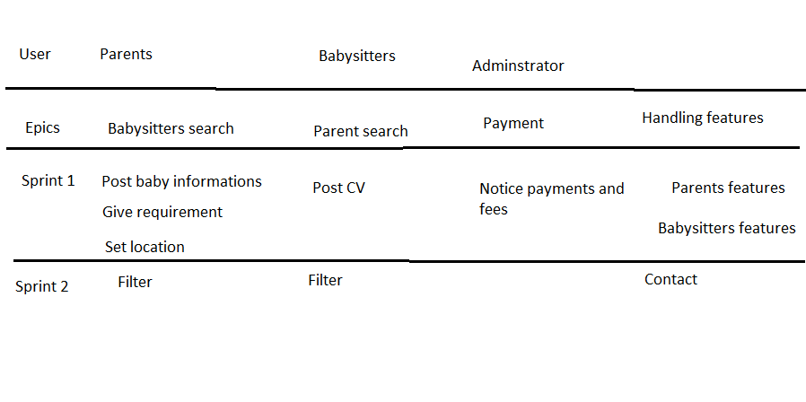

1. Although the requirements are given clearly , it does not notice about the size of the project . Moreover , the development team here include an administrator – a start up and a software development professional. It will lead to the lack of resources providing , the functions are not sure to complete on time and the failure can be happen anytime. Beside , it need to the highly noticeable management . So from my point of view, I do not recommend ITERATIVE methodology in this project