

**Software Requirement Specification**

– Hanoi, September 15, 2022–

Table of Contents

1. Product Overview 4

2. User Requirements 4

2.1. Actors 4

2.2. Use Cases 5

2.2.1 Use Case Diagrams 5

2.2.2 Use Case Description 6

3. Functional Requirements 8

3.1 System Functional Overview 8

3.1.1 Screens Flow 8

3.1.2 Screen Description 8

3.1.3 Screen Authorization 10

3.1.3 Entity Relationship Diagram 12

Entities Description 12

3.2. Register Account 13

3.3. Sign In 14

3.4. Forgot password 16

3.5. View profile 17

Learner 17

Expert 18

3.6. Edit profile 19

3.7. Homepage 20

3.8. Manage Course 21

3.9. Mooc Management 22

3.10. Lesson Manage 23

3.11. Assignment Management 25

3.12. Dashboard 26

3.13. Manage User 27

3.14. View Income, Package Purchase, New User Register 28

3.15. See overview of course 30

3.16. View Mooc Detail 31

3.17. Lesson Detail 32

3.18. Assignment Detail 34

3.19. Send Report Mooc 35

3.20. View my course 36

3.21. Manage Report 38

3.22. View Report 39

3.23. Action to report 40

3.24. Add Lesson 42

3.25. Add Mooc 43

4. Non-functional requirements 44

4.1 External Interfaces 44

4.1.1. User Interface 44

4.1.2.Software Interfaces 44

4.1.3 Hardware Interfaces 45

4.1.4. Communications Interfaces 45

4.2 Quality Attributes 45

4.2.1.Usability 45

4.2.2. Reliability 45

4.2.3. Performance 46

4.2.4. Security 46

4.2.5. Safety 46

5. Requirements Appendix 46

5.1. Notification List 46

5.2. Bussiness Rules 47

# 1. Product Overview

This project is aimed at developing an online learning system that supports the organization/expert to build up & sell the online courses and supports the user too search-register-and-access for online courses for learning.

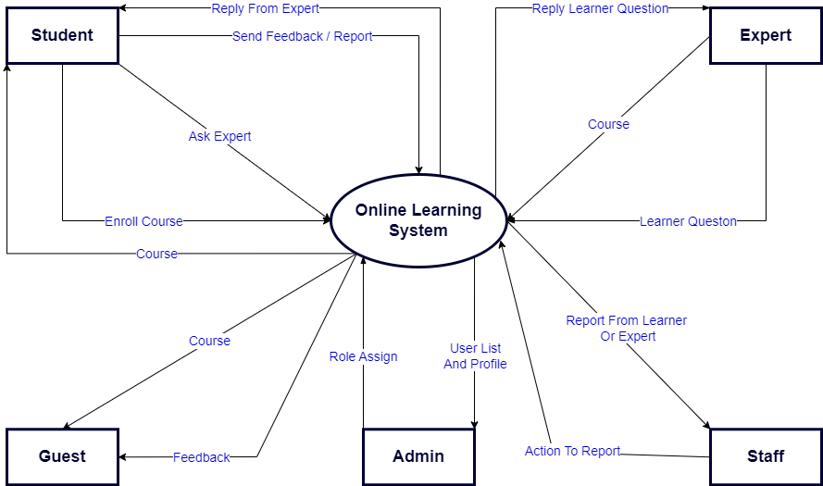

Figure 1: Context diagram

# 2. User Requirements

## 2.1. Actors

|  |  |  |
| --- | --- | --- |
| **#** | **Actors** | **Description** |
| 1 | Admin | People who manage the Online Learning System |
| 2 | Guest | The user that has not yet registered an account |
| 3 | Learner | People who already have an account and are using the course |
| 4 | Expert | Expert of Online Learning System |
| 5 | Staff | People who work the Online Learning System |

Table 1: Actors

## 2.2. Use Cases

### 2.2.1 Use Case Diagrams

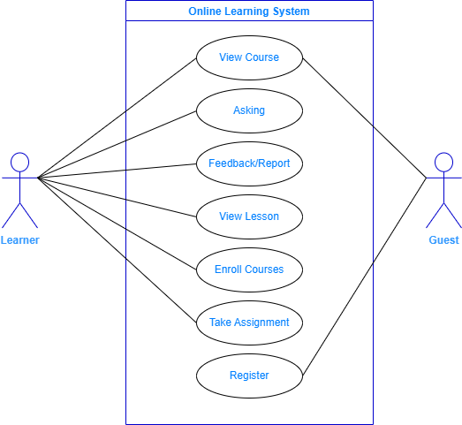

Figure 2: Use case diagram

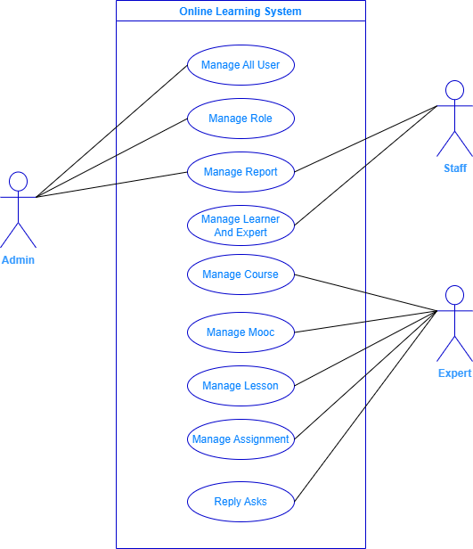

Figure 3: Use case diagram

### 2.2.2 Use Case Description

|  |  |  |  |
| --- | --- | --- | --- |
| **ID** | **Use Case** | **Primary Actors** | **Description** |
| UC-01 | Sign Up | Guest | Sign up for an account on the system |
| UC-02 | Sign In | Learner, Admin, Staff, Expert | User login to the website |
| UC-03 | Forget Password | Learner, Admin, Staff, Expert | User can verify to restore password |
| UC-04 | View Profile | Learner, Admin, Staff, Expert | User can see their profile’s information |
| UC-05 | Edit Profile | Learner, Admin, Staff, Expert | User can edit their profile’s information |
| UC-06 | View Home Page | All | View home page |
| UC-07 | Course Manage | Expert | Expert can see, take action their course |
| UC-08 | Mooc Manage | Expert | Expert can see, take action their mooc of course |
| UC-09 | Lesson Manage | Expert | Expert can see, take action their lesson in mooc |
| UC-10 | Assignment Manage | Expert | Expert can see, take action their assignment |
| UC-11 | Dashboard | Admin | Admin can see total information in a month |
| UC-12 | Manage Users | Admin, Staff | Admin can see total information of user |
| UC-13 | View Income, Package Purchase, New User Register | Admin | Admin can see insight of page |
| UC-14 | See overview of course | All | See highlight information of a course |
| UC-15 | View Mooc Detail | Learner, Admin, Staff, Expert | See highlight information of a mooc |
| UC-16 | Lesson Detail | Learner, Admin, Staff, Expert | See highlight information of a lesson |
| UC-17 | Assignment Detail | Learner, Admin, Staff, Expert | See highlight information of a course |
| UC-18 | Send Report Mooc | Learner | Learner can report mooc of course |
| UC-19 | View My Courses | Learner | User can see course that they enrolled in |
| UC-20 | Manage Report | Admin, Staff | User can see information of the report |
| UC-21 | View Report | Learner, Admin, Staff, Expert | See detail of report |
| UC-22 | Action to Report | Admin, Staff | Admin, staff can see detail of report |
| UC-23 | Add Lesson | Expert | Expert can add new Lesson to the Mooc |
| UC-24 | Add Mooc | Expert | Expert can add new Mooc to the course |

Table 2: Use case list and description

# 3. Functional Requirements

## 3.1 System Functional Overview

### 3.1.1 Screens Flow

Figure 4: System screen flow

### 3.1.2 Screen Description

|  |  |  |  |
| --- | --- | --- | --- |
| **#** | **Feature** | **Screen** | **Description** |
| 1 | Home | Sign In | Screen for the user to login into the system. |
| 2 | Home | Sign Up | Screen for guests to create an account. |
| 3 | Home | Forgot Password | Screen for the user to find the password. |
| 4 | User Profile | Home | The screen that shows general information of the website: list online mentors, list requests, list skills, logo, slogan, etc. |
| 5 | Manage Account | View Profile | The screen shows useful information. |
| 6 | Manage Account | Edit Profile | The screen where users edit their profiles. |
| 7 | Manage Course | My Course | The screen where users see their courses. |
| 8 | Manage Course | Manage Course | The screen where expert manage course. |
| 9 | Manage Course | Course Detail | The screen displays a list of course. |
| 10 | Manage Course | Detail lesson | The screen where learner study lesson. |
| 11 | Manage Course | Manage Users | The screen where the admin manages users. |
| 12 | Manage Course | Manage Lesson | The screen where expert manage lesson. |
| 13 | Manage Course | Assignment Manage | The screen where expert manage assignment. |
| 14 | Home | Dashboard | The screen where admin see insight |
| 15 | Manage Account | Manage Users | The screen where admin manage user |
| 16 | Home | View Income, Package Purchase, New User Register | The screen where admin see general information |
| 17 | Manage Course | See overview of course | The screen where user see information of course |
| 18 | Manage Course | Mooc Detail | The screen where learner study mooc. |
| 19 | Manage Course | Manage Report | The screen where learner manage report. |
| 20 | Manage Course | View Report | The screen where user can see report. |
| 21 | Manage Course | Action to Report | The screen where user can do action with report. |
| 22 | Manage Course | Add Lesson | The screen where expert can add lesson. |
| 23 | Manage Course | Add Mooc | The screen where expert can add mooc. |
| 24 |  |  |  |

Table 3: Screen description

### 3.1.3 Screen Authorization

|  |  |  |  |  |
| --- | --- | --- | --- | --- |
| **Screen** | **Learner** | **Admin** | **Stafff** | **Expert** |
| **Sign Up** |  |  |  |  |
| **Sign In** | **x** | **x** | **x** | **X** |
| **Forget Password** | **X** | **x** | **x** | **x** |
| **View Profile** | **x** | **x** | **x** | **X** |
| **Edit Profile** | **X** | **x** | **x** | **x** |
| **View Home Page** | **x** | **x** | **x** | **X** |
| **Course Manage** |  |  |  | **X** |
| **Mooc Manage** |  |  |  | **X** |
| **Lesson Manage** |  |  |  | **X** |
| **Assignment Manage** |  |  |  | **X** |
| **Dashboard** |  | **X** |  |  |
| **Manage Users** |  | **x** | **x** |  |
| **View Income, Package Purchase, New User Register** |  | **X** |  |  |
| **View Mooc Detail** | **x** | **x** | **x** | **X** |
| **Lesson Detail** | **X** | **x** | **x** | **x** |
| **Assignment Detail** | **x** | **x** | **x** | **X** |
| **Send Report Mooc** | **X** |  |  |  |
| **View My Courses** | **X** |  |  |  |
| **Manage Report** |  | **x** | **X** |  |
| **View Report** | **X** | **x** | **x** | **x** |
| **Action to Report** |  | **x** | **X** |  |
| **Add Lesson** |  |  |  | **X** |
| **Add Mooc** |  |  |  | **x** |

Table 4: Screen Authorization

### **3.1.3 Entity Relationship Diagram**

Figure 5: Entity Relationshop Diagram

### **3.1.4 Entities Description**

|  |  |  |
| --- | --- | --- |
| **#** | **Entity** | **Description** |
| 1 | User | The registered user account of the system |
| 2 | Course | Contains information of courses |
| 3 | Lesson | Contains information of lesson |
| 4 | Role | The role of users on the system |
| 5 | Answer | The answers to the question |
| 6 | Ask | Contains information of question |
| 7 | Report_User | Information to report user |
| 8 | Assignment_Submit | Contains information of assignment submit |
| 9 | Grade_Assignment | Contains information of grade assignment |
| 12 | Report_Course | Information to report course |
| 13 | Mooc | Contains information of mooc in lesson |
| 14 | Category | Contains information of category |
| 15 | Feedback | Contains information of feedback |
| 16 | Role | The role of users on the system |
| 17 | Report_Assignment | Contains information of report assignment |

## 3.2. Register Account

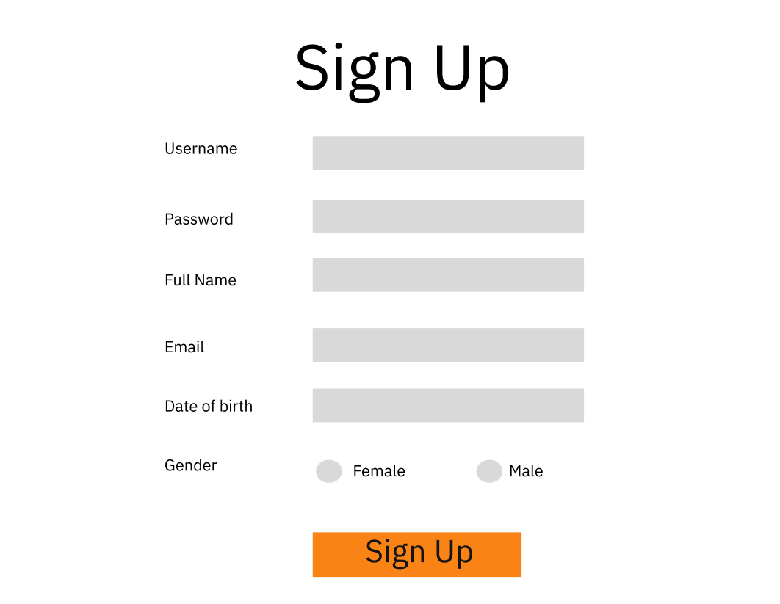

Figure 6: Register Account

|  |  |  |  |
| --- | --- | --- | --- |
| **Use Case ID** | UC - 01 | **Use Case Name** | Register Account |
| **Primary Actor** | Guest | **Secondary Actor** |  |
| **Description** | Sign up for an account on the system. | | |
| **Pre-conditions** | N/A | | |
| **Post-conditions** | When the normal flow completes successfully, a new account will be created with the role of mentee and saved into a database. | | |
| **Normal Flow** | 1. Go to the Home Page. 2. Click “Register”. 3. System displays “Register” form. 4. Input username, password, full name, email, date of birth and gender 5. Clicks “Sign up” button. 6. System displays an alert success message. 7. Redirect to Home screen | | |
| **Alternative Flow** | N/A | | |
| **Exceptions** | The system displays an error message when:   1. Not input all fields in “Sign up” form. 2. Username or Email existed. 3. Cannot connect to the server. | | |
| **Priority** | High | | |
| **Frequency of Use** | Medium | | |
| **Business Rules** | B01, B02, B04, B05 | | |
| **Other Information** | N/A | | |
| **Assumptions** | N/A | | |

## 3.3. Sign In

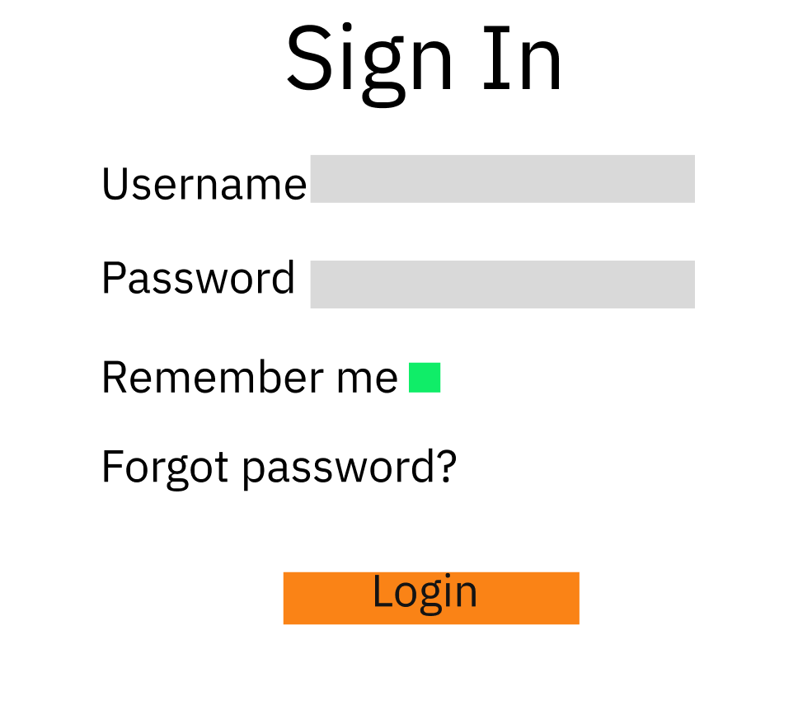

Figure 7: Sign In

|  |  |  |  |
| --- | --- | --- | --- |
| **Use Case ID** | UC – 02 | **Use Case Name** | Sign In |
| **Primary Actor** | Learner, Admin, Staff, Expert | **Secondary Actor** | N/A |
| **Description** | User login to the website | | |
| **Pre-conditions** | Account has been registered | | |
| **Post-conditions** | N/A | | |
| **Normal Flow** | 1. Go to the login page. 2. Write username and password. 3. Click “Login” button to login. 4. System displays successfully. | | |
| **Alternative Flow** |
| **Exceptions** | The system displays an error message when:   1. Cannot connect to the server. 2. Wrong username or password. System display “Invalid username or password”. | | |
| **Priority** | Medium | | |
| **Frequency of Use** | Medium | | |
| **Business Rules** |  | | |
| **Other Information** | N/A | | |
| **Assumptions** | N/A | | |

## 3.4. Forgot password

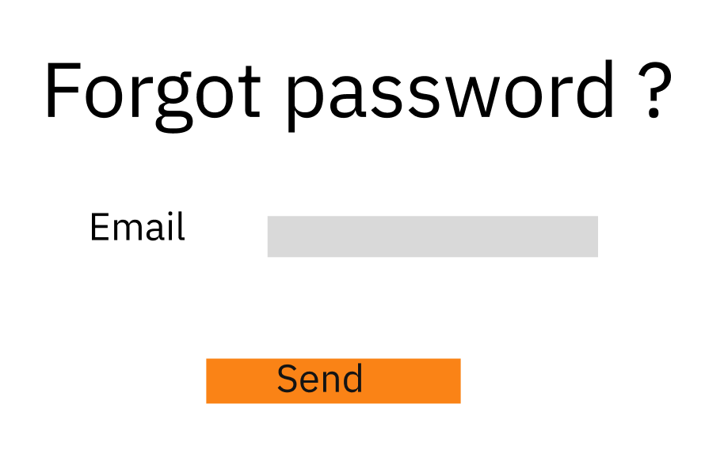

Figure 8: Forgot Password

|  |  |  |  |
| --- | --- | --- | --- |
| **Use Case ID** | UC – 03 | **Use Case Name** | Forgot password |
| **Primary Actor** | Learner, Admin, Staff, Expert | **Secondary Actor** | N/A |
| **Description** | User can verify to restore password | | |
| **Pre-conditions** | Account has been registered | | |
| **Post-conditions** | N/A | | |
| **Normal Flow** | 1. Go to the login page. 2. Click “Forget password?” 3. Enter “Email” and click “Send” button 4. System will send a reset password link to submitted email 5. Enter new password and confirm new password 6. Click submit to apply new password | | |
| **Alternative Flow** | N/A | | |
| **Exceptions** | The system displays an error message when:   1. Cannot connect to the server. 2. System display “Wrong information, please rewrite” | | |
| **Priority** | Medium | | |
| **Frequency of Use** | Low | | |
| **Business Rules** |  | | |
| **Other Information** | N/A | | |
| **Assumptions** | N/A | | |

## 3.5. View profile

### Learner

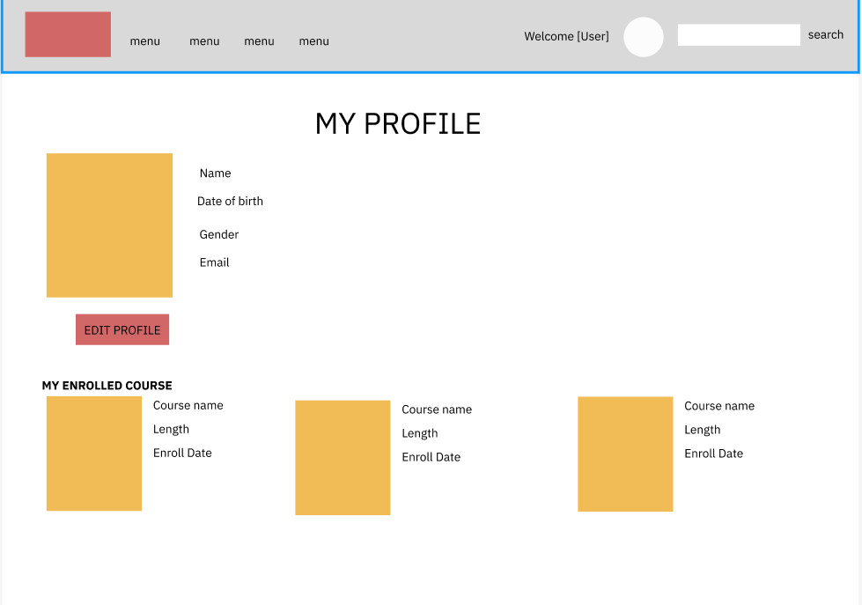

Figure 9: View Profile of Learner

### Expert

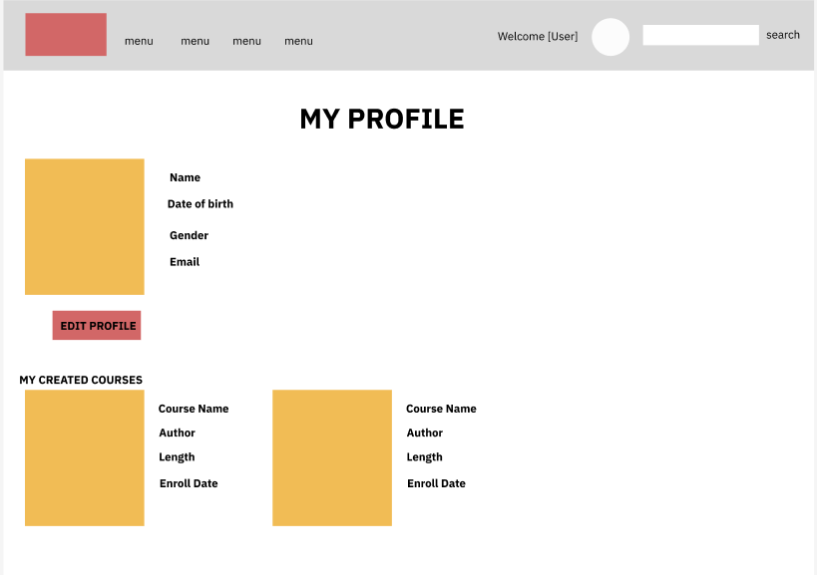

Figure 10: View Profile of Expert

|  |  |  |  |
| --- | --- | --- | --- |
| **Use Case ID** | UC – 04 | **Use Case Name** | View Profile |
| **Primary Actor** | Learner, Admin, Staff, Expert | **Secondary Actor** | N/A |
| **Description** | User can see their profile’s information | | |
| **Pre-conditions** | Account has been logged in | | |
| **Post-conditions** | N/A | | |
| **Normal Flow** | 1. Go to home page 2. Click on avatar 3. “My profile” screen has displayed | | |
| **Alternative Flow** | N/A | | |
| **Exceptions** | The system displays an error message when:   1. Cannot connect to the server. 2. System display “Wrong information, please rewrite” | | |
| **Priority** | Medium | | |
| **Frequency of Use** | High | | |
| **Business Rules** |  | | |
| **Other Information** | N/A | | |
| **Assumptions** | N/A | | |

## 3.6. Edit profile

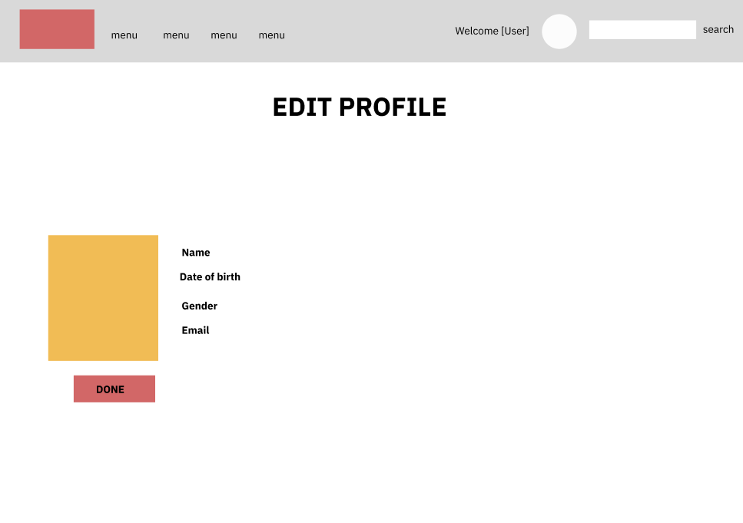

Figure 11: Edit profile

|  |  |  |  |
| --- | --- | --- | --- |
| **Use Case ID** | UC – 05 | **Use Case Name** | Edit Profile |
| **Primary Actor** | Learner, Admin, Staff, Expert | **Secondary Actor** | N/A |
| **Description** | User can edit their profile’s information | | |
| **Pre-conditions** | Account has been logged in | | |
| **Post-conditions** | N/A | | |
| **Normal Flow** | 1. Go to home page 2. Click on avatar 3. “My profile” screen has displayed | | |
| **Alternative Flow** | N/A | | |
| **Exceptions** | The system displays an error message when:   1. Cannot connect to the server. 2. System display “Wrong information, please rewrite” | | |
| **Priority** | Medium | | |
| **Frequency of Use** | High | | |
| **Business Rules** |  | | |
| **Other Information** | N/A | | |
| **Assumptions** | N/A | | |

## 3.7. Homepage

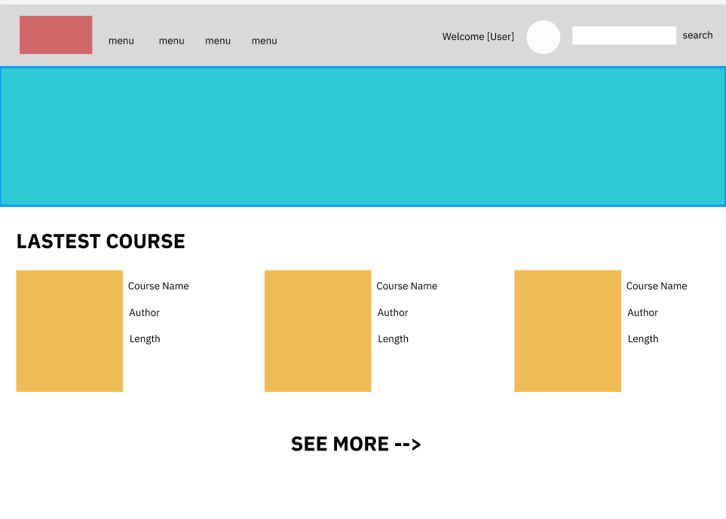

Figure 12: Homepage

|  |  |  |  |
| --- | --- | --- | --- |
| **Use Case ID** | UC – 06 | **Use Case Name** | View home page |
| **Primary Actor** | All | **Secondary Actor** | N/A |
| **Description** | View home page | | |
| **Pre-conditions** | N/A | | |
| **Post-conditions** | N/A | | |
| **Normal Flow** | 1. Go to the home page. 2. System will display lastest courses with its information | | |
| **Alternative Flow** | N/A | | |
| **Exceptions** | The system displays an error message when:   1. Cannot connect to the server. | | |
| **Priority** | Medium | | |
| **Frequency of Use** | High | | |
| **Business Rules** |  | | |
| **Other Information** | N/A | | |
| **Assumptions** | N/A | | |

## 3.8. Manage Course

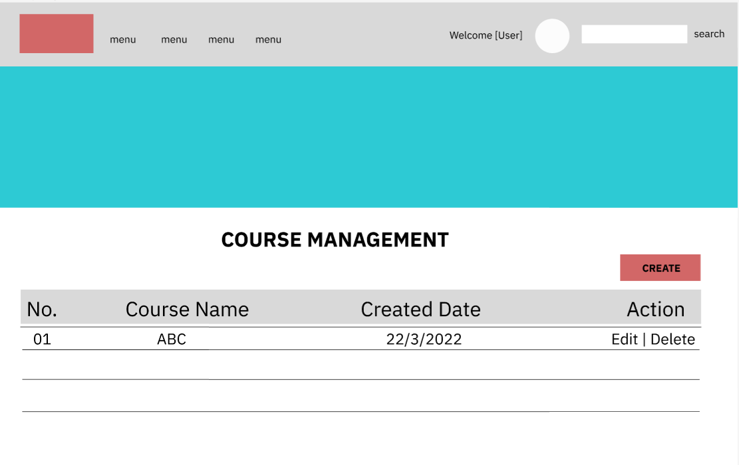

Figure 13: Manage Course

|  |  |  |  |
| --- | --- | --- | --- |
| **Use Case ID** | UC – 07 | **Use Case Name** | Manage Course |
| **Primary Actor** | Expert | **Secondary Actor** | N/A |
| **Description** | Expert can see, take action their course | | |
| **Pre-conditions** | Account has been logged in | | |
| **Post-conditions** | N/A | | |
| **Normal Flow** | 1. Go to home page 2. Click on avatar 3. Click “My course” on dashboard | | |
| **Alternative Flow** | N/A | | |
| **Exceptions** | The system displays an error message when:   1. Cannot connect to the server. | | |
| **Priority** | Medium | | |
| **Frequency of Use** | High | | |
| **Business Rules** |  | | |
| **Other Information** | N/A | | |
| **Assumptions** | N/A | | |

## 3.9. Mooc Management

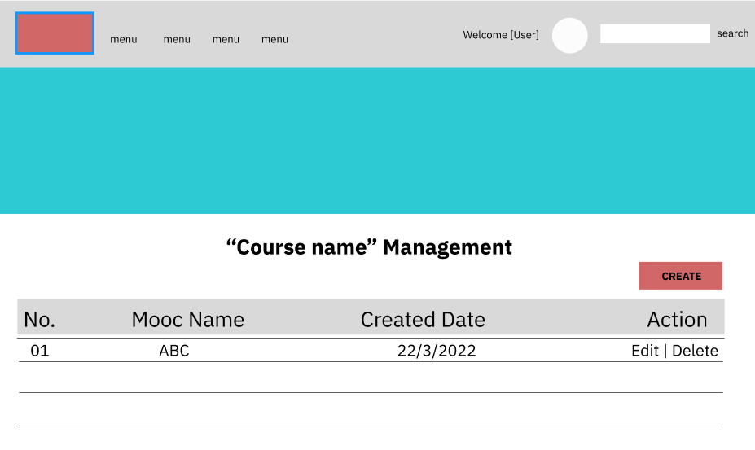

Figure 14: Course Management

|  |  |  |  |
| --- | --- | --- | --- |
| **Use Case ID** | UC-08 | **Use Case Name** | Manage Mooc |
| **Primary Actor** | Expert | **Secondary Actor** | N/A |
| **Description** | Expert can see, take action their mooc of course | | |
| **Pre-conditions** | Account has been logged in | | |
| **Post-conditions** | N/A | | |
| **Normal Flow** | 1. Go to home page 2. Click on avatar 3. Click “My course” on dashboard 4. Click on course name | | |
| **Alternative Flow** | N/A | | |
| **Exceptions** | The system displays an error message when:   1. Cannot connect to the server. | | |
| **Priority** | Medium | | |
| **Frequency of Use** | High | | |
| **Business Rules** |  | | |
| **Other Information** | N/A | | |
| **Assumptions** | N/A | | |

## 3.10. Lesson Manage

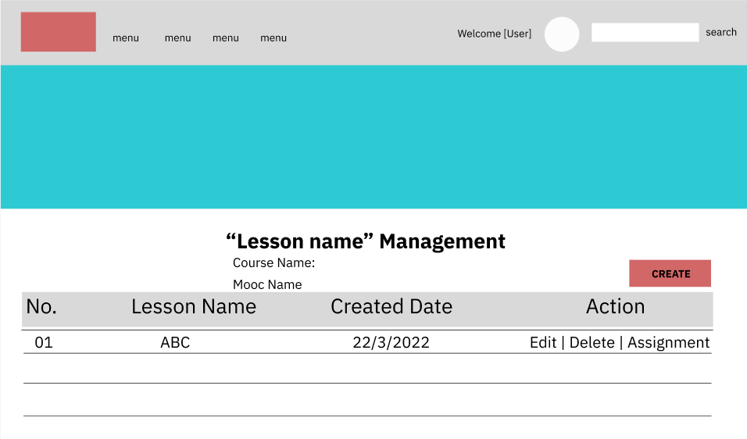

Figure 15: Lesson Manage

|  |  |  |  |
| --- | --- | --- | --- |
| **Use Case ID** | UC-09 | **Use Case Name** | Manage Lesson |
| **Primary Actor** | Expert | **Secondary Actor** | N/A |
| **Description** | Expert can see, take action their lesson in mooc | | |
| **Pre-conditions** | Account has been logged in | | |
| **Post-conditions** | N/A | | |
| **Normal Flow** | 1. Go to home page 2. Click on avatar 3. Click “My course” on dashboard 4. Click on course name 5. Click on mooc name | | |
| **Alternative Flow** | N/A | | |
| **Exceptions** | The system displays an error message when:   1. Cannot connect to the server. | | |
| **Priority** | Medium | | |
| **Frequency of Use** | High | | |
| **Business Rules** |  | | |
| **Other Information** | N/A | | |
| **Assumptions** | N/A | | |

## 3.11. Assignment Management

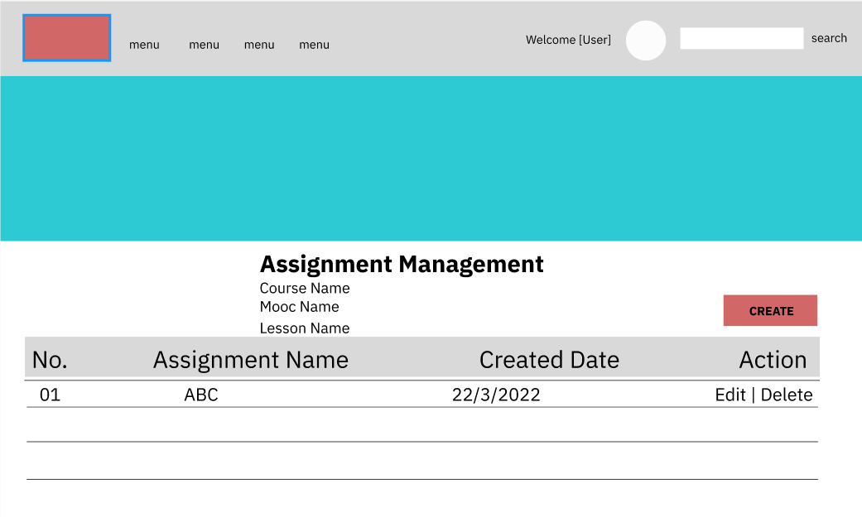

Figure 16: Assignment Management

|  |  |  |  |
| --- | --- | --- | --- |
| **Use Case ID** | UC-10 | **Use Case Name** | Manage Assignment |
| **Primary Actor** | Expert | **Secondary Actor** | N/A |
| **Description** | Expert can see, take action their assignment | | |
| **Pre-conditions** | Account has been logged in | | |
| **Post-conditions** | N/A | | |
| **Normal Flow** | 1. On “Mooc Management” interface, click on option “Assignment” | | |
| **Alternative Flow** | N/A | | |
| **Exceptions** | The system displays an error message when:   1. Go to home page 2. Click on avatar 3. Click “My course” on dashboard 4. Click on “Assignment” on dashboard | | |
| **Priority** | Medium | | |
| **Frequency of Use** | High | | |
| **Business Rules** |  | | |
| **Other Information** | N/A | | |
| **Assumptions** | N/A | | |

## 3.12. Dashboard

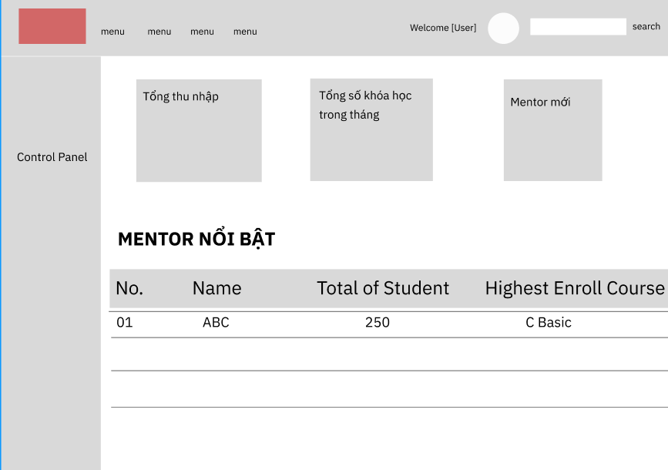

Figure 17: Dashboard

|  |  |  |  |
| --- | --- | --- | --- |
| **Use Case ID** | UC-11 | **Use Case Name** | Dashboard |
| **Primary Actor** | Admin | **Secondary Actor** | N/A |
| **Description** | Admin can see total information in a month | | |
| **Pre-conditions** | Account has been logged in | | |
| **Post-conditions** | N/A | | |
| **Normal Flow** | 1. Go to home page 2. Click on avatar 3. Click on “dashboard” on the screen | | |
| **Alternative Flow** | N/A | | |
| **Exceptions** | The system displays an error message when:   1. Cannot connect to the server. | | |
| **Priority** | Medium | | |
| **Frequency of Use** | High | | |
| **Business Rules** |  | | |
| **Other Information** | N/A | | |
| **Assumptions** | N/A | | |

## 3.13. Manage User

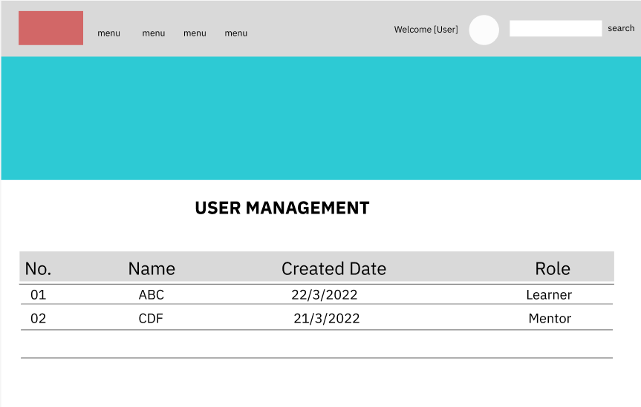

Figure 18: Manage User

|  |  |  |  |
| --- | --- | --- | --- |
| **Use Case ID** | UC-12 | **Use Case Name** | Manage User |
| **Primary Actor** | Admin | **Secondary Actor** | N/A |
| **Description** | Admin can see total information of user | | |
| **Pre-conditions** | Account has been logged in | | |
| **Post-conditions** | N/A | | |
| **Normal Flow** | 1. Go to home page 2. Click on avatar 3. Click on “dashboard” on the screen | | |
| **Alternative Flow** | N/A | | |
| **Exceptions** | The system displays an error message when:   1. Cannot connect to the server. | | |
| **Priority** | Medium | | |
| **Frequency of Use** | High | | |
| **Business Rules** |  | | |
| **Other Information** | N/A | | |
| **Assumptions** | N/A | | |

## 3.14. View Income, Package Purchase, New User Register

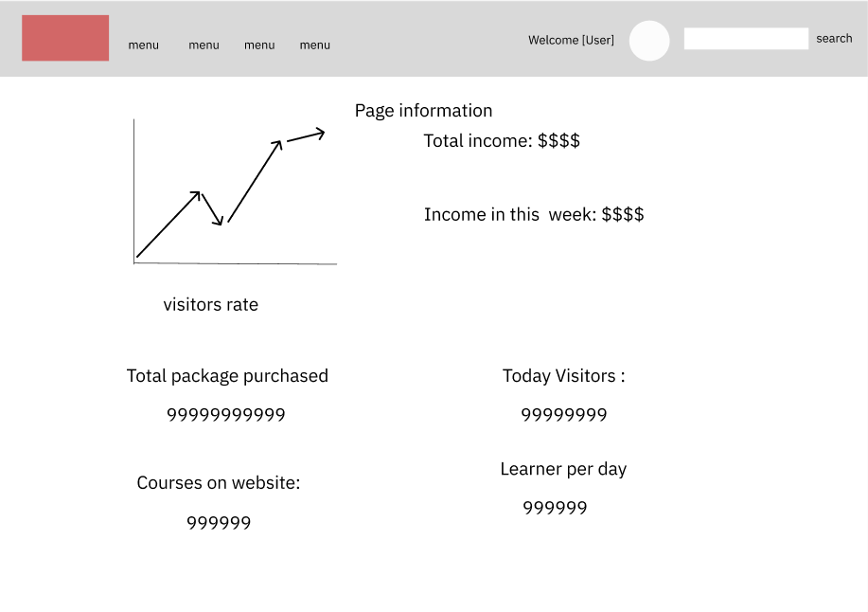

Figure 19: View Income, Package Purchase, New User Register

|  |  |  |  |
| --- | --- | --- | --- |
| **Use Case ID** | UC-13 | **Use Case Name** | View Income, Package Purchase, New User Register |
| **Primary Actor** | Admin | **Secondary Actor** | N/A |
| **Description** | Admin can see insight of page | | |
| **Pre-conditions** | Account has been logged in | | |
| **Post-conditions** | N/A | | |
| **Normal Flow** | 1. Go to home page 2. Click on avatar 3. Click on “dashboard” on the screen 4. Click on “View Insight” on the screen | | |
| **Alternative Flow** | N/A | | |
| **Exceptions** | The system displays an error message when:   1. Cannot connect to the server. | | |
| **Priority** | Medium | | |
| **Frequency of Use** | High | | |
| **Business Rules** |  | | |
| **Other Information** | N/A | | |
| **Assumptions** | N/A | | |

## 3.15. See overview of course

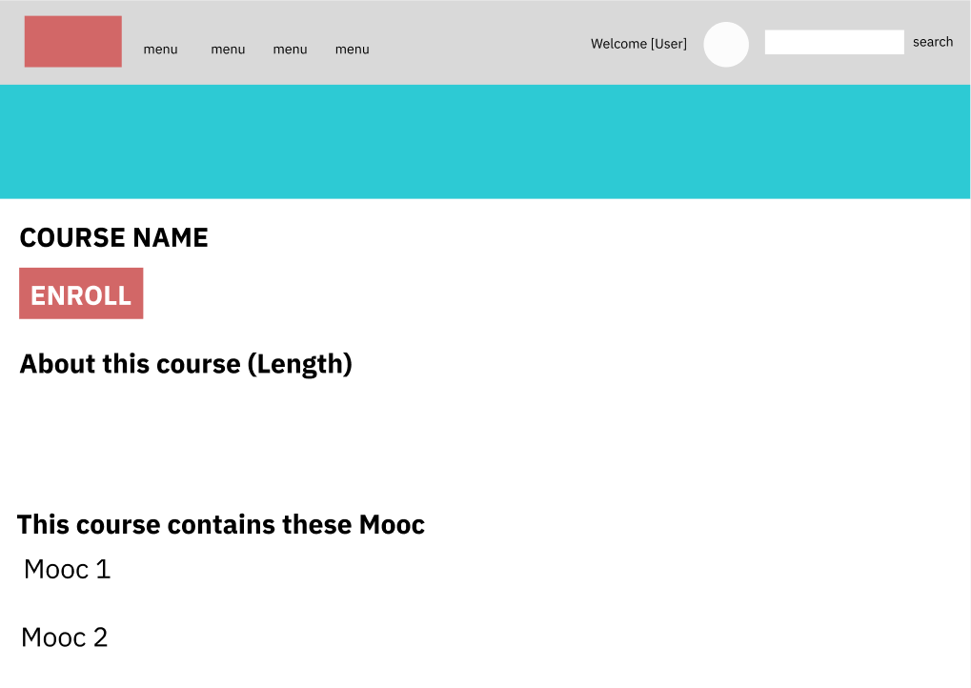

Figure 20: See overview of course

|  |  |  |  |
| --- | --- | --- | --- |
| **Use Case ID** | UC-14 | **Use Case Name** | See overview of course |
| **Primary Actor** | Learner, Admin, Staff, Expert | **Secondary Actor** | N/A |
| **Description** | User can see highlight information of a course | | |
| **Pre-conditions** | Account has been logged in | | |
| **Post-conditions** | N/A | | |
| **Normal Flow** | 1. Go to home page 2. Click on course | | |
| **Alternative Flow** | N/A | | |
| **Exceptions** | The system displays an error message when:   1. Cannot connect to the server. | | |
| **Priority** | Medium | | |
| **Frequency of Use** | High | | |
| **Business Rules** |  | | |
| **Other Information** | N/A | | |
| **Assumptions** | N/A | | |

## 3.16. View Mooc Detail

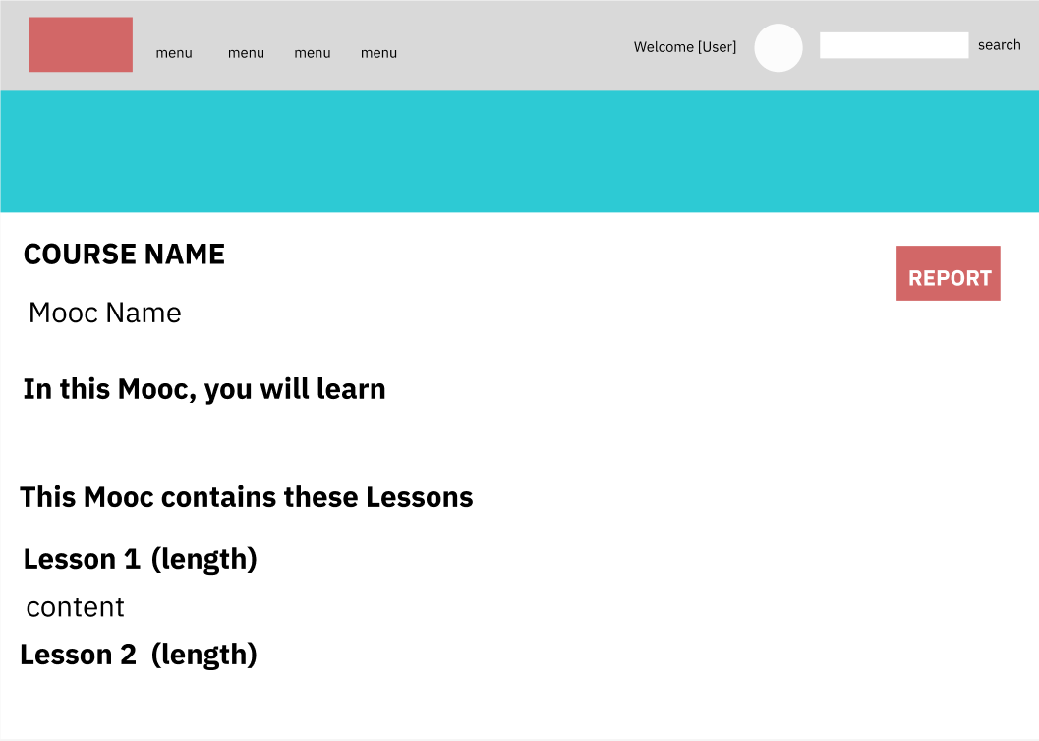

Figure 21: View Mooc Detail

|  |  |  |  |
| --- | --- | --- | --- |
| **Use Case ID** | UC-15 | **Use Case Name** | View Mooc Detail |
| **Primary Actor** | Learner, Admin, Staff, Expert | **Secondary Actor** | N/A |
| **Description** | User can see highlight information of a mooc | | |
| **Pre-conditions** | Account has been logged in | | |
| **Post-conditions** | N/A | | |
| **Normal Flow** | 1. Go to home page  2. Click on avatar  3. Click on “course” on the screen  4. Click on “mooc” on the screen | | |
| **Alternative Flow** | N/A | | |
| **Exceptions** | The system displays an error message when:  1. Cannot connect to the server. | | |
| **Priority** | Medium | | |
| **Frequency of Use** | High | | |
| **Business Rules** |  | | |
| **Other Information** | N/A | | |
| **Assumptions** | N/A | | |

## 3.17. Lesson Detail

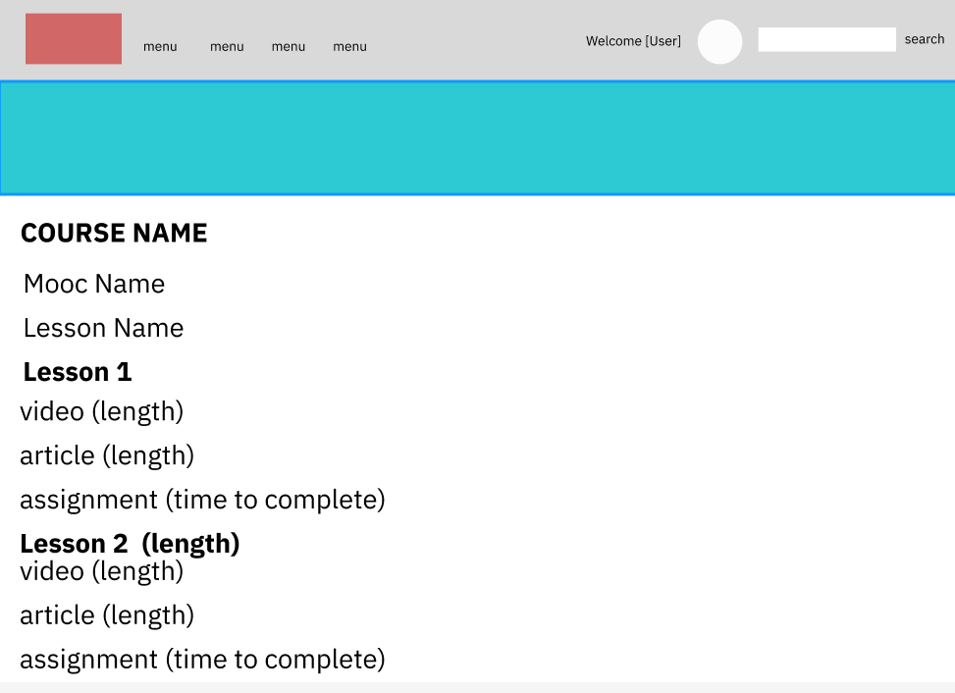

Figure 22: Lesson Detail

|  |  |  |  |
| --- | --- | --- | --- |
| **Use Case ID** | UC-16 | **Use Case Name** | Lesson Detail |
| **Primary Actor** | Learner, Admin, Staff, Expert | **Secondary Actor** | N/A |
| **Description** | User can see highlight information of a lesson | | |
| **Pre-conditions** | Account has been logged in | | |
| **Post-conditions** | N/A | | |
| **Normal Flow** | 1. Go to home page 2. Click on avatar 3. Click on “course” on the screen 4. Click on “mooc” on the screen 5. Click on “lesson” on the screen | | |
| **Alternative Flow** | N/A | | |
| **Exceptions** | The system displays an error message when:   1. Cannot connect to the server. 2. System display “Wrong information, please rewrite” | | |
| **Priority** | Medium | | |
| **Frequency of Use** | High | | |
| **Business Rules** |  | | |
| **Other Information** | N/A | | |
| **Assumptions** | N/A | | |

## 3.18. Assignment Detail

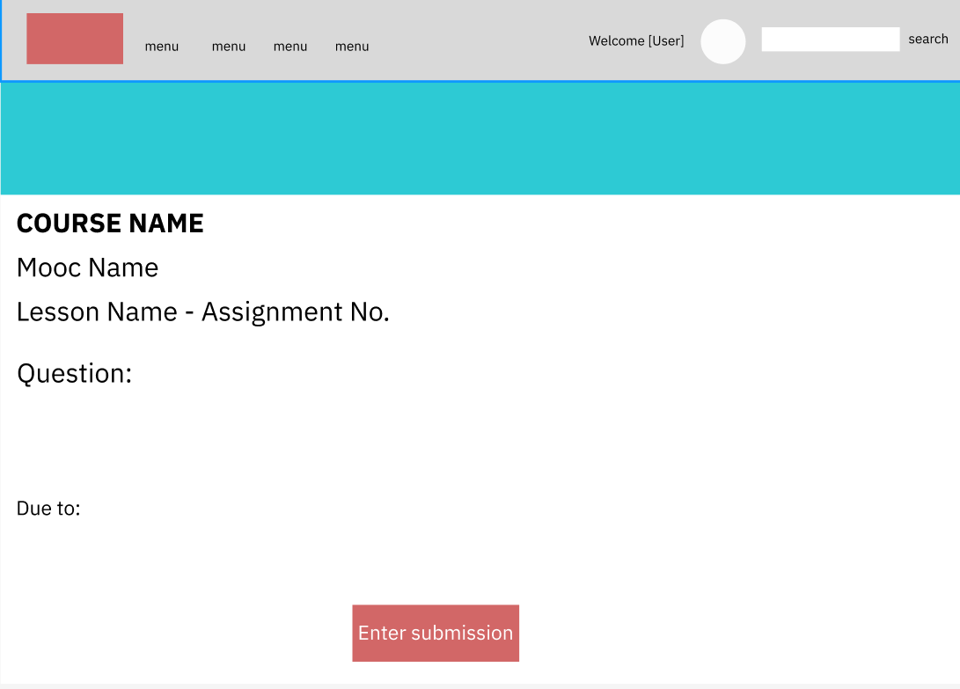

Figure 23: Assignment Detail

|  |  |  |  |
| --- | --- | --- | --- |
| **Use Case ID** | UC-18 | **Use Case Name** | Assignment Detail |
| **Primary Actor** | Learner, Admin, Staff, Expert | **Secondary Actor** | N/A |
| **Description** | User can see highlight information of a course | | |
| **Pre-conditions** | Account has been logged in | | |
| **Post-conditions** | N/A | | |
| **Normal Flow** | 1. On “Mooc Management” interface, click on option “Assignment” 2. Click on “Create” on the screen | | |
| **Alternative Flow** | N/A | | |
| **Exceptions** | The system displays an error message when:   1. Cannot connect to the server. | | |
| **Priority** | Medium | | |
| **Frequency of Use** | High | | |
| **Business Rules** |  | | |
| **Other Information** | N/A | | |
| **Assumptions** | N/A | | |

## 3.19. Send Report Mooc

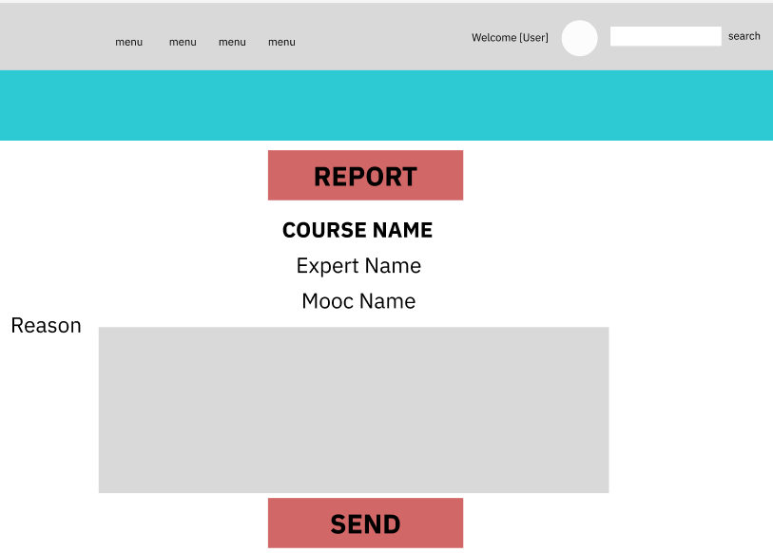

Figure 24: Send Report Mooc

|  |  |  |  |
| --- | --- | --- | --- |
| **Use Case ID** | UC-18 | **Use Case Name** | Send report mooc |
| **Primary Actor** | Learner | **Secondary Actor** | N/A |
| **Description** | Learner can report mooc of course | | |
| **Pre-conditions** | Account has been logged in | | |
| **Post-conditions** | N/A | | |
| **Normal Flow** | 1. Go to home page 2. Click on avatar 3. Click on “course” on the screen 4. Click on “mooc” on the screen 5. Click on “Report” on the screen | | |
| **Alternative Flow** | N/A | | |
| **Exceptions** | The system displays an error message when:  1. Cannot connect to the server. | | |
| **Priority** | Medium | | |
| **Frequency of Use** | High | | |
| **Business Rules** |  | | |
| **Other Information** | N/A | | |
| **Assumptions** | N/A | | |

## 3.20. View my course

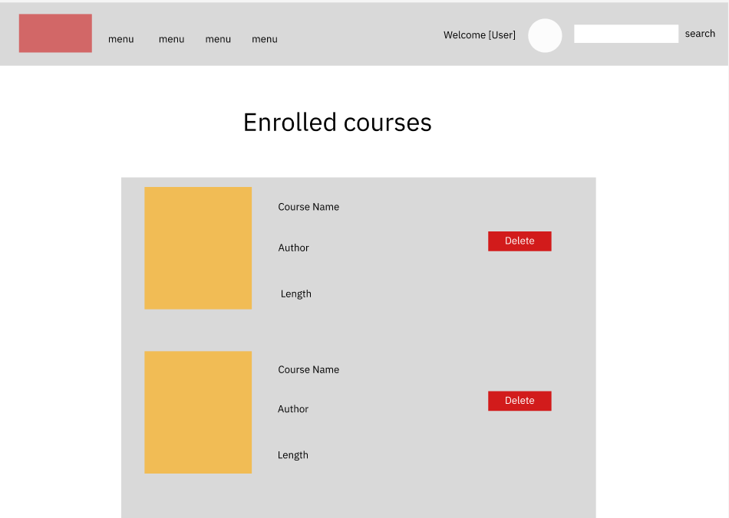

Figure 25: View my course

|  |  |  |  |
| --- | --- | --- | --- |
| **Use Case ID** | UC-19 | **Use Case Name** | View my course |
| **Primary Actor** | User | **Secondary Actor** | N/A |
| **Description** | User can see course that they enrolled in | | |
| **Pre-conditions** | Account has been logged in | | |
| **Post-conditions** | N/A | | |
| **Normal Flow** | 1. Go to home page 2. Click on avatar 3. Click on “Enroll courses” on the screen | | |
| **Alternative Flow** | N/A | | |
| **Exceptions** | The system displays an error message when:   1. Cannot connect to the server. | | |
| **Priority** | Medium | | |
| **Frequency of Use** | High | | |
| **Business Rules** |  | | |
| **Other Information** | N/A | | |
| **Assumptions** | N/A | | |

## 3.21. Manage Report

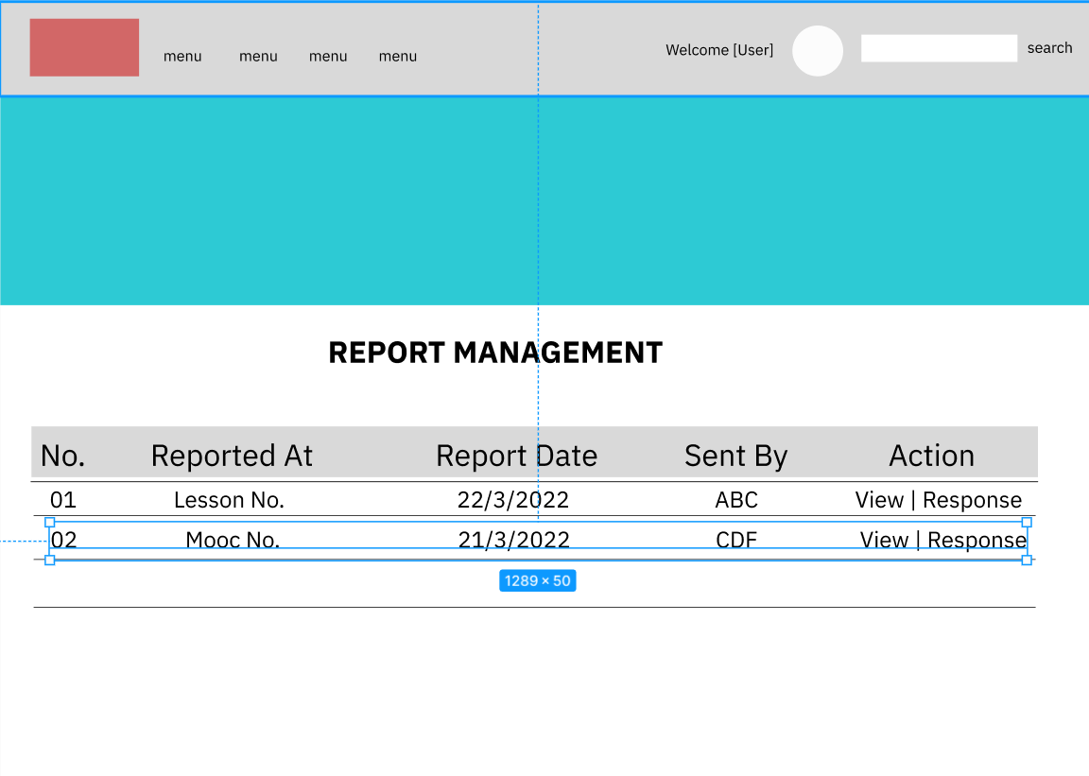

Figure 26: Manage Report

|  |  |  |  |
| --- | --- | --- | --- |
| **Use Case ID** | UC-20 | **Use Case Name** | Manage Report |
| **Primary Actor** | Admin | **Secondary Actor** | N/A |
| **Description** | User can see information of repory | | |
| **Pre-conditions** | Account has been logged in | | |
| **Post-conditions** | N/A | | |
| **Normal Flow** | 1. Go to home page 2. Click on avatar 3. Click on “dashboard” on the screen 4. Click on “Report” on the screen | | |
| **Alternative Flow** | N/A | | |
| **Exceptions** | The system displays an error message when:   1. Cannot connect to the server. | | |
| **Priority** | Medium | | |
| **Frequency of Use** | High | | |
| **Business Rules** |  | | |
| **Other Information** | N/A | | |
| **Assumptions** | N/A | | |

## 3.22. View Report

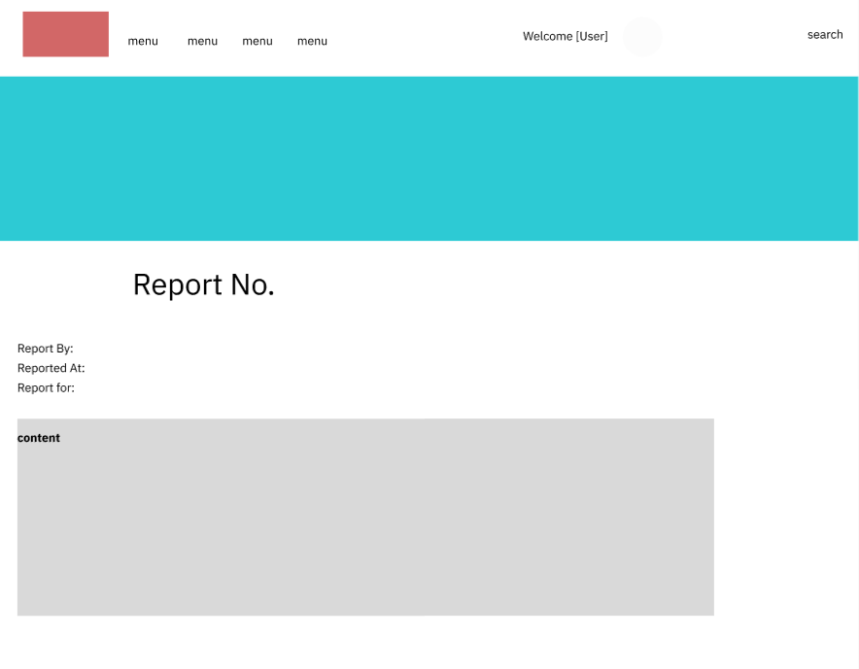

Figure 27: View Report

|  |  |  |  |
| --- | --- | --- | --- |
| **Use Case ID** | UC-21 | **Use Case Name** | View report |
| **Primary Actor** | Learner, Admin, Staff, Expert | **Secondary Actor** | N/A |
| **Description** | See detail of report | | |
| **Pre-conditions** | Account has been logged in | | |
| **Post-conditions** | N/A | | |
| **Normal Flow** | 1. Go to home page 2. Click on avatar 3. Click on “dashboard” on the screen 4. Click on “Report” on the screen 5. Click on name of report | | |
| **Alternative Flow** | N/A | | |
| **Exceptions** | The system displays an error message when:   1. Cannot connect to the server. | | |
| **Priority** | Medium | | |
| **Frequency of Use** | High | | |
| **Business Rules** |  | | |
| **Other Information** | N/A | | |
| **Assumptions** | N/A | | |

## 3.23. Action to report

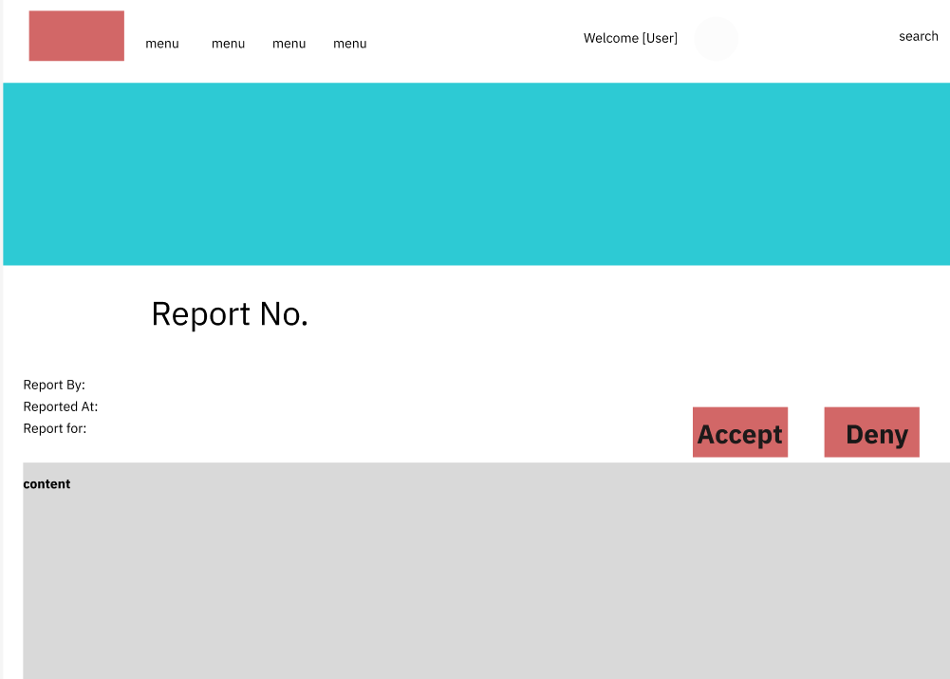

Figure 28: Action to report

|  |  |  |  |
| --- | --- | --- | --- |
| **Use Case ID** | UC-22 | **Use Case Name** | Action to report |
| **Primary Actor** | Admin | **Secondary Actor** | N/A |
| **Description** | User can see detail of report | | |
| **Pre-conditions** | Account has been logged in | | |
| **Post-conditions** | N/A | | |
| **Normal Flow** | 1. Go to home page 2. Click on avatar 3. Click on “dashboard” on the screen 4. Click on “Report” on the screen 5. Click on name of report | | |
| **Alternative Flow** | N/A | | |
| **Exceptions** | The system displays an error message when:   1. Cannot connect to the server. 2. System display “Wrong information, please rewrite” | | |
| **Priority** | Medium | | |
| **Frequency of Use** | High | | |
| **Business Rules** |  | | |
| **Other Information** | N/A | | |
| **Assumptions** | N/A | | |

## 3.24. Add Lesson

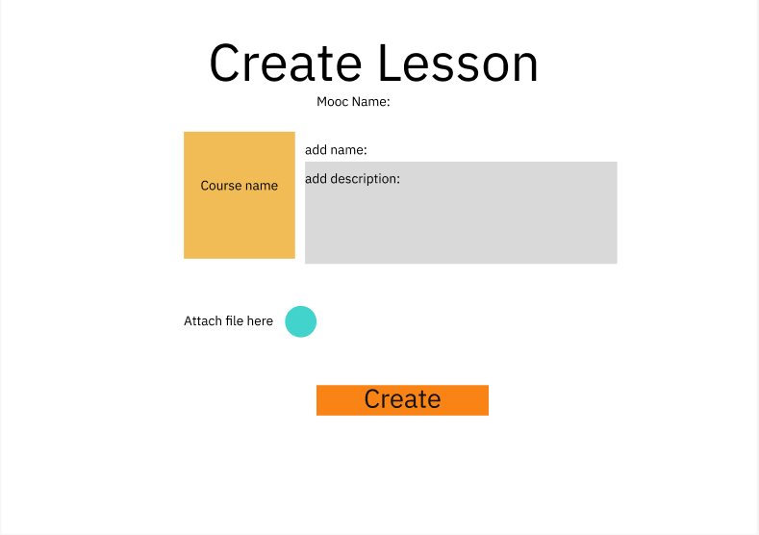

Figure 29: Add Lesson

|  |  |  |  |
| --- | --- | --- | --- |
| **Use Case ID** | UC-23 | **Use Case Name** | Add Lesson |
| **Primary Actor** | Expert | **Secondary Actor** | N/A |
| **Description** | User can see highlight information of a course | | |
| **Pre-conditions** | Account has been logged in | | |
| **Post-conditions** | N/A | | |
| **Normal Flow** | 1. Go to home page 2. Click on avatar 3. Click “My course” on dashboard 4. Click on course name 5. Click on mooc name 6. Click on “Create” button | | |
| **Alternative Flow** | N/A | | |
| **Exceptions** | The system displays an error message when:   1. Cannot connect to the server. | | |
| **Priority** | Medium | | |
| **Frequency of Use** | High | | |
| **Business Rules** |  | | |
| **Other Information** | N/A | | |
| **Assumptions** | N/A | | |

## 3.25. Add Mooc

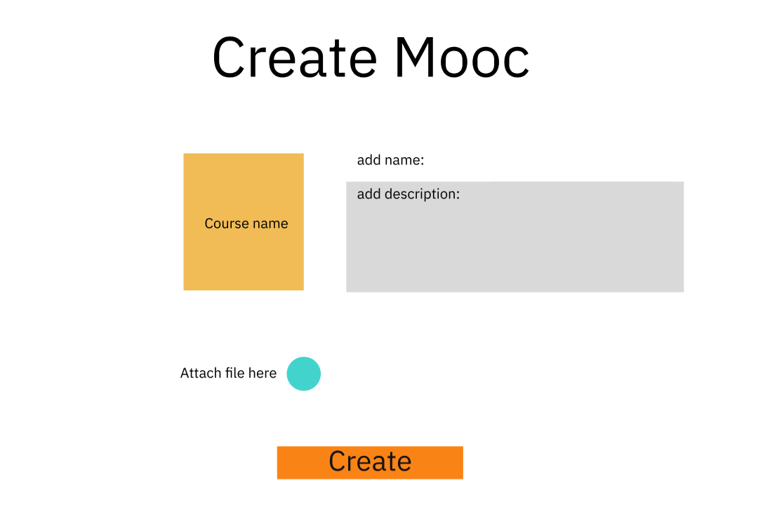

Figure 30: Add Mooc

|  |  |  |  |
| --- | --- | --- | --- |
| **Use Case ID** | UC-24 | **Use Case Name** | See overview of course |
| **Primary Actor** | Expert | **Secondary Actor** | N/A |
| **Description** | User can see highlight information of a course | | |
| **Pre-conditions** | Account has been logged in | | |
| **Post-conditions** | N/A | | |
| **Normal Flow** | 1. Go to home page 2. Click on avatar 3. Click “My course” on dashboard 4. Click on course name 5. Click on “Create” button | | |
| **Alternative Flow** | N/A | | |
| **Exceptions** | The system displays an error message when:   1. Cannot connect to the server. | | |
| **Priority** | Medium | | |
| **Frequency of Use** | High | | |
| **Business Rules** |  | | |
| **Other Information** | N/A | | |
| **Assumptions** | N/A | | |

# 4. Non-functional requirements

## 4.1 External Interfaces

### 4.1.1. User Interface

UI-1: The websites will have a user-friendly interface and are easy to use.

UI-2: The layout of the screen is streamlined, easy to operate, and implement for the user.

UI-3: Buttons have distinctive features and colors but are in sync with the interface.

UI-4: When the user is on a screen or function, the position of that function displayed on the sidebar will be bright and synchronized with the interface.

UI-5: Notifications displayed on the screen have a friendly banner outlining the content for the user.

UI-6: The GUI is suitable for display on the computer.

UI-7: The system will provide a website help link that is displayed explaining how to use that page to the user.

UI-8: Web pages will allow users to copy and paste using a mouse, in addition to using a mouse and keyboard combination.

### 4.1.2.Software Interfaces

SI-1: Login System

SI-1.1: The LCM will pass the username and password of the user to the sign-in system through a programming interface.

SI-1.2: The sign-in system will notify LCM that the user exists or not.

SI-1.3: When the sign-in system notifies LCM that the user exists or does not exist, LCM will take the user to the homepage or send a notification that the user does not exist.

SI-2: Manage System

The LCM shall communicate with the Manage System through a programmatic interface for the following operations:

SI-2.1: To allow an Admin to view all Users.

SI-2.2: To allow an Admin to view all Mentors.

SI-2.3: To allow an Admin to view all Requests.

SI-2.4: To allow an Admin to view all Skill.

SI-2.5: To inquire whether an Admin creates, updates, server or deletes skills.

### 4.1.3 Hardware Interfaces

No hardware interfaces have been identified.

### 4.1.4. Communications Interfaces

CI-1: The LCM shall send an email or text message (based on user account settings) to the Patron to confirm acceptance of forgotten password.

CI-2: The LCM provides mentees and mentors with a chat box to communicate with each other.

## 4.2 Quality Attributes

### 4.2.1.Usability

* The language is Vietnamese and English.
* The user interface of the solution should be elegant, easy to navigate, and user-friendly
* All the titles or names of functions should be easy to understand and reflect the purpose of the function.
* All error message should be clear for all users
* All related functions for each type of user should be grouped into categories and placed on a navigation bar for the efficiency of interactions.
* User should be able to learn to use the specified functions in no time
* Links, buttons are easily clickable.
* Links are easily recognizable, which looks clickable.
* Main functions are organized into tabs for easier access.
* Links, buttons, and checkboxes are easily clickable.
* The Front-end web application should support Chrome and Firefox browsers.

### 4.2.2. Reliability

* The system function is carefully observed and learned from the actual needs of users (mentee, mentor) and the LCM's demand.
* The average time it takes to repair the system if a module fails is about 4-8 hours.
* The system is only allowed to stop working for at most 8 hours since the problem occurred so that users can continue using the system.

### 4.2.3. Performance

* All pages have loading speed less than 3 seconds on average
* The system can support up to 500 requests at the same time; The system allows up to

1200 students to register in system per semester.

* The system shall display confirmation messages to users within an average of 1.5

seconds and a maximum of 3 seconds after the user submits information to the system.

### 4.2.4. Security

* HTTPs between client and server.
* Encrypt password with BCrypt algorithm.

### 4.2.5. Safety

* This product is a web application running on the web browser so it will not affect any other application or user’s hardware, which may lead to data loss or system damage. The software is designed mainly for devices with an appropriate wide display so for maintaining the correctness of the user’s actions and data, the user should use this application on a device with a wide enough screen so the software can fit the screen.

# 5. Requirements Appendix

## 5.1. Notification List

|  |  |  |  |  |
| --- | --- | --- | --- | --- |
| **#** | **Notification code** | **Notification Type** | **Context** | **Content** |
| 1 | NOT01 | Request | The user does not enter information in the fields | *Fields cannot be blank.* |
| 2 | NOT02 | Request | The user enters information in one field, leaving the remaining fields blank. | *Fields cannot be blank.* |
| 3 | NOT03 | Request | User input correct format of Username, Password, Re-password, Full name, Email | *Register Successfully.* |
| 4 | NOT04 | Request | Username already exists | *Show message "Username has already existed.* |
| 5 | NOT05 | Request | User input email does not contain the character "@". | *Email must contain one character @.* |
| 6 | NOT06 | Request | User input Re-password contains special characters such as:! @ # $ | *Passwords do not contain special characters such as: “! @ #$”.* |
| 7 | NOT07 | Request | Register successfully | *Register Successfully.* |
| 8 | NOT08 | Request | Input Password’s length between 8 to 24 characters | *Password’s length between 8 to 24 characters.* |

Table 5: Notification List

## 5.2. Bussiness Rules

|  |  |
| --- | --- |
| **ID** | **Description** |
| B01 | The email address must be unique and valid format |
| B02 | Password must at least 8 characters, include uppercase and lowercase letters, a number and a special character |
| B03 | Password must be encrypted |
| B04 | When registering or changing a password, a user must enter the new password twice. The new password must match the confirm password |
| B05 | Username is less than 25 character and must be unique |
| B06 | User must provide their username and password when logging into the website |
| B07 | The access token must be encrypted when saving into the browser’s storage |
| B08 | JWT token is expired in 3 days |
| B09 | User cannot update their username and email once it has been registered |
| B10 | A guest cannot register with a username and email that has already been registered |
| B11 | An account must be active through an active link in email |
| B12 | Account must active before purchase course package or comment |
| B13 | A user must belong to one of the 4 roles: Learner, Expert, Staff or Admin |
| B14 | When an account is registered, the initial role of the account is Leaner |
| B15 | User and guest can view detail of a course |
| B16 | User must purchase a package if they want view lesson and do quiz |
| B17 | Staff can update package price for a period time |
| B18 | When the package expires, the courses are automatically closed |
| B19 | Only expert can create course |
| B20 | There are 4 sliders in home page |
| B21 | Leaner can enrol all course after purchase course package |
| B22 | Leaner can comment and like to blog |
| B23 | Leaner can take and review quizzes in courses |
| B24 | Leaner can view all review of a course |
| B25 | Leaner must enrol courses to view lesson detail and do quiz |
| B26 | Leaner can cancellation of course registration |
| B27 | The administrator has the highest privilege and cannot be changed by others. |
| B28 | Admin can manage all user accounts |
| B29 | Only Admin can assign Staff or Expert for an account |
| B30 | Admin can change all information of account except username and email |
| B31 | Admin can delete accounts |
| B32 | Home page will display slider, hot courses, hot posts and price package info |

Table 6: Bussiness Rules