R has several data sets pre-programmed. One of them is particularly depressing: German Suicide Records.

Here's what the top of the data set looks like:
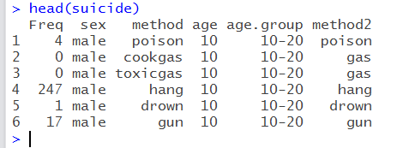
The columns are rather obvious. The only odd label is “Freq” which is just the count of suicides. Within method there are two labels that might need some explaining: poison and cookgas. Poison, I believe, is a reference to purposeful pharmaceutical overdoses and obviously overt poisoning. Cookgas refers to sticking your head in an oven and suffocating on the gas. I do not know where siting in your car while your garage fills with carbon monoxide falls on this list; I think toxicgas. The documentation was not clear. Age and age.group are a little redundant as age is incremented every five years. Also method1 and method2 are a little repetitive. Method2 does give a bit more detail about the chosen method of suicide; however, I ignored it completely. I like to find broad observations, not odd specifics.

Quick Notes: Looking at the data it becomes clear that separating by men and women is important. That will become evident. One other thing to note. Men commit suicide far more often than women. Because of that, I did not use raw counts of suicides, but percentage of total. This will allow us to then compare men and women and their tenancies. This will make more sense as you read.

My first graph looks at the age distribution of suicides among men.
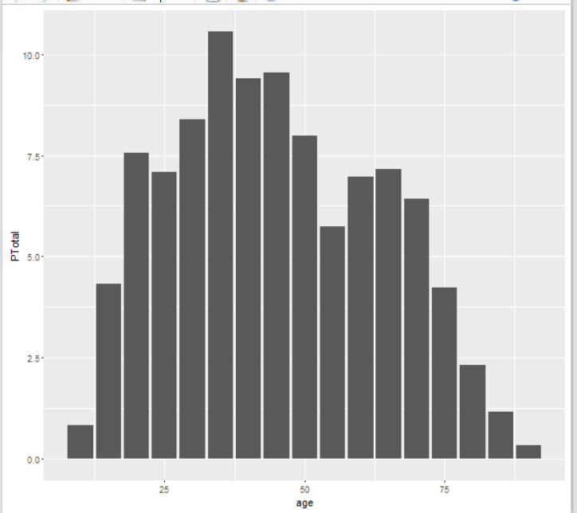
As you can see the distribution skews left or younger. This is a relatively known fact. And, shows that men are most likely to commit suicide in their 30s. With a majority of the suicides occurring before the age of 50. Nothing too weird happens on the edges/tails.

Graph number 2. The age distribution of suicides among females.
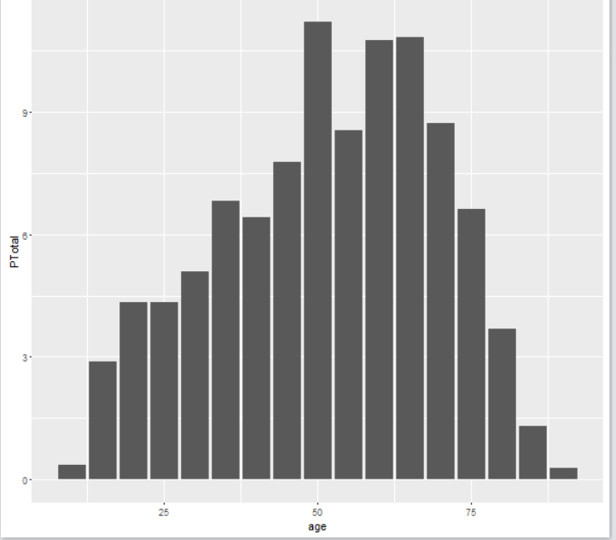
When it comes to suicides, women are skew older. The average and the majority of suicides are above the age fifty. Which is pretty much the complete opposite of the male graph. I honestly have no idea why this would be the case. I am not an expert on suicide so I hesitant to speculate on a cause. These graphs certainly raise interesting psychological questions about men and women.

To drive the point home about how the genders tend to kill themselves at different ages.
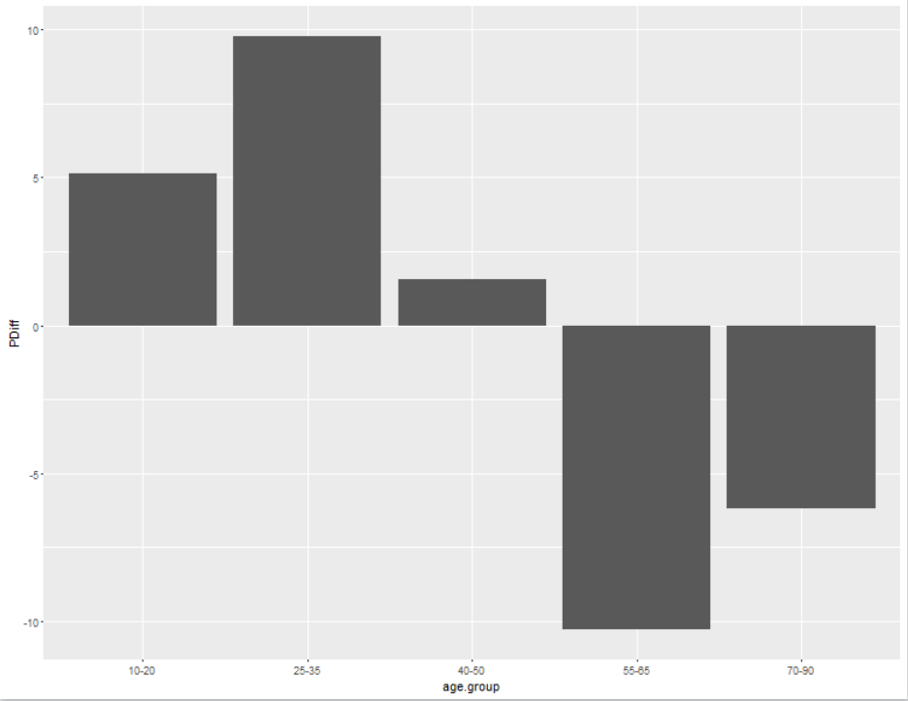
Each bar represents an age group. The value of the bar is the likelihood that a male will commit suicide minus the likelihood that a female will commit suicide in that age group. The more negative the bar the more likely for females to commit suicide in that age group. This is not exactly a scientific or great graph, but it does get the point across. As the graphs have shown men are more likely to kill themselves when they are younger than thirty-five. Women are more likely to kill themselves when they are older than fifty-five. And right around the ages of forty to fifty it's about equally likely.

Now let's look at how the genders choose to commit suicide.

Here is a graph of men’s suicide counts by age, however, each graph represents a different method of suicide.
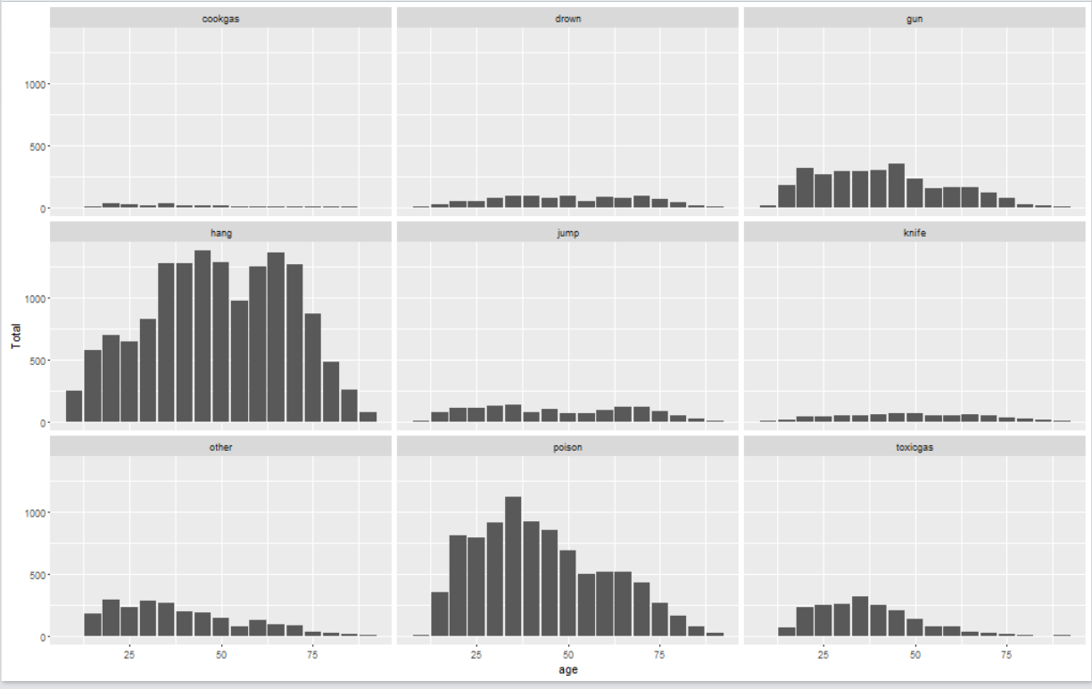
We can assume that all the methods should see averages on the younger side of the graphs. As shown previously, men are more likely to commit suicide before the age of fifty. It should be noted, these are the raw counts of suicides and not a proportion. Since I am comparing men with men, it seems acceptable. The only real anomaly among these graphs is the “hanging” method. It seems to have an older average age, approximately fifty. And has very little skewness and after the age of 30 it is the preferred method of suicide. Among the youth of Germany, poison seems to be the way to go about it.
Now, how women compare.
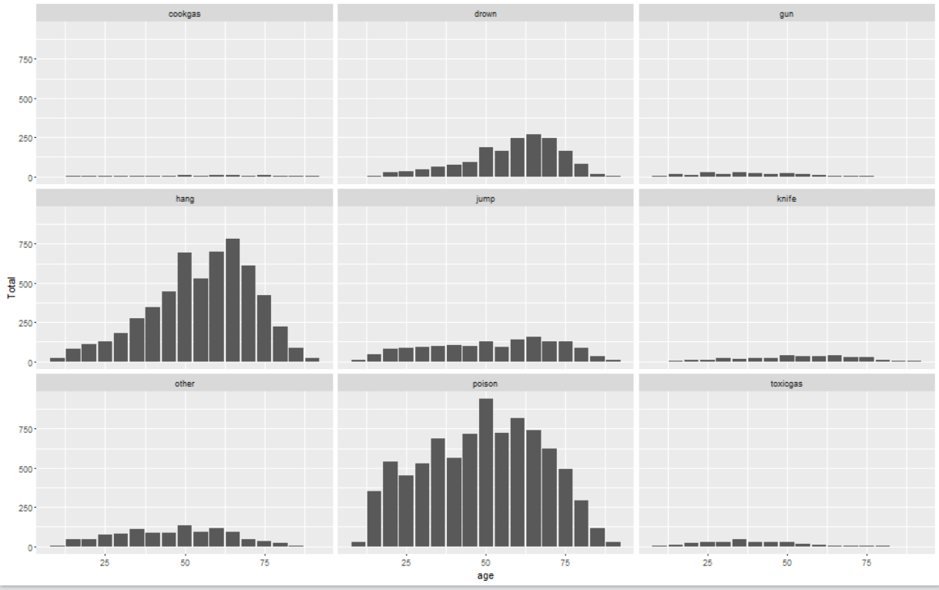
We can expect the female graphs to average older when compared to the men. Interestingly, poison has a somewhat normal distribution. With an average age just slightly north of fifty. Hanging skews younger and drowning skew younger. This is inline with what was seen earlier. None of the methods dramatically favored by younger women. It's interesting to see how these graphs are populated relative to the male graphs.

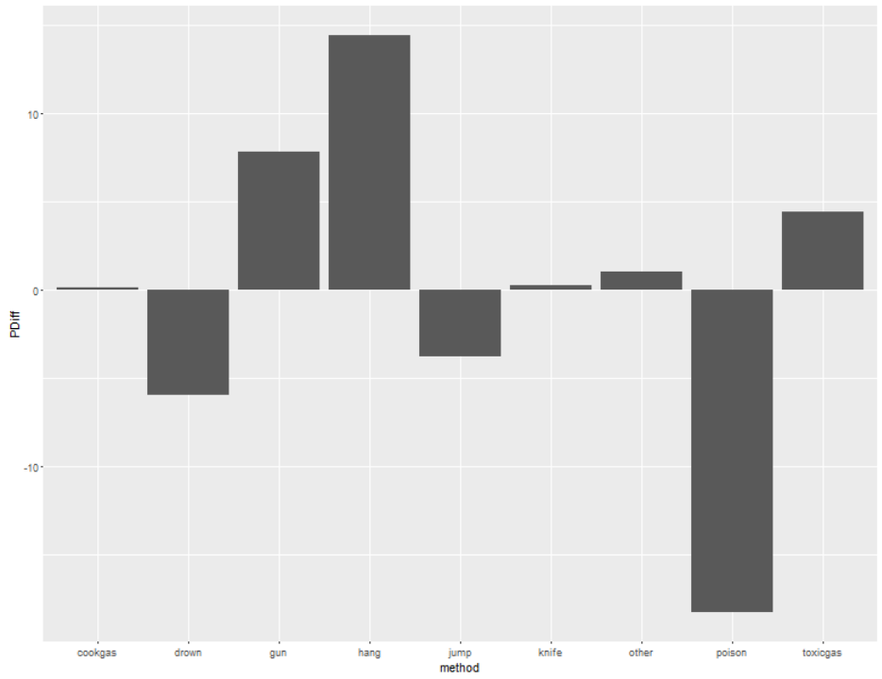
This graph needs some explaining. Each bar represents a different method. And the magnitude is determined by the likelihood of a male using that method minus the likelihood of a female using that method. So if a woman is more likely to use that method the bar will be negative. If the genders use that method roughly equally, then the bar should equal about zero. Again, this is percentage use, not actual use. If it were raw totals, males would out number females in just about every category.
Right away you can see men are more likely to use shooting, hanging, and toxicgas as means to commit suicide. While women are more likely to poison, drown, and jump.
Interestingly enough and probably unrelated, the male methods all correlate to historically accepted versions of capital punishment: shooting squad, hanging, and the gas chamber. I have read, anecdotally, that male suicides are more “violent,” and gruesome. Men tend to not think about who has to “clean up.” Also interesting, the female methods appear to be slower deaths. I have read, again anecdotally, that women attempt suicide more often than men, but are less successful. A reason for that could be the methods preferred by women. You can recover from an overdose or drowning. Also, there is more time to call for help with the methods preferred by females.

Further study
It would be interesting to see how suicides compare across countries. I am curious as to whether societal factors affect the average age the different genders commit suicide. Furthermore, I would like to see if education, religion, and income affect the average age, the methods used, and the likelihood of suicide. The method used would also be interesting to see across country. I have heard an anti-gun argument stating that with fewer guns there would be fewer suicides. Guns make suicide easy. It would be interesting to compare the United States' rates verses the United Kingdom's rates. Accessibility of suicide is an interesting hypothesis and one that makes sense.

