A look at Baseball Player’s Heights and Weights

The Lahman database is a package in R and it makes it very easy to look up baseball stats. All you need it to load it up and merge/join some tables. People love to look at player stats and look at production. But, no one ever seems to look at a player’s build and how it varies by position and play style. I thought I would use that as I play and get more experience with the R ggplot2 package.
A note about the data, there is only one weight and height listed for a player. It might be an average of their weight, it might not. I’m not overly sure what this measure is and this is a little disappointing. As player’s weights change over the course of their careers. Example: look at Barry Bonds in the early 90s and then look at him in the 2000s. He’s gets a lot bigger.
So let’s look at the first graph I came up with. It has Height on the y-axis and Weight on the x-axis. There is a positive relationship between the two. But not always. Pablo Sandoval. Prince Fielder I’m lookin’ at you! I have also split the graphs up by position to see how they are spread. Furthermore, the size and color of the point correspond to the amount of home runs hit by that person. The bigger and “bluer” the point the more home runs.
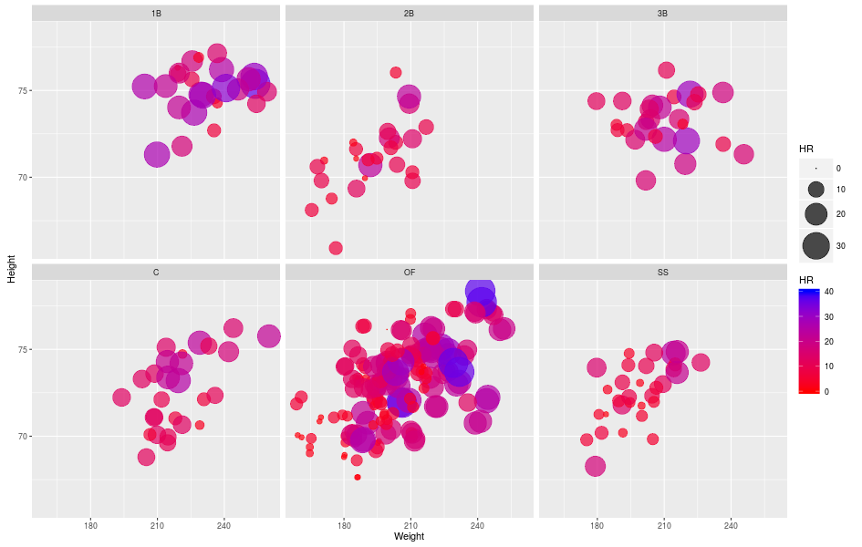
I wanted to make this graph to show how the different positions have a different build and a different expectation for power. First Basemen tend to be taller, heavier, and hit for more power. While second basemen and shortstops are smaller. Few are over 210lbs, few are taller than 75in (6’3”), and none of them hit for significant power.
Third baseman have a nice round distribution. And does not have that nice positive relationship between height and weight. This is probably due to the fact that teams will stash a good hitter that isn’t athletic (I’m lookin’ at you Pablo Sandoval!!). Outfielders are all over the place, but you can see on the smaller side of players hit for almost no power. Speaking of power, there aren’t many players below 210lbs that hit for significant power. And catchers appear unremarkable.
Now the same graph, but now I replace home runs with steals.
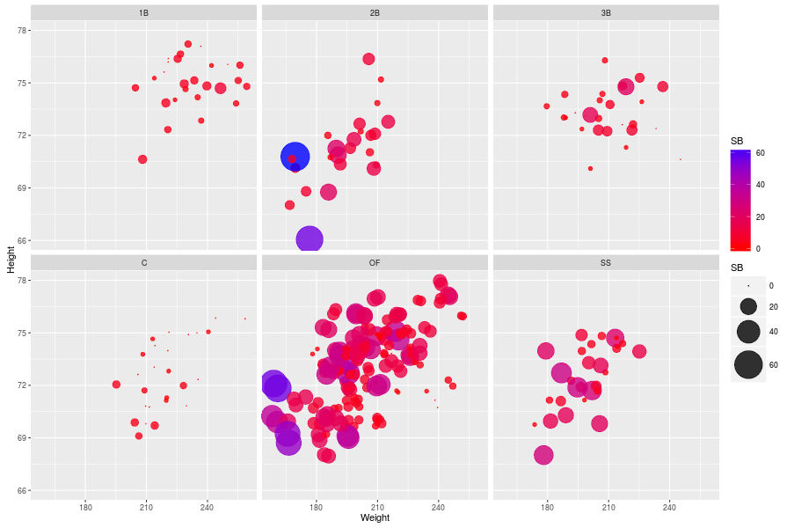
In general, first basemen, third basemen, and catchers don’t steal with any regularity. Outfielders, second basemen, and shortstops make up the majority of steals. And not surprisingly, they are the more athletic players. Interestingly none of high volume base stealers are over 180lbs and are shorter than 72in (6’). This is the complete opposite body type that tends to lend itself to power. The weight aspect of this fact isn’t surprising. You wouldn’t think that height players into it, but it appears to.
Now let’s look at how these heights, weights, and HRs have changed over time. I have graphed the average height of players by position since the year 1980. I have also smoothed the graph out using geom_smooth(). I have left the pure data lines in the background just faded. It helps capture the general trend, if there is one (I did this for all the graphs).
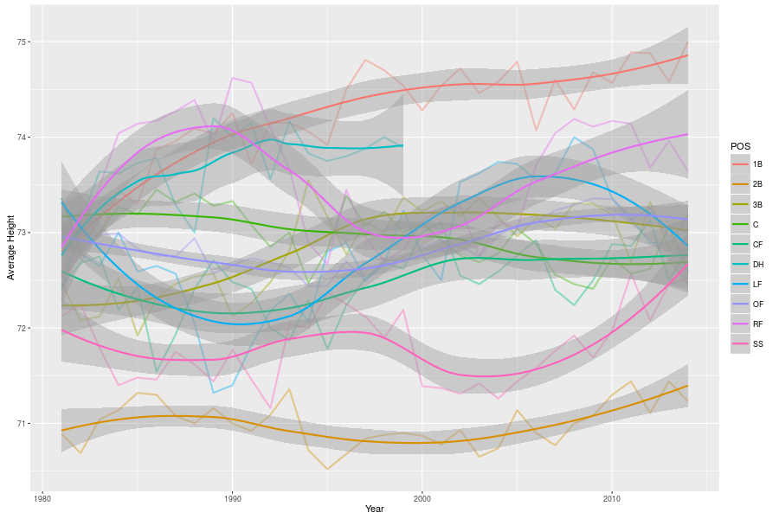
Why the DH position stopped recording heights in 1999 I have no idea. Generally there is no overarching trends. You can see that first basemen have gotten taller and are generally the tallest players. And second basemen are on average the shortest players. This is to be expected. Why would heights of players have an overall trend for the past 30 years? They wouldn’t. The more interesting graphs are looking at what happens at Weight and Home runs.
Here is the graph for weights:
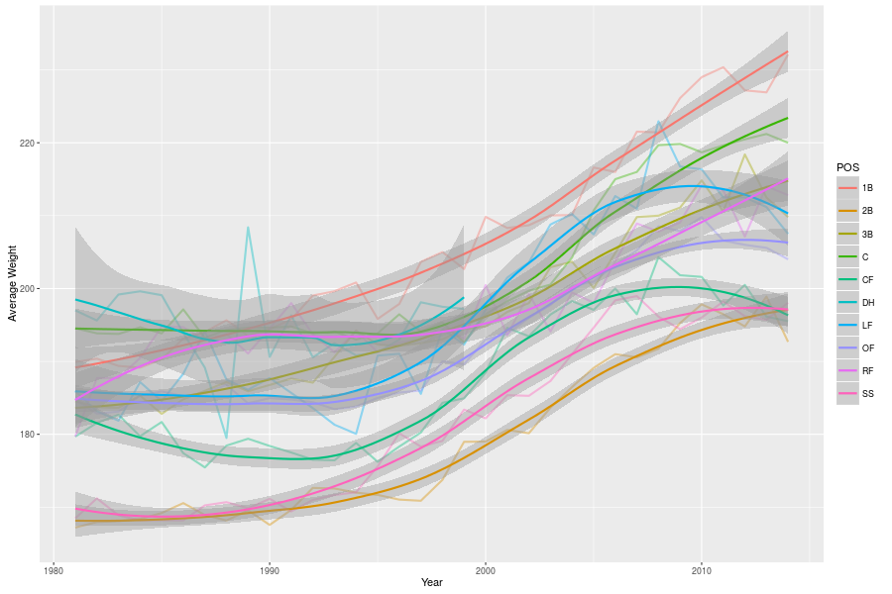
They have all gotten heavier. Starting in 1990, the weights very obviously trend upwards. The main reason for this the “Steroid Era.” It has to be. Steroids help you put on more muscle so naturally you’ll weight more. And since I’ve shown that heights haven’t changed, it is hard to refute that players have gotten larger. The surprising thing is that weights haven’t gone down as more rigorous testing become implemented (mid 2000s). Although, we may be too close to the steroid era to observe a general decline. Also, the weights of all positions except first basemen, catchers, and right fielders do appear to declining or at least plateauing (around 2010). But it’s hard to really have any definite conclusions other than they’ve gotten larger.
And now the graphs of Home runs:
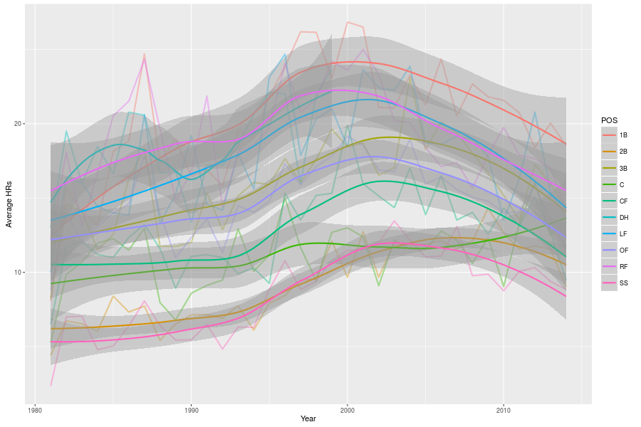
This graph is very messy. But the overall trend is that home runs spike in the early 2000s. This is consistent with the timing of the “Steroid Era.” And it appears that home run/power numbers are beginning to drop back to 1980s and pre1980s levels.

