Design and Development of a Locally Contextualized Nutrition Education Information System for Stunting Prevention Support at Puskesmas Tilango
  ARTICLE HISTORY  Received: xx-xx-xxxx  Revised: xx-xx-xxxx  Accepted: xx-xx-xxxx  KEYWORDS  Nutrition information system;  local food;  digital health;  e-stunting consultation;  stunting prevention; | ABSTRACT  Purpose – This study aimed to identify nutrition-education and system requirements at Puskesmas Tilango and translate them into NutriEdukasi, a locally contextualized nutrition education information system prototype for stunting-prevention support.  Methods – This Research and Development/design-and-development study followed a linear Waterfall-based process: needs analysis, requirements specification, system and content design, prototype development, expert content review, and Black-Box functional verification. Semi-structured interviews involved five purposively selected informants (one village midwife, one nutrition officer, and three Posyandu cadres). Literature-informed local-food, recipe, and nutrition-education categories were qualitatively reviewed by three experts. Nine predefined Black-Box scenarios tested selected authentication, content-management, and consultation functions.  Findings – Needs analysis identified three requirement areas: digitized nutrition-data recording, accessible locally relevant food/complementary-feeding (MPASI) information, and an asynchronous online two-way consultation channel. Two of these requirements (locally relevant food/MPASI information and an online two-way consultation channel) were translated into a functional web prototype; the digitized nutrition-data recording requirement remains at the design stage only. All nine predefined Black-Box scenarios produced the expected responses under the tested conditions.  Research implications – The findings support functional verification of the tested prototype functions only. The anthropometric classification module remains at the design stage and was not included in functional testing. Usability, user acceptance, implementation feasibility, and effectiveness require subsequent evaluation.  Originality – Among the five prior Puskesmas- and nutrition-oriented systems reviewed, NutriEdukasi combines needs-derived requirements, literature-informed locally contextualized nutrition content, local-food/recipe information, and asynchronous two-way consultation within one prototype. Its contribution is positioned as a needs-derived system design and functional prototype.
Rosdiana Kaharu🖂 | Basri Umar | Darmayanti Waluyo
Affiliation (Universitas Gorontalo, Gorontalo, Indonesia) | Affiliation (Universitas Gorontalo, Gorontalo, Indonesia) | Affiliation (Universitas Gorontalo, Gorontalo, Indonesia)

INTRODUCTION
Stunting is one of the most critical chronic nutrition problems in Indonesia, caused by prolonged inadequate nutrient intake, particularly during the golden period of the first 1,000 days of life (Hari Pertama Kehidupan [HPK]). According to the national Survei Status Gizi Indonesia (SSGI), national stunting prevalence stood at 19.8% in 2024, indicating that the problem remains far from resolved despite a declining trend over the past few years (Badan Kebijakan Pembangunan Kesehatan Kementerian Kesehatan RI, 2025). Determinants of stunting in Indonesia are multidimensional, spanning maternal, household, sanitation, and health-service factors (Beal et al., 2018). Addressing stunting requires accurate child growth-monitoring data as well as comprehensive and sustainable nutrition intervention. At the primary healthcare level, such as Community Health Centers (Puskesmas), the recording and reporting of nutritional-status recording for children under five frequently encounters classic obstacles. As identified by (Desi and Syarifuddin, 2021), manual, paper-based health administration systems trigger document accumulation, the risk of data loss, and delays in retrieving information needed for clinical decision-making. This efficiency limitation is further confirmed by (Sholehah, 2019), who stated that the use of conventional tools such as standalone spreadsheets without a centralized, secured database hampers the integration of malnutrition reporting from the Posyandu (integrated health post) level up to the Puskesmas. Broader efforts to implement information systems at the Puskesmas level have likewise been shown to improve administrative service delivery in general (Hakam, 2024). Similar Puskesmas-level management information systems have also been developed for other administrative purposes, such as adolescent health records (Azis et al., 2019) and general clinical service data at Puskesmas Ambal II, while similar administrative digitalization efforts have also been extended to disease-surveillance information systems, such as a web-based management information system supporting malaria control in South Sumatra Province (Hasyim and others, 2020).

Consistent with this, an evaluation of a Puskesmas management information system (SIMPUS) reported measurable improvements in health-service delivery once the system was properly adopted, reinforcing the argument that digitalization alone is not sufficient without contextual and interactive content. In its development, various digitalization efforts for nutrition monitoring have been initiated. (Fajriani et al., 2023) designed a nutrition-monitoring for children under five system to help officers generate monthly reports semi-automatically. Meanwhile, (Susanti et al., 2019) developed the “mozita” information system, which actively involves Posyandu cadres to produce accurate and rapid nutritional-status data. Nutrition-focused decision-support tools have also been explored, including an expert system for diagnosing malnutrition in child under fives using the Certainty Factor method (Kirana et al., 2019) and a conceptual expert-system framework for malnutrition detection (Nugroho and Sudibyo, 2024)), as well as an information system providing child under five nutrition guidelines (Rahma and Suhartini, 2020). Beyond monitoring systems, mobile application-based interventions have also shown promise for improving maternal nutritional literacy regarding stunted children, although most remain limited to one-way educational content rather than two-way consultation (Hasan et al., 2024). At the same time, qualitative evidence from health cadres in Indonesia suggests that limited knowledge and communication skills, rather than a lack of monitoring tools alone, are often the main barrier to effective stunting detection and prevention (Sukmawati et al., 2025). Although these systems have succeeded in accelerating the administrative processing of quantitative anthropometric data or in supporting diagnostic reference, a significant research gap remains: most existing nutrition management information systems function only as passive recording or diagnostic-reference tools and neglect the aspect of contextual, culturally interactive educational intervention.

Many digital stunting-education platforms may face grassroots implementation challenges when dietary recommendations or complementary-feeding (MPASI) recipes are difficult to access, unaffordable, or unfamiliar to intended users. Local-food-based supplementary feeding and nutrition counseling have therefore been explored as context-sensitive approaches to stunting prevention. Published Indonesian studies have reported the use of local-food interventions and nutrition education, including local-menu demonstrations and digital/QR-supported educational media, to support caregiver knowledge and practice (Apriliani et al., 2024; Nurpratama et al., 2024; Widyaningsih et al., 2026). These studies provide a health- and nutrition-relevant basis for considering locally available foods and context-appropriate communication in the design of NutriEdukasi; they are not used to claim formal cultural validation of the prototype.(Nurpratama, et al, 2024)(Apriliani et al., 2024)(Widyaningsih et al., 2026)
Puskesmas Tilango faces a similar challenge, where nutrition counseling still relies substantially on one-way printed materials and locally relevant MPASI references are not always easy to access. Therefore, this study develops NutriEdukasi as a locally contextualized nutrition education information system prototype. The system combines digitized nutrition-data support, literature-informed local-food and recipe information, and an online two-way consultation channel intended to support follow-up communication between caregivers and health personnel. The term 'locally contextualized' is used deliberately because the study did not conduct formal cultural validation with community or cultural stakeholders.
To sharpen the study's focus and make the adequacy of the Results section easier to judge, this study is guided by three research questions: RQ1. What system and content requirements — including nutrition-education content, local-food information, and local cultural elements — are needed for a locally contextualized nutrition education information system at Puskesmas Tilango? RQ2. How can these requirements be translated into the design and development of the NutriEdukasi prototype, integrating local-food resources and locally contextualized content? RQ3. Do the core functions of the developed prototype produce the expected outputs when verified through Black-Box functional testing? This study is positioned as a limited-scope Research and Development (R&D) study whose contribution is the prototype itself and its functional verification, not a usability, acceptance, or effectiveness evaluation. Table 1 positions NutriEdukasi analytically against five representative prior systems, grouping them by the capabilities each provides rather than listing them chronologically, to support a proportionate, verifiable novelty claim rather than an absolute one.

Table 1. Feature Comparison Between NutriEdukasi and Prior Nutrition/Puskesmas Information Systems
System | Anthropometric Recording | Diagnostic / Decision Support | Local-Food Database | Online Two-Way Consultation | Locally contextualized content
Fajriani et al. (2023) – child under five nutrition monitoring system | ✓ | ✗ | ✗ | ✗ | ✗
Susanti et al. (2019) – “mozita” information system | ✓ | ✗ | ✗ | ✗ | ✗
Kirana et al. (2019) – Certainty Factor expert system | ✗ | ✓ | ✗ | ✗ | ✗
Rahma and Suhartini (2020) – nutrition guideline information system | ✗ | ✗ | Partial (static) | ✗ | Partial
Aisyah et al. (2025) – WhatsApp nutrition-surveillance chatbot | ✓ | ✗ | ✗ | ✓ | ✗
NutriEdukasi (this study) | Not implemented (design only) | Not implemented (design only) | ✓ | ✓ | ✓

Among the five prior systems reviewed in Table 1, the reviewed systems did not present the same combination of local-food/recipe information, contextualized nutrition-education content, and an online two-way consultation workflow within one prototype. This comparison is limited to the systems reviewed in this study and is used to position NutriEdukasi's feature combination rather than to claim comprehensive uniqueness across all existing digital-health systems.(Fajriani et al., 2023; Susanti et al., 2019; Kirana, et al, 2019) (Aisyah et al., 2025)
METHOD
(Susanti et al., 2019) This study was conducted as a Research and Development (R&D)/design-and-development study using a linear Waterfall-based system-development process. The procedure comprised needs analysis, requirements specification, system and content design, prototype development, expert content review, and Black-Box functional verification. The study did not employ Action Research cycles because the actual development process was linear and did not include recurring plan-act-observe-reflect cycles or repeated co-development iterations with participants. The Waterfall-based sequence was selected to reflect the documented progression from requirements elicitation to design, development, and functional verification (Sholehah, 2019; Ferdiansyah et al., 2024; Said et al., 2025).

1. Information Needs Analysis (Data Acquisition)

The initial step used in-depth, semi-structured interviews with a purposive sample of five Puskesmas Tilango informants: one village midwife, one nutrition officer, and three Posyandu cadres. They were selected because their roles are directly related to child under five growth monitoring, nutrition/MPASI counseling, and Posyandu-level reporting. The small purposive sample was used for focused requirements elicitation rather than population-level qualitative generalization. Its adequacy was considered in terms of information power: the study had a narrow operational aim and a highly specific sample covering the principal service roles relevant to the intended system requirements (Malterud et al., 2016). The study does not claim formal thematic saturation. Interviews focused on (1) the existing nutrition-reporting workflow and its obstacles and (2) barriers in manual, face-to-face nutrition counseling. Interview responses were reviewed and coded inductively for requirements elicitation and grouped into themes following a thematic-analysis approach (Braun & Clarke, 2006); the resulting themes were translated into the requirements summarized in Table 2. Coding responsibility was not separately documented at the individual-author level, and no formal independent dual-coding, inter-coder agreement statistic, or member-checking procedure was recorded; these are therefore not claimed retrospectively. Traceability is instead provided through Table 2, which links field findings, themes, user requirements, URS requirements, and implemented features. The local-food categories, recipes, and related nutrition-education material were not derived from the interviews as evidence of cultural validity. Instead, they were compiled through desk research using published studies relevant to local-food-based stunting interventions in Gorontalo Province and comparable Indonesian settings (Daud et al., 2025; Makale, 2025). All interview participants provided informed consent prior to participation. The chronology of formal ethical approval relative to the interviews is reported transparently in the Ethical Considerations subsection.(Daud, Moko and Kadir, 2025; Makale, 2025)(Braun and Clarke, 2006)

Table 2. Needs-Analysis Traceability: Field Finding → Theme → User Requirement → URS Requirement → System Feature
Field Finding | Theme | User Requirement | Requirement (URS) | System Feature
Nutrition-reporting at Puskesmas Tilango relies on manual/paper-based recording, causing delayed and incomplete records. | Fragmented, manual reporting workflow | Staff need a structured digital workflow for recording child anthropometric/nutrition data. | REQ-01: The system shall provide a digital form for recording child under five anthropometric/nutrition data. | Not implemented in the current prototype (design requirement only).
Face-to-face counseling relies on printed brochures with limited, hard-to-access local-food/MPASI references. | One-way, limited counseling materials | Staff and caregivers need accessible, locally relevant food/MPASI reference material. | REQ-02: The system shall provide a searchable local-food and recipe database with local-context content. | Local-Food and Local Recipe modules.
Mothers/caregivers have no direct channel to ask follow-up nutrition questions between scheduled visits. | No channel for follow-up questions between visits | Caregivers need a way to reach nutrition experts for follow-up questions outside visit hours. | REQ-03: The system shall provide an online, two-way consultation channel between caregivers and experts. | Online Two-Way Consultation module.

2. System and Database Design (Preprocessing and Modeling)
The local-food component was organized as categories and educational content derived from relevant published literature rather than as an item-by-item culturally validated food database. Candidate local-food and recipe categories were identified through desk research on local-food-based nutrition and stunting interventions in Gorontalo Province and comparable Indonesian settings. TKPI was used as a nutritional reference where applicable; however, this study does not claim that every food or recipe entry in the prototype underwent complete item-level TKPI validation. Accordingly, the local-food module is described as locally contextualized and literature-informed, and item-level nutritional verification remains necessary before routine public-health deployment.(Daud, Moko and Kadir, 2025; Makale, 2025)

Expert Review of Educational Content
The compiled nutrition-education material, local-food categories, recipes, and contextual elements were reviewed by a panel of three content experts: two nutrition/dietetics experts from the Nutrition Science (S1 Gizi) study program, Universitas Gorontalo (DW and St. MR), and one Puskesmas practitioner (YK), a midwife who provides nutrition counseling to pregnant women and mothers of child under fives at Puskesmas Tilango. The review was used to assess the appropriateness of the content categories and their suitability for the prototype. Because the study did not establish cultural validity through direct participation of mothers, caregivers, community representatives, or cultural stakeholders, the manuscript uses the term locally contextualized rather than culturally validated.
Experts reviewed the content against eight predefined aspects: (1) accuracy of nutrition information, (2) consistency with national nutrition guidelines, (3) relevance to stunting prevention, (4) suitability of local-food categories to the Tilango/Gorontalo context, (5) clarity and comprehensibility of language, (6) feasibility as public nutrition-education material, (7) contextual appropriateness, and (8) consistency of recipes and nutrient information with official or scientific sources. The review is reported as qualitative expert review at the category/content level. The study did not use a quantitative scoring instrument, numerical acceptance threshold, or inter-expert agreement statistic, and no retrospective scores or agreement measures were reconstructed for this revision. Accordingly, the manuscript does not claim formal item-level validation.

The system uses a PHP-based web architecture with the Laravel framework to ensure fast and secure performance. To classify food ingredients and provide appropriate dietary recommendations for child under fives based on their nutritional status, the system was designed to adopt rule-based decision logic resembling a nutritional-classification model. Children under five's nutritional status (Severely Deficient, Deficient, Normal, At Risk of Excess) is intended to be calculated automatically based on the Ministry of Health's anthropometric standards using a simple classification algorithm based on age, weight, and height variables (Kementerian Kesehatan Republik Indonesia, 2020).

Specifically, the module is designed to compute weight-for-age, height-for-age, and weight-for-height z-scores following the anthropometric standard, and to classify a child under five's status by comparing each z-score against its published cut-off bands (e.g., Severely Deficient below −3 SD, Deficient between −3 SD and −2 SD, Normal between −2 SD and +1 SD, and At Risk of Excess above +1 SD, following the age- and sex-specific reference tables in that standard). The intended z-score computation follows the WHO Child Growth Standards (WHO Multicentre Growth Reference Study Group, 2006) LMS (Lambda-Mu-Sigma) method, consistent with the standard: for L ≠ 0, Z = [(X/M)^L − 1] / (L × S); for L = 0, Z = ln(X/M) / S; where X is the child's observed measurement for the relevant indicator (weight-for-age, height-for-age, or weight-for-height) and L, M, and S are the age- and sex-specific skewness, median, and coefficient-of-variation parameters, respectively, from the reference tables in that standard. This computation logic has been designed but not yet implemented in executable code. The module is documented here at the design/proposed level only, is excluded from the Black-Box functional verification reported in the Results and Discussion, and its implementation and functional and clinical validation are identified as priority future work before it is presented as an operational system feature.(Kementerian Kesehatan Republik Indonesia, 2020)(Kementerian Kesehatan Republik Indonesia, 2020)
3. System Implementation (NutriEdukasi)
The information system was implemented as a responsive (mobile-friendly) web platform to facilitate access for Posyandu cadres and the community through smartphones (Octaviani and Sihananto, 2023). Its implemented modules comprise: (1) a Public Education Portal presenting nutrition information, local recipes, local-food information, articles, gallery content, videos, and frequently asked questions (FAQ); (2) an Admin/Cadre Panel used to manage categories and educational content; and (3) an Online Consultation Portal that supports asynchronous two-way question-and-answer communication between users and Puskesmas nutrition personnel. The consultation function is not presented as synchronous or real-time clinical consultation.(Octaviani and Sihananto, 2023)

4. Validation and System Testing
The developed system was tested functionally using the Black-Box Testing method to verify the implemented navigation, authentication, data-management, validation, and consultation functions. The software prototype itself was developed by an external vendor based on the functional requirements specified by the research team. Table 3 presents nine predefined test scenarios covering admin authentication, content-management data validation, and the public consultation workflow. The test cases were prepared collaboratively by the external developer and BU, a member of the research team with an information-technology background. Functional test execution was subsequently conducted by the three researchers (RK, BU, and DW), who compared the observed outputs with the predefined expected results. Because the testers were members of the research team, this procedure is described as internal functional verification rather than external or independent testing. The nine scenarios cover authentication and CRUD-level data validation across the implemented modules and therefore support only a claim of basic functional correctness under the tested conditions. They do not constitute load testing, concurrent-submission testing, malformed-data testing, usability testing, user acceptance testing, or comparison against a baseline system, and the pass rate reported below should not be interpreted as evidence of reliability, usability, user acceptance, or effectiveness in real-world use.

Table 3. Black-Box Test Case Design
Test ID | Test Objective | Test Data (Payload) | Expected Result
TC-01 | Admin authentication (valid credentials) | { username: "admin", password: "admin123" } | System returns status 200 and issues an access token (login successful)
TC-02 | Admin authentication (empty username) | { username: "", password: "[test password]" } | Client-side validation blocks the form and displays "username is required"
TC-03 | Create category (empty name) | { category_name: "", type: "article" } | System rejects the submission and displays "category name is required"
TC-04 | Create article (normal submission) | { title: "Benefits of Moringa", category_id: "cat-1", author: "[synthetic clinician]" } | Article data is saved via REST API; system returns status 201 (Created)
TC-05 | Create article (empty category) | { title: "How to Prepare Anchovies", category_id: "" } | System displays a red validation warning on the category dropdown and blocks submission
TC-06 | Create local food (missing nutrition info) | { food_name: "Moringa", nutrition_information: "" } | System prevents local-food entries without nutrition values from being saved
TC-07 | Public consultation submission | { sender_name: "Budi [synthetic]", message: "My child is underweight" } | Consultation is sent to the database with status "pending"; system returns status 201 (Created)
TC-08 | Admin reply to consultation | { id: "con-1", reply: "[synthetic nutrition reply]", status: "answered" } | Reply is saved and consultation status updates to "answered" (status 200)
TC-09 | Delete category record | Delete category ID "kat-101" | Category is successfully removed from the database (status 200)

All credentials and payload values used in the test cases in Table 3 (e.g., the "admin"/"admin123" login pair and the sender name "Budi") are synthetic/dummy data created solely for testing purposes; they do not represent real user accounts, passwords, or personal data.

5. Prototype Refinement
Because all nine predefined Black-Box test scenarios produced the expected outputs on their first execution (Table 3), no functional defects were identified within those specific scenarios. This result does not demonstrate robustness beyond the tested cases. Content refinement in this study was limited to adjustments arising from the expert content-review process; usability-driven refinement based on end-user evaluation was outside the study scope and is identified as future work.

Ethical Considerations
The needs-analysis interviews involved five Puskesmas Tilango informants. Before participation, informants were informed of the study purpose and procedures, their voluntary participation, and their right to decline or withdraw, and informed consent was obtained. Formal research ethics approval was subsequently issued by the Research Ethics Committee, Universitas Gorontalo (approval number 006655/KEP-FKM.UNIGO/2026), dated 11 August 2026, with an approval period from 11 August 2026 to 11 August 2027. Because the formal approval was issued after the needs-analysis interviews, this chronology is disclosed transparently and the manuscript does not describe the approval as prospective. No prospective exemption or waiver is claimed because no such formal documentation is reported for the interview period. Participant identities were kept confidential and only aggregate or de-identified findings are reported. The approval certificate and chronology should therefore be provided to the editor for assessment under the applicable institutional and journal requirements.

RESULTS AND DISCUSSION

4.1 Needs Analysis
As detailed in the Method section, needs analysis was conducted through semi-structured interviews with five purposively selected Puskesmas Tilango informants (one village midwife, one nutrition officer, and three Posyandu cadres), using the inclusion criteria, interview protocol, and thematic-analysis procedure described above. The resulting themes and their supporting field evidence are summarized in Table 2.

4.2 User Requirement Specification
The three themes identified in the needs analysis (Table 2) were translated into user and system requirements: (1) a faster, centralized approach to nutrition-data recording and reporting; (2) accessible, locally relevant food and MPASI reference material; and (3) a channel for follow-up nutrition questions between scheduled visits. These were specified as digitized growth-data recording, a local-food/recipe content repository, and an online two-way consultation function, together with web-based accessibility requirements.

4.3 System Design Document
The system requirements were translated into the three-module architecture described in the Method section: a local-food/recipe and content-management module, a public education portal, and an online two-way consultation module, implemented using a web-based architecture with a MySQL relational database. The prototype figures are linked directly to the URS requirements: Figures 1-2 illustrate the public education and local-food/recipe content supporting REQ-02; Figures 3-4 show the authenticated administrative environment used to manage content and follow consultation activity supporting implementation of REQ-02 and REQ-03; and Figure 5 illustrates the asynchronous consultation interface implementing REQ-03. The corresponding tested behaviors are reported separately as Black-Box test cases in Section 4.6.

4.4 Category-Level Educational Content Review Matrix
Table 4 summarizes the category-level educational content review used in this study. The matrix provides an audit trail linking the principal content categories to their evidence basis, contextual basis, review scope, and status in the prototype. It does not represent item-level nutritional validation or formal cultural validation. The expert review was qualitative by design; numerical scores, inter-expert agreement statistics, and a quantitative acceptance threshold were not collected, and none were reconstructed retrospectively for this revision.

Table 4. Category-Level Educational Content Review Matrix
Content category | Evidence/source basis | Contextual basis | Expert review scope | Requested revision / audit trail | Status in this study
Nutrition-education material | National nutrition guidance and relevant scientific literature | Nutrition education for stunting-prevention support | Reviewed against the eight predefined content-review aspects | Category-level review; item-level revision log not claimed | Included in prototype as expert-reviewed educational content
Local-food categories | Published local-food/stunting-intervention studies relevant to Gorontalo and comparable Indonesian settings | Locally relevant food categories identified from literature | Reviewed for nutrition relevance, contextual suitability, clarity, and source consistency | Item-level cultural validation was not performed | Included as locally contextualized, literature-informed categories
Recipes / MPASI information | Published nutrition/local-food literature and applicable official/scientific sources | Recipes selected to support locally relevant nutrition education | Reviewed for relevance, clarity, feasibility, and consistency with scientific/official sources | Complete item-level TKPI verification is not claimed | Included as prototype educational content; further item-level verification required
Contextual language and presentation | Service context and expert review | Adaptation to Puskesmas/Posyandu communication context | Reviewed for clarity, comprehensibility, feasibility, and contextual appropriateness | Formal cultural validation with community/cultural stakeholders was not conducted | Locally contextualized; not claimed as culturally validated

4.5 Prototype Implementation
The public-facing portal of NutriEdukasi (Figure 1) presents nutrition-education material and information on locally relevant foods. The content is framed as literature-informed and locally contextualized. Comparative public-facing claims such as direct moringa-versus-milk or fish-fatty-acid superiority statements are not used as evidence of the system contribution because such comparisons require standardized serving bases and directly traceable composition values.
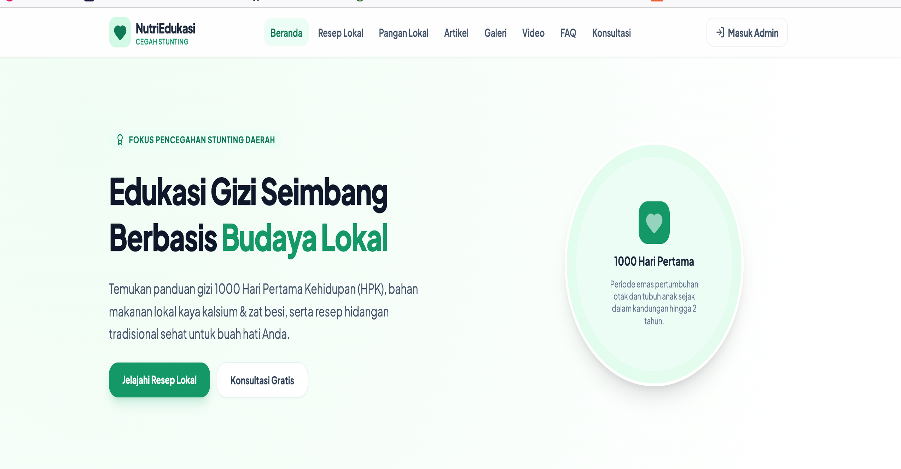
Figure 1. NutriEdukasi public portal homepage (REQ-02). English labels: Home, Local Recipes, Local Foods, Articles, Gallery, Videos, FAQ, Consultation, Admin Login. Source: Authors’ NutriEdukasi prototype (2026).
The Local Recipe and Local Food modules (Figure 2) provide short recipes, such as “Iron-Rich Baby MPASI,” and local-food profiles, such as Tiliaya, complete with nutrient content and health benefits, directly linking the food database designed in the Method stage with public-facing educational content.
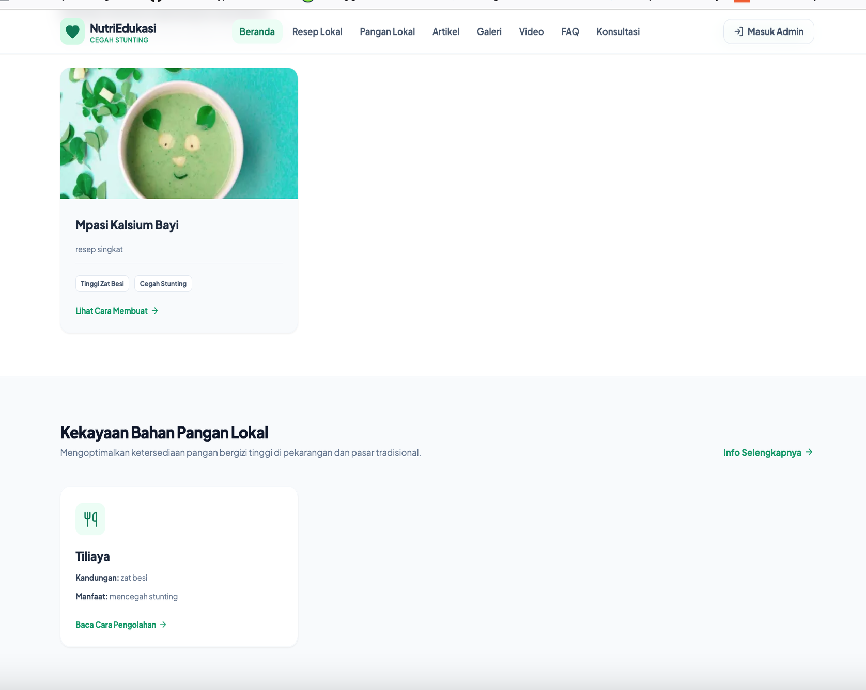
Figure 2. Local recipe and local-food prototype content (REQ-02). Tiliaya is a traditional Gorontalo food included as literature-informed prototype content; item-level nutritional validation is not claimed. Source: Authors’ NutriEdukasi prototype (2026).

Access to content management is restricted through an admin authentication portal (Figure 3), consistent with the authentication mechanism verified in TC-01 and TC-02.
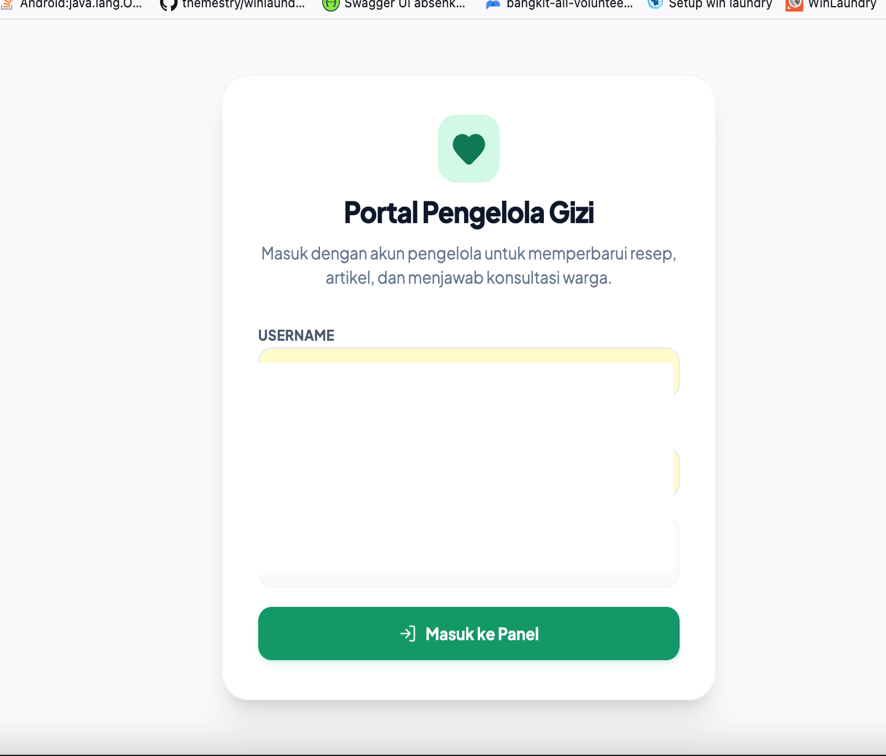
Figure 3. Nutrition Manager Portal login (supporting REQ-02/REQ-03 administration). Visible demonstration credentials have been redacted. Source: Authors’ NutriEdukasi prototype (2026).
Once authenticated, the Nutrition Manager Dashboard (Figure 4) displays a real-time summary of system content (total articles, local recipes, local food entries, and portal visits), a visit-traffic chart, and an incoming-consultation queue, supporting the cadre or nutritionist in monitoring and following up on public engagement.
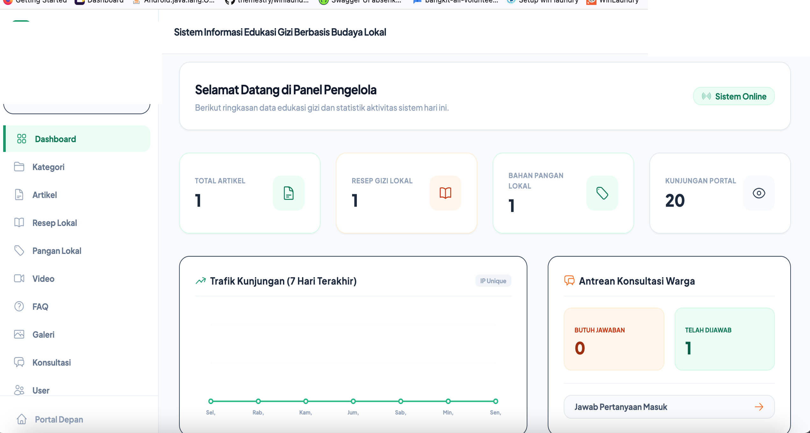
Figure 4. Nutrition Manager Admin Dashboard (supporting REQ-02/REQ-03 administration). Personal identifiers have been redacted. English labels are provided in the manuscript text. Source: Authors’ NutriEdukasi prototype (2026).
The Online Consultation module (Figure 5) enables users to submit nutrition-related questions that can subsequently be reviewed and answered by authorized health personnel and displayed on the Q&A board. TC-07 and TC-08 verify the submission and reply workflow. Because a submitted question first receives a “pending” status before a later reply, the module is described as asynchronous online two-way consultation rather than real-time consultation.

Figure 5. Public Online Nutrition Consultation Module (REQ-03). Public Q&A content has been redacted from the figure to protect confidentiality pending author confirmation of its synthetic status. Source: Authors’ NutriEdukasi prototype (2026).

4.6 Black-Box Functional Verification
Functional verification using Black-Box Testing was carried out on nine test scenarios covering authentication, content-management data validation (category, article, and local-food data), and the public consultation workflow. The complete testing results are presented in Table 3.

Table 5. Black-Box Testing Results
Test ID | Scenario | System Response | Result
TC-01 | Admin authentication with valid credentials | Status 200 – login successful, token issued | PASSED
TC-02 | Admin authentication with empty username | Client-side validation blocked the form and displayed “username is required”. | PASSED
TC-03 | Create category with empty name | Submission rejected; “category name is required” displayed. | PASSED
TC-04 | Create article with complete data | Article saved via REST API; status 201 (Created). | PASSED
TC-05 | Create article with empty category | Red dropdown validation warning displayed | PASSED
TC-06 | Create local food without nutrition value | Submission prevented; nutrition field required | PASSED
TC-07 | Public consultation form submission | Status 201 (Created), status set to "pending" | PASSED
TC-08 | Admin replies to a consultation | Reply saved; status 200; consultation status updated to “answered”. | PASSED
TC-09 | Delete category record | Status 200 (Success), record removed | PASSED

All nine predefined test cases produced the expected outputs. TC-01–TC-02 verified the tested authentication behaviors; TC-03, TC-05, and TC-06 verified selected required-field validation; TC-04 verified article creation; TC-07–TC-08 verified the consultation submission-and-reply workflow; and TC-09 verified deletion of the specified category record. TC-09 did not independently verify deletion or preservation of dependent records and is therefore not interpreted as cascade verification. The 9/9 result applies only to these predefined scenarios and does not establish overall reliability, robustness, security, usability, or implementation readiness.(Sholehah, 2019)(Fahrullah et al., 2025)

The nine Black-Box scenarios reported above verified the system's authentication, content-management, and public-consultation functions. The anthropometric classification module described in the System Implementation section remains a designed/proposed module only: its computation logic has been specified but not yet implemented in executable code, and it was therefore excluded from Black-Box functional verification. No functional, reliability, or accuracy claim is made for this module at this stage; its implementation and functional verification are identified as priority future work, positioned as a supporting extension rather than the central contribution of this study, which centers on the system design, the User Requirement Specification, and the expert-reviewed content matrix.

Taken together, the requirements traceability, prototype implementation, category-level content review, and predefined functional tests establish the scope of this study as a design-and-development contribution. Subsequent evaluation should proceed through usability and accessibility testing, task-based User Acceptance Testing, implementation-feasibility and consultation-governance assessment, and only thereafter effectiveness or impact evaluation (Susanti et al., 2019; Fajriani et al., 2023; Aisyah et al., 2025; Prafiantini et al., 2025).(Susanti et al., 2019)(Fajriani et al., 2023)(Aisyah et al., 2025)(Aisyah et al., 2025)(Prafiantini and others, 2025)(Apriliani et al., 2024)(Widyaningsih et al., 2026)

Limitations
This study is limited to requirements elicitation, system design, prototype development, qualitative category-level expert content review, and predefined Black-Box functional verification. The nine Black-Box scenarios cover selected authentication, CRUD/data-validation, and consultation-workflow behaviors only; they do not constitute comprehensive malformed-input, boundary, authorization, session/token, concurrency, database-failure, recovery, load, security, or reliability testing. The qualitative requirements analysis used a small, role-specific sample and did not employ documented independent dual coding, inter-coder agreement measurement, or member checking. The expert content review was qualitative and did not use numerical scoring or inter-expert agreement statistics. Before real-world deployment, the consultation module also requires governance arrangements covering professional responsibility, expected response time, privacy and confidentiality, sensitive health questions, emergency escalation, moderation, and data retention. Usability, accessibility, formal UAT, implementation feasibility, and effectiveness remain subjects for subsequent studies. One author (DW) also served as one of the three content experts; this dual role is disclosed as a potential source of interpretive bias, and the expert review should not be interpreted as fully independent external validation.

The automatic anthropometric classification module, designed to apply the Kementerian Kesehatan Republik Indonesia (2020) anthropometric standard — Indonesia's national adaptation of the WHO child growth standards — through a rule-based approach, remains at the design stage: it has not yet been implemented in executable code and was therefore excluded from Black-Box functional verification. No functional, accuracy, or reliability claim is made for this module.
For clarity, anthropometric recording and classification are treated in this manuscript as design-stage requirements only. They were not implemented in executable form and were not included in the nine Black-Box functional test scenarios. Accordingly, no functional, accuracy, reliability, or clinical-performance claim is made for this component.

Usability evaluation, formal User Acceptance Testing with Posyandu cadres and health workers, and effectiveness or impact evaluation are identified as priority future work, to be reported separately with their own research questions, methods, and contribution, distinct from the prototype-development and functional-verification scope of this manuscript.(Aisyah et al., 2025)

CONCLUSION
This study translated focused nutrition-education and system requirements at Puskesmas Tilango into the NutriEdukasi prototype through a linear R&D/design-and-development process. The resulting web prototype integrates a public education portal, administrative content management, literature-informed local-food/recipe information, and an asynchronous online two-way consultation module. Five purposively selected informants representing a village midwife, a nutrition officer, and Posyandu cadres informed the requirements, while published literature and qualitative expert review informed the contextualized educational content. All nine predefined Black-Box scenarios produced the expected outputs under the tested conditions, supporting a narrow claim of functional verification of those tested functions. The prototype therefore provides a foundation for subsequent item-level content verification, usability/accessibility evaluation, task-based UAT, consultation-governance assessment, implementation-feasibility study, and later effectiveness evaluation.
ACKNOWLEDGMENT
The authors thank Puskesmas Tilango and the five informants who participated in the needs-analysis interviews: one village midwife, one nutrition officer, and three Posyandu cadres. All participants were informed of the study purpose and provided informed consent. Formal research ethics approval was issued by the Research Ethics Committee, Universitas Gorontalo (approval number 006655/KEP-FKM.UNIGO/2026), dated 11 August 2026; the chronology relative to data collection is disclosed in the Ethical Considerations subsection. The authors declare no known competing financial or personal interests that could have influenced the work reported in this article.

AUTHOR CONTRIBUTION STATEMENT
Rosdiana Kaharu (RK): Conceptualization, Investigation, Formal Analysis, Validation, Writing – Review & Editing. Basri Umar (BU): Conceptualization, Methodology, Formal Analysis, Validation, Writing – Review & Editing. Darmayanti Waluyo (DW): Conceptualization, Investigation, Validation, Writing – Review & Editing. The software prototype was developed by an external vendor based on requirements specified by the research team; therefore, the CRediT Software role is not assigned to any author. Black-Box test cases were prepared collaboratively by the external developer and BU, while functional test execution was conducted by RK, BU, and DW. Student data collectors assisted RK and DW with the needs-analysis interviews. DW also conducted the nutrition-content review based on her professional and academic expertise in nutrition. All authors reviewed and approved the final manuscript.

AI DISCLOSURE STATEMENT
The authors declare that artificial intelligence (AI) tools (specifically Gemini and Grammarly) were utilized solely to improve the language, grammar, and readability of the manuscript. The human authors maintain full responsibility for the originality, core ideas, data analysis, and final content of this research.
REFERENCES
Aisyah, D. N., Mayadewi, C. A., Utami, A., Rahman, F. M., Adriani, N. H., Al Farozi, E., Sayoko, M. H., Chairunisa, A., Restiana, L., Manikam, L., & Kozlakidis, Z. (2025). Using WhatsApp for nutrition surveillance among children under 5 years in West Java, Indonesia: Cross-sectional survey and feasibility study. JMIR Pediatrics and Parenting, 8, e58752. https://doi.org/10.2196/58752
Apriliani, F., Fajar, N. A., & Rahmiwati, A. (2024). Efektivitas pemberian makanan tambahan berbahan pangan lokal terhadap status gizi balita stunting: Systematic review. Media Informasi, 20(2), 25–34. https://doi.org/10.37160/mijournal.v20i2.585
Azis, A., Fakhrurrifqi, M. and Santoso, D.B. (2019). Pengembangan Sistem Informasi Kesehatan Remaja di Puskesmas Bantul II Kabupaten Bantul. Jurnal Manajemen Informasi Kesehatan Indonesia, 7(2),, 87–92. https://doi.org/10.33560/jmiki.v7i2.240.
Badan Kebijakan Pembangunan Kesehatan Kementerian Kesehatan RI (2025) Survei Status Gizi Indonesia (SSGI) 2024. https://www.badankebijakan.kemkes.go.id/survei-status-gizi-indonesia-ssgi-2024/.
Beal, T., Tumilowicz, A., Sutrisna, A., Izwardy, D. and Neufeld, L.M. (2018). A Review of Child Stunting Determinants in Indonesia. Maternal & Child Nutrition, 14(4),, e12617. https://doi.org/10.1111/mcn.12617.
Borghi, E., de Onis, M., Garza, C., Van den Broeck, J., Frongillo, E. A., Grummer-Strawn, L., Van Buuren, S., Pan, H., Molinari, L., Martorell, R., Onyango, A. W., & Martines, J. C. (2006). Construction of the World Health Organization child growth standards: Selection of methods for attained growth curves. Statistics in Medicine, 25(2), 247–265. https://doi.org/10.1002/sim.2227
Braun, V. and Clarke, V. (2006). Using Thematic Analysis in Psychology. Qualitative Research in Psychology, 3(2),, 77–101. https://doi.org/10.1191/1478088706qp063oa.
Daud, D. R., Moko, M. Y., & Kadir, R. (2025). Inovasi makanan tradisional (Tiliaya) dikombinasi tanaman lokal (singkong) untuk mencegah stunting di Desa Pentadu Barat, Kab. Boalemo, Gorontalo. PESHUM: Jurnal Pendidikan, Sosial dan Humaniora, 4(3), 4978–4982. https://doi.org/10.56799/peshum.v4i3.9218
Desi, I. S. K., & Syarifuddin. (2021). Sistem informasi manajemen data pasien untuk meningkatkan pelayanan kesehatan di Puskesmas Curug. Jurnal Sistem Informasi, 8(2), 104–112. https://doi.org/10.51998/jsi.v8i2.375
Fahrullah, F., Haerullah, H. and Ridhawani, A. (2025). Analisis Blackbox Testing dan User Acceptance Testing terhadap Sistem Informasi Posyandu Dondang. Journal of Practical Computer Science, 5(1),, 42–50. https://doi.org/10.37366/jpcs.v5i1.5780.
Fajriani, F., Widiastuti, S. H., & Susanto, H. (2023). Sistem informasi monitoring kesehatan ibu hamil dan gizi balita terhadap stunting di Puskesmas Bontang Selatan II. Jurnal Sains dan Sistem Teknologi Informasi, 5(1), 1–9. https://doi.org/10.59811/sandi.v5i1.15
Ferdiansyah, F., Anshor, A.H. and Widodo, E. (2024). Implementation of a Web-Based Village Information System Using the Waterfall Method in Hegarmukti Village. International Journal of Software Engineering and Computer Science (IJSECS), 4(2),, 566–575. https://doi.org/10.35870/ijsecs.v4i2.2986.
Hakam, F. (2024). Implementasi sistem informasi Puskesmas (SIP) di Puskesmas Baki Sukoharjo. Jurnal Manajemen Informasi dan Administrasi Kesehatan, 7(1), 23–30. https://doi.org/10.32585/jmiak.v6i2.4858
Hasan, D.S., Arief, Y.S. and Krisnana, I. (2024). Mobile Application Intervention to Improve Nutritional Literacy of Mothers with Stunting Children: A Systematic Review. Pediomaternal Nursing Journal, 10(2),, 70–75. https://doi.org/10.20473/pmnj.v10i2.47436.
Hasyim, H., Firdaus, F., Prabawa, A., Dale, P., Harapan, H., Groneberg, D.A., Kuch, U. and Müller, R. (2020). Potential for a Web-Based Management Information System to Improve Malaria Control: An Exploratory Study in the Lahat District, South Sumatra Province, Indonesia. PLOS ONE, 15(6),, e0229838. https://doi.org/10.1371/journal.pone.0229838.
Hidayat, T. and Muttaqin, M. (2020). Pengujian Sistem Informasi Pendaftaran dan Pembayaran Wisuda Online menggunakan Black Box Testing dengan Metode Equivalence Partitioning dan Boundary Value Analysis. Jurnal Teknik Informatika UNIS, 6(1),, 25–29. https://doi.org/10.33592/jutis.Vol6.Iss1.38.
Kementerian Kesehatan Republik Indonesia (2020) Peraturan Menteri Kesehatan Republik Indonesia Nomor 2 Tahun 2020 tentang Standar Antropometri Anak.
Kirana, C., Tommy, L. and Wijaya, M.I. (2019). Sistem Pakar Diagnosa Penyakit Gizi Buruk pada Balita dengan Metode Certainty Factor. E-Jurnal JUSITI: Jurnal Sistem Informasi dan Teknologi Informasi, 8(2),, 141–154. https://doi.org/10.36774/jusiti.v8i2.615.
Makale, S.T. (2025) Edukasi Inovasi MPASI Berbahan Pangan Lokal terhadap Pengetahuan Ibu dalam Upaya Pencegahan Stunting di Wilayah Kerja Puskesmas Limboto [Undergraduate thesis, Universitas Muhammadiyah Gorontalo]. https://repository.umgo.ac.id/6096/.
Malterud, K., Siersma, V.D. and Guassora, A.D. (2016). Sample Size in Qualitative Interview Studies: Guided by Information Power. Qualitative Health Research, 26(13),, 1753–1760. https://doi.org/10.1177/1049732315617444
Nugroho, S. and Sudibyo, N.A. (2024). Sistem Pakar Gizi Balita: Kerangka Kerja Konseptual untuk Deteksi Gizi Buruk. Decode: Jurnal Pendidikan Teknologi Informasi, 4(3),, 1045–1056. https://doi.org/10.51454/decode.v4i3.810.
Nurpratama, W. L., Asmi, N. F., & Prakoso, A. D. (2024). Pengaruh intervensi pangan lokal dan konseling gizi terhadap stunting pada balita. Jurnal SAGO Gizi dan Kesehatan, 5(3B), 1086–1093. https://doi.org/10.30867/gikes.v5i3B.2177
Octaviani, V. I., & Sihananto, A. N. (2023). Rancang bangun sistem informasi gizi online pada rumah sakit berbasis web. Informasi Interaktif: Jurnal Informatika dan Teknologi Informasi, 7(3), 162–169. https://doi.org/10.37159/jii.v7i3.4
Prafiantini, E., Agustina, R., Purwandari, B., Chandra, D.N., Bintari, D.R., Rajwadini, F.Z., Farhanah, J. and Hendarto, A. (2025). Usability Testing of EatsUp®: Mobile Application for Monitoring Balanced Dietary Practices and Active Lifestyle among Adolescents—A Study in Jakarta, Indonesia. Frontiers in Digital Health, 7,, 1506952. https://doi.org/10.3389/fdgth.2025.1506952.
Rahma, Y. and Suhartini, D. (2020). Sistem Informasi Panduan Gizi Balita. Krea-TIF: Jurnal Teknik Informatika, 8(2),, 27–33. https://doi.org/10.32832/kreatif.v8i2.3551.
Said, A.U., Khotimah, T. and Jazuli, A. (2025). Perancangan Sistem Informasi Monitoring Gizi Anak Berbasis Website pada Posyandu. Jurnal Ekonomi Manajemen Sistem Informasi, 6(6), 5714–5724. https://doi.org/10.38035/jemsi.v6i6.5714
Sholehah, F. (2019). Sistem informasi pelaporan status gizi balita berbasis web di Puskesmas Banjarsengon. J-REMI: Jurnal Rekam Medik dan Informasi Kesehatan, 1(1), 14–22. https://doi.org/10.25047/j-remi.v1i1.1931
Sukmawati, S., Hermayanti, Y., Fadlyana, E., Maulana, I. and Mediani, H.S. (2025). Health Cadres’ Experiences in Detecting and Preventing Childhood Stunting in Indonesia: A Qualitative Study. BMC Public Health, 25(1),, 2987. https://doi.org/10.1186/s12889-025-24192-z.
Susanti, W.I., Widodo, A.P. and Nugraheni, S.A. (2019). Pengembangan Sistem Informasi Pencatatan dan Pelaporan Status Gizi Balita Stunting di Kelurahan Gajah Mungkur. Jurnal Manajemen Kesehatan Indonesia, 7(1),, 67–74. https://doi.org/10.14710/jmki.7.1.2019.67-74.
Widyaningsih, Y. I., Ambas, J., Amin, A. N., Putri, M. D., & Harfah, N. (2026). Implementasi PERAK SEHAT: Integrasi edukasi gizi klinik, leaflet kode QR, dan demonstrasi masak pangan lokal untuk pencegahan stunting. Jurnal Abdi Insani, 13(1), 34–44. https://doi.org/10.29303/abdiinsani.v13i1.3096
WHO Multicentre Growth Reference Study Group. (2006). WHO Child Growth Standards based on length/height, weight and age. Acta Paediatrica, 95(S450), 76–85. https://doi.org/10.1111/j.1651-2227.2006.tb02378.x

