

SQL And Power BI Project

Abstract

As a proficient Business Analyst skilled in utilizing SQL, Excel, and Power BI to drive data-driven decision-making, operational efficiency, and revenue growth within the consumer goods sector, my demonstrated track record of delivering impactful results positions me well to contribute to the continued success for the organization

Basamma Madival

basammamadival@gmail.com

**Project Overview:**

As a Business Analyst mindset, a focus on solving complex problems, analysing data, and driving business impact. This project showcases my expertise in SQL, Excel, and Power BI tools:

* Solve a critical business challenge.
* Master data analysis techniques.
* Create compelling Power BI visualizations.
* Demonstrate effective soft skills in collaboration and problem-solving.
* Business Impact: Informed decision-making.
* Increased efficiency.
* Revenue growth.

**Why Explore This Project:**

This project highlights my ability to turn data into insights, drive business growth, and facilitate informed decisions

**Purpose of Project:** Data-Driven Decision-Making: Empower informed choices through data analytics across all operations.

**Sales Enhancement:** Boost revenue by identifying profitable areas and optimizing sales strategies.

**Cost Reduction & Sales Optimization:** Uncover sales patterns and target customer segments for efficiency and profitability. optimize sales and revenue generation.

**Business Requirements:**

**Domain: Consumer Goods | Function: Executive Management**

Atliq Hardware (imaginary company) is one of the leading computer hardware producers in India and well expanded in other countries too. However, the management noticed that they do not get enough insights to make quick and smart data- informed decisions. They want to expand their data analytics team by adding several junior data analysts. Tony Sharma, their data analytics director wanted to hire someone who is good at both tech and soft skills. Hence, he decided to conduct a SQL challenge which will help him understand both the skills.

**Scope of the Project: •**

**Data Analysis:** Conduct a thorough analysis of historical sales data to identify trends, patterns, and opportunities for improvement.

**Customer Segmentation:** Define and segment target customer groups based on purchasing behavior, demographics, and other relevant factors.

**Sales Strategy Development:** Collaborate with stakeholders to develop data-driven sales strategies and tactics tailored to each customer segment.

**Performance Monitoring:** Implement performance tracking mechanisms to continuously assess the impact of new strategies and make data-driven adjustments as needed.

**Software Requirement**: **• MySQL**

* **Ms Excel**
* **Power BI**
* **Presentation Tool**

**CONSUMER GOODS: FUNCTION-EXECUTIVE MANAGEMENT**



**PURPOSE OF PROJECT:**

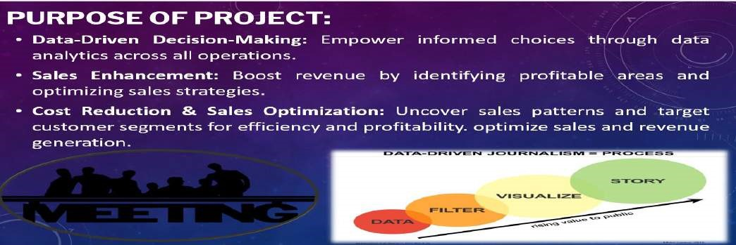

**BUSINESS REQUIREMENTS:**

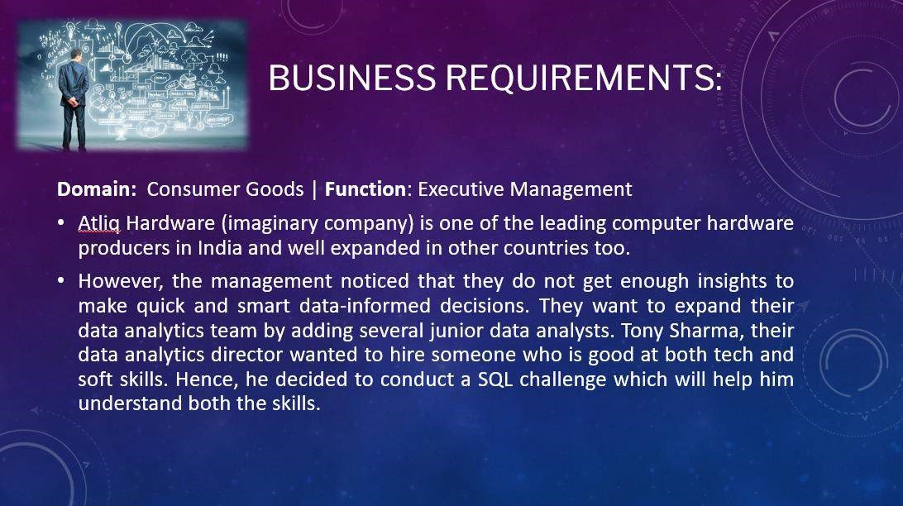

**SCOPE OF THE PROJECT:**

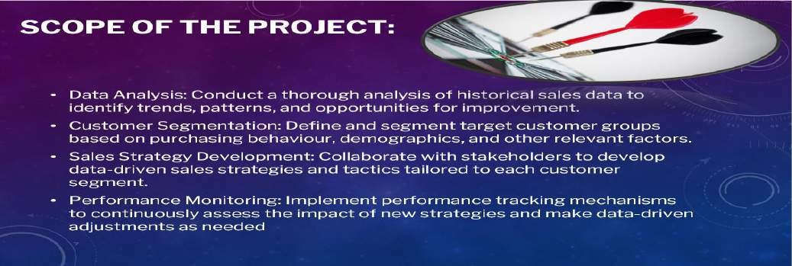

**SOFTWARE REQUIREMENT:**

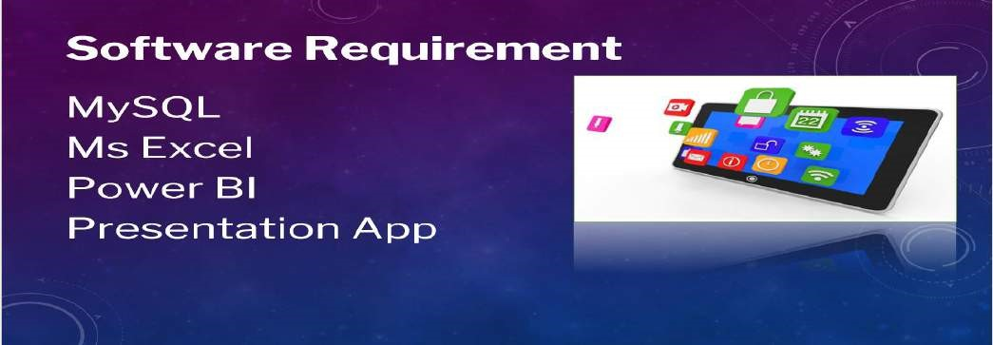

**DATA MODEL:**

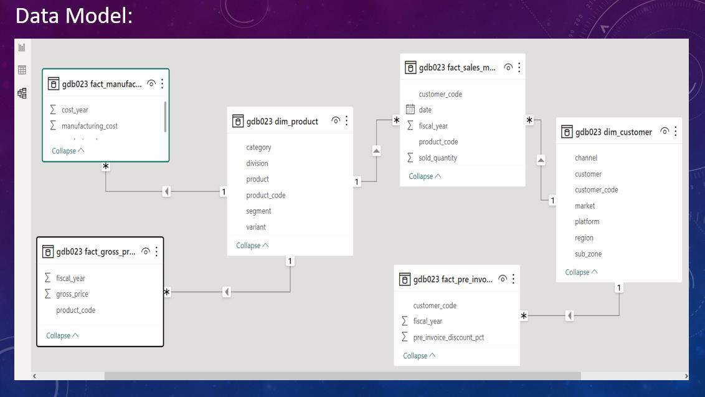

**1)CHALLENGE:**

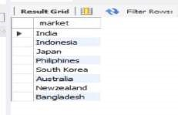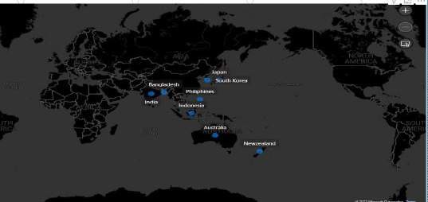

**2)CHALLENGE:**

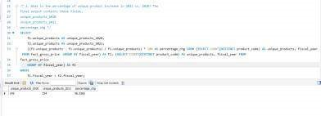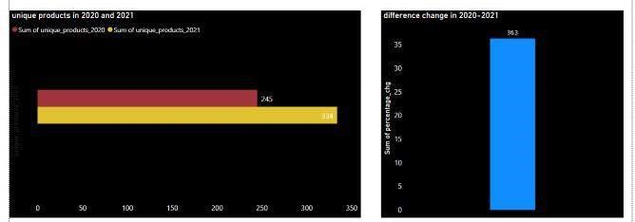

**3)CHALLENGE**

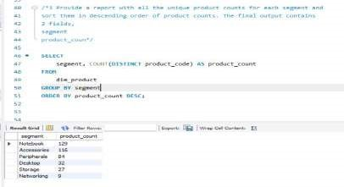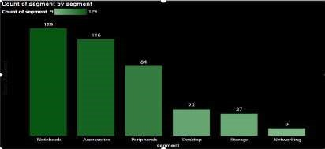

**4)CHALLENGE:**

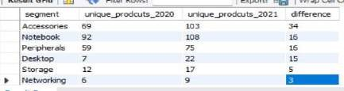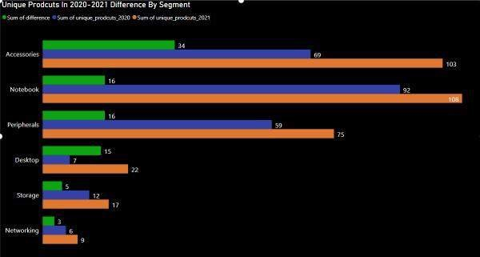

In

t e cce or e c te or e t red re ter

n er o n e rod ct co red to

In contr t

t ere were ewer n e networ n

rod ct n

co red to

**5)CHALLENGE:**

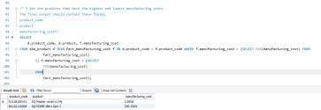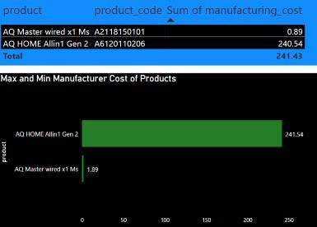

n

Prod ct

AQ n

en

Prod ct

AQ ter w red

**6)CHALLENGE:**

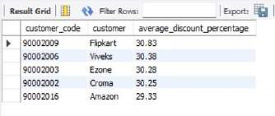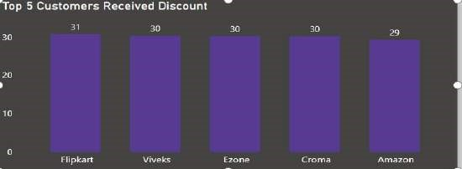

**7)CHALLENGE:**

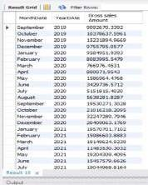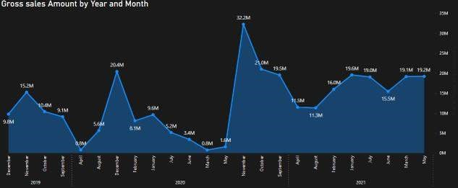

**8)CHALLENGE:**

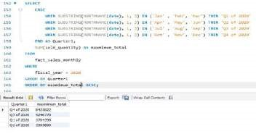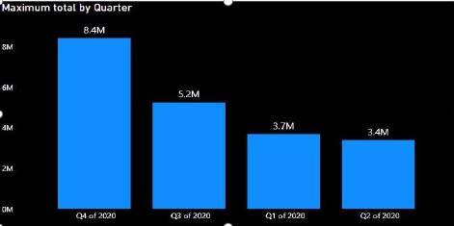

**9)CHALLENGE:**

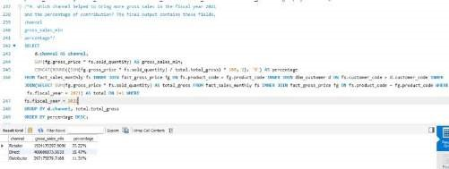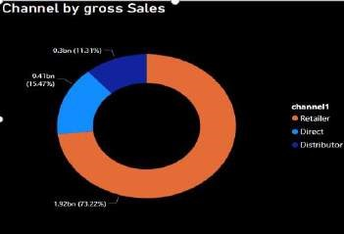

**10)CHALLENGE:**

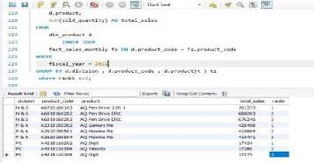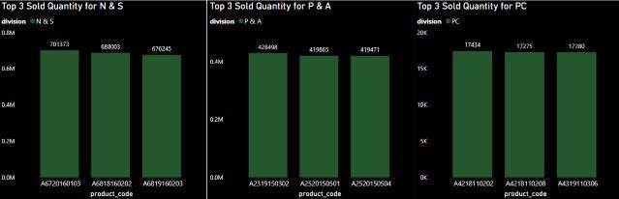

**OVERVIEW1:**

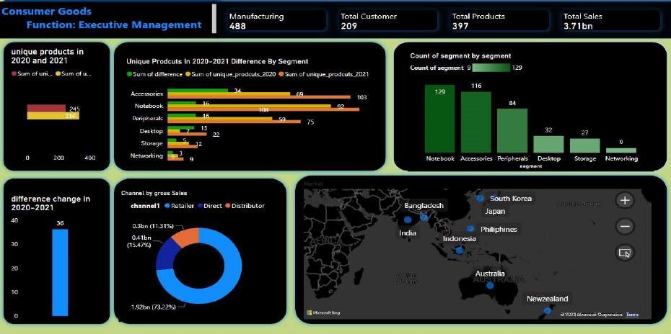

**OVERVIEW2:**

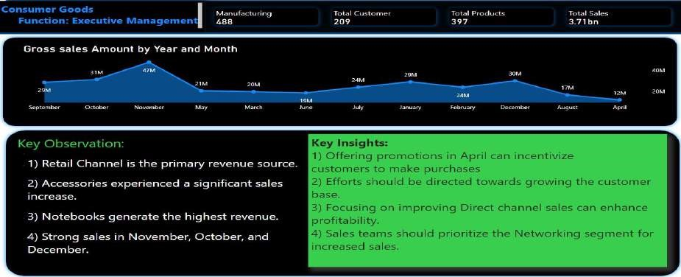

**THANK YOU:**



BASA A A I AL

