**Project 1**

Title

<Fighter Fighter>

Class:

CIS-5

Due Date:

May 4, 2016

By:

Bassam Elsaleh

Table of contents

Summary………………………………………………………………………………….Pg.3

Pseudo Code…………………..………………………………………………………….Pg.4

Flow Chart…….………………………………………………………………………….Pg.6

C++ Coding……………………………………………………………………………….Pg.8

Summary

Fighting games are always fun to play from the more famouse mortalcombat to the lesser known like skull girls. These games deal with a lot of skill and timing, but there were and still exsistgames that are not as complex and chalinging. This game requiers little to no skill, its a simple rock papper sicors match. Where the user can have fun with friends or play agenst the computer.

This porgram is not complex yet requiered over 900 lines because of one simple aspect of the game, special attacks, witch will be covered in this section. Each player will start in the menu and chose to either play one player, two players, look at the rules or quit. Now, as for rules, the player can use one of 4 moves, the first being a simple punch that will deal 2 damage to the opponat, now that doesn’t mean there is no way to prevent the attack, the players are allowed to block the damage by using the next ability Blocking. Blocing stops all the damage coming from the punch, now some players are strange and like to joke around by doing noting and just keep blocking so I created the specual attack. The special attack will deal damage to a caricter that isn blocking and 2 damge to a blocking charicter. Though, because the attack is so strong I had to ristrict the amount of special attacks to 4 times, this is why the code took up so manny lines, I had to re-write the code for every instance that one or both players might run out of special attacks. I then added one more move just for fun that would allow the charicter to be able to counter only the special attack, dealing all 4 damge back to the player, but wont block the puch attack.

Pseudo Code

//function for the menu

//function for the rules

//function for one player

//function for two players

//declare variables

//do while choice=4

//call menu function

//players pick

//go to the function player picked

//exit stage right

//menu function

//show menu

//rules function

//declare variables

//show the rules until player exits

//one player function

//declare variables

//computer random

//player picks move

//show health

//1 = punch

//2 = spc.

//3 = block

//4 = counter

//keep looping till one player has no health or quits

//player and computer both pick their movies as described in the rules

//describe to the player what happens and heath is removed where needed.

// show heath and specials

//same code but both players are out of specials

//same code only player one is out of specials

//same code only cpu is out of specials

//if both players die

//if player one dies

//if cpu dies

//if player one gives up

//go to file and show that player one wins.

//two player function

//declare variables

//player picks move

//player 2 picks

//show health

//1 = punch

//2 = spc.

//3 = block

//4 = counter

//keep looping till one player has no health or quits

//player and computer both pick their movies as described in the rules

//describe to the player what happens and heath is removed where needed.

// show heath and specials

//same code but both players are out of specials

//same code only player one is out of specials

//same code only cpu is out of specials

//if both players die

//if player one dies

//if player 2 dies

//if both players give up

//if player one gives up

//if player two gives up

Flow Chart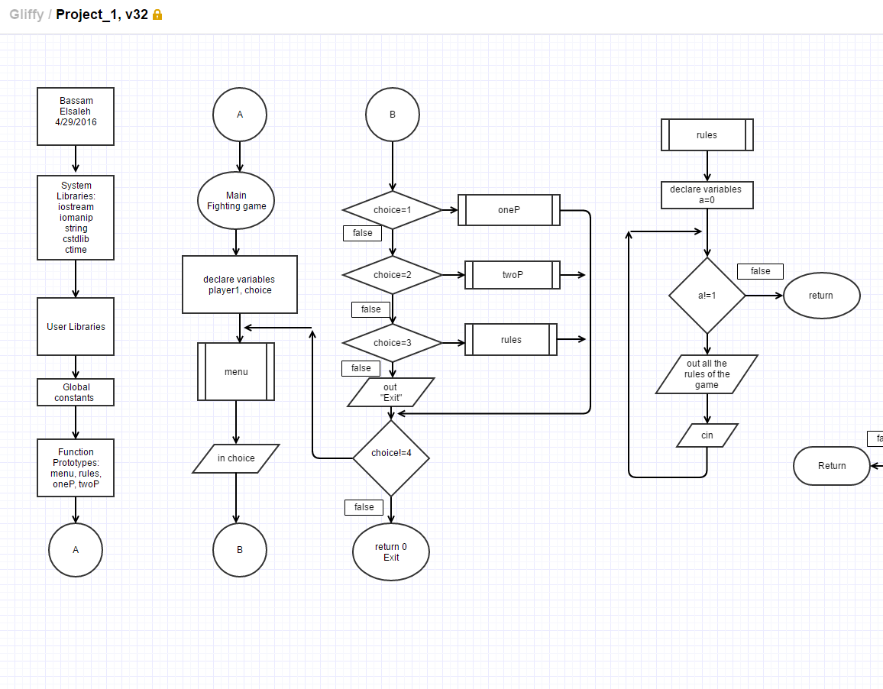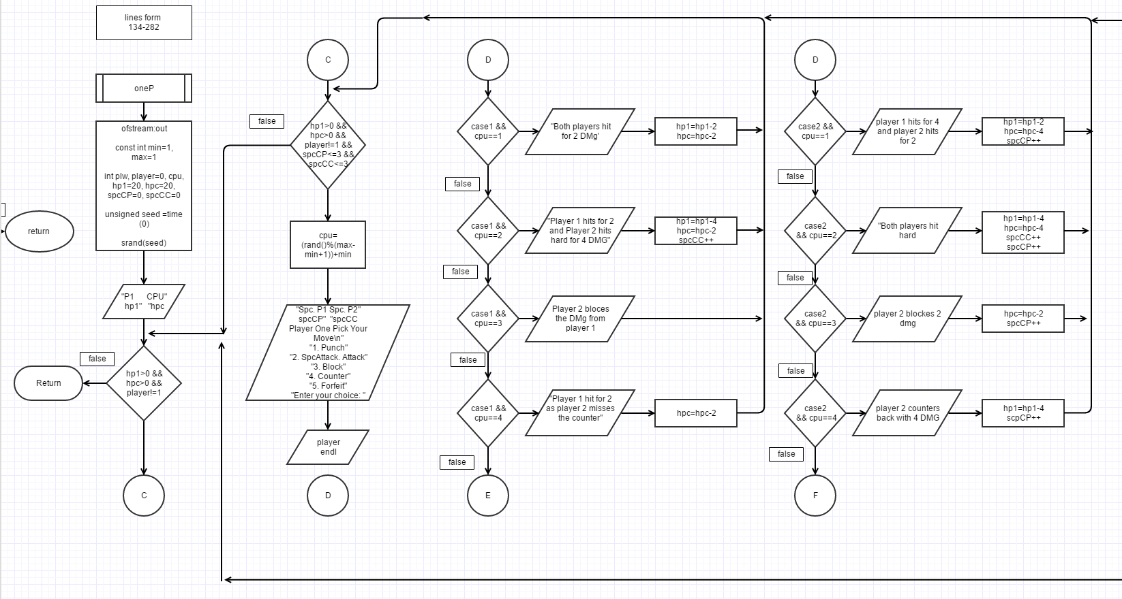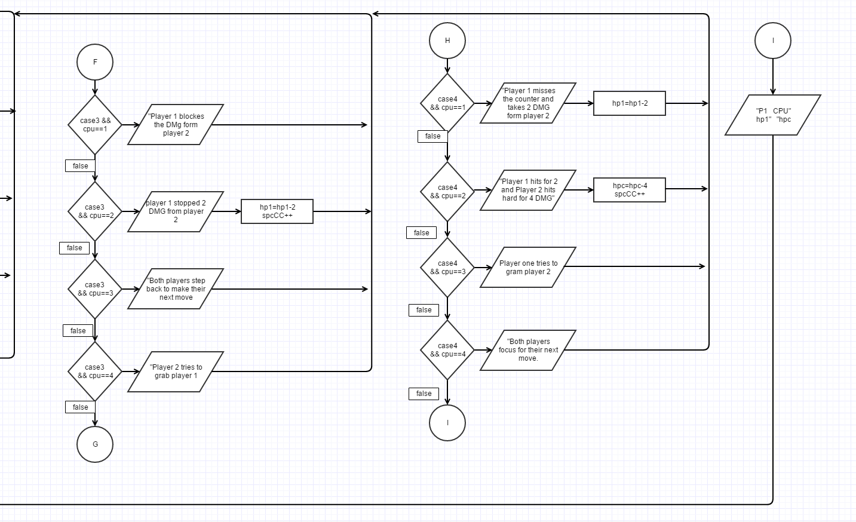

C++ Codeing

//Function Prototypes

void menu();

void rules();

void oneP();

void twoP();

//Execution Begins Here

int main(int argc, char** argv) {

int choice;//menu pick

do

{

//Display the menu

menu();

//Read the choice

cin>>choice;

//Solve a problem that has been chosen.

switch(choice){

case 1:oneP();break;

case 2:twoP();break;

case 3:rules();break;

default:{

cout<<"Exit?"<<endl;

}

};

}while (choice != 4);

return 0;

}

//****************************************************************************

//Game Menu

void menu(){

cout<<endl;

cout<<"\n\t\tFighter Fighter\n\n"

<<"1. Single Player\n"

<<"2. Two Players\n"

<<"3. rules\n"

<<"4. Quit the Program\n"

<<"Enter your choice: ";

}

//****************************************************************************

//Game Rules

void rules(){

int a;

cout<<endl;

for(a=0;a!=1;) {

cout<<"This game is a turn by turn fighting game, where each"

" player will start with 20 Health Point, or HP, once a player"<<endl<<

"hits 0 HP or if one the payers forfeits, the game ends "

"and the remaining player wins the game."<<endl<<endl<<"In order to"

" lower the opponents HP each player must inflect Damage ,"

"or DMG. Each play will do so by picking"<<endl<<"a move each turn "

"and see the result of their moves, be sure to keep track "

"of your own health to see when to"<<endl<<"Defend, or DEFF, yourself"

" or if its safe to hit the opponent to be the best fighter around."

<<endl<<endl<<endl;

cout<<" There are 2 types of attacks: "<<endl<<endl;

cout<<" Punch - a punch is a standard attack that "

"will inflict 2 DMG to your opponent."<<endl<<endl;

cout<<" Spc. Attack - a Special Attack will inflect 4 DMG to your"

"opponent, but keep in mind that you can only use"<<endl<<" this"

"ability 3 time per match."<<endl<<endl<<endl;

cout<<" There are 2 way to DEFF yourself form these attacks:"<<endl<<endl;

cout<<" Block - a block will stop 2 DAM that would "

"naturally hit you from both types of Attacks,"

" but no damage will be dealt to the other player."<<endl<<endl;

cout<<" Counter - will only affect Spc. Attacks, but unlike"

"Spc. Attacks you may activate it whenever you like"<<endl<<

" but if be aware of what your opponent might do,"

"because punches will not be countered and will just do DMG"

<<endl<<endl;

cout<<" Forfeit - You realized you made a mistake fighting "

"this individual"<<endl<<" so you surrender a win"

" to your opponent and the game will end."<<endl<<endl;

cout<<" Each game will end by announcing the winner and take you "

"back to the main menu."<<endl<<" when you are ready press"

" 1 and ENTER."<<endl<<endl;

cin>>a;

}

}