**Project 2**

Title

<Fighter Fighter>

Class:

CIS-5

Due Date:

May 4, 2016

By:

Bassam Elsaleh

Table of contents

Summary………………………………………………………………………………….Pg.3

Pseudo Code…………………..………………………………………………………….Pg.5

Flow Chart…….………………………………………………………………………….Pg.

Constructs Used.………………………………………………………………………….Pg.

Sources……………………………………………………………………………………Pg.

Summary

Fighting games are always fun to play both alone and with friends, from the more famouse ones like mortalcombat to the lesser known games like skull girls. These games deal with a lot of skill and timing, but there were and still exsistgames that are not as complex and chalinging. This game requiers little to no skill, its a simple rock papper sicors match. Where the user can have fun with friends or play agenst the computer.

This porgram is not complex yet requiered over 900 lines due to the fact that I added a special attacks that has restrictions, witch will be covered in this section. Players will start in the menu and chose to either play one player, two players, look at the rules or quit whitch will end the game.

Now, as for rules, the player can use one of 4 moves, the first being a simple punch that will deal 2 damage to the opponat, now that doesn’t mean there is no way to prevent the attack, the players are allowed to block the damage by using the next ability Blocking. Blocing stops all the damage coming from the punch, now some players are strange and like to joke around by doing noting and just keep blocking so I created the specual attack. The special attack will deal damage to a caricter that isn blocking and 2 damge to a blocking charicter. Though, because this attack is so strong I had to ristrict the special attack so that it could only be used 4 times, by doing so I had to re-write the code (copy and paste) for every instance that one or both players might run out of special attacks. I then added one more move just for fun that would allow the charicter to be able to counter only the special attack, dealing all 4 damge back to the player who is using the special attack, again this will only block the special attack not the standard punch.

This code took me about a 2 day to write up both the single player and multiplayer, but it wasn’t perfected with all the damg and outputs that were needed. Within a week I had the single player up and running and it was a simple copy and paste with a few modifications to make it multiplayer. The hardest part of the code was that because of the intensity of the code and gaing over 900 lines of code it made it dificult to relocate spicific areas, if I were to re-write it, I might add in more voids that would exicute when the players us up their specual moves. Doing this might add more lines, but it will also make it cleaner and easier to find spicific areas of the code.

Also if I wanted to shorten the code it might be better to lose one of the moves, because as of right now there are 4 moves a player can pick and the second player will then pick theirs. For each move the single player picks there are 4 options that need to be forseen that makes 16 possible outcomes not including weather or not the player is out of special attacks.

Version number 2

When wriginh the second version of the progject, I decided to take a part of the code that simulated the figing and inputted it into a new programing file. I did this in order to play around with the code so that I was able to implament the new concepts and not mess with the old code.

I realized before I did anythuing that to use the new concept of arrays i was going to have to make a new game play, thus I created the “Challenge Mode”. In essence, Challenge Mode alows the player to pick any number up to 10 games and pick 15 moves for the possible figts. This was perfict for me because I was able to demonstrate my ability to use not only arrays but dubble arrays.

The next concept I added was the search. What I besicaly did was after the player finishes game #x, the program should search to see if they won that game. If so a message should be reveaild that they won and saved.

A problem I noticed with changing the program to only having 15 moves was that, one player might still be alive after the 15th turn, so I had to add extra lines of code that would still represent a win or loss based on the who had the most helth, and I decided on my own to remove the surrender button just incase someone were to press it by accedent and the fact that they picked the number of games whitch run really fast, so there is no need to surrender.

Pseudo Code

//function for the menu

//function for the rules

//function for one player

//function for two players

//declare variables

//do while choice=4

//call menu function

//players pick

//go to the function player picked

//exit stage right

//menu function

//show menu

//rules function

//declare variables

//show the rules until player exits

//one player function

//declare variables

//computer random

//player picks move

//show health

//1 = punch

//2 = spc.

//3 = block

//4 = counter

//keep looping till one player has no health or quits

//player and computer both pick their movies as described in the rules

//describe to the player what happens and heath is removed where needed.

// show heath and specials

//same fighting code but both players are out of specials

//same fighting code only player one is out of specials

//same fighting code only cpu is out of specials

//if both players die

//if player one dies

//if cpu dies

//if player one gives up

//go to file and show that player one wins.

//two player function

//declare variables

//player picks move

//player 2 picks

//show health

//1 = punch

//2 = spc.

//3 = block

//4 = counter

//keep looping till one player has no health or quits

//player and computer both pick their movies as described in the rules

//describe to the player what happens and heath is removed where needed.

// show heath and specials

//same fighting code but both players are out of specials

//same fighting code only player one is out of specials

//same fighting code only cpu is out of specials

//if both players die

//if player one dies

//if player 2 dies

//if both players give up

//if player one gives up

//if player two gives up

//Version number 2

//Challenge mode function

//declare variables

//player picks move

//player 2 picks

//show health

//1 = punch

//2 = spc.

//3 = block

//4 = counter

//keep looping till one player has no health or quits

//player and computer both pick their movies as described in the rules

//describe to the player what happens and heath is removed where needed.

// show heath and specials

//same fighting code but both players are out of specials

//same fighting code only player one is out of specials

//same fighting code only cpu is out of specials

//if both players die

//if player one dies

//if player 2 dies

//if both players give up

//if player one gives up

//if player two gives up

//if player one has more health

//if player two has more health

Flow Chart #1

First set of flow charts to Project 1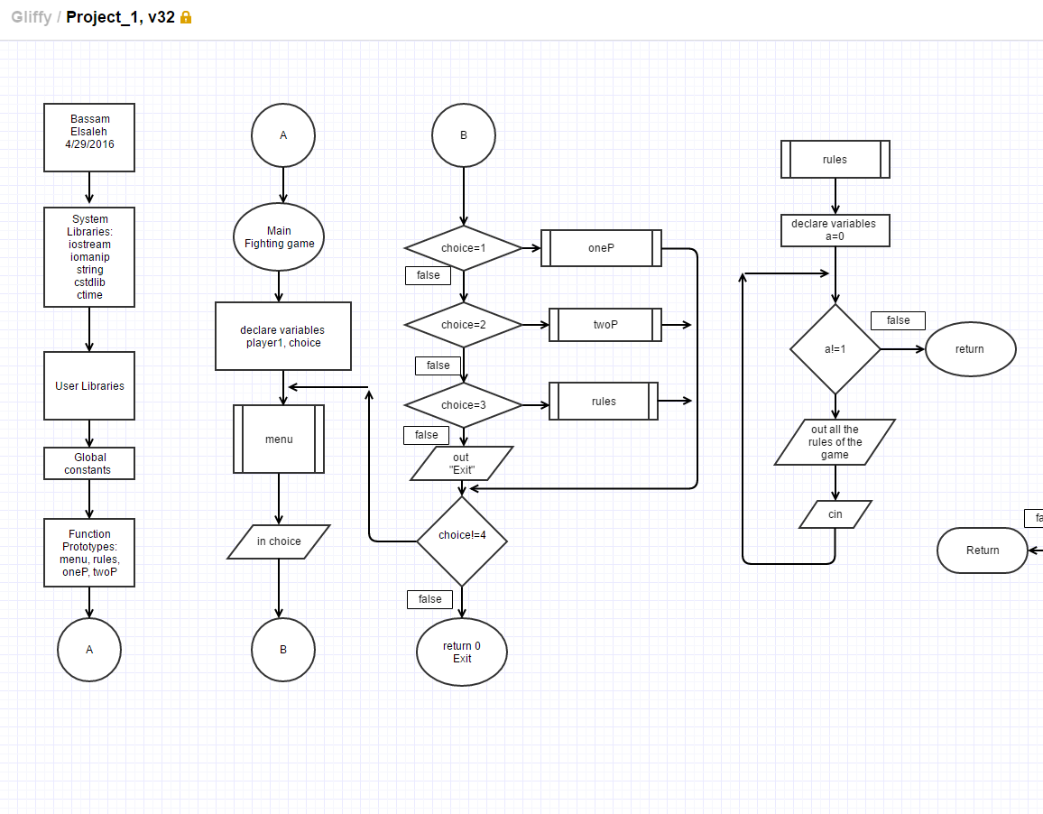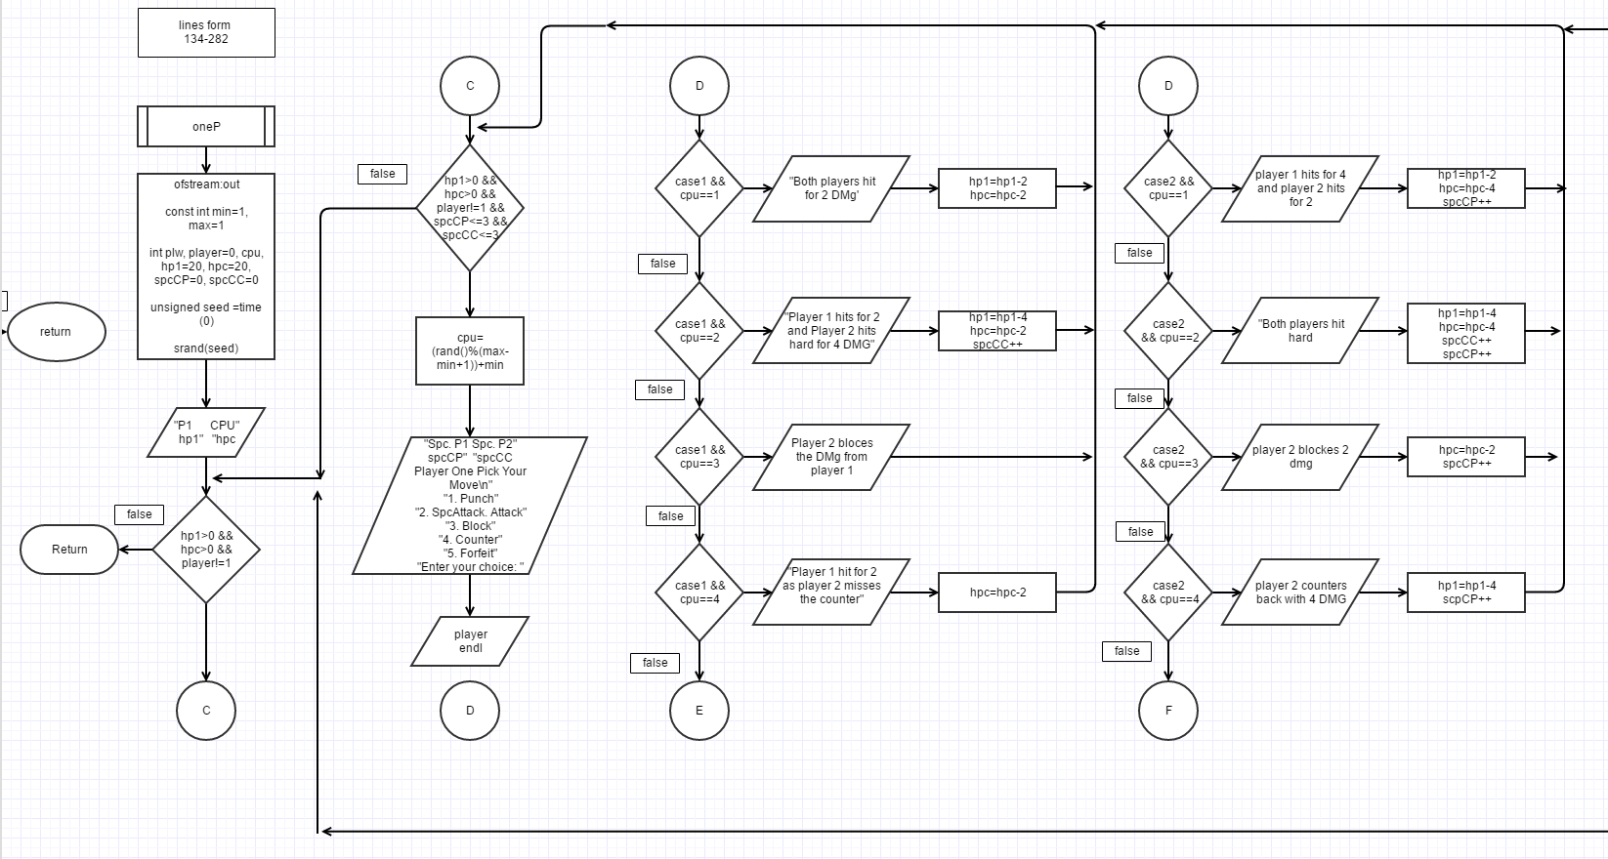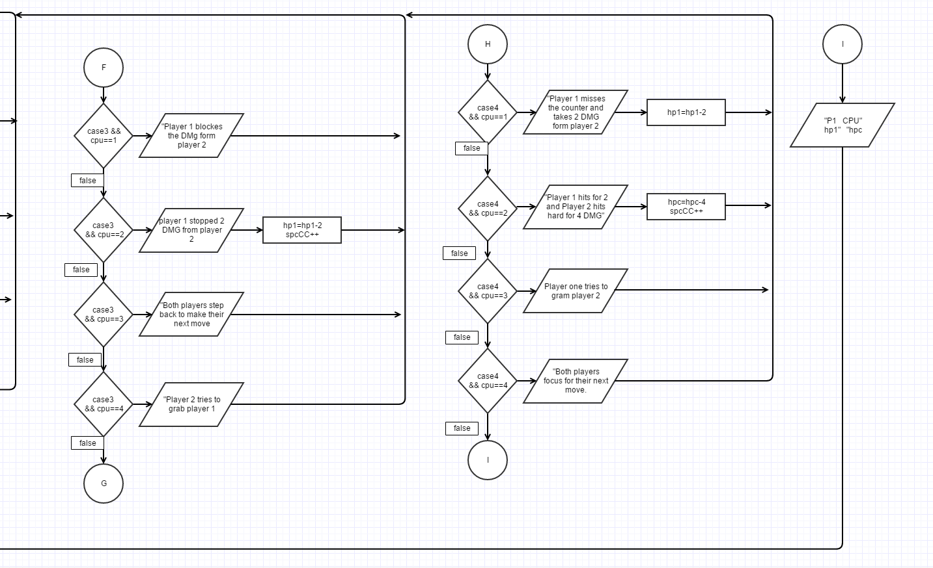

Flow Chart #2

Second set of flow charts for Progect 2

Constructs used

Do loops: I mainly used the do loop in the menu so that it runes right into the menu and alowing the player to pick their game mode.

For loops: I ued this in the rules section when I didn’t need to incrament but I set a veriable for what the user will input to exit the statement when they press 1

Switch statements: I belive that using the switch statement was the best way to code with the lest amount of lines, rather than using an outstanding amount of if and if else statements I decided to run a switch stament that only runs through the second players options that exsistes inside player ones switch statement.

If, else if and else statements: my code was riddled with this type of code to decide the outcome of the players hp and win lose.

Rand: This was only used in single player where the computer would need to pick its on moves. So I had to brin in cstdlip file and ctime to make sure the reandom generater wasn’t reporting the same random numbers.

Funcitons: I decided to use funciton in my project because doing one player allows for a whole set of rules and outcomes that I found were better to keep all on its on so that the in 2 palyer mode there wouldn’t be any misscomunication in the code.

fstream: I decided to send an out file that will occer if you win the computer in single player.

Data Types: I used primerly int’s in my codding no floats were needed because I didn’t have any decimals, i used ofstream to read out to a file, and had set the const in for a max and an min for the random generator. Along with the random generator I needed and unsigned seed and srand to make the random work.

Sources

Gaddis, T. (2012). Starting out with C. Boston: Pearson Addison-Wesley.

Rcc Class. Dr. Lehr.