**Debuggers**

There are several debugs available.

* IDA (Win, Linux, MacOS).
* DGB (Unix, Win).
* X64DGB (Win).
* EDB (Linux).
* WinDGB (Windows).
* OllyDGB (Windows).
* Hopper (MacOD, Linux).
* Immunity Debugger.

**Immunity Debuggers**

Immunity debugger GUI examine:

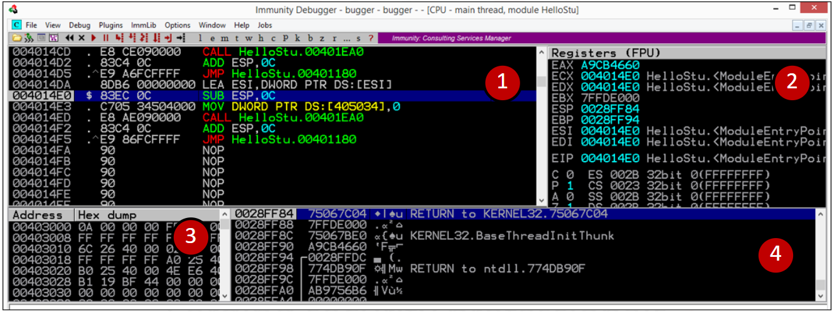

PANEL 1:

* First column: is the address location.
* Second column: is the machine language.
* Third column: is the assembly language.
* Fourth column: is a debugger comment.

PANEL 2:

* First column: name of registers.
* Second column: content of registers.
* Third column: if a register pointer to an ASCII string, the value of the string.

PANEL 3:

The memory dump panel shows the memory locations and relative contents in multiple formats (i.e., hex, UNICODE, etc.).

PANEL 4:

* First column: is the addresses.
* Second column: is the value on the stack at that address.
* Third column: is an explanation of the content.
* Fourth column: is the debugger comments.

**Immunity scripts**

**Mona script:**

Installation steps:

1. Download mona script: [link](https://github.com/corelan/mona)
2. Move mona.py to PyCommand directory at immunity debugger.

Mona commands:

* mona help command:
  + !mona [Enter].
* pattern create by mona.
  + !mona pc <pattern_length> [Enter].
    - <pattern_length>: length in bytes
* Get pattern offset by mona.
  + !mona po <hex_value> [Enter].
    - <hex_value>: refer to EIP value.
* Search on jmp esp or call esp by mona.
  + !mona jmp -r esp -m * [Enter].
    - Search on jmp esp in all modules.