**ICT SEMESTER PROJECT (PHASE:02)**

***Group Members***

* **Bassam Abrar Raja ; Roll no : 232529**
* **Mubashir Ahmed Mumtaz ; Roll No : 232412**
* **Class :- BSCS-ev-C**

***General introduction to the website***

Welcome to Lisbon Chair Shop, this is the website for hand-crafted sofas in the northern Ireland and this shop sells sofa sets and arm chairs. By considering the need for furniture in that area we are constructing this website and we are hopeful it will be beneficial for the users

***Task#03 : Project Requirements***

* **Installment Programs**: Display different types of furniture funding programs
* **Furniture Physical Visibility:** Provide videos or images showing different sofas.
* **Bill Estimator**: Allows users to estimate their order price including all expenses
* **User Accounts**: Allow users to create accounts, customize profiles, and save their wishlists
* **Search and Filter Options**: Enable users to search and filter out the products they want
* **24/7 Support**: Allow users to be in contact with a support person.
* **Responsive Design**: Ensure the website looks good and functions well across various devices (desktops, tablets, mobile phones).
* **Clean and Intuitive Interface**: Design a user-friendly interface with easy navigation and clear calls-to-action.

***Task#04 : Front-End display of our website and how a user operates it:***

Our front end looks like this

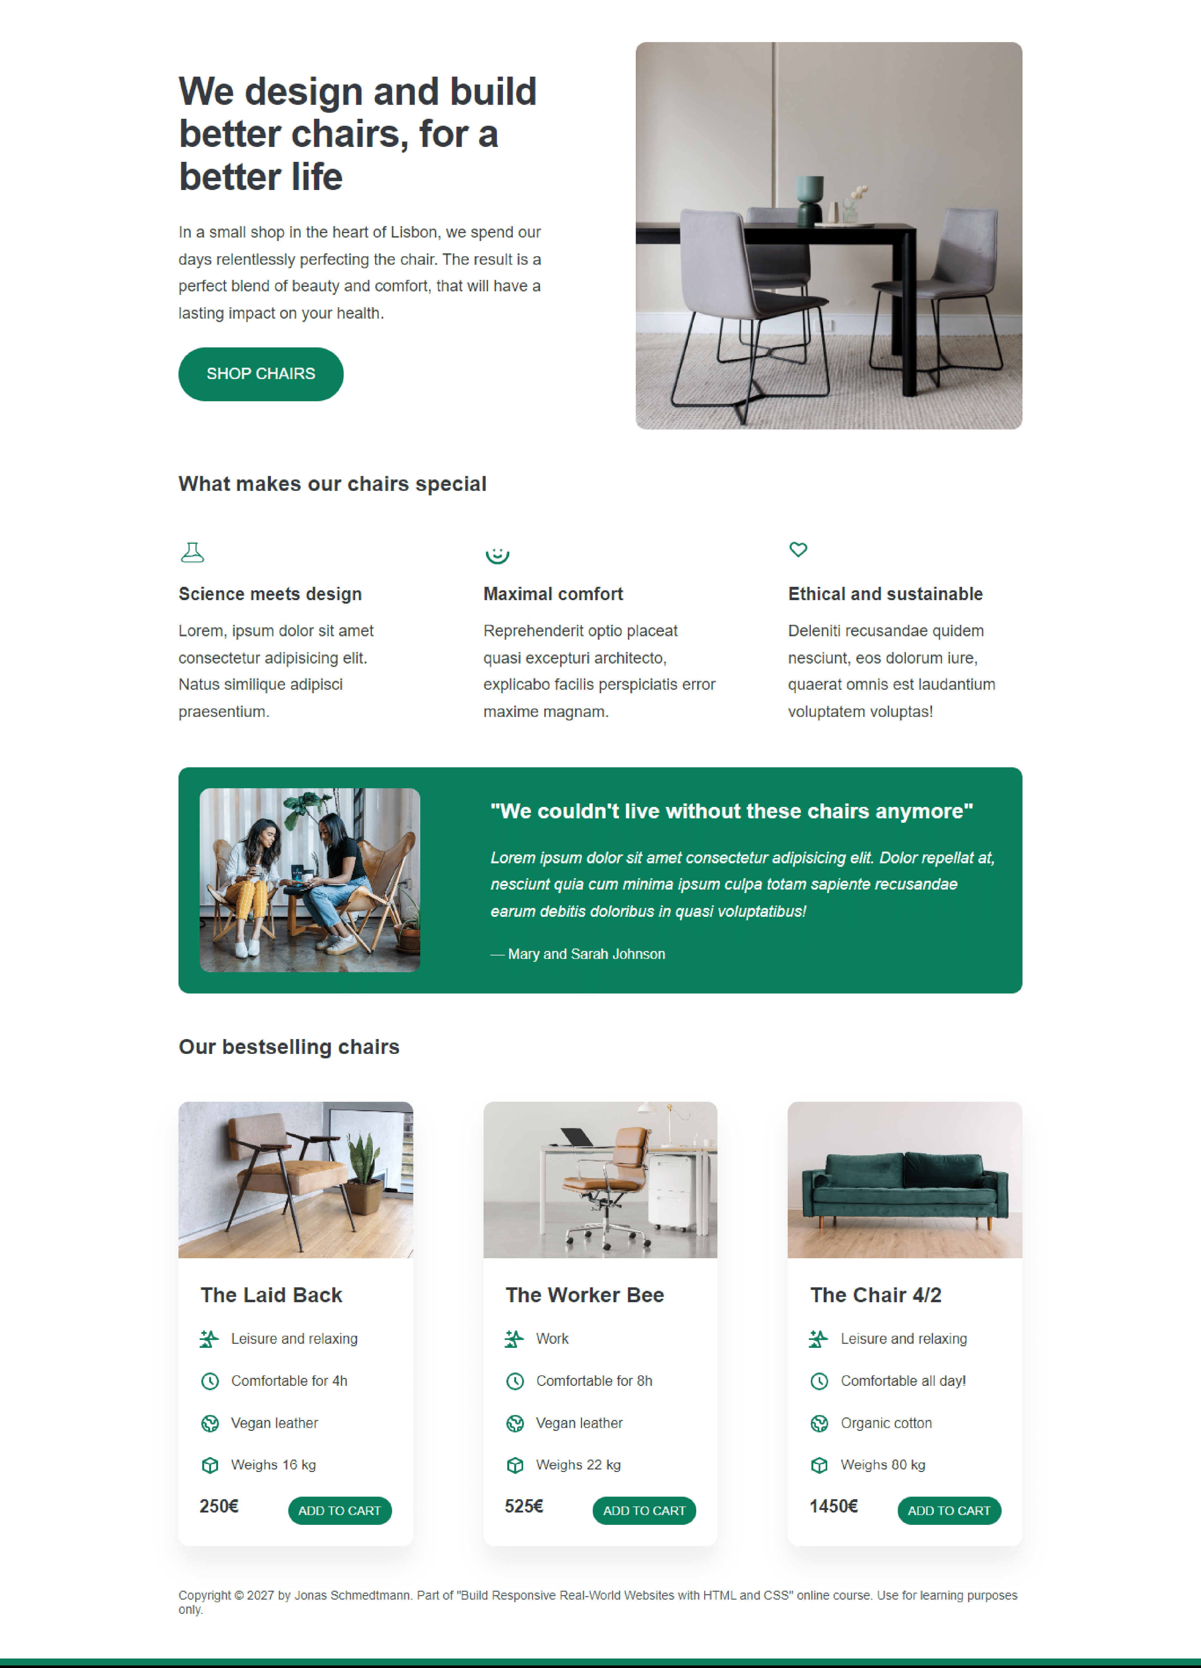

* I, as a user, actively navigate to the website of the furniture shop through either a search engine or direct link. Upon landing, a visually appealing homepage greets me with its display of featured products or promotions. Easily, I identify the main navigation menu; this allows me to explore a variety of furniture categories. A well-organized menu presents categories: living room, bedroom, dining office--and more. I swiftly find the type of furniture that interests me, thanks to the intuitive navigation.
* Thumbnails of the Product: Clear and high-quality thumbnails of furniture products adorn each category page. For swift assessment, thumbnails provide the name, price, and a concise description.
* Functionality of Search: I possess the ability to access a prominent search bar, where I can enter specific product names or keywords. As I type, the system offers relevant search results and provides proactive suggestions.
* Filtering and Sorting: The option I possess involves filtering and sorting the products according to diverse criteria: price range, color, material - even popularity. I find filters to be user-friendly tools that enhance my efficiency in narrowing down choices.
* Pages of the product: A click on a product thumbnail directs me to an exclusive product page: this dedicated space provides comprehensive and detailed information. Multiple images, a detailed description, dimensions and customer reviews populate the product page. You may choose to utilize the Virtual Room Preview. Select products offer an option: one can visualize the appearance of furniture in a virtual room setting. By offering a perception of scale and style, this feature elevates the online shopping experience. With a single click from the product page, I can effortlessly add a product to my shopping cart. The shopping cart icon's dynamic update and visual confirmation it has been added, instills in me a reassurance.
* The shopping cart: When I click on the shopping cart icon, a summary page opens. This page displays: the items in my cart, their respective prices and quantities. Easily, I have the ability to modify quantities; eliminate items - or-- proceed directly towards checkout.
* Process for Checking Out: Clear instructions and visual indicators of each step make the checkout process straightforward. Entering necessary information such as the shipping address, payment details, and any discount codes prompts me. The department is responsible for confirmation and tracking: it ensures that all relevant information--such as receipts, invoices, and shipping details--is accurately recorded; furthermore, it monitors these records to guarantee compliance with established policies. Upon my completion of the purchase, a confirmation message--enriched with order details and an estimated delivery date--is promptly sent to me. I possess the choice to track my order; moreover, I can receive updates regarding its status.
* Design that is responsive: Ensuring a seamless experience across various devices--desktops, tablets, and smartphones: that is the website's responsive design.
* The department of Customer Support: Should I have any questions or encounter issues during the browsing or purchasing process, I can easily access customer support contact information. You may elect to create an account. The option lies in my hands to create a user account; this choice promises a more personalized experience - one that encompasses order history, saved items and exclusive offers.