Features:

List of books.

Search.

Login

Add book

reserve book

Return book

List of borrowed books

Three pages

<https://phpforever.com/vuejs/login-example-in-vuejs-and-php/>

to convert array to json:

array need to be key and value pairs : ex: [“1”:[…], “2”:[..], ..] --json--> {“1”:{}, “2”:{}, ..}

bootsrap 3

DB ERD:

Tables:

Book -> id, title, author, description, img_url.

User ->id, name, mail, pwd.

CREATE TABLE users (

id int NOT NULL PRIMARY KEY AUTO_INCREMENT,

name varchar(255),

mail varchar(255),

pwd varchar(255),

type int

);

INSERT INTO users (name, mail, pwd, type)

VALUES ('bassant', 'b@gmail.com', '123456', 0);

INSERT INTO users (name, mail, pwd, type)

VALUES ('b', 'bass@gmail.com', '123456',1);

CREATE TABLE Book (

id int NOT NULL PRIMARY KEY AUTO_INCREMENT,

title varchar(255),

author varchar(255),

description varchar(800),

img_url varchar(800),

added_by int,

FOREIGN KEY (added_by ) REFERENCES users(id)

);

INSERT INTO Book (title, author, description, added_by)

VALUES ("Sherlok Holmes 1", "Arthur Conan Doyle", "Watson describes Sherlock Holmes as being more than six feet tall, very lean, with piercing eyes and a thin hawk-like nose. Holmes's voice was high and occasionally strident. We learn later that his eyes were gray and he had a narrow face and black hair. ", 1);

CREATE TABLE Borrow (

user_id int,

book_id int,

FOREIGN KEY (user_id) REFERENCES users(id),

FOREIGN KEY (book_id) REFERENCES Book(id)

);

ALTER TABLE Borrow  
ADD CONSTRAINT PK_Borrow PRIMARY KEY (user_id, book_id);

Connect to MariaDB:

1. Open wamp

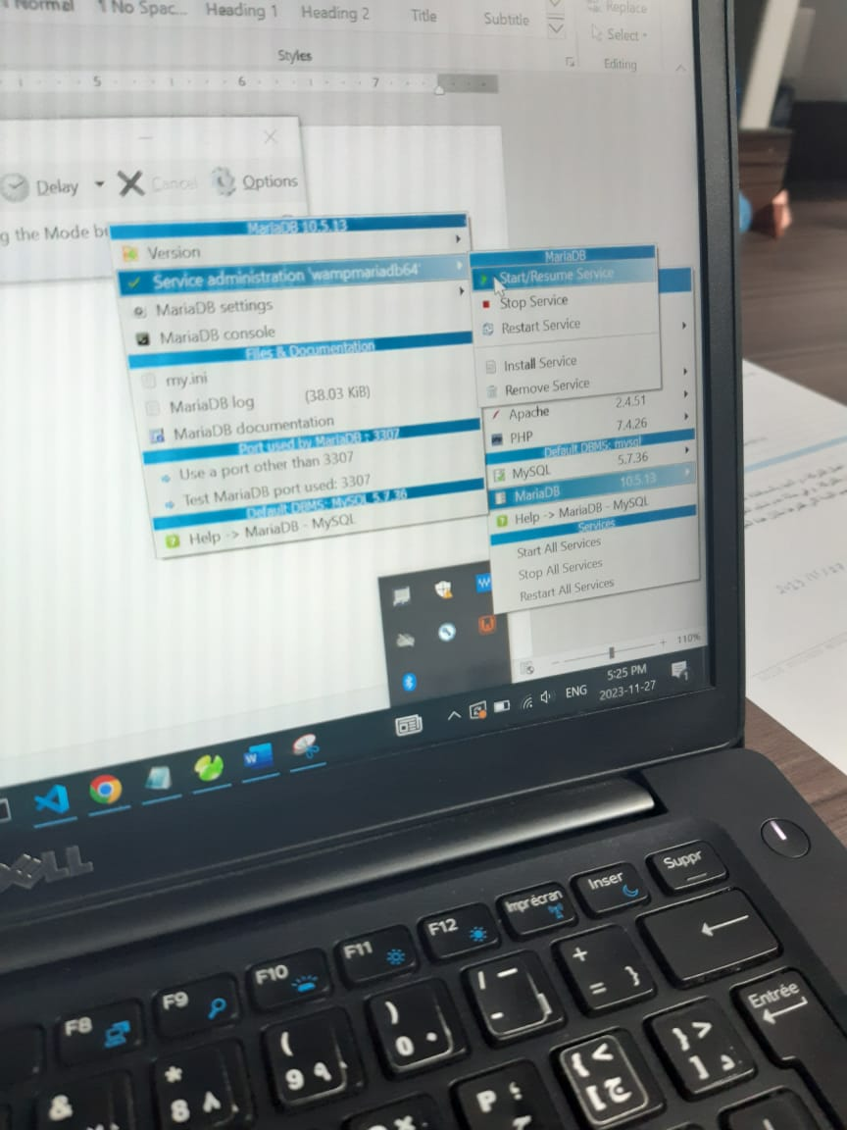

Same to start any service such as php.

1. Open navicat

4-

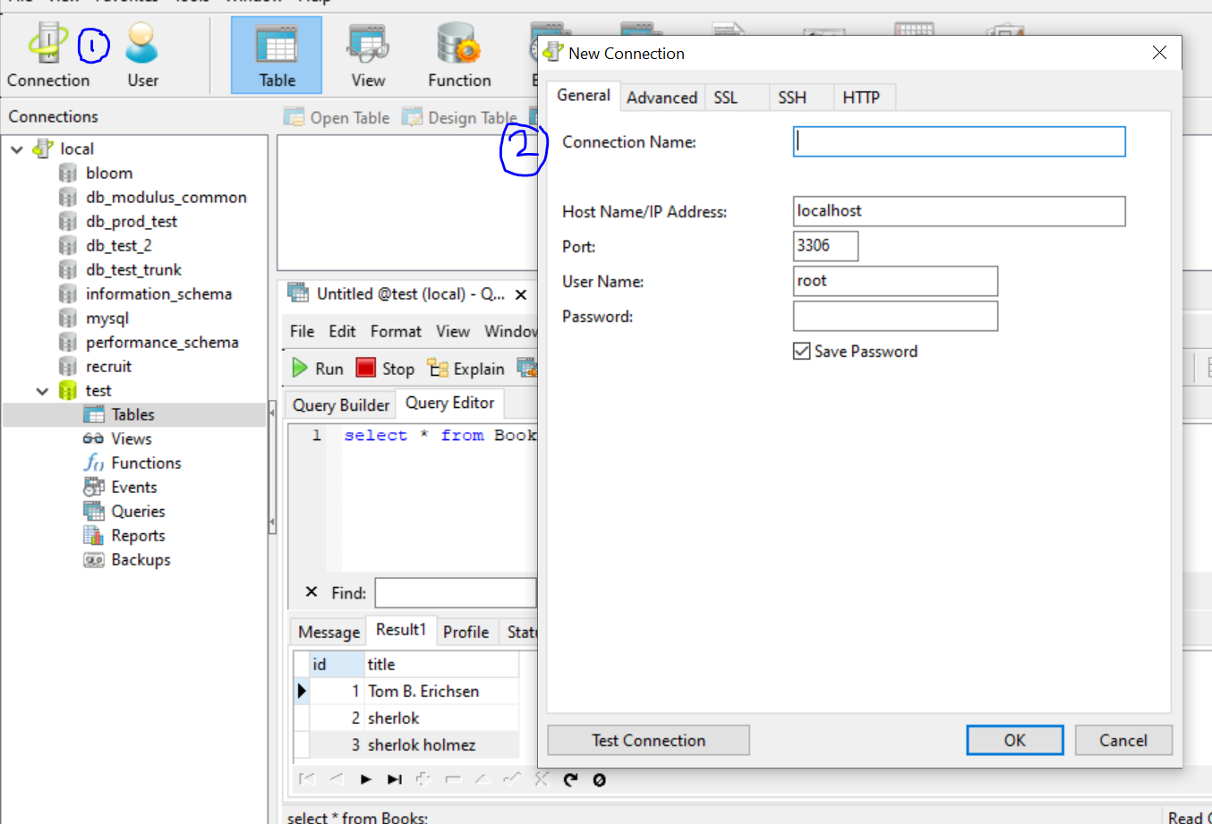

Pick the connection name, username, password.

And port from wamp:\ 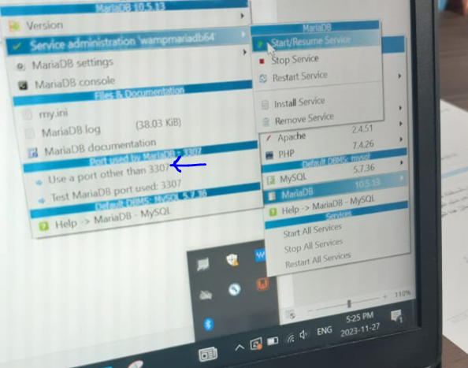

So port is 3307.

5- then work wit navicat by create DB, then tables,..etc same as phpMyAdmin.

6- you can connect to db in php:

Ex:

<!DOCTYPE html>

<html lang="en">

<head>

    <meta charset="UTF-8">

    <meta name="viewport" content="width=device-width, initial-scale=1.0">

    <title>Document</title>

</head>

<body>

    <?php

    $servername = "localhost:3307";

    $username = "root";

    $password = "";

    $dbname = "test";

    // Create connection

    $conn = new mysqli($servername, $username, $password, $dbname);

    // Check connection

    if ($conn->connect_error) {

      die("Connection failed: " . $conn->connect_error);

    }

    echo "Connected successfully";

    $sql = "INSERT INTO Books (id, title)

VALUES (3, 'sherlok holmez')";

    if ($conn->query($sql) === TRUE) {

      echo "New record created successfully";

    } else {

      echo "Error: " . $sql . "<br>" . $conn->error;

    }

    $conn->close();

    ?>

</body>

</html>