

Data Warehouse Project 2026
Eng : Norhan Ihab
S3,4

Student’s information

ID | Name
20231037 | Bassant Tarek
20231089 | Doha Yaser
20230117 | Habiba Hosam

In this project we user “NYC Taxi Trip Duration” data set which you can check from the next link , Visit
------------------------------------------------------------------------------------------
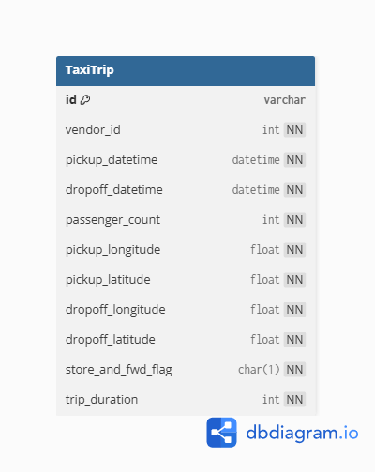
Physical model of the source system :
Dimensional model:
- business processes:
Recording and tracking individual taxi trip
transactions in NYC Monitoring and
comparing vendor (taxi provider) daily
performance Analyzing hourly trip demand
patterns across the city

- grain of each fact table:
Fact_Trip: one completed taxi trip
Fact_VendorPerformance: one vendor's aggregated activity for one calendar day
Fact_HourlyDemand: total trip activity within one specific hour of one day

- type of each fact table:
Fact Table | Type
Fact_Trip | Transactional
Fact_VendorPerformance | Periodic Snapshot
Fact_HourlyDemand | Periodic Snapshot

- the dimensions and the type of each one:
Dimension | SCD Type | Reason
Dim_Date | Type 1 | Dates never change
Dim_Time | Type 1 | Time slots never change
Dim_Vendor | Type 1 | Only 2 vendors, static data
Dim_Location | Type 1 | Coordinates are fixed
Dim_Passenger | Type 1 | Small static lookup table
Dim_TripType | Type 1 | Only 2 values, never changes

- measures that will appear in the fact tables and their types :

Measure | Fact Table | Type | Why
trip_duration_sec | Fact_Trip | Additive | Can sum across all dimensions
passenger_count | Fact_Trip | Additive | Can sum across all dimensions
trip_distance_km | Fact_Trip | Additive | Can sum across all dimensions
total_trips | Fact_VendorPerformance | Additive | Can sum across time and vendor
avg_trip_duration_sec | Fact_VendorPerformance | Non-Additive | Cannot sum averages meaningfully
avg_passenger_count | Fact_VendorPerformance | Non-Additive | Cannot sum averages meaningfully
trip_count | Fact_HourlyDemand | Additive | Can sum across hours and days
avg_duration_sec | Fact_HourlyDemand | Non-Additive | Cannot sum averages meaningfully
total_passengers | Fact_HourlyDemand | Additive | Can sum across hours and days

- Physical model
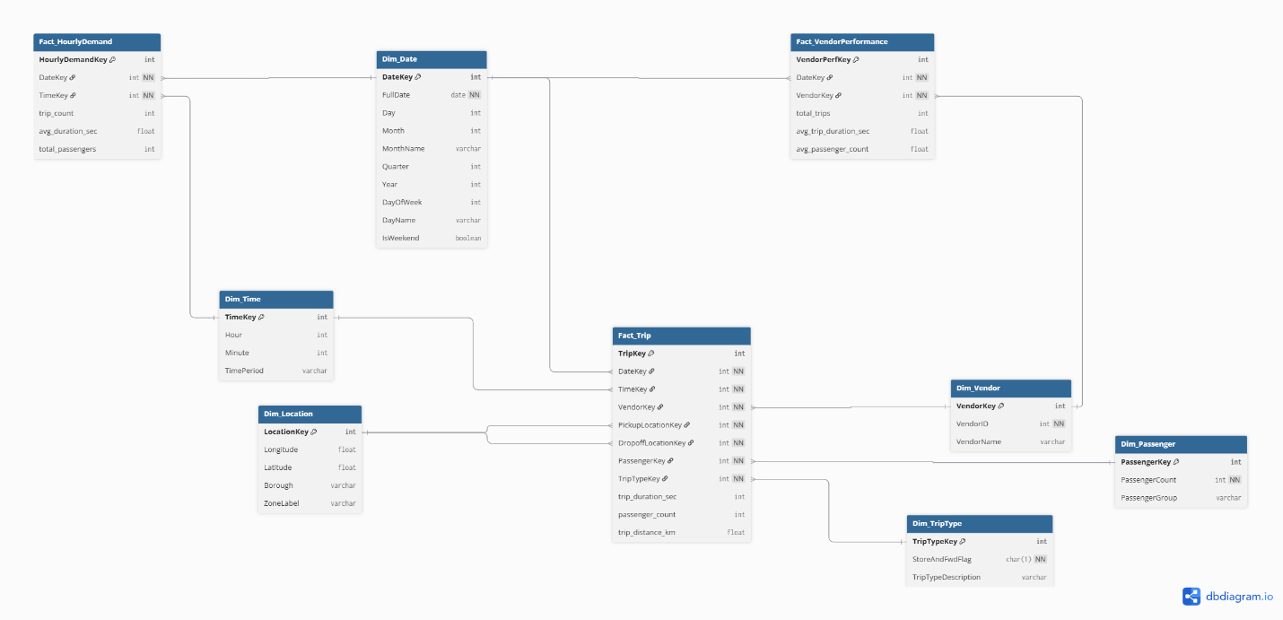

------------------------------------------------------------------------------------------
Screenshots:
- LoadCSV package :
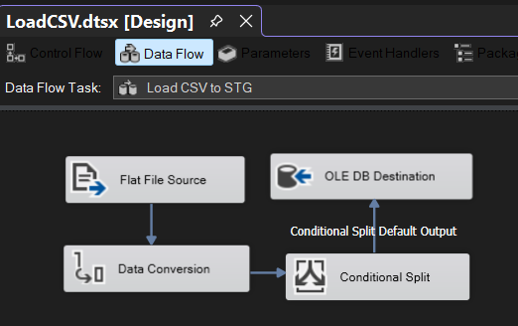
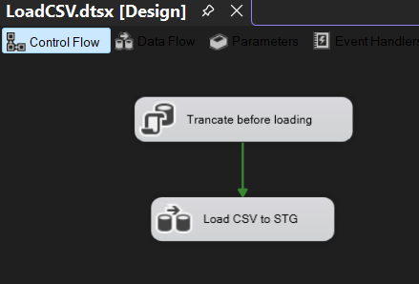
This package is made to load data from our chosen data set as the source to the database destination after filtering it

- LoadDimentions package :
This package is made to load data from the created database (created in the step before) in the needed dimensions as destinations after adding any needed data clearing and conversions

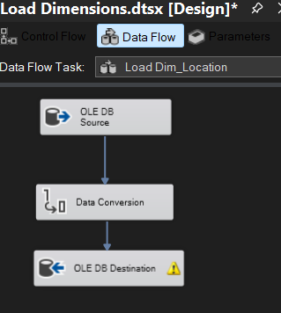
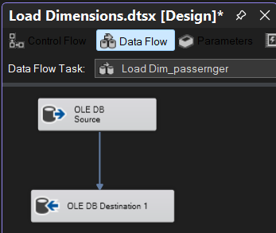
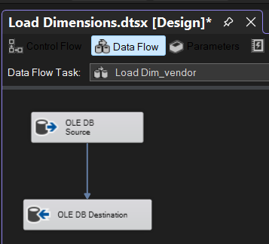

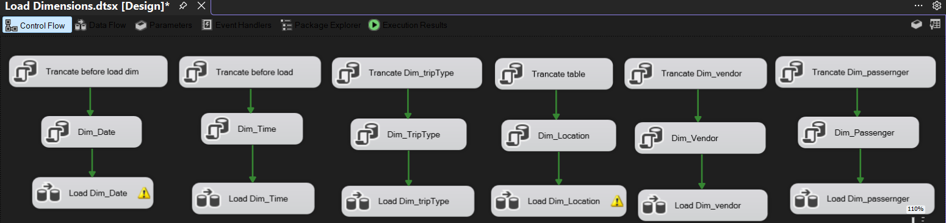
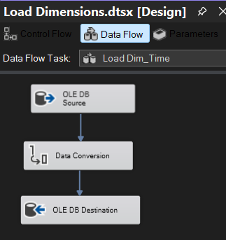
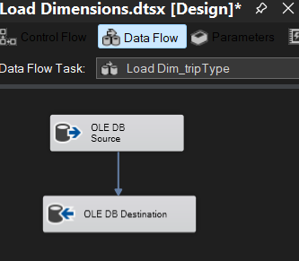
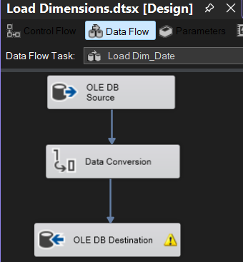

c.TripFactTable Package :
this package it made to create a the transactional fact table (Fact_Trip) that linke the 6 dimentions and ansewer amy question related to the “Trip”
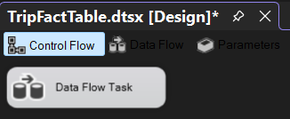
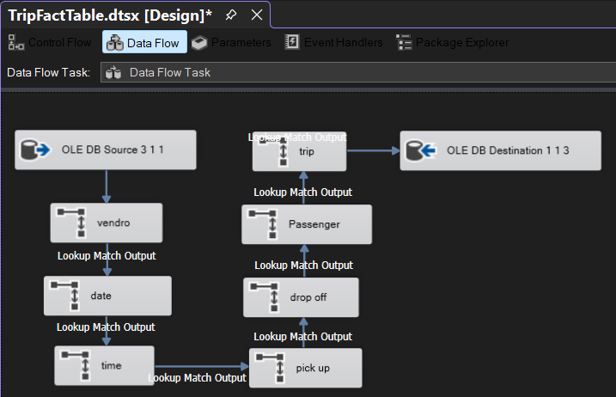

This fact table cat anwer the following queries or any others like them:

1. Average Trip Duration Per Vendor
SELECT vendor_key,
AVG(trip_duration) AS avg_duration
FROM Fact_Trip
GROUP BY vendor_key;

2. Vendor With Most Trips
SELECT TOP 1 vendor_key,
COUNT(*) AS total_trips
FROM Fact_Trip
GROUP BY vendor_key
ORDER BY total_trips DESC;

3. Most Common Pickup Location
SELECT TOP 1 pickup_location_key,
COUNT(*) AS total_pickups
FROM Fact_Trip
GROUP BY pickup_location_key
ORDER BY total_pickups DESC;

4. Trips Between Specific Locations
SELECT pickup_location_key,
dropoff_location_key,
COUNT(*) AS total_trips
FROM Fact_Trip
GROUP BY pickup_location_key, dropoff_location_key;

5. Most Popular Route
SELECT TOP 1
pickup_location_key,
dropoff_location_key,
COUNT(*) AS total_trips
FROM Fact_Trip
GROUP BY pickup_location_key, dropoff_location_key
ORDER BY total_trips DESC;

6. Trips With More Than 4 Passengers
SELECT *
FROM Fact_Trip
WHERE passenger_count > 4;

7. Top 5 Dropoff Locations
SELECT TOP 5
dropoff_location_key,
COUNT(*) AS total_trips
FROM Fact_Trip
GROUP BY dropoff_location_key
ORDER BY total_trips DESC;

8. Trips By Passenger Type
SELECT passenger_key,
COUNT(*) AS total_trips
FROM Fact_Trip
GROUP BY passenger_key;

9. Total Trips By Location and Hour
SELECT pickup_location_key,
time_key,
COUNT(*) AS total_trips
FROM Fact_Trip
GROUP BY pickup_location_key, time_key;

10. Most Active Vendor During Peak Hours
SELECT TOP 1
vendor_key,
COUNT(*) AS total_trips
FROM Fact_Trip f
JOIN Dim_Time t
ON f.time_key = t.TimeKey
WHERE t.hour BETWEEN 17 AND 20
GROUP BY vendor_key
ORDER BY total_trips DESC;
------------------------------------------------------------------------------------------
d. Fact table 2 :
e. Fact table 3 :
------------------------------------------------------------------------------------------
f. Deployment
------------------------------------------------------------------------------------------
g. Bouns

