- Physical model:
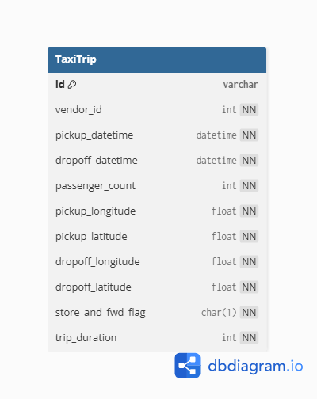
- Dimensional model:
- business processes:
Recording and tracking individual taxi trip transactions in NYC
Monitoring and comparing vendor (taxi provider) daily performance
Analyzing hourly trip demand patterns across the city
- grain of each fact table:
Fact_Trip: one completed taxi trip
Fact_VendorPerformance: one vendor's aggregated activity for one calendar day
Fact_HourlyDemand: total trip activity within one specific hour of one day
- type of each fact table:
Fact Table | Type
Fact_Trip | Transactional
Fact_VendorPerformance | Periodic Snapshot
Fact_HourlyDemand | Periodic Snapshot

- the dimensions and the type of each one:
Dimension | SCD Type | Reason
Dim_Date | Type 1 | Dates never change
Dim_Time | Type 1 | Time slots never change
Dim_Vendor | Type 1 | Only 2 vendors, static data
Dim_Location | Type 1 | Coordinates are fixed
Dim_Passenger | Type 1 | Small static lookup table
Dim_TripType | Type 1 | Only 2 values, never changes

- measures that will appear in the fact tables and the type of each one:
Measure | Fact Table | Type | Why
trip_duration_sec | Fact_Trip | Additive | Can sum across all dimensions
passenger_count | Fact_Trip | Additive | Can sum across all dimensions
trip_distance_km | Fact_Trip | Additive | Can sum across all dimensions
total_trips | Fact_VendorPerformance | Additive | Can sum across time and vendor
avg_trip_duration_sec | Fact_VendorPerformance | Non-Additive | Cannot sum averages meaningfully
avg_passenger_count | Fact_VendorPerformance | Non-Additive | Cannot sum averages meaningfully
trip_count | Fact_HourlyDemand | Additive | Can sum across hours and days
avg_duration_sec | Fact_HourlyDemand | Non-Additive | Cannot sum averages meaningfully
total_passengers | Fact_HourlyDemand | Additive | Can sum across hours and days

- Physical model:
