Software Requirements Specification
for
Panapol.com
Version 1.0 approved
Prepared by Rishabh Chakrabarti, Sarang Kurani, Saurabh Jha, Vineet Patawari
NIIT University
14/10/15
Table of Contents
Table of Contents ii
Revision History ii
1. Introduction 1
1.1 Purpose 1
1.2 Document Conventions 1
1.3 Intended Audience and Reading Suggestions 1
1.4 Product Scope 1
1.5 References 1
2. Overall Description 2
2.1 Product Perspective 2
2.2 Product Functions 2
2.3 User Classes and Characteristics 2
2.4 Operating Environment 2
2.5 Design and Implementation Constraints 2
2.6 User Documentation 2
2.7 Assumptions and Dependencies 3
3. External Interface Requirements 3
3.1 User Interfaces 3
3.2 Hardware Interfaces 3
3.3 Software Interfaces 3
3.4 Communications Interfaces 3
4. System Features 4
4.1 System Feature 1 4
4.2 System Feature 2 (and so on) 4
5. Other Nonfunctional Requirements 4
5.1 Performance Requirements 4
5.2 Safety Requirements 5
5.3 Security Requirements 5
5.4 Software Quality Attributes 5
5.5 Business Rules 5
6. Other Requirements 5
Appendix A: Glossary 5
Appendix B: Analysis Models 5
Appendix C: To Be Determined List 6

Revision History (Will be edited later)
Name | Date | Reason For Changes | Version

Introduction

Purpose
The purpose of this document is to present a detailed description of the Web Photograph Publishing/Competition Platform. It will explain the purpose and features of the system, the interfaces of the system, what the system will do, the constraints under which it must operate and how the system will react to external stimuli. This document is intended for both the stakeholders and the developers of the system and will be proposed to the client for approval.
We at Panapoll.com will provide users with the ability to hold competitions, compete, and vote on pictures uploaded by them in an easy, convenient, and secure manner.

Document Conventions
We have differentiated the users of the system into 3 different categories:

1. Users – Can participate in the contests by posting and upvoting the photos
2. Hosts – Can host, judge and review the photos
3. Admins – Can moderate and manage the system.

Every requirement statement has to have it's own priority. No priority weights have been assigned as such.

The main focus in these systems comes through the appearance/UI requirement because it's visual creativity that attracts clients to the main system.

Intended Audience and Reading Suggestions
The intended audience / target user group for our product is anyone who would wish to painlessly hold photography competitions, browse taken photographs, and for photography enthusiasts in general. The website will also help advertisers reach their target audiences as well as be noticed by other big brands and sponsors.

The site will also act as a platfrom for photographers to showcase their portfolios. It will also have side competitions like captioning, meming, editing etc. The secondary aim is to develop a mentor-mentee relationship and information(wiki) site for newbies.

Thus, this system targets anyone who is a photography enthusiast.

Target readers:

The document is intended for stakeholders and ordinary non-technical people for the main purpose of explaining the system in the most lucid and clear fashion.

Further down:

The next chapter, the Overall Description section, of this document gives an overview of the functionality of the product. It describes the informal requirements and is used to establish a context for the technical requirements specification in the next chapter.
The third chapter, Requirements Specification section, of this document is written primarily for the developers and describes in technical terms the details of the functionality of the product.
Both sections of the document describe the same software product in its entirety, but are intended for different audiences and thus use different language.

Product Scope
Panapol.com will allow certain (paid) users to host photography contests and other users to vote on them in a fair, secure, and convenient way. Users will also be able to browse different photography contests according to their interests, and sort them in various ways. If you are an advertiser, you will also be able to post ads to reach your target audience.

Vision of the Project:

This software system will be a Web Photography Platform intended for photography enthusiasts and all related personnel as well as professionals to showcase and compete with other photographers globally.
Possible Scenarios keeping futuristic scope:
1. Since we are college students, we were amazed at the talent displayed by our peers and juniors with regard to Photography and we believe that the
2. Companies in need of the best photograph for various media.
3. Photographs can be judged and budding photographers can be given a chance to display their talent. One can receive tips on photography, photo-editing and other nitty-gritties regarding photography. The Newbies can develop a mentor-mentee relationship with other expert photographers.
4. Captioning can be rewarded.

References

Overall Description

Product Perspective
Panapol.com is a new product ready to meet the ever growing need for an easy and systematic system to hold contests. No other product at this time allows photographers to get the sort of exposure from a wide audience as well as industry professionals, and also offers the possibility of winning a reward from sponsors, and paid users who host the competitions. Sponsors as well as third parties will also be able to post ads on this website.

Product Functions
The user will be able to
- Host photography competitions.
- Be a participant in competitions.
  - Maintain a profile with a link to their other work.
  - Be eligible to win contests hosted by sponsors/paid members.
- Vote on photographs uploaded by participants.
- Find contests according to their interests.
- Buy spots for, and post banner ads.

User Classes and Characteristics
Users may be of many kinds:
- Users may be voters, who may just vote on photographs.
- Users may be participants, who may upload photographs and participate in contests.
- Users may be advertisers, who may post ads on the website.
- Users may be paid users, who might want to host the contests.
  - These users will not be able to vote on the contests.
  - These users may (optionally) be able to choose a winner.
  - These users will be able to delete entries from their contests.
  - These users will also be able to ban participants from posting in their contests.

Operating Environment
The website should work well on all on all operating systems with minimal hardware requirements. Needs
- IE 10.0 or above. OR
- Mozilla Firefox 21 and above. OR
- Chrome 35 or above. OR
- Safari 5 or above.
- Mobile Browsers will work too.

Design and Implementation Constraints

User Documentation
An online manual as well as a special FAQ page will be provided online at Panapoll.com

Assumptions and Dependencies
- Hardware is assumed to be capable enough.
- Django will be used, so the server should be able to run it.

System Requiremeents

Functional Requirements

Functional Requirements
Requirement ID | Description | Remark
REQ1 | The system should allow the user,hosts and administrator to have a unique username (identity) to login for accessing their respective interfaces | A basic database is required to validate the login. Also, other verification steps should be applied.
REQ2 | The system should allow the administrators and users to modify the user list | Basic moderation
REQ3 | The system should allow the hosts to hold and moderate multiple contests at any given time
REQ4 | The system should allow the host to set the participation details, voting deadlines, judging criteria, theme setup, etc. But this can only be done before the contest is hosted. Any change later would not be entertained.
REQ5 | The system should allow the users to see the results of the contest as soon as it is declared.
REQ6 | The system should allow the users to see the result as soon as it is declared.
REQ7 | The system should allow the users to view the information of any contestant
REQ8 | The system should allow the host to select the winner based on votes or the judge's selection.
REQ9 | The system should allow the host to set any kind of award for the contest
REQ10 | The system should allow the user to modify his details.
REQ11 | The system should allow the user to participate in any contest if he/she satisfies the eligibility criteria.

Non-Functonal Requirements

Non-functional requirements
Requirement ID | Description | Remark
REQ12 | The host should be able to review any of his/her previous contests
REQ13 | The software should support multiple users at a time. | The software is a web-based system, hence there are no constraints on the system requirements
REQ14 | The database may crash at any point hence, timely backups are needed | A web based reliability issue
REQ15 | The user has to validate his/her vote using a captcha system to avoid clickbots | Security Requirement
REQ16 | The user has to validate his/her submission in a contest | Security Requirement
REQ17 | The user has to accept terms/conditions about the authenticity of the photo before participating in a contest | Security Requirement
REQ18 | If the software is being used in places where thereis no internet connectivity, the photos can be accessed with offline storage facility available for all environments | Reliablitiy/Portability requirement

Appearance Requirements

Appearance Requirements
Requirement ID | Requirements | Remarks
REQ19 | The user should be able to vote in any contest only after logging in through a unique identity
REQ20 | The most popular contests should be sorted and listed based on the participation, popularity, number of votes, etc.
REQ21 | The user can also view the contest based on recommendation, deadline and newest first etc.
REQ22 | The host can view all the photos that have entered in the contests | This means a different view/canvas for every scenario.
REQ23 | The user can see a brief description of the contest when it is selected.
REQ24 | The user should be directed to an interactive dashboard and interface post login for accessing the system, profile, contests and portfolio.

Use-case Diagram

Use Case
Use Case Title (ID) | Description | Remarks | Special Cases
Login (UC1) | The Hosts, Admin and the User ( Participants as well as casual voters) can access the main page and login through the first page of the website.
Since there is a clear distinction between the hosts and the users, we need to define the use cases associated with both the actors separately and in a certain order. The users are divided into 2 main types (Participants i.e. the photographers and the voters or people interested in this contest.). The host can put up a contest and then decide the intricate details of the contest like awards, judging criteria and other details. Since chronologically, the first event that should occur in the system is a contest being prepared by the host. The contest will be live at once and open to participation for all photographers
Host_Contest(UC2) | Modify contest details, elaborate the theme and deliverables, the judging criteria, the reward system, adult filter system.
Post(UC3) | The User is allowed to participate, post the photos, add descriptions, captions, in any open contest. He/she would also be required to post in necessary details like theme, background, technique, device used and othe photographic details.. He/she would also have to provide an undertaking about the authenticity of the photograph.
Unpost(UC4) | The User is allowed to unpost his photos or remove the photos.
Vote(UC5) | The User can upvote any photograph from any contest.
The System contains a database link through which the Hosts, Admin and Users can register themselves, create a profile and also make changes to it. The Profile would contain details about the User/Host, i.e. photographer, art enthusiast, company representative, senior official/employee… Brief background is an optional detail. A portfolio website link for showcase can be provided.
Register(UC6) | The Hosts,User and Admin can register themselves on the system (Web-site) by filling in a form and verifying their details. This form generates a profile page for the Host/User. | extends | User_reg, Host_reg,Admin_reg
User_reg(UC7) | An extension of UC6, the user has a different registration method and links to a different profile setup.
Host_reg(UC8) | An extension of UC6, the competition host has a different registration method and links to a different profile setup.
Admin_reg(UC9) | An extension of UC6, the Administrator has a different registration method and links to a different profile setup.
View_Profile(UC10) | Any Host, User and Admin can view any profile(including their own) whenever they want using this function.
Modify_Profile(UC11) | The Hosts , Users and Admins can update, modify and input their profile details on the system database.
Delete_Profile(UC12) | The Hosts and Users are allowed to delete their profiles and remove unregister themselves from the system.
Scenarios regarding contest viewing
View_Contest(UC13) | Any Host, User, Admin can view any contest being held at that point of time. They can view it according to the following filters: Deadlines, Recommendations, Newest first. Etc.
Review_contest(UC14) | The Host can review the contest contents/entries for later reference.
Delete_Contest(UC15) | The Host or Admin is allowed to delete the contest when they feel like it. | extends | Host_delete, Admin delete
Host_delete(UC16) | An extension of UC15, the host can delete a competition after giving a prior review and reason to the Users.
Admin_delete(UC17) | An extension of UC15, the host can delete a competition without giving a prior review and reason to the Users.
Moderating Scenarios:
Remove_User(UC18) | Remove_User. This functionality can be used by the Host and the Admin to remove any user from the hosted contest. | extends | Host_remove, Admin_remove
Host_Remove(UC19) | An extension of UC18, the Host is allowed to remove a user from accessing/participating in the competition.
Admin_remove(UC20) | An extension of UC18, the Admin is allowed to remove a user from accessing/participating in any competition.
Delete_User(UC21) | The Admin is allowed to remove any user from the system.
Block_User(UC22) | The Admin is allowed to block a user from accessing the system for a certain period of time.
Version 2 use cases:
Caption_photo (UC23) | The users can also caption the images according to the theme specified
Tag_photo(UC24) | The users and hosts can tag photos based on genre/hash tags.
Meme_photo(UC25) | The user can be given an interface to edit and transform the image into a meme.
Auction_photo(UC26) | The host/user can auction the contest photos and art.

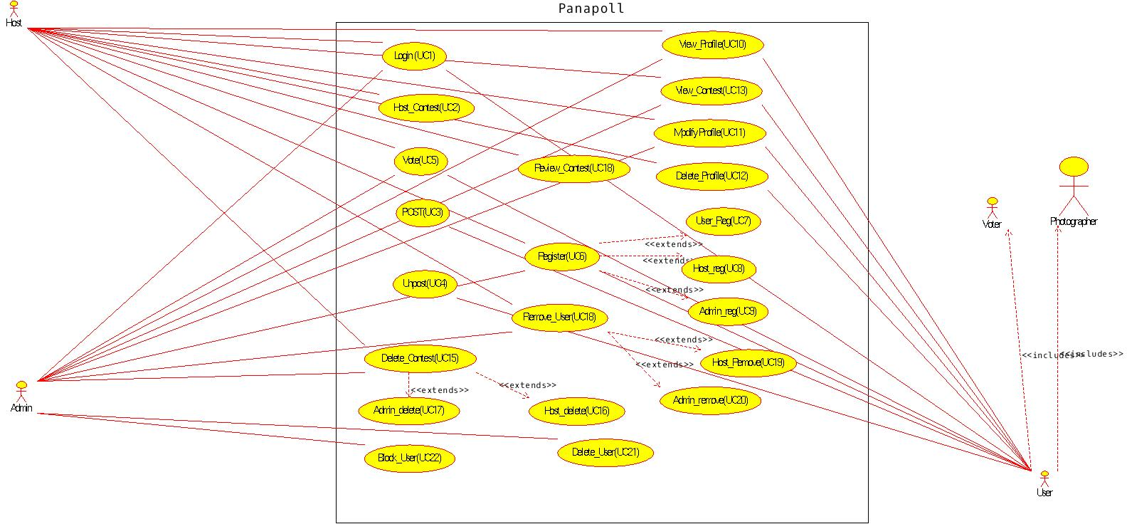

System Features

System Feature 1: Contest Hosting
4.1.1 Description and Priority
Paid users/Sponsors will be able to:
- Host contests.
- Decide judging criteria.
- Set a theme for the contest.
- Decide the number of winners.
- Deciding the number and types of prizes.
- Delete their contests.

4.1.2 Stimulus/Response Sequences
4.1.3 Functional Requirements

System Feature 2 (and so on): Contest Participation
4.2.1 Description and Priority
Registered users will be able to participate in contests and be eligible to win prizes. Users can submit one picture to each contest they wish to participate in, along with a caption to go with each photograph. Users will be able to search for contests that they may be interested in, using a number of tag words.
4.2.2
4.2.3

System Feature 3: Winner Choosing
4.3.1 Description and Priority
- Participants may win the contest in either one of two ways:
  - Winning by number of Votes awarded.
  - Getting chosen as winner by host.
- Participants will be notified if they happen to win the contest.
4.3.2
4.3.3

System Feature 4: Registering as a User
4.4.1 Description and Priority
Users must, in order to participate, vote, or host, must register their email with Panapol.com. Users may sign up for a free account, or a paid account.
- Free users may participate in contests.
- Free users may vote in contests.
- Free users may view contests.
- Paid users have the ability to host contests.
  - Paid users may offer prizes for winning these contests.
  - Paid users may choose a winner, if that is the format of the contest.
4.4.2
4.4.3

System Feature 5:

Other Nonfunctional Requirements

Performance Requirements
The system must be interactive and the delays involved must be less .So in every action-response of the system, there are no immediate delays.
In case of opening windows forms, of popping error messages and saving the settings or sessions there is delay much below 2 seconds, In case of opening databases, sorting questions and evaluation there are no delays and the operation is performed in less than 2 seconds for opening ,sorting, computing, posting > 95% of the files.
Also when connecting to the server the delay is based editing on the distance of the 2 systems and the configuration between them so there is high probability that there will be or not a successful connection in less than 20 seconds for sake of good communication.

There should be no delay in searching any detail. A graph search can be implemented in later versions.

Safety Requirements
Information transmission should be securely transmitted to server without any changes in the information. There may be copyright issues which needs to be resolved using individual judging.

As the system provide the right tools for discussion, problem solving it must be made sure that the system is reliable in its operations and for securing the sensitive details.

Security Requirements
The main security concern is for users account hence proper login mechanism should be used to avoid hacking. The tablet id registration is way to spam check for increasing the security. Hence, security is provided from unwanted use of recognition software.

Other security concerns :

1. Clickbot
2. Click-farm
3. Click-jacking
4. SQL injecctions

Software Quality Attributes
Adaptability :

Since the product is a web-based platform, it is adaptable to all systems. It can be ported as well as supported by all devices. Mobile as well as Desktop platforms are accessible by such a system. It is covered in the scope.

Availibility :

Since the site is hosted on servers and mirrors, it can be accessed as well as stay available 24x7. The only issue, being downtime which can be resolved using backup/mirror servers. It is a convenient system but database would require security as well as regular backups. Since the data generated is sort of unstructured and random, the management and maintenance of the system could be heavy and would require newer methodologies.

Correctness :

The software cannot have errors on the fundamental level. It will be tested before being hosted online.

Flexibility:

The Platform is version-controlled and managed by using Git. The methodology being usage of branches. There be stability branches and Alpha/Beta testing branches. The branch hierarchy makes it easier to incorporate changes into the system.

Maintainability:

The crux of the whole system is the usage of AGILE software methodology. In this method, we need to simply undergo iterations and design the product using a make-and-add method. The project goes through stages in each iteration. With each iteration adding and building on the main skeletal structure.
Since this is a flexible methodology and focuses on the maintainable aspect too, the platform can be easily maintained.

Portability:

As pointed out earlier, the web-based platform can be easily ported onto a mobile application as well as a normal website. The main difference being the queries sent to the database.
This is a forever debate, yet we would like to keep the system/platform available for all the Operating Environments and both as an App, as well as a website. Hence, the platform justifies portability since the best click can come up at any time and any place.

Another feature is similar to Instagram, wherein the user can post and share their photos through their smart devices any time and anywhere. Offline access is also available if there is no internet availability

Business Rules

Other Requirements
Appendix A: Glossary
Appendix B: Analysis Models
Canvas:

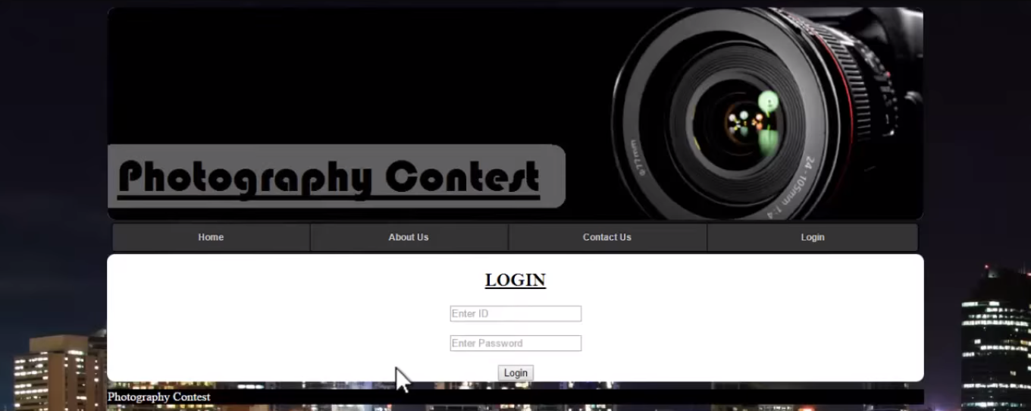
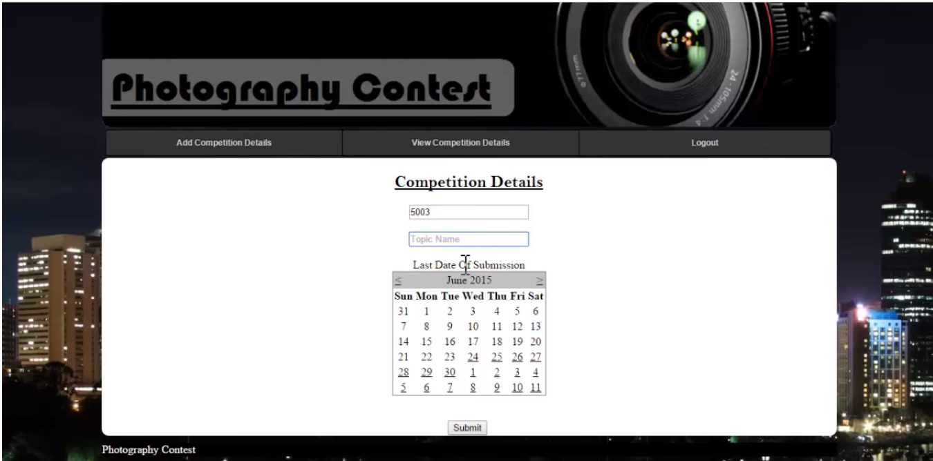
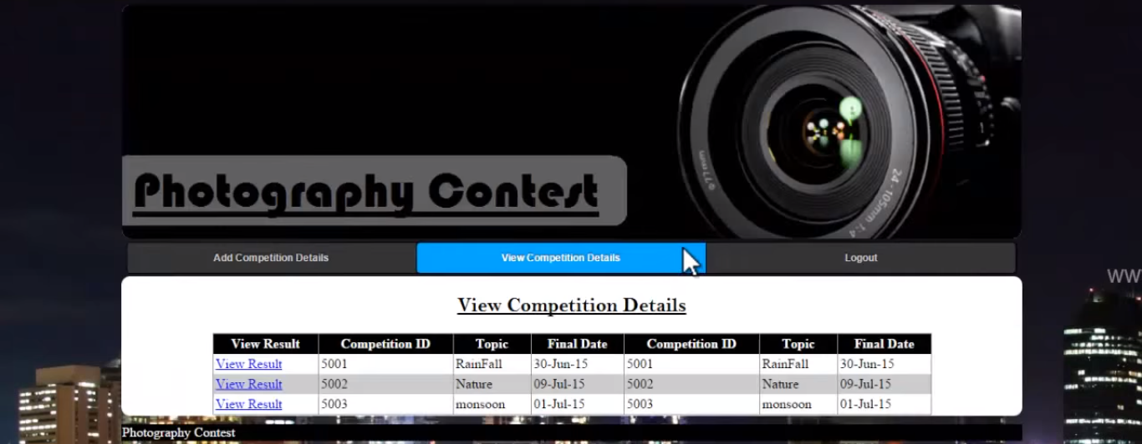
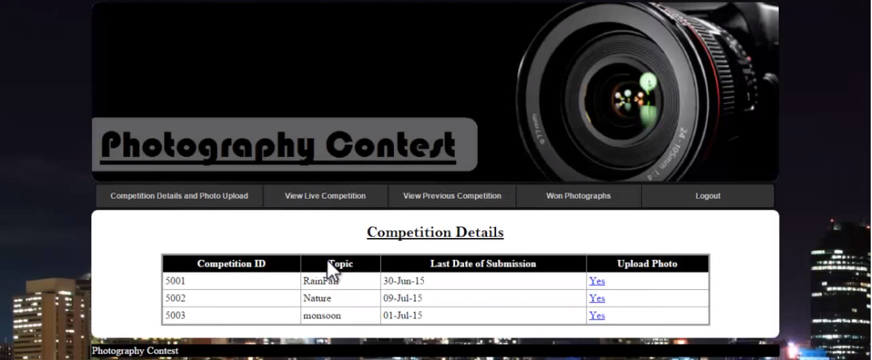
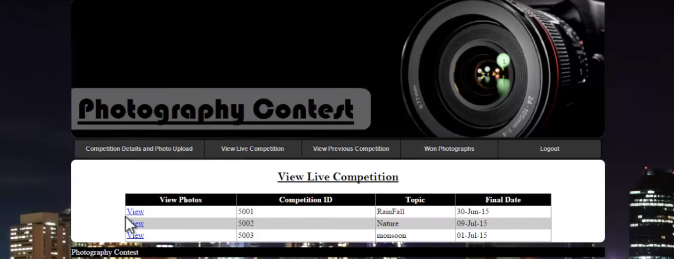
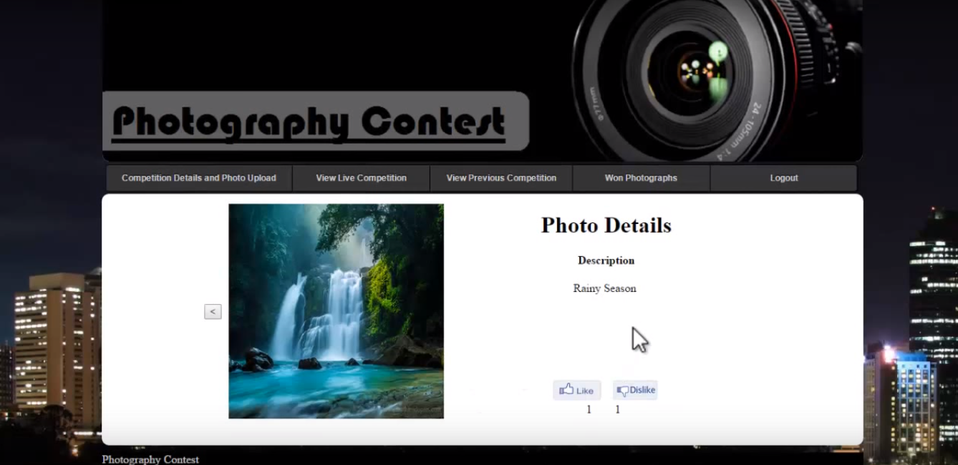
<Optionally, include any pertinent analysis models, such as data flow diagrams, class diagrams, state-transition diagrams, or entity-relationship diagrams.>
Appendix C: To Be Determined List
<Collect a numbered list of the TBD (to be determined) references that remain in the SRS so they can be tracked to closure.>

