Software Requirements Specification
for
Rafeeq

Version 1.1

Prepared by the WHOLE TEAM

30/5/2026

Table of Contents
Table of Contents 1
Revision History 2
1. Introduction 2
1.1 Purpose 3
1.2 Document Conventions 3
1.3 Intended Audience 3
1.4 Product Scope 4
2. Overall Description 4
2.1 Product Perspective 5
2.2 Product Functions 5
2.3 User Classes and Characteristics 5
2.4 Operating Environment 6
2.5 Design and Implementation Constraints 6
3. External Interface Requirements 7
3.1 User Interfaces 8
3.2 Hardware Interfaces 8
3.3 Software Interfaces 9
3.4 Communications Interfaces 10
4. User Stories & Acceptance Criteria 10
4.1 Epic: User Management 11
4.2 Epic: Site Discovery 12
4.3 Epic: Google Maps Integration & Navigation 14
4.4 Epic: Favorites (Wishlist) 15
4.5 Epic: Sponsors & Promotions 16
4.6 Epic: Itinerary & Trip Planner 17
4.7 Epic: Admin & Content Management 17
4.8 Epic: Nearby 19
4.9 Epic: Multi-City & Regional Support 19
4.10 Epic: Transportation Enhancements 19
5. Non-functional Requirements 20
5.1 Performance Requirements 21
5.2 Safety Requirements 21
5.3 Security Requirements 21
5.4 Software Quality Attributes 22
5.5 Business Rules 23
6. System Models 23
6.1 Use Case Diagrams 24
6.2 Sequence Diagrams 25
5.3 Activity Diagrams 28
5.4 Class Diagrams 34
6.5 Entity–Relationship (ER) Diagram 36

Revision History
Name | Date | Reason For Changes | Version

1. Introduction

1.1 Purpose
This Software Requirements Specification (SRS) document describes the functional and non-functional requirements for the Egypt Tourist Guide Mobile Application, Rafeeq, Version 1.0.
The purpose of this document is to provide a complete and detailed description of the system behavior, features, and constraints for stakeholders including developers, project supervisors, and evaluators.
This SRS covers the mobile application developed using Flutter, the backend services implemented using ASP.NET Core Web API, and the supporting database system. The scope includes all major subsystems such as user management, tourist site discovery, map and navigation services, trip planning, artifact images recognition, sponsor management, and administration modules.
This document serves as a reference for system design, implementation, testing, and validation throughout the development lifecycle of the graduation project.

1.2 Document Conventions
The following conventions are used throughout this document:
- Functional Requirements:
  - US-xx: User Story ID (for Agile tracking).
- Non-Functional Requirements:
  - PRx.y.z: Performance Requirements.
  - SaR: Safety Requirements.
  - SecR: Security Requirements.
  - QA: Quality Attributes (Usability, Reliability, Maintainability, Portability).
  - ScalR: Scalability Requirements.
  - BR: Business Rules.
- The keyword “shall” is used to indicate a mandatory requirement.
- Important terms and section titles are written in bold.
All requirements are written in clear, unambiguous language.

1.3 Intended Audience
This document is intended for the following audiences:
- Project Supervisors and Examiners: To understand the system scope, objectives, and evaluation criteria.
- Developers: To implement the mobile application, backend services, and database according to specified requirements.
- Documentation Writers: To prepare user manuals and technical guides.
The document is organized as follows:
- Introduction: Provides an overview of the system, scope, and objectives.
- Overall Description: Describes system context, user classes, and operating environment.
- External interface requirements: Includes User, Hardware, Software, Communication Interfaces Requirements.
- User Stories / Functional Requirements: Details all system features and behaviors.
- Non-Functional Requirements: Defines quality attributes such as performance, security, and usability.
- System Models: Includes use-case diagrams, sequence diagrams, and ER diagrams.

1.4 Product Scope
The Rafeeq Application is a location-based mobile system designed to assist tourists in discovering, exploring, and navigating historical and cultural sites across Egypt. The system provides detailed information about attractions, interactive maps with routing and transportation options, trip planning tools, AI-based recommendations, sponsor recommendations, and emergency assistance.
The system encompasses:
- Discovery: Detailed information on historical sites, temporary exhibitions, and events.
- Navigation: Interactive Google Maps integration with multi-modal routing (driving, walking, transit).
- Planning: Tools for creating single-day or multi-city trips with route optimization.
- Monetization: A platform for sponsors to offer time-limited discounts to tourists.
The primary objectives of the system are:
- To enhance the tourist experience by providing accurate, up-to-date, and accessible information.
- To enable easy navigation and route planning using Google Maps services.
- To support multi-language content for international users.
- To offer personalized recommendations and itinerary planning.
- To provide a scalable platform that can integrate sponsors and tourism services.
This application supports Egypt’s digital tourism strategy by promoting cultural heritage, improving tourist accessibility, and enabling data-driven tourism services.

2. Overall Description

2.1 Product Perspective
The Rafeeq Application is a new Egypt Tourist Guide Mobile App, self-contained software product developed as a graduation project. It is not a direct replacement for an existing system, but rather an integrated digital solution that combines location services, tourism information systems, and mobile navigation technologies into a single platform.
The system consists of three main components:
- Mobile Application (Flutter): Provides the user interface for tourists, including site browsing, maps, trip planning, and notifications.
- Backend Server (ASP.NET Core Web API): Handles business logic, user authentication, data management, sponsor management, and integration with external APIs.
- Admin Dashboard (Web-based): A management portal for Administrators and Moderators to manage sites, sponsors, and users.
- Machine Learning Services:
  - Scanner: Provides artifact image recognition (Scan)
  - Trip Planner: Generates optimized trip plans using recommendation algorithms.
External Service Integrations:
- Google Maps Platform: For maps, places, routing, and traffic data.
- Cloudinary: For images storage.
The mobile application communicates with the backend through RESTful APIs, and the backend integrates with external services to provide real-time location-based information.

2.2 Product Functions
At a high level, the system provides the following major functions:
- User registration, authentication, and profile management
- Browsing and searching historical and cultural sites in Egypt
- Viewing detailed site information, images, and multimedia
- Displaying sites and routes on interactive Google Maps
- Trip planning and itinerary creation
- Scan artifacts images
- Nearby site recommendations based on user location
- Favorite sites.
- Sponsor and partner promotion
- Administrative content management and moderation

2.3 User Classes and Characteristics
The system supports the following user classes:

1. Tourist (Registered)
- Can save favorites and create trips.
- General public users, both local and international.
- Limited technical knowledge.
- Use the mobile application to explore sites, navigate, plan trips, and scan images.

2. Moderator
- Technically trained personnel.
- Manage sites, cities, etc.

3. Administrator
- Technically trained personnel.
- Full system privileges.
- Same as Moderator but plus manage sponsors, users, and system configuration.

2.4 Operating Environment
The system shall operate in the following environment:
- Mobile Platforms:
  - Android 9.0+
  - iOS 13+
  - Requires GPS and Internet (Wi-Fi/4G/5G).
- Backend Server:
  - ASP.NET Core (.NET 10) hosted on cloud infrastructure (e.g., Azure/AWS).
- Database:
  - SQL Server or PostgreSQL
- Web Admin Portal:
  - Accessible via modern web browsers (Brave, Edge, Chrome).

2.5 Design and Implementation Constraints
The system is subject to the following constraints:
- The mobile application must be developed using Flutter.
- The backend must be developed using ASP.NET Core.
- The system must integrate with Google Maps Platform for location and routing services.
- The database must be a relational database system.
- All communication must use HTTPS.
- The system must support English and Arabic languages, at least.
- Development must follow Clean Architecture and RESTful API design principles.
- The project timeline and resources are constrained by academic semester duration.
- The application must comply with mobile platform privacy and location permission policies.

3. External Interface Requirements

3.1 User Interfaces
The system shall provide a mobile-based graphical user interface designed for tourists using smartphones. The user interface will be developed using Flutter, ensuring a consistent look and feel across Android and iOS platforms.
The application shall include the following user interface components:
- Home Screen: Displays feature historical sites, sponsored sites, and navigation options.
- Site Listing Screen: Displays a list of historical sites with images, names, and cities.
- Site Details Screen: Displays detailed information about a selected site, including description, images, opening hours, ticket prices, and location on Google Maps.
- Map Screen: Displays the selected site and route directions using Google Maps.
- Favorites Screen: Displays sites bookmarked by the user.
- Trip Planner Screen: Allows users to create and manage itineraries.
- Image Recognition Screen: Allows users to scan artifact images.
- User Profile Screen: Allows users to manage account details and language preferences.
- Admin Dashboard (Web-based): Allows administrators to manage sites, sponsors, users, and reviews.
The user interface shall follow these standards and constraints:
- The interface shall support English and Arabic languages.
- The interface shall use standard mobile navigation components such as bottom navigation bars and icons.
- Consistent buttons (Back, Save, Cancel) shall be used throughout the application.
- Error messages shall be displayed in a clear and user-friendly manner.
- Confirmation messages shall be shown for critical actions (e.g., deleting favorites, submitting reviews).

3.2 Hardware Interfaces
The system shall operate on standard smartphone hardware and cloud-based server infrastructure.

Mobile Devices:
- Smartphones running Android or iOS
- GPS sensor for location-based services to determine the user's current coordinates (Latitude/Longitude).
- Camera and access photo gallery to allow users to scan images.
- Storage to cache images and user preferences (approx. 100MB max cache size).
- Internet connectivity via Wi-Fi or mobile data

Server Hardware:
- Cloud-based server hosting the ASP.NET Core API
- Database server for storing application data
The application shall interact with hardware components as follows:
- GPS hardware shall be used to obtain the user’s current location.
- Network hardware shall be used to communicate with backend services and third-party APIs.
No direct low-level hardware control is required by the system.

3.3 Software Interfaces
The system shall interface with the following software components:

Backend:
- ASP.NET Core Web API (.NET 10)
- SQL Server database for persistent data storage

Frontend:
- Flutter Framework for mobile application development

Third-Party Services:
- Google Maps API for map display, location services, and route generation
- Authentication Services (Email / Google Sign-In)

Operating Systems:
- Android OS
- iOS
- Windows or Linux (server environment)

Data Exchange:
- Communication between Flutter app and backend API shall use RESTful services.
- Data shall be exchanged in JSON format.
- All protected endpoints require authentication using a valid JWT, either via secure HttpOnly cookies or a Bearer Token in the HTTP Authorization header.
- The backend shall provide endpoints for sites, users, sponsors, and trips.
- Shared data includes user profiles, site information, reviews, and sponsor details.
All API communication shall follow REST standards and be documented using OpenAPI (Swagger).

3.4 Communications Interfaces
The system shall support communication over standard internet protocols.
- The application shall use HTTP/HTTPS for all client-server communications.
- All sensitive data transmissions shall use HTTPS encryption.
- The system shall communicate with external services such as Google Maps via secure API calls.
- JSON shall be used as the standard message format for all communications.
- The system shall support real-time location data retrieval for route generation.
Security requirements:
- API access shall be protected using authentication tokens.
- User data shall not be transmitted in plain text.
- The system shall prevent unauthorized access to admin functionalities.
The system does not require support for email, FTP, or peer-to-peer communication in its current scope.

4. User Stories & Acceptance Criteria
This section organizes the main system features of the Rafeeq into Epics. where each Epic represents a high-level system capability. Each user story represents a functional requirement from the perspective of an end user and defines how the system should behave to deliver value. Each Epic is decomposed into user stories, and each user story is supported by acceptance criteria to ensure clarity, completeness, and testability.

4.1 Epic: User Management

4.1.1 Authentication & Security
- User Registration
As a new tourist, I want to create an account using my email or Google account, So that I can access personalized features like favorite sites.
Acceptance Criteria:
  - User can sign up by entering a valid email and password.
  - User can sign up using the "Continue with Google" button (OAuth).
  - System validates that the email format is correct and not already in use.
  - System creates a record in the database upon success.
- Secure Login & Logout
As a registered user, I want to log in and log out securely, So that I can access my account on different devices without unauthorized access.
Acceptance Criteria:
- User can log in with registered credentials.
- Failed login attempts display a generic error message (e.g., "Invalid credentials") for security.
- Clicking "Logout" invalidates the current session immediately.
- User is redirected to the home/login screen after logout.
- Password Reset
As a user who forgot their password, I want to reset it via email, So that I can recover access to my account.
Acceptance Criteria:
- User can request a reset link by providing their registered email.
- System sends a time-sensitive link to the email.
- Clicking the link allows the user to set a new password.
- Old password is no longer valid after the reset.

4.1.2 Profile & Preferences
- Edit Profile Details
As a registered user, I want to edit my personal details (name, email), So that my profile information is always up to date.
Acceptance Criteria:
- User can update their Display Name and Email.
- Changes are saved to the database immediately upon clicking "Save."
- Email changes require re-verification (optional but recommended).
- Delete Account
As a privacy-conscious user, I want to permanently delete my account, So that my personal data is removed from the system.
Acceptance Criteria:
- User must confirm the deletion action (e.g., a "Are you sure?" popup).
- System performs a "soft delete" or permanent purge (depending on data policy) of user PII (Personally Identifiable Information).
- User is logged out and redirected to the welcome screen.

4.1.3 Authorization & Roles
- Role-Based Access Control (RBAC)
As a System Admin, I want to assign roles (User, Moderator, Admin) to accounts, So that users only have access to features permitted for their level.
Acceptance Criteria:
- Standard Users can only edit their own data.
- Moderators can hide/delete inappropriate reviews but cannot delete users.
- Admins have full access to all system configurations and user management.
- The system checks the user's role token before loading protected pages.

4.2 Epic: Site Discovery

4.2.1 Browsing & Search
- Browse Historical Sites
As a tourist, I want to view a list of historical sites in Egypt, So that I can discover interesting locations to visit.
Acceptance Criteria:
- The home screen displays a scrollable list (or grid) of sites.
- Each list item shows a thumbnail image and the site name.
- Pagination or "infinite scroll" is implemented if there are more than 20 sites.
- Search and Filter Sites
As a user who knows what they are looking for and have specific preferences, I want to search (by name or keyword) and filter (by City, Type, etc.) sites, So that I can quickly find specific attractions.
Acceptance Criteria:
- Search bar is visible at the top of the sites screen.
- Results update as I type (live search) OR upon clicking "Search."
- If no results are found, display a "No sites found" message.
- User can select filters from a menu (e.g., City: "Luxor", Type: "Temple").
- User can sort results by "Popularity" (High to Low).
- The list updates immediately to show only matching items.
- "Clear All" button resets the list to default.

4.2.2 Site Information
- View Site Details
As a user, I want to see detailed information about a specific site (images, price, hours), So that I can decide if it fits my schedule and budget.
Acceptance Criteria:
- Tapping a site in the list opens a Details Page.
- The page displays: Name, Description, Location, Ticket Price, and Opening Hours.
- A gallery or carousel allows swiping through multiple images.
- Contact details (phone/website) are clickable.

4.3 Epic: Google Maps Integration & Navigation

4.3.1 Map Visualization & Interaction
- View Site on Map
As a traveler, I want to view the exact location of a site on an interactive map, So that I can understand its surroundings.
Acceptance Criteria:
- User can click "View on Map" from the Details page.
- The map opens with a pin dropped on the specific latitude/longitude.
- Tapping the pin displays the site name.
- Map Controls (Zoom & Layers)
As a user navigating the map, I want to zoom in/out and switch between Map and Satellite views, So that I can see the terrain or street details clearly.
Acceptance Criteria:
- Standard pinch-to-zoom gestures work smoothly.
- A toggle button switches the layer between "Default" (Vector) and "Satellite".
- Controls are positioned so they don't obscure the map center.

4.3.2 Routing & Navigation (TO BE DELETED)
- Route Planning & Transport Modes
As a traveler, I want to generate a route from my current location and choose my transport mode (Driving, Walking, Transit), So that I can estimate my travel time.
Acceptance Criteria:
- System detects the user's current GPS location as the "Start" point.
- User can switch tabs for Driving, Walking, or Public Transit.
- System displays the route line on the map.
- System displays estimated Time and Distance for the selected mode.
- Alternative Routes
As a user, I want to see multiple route options (if available), So that I can choose the fastest or most scenic path.
Acceptance Criteria:
- If Google APIs return multiple routes, they are displayed as grayed-out alternative lines.
- Tapping an alternative line makes it the active route and updates the time/distance estimates.
- Dynamic Navigation (Rerouting)
As a driver, I want the route to update automatically if I deviate from the path, So that I can get back on track without manual input.
Acceptance Criteria:
- App tracks user movement in real-time.
- If the user leaves the calculated path, the system triggers a re-calculation (Rerouting).
- Note: This usually requires specific Navigation SDK implementation.
- Offline Route Access
As a user with spotty internet, I want to save a generated route, So that I can view the path even when I go offline.
Acceptance Criteria:
- User can click a "Save Route" button after a route is generated.
- The polyline (route path) is cached locally.
- When offline, the map still renders the route line (even if background map tiles are missing).

4.4 Epic: Favorites (Wishlist)

4.4.1 Manage Favorites
- Toggle Favorite Status
As a user browsing sites, I want to mark a site as a "Favorite" (or remove it), So that I can easily find it later without searching again.
Acceptance Criteria:
- A "Heart" icon is visible on both the list view and details page.
- Tapping the empty heart fills it (Add to Favorites) and triggers a brief success message (toast).
- Tapping the filled heart empties it (Remove from Favorites).
- The status updates immediately in the database.

4.5 Epic: Sponsors & Promotions

4.5.1 Sponsored Place Visibility & Information
- View Sponsored Places (Priority Listing)
As a user searching for recommendations, I will see sponsored places appearing near the top of my list, So that I am exposed to premium partners (hotels/restaurants).
Acceptance Criteria:
- Sponsored sites appear within the top 3-5 results in the list view.
- These items are clearly marked with a "Sponsored" or "Ad" tag to distinguish them from organic results.
- The ranking algorithm prioritizes these items over standard sites in the default sort order.
- View Sponsor Details
As a user interested in a sponsored service, I want to view their specific details (Website, Logo, Contact), So that I can book a service or learn more.
Acceptance Criteria:
- Clicking a sponsored site opens a specialized Details Page.
- The page prominently displays the Sponsor's Logo and Website link.
- A "Contact" button allows direct dialing or emailing.

4.5.2 Promotional Offers & Discounts
- Time-Limited Offers
As a budget-conscious traveler, I want to see special time-limited discounts from sponsors, So that I can save money on my trip.
Acceptance Criteria:
- If a sponsor has an active campaign, a "Special Offer" badge is visible on their listing (e.g., "20% Off").
- The Details Page displays the offer terms and the expiration date/time.
- Expired offers are automatically hidden from the view.

4.6 Epic: Itinerary & Trip Planner

4.6.1 Trip Management
- Create and Manage Trips
As a user planning a vacation, I want to create a new trip by adding multiple sites, So that I can organize my visit in one list.
Acceptance Criteria:
- User can create a named trip (e.g., "Cairo Weekend").
- User can add sites to the trip from the "Details" page or "Favorites" list.
- User can edit the trip (add/remove sites) or delete the entire trip.
- Trips are saved to the user's profile.
- Trip Estimates
As a user, I want to see the total estimated duration and travel time for my itinerary, So that I know if my plan is realistic for one day.
Acceptance Criteria:
- System calculates total estimated travel time between points.
- System adds estimated "Time Spent" at each location (e.g., default 1 hour per museum) to the total duration.
- The UI displays "Total Trip Time: X hours."

4.6.2 Route Planning & Optimization
- Route Optimization
As a traveler visiting multiple spots, I want the system to suggest the best order to visit them, So that I save travel time and avoid backtracking.
Acceptance Criteria:
- System analyzes the selected locations.
- System reorders the list to minimize total travel distance (a simple "Traveling Salesman" logic).
- User can manually override the suggested order by dragging and dropping items.

4.7 Epic: Admin & Content Management

4.7.1 Sites & Sponsor Management
- Manage Sites (CRUD)
As an Admin, I want to add, edit, or delete tourist sites, So that the app content remains accurate and up-to-date.
Acceptance Criteria:
- Admin can fill a form to create a new site (Name, Description, Coordinates, Images).
- Admin can search for an existing site and update its details (e.g., change ticket price).
- Admin can "Soft Delete" a site (mark as inactive) so it doesn't break old user trips.
- Manage Sponsors & Offers
As an Admin, I want to manage sponsor profiles and their active offers, So that monetization partnerships are handled correctly.
Acceptance Criteria:
- Admin can link a Sponsor profile to a specific Site ID.
- Admin can set start/end dates for promotional offers.
- Admin can upload sponsor logos and contact info.

4.7.2 User Management & Audit
- User Management & Moderation
As an Admin, I want to manage user accounts (block, suspend), So that I can maintain a safe community.
Acceptance Criteria:
- Admin can search for users by email or name.
- Admin can change a user's status to "Active," "Suspended," or "Banned."
- Admin can flag accounts as "Suspicious" for further review.
- Audit Logs
As a Super Admin, I want to view a log of all administrative actions, So that I have accountability for changes made to the system.
Acceptance Criteria:
- A read-only "Audit Log" table displays: Timestamp, Admin Username, Action (e.g., "Deleted Site X"), and IP Address.
- Logs cannot be deleted by standard admins.

4.8 Epic: Nearby

4.8.1 Location-Based Discovery
- View Nearby Sites
As a tourist on the go, I want to see sites near my current location, So that I can find something to do right now without traveling far.
Acceptance Criteria:
- App requests GPS permission.
- List automatically filters to show items within X km (configurable radius, e.g., 5km).
- Results are sorted by "Distance: Closest First."

4.9 Epic: Multi-City & Regional Support

4.9.1 City/Region Selection & Multi-City Trips
- Select Region/City
As a user planning a trip, I want to switch the app view to a specific city (e.g., Luxor), So that I only see sites relevant to that area.
Acceptance Criteria:
- A "Location/City" dropdown is available in the top bar.
- Selecting "Luxor" filters the Home Feed and Map View to show only Luxor data.
- "All Egypt" is the default view.

4.10 Epic: Transportation Enhancements

4.10.1 Public Transportation Discovery
- Nearby Public Transport
As a backpacker relying on public transit, I want to see nearby metro and bus stations on the map, So that I can find my way to the site without a car.
Acceptance Criteria:
- User can toggle a "Transit" layer on the map.
- System highlights nearby Metro stations and Bus stops using distinct icons.
- Tapping a station shows its name and served lines.

5. Non-functional Requirements
This section defines the quality attributes, performance constraints, and safety regulations that the system must satisfy to ensure reliable and secure user experience.

5.1 Performance Requirements
The system shall meet the following performance requirements to ensure acceptable response time, throughput, and efficient resource usage for mobile users and backend services.
PR5.1.1 The system shall load the home screen within 3 seconds on a standard mobile network.
PR5.1.2 The system shall return search results within 2 seconds for up to 10,000 sites.
PR5.1.3 The system shall display map tiles and routes with a response time not exceeding 2 seconds after user interaction.
PR5.1.4 The backend API shall support at least 1,000 concurrent users without degradation of service.
PR5.1.5 The system shall cache frequently accessed data (popular sites, cities, categories) to reduce response time.

5.2 Safety Requirements
The system shall be designed to prevent any situation that may cause physical, financial, or informational harm to users during its operation.
SaR5.2.1 The system shall display clear warnings that navigation and map information are for guidance only and that users must follow official traffic rules and on-site safety instructions.
SaR5.2.2 The system shall not provide unsafe or restricted routes (e.g., closed roads, military zones) when such information is available from the map service provider.
SaR5.2.3 The system shall require user confirmation before enabling location tracking.
SaR5.2.4 The system shall protect personal and location data to prevent misuse or unauthorized access.
SaR5.2.5 The system shall provide emergency contact information (police, ambulance, tourism hotline) that can be accessed with one action from any screen.
SaR5.2.6 The system shall display safety alerts for dangerous weather conditions, natural hazards, or temporary site closures when such data is available.
SaR5.2.7 The system shall prevent sponsors or third parties from displaying misleading or unsafe information.
SaR5.2.8 The system shall comply with mobile application safety and data protection regulations, including user consent and privacy policies.
SaR5.2.9 The system shall ensure that no critical function (such as emergency contact access) is blocked by advertisements or sponsored content.

5.3 Security Requirements
SecR5.3.1 All communication between the mobile application and backend shall use HTTPS.
SecR5.3.2 User authentication shall be implemented using secure token-based authentication (JWT).
SecR5.3.3 User passwords shall be stored in encrypted and hashed form.
SecR5.3.4 The system shall enforce role-based access control (User, Admin).
SecR5.3.5 The system shall protect against common web attacks (SQL Injection, XSS, CSRF).
SecR5.3.6 Sensitive data (API keys, tokens) shall not be stored in plain text in the client application.

5.4 Software Quality Attributes
The software shall satisfy the following quality attributes:

Usability
QA5.4.1 The system shall allow a first-time user to search for a site and view its directions within three interactions.
QA5.4.2 The system shall support Arabic and English with clear, readable fonts and consistent layout.

Reliability
QA5.4.3 The system shall operate continuously with an uptime of at least 99% excluding maintenance.
QA5.4.4 The system shall recover automatically from application crashes without loss of user data.
QA5.4.5 The system shall ensure data consistency between the mobile application and backend database.
QA5.4.6 The system shall automatically retry failed API requests due to temporary network issues.
QA5.4.7 The system shall prevent duplicate entries of sites and sponsors.
QA5.4.8 The system shall validate all input data before saving to the database.

Maintainability
QA5.4.9 The backend system shall follow Clean Architecture principles, separating the solution into distinct layers:
- Presentation Layer (API Controllers)
- Application Layer (Use Cases)
- Domain Layer (Entities, Value Objects, Interfaces)
- Infrastructure Layer (Database, External APIs, Google Maps, Notification Services)
QA5.4.10 The system shall ensure that changes in external services (e.g., Google Maps API, database provider, notification service) do not affect the core business logic.
QA5.4.11 The system shall include clear project structure and coding standards to allow new developers to understand and extend the system within a short onboarding time.

Portability
QA5.4.12 The system shall run on Android and iOS without code changes to core business logic.

Scalability
QA5.4.13 The system architecture shall support horizontal scaling of the API services.
QA5.4.14 The database design shall support growth to at least 1 million users and 100,000 sites.
QA5.4.15 The system shall allow new cities and languages to be added without major redesign.

Interoperability
QA5.4.16 The system shall integrate with external services such as Google Maps and weather APIs using standard REST interfaces.

5.5 Business Rules
BR5.5.1 Only administrators shall be allowed to add, edit, or delete tourist sites and cities.
BR5.5.3 Only registered users shall be allowed to submit reviews, ratings, and create trip itineraries.
BR5.5.4 Only sponsors approved by the system administrator shall be allowed to publish promotional content.
BR5.5.5 Sponsored content shall always be clearly labeled as “Sponsored”.
BR5.5.6 A user shall not be allowed to submit more than one review for the same site.
BR5.5.7 A user shall not be allowed to rate a site without submitting a visit confirmation or minimum interaction.
BR5.5.8 A sponsor’s offer shall be displayed only within its defined start and end date.
BR5.5.9 Admin actions (create, update, delete, approve, suspend) shall be logged for auditing purposes.
BR5.5.10 User personal data shall not be shared with sponsors or third parties without explicit user consent.

6. System Models
This section presents the system models used to illustrate the structure and behavior of the Tourist Application. These models provide a visual representation of system functionality, data relationships, and interactions between users and system components. The models included are Use Case Diagrams, Activity Diagrams, Sequence Diagrams, Class Diagrams, and an Entity–Relationship (ER) Diagram.
The system models presented in this section provide a clear understanding of how the Tourist Application operates, how users interact with the system, and how data is structured and managed. These models support system design, implementation, and testing, and ensure alignment between requirements and system architecture.

6.1 Use Case Diagrams
Use case diagrams are used to represent the interactions between users and the system. They identify the main actors and the services (use cases) the system provides.

Actors
- Guest: Uses the mobile application to explore sites and get directions.
- Tourist (Registered User): The same privileges as Guest and more such as get recommendations, etc.
- Administrator: Manages sites, sponsors, users, and system data.

Main Use Cases
- Browse Sites
- View on Map
- View Site Details
- Add Sites to Favorites
- Submit Reviews and Ratings
- Manage Sites (Admin)
- Manage Sponsors (Admin)
The use-case diagram provides a high-level overview of system functionality and defines the system boundary.

Use-case Diagram
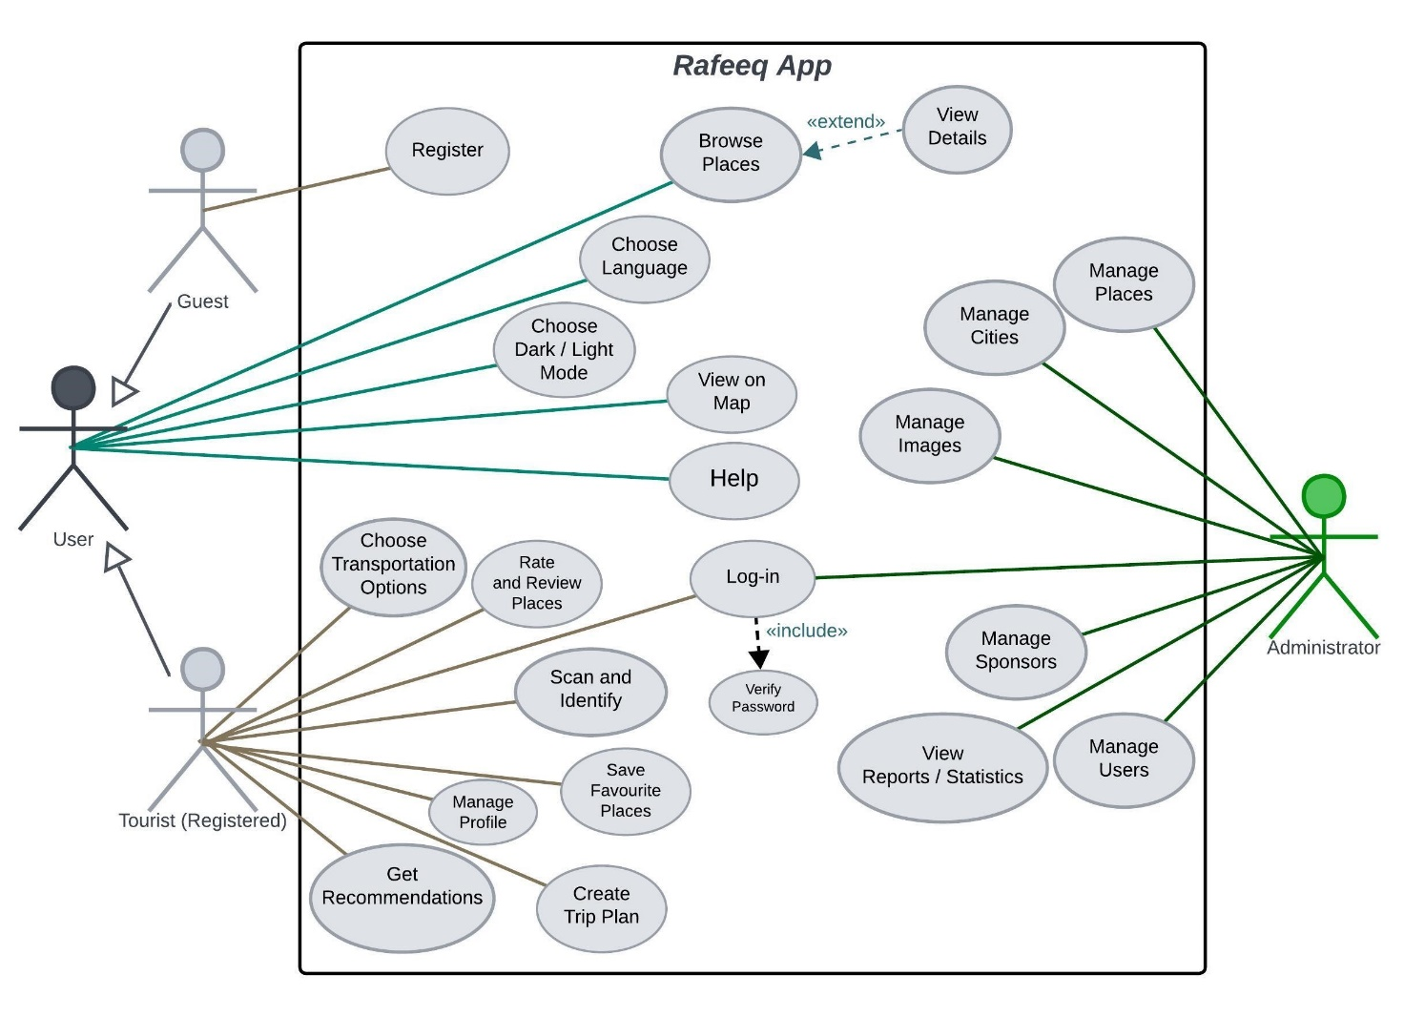

6.2 Sequence Diagrams
Sequence diagrams are used to illustrate the flow of interactions between the user, the mobile application, the backend API, and external services over time.

Example Scenarios Modeled
- Logging in to the system
- Getting recommendations for historical sites
- Scanning images of ancient statues
Each sequence diagram shows:
- The order of messages exchanged
- Communication between the Flutter mobile application and the ASP.NET Core API
These diagrams help clarify system behavior and validate functional requirements.

Figure 1: Sequence Diagram for Login
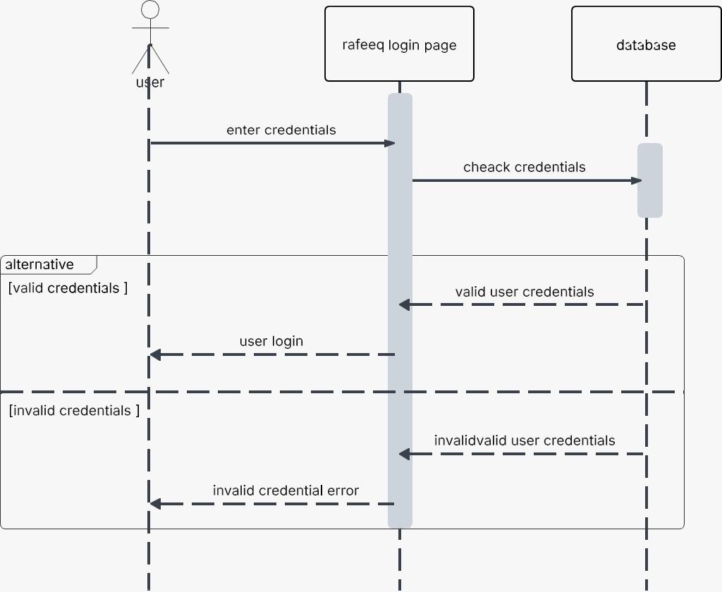

Figure 2: Sequence Diagram for Get Recommendation
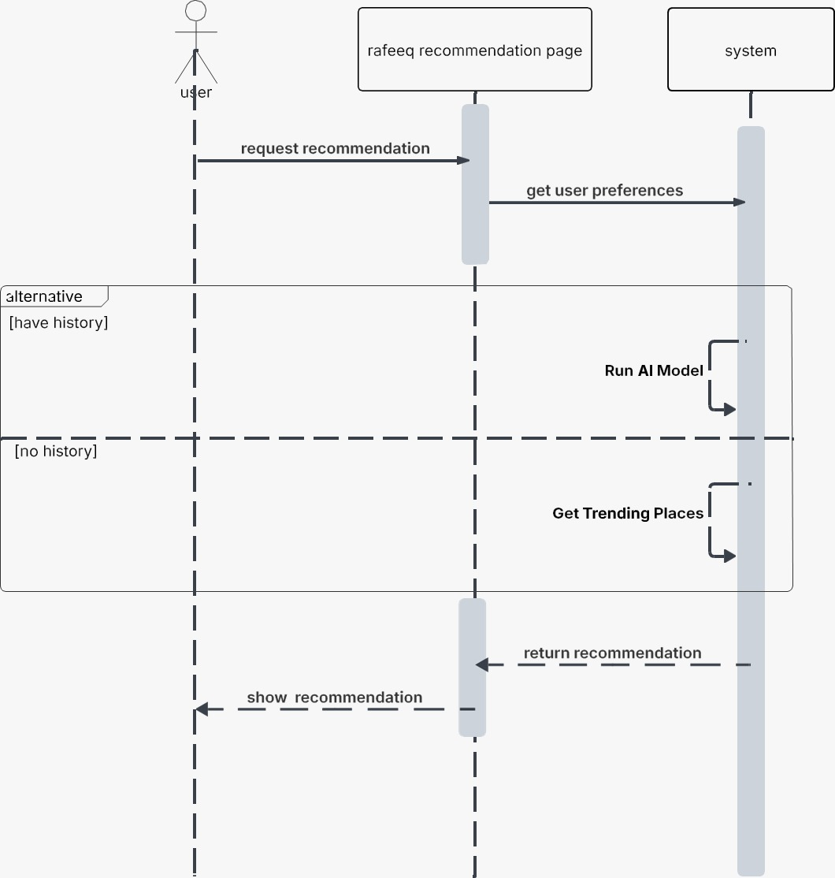

Figure 3: Sequence Diagram for Scanning Images
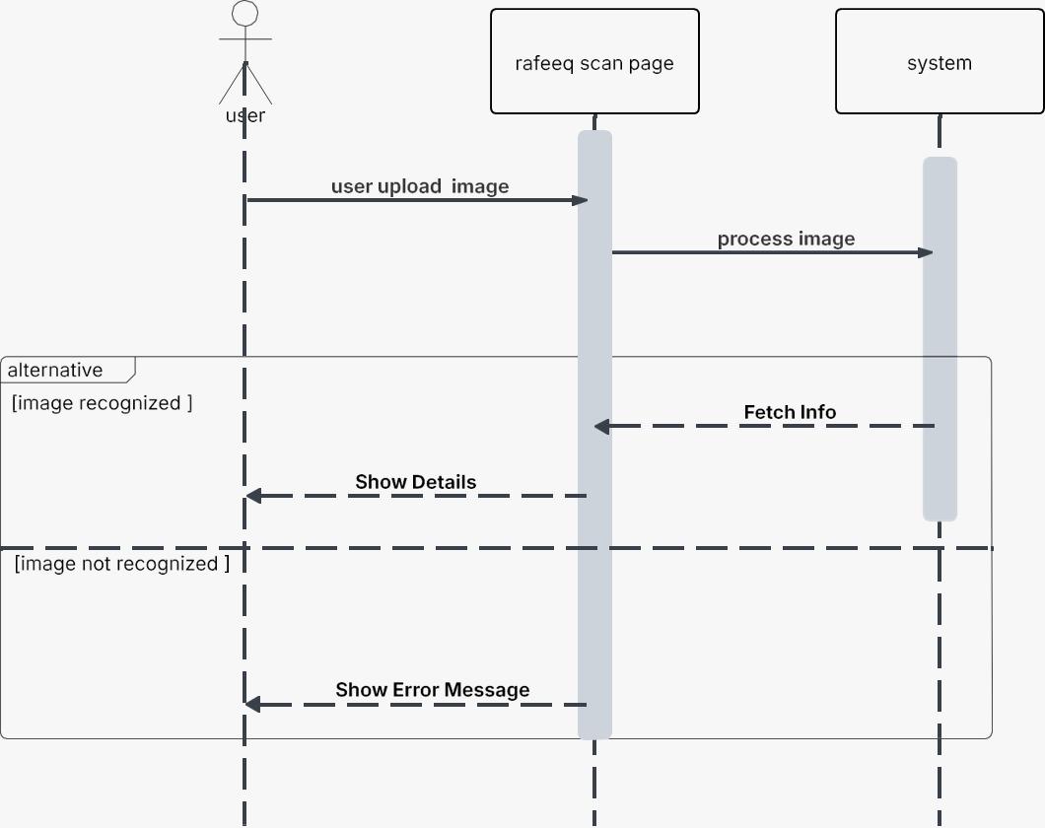

5.3 Activity Diagrams
Activity diagrams are used to model the dynamic behavior of the Tourist Application by illustrating the flow of activities and decisions within the system. These diagrams show how users and the system interact through a sequence of actions, including conditional flows and parallel activities.
The activity diagrams in this project represent key user workflows, such as browsing historical sites, viewing site details, obtaining navigation directions, and submitting reviews. Each diagram starts with an initial node and ends with a final node, with activities connected by control flows that describe the order of execution.

Figure 1: Activity Diagram for Login and Register
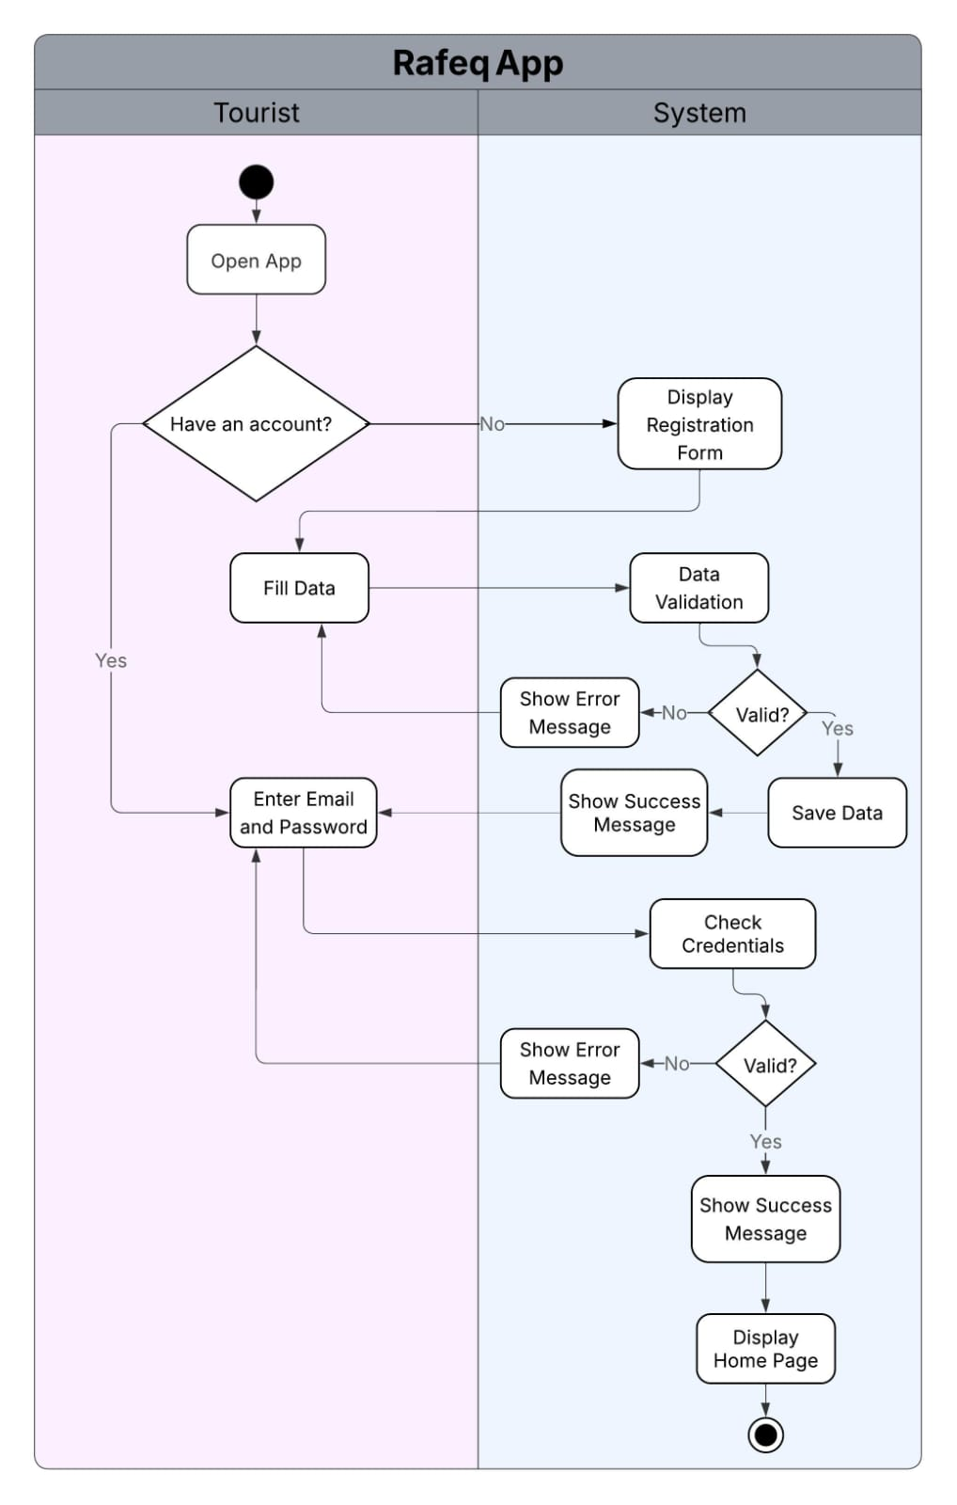

Figure 2: Activity Diagram for Adding New Site
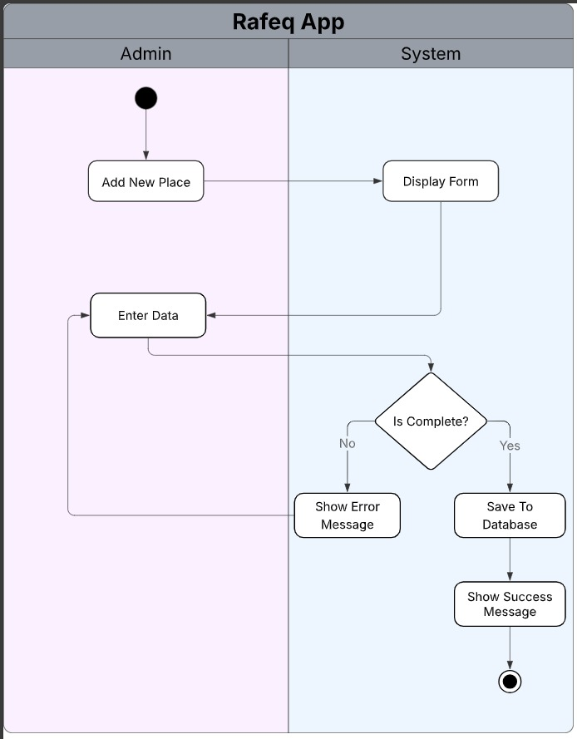

Figure 3: Activity Diagram for Get Recommendation
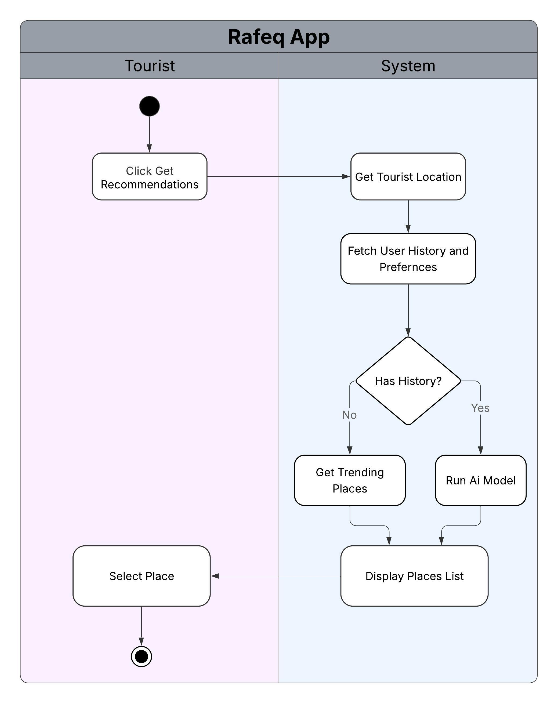

Figure 4: Activity Diagram for Scanning and Identify
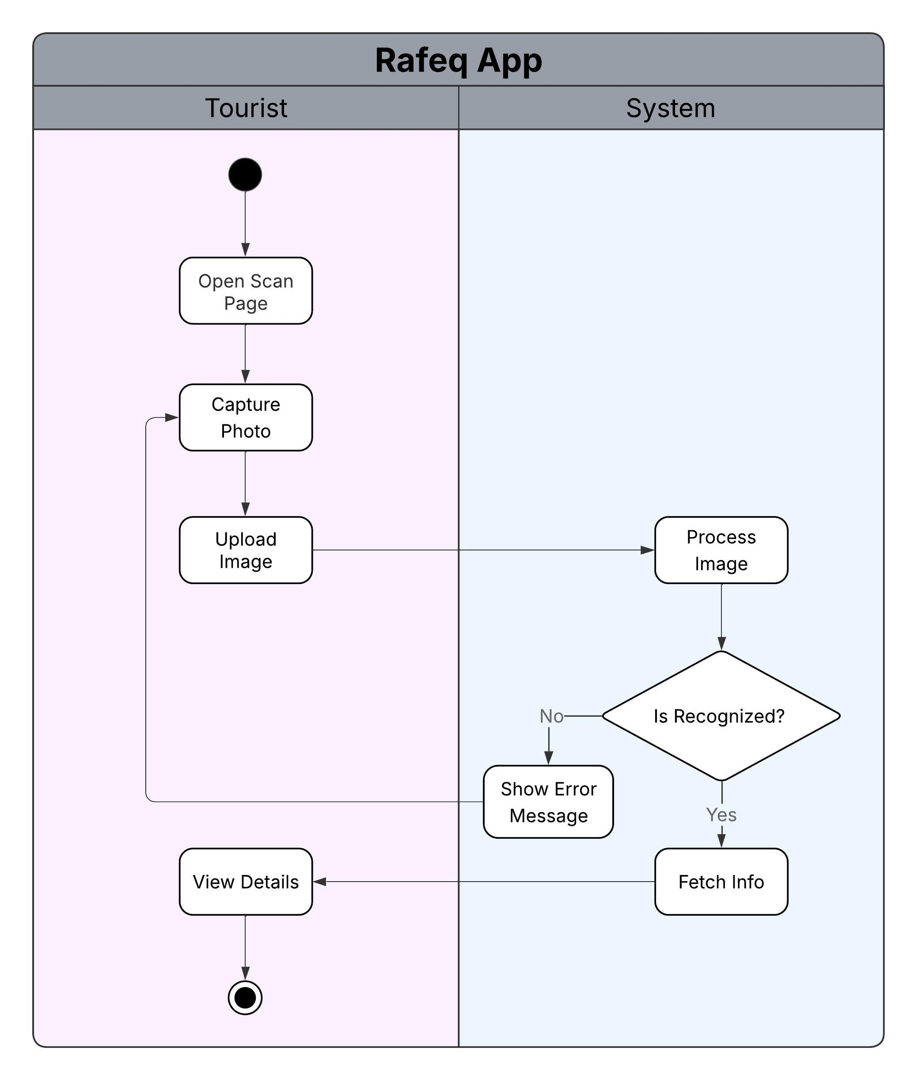

Figure 5: Activity Diagram for Showing Transportation
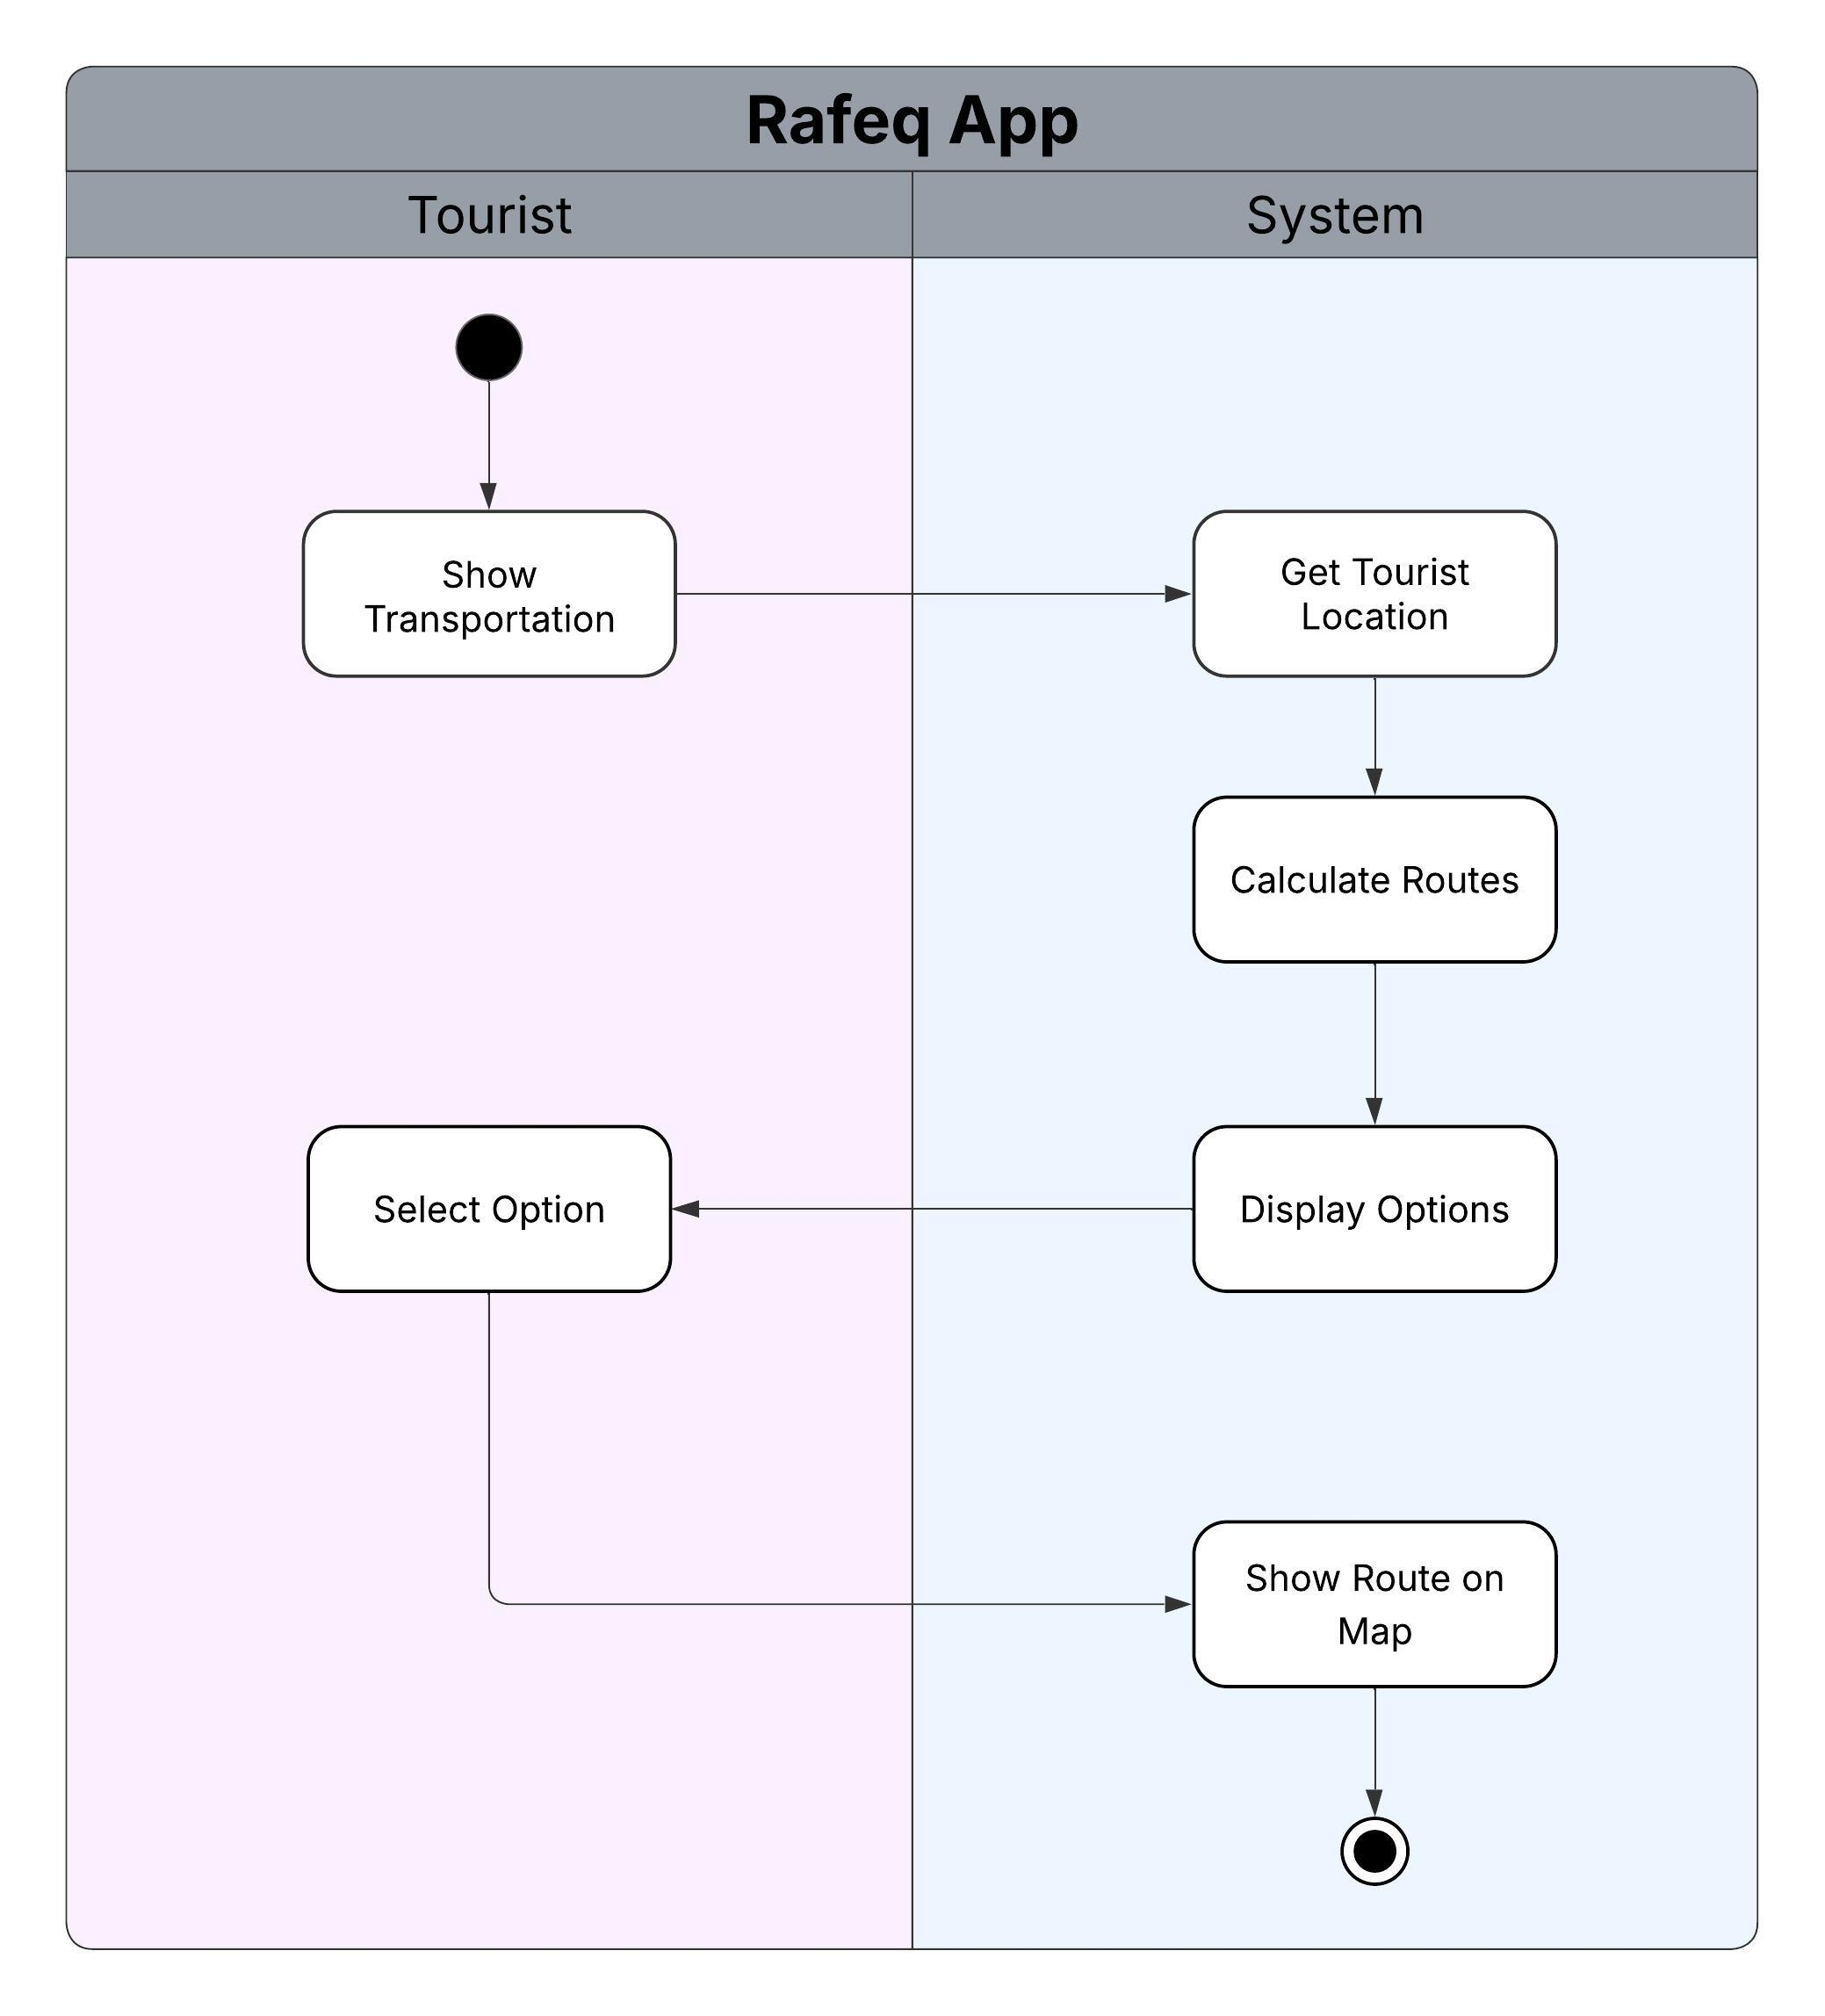

Figure 6: Activity Diagram for Adding Review
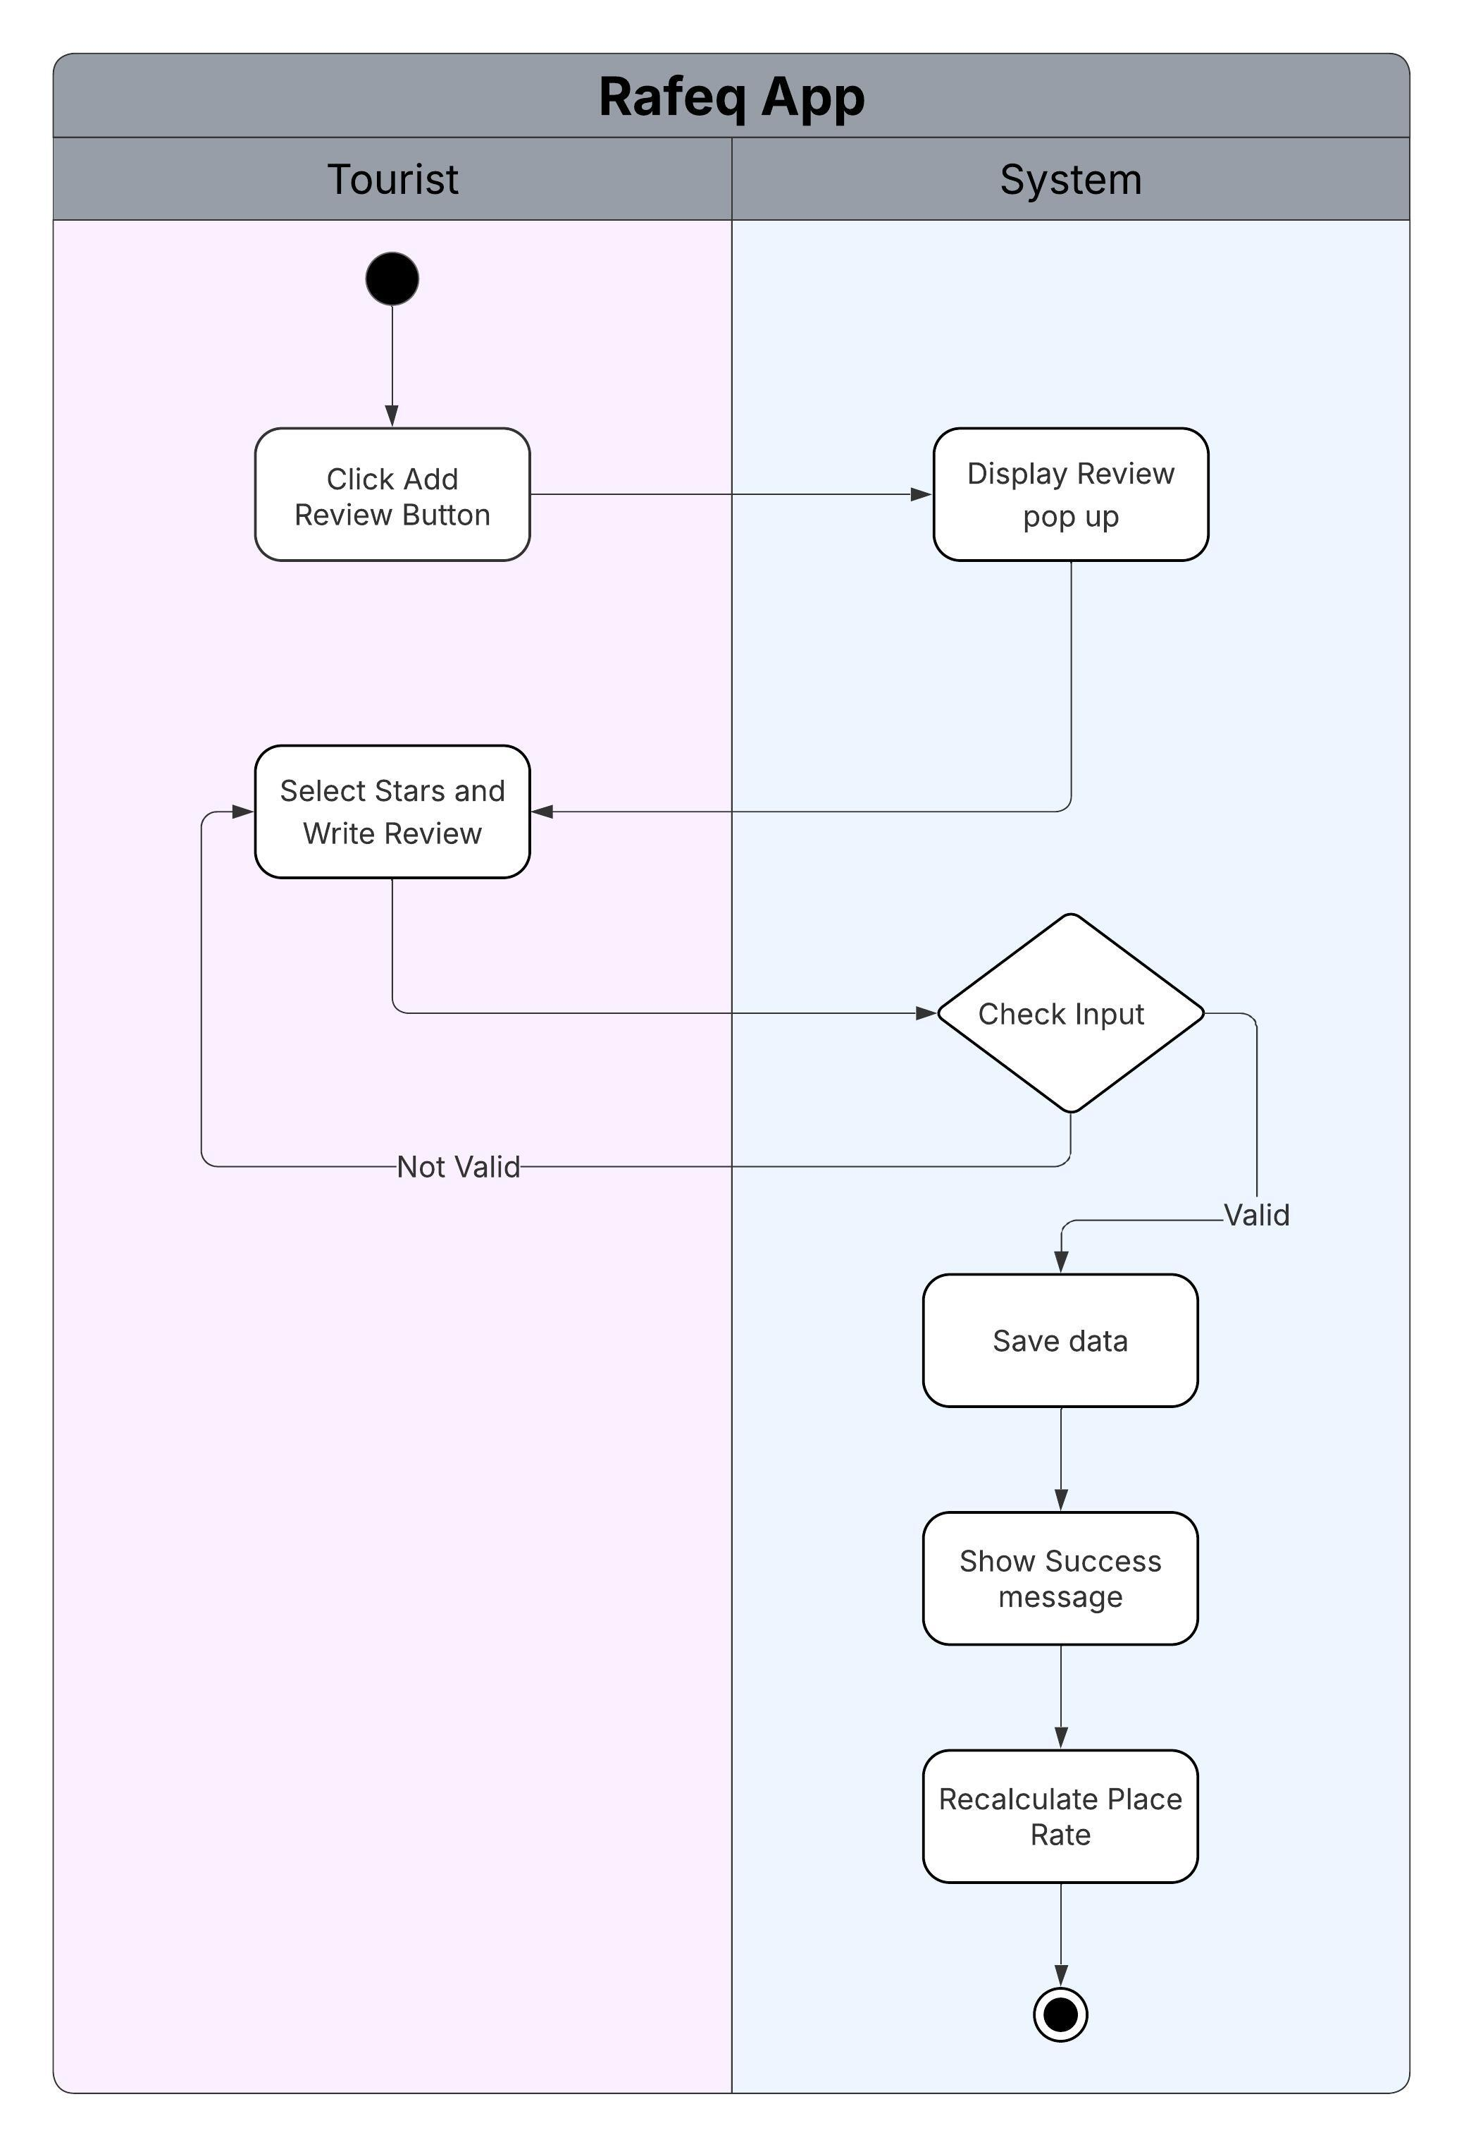

5.4 Class Diagrams
Class diagrams are used to describe the static structure of the Tourist Application by showing the system classes, their attributes, methods, and relationships. The class diagram provides a clear view of how system components are organized and how they interact at an object-oriented level.
The main classes identified in the system include:
- Tourist: Represents a tourist using the application. Contains attributes such as user ID, name, email, and language preference.
- Admin: Represents an administrator responsible for managing system data.
- Site: Represents a historical site, including attributes such as name, description, location, opening hours, and ticket price.
- City: Represents a city in Egypt that contains multiple historical sites.
- Review: Represents a user’s review and rating for a site.
- Favorite: Represents the relationship between a user and a saved site.
- Sponsor: Represents a partner business associated with sites.
- Offer: Represents promotional offers provided by sponsors.
The class diagram defines the relationships between these classes, such as associations, one-to-many, and many-to-many relationships. It also supports system features such as site discovery, user reviews, favorites management, and sponsor promotions.
The class diagram serves as a foundation for implementation in the backend using object-oriented principles and ensures consistency between system requirements and software design.

Class Diagram
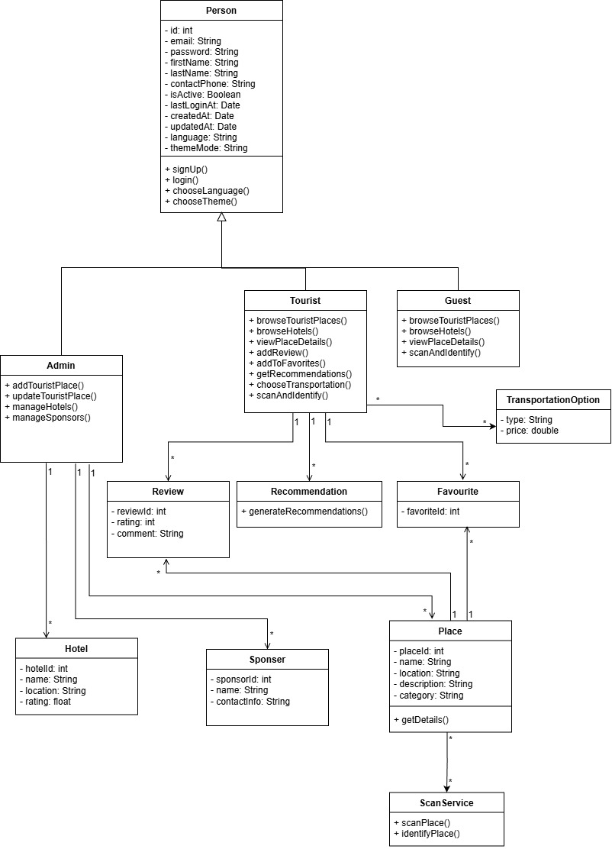

6.5 Entity–Relationship (ER) Diagram
The ER diagram represents the logical structure of the database and the relationships between data entities in the system.

Main Entities
- User, Role, User Role
- Site, Site Image, Favorite Site, Site Opening Hours
- City
- Review
- Sponsor, Sponsored Site
- Offer
- Transportation Options

Relationships
- A city can contain multiple sites
- A site can have multiple reviews
- A user can add multiple sites to favorites
- A sponsor can be associated with multiple sites
- A site can be linked to zero or more sponsors
The ER diagram ensures data consistency and supports the functional requirements of the system.

Entity–Relationship Diagram
