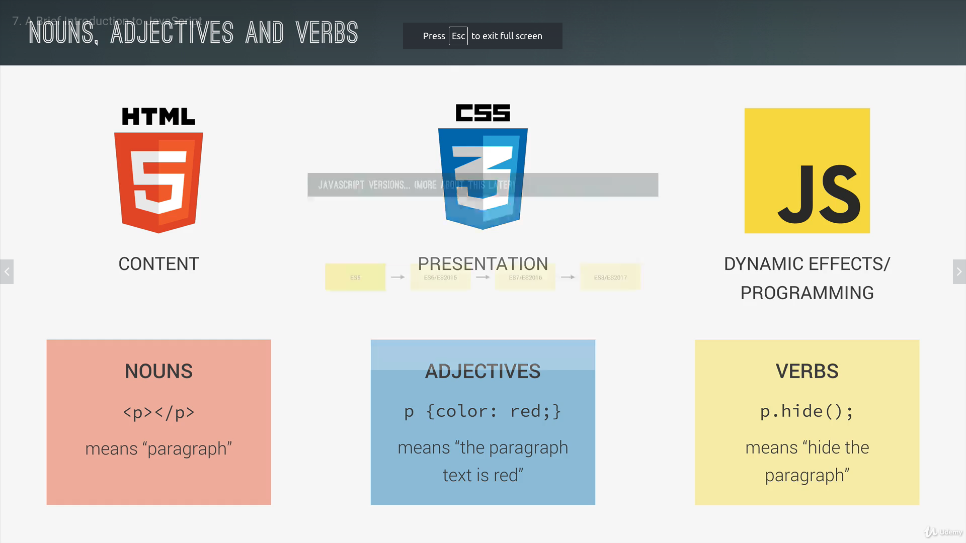

Variables and data types

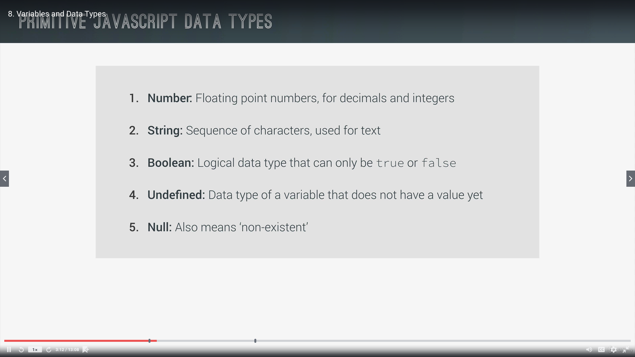

all varnames must start with = $ or _ or a letter

reserved keywords cannot be used

undefined and booleans are converted to strings => TYPE coercion

when we declare a variable for a second time in a script, there is no need to reuse the var keyword

prompt() - alert() – console.log()

link on operator precedence :
https://developer.mozilla.org/en-US/docs/Web/JavaScript/Reference/Operators/Operator_Precedence

teacher website :
http://codingheroes.io/resources/

assignment operators are read from right to left.
Always keep in mind precedence and associativity

if and else statements allow us to take decisions using code

BOOLEAN LOGIC

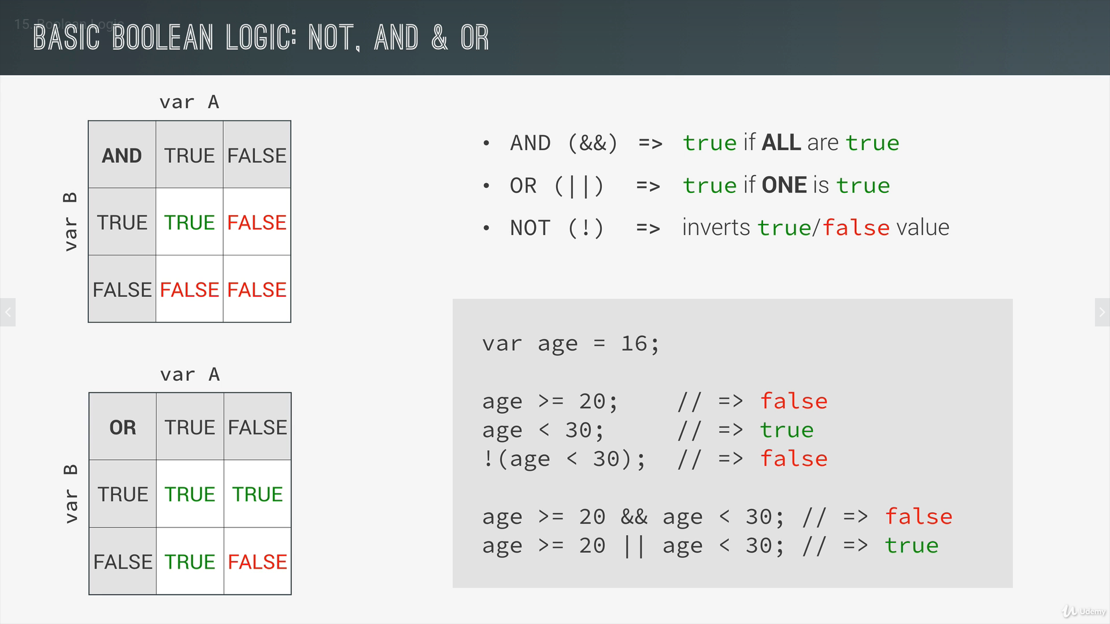
Falsy values = undefined, null, 0, ‘ ’, NAN (are evaluated as False in an if-else conditional loop)
Truthy values = NOT falsy values

== : not strict equality operator (JS converts one type to another : eg : var height == ‘23’, ‘23’ is converted to number)

=== : strict equality operator (this is best practice because there is no coercion)

