bi report
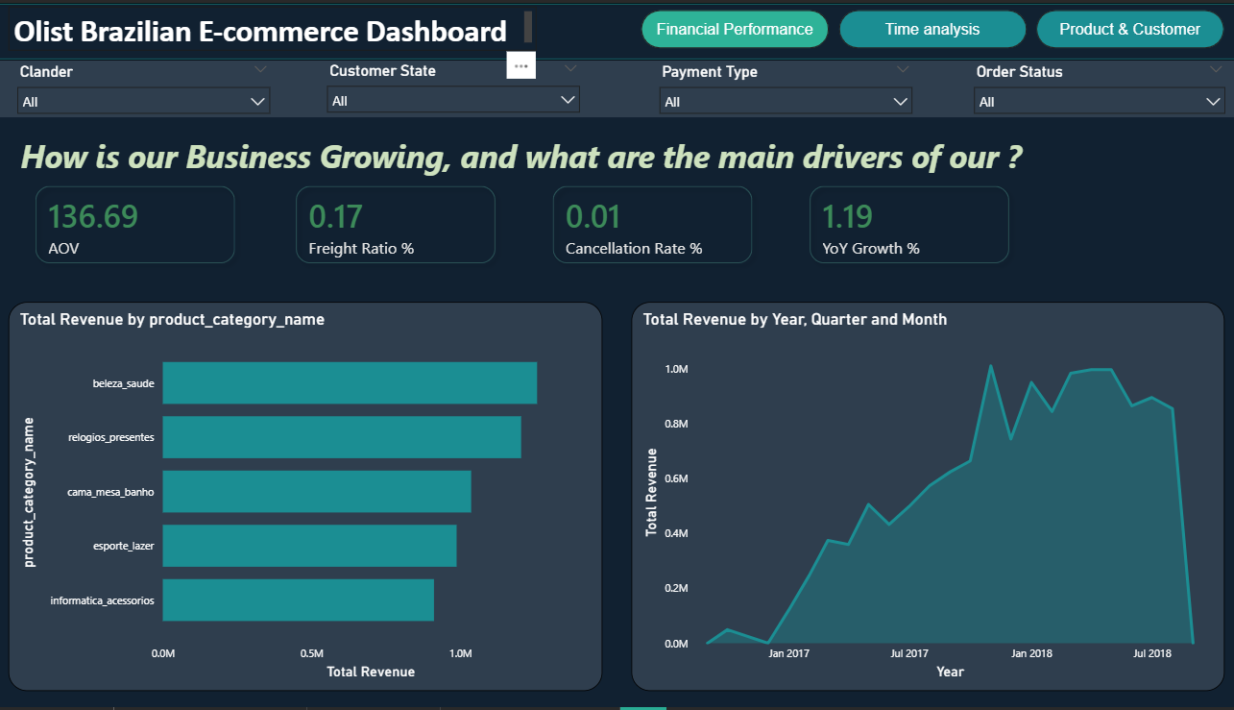

1. Financial Performance & Growth (image_56d6b5.png)
- The Narrative: This view highlights a business in a "Steady Ascent" phase.
- Key Drivers: The Average Order Value (AOV) stands at 136.69, supported by an impressive 1.19% YoY Growth.
- Product Leaders: Health and Beauty (beleza_saude) is the primary revenue engine, followed closely by Watches and Gifts.
- Operational Health: A cancellation rate of only 0.01% indicates that once an order is placed, it almost always results in a successful sale.

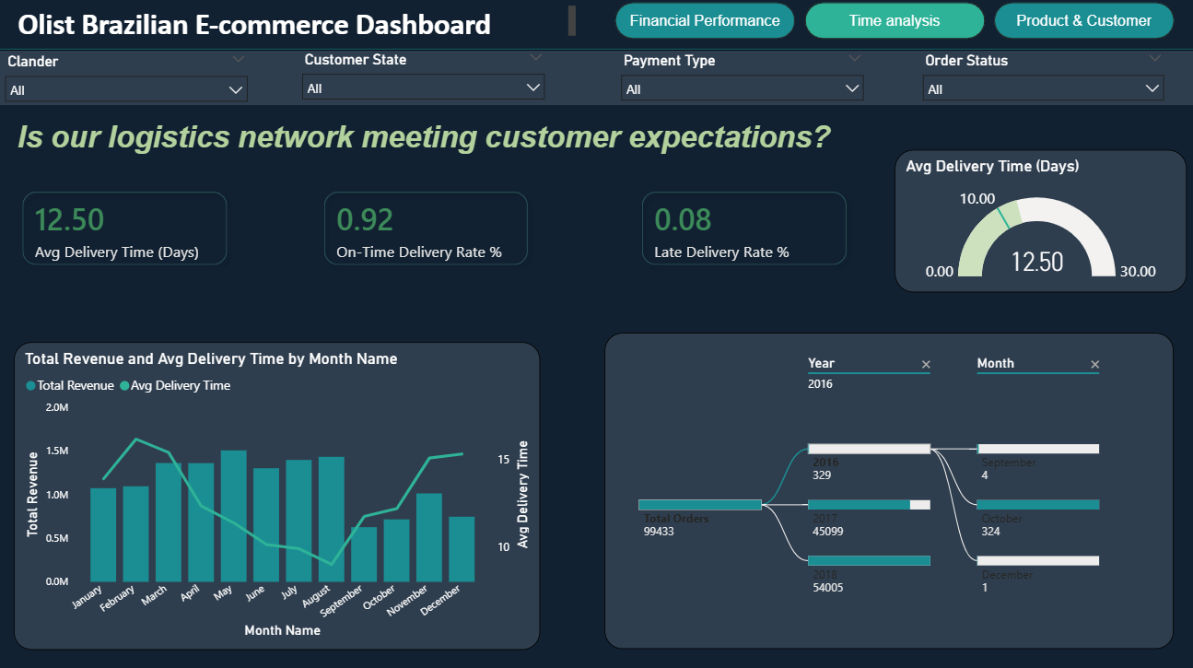

2. Logistics & Time Analysis (image_56d710.png)
- The Narrative: "Reliable Delivery Under Seasonal Pressure".
- Efficiency: The logistics network maintains a high 92% On-Time Delivery Rate, with an average wait time of 12.5 days.
- Capacity Warning: Delivery times spike significantly in February and March (exceeding 15 days), coinciding with higher revenue months, which suggests a need for increased carrier capacity during those periods.
- Volume Growth: Total orders surged in 2018 to over 54,000, dwarfing the volume from 2016 and 2017.

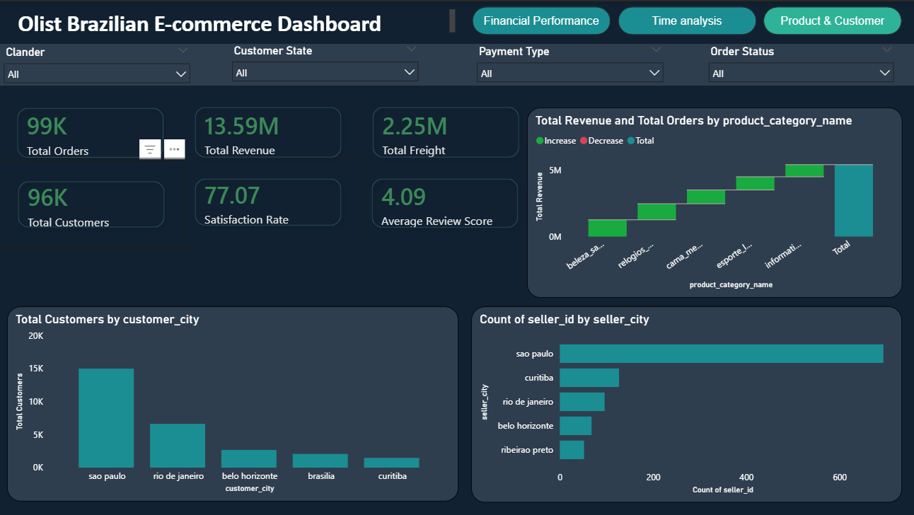

3. Product & Customer Overview (image_56d9f7.png)
- The Narrative: "Geographic Concentration as a Strength".
- Scale: The platform has processed 13.59M in total revenue from 99K total orders.
- The Hub: Sao Paulo is the undisputed center of the ecosystem, hosting the highest density of both customers (~15K) and sellers (~650+).
- Sentiment: A solid 4.09 average review score suggests high product-market fit and customer satisfaction.

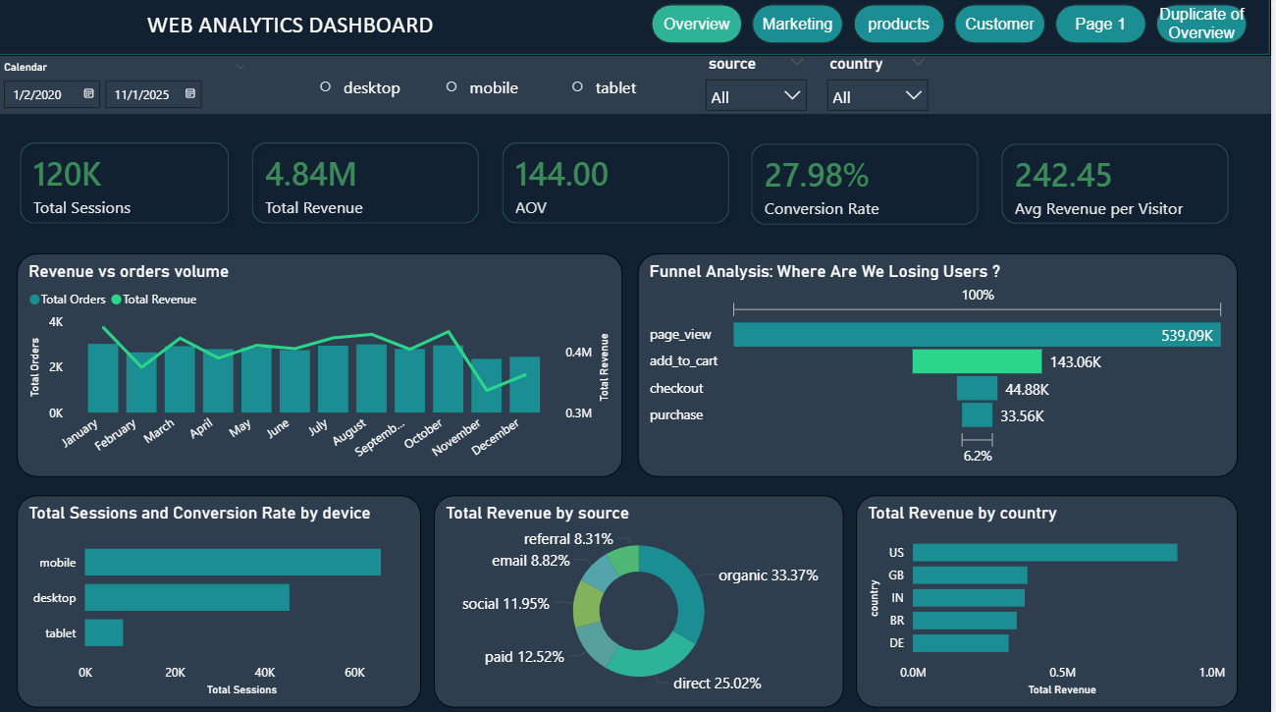

4. Web Analytics & Conversion Funnel (image_56da39.png)
- The Narrative: "The Engagement Gap".
- The Leak: While the site generates massive traffic (539K page views), only 6.2% of sessions convert into a final purchase.
- Acquisition Strategy: Organic search (33.37%) and Direct traffic (25.02%) are the most effective drivers, indicating strong brand recognition.
- Platform Preference: Mobile is the dominant platform for users, significantly outperforming desktop and tablet sessions.

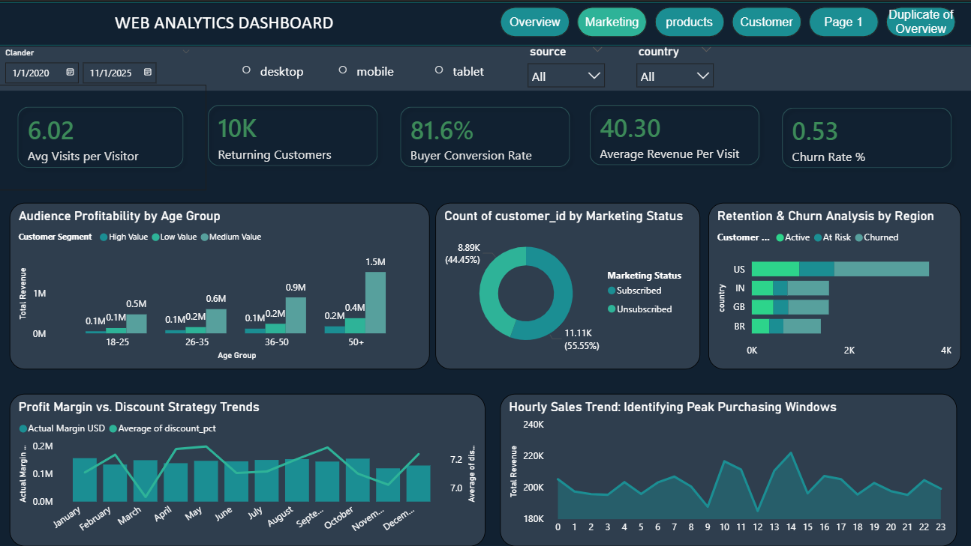

5. Marketing & Audience Profitability (image_56daed.png)
- The Narrative: "Profitability Resides in the Mature Audience".
- High-Value Segments: The 50+ age group is the most profitable, contributing over 1.5M in revenue, largely driven by "High Value" customer segments.
- Subscription Opportunity: Over 55% of customers are unsubscribed from marketing, representing a massive untapped opportunity for email re-engagement.
- Margin Health: Actual margins remain stable despite the application of discounts throughout the year.

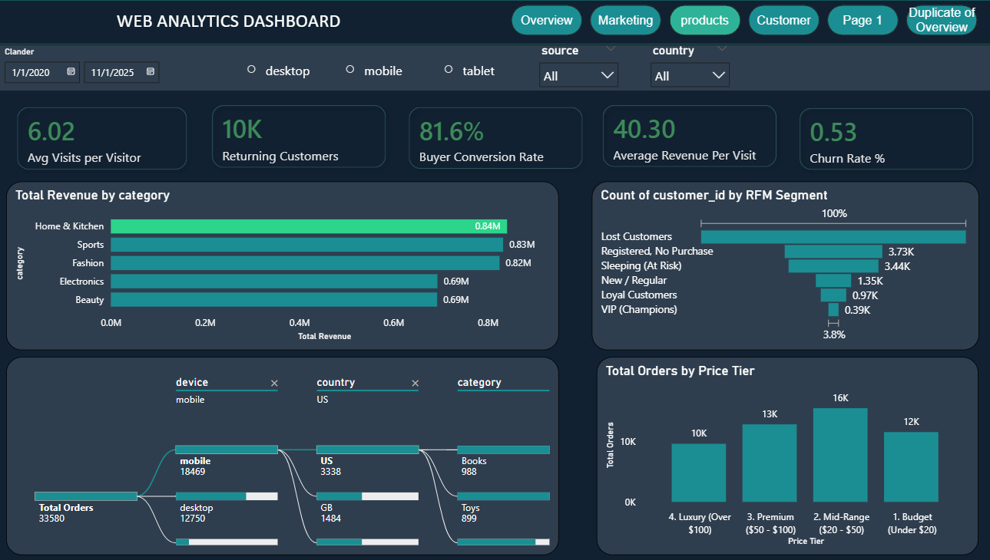

6. RFM Segmentation & Product Categories (image_56dbb6.png)
- The Narrative: "A Diversified Catalog Facing Retention Challenges".
- Category Dominance: Home & Kitchen is the top-grossing category at 0.84M.
- Retention Red Flag: The RFM funnel shows that "Lost Customers" are the largest segment, while "VIP Champions" make up only 3.8% of the base.
- Pricing Sweet Spot: Most customers prefer Mid-Range products ($20-$50), which accounts for the highest order volume at 16K.

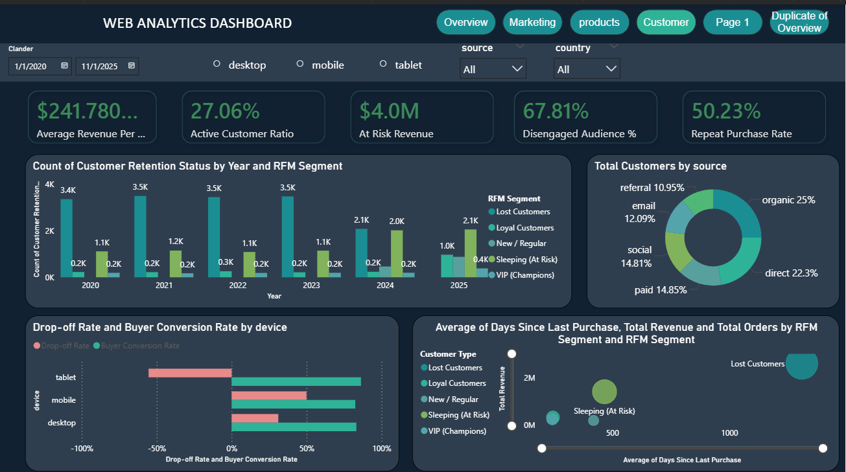

7. Retention & Churn Deep Dive (image_56dddd.png)
- The Narrative: "The $4 Million Recovery Mission".
- Risk Assessment: The business faces a 67.81% disengaged audience rate, with $4.0M in revenue currently 'at risk'.
- The Churn Reality: The bubble chart illustrates that a vast majority of the "Lost" segment has not purchased in over 1,000 days.
- Positive Note: The Repeat Purchase Rate of 50.23% shows that once a customer is hooked, they have a one-in-two chance of returning.

