**1-problem description**

The aim of this project is to develop an grammer checker for the English language, our project takes a text and returns a number of errors and correct sentences,each word od the text is assigned its part-od-speech tag is split into chunks e.g.noun pharses . then the text is matched against all pre_defined error rules

**2-model design**

**rule based system component**

Text file

Text file

-

-

-

Text file

Return sentence and 0 error

else

Else if subject isn't n_subj or n_subjpass

If main verb is[ am,is,are,was,were]

Search in children of sentence about key words

Future simple

Tomorrow,next,afternoon

Present perfect

Past perfect

Past continuous

Present continuous

Now,right now, at this moment

Past simple

Lately,yesterday,ago

Present simple

Always,often

Usually,sometimes,

never

Call VB_VB_correction function

Call VB_VB_ VB_correction function

**3-expermimental results**

Example 1:

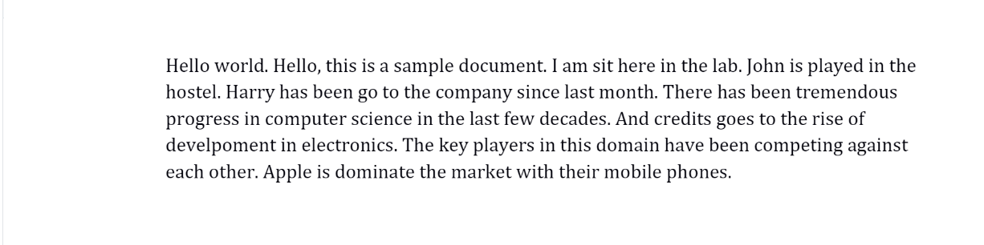

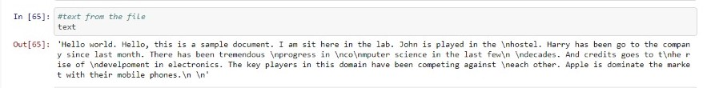

output :

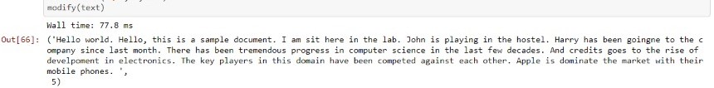

Example 2 :

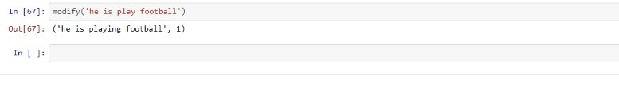

**4-model performance**

The checker time on my system is 77.8 ms.

This has been been checked with the empty file test.txt

Once the checker is running, the number of sentence checks per second depends on the number of activated rules and the length of the sentences.

As another hand we use a another tool to measure model performance by test code by list with 20 sentence containing errors and the errors and correct of this sentences are known and at the end compare our model result with target output and compute accuracy.

Accuracy=83.3%