COMPARATIVE ANALYSIS OF CHEMICAL SPACE COVERAGE FOR GLUCOCORTICOID RECEPTOR LIGANDS
Datasets: Reference (ChEMBL2034), DrugEx_GT_epsilon_0.6, GB_GA_mut_r_0.5
Introduction
Chemical space visualization provides insight into how generative models explore molecular diversity relative to known ligands. Three datasets were analyzed: the ChEMBL2034 reference set, molecules generated by DrugEx_GT_epsilon_0.6, and those produced by GB_GA_mut_r_0.5. Two complementary representations were used: Morgan fingerprints (radius 2, 2048 bits) for structural similarity. Physicochemical descriptors (MolWt, LogP, TPSA, HBD, HBA, RotB) for property-based similarity. Dimensionality reduction was performed using PCA and t-SNE to visualize the datasets in two dimensions.
Discussion & Results
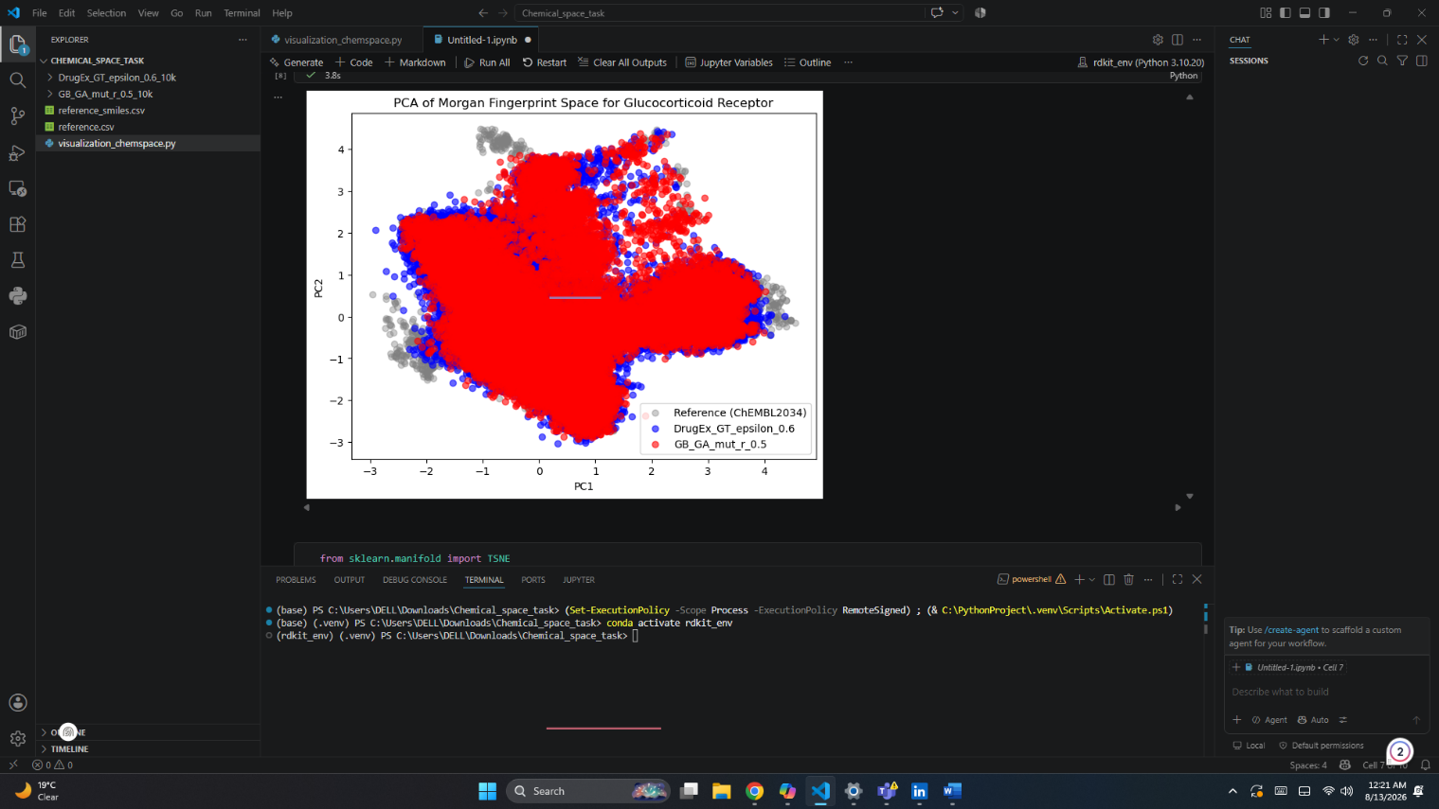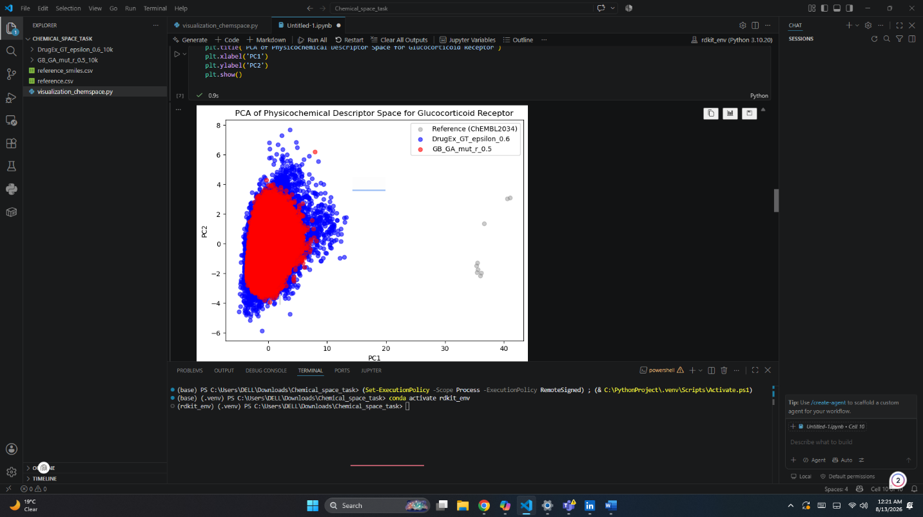
Figure 1a. Morgan Fingerprint PCA Figure 1b. Descriptors PCA

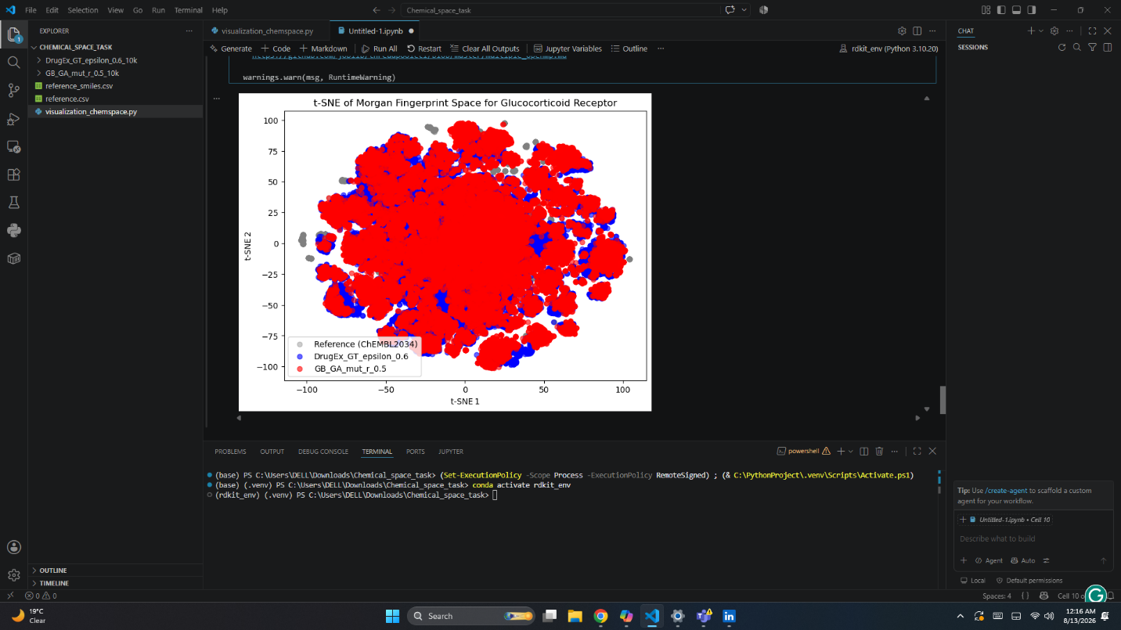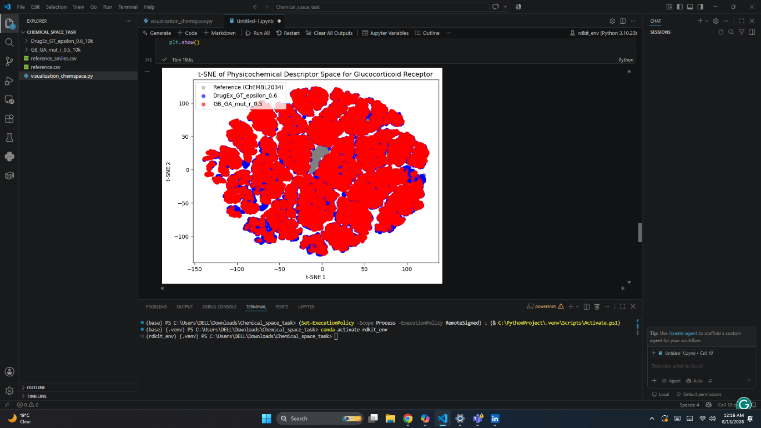
Figure 2a. Morgan Fingerprint t-SNE Figure 2b. Descriptors t-SNE

1. Which datasets overlap strongly, and which are clearly separated?
Across both PCA and t-SNE plots, the GB_GA_mut_r_0.5 (red) and DrugEx_GT_epsilon_0.6 (blue) datasets overlap extensively with each other and with the reference (gray) set. The overlap is strongest in the fingerprint-based plots, where all three datasets occupy a shared central region. A clearer separation is evident in the descriptor-based t-SNE, where DrugEx molecules extend further outward, indicating the exploration of new physicochemical regions.
2. Do the generated sets stay close to reference chemistry, or do they explore a different region?
Both generated sets remain anchored near the reference chemistry, confirming that they learned glucocorticoid-relevant features. However, DrugEx_GT_epsilon_0.6 explores a broader structural and physicochemical space, which is visible as peripheral clusters and wider dispersion, while GB_GA_mut_r_0.5 stays tightly clustered around the reference, suggesting conservative optimization rather than exploration.
3. Which method, PCA or t-SNE, makes the cluster structure easier to see?
The t-SNE plots make cluster structure and density differences easier to interpret. t-SNE emphasizes local relationships, revealing compact clusters and peripheral expansions that PCA compresses into overlapping ellipses. PCA is useful for global variance trends, but t-SNE provides clearer visual separation between generated and reference regions.
4. Do you observe outliers, and if so, what might explain them?
Yes. A few gray reference points appear as outliers in the descriptor-based PCA, far from the main cluster. These likely correspond to atypical glucocorticoid ligands with extreme molecular weights, polar surface areas, or unusual hydrogen-bonding profiles.
5. How does the interpretation change when using descriptors instead of fingerprints?
Using descriptors shifts the focus from structural similarity to physicochemical property similarity. Descriptor-based plots show tighter clustering and less dispersion, indicating that most molecules (even structurally diverse ones) share comparable drug-like properties. Fingerprint-based plots, in contrast, reveal broader structural diversity and scaffold exploration. Thus, fingerprints highlight novel structural motifs, while descriptors emphasize property conservation across datasets.

